Name Date

1. Yolanda is planning out her vegetable garden. She decides that her garden will be square. Below are possible sizes of the garden she will create.
   1. Complete the table by continuing the pattern.

|  |  |  |  |  |  |  |
| --- | --- | --- | --- | --- | --- | --- |
| Side length | foot | feet | feet | feet | feet | feet |
| Notation |  |  |  |  |  |  |
| Formula |  |  |  |  |  |  |
| Representation |  |  |  |  |  |  |

* 1. Yolanda decides the length of her square vegetable garden will be She calculates that the area of the garden is . Determine if Yolanda’s calculation is correct. Explain.

1. Yolanda creates garden cubes to plant flowers. She will fill the cubes with soil and needs to know the amount of soil that will fill each garden cube. The volume of a cube is determined by the following formula: where represents the side length.
   1. Represent the volume of the garden cube above using a numerical expression.
   2. Evaluate the expression to determine the volume of the garden cube and the amount of soil she will need for each cube.
2. Explain why .
3. Yolanda is building a patio in her back yard. She is interested in using both brick and wood for the flooring of the patio. Below is the plan she has created for the patio. All measurements are in feet.
   1. Create an expression to represent the area of the patio.

**brick**

**wood**

* 1. Yolanda’s husband develops another plan for the patio because he prefers the patio to be much wider than Yolanda’s plan. Determine the length of the brick section and the length of the wood section. Then, use the dimensions to write an expression that represents the area of the entire patio.

1. The landscaper hired for Yolanda’s lawn suggests a patio that has the same measure of wood as it has brick.

* 1. Express the perimeter of the patio in terms of , first using addition, and then using multiplication.
  2. Use substitution to determine if your expressions are equivalent. Explain.

1. Elena and Jorge have similar problems and find the same answer. Each determines that the solution to the problem is .

Elena: Jorge:

* 1. Evaluate each expression to determine if both Elena and Jorge are correct.
  2. Why would each find the solution of ? What mistakes were made, if any?

1. Jackson gave Lena this expression to evaluate: . Lena said that to evaluate the expression was simple; just multiply the factors and . Jackson told Lena she was wrong. He solved it by finding the product of and , then adding that to the product of and .
   1. Evaluate the expression using each student’s method.

|  |  |
| --- | --- |
| Lena’s Method | Jackson’s Method |
|  |  |

* 1. Who was right in this discussion? Why?

|  |  |  |  |  |  |
| --- | --- | --- | --- | --- | --- |
| A Progression Toward Mastery | | | | | |
| Assessment  Task Item | | STEP 1  Missing or incorrect answer and little evidence of reasoning or application of mathematics to solve the problem. | STEP 2  Missing or incorrect answer but evidence of some reasoning or application of mathematics to solve the problem. | STEP 3  A correct answer with some evidence of reasoning or application of mathematics to solve the problem, or an incorrect answer with substantial evidence of solid reasoning or application of mathematics to solve the problem. | STEP 4  A correct answer supported by substantial evidence of solid reasoning or application of mathematics to solve the problem. |
| **1** | **a**  6.EE.A.1  6.EE.A.2 | Student completes the table with fewer than cells correct. An entire row may be incorrect, indicating that incomplete understanding is still present. | Student completes the table with at least of the cells correct. One or more of the three rows in the last column are incorrect, indicating the student does not understand the general form of the notation, formula, and representation. | Student completes the table with at least of the cells correct. All three rows in the last column are correct, indicating the student understands the general form of the notation, formula, and representation. | Student completes the table without error. All notations, formulas, and representations are correct. Please note student exemplar below. |
|  | | | |
| **b**  6.EE.A.1  6.EE.A.2 | Student states that Yolanda was correct in her calculation or states that Yolanda was incorrect, but offers no explanation. | Student states that Yolanda was incorrect, but offers an incomplete analysis of the error. | Student states that Yolanda was incorrect and that Yolanda calculated . | Student states that Yolanda was incorrect and that Yolanda found , the base times the exponent.  AND  Student calculates the correct area:  . |
| **2** | **a**  6.EE.A.2 | Student does not write a numerical expression or writes an expression unrelated to the problem. | Student writes a numerical expression that relates the volume and side length, but the student makes an error, such as using as an exponent. | Student writes an equation that correctly represents the data, or  , instead of a numerical expression. | Student correctly writes the numerical expression for the volume of the cube: , or |
| **b**  6.EE.A.1 | Student does not attempt to evaluate the expression or has no expression from part (a) to evaluate. | Student attempts to evaluate the expression but makes an arithmetic error. | Student correctly evaluates the expression and finds. The unit of volume, , is missing.  OR  Student correctly evaluates an incorrect expression from part (a). | Student correctly evaluates the expression and uses the correct unit. Student gives the answer |
| **3** | 6.EE.A.1 | Student does not demonstrate understanding of exponential notation. One example would be adding four times. | Student makes a common error, such as or  . | Student shows that , but makes an arithmetic error and arrives at an answer other than . | Student shows that |
| **4** | **a**  6.EE.A.3 | Student does not write an expression or does not indicate an understanding of . | Student writes an expression relating the width () to only one part of the length ( or ). | Student writes the expression incorrectly, without parentheses:  , but includes each term needed to find the area. | Student writes the correct expression:  or |
| **b**  6.EE.A.3 | Student does not write an expression or does not indicate an understanding of | Student writes an expression using the width, feet, but does not calculate the length, , correctly. | Student writes the correct expression, | Student writes the correct expression, and identifies the width, feet, and the length, feet. |
| **5** | **a**  6.EE.A.3 | Student does not express the perimeter of the figure in terms of , using neither addition nor multiplication. | Student expresses the perimeter of the figure in terms of , using either addition or multiplication, but not both. | Student expresses the perimeter of the figure in terms of , using addition and multiplication but makes an error in one of the expressions. | Student expresses the perimeter of the figure as: (or uses any other order of addends that is equivalent) and writes the expression |
| **b**  6.EE.A.4 | Student states that the expressions are not equivalent, does not use substitution, and offers no explanation. | Student states that the expressions are equivalent, but student does not use substitution and offers no explanation. | Student substitutes a value for in both equations, but makes one or more arithmetic mistakes and claims that the two expressions are not equivalent. | Student substitutes any value for into both the addition and multiplication expression, calculates them accurately, and finds them equivalent. |
| **6** | **a**  6.EE.A.1  6.EE.A.2 | Student evaluates both expressions incorrectly. Errors are both in order of operations and arithmetic. | Student evaluates one expression correctly and one incorrectly. Errors are due to lack of application of order of operation rules. | Student follows the correct order of operations on both expressions but fails to compute the exponents correctly on one or both expressions. | Student evaluates both expressions accurately, applying the rules of order of operations correctly. Elena’s answer is and Jorge’s answer is . |
| **b**  6.EE.A.1  6.EE.A.2 | Student offers no credible reason why both Elena and Jorge would arrive at the answer . Jorge’s mistakes are not identified. | Student shows partial understanding of order of operations, but is unable to find or describe Jorge’s mistake. Student may have an incomplete understanding of exponents. | Student finds that Elena followed the order of operation rules correctly. Jorge’s mistake is noted, but it is not described in detail. | Student finds that Elena followed the order of operation rules correctly. Also, Jorge’s mistake is identified: Jorge did not evaluate the operation inside the parentheses first. Instead, he added first, arriving at a sum of . He then divided by to get , added to , and arrived at a final answer of . |
| **7** | **a**  6.EE.A.3 | Student evaluates neither Lena’s nor Jackson’s methods accurately. | Student evaluates both expressions using the same method. | Student evaluates either Lena’s or Jackson’s methods accurately. The other is evaluated inaccurately. | Student evaluates both Lena’s and Jackson’s methods accurately. |
| **b**  6.EE.A.2  6.EE.A.3 | Student claims both Lena and Jackson are incorrect. Evidence is missing or lacking. | Student chooses either Lena or Jackson as being correct, implying that the other is wrong. Evidence is not fully articulated. | Student indicates that methods used by both Lena and Jackson are correct. Both methods are described. No mention of the distributive property is made. | Student indicates that methods used by both Lena and Jackson are correct. The student claims Lena followed the order of operations by adding first because they were contained in parentheses, and then Lena multiplied the sum () by to arrive at a product of . The student also identifies Jackson’s method as an application of the distributive property. Partial products of and are found first, and then added to arrive at . |

Name Date

1. Yolanda is planning out her vegetable garden. She decides that her garden will be square. Below are possible sizes of the garden she will create.
   1. Complete the table by continuing the pattern.

|  |  |  |  |  |  |  |
| --- | --- | --- | --- | --- | --- | --- |
| Side length | foot | feet | feet | feet | feet | feet |
| Notation |  |  |  |  |  |  |
| Formula |  |  |  |  |  |  |
| Representation |  |  |  |  |  |  |

* 1. Yolanda decides the length of her square vegetable garden will be . She calculates that the area of the garden is . Determine if Yolanda’s calculation is correct. Explain.

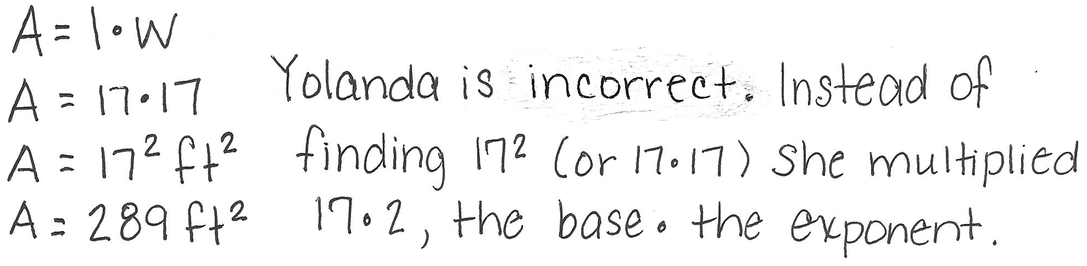

1. Yolanda creates garden cubes to plant flowers. She will fill the cubes with soil and needs to know the amount of soil that will fill each garden cube. The volume of a cube is determined by the following formula: where equals the side length.
   1. Represent the volume of the garden cube above using a numerical expression.

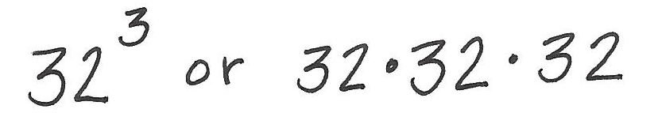

* 1. Evaluate the expression to determine the volume of the garden cube and the amount of soil she will need for each cube.

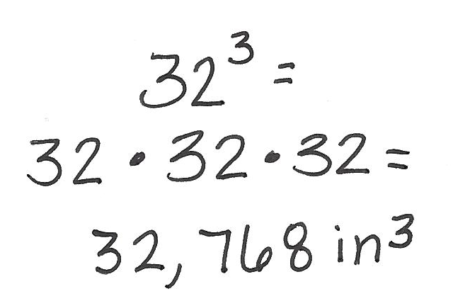

1. Explain why *.*

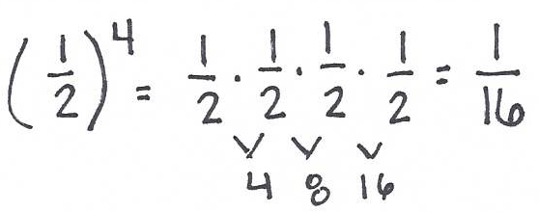

1. Yolanda is building a patio in her back yard. She is interested in using both brick and wood for the flooring of the patio. Below is the plan she has created for the patio. All measurements are in feet.
   1. Create an expression to represent the area of the patio.

brick

wood

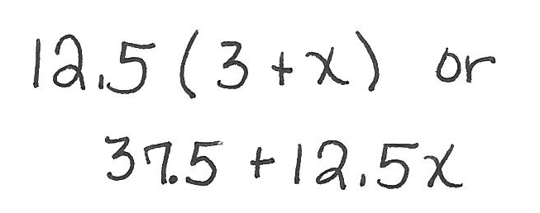

* 1. Yolanda’s husband develops another plan for the patio because he prefers the patio to be much wider than Yolanda’s plan. Determine the length of the brick section and the length of the wood section. Then, use the dimensions to write an expression that represents the area of the entire patio.

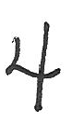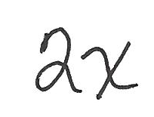

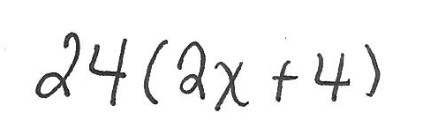

1. The landscaper hired for Yolanda’s lawn suggests a patio that has the same measure of wood as it has brick.

* 1. Express the perimeter of the patio in terms of , first using addition, and then using multiplication.

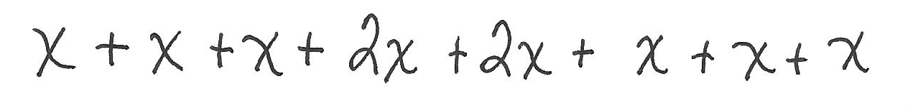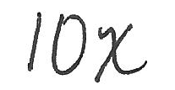

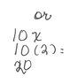

* 1. Use substitution to determine if your expressions are equivalent. Explain.

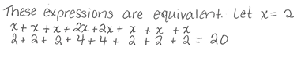

1. Elena and Jorge have similar problems and find the same answer. Each determines that the solution to the problem is .

Elena: Jorge:

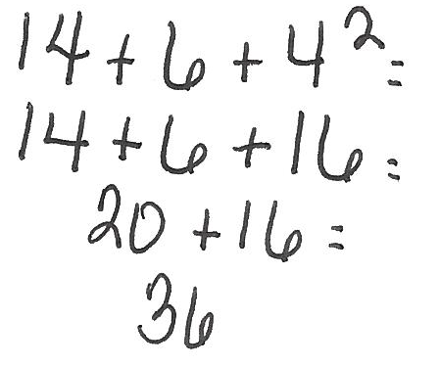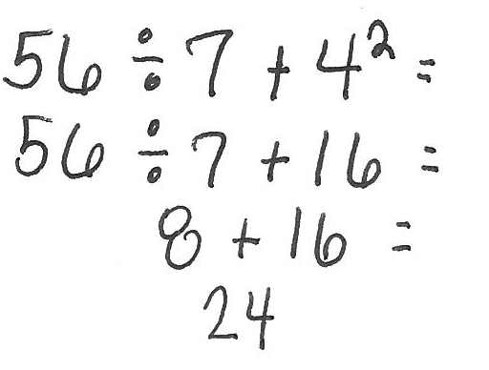

* 1. Evaluate each expression to determine if both Elena and Jorge are correct.
  2. Why would each find the solution of ? What mistakes were made, if any?

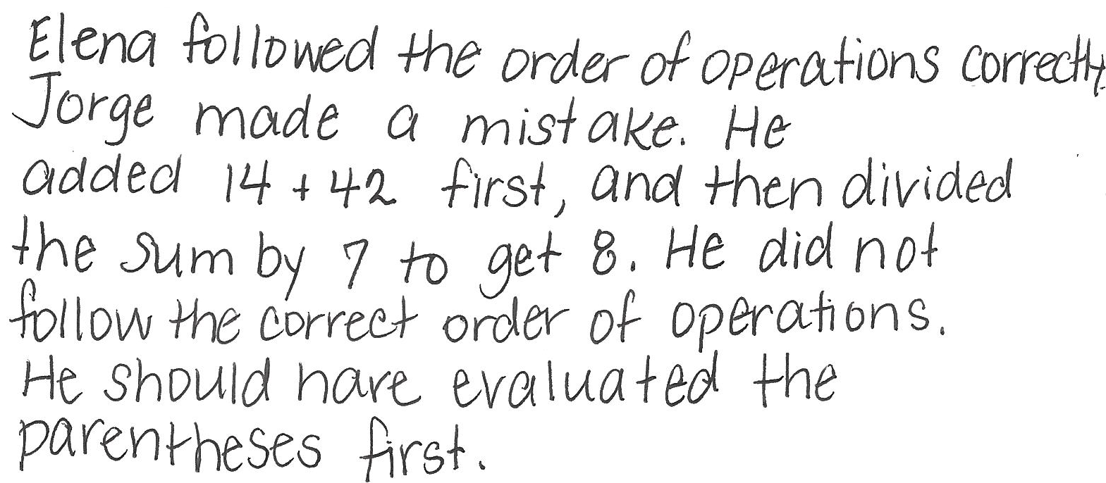

1. Jackson gave Lena this expression to evaluate: . Lena said that to evaluate the expression was simple; just multiply the factors and . Jackson told Lena she was wrong. He solved it by finding the product of and , then adding that to the product of and .
   1. Evaluate the expression using each student’s method.

|  |  |
| --- | --- |
| Lena’s Method | Jackson’s Method |
|  |  |

* 1. Who was right in this discussion? Why?

