Name Date
- Gertrude is deciding which cell phone plan is the best deal for her to buy. Super Cell charges a monthly fee of $\$10$ and also charges $\$0.15$ per call. She makes a note that the equation is $M=0.15C+10$, where $M$ is the monthly charge, in dollars, and $C$ is the number of calls placed. Global Cellular has a plan with no monthly fee, but charges $\$0.25$ per call. She makes a note that the equation is $M=0.25C$, where $M$ is the monthly charge, in dollars, and $C$ is the number of calls placed. Both companies offer unlimited text messages.

  - Make a table for both companies showing the cost of service, $M$, for making from $0$ to $200$ calls per month. Use multiples of $20$.

Number of Calls, $C$ | Super Cell  $$M=0.15C+10$$ | Global Cellular  $$M=0.25C$$

  - Construct a graph for the two equations on the same graph. Use the number of calls, $C$, as the independent variable, and the monthly charge, in dollars, $M$, as the dependent variable.

  - Which cell phone plan is the best deal for Gertrude? Defend your answer with specific examples.

- Sadie is saving her money to buy a new pony, which costs $\$600$. She has already saved $\$75$. She earns $\$50$ per week working at the stables and wonders how many weeks it will take to earn enough for a pony of her own.

  - Make a table showing the week number, $W$, and total savings, in dollars, $S$, in Sadie’s savings account.

Number of Weeks
Total Savings

  - Show the relationship between the number of weeks and Sadie’s savings using an expression.

  - How many weeks will Sadie have to work to earn enough to buy the pony?

- The elevator at the local mall has a weight limit of $1,800$ pounds and requires that the maximum person allowance be no more than nine people.

  - Let $x$ represent the number of people. Write an inequality to describe the maximum allowance of people allowed in the elevator at one time.

  - Draw a number line diagram to represent all possible solutions to part (a).

  - Let $w$ represent the amount of weight, in pounds. Write an inequality to describe the maximum weight allowance in the elevator at one time.

  - Draw a number line diagram to represent all possible solutions to part (c).

- Devin’s football team carpools for practice every week. This week is his parents’ turn to pick up team members and take them to the football field. While still staying on the roads, Devin’s parents always take the shortest route in order to save gasoline. Below is a map of their travels. Each gridline represents a street and the same distance.

Stop 4
Stop 3
Stop 2
Stop 1
Devin’s House
Football Field

Devin’s father checks his mileage and notices that he drove $18$ miles between his house and Stop 3.

  - Create an equation and determine the amount of miles each gridline represents.

  - Using this information, determine how many total miles Devin’s father will travel from home to the football field, assuming he made every stop. Explain how you determined the answer.

  - At the end of practice, Devin’s father dropped off team members at each stop and went back home. How many miles did Devin’s father travel all together?

- For a science experiment, Kenneth reflects a beam off a mirror. He is measuring the missing angle created when the light reflects off the mirror. (Note: Figure is not drawn to scale.)

$$51°$$
$$x°$$
$$51°$$

Use an equation to determine the missing angle, labeled$x$ in the diagram.

A Progression Toward Mastery
Assessment  Task Item |  | STEP 1  Missing or incorrect answer and little evidence of reasoning or application of mathematics to solve the problem. | STEP 2  Missing or incorrect answer but evidence of some reasoning or application of mathematics to solve the problem. | STEP 3  A correct answer with some evidence of reasoning or application of mathematics to solve the problem, or an incorrect answer with substantial evidence of solid reasoning or application of mathematics to solve the problem. | STEP 4  A correct answer supported by substantial evidence of solid reasoning or application of mathematics to solve the problem.
1 | a  6.EE.C.9 | Student is not able to make a table with multiples of $20$ calls or cannot calculate the monthly charge based on number of calls. | Student correctly completes the Number of Calls column, but is not able to use the equations to accurately complete the other two columns. | Student accurately calculates one column, but the other two columns have errors. | Student accurately calculates all of the columns.
 | b  6.EE.C.9  6.EE.B.6 | Student is not able to graph the data from the table. | Student attempts to graph the data from the table. Several mistakes or omissions are present. | Student graphs the data from the table but has minor mistakes or omissions. Student includes at least three of the four criteria of a perfect graph. | Student graphs the data from the table without error (i.e., graph is titled, axes are labeled, units are included on axes, and points are plotted accurately).
 | c  6.EE.C.9 | Student cannot conclude which plan is better or chooses a plan without evidentiary support. | Student chooses one plan or the other, showing support for that plan. Student does not recognize that the best deal depends on the number of calls placed in a month. | Student concludes that the best deal depends on the number of calls placed in a month. Student does not describe a complete analysis. | Student concludes that the best deal depends on the number of calls placed in a month. The break-even point, $100$ calls costing $\$25$, is identified. Answer specifically states that Super Cell is the better deal if the number of calls per month is $<100$, and Global Cellular is the better deal if the number of calls per month is $>100$.
2 | a  6.EE.C.9 | Student is not able to make the table or attempts to make the table but has many errors. | Student is able to make the table and calculate most rows accurately. Compounding errors may be present. Titles or variables may be missing. | Student accurately makes the table and accurately computes the total savings for each week. Titles or variables may be missing.  OR  Student begins with $50$ and $75$ every week. | Student accurately makes the table and accurately computes the total savings for each week. Titles and variables are present.
 | b  6.EE.C.9 | Student is not able to write the expression. | Student attempts to write the expression but is inaccurate (perhaps writing $75W+50$). | Student writes the expression $50W+75$ but does not include a description of what the variable represents. | Student accurately writes the expression $50W+75$ and includes a description of what the variable represents.
 | c  6.EE.C.9 | Student cannot make a conclusion about how many weeks are needed for the purchase, or an answer is provided that is not supported by the student’s table. | Student concludes that some number of weeks other than $11$ weeks will be needed for the purchase. | Student concludes that $11$ weeks of work will be needed for the purchase. | Student concludes that $11$ weeks of work will be needed for the purchase and that Sadie will have $\$625$, which is $\$25$ more than the cost of the pony.
3 | a  6.EE.B.8 | Student does not write an inequality or tries writing the inequality with incorrect information (e.g., $1,800$). | Student writes the inequality$x≥9$ or $x>9$. | Student writes the inequality $x<9$ because student does not realize there can be $9$ people on the elevator. | Student writes the inequality $0≤x≤9$.
 | b  6.EE.C.9 | Student does not draw a number line or draws a line but does not indicate$0≤x≤9$. | Student draws an accurate number line and uses either a line segment or discrete symbols, but does not include $0$ and/or $9$ in the solution set. | Student draws a number line but uses a line segment to indicate continuous points $0≤x≤9$. | Student draws an accurate number line, using discrete symbols indicating whole numbers from $0$ to $9$.
 | c  6.EE.B.8 | Student does not write an inequality or tries writing the inequality with incorrect information (e.g., $9$). | Student writes the inequality $W≥1,800$ or $W>1,800$. | Student writes the inequality  $W<1,800$because student does not realize there can be $1,800$ pounds on the elevator. | Student writes the inequality  $0≤W≤1,800$.
 | d  6.EE.C.9 | Student does not draw a number line or draws a line but does not indicate  $0≤W≤1,800$. | Student draws an accurate number line and uses either a line segment or discrete symbols but does not include $0$and/or $1,800$ in the solution set. | Student draws a number line but uses discrete symbols indicating whole numbers from $0$ to $1,800$ are in the solution set $0≤W≤1,800$. | Student draws an accurate number line, using a line segment indicating all numbers from $0$ to $1,800$ are in the solution set $0≤W≤1,800$.
4 | a  6.EE.B.7  6.EE.C.9  6.EE.B.5  6.EE.B.6 | Student is unable to create an equation and is unable to determine the amount of miles Devin’s father traveled between their house and Stop 3. | Student is able to determine the amount of miles Devin’s father traveled between their house and Stop 3 but does not write an equation. | Student creates an equation, $9G=18 miles$ but does not use the equation to determine the amount of miles Devin’s father traveled between their house and Stop 3. | Student creates an equation and uses it to determine the amount of miles Devin’s father traveled between their house and Stop 3. Let $G$represent the number of gridlines passed on the map.  $$9G=18 miles \\ \frac{G}{9}=\frac{18 miles}{9} \\ G=2 miles$$
 | b  6.EE.A.2  6.EE.B.6  6.EE.B.6 | Student does not describe how the answer was derived or leaves the answer blank. | Student determines the correct distance ($30 miles$) but does not explain how the answer was determined or offers an incomplete explanation. | Student inaccurately counts the intersections passed ($15$) but accurately applies the equation with the incorrect count. Explanation is correct and clear. | Student accurately counts the intersections passed ($15$) and applies that to the correct equation: $15∙2 miles=30 miles$.
 | c  6.EE.C.9  6.EE.B.5  6.EE.B.6 | Student answer does not indicate a concept of round-trip distance being double that of a one-way trip. | Student does not double the correct one-way trip distance ($30 miles$) from part (b) or doubles the number incorrectly. | Student does not use the one-way trip distance ($30 miles$) from part (b), but counts the blocks for the round-trip. | Student doubles the correct one-way trip distance ($30 miles$) from part (b) to arrive at the correct round-trip distance ($60 miles$).
5 | 6.EE.B.5  6.EE.B.6  6.EE.B.7 | Student does not show any of the steps necessary to solve the problem or simply answers $51°$. | Student adds $51°+51°$ to arrive at $102°$, but does not subtract this from $180°$ to find the missing angle. | Student correctly finds the missing angle, $78°$, showing clearly the steps involved, but does not use an equation.  OR  Student makes an arithmetic error, but clear evidence of conceptual understanding is evident. | Student correctly finds the missing angle, $78°$, by using an equation and clearly showing the steps involved. Student might reference the terms supplementary angles or straight angles, or start with $51°+51°+x°=180°$ before solving it correctly.

Name Date
- Gertrude is deciding which cell phone plan is the best deal for her to buy. Super Cell charges a monthly fee of $\$10$ and also charges $\$0.15$ per call. She makes a note that the equation is $M=0.15C+10$, where $M$ is the monthly charge, in dollars, and $C$ is the number of calls placed. Global Cellular has a plan with no monthly fee, but charges $\$0.25$ per call. She makes a note that the equation is $M=0.25C$, where $M$ is the monthly charge, in dollars, and $C$ is the number of calls placed. Both companies offer unlimited text messages.

  - Make a table for both companies showing the cost of service, $M$, for making from $0$ to $200$ calls per month. Use multiples of $20$.
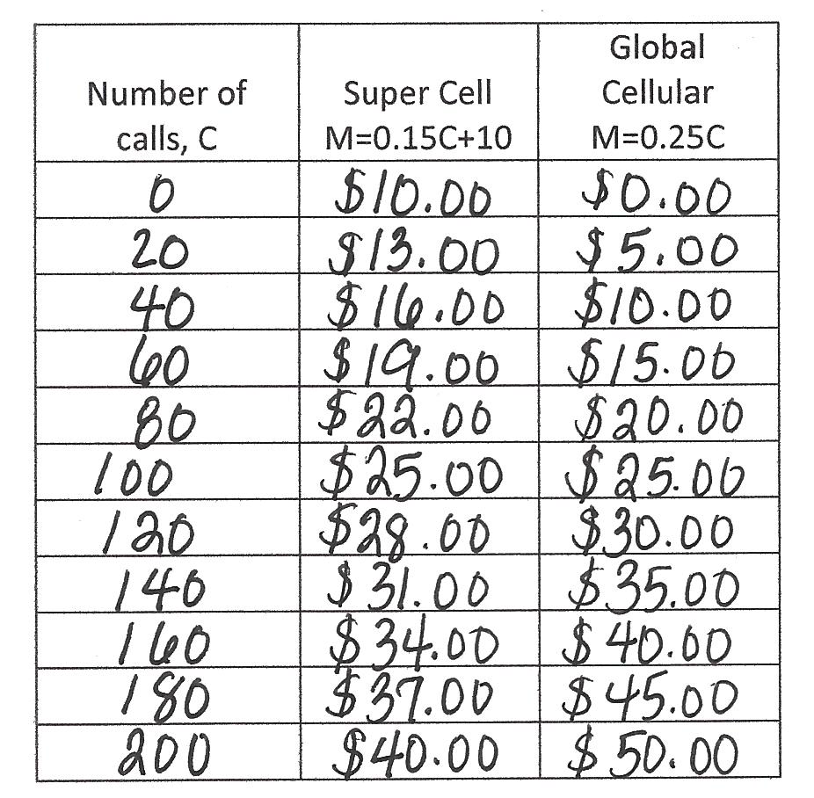

  - Construct a graph for the two equations on the same graph. Use the number of calls, $C$, as the independent variable and the monthly charge, in dollars, $M$, as the dependent variable.
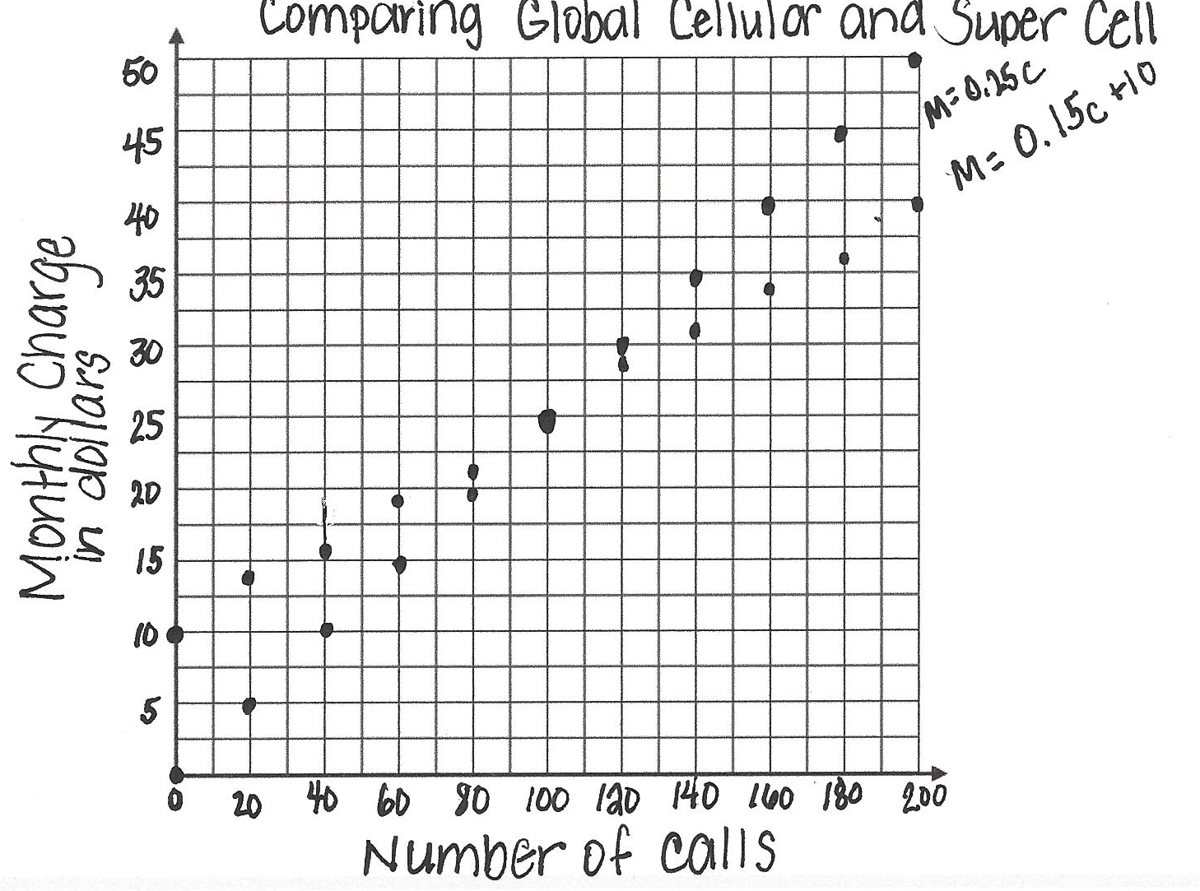

  - Which cell phone plan is the best deal for Gertrude? Defend your answer with specific examples.
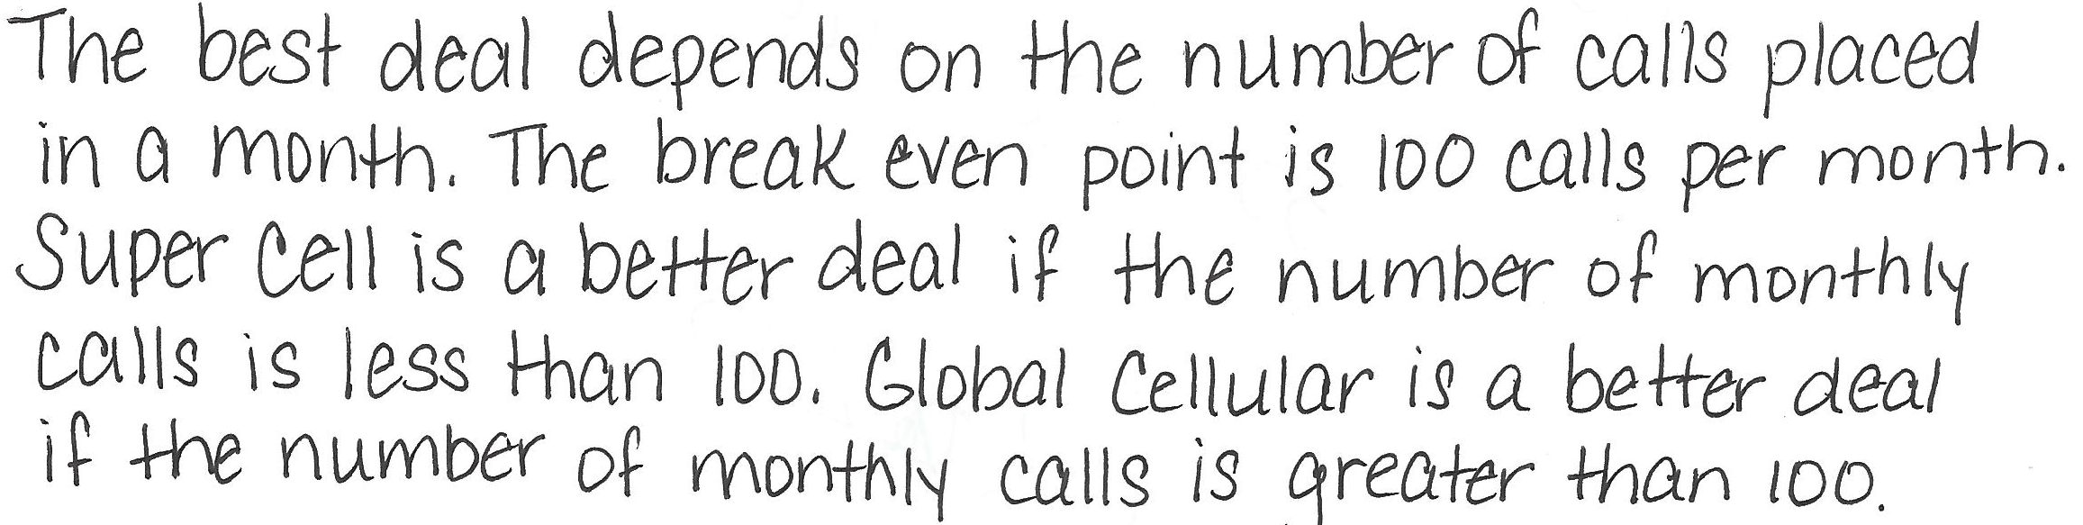

- Sadie is saving her money to buy a new pony, which costs $\$600$. She has already saved $\$75$. She earns $\$50$ per week working at the stables and wonders how many weeks it will take to earn enough for a pony of her own.

  - Make a table showing the week number, $W$, and total savings, in dollars, $S$, in Sadie’s savings account.

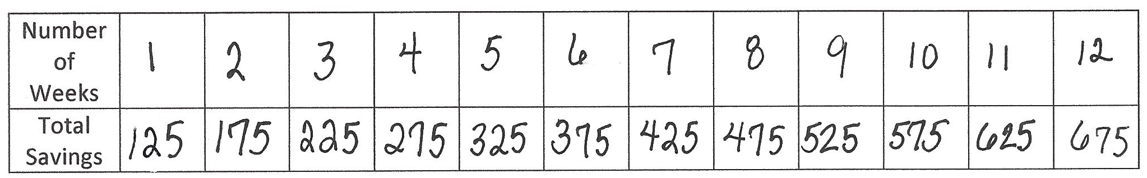

  - Show the relationship between the number of weeks and Sadie’s savings using an expression.

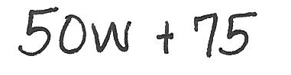

  - How many weeks will Sadie have to work to earn enough to buy the pony?

- The elevator at the local mall has a weight limit of $1,800$pounds and requires that the maximum person allowance be no more than nine people.

  - Let $x$ represent the number of people. Write an inequality to describe the maximum allowance of people allowed in the elevator at one time.
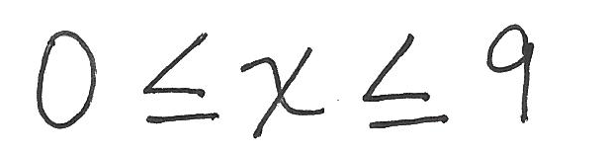

  - Draw a number line diagram to represent all possible solutions to part (a).

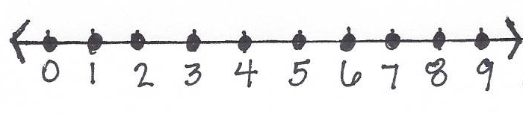

  - Let $w$ represent the amount of weight, in pounds. Write an inequality to describe the maximum weight allowance in the elevator at one time.

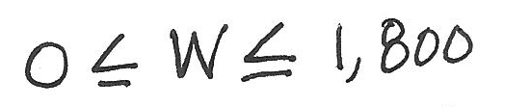

  - Draw a number line diagram to represent all possible solutions to part (c).

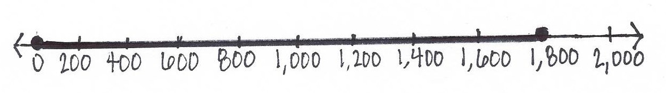

- Devin’s football team carpools for practice every week. This week is his parents’ turn to pick up team members and take them to the football field. While still staying on the roads, Devin’s parents always take the shortest route in order to save gasoline. Below is a map of their travels. Each gridline represents a street and the same distance.

Stop 4
Stop 3
Stop 2
Stop 1
Devin’s House
Football Field

Devin’s father checks his mileage and notices that he drove $18$ miles between his house and Stop 3.

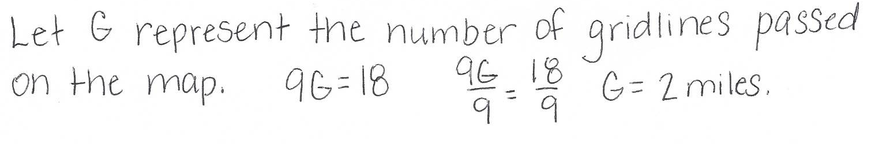
  - Create an equation and determine the amount of miles each gridline represents.

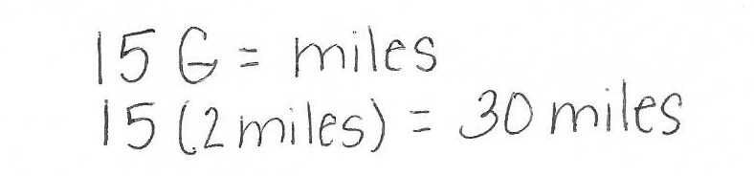
  - Using this information, determine how many total miles Devin’s father will travel from home to the football field, assuming he made every stop. Explain how you determined the answer.

  - At the end of practice, Devin’s father dropped off team members at each stop and went back home. How many miles did Devin’s father travel all together?
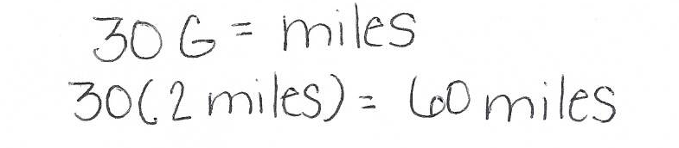

- For a science experiment, Kenneth reflects a beam off a mirror. He is measuring the missing angle created when the light reflects off the mirror. (Note: Figure is not drawn to scale.)

$$51°$$
$$x°$$
$$51°$$

Use an equation to determine the missing angle, labeled$x$ in the diagram.

