Table of Contents

GRADE K • MODULE 1

Numbers to 10

**Module Overview** i

Topic A: Attributes of Two Related Objects 1.A.1

Topic B: Classify to Make Categories and Count. 1.B.1

Topic C: Numbers to 5 in Different Configurations, Math Drawings,  
and Expressions 1.C.1

Topic D: The Concept of Zero and Working with Numbers 0–5 1.D.1

Topic E: Working with Numbers 6–8 in Different Configurations 1.E.1

Topic F: Working with Numbers 9–10 in Different Configurations 1.F.1

Topic G: *One More* with Numbers 0–10 1.G.1

Topic H: *One Less* with Numbers 0–10 1.H.1

**Module Assessments** 1.S.1

Grade K • Module 1

Numbers to 10

OVERVIEW

The first day of Kindergarten is long anticipated by parents and young students. Students expect school to be a dynamic and safe place to learn, an objective that is realized immediately by their involvement in purposeful and meaningful action.

In Topics A and B, classification activities allow students to analyze and observe their world and articulate their observations. Reasoning and dialogue begin immediately. “These balloons are exactly the same.” “These are the same but a different size.” As Topic B closes, students recognize cardinalities as yet one more lens for classification (**K.MD.3**). “I put a pencil, a book, and an eraser, three things, in the backpack for school.” “I put five toys in the closet to keep at home.” From the moment students enter school, they practice the counting sequence so that when counting a set of objects, their attention can be on matching one count to one object, rather than on retrieving the number words (**K.CC.4a**).

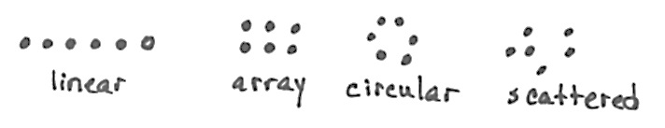In Topics C, D, E, and F, students order, count (**K.CC.1**), and write (**K.CC.3**) up to ten objects to answer *how many* questions from linear, to array, to circular, and finally to scattered configurations wherein they must devise a path through the objects as they count. Students use their understanding of numbers and matching numbers with objects to answer *how many* questions about a variety of objects, pictures, and drawings (**K.CC.5**).

They learn that the last number name said tells the number of objects counted (**K.CC.4b**). Daily, they engage in mathematical dialogue. They might compare their seven objects to a friend’s. For example, “My cotton balls are bigger than your cubes, but when we count them, we both have seven!”

Very basic expressions and equations are introduced early in order to ensure students’ familiarity with numbers throughout the entire year so that they exit fluent in sums and differences to 5 (**K.OA.5**). Decomposition is modeled with small numbers with materials and drawings and as addition equations. Students see that both the expression 2 + 1 (Topic C) and the equation 3 = 2 + 1 (Topic D) describe a stick of three cubes decomposed into two parts (**K.OA.3**). Emphasis is not placed on the expressions and equations or using them in isolation from the concrete and pictorial—they are simply included to show another representation of decompositions alongside counters and drawings.

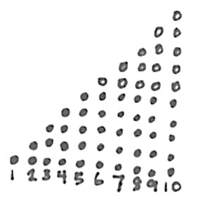In Topics G and H, students use their understanding of relationships between numbers to recognize that each successive number name refers to a quantity that is one greater and that the number before is one less (**K.CC.4c**). This important insight leads students to use the Level 2 strategy of counting on rather than counting all, later in the year and on into Grade 1.

In this module, daily fluency activities with concentration and emphasis on counting (**K.CC.4ab, K.CC.5**) are integrated throughout the concept development: “I counted six beans in a row. I counted six beans in a circle and then squished them together and counted again. There were still six!” “I can make my six beans into rows, and there are no extras.” Students complete units of five using the fingers of their left hand and 5-groups. The numbers 6, 7, 8, and 9 are introduced relative to the number 5: “Five fingers and ____ more.” Students also explore numbers 5 to 9 in relation to 10, or two complete fives: “Nine is missing one to be ten or two fives.” (**K.OA.4**)

As students begin to master writing numbers to 10, they practice with paper and pencil. This is a critical daily fluency that may work well to close lessons, since management of young students is generally harder towards the end of math time. The paper and pencil work is calming, though energized.

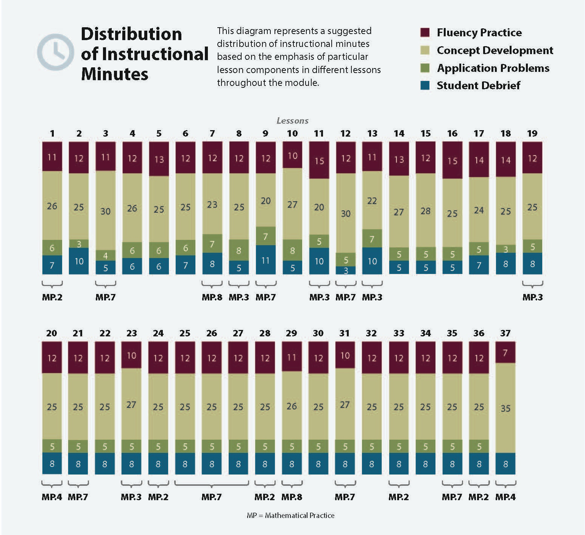

Focus Grade Level Standards[1]

Know number names and the count sequence.[2]

**K.CC.3** Write numbers from 0 to 20. Represent a number of objects with a written numeral 0–20 (with 0 representing a count of no objects).

Count to tell the number of objects.[3]

**K.CC.4** Understand the relationship between numbers and quantities; connect counting to cardinality.

a. When counting objects, say the number names in the standard order, pairing each object with one and only one number name and each number name with one and only one object.

b. Understand that the last number name said tells the number of objects counted. The number of objects is the same regardless of their arrangement or the order in which they were counted.

c. Understand that each successive number name refers to a quantity that is one larger.

**K.CC.5** Count to answer “how many?” questions about as many as 20 things arranged in a line, a rectangular array, or a circle, or as many as 10 things in a scattered configuration; given a number from 1–20, count out that many objects.

Understand addition as putting together and adding to, and understand subtraction as taking apart and taking from.[4]

**K.OA.3** Decompose numbers less than or equal to 10 into pairs in more than one way, e.g., by using objects or drawings, and record each decomposition by a drawing or equation (e.g., 5 = 2 + 3 and 5 = 4 + 1).

Classify objects and count the number of objects in each category.

**K.MD.3** Classify objects into given categories; count the numbers of objects in each category and sort the categories by count. (Limit category counts to be less than or equal to 10.)

Foundational Standards

**PK.CC.1** Count to 20.

**PK.CC.2** Represent a number of objects with a written numeral 0–5 (with 0 representing a count of no objects).

**PK.CC.3** Understand the relationship between numbers and quantities to 10; connect counting to cardinality.

1. When counting objects, say the number names in the standard order, pairing each object with one and only one number name and each number name with one and only one object.

b. Understand that the last number name said tells the number of objects counted. The number of objects is the same regardless of their arrangement or the order in which they were counted.

c. Understand that each successive number name refers to a quantity that is one larger.

**PK.CC.4** Count to answer “how many?” questions about as many as 10 things arranged in a line, a rectangular array, or a circle, or as many as 5 things in a scattered configuration; given a number from 1–10, count out that many objects.

**PK.CC.6** Identify “first” and “last” related to order or position.

Focus Standards for Mathematical Practice

**MP.2** **Reason abstractly and quantitatively.** Students represent quantities with numerals.

**MP.3** **Construct viable arguments and critique the reasoning of others.** Students reason about each other’s ways of counting fingers or a scattered set of objects. They reason about counting fingers by comparing the fingers counted and about scattered objects by comparing counting paths through a set of up to 10 scattered objects.

**MP.4 Model with mathematics.** Students model decompositions of three objects as math drawings and addition equations.

**MP.7 Look for and make use of structure.** Students use the 5-group to reason about numbers within 10.

MP.8 **Look for and express regularity in repeated reasoning.** Students build a number stair to reason about 1 more and 1 less than each number within 10.

Overview of Module Topics and Lesson Objectives

|  |  |  |  |
| --- | --- | --- | --- |
| **Standards** | **Topics and Objectives** | | **Days** |
| **K.MD.3** | A | Attributes of Two Related Objects  Lesson 1: Analyze to find two objects that are *exactly the same* or *not exactly the same.*  Lesson 2: Analyze to find two similar objects—*these* *are the same but….*  Lesson 3: Classify to find two objects that share a visual pattern, color, and use. | 3 |
| **K.CC.4a**  **K.CC.4b K.MD.3** | B | Classify to Make Categories and Count  Lesson 4: Classify items into two pre-determined categories.  Lesson 5: Classify items into three categories, determine the count in each, and reason about how the last number named determines the total.  Lesson 6: Sort categories by count. Identify categories with 2, 3, and 4 within a given scenario. | 3 |
| **K.CC.4a**  **K.CC.4b**  **K.CC.5**  **K.OA.3**  K.MD.3 | C | Numbers to 5 in Different Configurations, Math Drawings, and Expressions  Lesson 7: Sort by count in vertical columns and horizontal rows (linear configurations to 5). Match to numerals on cards.  Lesson 8: Answer *how many* questions to 5 in linear configurations (5-group), with 4 in an array configuration. Compare ways to count five fingers.  Lesson 9: Within linear and array dot configurations of numbers 3, 4, and 5, find *hidden partners.*  Lesson 10: Within circular and scattered dot configurations of numbers 3, 4, and 5, find *hidden partners*.  Lesson 11: Model decompositions of 3 with materials, drawings, and expressions. Represent the decomposition as 1 + 2 and 2 + 1. | 5 |
| **K.CC.3**  **K.CC.4a**  **K.CC.4b**  **K.CC.5** | D | The Concept of Zero and Working with Numbers 0–5  Lesson 12: Understand the meaning of zero. Write the numeral 0.  Lesson 13: Order and write numerals 0–3 to answer *how many* questions.  Lesson 14: Write numerals 1–3. Represent decompositions with materials, drawings, and equations, 3 = 2 + 1 and 3 = 1 + 2.  Lesson 15: Order and write numerals 4 and 5 to answer *how many* questions in categories; sort by count.  Lesson 16: Write numerals 1–5 in order. Answer and make drawings of decompositions with totals of 4 and 5 without equations. | 5 |
|  |  | Mid-Module Assessment: Topics A–D (Interview style assessment: 3 days) | 3 |
| **K.CC.3**  **K.CC.4a**  **K.CC.4b**  **K.CC.5**  K.MD.3 | E | Working with Numbers 6–8 in Different Configurations  Lesson 17: Count 4–6 objects in vertical and horizontal linear configurations and array configurations. Match 6 objects to the numeral 6.  Lesson 18: Count 4–6 objects in circular and scattered configurations. Count 6 items out of a larger set. Write numerals 1–6 in order.  Lesson 19: Count 5–7 linking cubes in linear configurations. Match with numeral 7. Count on fingers from 1 to 7 and connect to 5-group images.  Lesson 20: Reason about sets of 7 varied objects in circular and scattered configurations. Find a path through the scattered configuration. Write numeral 7. Ask, “How is your seven different than mine?”  Lesson 21: Compare counts of 8. Match with numeral 8.  Lesson 22: Arrange and strategize to count 8 beans in circular (around a cup) and scattered configurations. Write numeral 8. Find a path through the scattered set and compare paths with a partner. | 6 |
| **K.CC.3**  **K.CC.4a**  **K.CC.4b**  **K.CC.5** | F | Working with Numbers 9–10 in Different Configurations  Lesson 23: Organize and count 9 varied geometric objects in linear and array (3 threes) configurations. Place objects on 5-group mat. Match with numeral 9.  Lesson 24: Strategize to count 9 objects in circular (around a paper plate) and scattered configurations printed on paper. Write numeral 9. Represent a path through the scatter count with a pencil. Number each object.  Lessons 25–26: Count 10 objects in linear and array configurations (2 fives). Match with numeral 10. Place on the 5-group mat. Dialogue about 9 and 10. Write numeral 10.  Lesson 27: Count 10 objects and move between all configurations.  Lesson 28: Act out *result unknown* story problems without equations. | 6 |
| **K.CC.4a**  **K.CC.4b**  **K.CC.4c**  K.CC.2  K.CC.5 | G | *One More* with Numbers 0–10  Lesson 29: Order and match numeral and dot cards from 1 to 10. State 1 more than a given number.  Lesson 30: Make math stairs from 1 to 10 in cooperative groups.  Lesson 31: Arrange, analyze, and draw 1 more up to 10 in configurations other than towers.  Lesson 32: Arrange, analyze, and draw sequences of quantities of 1 more, beginning with numbers other than 1. | 4 |
| **K.CC.4a**  **K.CC.4b**  **K.CC.4c**  K.CC.5 | H | *One Less* with Numbers 0–10  Lesson 33: Order quantities from 10 to 1 and match numerals.  Lesson 34: Count down from 10 to 1, and state 1 less than a given number.  Lesson 35: Arrange number towers in order from 10 to 1, and describe the pattern.  Lesson 36: Arrange, analyze, and draw sequences of quantities that are 1 lessin configurations other than towers.  Lesson 37: Culminating task  *Decide how to classify the objects in your bag into two groups. Count the number of objects in each group. Represent the greater number in various ways. Next, remove the card from your pack that shows the number of objects in the smaller group. Put your remaining cards in order from smallest to greatest. Your friends will have to figure out what card is missing when they visit your station!* | 5 |
|  |  | End-of-Module Assessment: Topics E–H (Interview style assessment: 3 days) | 3 |
| **Total Number of Instructional Days** | | | **43** |

Terminology

New or Recently Introduced Terms

* Exactly the same, not exactly the same, and the same, but…(ways to analyze objects to match or sort)
* Match (group items that are the same or that have the same given attribute)
* Sort (group objects according to a particular attribute)
* How many? (with reference to counting quantities or sets)
* Hidden partners (embedded numbers)
* Counting path (with reference to order of count)
* Number story (stories with *add to* or *take from* situations)
* Zero (understand the meaning of, write, and recognize)
* Number sentence (3 = 2 + 1)
* 5-group (pictured right)
* Rows and columns (linear configuration types)
* Number path
* 1 more (e.g., 4. 1 more is 5.)
* 1 less (e.g., 4. 1 less is 3.)

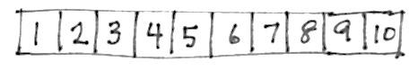Suggested Tools and Representations



*Left Hand Mat*

* Rulers for use as a straightedge
* Five dot mat
* Five-frame and ten-frame cards

*Number Path*

* Number path
* Left hand mat

*20-Bead Rekenrek*



* Two hands mat
* 5-group cards
* [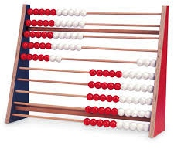](http://www.google.com/imgres?hl=en&biw=1476&bih=588&tbm=isch&tbnid=kiYDJDizmYMxMM:&imgrefurl=http://www.enasco.com/product/TB22814J&docid=fBt2svwX6gYduM&imgurl=http://www.enasco.com/prod/images/products/05/AC045101l.jpg&w=600&h=600&ei=JOJqUaD1GpHqiQKFxIGICw&zoom=1&ved=1t:3588,r:30,s:0,i:185&iact=rc&dur=1133&page=2&tbnh=148&tbnw=157&start=16&ndsp=25&tx=94&ty=77)Rekenrek (Slavonic abacus having beads with a color change at the five)
* Concrete materials in individual bags for counting and sorting (white beans painted red on one side, bags of twigs, dried leaves, dry pasta, pennies; plates, forks, spoons, cups, etc.)
* Commercial concrete materials (linking cubes in tens, non-linking cubes, square-inch tiles, etc.)

*100-Bead Rekenrek*

Suggested Methods of Instructional Delivery

Personal White Boards

Materials Needed for Personal White Boards

1 heavy duty, clear sheet protector

1 piece of stiff red tag board 11" × 8 ¼"

1 piece of stiff white tag board 11" × 8 ¼"

1 3" × 3" piece of dark synthetic cloth for an eraser (e.g., felt)

1 low odor blue dry erase marker, fine point

Directions for Creating Personal White Boards

Cut your white and red tag to specifications. Slide into the sheet protector. Store your eraser on the red side. Store markers in a separate container to avoid stretching the sheet protector.

Frequently Asked Questions About Personal White Boards

*Why is one side red and one white?*

The white side of the board is the “paper.” Students generally write on it, and if working individually, turn the board over to signal to the teacher they have completed their work. The teacher then says, “Show me your boards,” when most of the class is ready.

*What are some of the benefits of a personal white board?*

* The teacher can respond quickly to a gap in student understandings and skills. “Let’s do some of these on our personal white boards until we have more mastery.”
* Students can erase quickly so that they do not have to suffer the evidence of their mistake.
* They are motivating. Students love both the drill and thrill capability and the chance to do story problems with an engaging medium.
* Checking work gives the teacher instant feedback about student understanding.

*What is the benefit of this personal white board over a commercially purchased dry erase board?*

* It is much less expensive.
* Templates such as place value charts, number bond mats, hundreds boards, and number lines can be stored between the two pieces of tag board for easy access and reuse.
* Worksheets, story problems, and other problem sets can be done without marking the paper so that students can work on the problems independently at another time.
* Strips with story problems, number lines, and arrays can be inserted and still have a full piece of paper on which to write.
* The red versus white side distinction clarifies your expectations. When working collaboratively, there is no need to use the red. When working independently, the students know how to keep their work private.
* The tag board can be removed so that student work can be projected on an overhead.

Scaffolds[5]

The scaffolds integrated into *A Story of Units* give alternatives for how students access information as well as express and demonstrate their learning. Strategically placed margin notes are provided within each lesson elaborating on the use of specific scaffolds at applicable times. They address many needs presented by English language learners, students with disabilities, students performing above grade level, and students performing below grade level. Many of the suggestions are organized by Universal Design for Learning (UDL) principles and are applicable to more than one population. To read more about the approach to differentiated instruction in *A Story of Units,* please refer to “How to Implement *A Story of Units*.”

Assessment Summary

|  |  |  |  |
| --- | --- | --- | --- |
| **Assessment Type** | **Administered** | **Format** | **Standards Addressed** |
| Mid-Module Assessment Task | After Topic D | Interview with Rubric | (Numbers 1–5)  K.CC.3  K.CC.4ab  K.CC.5  K.OA.3  K.MD.3 |
| End-of-Module Assessment Task | After Topic H | Interview with Rubric | (Numbers 0–10)  K.CC.3  K.CC.4abc  K.CC.5 |
| Culminating Task | Lesson 37 | *“Decide how to classify the objects in your bag into two groups. Count the number of objects in each group. Represent the greater number in various ways. Next, remove the 5-group card from your pack that shows the number of objects in the smaller group. Put your remaining cards in order from smallest to greatest. Your friends will have to figure out what card is missing when they visit your station!”* | K.CC.3  K.CC.4abc  K.CC.5  K.MD.3 |

1. In this module work is limited to within 10.
2. The balance of this cluster is addressed in Module 5.
3. K.CC.4d is addressed in Module 6.
4. The balance of this cluster is addressed in Module 4.
5. Students with disabilities may require Braille, large print, audio, or special digital files. Please visit the website

   www.p12.nysed.gov/specialed/aim for specific information on how to obtain student materials that satisfy the National Instructional Materials Accessibility Standard (NIMAS) format.