Table of Contents
GRADE 3 • MODULE 5
Fractions as Numbers on the Number Line

Module Overview i

Topic A: Partitioning a Whole into Equal Parts 5.A.1

Topic B: Unit Fractions and Their Relation to the Whole 5.B.1

Topic C: Comparing Unit Fractions and Specifying the Whole 5.C.1

Topic D: Fractions on the Number Line 5.D.1

Topic E: Equivalent Fractions 5.E.1

Topic F: Comparison, Order, and Size of Fractions 5.F.1

Module Assessments 5.S.1

Grade 3 • Module 5
Fractions as Numbers on the Number Line
OVERVIEW
In this 35-day module, students extend and deepen Grade 2 practice with equal shares to understanding fractions as equal partitions of a whole (2.G.3). Their knowledge becomes more formal as they work with area models and the number line. Throughout the module, students have multiple experiences working with the Grade 3 specified fractional units of halves, thirds, fourths, sixths, and eighths. To build flexible thinking about fractions, students are exposed to additional fractional units such as fifths, ninths, and tenths.
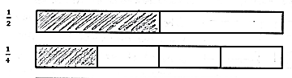
Topic A opens Module 5 with students actively partitioning different models of wholes into equal parts (e.g., concrete models and drawn pictorial area models on paper). They identify and count equal parts as 1 half, 1 fourth, 1 third, 1 sixth, and 1 eighth in unit form before introduction to the unit fraction $\frac{1}{b}$ (3.NF.1). In Topic B, students compare and make copies of unit fractions to build non-unit fractions. They understand unit fractions as the basic building blocks that compose other fractions (3.NF.3d), which parallels the understanding that the number 1 is the basic building block of whole numbers. In Topic C, students practice comparing unit fractions to fraction strips. They specify the whole and label fractions in relation to the number of equal parts in that whole (3.NF.3d).
Compare unit fractions using fraction strips.
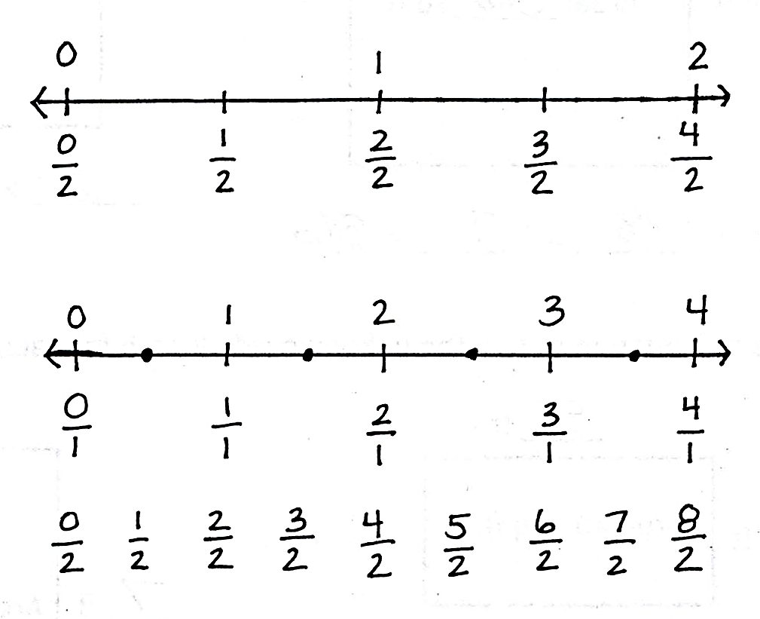
Students transfer their work to the number line in Topic D. They begin by using the interval from 0 to 1 as the whole. Continuing beyond the first interval, they partition, place, count, and compare fractions on the number line (3.NF.2a, 3.NF.2b, 3.NF.3d). In Topic E, they notice that some fractions with different units are placed at the exact same point on the number line, and therefore, are equal (3.NF.3a). For example, $\frac{1}{2}$, $\frac{2}{4}$, $\frac{3}{6}$, and $\frac{4}{8}$ are equivalent fractions (3.NF.3b). Students recognize that whole numbers can be written as fractions, as exemplified on the number lines to the left (3.NF.3c).
Topic F concludes the module with comparing fractions that have the same numerator. As students compare fractions by reasoning about their size, they understand that fractions with the same numerator and a larger denominator are actually smaller pieces of the whole (3.NF.3d). Topic F leaves students with a new method for precisely partitioning a number line into unit fractions of any size without using a ruler.

Focus Grade Level Standards
Develop understanding of fractions as numbers. (Grade 3 expectations in this domain are limited to fractions with denominators 2, 3, 4, 6, and 8.)
3.NF.1 Understand a fraction 1/b as the quantity formed by 1 part when a whole is partitioned into b equal parts; understand a fraction a/b as the quantity formed by a parts of size 1/b.
3.NF.2 Understand a fraction as a number on the number line; represent fractions on a number line diagram.
- Represent a fraction 1/b on a number line diagram by defining the interval from 0 to 1 as the whole and partitioning it into b equal parts. Recognize that each part has size 1/b and that the endpoint of the part based at 0 locates the number 1/b on the number line.
- Represent a fraction a/b on a number line diagram by marking off a lengths 1/b from 0. Recognize that the resulting interval has size a/b and that its endpoint locates the number a/b on the number line.

3.NF.3 Explain equivalence of fractions in special cases, and compare fractions by reasoning about their size.
- Understand two fractions as equivalent (equal) if they are the same size, or the same point on a number line.
- Recognize and generate simple equivalent fractions, e.g., 1/2 = 2/4, 4/6 = 2/3. Explain why the fractions are equivalent, e.g., by using a visual fraction model.
- Express whole numbers as fractions, and recognize fractions that are equivalent to whole numbers. Examples: Express 3 in the form of 3 = 3/1; recognize that 6/1 = 6; locate 4/4 and 1 at the same point of a number line diagram.
- Compare two fractions with the same numerator or the same denominator by reasoning about their size. Recognize that comparisons are valid only when the two fractions refer to the same whole. Record the results of comparisons with the symbols >, =, or <, and justify the conclusions, e.g., by using a visual fraction model.
Reason with shapes and their attributes.
3.G.2 Partition shapes into parts with equal areas. Express the area of each part as a unit fraction of the whole. For example, partition a shape into 4 parts with equal area, and describe the area of each part as 1/4 of the area of the shape.
Foundational Standards
2.G.2 Partition a rectangle into rows and columns of same-size squares and count to find the total number of them.
2.G.3 Partition circles and rectangles into two, three, or four equal shares, describe the shares using the words halves, thirds, half of, a third of, etc., and describe the whole as two halves, three thirds, four fourths. Recognize that equal shares of identical wholes need not have the same shape.
Focus Standards for Mathematical Practice
MP.2 Reason abstractly and quantitatively. Students represent fractions concretely, pictorially, and abstractly, as well as move between representations. Students also represent word problems involving fractions pictorially, and then express the answer in the context of the problem.
MP.3 Construct viable arguments and critique the reasoning of others. Students reason about the area of a shaded region to determine what fraction of the whole it represents.
MP.6 Attend to precision. Students specify the whole amount when referring to a unit fraction and explain what is meant by equal parts in their own words.
MP.7 Look for and make use of structure. Students understand and use the unit fraction as the basic building block or structure of all fractions on the number line.
Overview of Module Topics and Lesson Objectives
Standards | Topics and Objectives |  | Days
3.G.2  3.NF.1 | A | Partitioning a Whole into Equal Parts  Lesson 1: Specify and partition a whole into equal parts, identifying and counting unit fractions using concrete models.  Lesson 2: Specify and partition a whole into equal parts, identifying and counting unit fractions by folding fraction strips.  Lesson 3: Specify and partition a whole into equal parts, identifying and counting unit fractions by drawing pictorial area models.  Lesson 4: Represent and identify fractional parts of different wholes. | 4
3.NF.1  3.NF.3c  3.G.2 | B | Unit Fractions and Their Relation to the Whole  Lesson 5: Partition a whole into equal parts and define the equal parts to identify the unit fraction numerically.  Lesson 6: Build non-unit fractions less than one whole from unit fractions.  Lesson 7: Identify and represent shaded and non-shaded parts of one whole as fractions.  Lesson 8: Represent parts of one whole as fractions with number bonds.  Lesson 9: Build and write fractions greater than one whole using unit fractions. | 5
3.NF.3d  3.NF.1  3.NF.3a–c  3.G.2 | C | Comparing Unit Fractions and Specifying the Whole  Lesson 10: Compare unit fractions by reasoning about their size using fraction strips.  Lesson 11: Compare unit fractions with different-sized models representing the whole.  Lesson 12: Specify the corresponding whole when presented with one equal part.  Lesson 13: Identify a shaded fractional part in different ways depending on the designation of the whole. | 4
 |  | Mid-Module Assessment: Topics A–C (assessment 1 day, return 1 day, remediation or further applications 1 day) | 3
3.NF.2ab  3.NF.3cd | D | Fractions on the Number Line  Lesson 14: Place fractions on a number line with endpoints 0 and 1.  Lesson 15: Place any fraction on a number line with endpoints 0 and 1.  Lesson 16: Place whole number fractions and fractions between whole numbers on the number line.  Lesson 17: Practice placing various fractions on the number line.  Lesson 18: Compare fractions and whole numbers on the number line by reasoning about their distance from 0.  Lesson 19: Understand distance and position on the number line as strategies for comparing fractions. (Optional.) | 6
3.NF.3a–c | E | Equivalent Fractions  Lesson 20: Recognize and show that equivalent fractions have the same size, though not necessarily the same shape.  Lesson 21: Recognize and show that equivalent fractions refer to the same point on the number line.  Lessons 22–23: Generate simple equivalent fractions by using visual fraction models and the number line.  Lesson 24: Express whole numbers as fractions and recognize equivalence with different units.  Lesson 25: Express whole number fractions on the number line when the unit interval is 1.  Lesson 26: Decompose whole number fractions greater than 1 using whole number equivalence with various models.  Lesson 27: Explain equivalence by manipulating units and reasoning about their size. | 8
3.NF.3d | F | Comparison, Order, and Size of Fractions  Lesson 28: Compare fractions with the same numerator pictorially.  Lesson 29: Compare fractions with the same numerator using <, >, or =, and use a model to reason about their size.  Lesson 30: Partition various wholes precisely into equal parts using a number line method. | 3
 |  | End-of-Module Assessment: Topics A–F (assessment 1 day, return 1 day, remediation or further applications 1 day) | 3
Total Number of Instructional Days |  |  | 36

Terminology
New or Recently Introduced Terms
- Copies (refers to the number of unit fractions in 1 whole)
- Equivalent fractions (fractions that name the same size or the same point on the number line)
- Fractional unit (half, third, fourth, etc.)
- Non-unit fraction (fraction with numerator other than 1)
- Unit fraction (fraction with numerator 1)
- Unit interval (the interval from 0 to 1, measured by length)
Familiar Terms and Symbols
- =, <, > (equal, less than, greater than)
- Array (arrangement of objects in rows and columns)
- Equal parts (parts with equal measurements)
- Equal shares (pieces of a whole that are the same size)
- Fraction (e.g., $\frac{1}{3}$, $\frac{2}{3}$, $\frac{3}{3}$, $\frac{4}{3}$)
- Half of, one third of, one fourth of, etc. ($\frac{1}{2}$, $\frac{1}{3}$, $\frac{1}{4}$, $\frac{1}{6}$, $\frac{1}{8}$)
- Halves, thirds, fourths, sixths, eighths ($\frac{1}{2}$, $\frac{1}{3}$, $\frac{1}{4}$, $\frac{1}{6}$, $\frac{1}{8}$)
- Number line
0 1 2

- Partition (divide a whole into equal parts)
- Whole (e.g., 2 halves, 3 thirds, etc.)
Suggested Tools and Representations
- 1 m length of yarn
- 12″ × 1″ strips of yellow construction paper
- 1-liter beaker (optional)
- 2″ × 6″ strips of brown construction paper
- 200 g ball of clay or play dough
- 4 $\frac{1}{4}″$ × 1″ paper strips
- 4” × 4” orange squares
- Arrays
- Clear plastic cups
- Concrete fraction models (e.g., water, string, clay)
- Food coloring (to color water)
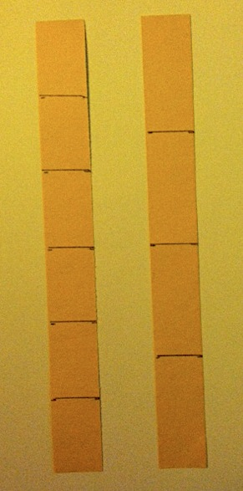
- Fraction strips (made from paper, used to fold and model parts of a whole. See example to the right.)
Fraction strips
- Number line
- Pictorial fraction model (e.g., drawing of a circle or square)
- Rectangular- and circular-shaped paper
- Rulers
- Sets of <, >, = cards
- Shapes partitioned into fractional parts
- Tape diagram
Scaffolds
The scaffolds integrated into A Story of Units give alternatives for how students access information as well as express and demonstrate their learning. Strategically placed margin notes are provided within each lesson elaborating on the use of specific scaffolds at applicable times. They address many needs presented by English language learners, students with disabilities, students performing above grade level, and students performing below grade level. Many of the suggestions are organized by Universal Design for Learning (UDL) principles and are applicable to more than one population. To read more about the approach to differentiated instruction in A Story of Units, please refer to “How to Implement A Story of Units.”
Assessment Summary
Type | Administered | Format | Standards Addressed
Mid-Module Assessment Task | After Topic C | Constructed response with rubric | 3.G.2  3.NF.1  3.NF.3cd
End-of-Module Assessment Task | After Topic F | Constructed response with rubric | 3.NF.2ab  3.NF.3a–d

3.G.1 is addressed in Module 7.
These are terms and symbols students have used or seen previously.
Students with disabilities may require Braille, large print, audio, or special digital files. Please visit the website www.p12.nysed.gov/specialed/aim for specific information on how to obtain student materials that satisfy the National Instructional Materials Accessibility Standard (NIMAS) format.

