Name Date
- Use the expression below to answer parts (a) and (b).
$$4x-3\left(x-2y\right)+\frac{1}{2}(6x-8y)$$
  - Write an equivalent expression in standard form and collect like terms.

  - Express the answer from part (a) as an equivalent expression in factored form.

- Use the information to solve the problems below.

  - The longest side of a triangle is six more units than the shortest side. The third side is twice the length of the shortest side. If the perimeter of the triangle is $25$units, write and solve an equation to find the lengths of all three sides of the triangle.

  - The length of a rectangle is $(x+3)$ inches long, and the width is $3\frac{2}{5}$ inches. If the area is $15\frac{3}{10}$ square inches, write and solve an equation to find the length of the rectangle.

- A picture $10\frac{1}{4}$ feet long is to be centered on a wall that is $14\frac{1}{2}$feet long. How much space is there from the edge of the wall to the picture?

  - Solve the problem arithmetically.

  - Solve the problem algebraically.

  - Compare the approaches used in parts (a) and (b). Explain how they are similar.

- In August, Cory begins school shopping for his triplet daughters.

  - One day, he bought $10$ pairs of socks for $\$2.50$ each and $3$ pairs of shoes for $d$ dollars each. He spent a total of $\$135.97$. Write and solve an equation to find the cost of one pair of shoes.

  - The following day Cory returned to the store to purchase some more socks. He had $\$40$ to spend. When he arrived at the store, the shoes were on sale for $\frac{1}{3}$ off. What is the greatest amount of pairs of socks Cory can purchase if he purchases another pair of shoes in addition to the socks?

- Ben wants to have his birthday at the bowling alley with a few of his friends, but he can spend no more than $\$80$. The bowling alley charges a flat fee of $\$45$ for a private party and $\$5.50$ per person for shoe rentals and unlimited bowling.

  - Write an inequality that represents the total cost of Ben’s birthday for $p$ people given his budget.

  - How many people can Ben pay for (including himself) while staying within the limitations of his budget?

  - Graph the solution of the inequality from part (b).

- Jenny invited Gianna to go watch a movie with her family. The movie theater charges one rate for 3D admission and a different rate for regular admission. Jenny and Gianna decided to watch the newest movie in 3D. Jenny’s mother, father, and grandfather accompanied Jenny’s little brother to the regular admission movie.

  - Write an expression for the total cost of the tickets. Define the variables.

  - The cost of the 3D ticket was double the cost of the regular admission ticket. Write an equation to represent the relationship between the two types of tickets.

  - The family purchased refreshments and spent a total of $\$18.50$. If the total amount of money spent on tickets and refreshments was $\$94.50$, use an equation to find the cost of one regular admission ticket.

- The three lines shown in the diagram below intersect at the same point. The measures of some of the angles in degrees are given as $3\left(x-2\right)°$,$\left(\frac{3}{5}y\right)°$, $12°$, $42°$.
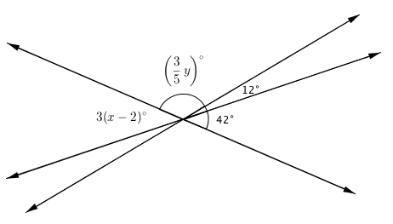

  - Write and solve an equation that can be used to find the value of $x$.

  - Write and solve an equation that can be used to find the value of $y$.

A Progression Toward Mastery
Assessment  Task Item |  | STEP 1  Missing or incorrect answer and little evidence of reasoning or application of mathematics to solve the problem | STEP 2  Missing or incorrect answer but evidence of some reasoning or application of mathematics to solve the problem | STEP 3  A correct answer with some evidence of reasoning or application of mathematics to solve the problem, or an incorrect answer with substantial evidence of solid reasoning or application of mathematics to solve the problem | STEP 4  A correct answer supported by substantial evidence of solid reasoning or application of mathematics to solve the problem
1 | a  7.EE.A.1 | Student demonstrates a limited understanding of writing the expression in standard form.  OR  Student makes a conceptual error, such as dropping the parentheses or adding instead of multiplying. | Student makes two or more computational errors. | Student demonstrates a solid understanding but makes one computational error and completes the question by writing a correct equivalent expression in standard form.  OR  Student answers correctly, but no further correct work is shown. | Student writes the expression correctly in standard form, $4x+2y$.  Student shows appropriate work, such as using the distributive property and collecting like terms.
 | b  7.EE.A.1 | Student demonstrates a limited understanding of writing the expression in factored form. | Student writes the expression correctly in factored form but has part (a) incorrect. | Student demonstrates a solid understanding by writing a correct equivalent expression in factored form based on the answer from part (a) but makes one computational error. | Student uses the correct expression from part (a).  Student writes an equivalent expression in factored form.
2 | a  7.EE.B.3  7.EE.B.4a | Student demonstrates a limited understanding of perimeter by finding three sides of a triangle whose sum is $25$, but the sides are incorrect and do not satisfy the given conditions.  For example, a student says the sides are $4$, $10,$ and $11$ because they add up to $25$ but does not satisfy the given conditions. | Student makes a conceptual error and one computational error.  OR  Student makes a conceptual error but writes an equation of equal difficulty and solves it correctly but does not find the lengths of the sides of the triangle. | Student demonstrates a solid understanding and finishes the problem correctly but makes one computational error with a value still resulting in a fractional value..  OR  Student sets up and solves an equation correctly but does not substitute the value back  into the expressions to determine the actual side lengths.  OR  Student defines the sides correctly and sets up an equation but makes one error in solving the equation and finding the corresponding side lengths. | Student correctly defines the variable, sets up an equation to represent the perimeter, such as $2x+x+x+6=25$, solves the equation correctly, $x=4\frac{3}{4}$ , and determines the lengths of the three sides to be $4\frac{3}{4}$,$9\frac{1}{2}$, and$10\frac{3}{4}$.  OR  Student finds the correct lengths of the sides of a triangle to be $4\frac{3}{4}$,$9\frac{1}{2}$, and$10\frac{3}{4}$, using arithmetic or a tape diagram, showing appropriate and correct work.
 | b  7.EE.B.3  7.EE.B.4a | Student makes a conceptual error, such as finding the perimeter, and makes two or more computational errors, without finding the length. | Student writes a correct equation demonstrating area, but no further correct work is shown. OR  Student makes a conceptual error, such as finding perimeter instead of area, and makes one computational error solving the equation but finds the appropriate length. | Student demonstrates the concept of area and finds the appropriate length based on the answer obtained but makes one or two computational errors.  OR  Student finds the correct value of $x$but does not determine the length of the rectangle.  OR  Student makes a conceptual error such as adding to find the perimeter instead of multiplying for the area. For example, student sets up the following equation of equal difficulty:$3\frac{2}{5}+3\frac{2}{5}+x+3+x+3=15\frac{3}{10}$; student solves the equation correctly, $x=1\frac{1}{4}$, and finds the correct length according to the answer obtained. | Student correctly defines the variable, sets up an equation to represent the area, such as  $3\frac{2}{5}\left(x+3\right)=15\frac{3}{10}$, solves the equation correctly, $x=1\frac{1}{2}$, and determines the length to be $4\frac{1}{2}$ inches.  Student finds the correct length to be $4\frac{1}{2}$, uses arithmetic or a tape diagram, and shows appropriate and correct work.
3 | a  7.EE.B.3 | Student shows a limited understanding but makes a conceptual error, such as finding half of the sum of the lengths. | Student finds the correct difference between the length of the wall and the length of the picture as $4\frac{1}{4}$, but no further correct work is shown. | Student shows that half the difference must be found but makes a computational error. | Student demonstrates understanding by finding half of the difference between the length of the wall and the length of the picture and shows appropriate work, possibly using a tape diagram, to obtain an answer of $2\frac{1}{8}$.
 | b  7.EE.B.4a | Student demonstrates a limited understanding of writing an equation to demonstrate the situation, but very little correct work is shown. | Student makes a conceptual error writing the equation, such as $x+10\frac{1}{4}=14\frac{1}{2}$.  OR  Student makes a conceptual error in solving the equation.  OR  Student makes two or more computational errors in solving the equation. | Student sets up a correct equation but makes one computational error. | Student correctly defines a variable, sets up an equation such as  $x+10\frac{1}{4}+x=14\frac{1}{2}$, and finds the correct value of $2\frac{1}{8}$.
 | c  7.EE.B.3  7.EE.B.4a | Student demonstrates some understanding between an arithmetic and algebraic approach. | Student fully understands the similarities between both approaches.
4 | a  7.EE.A.2 7.EE.B.4a | Student demonstrates a limited understanding by writing an incorrect equation and solving it incorrectly. | Student makes a conceptual error in solving the equation, such as subtracting by $3$ instead of multiplying by $\frac{1}{3}$.  OR  Student makes a conceptual error in writing the equation, such as $10+2.50+3d=135.97$  or $2.50+3d=135.97$,  but further work is solved correctly.  OR  Student writes a correct equation, but no further correct work is shown.  OR  Student finds the correct answer without writing an equation, such as using a tape diagram or arithmetic. | Student sets up a correct equation but makes one computational error.  OR  Student finds the correct value of the variable but does not state the cost of one pair of shoes.  OR  Student sets up a wrong equation of equal difficulty by writing a number from the problem incorrectly, but all further work is correct. | Student clearly defines the variable, writes a correct equation, such as $10\left(2.50\right)+3d=135.97$,  and finds the correct cost of one pair of shoes as $\$36.99$.
 | b  7.EE.A.2 7.EE.B.4b | Student demonstrates a limited understanding of discount price, inequality, and solution of inequality.  OR  Student finds the correct new price for the shoes of $\$24.66$, but no further correct work is shown.  OR  Student writes an inequality representing the total cost as an inequality, but no further correct work is shown, nor is the new price for the shoes found correctly. | Student makes a conceptual error such as not finding the new discount price of the shoes.  OR  Student makes a conceptual error in writing or solving the inequality.  OR  Student makes two or more computational or rounding errors. | Student demonstrates a solid understanding but makes one computational error.  OR  Student calculates the discount on the shoes incorrectly but finishes the remaining problem correctly. For example, student uses the discount amount, $\$12.33$, as the new price of shoes but writes a correct inequality and solution of $\$11$ based on the discount amount.  OR  Student determines the correct discount price for the shoes but uses $≥$ instead of $≤$.  OR  Student determines the correct discount price for the shoes, writes and solves the inequality correctly, but does not round or rounds incorrectly. | Student determines the correct new price for the shoes including the $\frac{1}{3}$ off as $\$24.66$, writes a correct inequality,  $$2.50d+24.66≤40,$$  solves the inequality correctly, $d≤6.136$, and determines by rounding correctly that the amount of socks that could be purchased is $6$ pairs.
5 | a  7.EE.B.4b | Student demonstrates some understanding of writing an inequality but makes an error, such as $≥$ or subtracting $45$ instead of adding. | Student writes a correct inequality,  $45+5.50p≤80$, to represent the situation.
 | b  7.EE.B.4b | Student demonstrates a limited understanding of solving the inequality and interpreting the solution. | Student makes a conceptual error in solving the inequality.  OR  Student makes two or more computational or rounding errors. | Student demonstrates a solid understanding of solving the inequality but makes one computational or one rounding error. | Student solves the inequality written from part (a) correctly,  $p≤6\frac{4}{11}$, and determines the correct number of people by rounding correctly to $6$.
 | c  7.EE.B.4b | Student demonstrates a limited understanding of graphing inequalities by only plotting the point correctly. | Student graphs the inequality but makes two or more errors.  OR  Student makes a conceptual error such as graphing on a coordinate plane instead of a number line. | Student demonstrates a solid understanding of graphing an inequality but makes one error such as an open circle, an incorrect scale, a circle placed in the wrong area, or an arrow drawn in the wrong direction. | Student correctly graphs the solution of the inequality from part (b). An appropriate scale is provided, clearly showing $6$ and $7$. A closed circle is shown at approximately $6\frac{4}{11}$, a little less than $6.5$, and an arrow is pointing to the left.
6 | a  7.EE.B.4 | Student demonstrates a limited understanding, such as indicating a sum, but the variables are not clearly defined, and the expression is left without collecting like terms. | Student makes a conceptual error such as finding the difference of all the costs of admissions.  OR  Student does not write an expression to find the total cost. Instead, the student leaves each admission as a separate expression, $2d$ and $4r$. | Student writes a correct expression but does not define the variables or does not define them correctly, such as $d$ represents the 3D admission and $r$ represents regular. The variables need to specifically indicate the cost.  OR  Student makes one computational error in collecting like terms.  OR  Student clearly defines the variables correctly but makes one mistake in the expression, such as leaving out one person. | Student clearly defines the variables and writes an expression such as $2d+4r$, with appropriate work shown. The definition of the variables must indicate the cost of each admission.
 | b  7.EE.B.4a | Student demonstrates a limited understanding, such as $2$ times or $\frac{1}{2}$, but the variables are reversed:  $r=2d$,$d=\frac{1}{2}r$. | An expression is written, such as $d=2r$ or  $r=\frac{1}{2}d$, to demonstrate that the cost of 3D admission is double, or two times, the cost of a regular admission ticket.
 | c  7.EE.B.4a | Student demonstrates a limited understanding of writing an equation and solving the equation. | Student writes a correct equation but no further correct work is shown.  OR  Student makes a conceptual error, such as solving the equation but disregarding the two variables and making them one, such as $6d$.  OR  Student writes a correct equation but makes two or more computational errors. | Student writes a correct equation but makes one computational error.  OR  Student solves the equation correctly but does not indicate the final cost of admission as $\$9.50$. | Student writes a correct equation such as  $2d+4r+18.50=94.50$,  and solves it correctly by substituting $2r$ for $d,$resulting in $d=9.5$, and writes the correct answer of the cost of regular admission, $\$9.50$.
7 | a  7.G.B.5 | Student demonstrates a limited understanding of vertical angle relationships by writing an equation such as  $3\left(x-2\right)=12$, but no further work is shown, or the work shown is incorrect. | Student writes the correct equation, but no further correct work is shown, or two or more computational errors are made solving the equation.  OR  Student makes a conceptual error such as adding the angles to equal $180$, and all further work shown is correct.  OR  Student makes a conceptual error writing the equation, such as  $3\left(x-2\right)=12$,  but solves the equation correctly, getting $x=6$,  and all work is shown.  OR  Student writes a correct equation with two variables,  $3\left(x-2\right)+\frac{3}{4}y+12=180$,  but no further work is shown. | Student writes the correct equation representing the vertical angle relationship but makes one computational error in solving the equation. | Student correctly recognizes the vertical angle relationship, writes the equation  $3\left(x-2\right)=42,$ and  solves the equation  correctly, showing all  work, getting a value of  $16$ for $x$.
 | b  7.G.B.5 | Student demonstrates a limited understanding of supplementary angles adding up to equal $180$, but the wrong angles are used, and no other correct work is shown. | Student writes the correct equation but makes two or more computational errors or a conceptual error in solving the equation.  OR  Student writes a correct equation with two variables,  $3\left(x-2\right)+\frac{3}{4}y+12=180$,  but no further work is shown. | Student writes the correct equation but makes one computational error in solving. | Student writes a correct equation demonstrating the supplementary angles,  $\frac{3}{5}y+12+42=180$,  solves the equation correctly showing all work, and arrives at  $$y=210.$$

Name Date
- Use the following expression below to answer parts (a) and (b).
$$4x-3\left(x-2y\right)+\frac{1}{2} (6x-8y)$$
  - Write an equivalent expression in standard form and collect like terms.
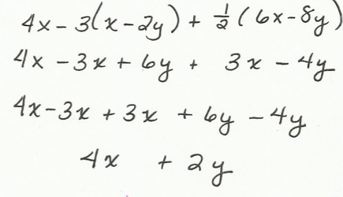

  - Express the answer from part (a) as an equivalent expression in factored form.
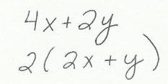

- Use the following information to solve the problems below.

  - The longest side of a triangle is six more units than the shortest side. The third side is twice the length of the shortest side. If the perimeter of the triangle is $25$ units, write and solve an equation to find the lengths of all three sides of the triangle.
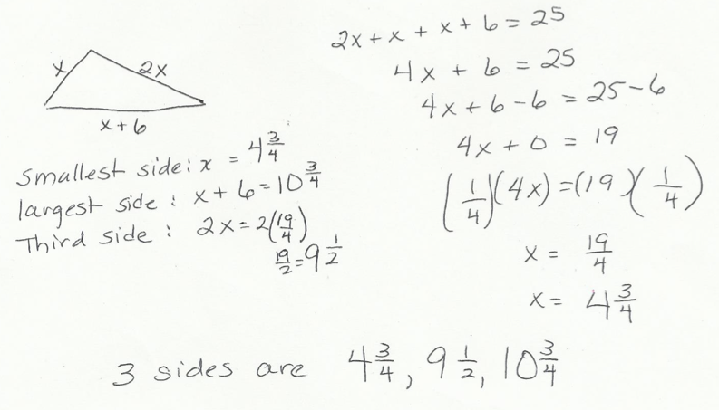

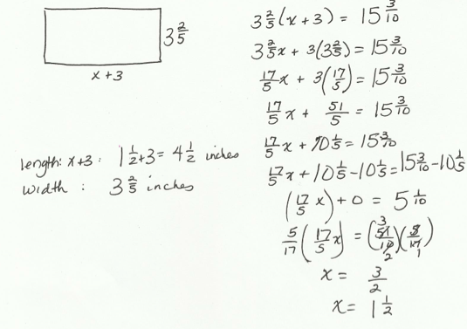
  - The length of a rectangle is $(x+3)$ inches long, and the width is $3\frac{2}{5}$ inches. If the area is $15\frac{3}{10}$ square inches, write and solve an equation to find the length of the rectangle.

- A picture $10\frac{1}{4}$ feet long is to be centered on a wall that is $14\frac{1}{2}$feet long. How much space is there from the edge of the wall to the picture?
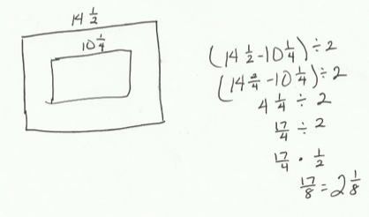
  - Solve the problem arithmetically.

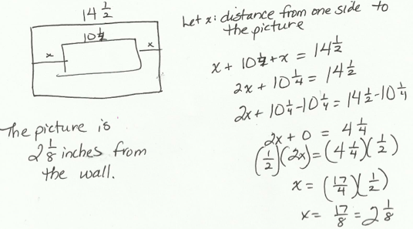
  - Solve the problem algebraically.

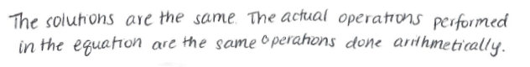
  - Compare the approaches used in parts (a) and (b). Explain how they are similar.

- In August, Cory begins school shopping for his triplet daughters.

  - One day, he bought $10$ pairs of socks for $\$2.50$ each and $3$ pairs of shoes for $d$ dollars each. He spent a total of $\$135.97$. Write and solve an equation to find the cost of one pair of shoes.
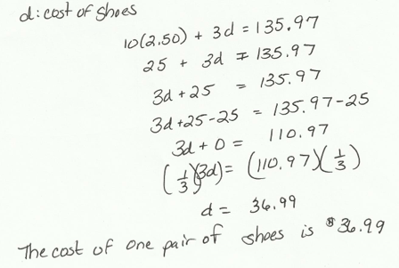

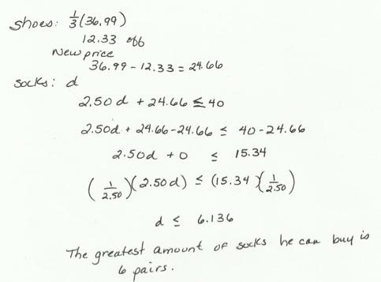
  - The following day Cory returned to the store to purchase some more socks. He had $\$40$ to spend. When he arrived at the store, the shoes were on sale for $\frac{1}{3}$ off. What is the greatest amount of pairs of socks Cory can purchase if he purchases another pair of shoes in addition to the socks?

- Ben wants to have his birthday at the bowling alley with a few of his friends, but he can spend no more than $\$80$. The bowling alley charges a flat fee of $\$45$ for a private party and $\$5.50$ per person for shoe rentals and unlimited bowling.

  - Write an inequality that represents the total cost of Ben’s birthday for $p$ people given his budget.
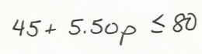

  - How many people can Ben pay for (including himself) while staying within the limitations of his budget?
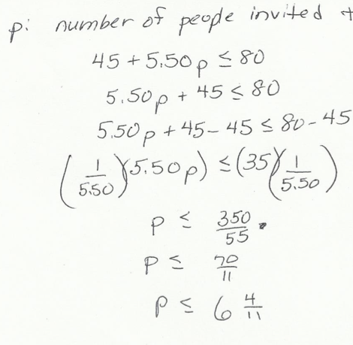

  - Graph the solution of the inequality from part (b).

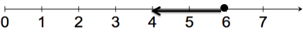

- Jenny invited Gianna to go watch a movie with her family. The movie theater charges one rate for 3D admission and a different rate for regular admission. Jenny and Gianna decided to watch the newest movie in 3D. Jenny’s mother, father, and grandfather accompanied Jenny’s little brother to the regular admission movie.

  - Write an expression for the total cost of the tickets. Define the variables.
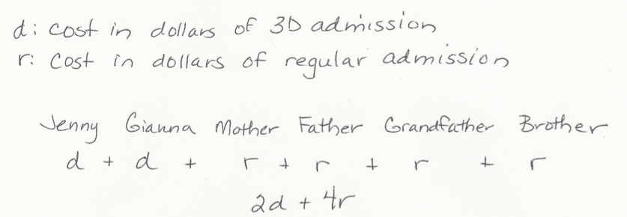

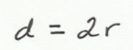
  - The cost of the 3D ticket was double the cost of the regular admission. Write an equation to represent the relationship between the two types of tickets.

  - The family purchased refreshments and spent a total of $\$18.50$. If the total amount of money spent on tickets and refreshments was $\$94.50$, use an equation to find the cost of one regular admission ticket.
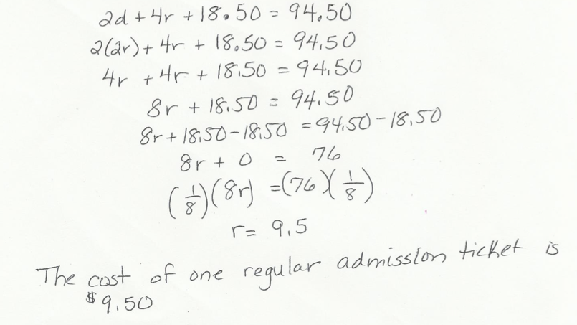

- The three lines shown in the diagram below intersect at the same point. The measures of some of the angles in degrees are given as $3\left(x-2\right)°,\left(\frac{3}{5}y\right)°,12°,42°.$

  - Write and solve an equation that can be used to find the value of $x$.
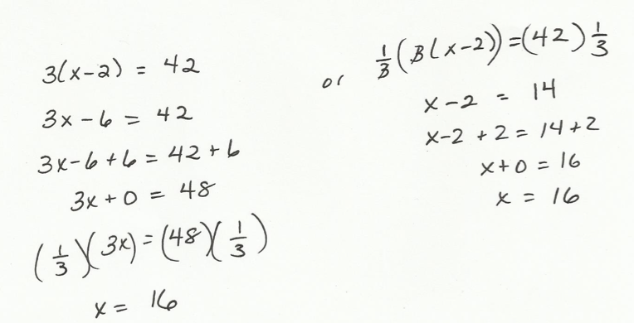

  - Write and solve an equation that can be used to find the value of $y$.
