Name Date
- Gloria says the two expressions $\frac{1}{4}\left(12x+24\right)-9x$and $-6\left(x+1\right)$ are equivalent. Is she correct? Explain how you know.

- A grocery store has advertised a sale on ice cream. Each carton of any flavor of ice cream costs $\$3.79$.

  - If Millie buys one carton of strawberry ice cream and one carton of chocolate ice cream, write an algebraic expression that represents the total cost of buying the ice cream.

  - Write an equivalent expression for your answer in part (a).

  - Explain how the expressions are equivalent.

- A new park was designed to contain two circular gardens. Garden A has a diameter of $50 m$, and garden B has a diameter of $70 m$.

  - If the gardener wants to outline the gardens in edging, how many meters will be needed to outline the smaller garden? (Write in terms of $π$.)

  - How much more edging will be needed for the larger garden than the smaller one? (Write in terms of $π$.)

  - The gardener wishes to put down weed block fabric on the two gardens before the plants are planted in the ground. How much fabric will be needed to cover the area of both gardens? (Write in terms of $π$.)

- A play court on the school playground is shaped like a square joined by a semicircle. The perimeter around the entire play court is $182.8 ft.$, and $62.8 ft.$ of the total perimeter comes from the semicircle.

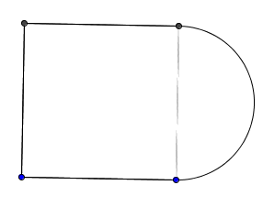

  - What is the radius of the semicircle? Use $3.14$ for $π$.

  - The school wants to cover the play court with sports court flooring. Using $3.14$ for $π$, how many square feet of flooring does the school need to purchase to cover the play court?

- Marcus drew two adjacent angles.

  - If $∠ABC$ has a measure one-third of $∠CBD$, then what is the degree measurement of $∠CBD$?
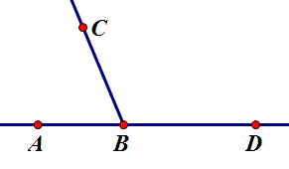

  - If $∠CBD=9(8x+11)$ degrees, then what is the value of $x$?

- The dimensions of an above-ground, rectangular pool are $25$ feet long, $18$feet wide, and $6$ feet deep.

  - How much water is needed to fill the pool?

  - If there are $7.48$ gallons in $1$ cubic foot, how many gallons are needed to fill the pool?

  - Assume there was a hole in the pool, and $3,366$gallons of water leaked from the pool. How many feet did the water level drop?

  - After the leak was repaired, it was necessary to lay a thin layer of concrete to protect the sides of the pool. Calculate the area to be covered to complete the job.

- Gary is learning about mosaics in art class. His teacher passes out small square tiles and encourages the students to cut up the tiles in various angles. Gary’s first cut tile looks like this:
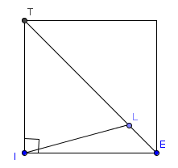
$$(m-10)°$$
3$m°$
  - Write an equation relating $∠TIL$ with$∠LIE$.

  - Solve for $m.$

  - What is the measure of$∠TIL$?

  - What is the measure of $∠LIE$?

A Progression Toward Mastery
Assessment  Task Item |  | STEP 1  Missing or incorrect answer and little evidence of reasoning or application of mathematics to solve the problem | STEP 2  Missing or incorrect answer but evidence of some reasoning or application of mathematics to solve the problem | STEP 3  A correct answer with some evidence of reasoning or application of mathematics to solve the problem, or an incorrect answer with substantial evidence of solid reasoning or application of mathematics to solve the problem | STEP 4  A correct answer supported by substantial evidence of solid reasoning or application of mathematics to solve the problem
1 | 7.EE.A.1 | Student demonstrates a limited understanding of writing expressions in standard form and determining if they are equivalent expressions. Student shows some knowledge of the distributive property. | Student makes a conceptual error in writing one of the expressions in standard form but writes the other expression correctly and provides an appropriate answer and explanation. | Student writes each expression in correct standard form, $-6x+6$ and $-6x-6$. Student indicates the expressions are not equivalent, but no explanation is provided, or the explanation is incorrect.  OR  Student demonstrates a solid understanding but makes one computational error, such as writing  $-6\left(x+1\right)$ as $-6x+6,$ and indicates the expressions are not equivalent. | Student writes each expression in correct standard form, $-6x+$6 and $-6x-6$.  Student indicates the expressions are not equivalent and provides an appropriate explanation.
2 | 7.EE.A.2 | Student work shows little evidence of correct reasoning, such as $s+c,$ but no further work is shown or is incorrect.  OR  Student does not demonstrate an understanding of the meaning of writing equivalent expressions. | Student makes a conceptual error such as distributing or factoring incorrectly. | Student writes a correct algebraic expression for part (a) and an equivalent expression for part (b), but the explanation for part (c) is incorrect or not shown. | Student writes a correct algebraic expression to represent the total cost of two flavors of ice cream, such as $\$3.79\left(s+c\right).$  Student writes an equivalent expression for part (a), such as $\$3.79s+\$3.79c$, providing an appropriate explanation on how the expressions are equivalent, such as applying the distributive property. Sample answers given for parts (a) and (b) could be reversed, and the explanation would include factoring the expression.
3 | a  7.G.B.4 | Student demonstrates knowing circumference is used, but no further correct work is shown. | Student makes a conceptual error, such as finding the area of the smaller garden correctly, as $625π$.  OR  Student uses the circumference formula, $C=2πr$, but uses the diameter instead of the radius to get an answer of $100π m$.  OR  Student makes two or more computational and/or labeling errors. | Student recognizes that the concept of circumference must be used, but makes a computational or labeling error.  OR  Student finds the correct circumference but does not leave the answer in terms of $π$, and instead uses $3.14$, getting an answer of $157 m$. | Student finds the circumference of the smaller garden correctly as $50π m$.
 | b  7.G.B.4 | Student demonstrates knowing circumference, but no further correct work is shown. | Student makes a conceptual error, such as incorrectly finding the area of the larger garden as $1225π$.  OR  Student finds the circumference, using the diameter instead of the radius, and gets$140π m$.  OR  Student makes two or more computational and/or labeling errors. | Student recognizes that the concept of circumference must be used but makes a computational or labeling error.  OR  Student finds the circumference of the larger garden correctly as $70π m$ but does not find how much more fencing is needed for the larger garden compared to the smaller garden, or finds it incorrectly.  OR  Student finds the correct circumference but does not leave the answer in terms of $π$, and instead uses $3.14$, getting an answer of $439.6 m$. | Student finds the circumference of the larger garden correctly as $70π m$ and determines the difference between the larger and smaller gardens to be $20π m$.
 | c  7.G.B.4 | Student does not find the areas of the gardens but adds the total circumferences of both the smaller and larger garden to get $120π$. | Student makes a conceptual error, such as multiplying the radius by $2$ instead of squaring the radius. In this case, the areas would be $140π$and $50π$. The total is $190π m^{2}$.  OR  Student makes two or more computational and/or labeling errors. | Student finds the area of both gardens correctly, in terms of $π$, as $1225π$ and $625π$, but does not find the total sum for both gardens.  OR  Student uses the area formulas correctly but makes one computational or labeling error ($m^{2})$.  OR  Student finds the correct areas but does not leave the answer in terms of $π$ and instead uses $3.14,$ getting an answer of $5809 m^{2}$. | Student finds the area of both gardens correctly in terms of $π$, as $1225π$ and $625π$, and finds the total amount of fabric needed for both gardens as $1850π m^{2}$.
4 | a  7.G.B.4 | Student answer is incorrect or missing. Student work shows little or no evidence of correct reasoning. | Student makes a conceptual error such as finding circumference or area of the semicircle but uses the diameter as $20$ in doing so. | Student makes a computational error, such as dividing incorrectly. | Student correctly determines the radius of the semicircle of $20 ft.$ by dividing the diameter of $40$ by $2$.
 | b  7.G.B.4 | Student answer is incorrect or missing. Student work shows little or no evidence of correct reasoning. | Student makes a conceptual error, such as using the wrong formulas for area or subtracting the areas as in the area of a shaded region.  OR  Student makes two or more computational or labeling errors. | Student makes one computational or labeling error.  OR  Student finds the correct area of the square, $900 {ft}^{2}$, and the semicircle, $628 {ft}^{2}$, but does not add them to get the total area.  OR  Student does not use $3.14$ for $π$ as instructed and leaves the area of the semicircle in terms of $π$.  OR  Student finds the area of the square correctly but finds the area of the entire circle, not the semicircle, while correctly finding the answer, $2,156 {ft}^{2}$. | Student finds the overall area correctly as $1,528 {ft}^{2}$.
5 | a  7.G.B.5 | Student work shows little understanding of supplementary angles. | Student makes a conceptual error such as translating the angles incorrectly, but all further work is correct.  OR  Student makes two or more computational errors. | Student makes one computational error in solving the equation. | Student correctly defines the variable, translates each angle into algebraic expressions, $\frac{1}{3}m$ and $m,$writes an equation,  $\frac{1}{3}m+m=180$, solves the equation correctly, $m=135$, and finds the measure of $∠CBD=135°$.  Students are not limited to using equations to solve this problem. For example, they could also set up an appropriate tape diagram.
 | b  7.G.B.5 | Student work shows little evidence of correct reasoning, such as writing an equivalent expression for $9\left(8x+11\right)$as $72x+99$, but with no further correct work shown. | Student does not write a correct equation using the answer from part (a) but solves the written equation correctly, provided it is of equal difficulty. | Student writes a correct equation based on the answer from part (a) but makes one computational error in solving. | Student uses the answer from part (a) to find the correct value for $x=\frac{1}{2}$.  Student may have an incorrect answer, but if the equation written is correct based on a wrong answer from part (a), and the equation is solved correctly, then full credit can be given.
6 | a  7.G.B.6 | Student work shows little evidence of correct reasoning. | Student makes a conceptual error such as not finding the volume and finding the surface area incorrectly.  OR  Student makes two or more computational and/or labeling errors. | Student uses the volume formula but makes one computational or labeling error. | Student correctly uses the volume formula for a rectangular prism to find how much water is needed to fill the pool, $2,700 {ft}^{3}$.
 | b  7.G.B.6 | Student work shows little evidence of correct reasoning, such as adding or subtracting $7.48$ or not using the volume from part (a). | Student makes a conceptual error such as dividing the volume by $7.48$ instead of multiplying. If so, the answer would be $361$ gallons. | Student knows to use the volume from part (a) and multiply by $7.48$ but makes one computational error. | Student uses the answer from part (a) and multiplies it by $7.48$to find the total number of gallons needed to fill the pool. If part (a) is answered correctly, then the correct answer is $20,196$ gallons.
 | c  7.G.B.6 | Student work shows little evidence of correct reasoning.  OR  Student finds the correct amount of gallons remaining, $16,830$, but no further work is shown or correct. | Student makes a conceptual error such as finding the change in gallons but incorrectly uses the volume formula with gallons. For example,  $$16830=25×18×h$$  $$h=37.4.$$ | Student demonstrates a solid understanding but makes one computational error.  OR  Student correctly determines the new height, $5 ft.$, after the water leaked but does not find the change in the height. | Student finds the new depth of the pool after the water leaked and determines the change in the height as $1 ft.$  Student can solve in a number of ways, such as finding the number of gallons remaining, dividing by $7.48$ to determine the new volume, setting up an equation (such as $2250=25×18×h$) to determine the new height, and finally, subtracting the height from the original height to get the change.  Another approach is to write an equation to find the height of the volume that was lost.
 | d  7.G.B.6 | Student work shows little evidence of correct reasoning.  OR  Student finds the area of one of the sides, either $450$, $108$, or $150$, but no further correct work is shown. | Student makes a conceptual error such as using the wrong area formulas or only finding the area of three of the surfaces.  OR  Student makes two or more computational or labeling errors. | Student demonstrates a solid understanding of surface area but makes one computational or labeling error.  OR  Student gets an answer of $1,416 {ft}^{2}$ by finding the surface area of all surfaces, including the top base. | Student correctly determines the surface area of the sides to be resurfaced with appropriate work shown.  $$25×18+2\left(6×18\right)+2\left(6×25\right)= 966 {ft}^{2}$$
7 | a–b  7.G.B.5 | Student work shows little evidence of correct reasoning.  OR  Student writes a correct equation, but no further work or correct work is shown. | Student makes a conceptual error, writing an incorrect equation for part (a) but solves it correctly for part (b).  OR  Student writes a correct equation but makes a conceptual error when solving the equation, such as  $$2m-10=90 \\ m=50.$$  OR  Student writes a correct equation but makes two or more computational errors. | Student writes a correct equation but makes one computational error. | Student writes and solves a correct equation,  $$3m+m-10=90 \\ m=25,$$  with all appropriate work shown.
 | c–d  7.G.B.5 | Student work shows little evidence of substituting the value of $m$ into the given angle measures. Instead, student assumes one angle is $25°$ and finds the complement for the other angle to be $65°$. | Student finds one angle measure correctly with appropriate supporting work.  OR  Student makes two or more computational errors. | Student uses the answer from part (b), replacing the value into the given angle measures $∠TIL$ and $∠LIE$, but makes one computational error. | Student correctly uses the answer from part (b) and substitutes its value into the given angle measures to find the measure of $∠TIL$ and $∠LIE$. If the student’s answer from part (b) is correct, then the measure of $∠TIL=75°$, and $∠LIE=15°$.

Name Date
- Gloria says the two expressions $\frac{1}{4}\left(12x+24\right)-9x$ and $-6\left(x+1\right)$ are equivalent. Is she correct? Explain how you know.
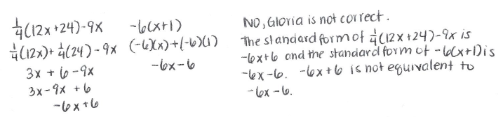

- A grocery store has advertised a sale on ice cream. Each carton of any flavor of ice cream costs $\$3.79$.
- If Millie buys one carton of strawberry ice cream and one carton of chocolate ice cream, write an algebraic expression that represents the total cost of buying the ice cream.
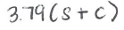

- Write an equivalent expression for your answer in part (a).

- Explain how the expressions are equivalent.

- A new park was designed to contain two circular gardens. Garden A has a diameter of $50 m$, and garden B has a diameter of $70 m$.
- If the gardener wants to outline the gardens in edging, how many meters will be needed to outline the smaller garden? (Write in terms of $π.$)
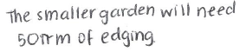
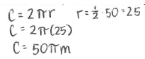

- How much more edging will be needed for the larger garden than the smaller one? (Write in terms of $π.$)
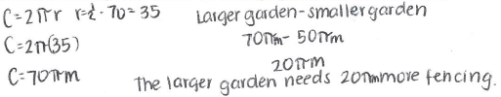

- The gardener wishes to put down weed block fabric on the two gardens before the plants are planted in the ground. How much fabric will be needed to cover the area of both gardens? (Write in terms of $π.$)

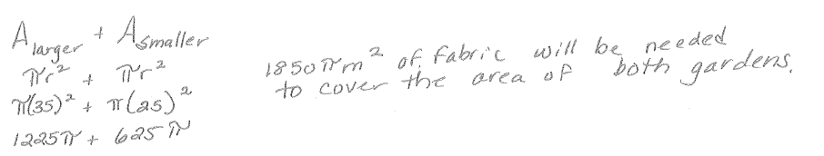

- A play court on the school playground is shaped like a square joined by a semicircle. The perimeter around the entire play court is $182.8 ft.$, and $62.8 ft.$ of the total perimeter comes from the semicircle.

- What is the radius of the semicircle? Use $3.14$ for $π$.

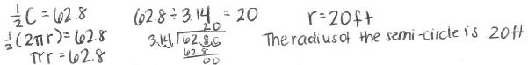

- The school wants to cover the play court with sports court flooring. Using $3.14$ for $π,$ how many square feet of flooring does the school need to purchase to cover the play court?

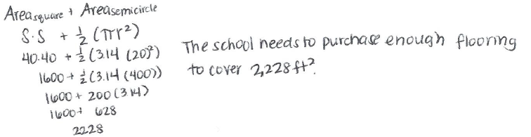

- Marcus drew two adjacent angles.

- If $∠ABC$ has a measure one-third of $∠CBD$, then what is the degree measurement of $∠CBD$?
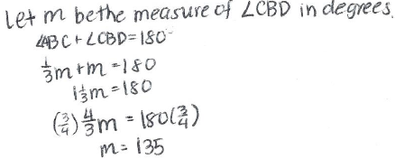

- If $∠CBD=9(8x+11)$, then what is the value of $x$?

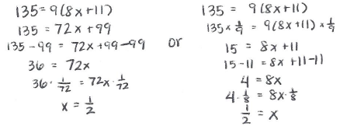

- The dimensions of an above-ground, rectangular pool are $25$ feet long, $18$ feet wide, and $6$ feet deep.

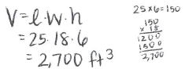
- How much water is needed to fill the pool?

- If there are $7.48$ gallons in $1$ cubic foot, how many gallons are needed to fill the pool?

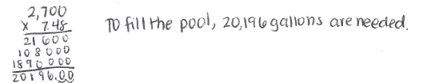

- Assume there was a hole in the pool, and$3,366$ gallons of water leaked from the pool. How many feet did the water level drop?

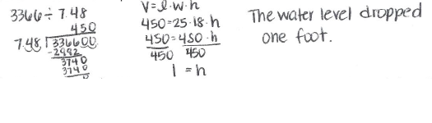

- After the leak was repaired, it was necessary to lay a thin layer of concrete to protect the sides of the pool. Calculate the area to be covered to complete the job.

- Gary is learning about mosaics in art class. His teacher passes out small square tiles and encourages the students to cut up the tiles in various angles. Gary’s first cut tile looks like this:
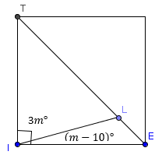

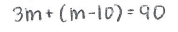
- Write an equation relating $∠TIL$ with $∠LIE$.

- Solve for $m.$
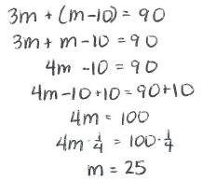

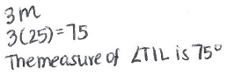
- What is the measure of $∠TIL$?

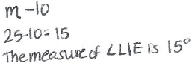
- What is the measure of $∠LIE$?

