Table of Contents
GRADE K • MODULE 6
Analyzing, Comparing, and Composing Shapes

Module Overview i

Topic A: Building and Drawing Flat and Solid Shapes 6.A.1

Topic B: Composing and Decomposing Shapes 6.B.1

Module Assessments 6.S.1

Grade K • Module 6
Analyzing, Comparing, and Composing Shapes

OVERVIEW
The kindergarten chapter of A Story of Units comes to a close with another opportunity for students to explore geometry. Throughout the year, students have built an intuitive understanding of two- and three-dimensional figures by examining exemplars, variants, and non-examples. They have used geometry as a context for exploring numerals as well as comparing attributes and quantities. To wrap up the year, students further develop their spatial reasoning skills and begin laying the groundwork for an understanding of area through composition of geometric figures.
Topic A begins with students applying their knowledge of attributes to analyze two- and three-dimensional shapes from the real world and construct models using straws and clay (K.G.5). “Let’s use the straws to make the sides of the rectangle, and we’ll stick the straws together at each corner using clay!” Students use their understanding of ordination to thirds to share and communicate the systematic construction of flats and solids. “First, I cut four straws to be the same length. Second, I made a square by placing the four straws so they look like a frame. Third, I connected the sides at the corners with four little clay balls” (K.CC.4d).
As in Module 2, students explore the relationship between flats and solids, this time using flats to build solids. “I made my square into a cube. First, I made another square the same size. Second, I attached the two squares with four straws the same length.” They also apply their knowledge of ordinal numbers to describe the relative position of shapes within a set (K.CC.4d). “The yellow circle is first, and the red square is tenth.”
The lessons of Topic B focus on composition and decomposition of flat shapes (K.G.6). Students begin by using flats to compose geometric shapes. “I put two triangles together to make a square.” They then decompose shapes by covering part of a larger shape with a smaller shape and analyzing the remaining space. “When I cover part of my square with this triangle, I can see another triangle in the empty space.”
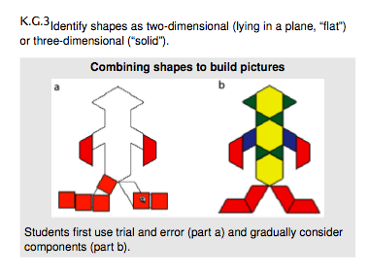
As they build competence in combining and composing shapes, students build toward more complex pictures and designs. Students progress through stages as they build competence in combining shapes to form pictures: beginning with trial and error and gradually considering the systematic combination of components. “This square fits here because the corners match the puzzle.” The culminating task of this module is set up as a Math Olympics, a celebration of student learning from the whole year. Students complete tasks related to number, measurement, operations, and geometry.
Composition and decomposition of geometric figures reinforce the idea that smaller units can combine to form larger units. This concept, central to A Story of Units, underlies not only area concepts but also the base ten number system. Students leave this module and the kindergarten year prepared to tackle the mathematical concepts of first grade and beyond.

Focus Grade Level Standards
Count to tell the number of objects.
K.CC.4 Understand the relationship between numbers and quantities; connect counting to cardinality.
d. Develop understanding of ordinal numbers (first through tenth) to describe the relative position and magnitude of whole numbers.
Analyze, compare, create, and compose shapes.
K.G.5 Model shapes in the world by building shapes from components (e.g., sticks and clay balls) and drawing shapes.
K.G.6 Compose simple shapes to form larger shapes. For example, “Can you join these two triangles with full sides touching to make a rectangle?”
Foundational Standards
PK.CC.6 Identify “first” and “last” related to order or position.
PK.G.3 Analyze, compare, and sort two- and three-dimensional shapes and objects, in different sizes, using informal language to describe their similarities, differences, and other attributes (e.g., color, size, and shape).
PK.G.4 Create and build shapes from components (e.g., sticks and clay balls).
Focus Standards for Mathematical Practice
MP.1 Make sense of problems and persevere in solving them. Students persist in their use of trial and error until they begin to use the attributes of a puzzle to determine which shape fits into an open space. “The empty space has a long side like my triangle. Let’s see if my triangle fits.”
MP.4 Model with mathematics. Students use shapes to create pictures of common objects and use straws and clay to create models of two- and three-dimensional objects in their environment.
MP.6 Attend to precision. Ordinal numbers provide students with vocabulary to precisely describe the spatial organization of ten shapes in a straight line.
MP.7 Look for and make use of structure. Students make use of their understanding of a shape’s attributes to build three-dimensional shapes from two-dimensional shapes.

Overview of Module Topics and Lesson Objectives
Standards | Topics and Objectives |  | Days
K.CC.4d  K.G.5  K.G.2  K.G.4 | A | Building and Drawing Flat and Solid Shapes  Lesson 1: Describe the systematic construction of flat shapes using ordinal numbers.  Lesson 2: Build flat shapes with varying side lengths and record with drawings.  Lesson 3: Compose solids using flat shapes as a foundation.  Lesson 4: Describe the relative position of shapes using ordinal numbers. | 4
K.G.6  K.G.1  K.G.4 | B | Composing and Decomposing Shapes  Lesson 5: Compose flat shapes using pattern blocks and drawings.  Lesson 6: Decompose flat shapes into two or more shapes.  Lesson 7: Compose simple shapes to form a larger shape described by an outline.  Lesson 8: Culminating task—review selected topics to create a cumulative year-end project. | 4
 |  | End-of-Module Assessment: Topics A–B | 2
Total Number of Instructional Days |  |  | 10

Terminology
New or Recently Introduced Terms
- First, second, third, fourth, fifth, sixth, seventh, eighth, ninth, tenth (ordinal numbers)
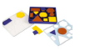
Familiar Terms and Symbols
- Above, below, beside, in front of, next to, behind (position words)
- Circle
- Cube (three-dimensional shape)
- Cylinder (three-dimensional shape)
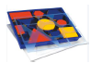
- Face (two-dimensional side of a shape )
- Flat (two-dimensional shape)
- Hexagon (flat figure enclosed by six straight sides)
- Rectangle (flat figure enclosed by four straight sides)
- Solid (three-dimensional shape)
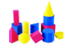
- Cone (three-dimensional shape)
- Sphere (three-dimensional shape)
- Square (flat figure enclosed by four straight, equal sides)
- Triangle (flat figure enclosed by three straight sides)
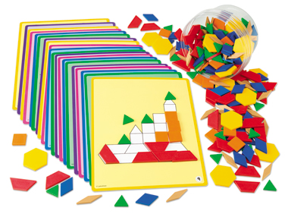
Suggested Tools and Representations
- Pattern block activity cards or attribute block activity cards
- Three-dimensional shapes: cone, sphere, cylinder, and cube
- Two-dimensional shapes: circle, hexagon, rectangle, square, and triangle
Scaffolds
The scaffolds integrated into A Story of Units give alternatives for how students access information as well as express and demonstrate their learning. Strategically placed margin notes are provided within each lesson elaborating on the use of specific scaffolds at applicable times. They address many needs presented by English language learners, students with disabilities, students performing above grade level, and students performing below grade level. Many of the suggestions are organized by Universal Design for Learning (UDL) principles and are applicable to more than one population. To read more about the approach to differentiated instruction in A Story of Units, please refer to “How to Implement A Story of Units.”
Assessment Summary
Type | Administered | Format | Standards Addressed
End-of-Module Assessment Task | After Topic B | Constructed response with rubric | K.CC.4d  K.G.5  K.G.6
Culminating Task | Lesson 8 | Collaborative project: Review selected topics to create a cumulative year-end project. | K.G.6

This descriptive image plus further clarification is found in the Geometry progressions document, p. 7.
Ordinality is introduced in the context of constructing and manipulating shapes. The balance of this cluster is addressed in Modules 1 and 5.
K.G.4 is addressed in Module 2.
These are terms and symbols students have seen previously.
Students with disabilities may require Braille, large print, audio, or special digital files. Please visit the website, www.p12.nysed.gov/specialed/aim, for specific information on how to obtain student materials that satisfy the National Instructional Materials Accessibility Standard (NIMAS) format.

