Name Date

1. Use the graph below to answer parts (a)–(c).

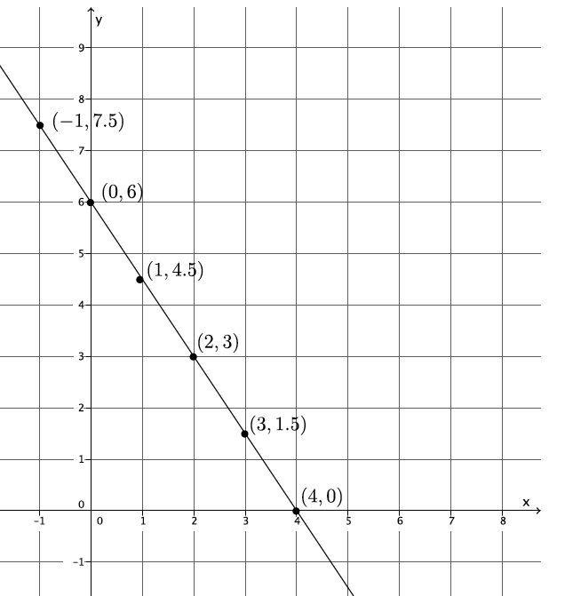

* 1. Use any pair of points to calculate the slope of the line.
  2. Use a different pair of points to calculate the slope of the line.
  3. Explain why the slopes you calculated in parts (a) and (b) are equal.

1. Jeremy rides his bike at a rate of miles per hour. Below is a table that represents the number of hours and miles Kevin rides. Assume both bikers ride at a constant rate.

|  |  |
| --- | --- |
| **Time in hours** | **Distance in miles** |
|  |  |
|  |  |
|  |  |
|  |  |

* 1. Which biker rides at a greater speed? Explain your reasoning.
  2. Write an equation for a third biker, Lauren, who rides twice as fast as Kevin. Use to represent the number of miles Lauren travels in hours. Explain your reasoning.
  3. Create a graph of the equation in part (b).

Macintosh HD:Users:stefaniehassan:Desktop:graph.pdf

* 1. Calculate the slope of the line in part (c) and interpret its meaning in this situation.

1. The cost of five protractors is at Store A. The graph below compares the cost of protractors at Store A with the cost at Store B.

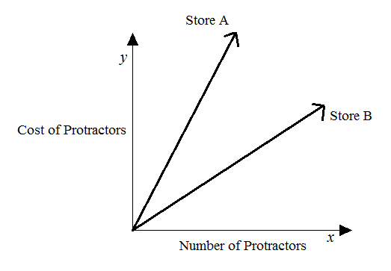

Estimate the cost of one protractor at Store B. Use evidence from the graph to justify your answer.

1. Given the equation, , write a second linear equation to create a system that
   1. Has exactly one solution. Explain your reasoning.
   2. Has no solution. Explain your reasoning.
   3. Has infinitely many solutions. Explain your reasoning.
   4. Interpret the meaning of the solution, if it exists, in the context of the graph of the following system of equations.
2. Students sold tickets for a fundraiser at school. Some tickets are for children and cost , while the rest are adult tickets that cost . If the total value of all tickets sold was , how many of each type of ticket was sold?
3. a. Determine the equation of the line connecting the points and
   1. Will the line described by the equation in part (a) intersect the line passing through the points and ? Explain why or why not.
4. Line and line are shown on the graph below. Use the graph to answer parts (a)–(f).

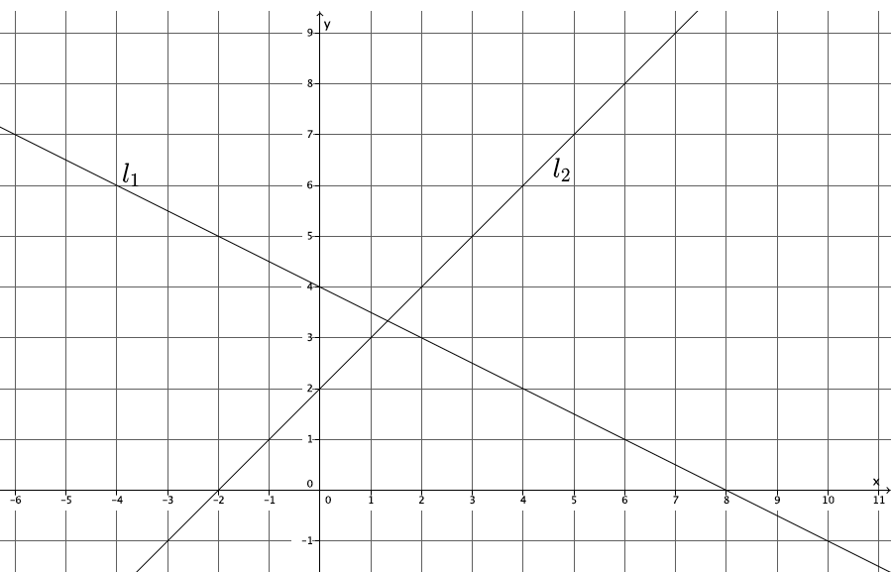

* 1. What is the -intercept of ?
  2. What is the -intercept of ?
  3. Write a system of linear equations representing lines and .
  4. Use the graph to estimate the solution to the system.
  5. Solve the system of linear equations algebraically.

* 1. Show that your solution from part (e) satisfies both equations.

|  |  |  |  |  |  |
| --- | --- | --- | --- | --- | --- |
| A Progression Toward Mastery | | | | | |
| Assessment  Task Item | | STEP 1  Missing or incorrect answer and little evidence of reasoning or application of mathematics to solve the problem. | STEP 2  Missing or incorrect answer but evidence of some reasoning or application of mathematics to solve the problem. | STEP 3  A correct answer with some evidence of reasoning or application of mathematics to solve the problem, OR an incorrect answer with substantial evidence of solid reasoning or application of mathematics to solve the problem. | STEP 4  A correct answer supported by substantial evidence of solid reasoning or application of mathematics to solve the problem. | |
| **1** | **a–b**  8.EE.B.5 | Student makes no attempt to find the slope in part (a) and/or part (b). | Student computes the slope in parts (a) and (b), but makes computational errors leading to slopes that are not equal. Student may have used the same two points for both parts (a) and (b). | Student computes slope both times but may have forgotten to include the negative sign, or makes another simple computational error. Student finds the slopes in both parts (a) and (b) to be equal. | Student correctly computes the slope, both times and finds (or an equivalent fraction). Student finds the slopes in both parts (a) and (b) to be equal. | |
| **c**  8.EE.B.6 | Student makes no attempt to answer the question. | Student states that the slopes in parts (a) and (b) are not equal. | Student makes a weak argument by stating that the slopes are equal because the fractions are equal or that the fractions representing the slope are equivalent. | Student makes a convincing argument and references similar triangles to explain why the slopes between any two points on a line are equal. | |
| **2** | **a**  8.EE.B.5 | Student makes no attempt to answer the question or writes “Kevin” or “Jeremy” with no evidence of an application of mathematics to solve the problem. | Student writes an incorrect answer but shows some evidence of reasoning in the explanation. | Student writes the correct answer. Student’s explanation lacks precision or is incorrect. For example, the student may have written that Jeremy travels a farther distance in two hours instead of referencing the rates of each biker. | Student writes the correct answer. Student provides a strong mathematical explanation as to which biker rides at a greater speed by referencing a graph (slopes of each line where one slope is steeper) or a numerical comparison of their rates. | |
|  | **b–d**  8.EE.B.5 | Student makes little or no attempt to complete parts (b)–(d). Student may have plotted points on the graph with no relevance to the problem. | Student writes an incorrect equation in part (b) and/or graphs the equation incorrectly and/or calculates the slope incorrectly. Student does not connect the slope of the line to Lauren’s rate. | Student correctly identifies the equation, graphs and calculates slope, and identifies it as Lauren’s rate but the answer shows no evidence of reasoning in part (b).  OR  Student makes a mistake in writing the equation for part (b) which leads to an incorrect graph and slope in parts (c)–(d). | Student correctly writes the equation, in part (b) or writes an equivalent equation. Student explains “twice as fast” in terms of distance traveled for a given time interval compared to the data for Kevin given in the table. Student correctly graphs the situation in part (c) and correctly identifies the slope of the line, , as the rate that Lauren rides for part (d). | |
| **3** | 8.EE.B.5 | Student makes no attempt to answer the question.  OR  Student writes a dollar amount with no explanation. | Student may or may not have correctly calculated the unit rate of protractors for Store A. Student writes an estimate for Store B but does not justify their estimate using evidence from the graph. | Student uses the information provided about Store A to determine the unit rate of protractors buy may have made a computation error leading to a poor estimate. Student may or may not have used evidence from the graph to justify the estimate or makes a weak connection between the estimate and the graph. | Student uses the information provided about Store A to determine the unit rate of protractors and references the unit rate at Store A in the justification of the estimate. Student writes an estimate that makes sense (e.g., less than Store A, about half as much) and uses evidence from the graph in the justification (e.g., comparison of slopes, size of angles). | |
| **4** | **a–c**  8.EE.C.7a  8.EE.C.8 | Student makes no attempt to answer any parts of (a)–(c).  OR  Student only rewrites the given equation as an answer. | Student answers at least one part of (a)–(c) correctly. Student may have left two parts blank. Answer may or may not show evidence of reasoning. | Student answers at least two parts of (a)–(c) correctly. Student may have left one part blank. Student explains reasoning in at least two parts of (a)–(c), noting the characteristics required to achieve the desired number of solutions. | Student provides a correct equation and explanation for each of the parts of (a)–(c). Specifically, for part (a) an equation that represents a distinct line from the given equation will have a slope different than , for part (b) an equation that represents a line parallel to the given equation will have the same slope, and for part (c), an equation that represents the same line as the given equation whose graphs coincide. | |
|  | **d**  8.EE.C.8 | Student makes little or no attempt to answer the question. Student does not provide a mathematical explanation or apply any mathematical reasoning to support the answer. | Student gives an incorrect answer. Student may have said that the point of intersection of the lines is the solution to the system or that there is no solution because the lines are parallel. | Student may have tried to find the solution algebraically. Student states that there are infinitely many solutions to the system but may not have referenced what the graph would look like (i.e., each equation produced the same line on the graph). Student supplies weak mathematical reasoning to support the answer. | Student correctly states that the graphs of the equations produce the same line. Student explains that one equation can be obtained by the other by multiplying the first equation by or the second equation by . OR  Student explains that both lines had the same slope of and the same -intercept of . Student supplies strong mathematical reasoning to support the answer. | |
| **5** | 8.EE.C.8 | Student makes little or no attempt to write and solve a system of linear equations. | Student may have written an incorrect system of equations to represent the situation. Student may or may not have defined the variables. Student may have used another strategy to determine the numbers of tickets of each type that were sold. There is some evidence of mathematical reasoning. | Student correctly writes a system of linear equations to represent the situation but makes a computational error leading to an incorrect solution.  OR  Student correctly writes and solves a system but does not define the variables. | Student correctly writes and solves a system of linear equations to solve the problem. Student defines the variables used in the system. Student states clearly that children’s tickets and adult’s tickets were sold. | |
| **6** | **a**  8.EE.C.8 | Student makes little or no attempt to write the equation. | Student incorrectly computes the slope of the line as something other than . Student does not write the correct equation of the line. | Student uses the points to correctly determine the slope of the line as , but may have written an incorrect equation. | Student uses the points to determine the slope of the line, then writes the equation of the line passing through those two points as or equivalent. | |
| **b**  8.EE.C.8 | Student makes little or no attempt to answer the question.  OR  Student responds with *yes* or *no* only. | Student incorrectly computes the slope of the line as something other than and may or may not have drawn an incorrect conclusion about whether or not the lines would intersect. | Student uses the points to correctly determine the slope of the line as but makes an incorrect conclusion about whether or not the lines would intersect.  OR  Student makes a computational error for the slope and draws the wrong conclusion about the lines.  OR  Student says the lines would intersect but does not provide an explanation. | Students uses the points to determine the slope as and correctly concludes that the lines will intersect because the slopes are different. | |
| **7** | **a–b**  8.EE.C.8 | Student leaves both parts (a) and (b) blank. OR  Student identifies coordinates that do not fall on either the or axis. | Student identifies one of the two -intercepts but may have inversed the coordinates. Student leaves either (a) or (b) blank. | Student identifies the  -intercepts of and but switches the coordinates, i.e., and or identifies the slope of as and as. | Student correctly identifies the  -intercepts of and as and , respectively. | |
| **c–d**  8.EE.C.8 | Student leaves the item blank.  OR  Student only writes one equation that may or may not have represented one of the lines on the graph. Student may or may not have written an estimate or writes an estimate where the -value is not between and and the -value is not between and. | Student writes two equations to represent the system but the equations do not represent the lines on the graph. Student may or may not have written an estimate or writes and estimate where the -value is not between and and the -value is not between and . | Student writes a system of equations but one of the equations is written incorrectly. Student writes an estimate where the -value is between and and the -value is between and . | Student correctly writes the system as or a system equivalent to this given one. Student writes an estimate where the  -value is between and and the -value is between and . | |
| **e–f**  8.EE.C.8 | Student is unable to solve the system algebraically. | Student solves the system algebraically but makes serious computational errors leading to an incorrect solution. Student is unable to complete part (f) or notices an error and does not correct it. | Student solves the system but may have made a computational error leading to an incorrect - or  -coordinate. Student verifies the solution in part (f). Student makes a computational error and believes the solution is correct. | Student correctly solves the system and identifies the solution as . Student verifies the solution in part (f). | |

Name Date

1. Use the graph below to answer parts (a)–(c).

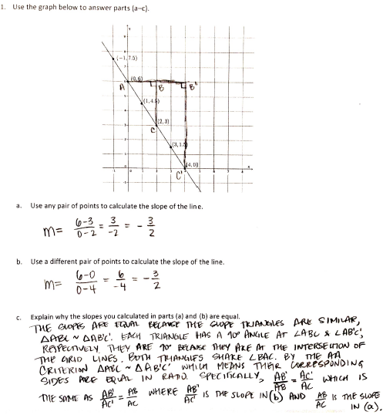

* 1. Use any pair of points to calculate the slope of the line.



* 1. Use a different pair of points to calculate the slope of the line.



* 1. Explain why the slopes you calculated in parts (a) and (b) are equal.

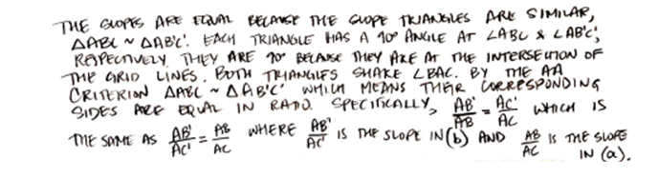

1. Jeremy rides his bike at a rate of miles per hour. Below is a table that represents the number of hours and miles Kevin rides. Assume both bikers ride at a constant rate.

|  |  |
| --- | --- |
| **Time in hours** | **Distance in miles** |
|  |  |
|  |  |
|  |  |
|  |  |

* 1. Which biker rides at a greater speed? Explain your reasoning.

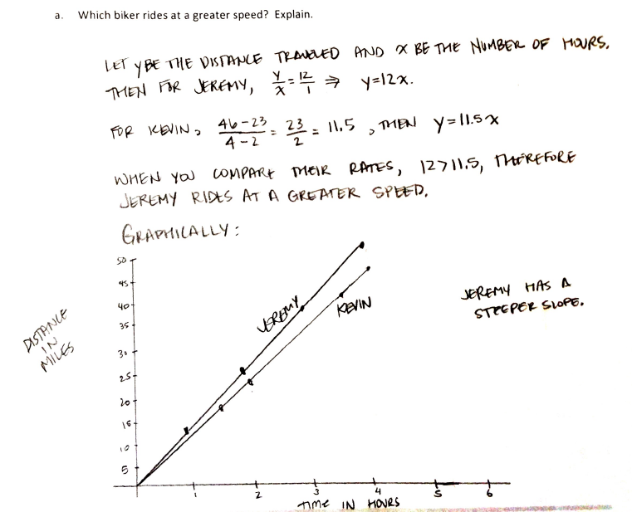

* 1. Write an equation for a third biker, Lauren, who rides twice as fast as Kevin. Use to represent the number of miles Lauren travels in hours. Explain your reasoning.

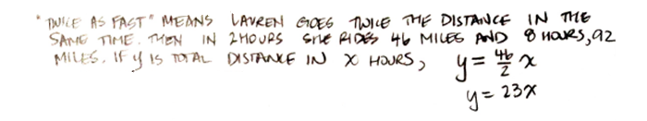

* 1. Create a graph of the equation in part (b).

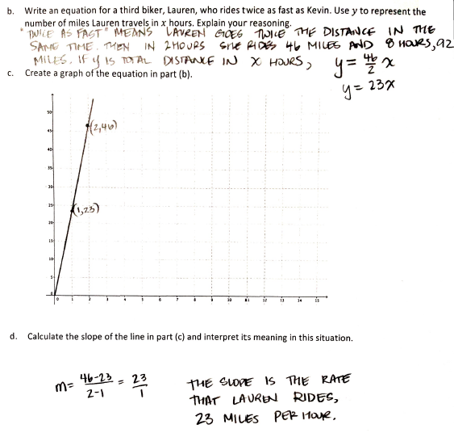

* 1. Calculate the slope of the line in part (c) and interpret its meaning in this situation.



1. The cost of five protractors is at Store A. The graph below compares the cost of protractors at Store A with the cost at Store B.



Estimate the cost of one protractor at Store B. Use evidence from the graph to justify your answer.

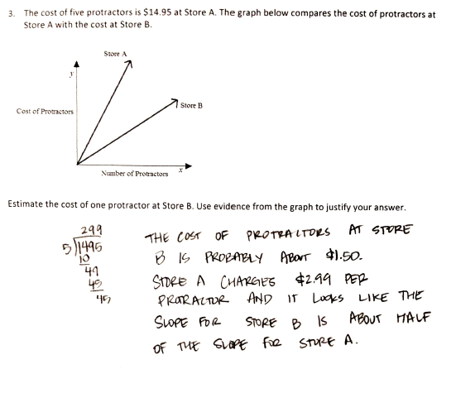

1. 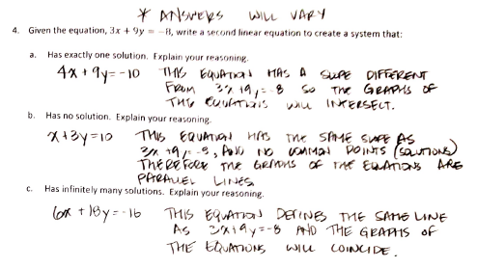Given the equation, , write a second linear equation to create a system that
   1. Has exactly one solution. Explain your reasoning.



* 1. Has no solution. Explain your reasoning.



* 1. Has infinitely many solutions. Explain your reasoning.



* 1. Interpret the meaning of the solution, if it exists, in the context of the graph of the following system of equations.

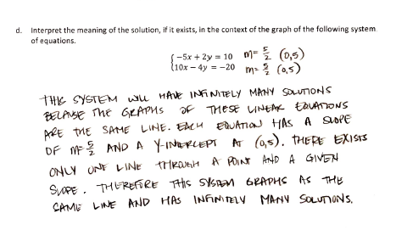

1. Students sold tickets for a fundraiser at school. Some tickets are for children and cost , while the rest are adult tickets that cost . If the total value of all tickets sold was , how many of each type of ticket was sold?

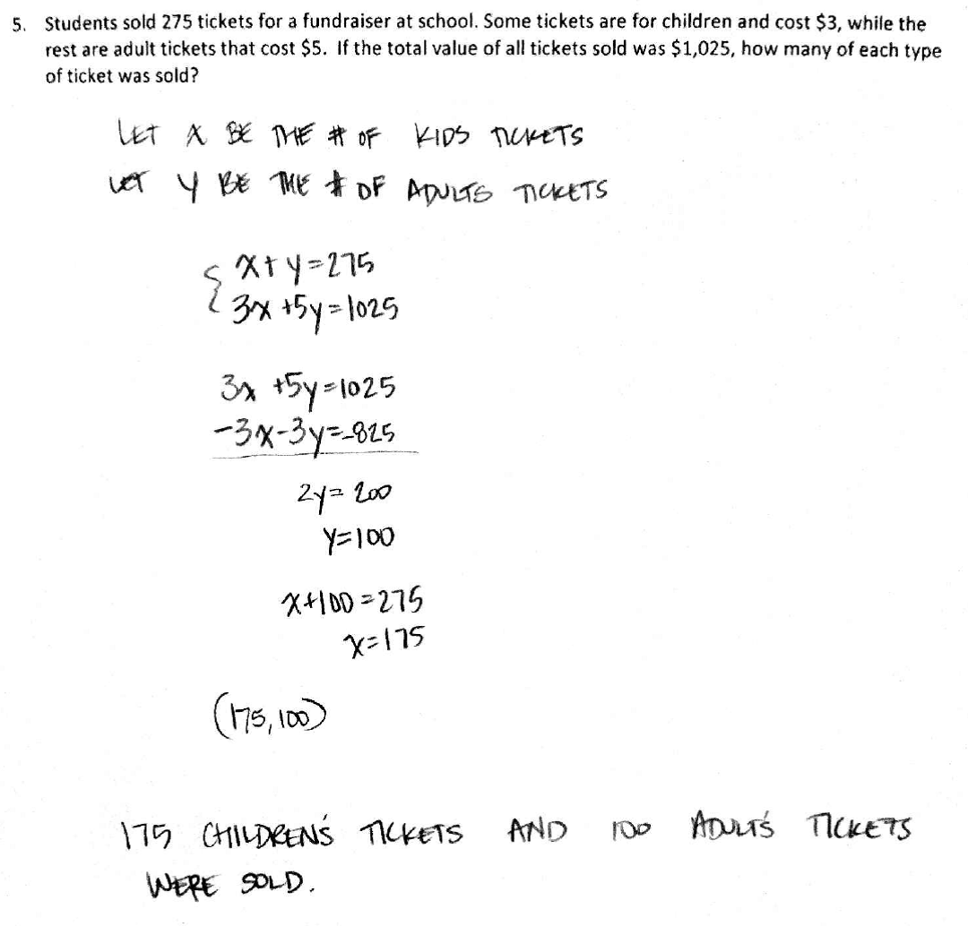

1. a. Determine the equation of the line connecting the points and

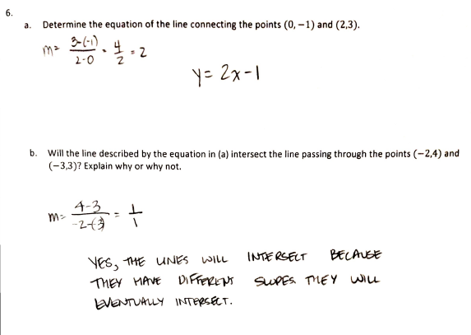

* 1. Will the line described by the equation in part (a) intersect the line passing through the points and ? Explain why or why not.



1. Line and line are shown on the graph below. Use the graph to answer parts (a)–(f).



* 1. What is the -intercept of ?

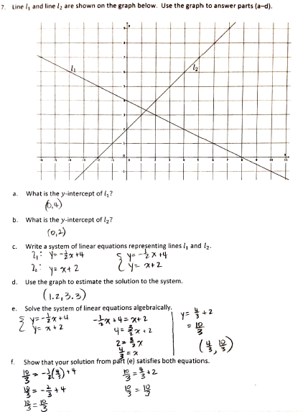

* 1. What is the -intercept of ?



* 1. Write a system of linear equations representing lines and .



* 1. Use the graph to estimate the solution to the system.



* 1. Solve the system of linear equations algebraically.

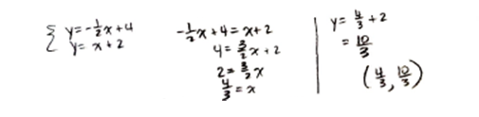

* 1. Show that your solution from part (e) satisfies both equations.

