Name Date

1. In their entrepreneurship class, students are given two options for ways to earn a commission selling cookies. For both options, students will be paid according to the number of boxes they are able to sell, with commissions being paid only after all sales have ended. Students must commit to one commission option before they begin selling.

Option 1: The commission for each box of cookies sold is dollars.

Option 2: The commission will be based on the total number of boxes of cookies sold as follows: cents is the total commission if one box is sold, cents is the commission if two boxes are sold,   
 cents if three boxes are sold, and so on, doubling the amount for each additional box sold. (This option is based upon the total number of boxes sold and is paid on the total, not each individual box.)

* 1. Define the variables and write function equations to model each option. Describe the domain for each function.
  2. If Barbara thinks she can sell five boxes of cookies, should she choose Option 1 or 2?
  3. Which option should she choose if she thinks she can sell ten boxes? Explain.
  4. How many boxes of cookies would a student have to sell before Option 2 pays more than Option 1? Show your work and verify your answer graphically.



1. The table shows the average sale price, ,of a house in New York City, for various years, ,since 1960.

|  |  |  |  |  |  |  |  |
| --- | --- | --- | --- | --- | --- | --- | --- |
| Years since 1960, |  |  |  |  |  |  |  |
| Average sale price (in thousands of dollars), |  |  |  |  |  |  |  |

* 1. What type of function most appropriately represents this set of data? Explain your reasoning.
  2. In what year is the price at the lowest? Explain how you know.
  3. Write a function to represent the data. Show your work.
  4. Can this function ever be equal to zero? Explain why or why not.
  5. Mr. Samuels bought his house in New York City in 1970. If the trend continued, how much was he likely to have paid? Explain and provide mathematical evidence to support your answer.

1. Veronica’s physics class is analyzing the speed of a dropped object just before it hits the ground when it is dropped from different heights. They are comparing the final velocity, in feet/second, versus the height, in feet, from which the object was dropped. The class comes up with the following graph.   
   1. Use transformations of the parent function*, ,* to write an algebraic equation that represents this graph. Describe the domain in terms of the context.



* 1. Veronica and her friends are planning to go cliff diving at the end of the school year. If she dives from a position that is above the water, at what velocity will her body be moving right before she enters the water? Show your work and explain the level of precision you chose for your answer.
  2. Veronica’s friend, Patrick, thinks that if she were able to dive from a - position, she would experience a velocity that is twice as fast. Is he correct? Explain why or why not.

1. Suppose that Peculiar Purples and Outrageous Oranges are two different and unusual types of bacteria. Both types multiply through a mechanism in which each single bacterial cell splits into four. However, they split at different rates: Peculiar Purples split every minutes, while Outrageous Oranges split every minutes.
   1. If the multiplication rate remains constant throughout the hour and we start with three bacterial cells of each, after one hour, how many bacterial cells will there be of each type? Show your work and explain your answer.
   2. If the multiplication rate remains constant for two hours, which type of bacteria is more abundant? What is the difference between the numbers of the two bacterial types after two hours?
   3. Write a function to model the growth of Peculiar Purples and explain what the variable and parameters represent in the context.
   4. Use your model from part (c) to determine how many Peculiar Purples there will be after three splits, i.e., at time minutes.  Do you believe your model has made an accurate prediction?  Why or why not?
   5. Write an expression to represent a different type of bacterial growth with an unknown initial quantity but in which each cell splits into two at each interval of time.
2. In a study of the activities of dolphins, a marine biologist made a slow-motion video of a dolphin swimming and jumping in the ocean with a specially equipped camera that recorded the dolphin’s position with respect to the slow-motion time in seconds. Below is a piecewise quadratic graph, made from the slow-motion dolphin video, which represents a dolphin’s vertical height (in feet, from the surface of the water) while swimming and jumping in the ocean, with respect to the slow-motion time (in seconds). Use the graph to answer the questions. (Note: The numbers in this graph are not necessarily real numbers from an actual dolphin in the ocean.)

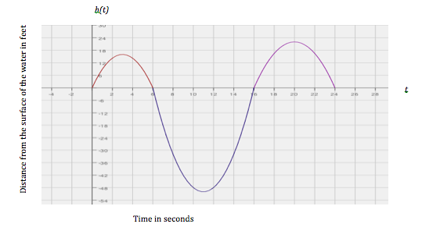

* 1. Given the vertex , write a function to represent the piece of the graph where the dolphin is underwater. Identify your variables and define the domain and range for your function.
  2. Calculate the average rate of change for the interval from to seconds. Show your work and explain what your answer means in the context of this problem.
  3. Calculate the average rate of change for the interval from to seconds. Show your work and explain what your answer means in the context of this problem.
  4. Compare your answers for parts (b) and (c). Explain why the rates of change are different in the context of the problem.

1. The tables below represent values for two functions, and , one absolute value and one quadratic.
   1. Label each function as either absolute value or quadratic. Then explain mathematically how you identified each type of function.

|  |  |  |  |  |
| --- | --- | --- | --- | --- |
| *:* | |  | *:* | |
|  |  |  |  |  |
|  |  |  |  |  |
|  |  |  |  |  |
|  |  |  |  |  |
|  |  |  |  |  |
|  |  |  |  |  |
|  |  |  |  |  |
|  |  |  |  |  |

* 1. Represent each function graphically. Identify and label the key features of each in your graph   
     (e.g., vertex, intercepts, axis of symmetry, etc.).



* 1. Represent each function algebraically.

|  |  |  |  |  |  |
| --- | --- | --- | --- | --- | --- |
| A Progression Toward Mastery | | | | | |
| Assessment  Task Item | | STEP 1  Missing or incorrect answer and little evidence of reasoning or application of mathematics to solve the problem. | STEP 2  Missing or incorrect answer but evidence of some reasoning or application of mathematics to solve the problem. | STEP 3  A correct answer with some evidence of reasoning or application of mathematics to solve the problem, or an incorrect answer with substantial evidence of solid reasoning or application of mathematics to solve the problem. | STEP 4  A correct answer supported by substantial evidence of solid reasoning or application of mathematics to solve the problem. |
| **1** | **a**  N-Q.A.2  N-Q.A.3  A-CED.A.2  F-BF.A.1a  F-LE.A.1  F-LE.A.2  F-IF.B.5 | Student is unable to respond.  OR  Student makes a minimal attempt to answer the three parts of the question.  OR  Student provides a response in which none of the three components are accurate or complete. | Student provides a response in which two of the following three components are missing, only partially correct, or incorrect:   1. Variables/quantities are defined appropriately; 2. The domain is described, including the need to use cents in Option 2 and dollars in Option 1; 3. Both equations are accurately created.   (Note: Only one of the three is accurate and complete.) | Student provides a response in which one of the following three components is missing, only partially correct, or incorrect:   1. Variables/quantities are defined appropriately; 2. The domain is described, including the need to use cents in Option 2 and dollars in Option 1; 3. Both equations are accurately created.   (Note: Two of the three are accurate and complete.) | Student provides an answer in which variables for the commission and the number of boxes sold are selected and defined appropriately. Student addresses the domain issues (cents are used for one domain and dollars for the other). Student creates accurate function equations using the defined quantities. |
| **b–c**  N-Q.A.3  F-IF.B.4 | Student makes little or no attempt to answer these questions.  OR  Student attempts the answers, but they are incorrect. | Student is able to answer the questions. Student provides an answer in which the work is missing or partially supportive, and the explanation is missing. | Student performs calculations correctly with accurate work shown and is able to answer the questions. Student attempts the explanation but it is incomplete or unclear. | Student answers the questions correctly, with accurate work shown, and with an appropriate level of precision, using cents or decimals for Option 2 and dollars for Option 1. Student provides an explanation that is clear and complete. |
| **d**  F-IF.B.4 | Student provides an answer that is incorrect, and there is no recognition of that fact as the student attempts to support the answer mathematically and graphically.  OR  Student provides little or no response to this question. | Student answers correctly that at 12 boxes Option 2 pays more than Option 1. Student provides little or no supporting mathematical or graphical reasoning. | Student answers correctly that at 12 boxes Option 2 pays more and provides some appropriate mathematical reasoning to support that answer– either tables, equations, or graphs. However, the student provides supporting work that is only partially helpful. For example, the graph may be missing or does not show an understanding of the discrete nature of the data; the tables may not extend far enough to support the answer, or the mathematical support may contain errors or be missing. | Student answers correctly that at 12 boxes Option 2 pays more and uses appropriate mathematical reasoning to support that answer (using tables or equations). Student provides an accurate graph that shows the discrete nature of the graphs and supports the answer. |
| **2** | **a**  F-IF.B.4 | Student misrepresents the function as something other than quadratic.  OR  Student makes no attempt to answer this question. | Student correctly identifies the function as quadratic but provides no supporting evidence. | Student correctly identifies the function as quadratic and includes a partial, or partially accurate, explanation of rationale. | Student correctly identifies the function as quadratic and includes an accurate explanation of why the second differences are constant or the pattern of the data shows a decrease, and then an increase with varying average rates of change over the interval. Student may also include graphic support for the decision. |
| **b, d**  F-IF.B.4 | Student makes no attempt to answer these questions. | Student attempts to interpret the data but answers the questions incorrectly. Student attempts an explanation but is not effective in highlighting the error. | Student accurately interprets the data to answer the questions correctly. Student provides an explanation that is only partially helpful or partially present. | Student accurately interprets the data to answer the questions correctly. Student provides an explanation that is accurate and complete and relates to the key feature being addressed (minimum value of the function and -intercepts). |
| **c**  A-CED.A.2  F-BF.A.1a | Student makes little or no attempt to answer this question. | Student attempts to determine a quadratic equation but makes computational errors that result in an incorrect function equation. | Student accurately arrives at the correct quadratic equation for this function. Student provides supporting work that is clear and accurate. However, student does not consider the value of the leading coefficient. | Student accurately arrives at the correct quadratic equation for this function. Student provides supporting work that is clear and accurate and determines the fact that the leading coefficient is . |
| **e**  N-Q.A.3  F-IF.B.4 | Student provides an incorrect answer.  OR  Student makes little or no attempt to answer this question. | Student provides the correct response of but provides no mathematical support or explanation of the solution.  OR  Student correctly determines that 1970 is interpreted as but makes an error in calculation that leads to an incorrect result. | Student accurately interprets the data to answer the question correctly; however, the results may not be reported with the correct level of precision. For example, 1970 is interpreted as , and the final solution is given as . Student provides an explanation that may be partially effective. For example, calculations or explanation is missing or partially present. | Student accurately interprets the data to answer the question correctly, and results are reported with the correct level of precision: 1970 is interpreted as , and the final solution is given as rather than . Student provides mathematical support that includes accurate calculations. |
| **3** | **a**  A-CED.A.1  A.CED.A.2  F-IF.B.5  F-BF.A.1a | Student does not recognize the graph as representing a square root function.  OR  Student makes little or no attempt to answer this question. | Student recognizes that the graph is a square root function and presents the correct parent function*:* . However, the student makes no attempt or used an incorrect method to find the specific function. Student does not provide a one-variable equation that would be used to find the function equation or it is ineffective. Student may or may not have domain restrictions correctly described for this rating level. | Student correctly interprets the graph to represent a square root function with parent of and accurately uses algebraic manipulation to solve the one-variable equation that indicates that the function equation is  .  However, restrictions on the domain are either not present, incorrect, or are missing information about the need for one interval to be open at .  OR  Student correctly interprets the graph as a square root function, and attempts to determine the function, but an error in calculation results in an incorrect result. Student accurately describes domain restrictions. | Student correctly does all three parts of this question:   1. Interprets the graph to represent a square root function with parent of . 2. Accurately determines that the function is stretched and uses correct algebraic manipulation to solve the 1-variable equation that indicates that the function equation is . 3. Restrictions on the domain are present either symbolically or as part of the explanation. Some understanding of the limitations on the domain in the context should be apparent. |
| **b**  N-Q.A.3  F-IF.B.4 | Student makes little or no attempt to answer this question. | Student attempts to interpret the problem situation but does not use the correct function value, , and/or makes calculation errors that lead to an incorrect answer. | Student accurately interprets the problem situation and correctly uses an incorrect equation (finds from part (a)). Even though they are not accurate, results are reported with the correct level of precision. | Student accurately interprets the problem situation to answer the question correctly. Student reports results with the correct level of precision: (or ). |
| **c**  N-Q.A.3  F-IF.B.4 | Student makes little or no attempt to answer this question.  OR  Student agrees with Patrick. | Student attempts to interpret the problem situation but does not use the correct function value, , and/or makes calculation errors that lead to an incorrect answer. Student agrees with Veronica, but there is no clear or valid explanation of the reasoning behind the agreement. | Student accurately interprets the problem situation and correctly uses an incorrect equation (finds from part (a)). Student agrees with Veronica but does not include a supporting argument involving the key features of a square root function as compared to a linear (Patrick’s assumption).  OR  Student accurately interprets the problem situation to answer the question correctly (or ) but provides no explanation of the reasoning. | Student accurately interprets the problem situation to answer the question correctly ( or ). Student agrees with Veronica and describes the key features of a square root function as it relates to a linear function (Patrick’s assumption). |
| **4** | **a–b**  N-Q.A.2  N-Q.A.3  F-LE.A.1 | Student makes little or no attempt to answer these questions. | Student defines the quantities and the variables in the problems but makes calculation errors that lead to an incorrect answer. Student provides inadequate explanation of the process and/or the relationship between the number of splits per hour and the growth of the two bacteria types. | Student defines the quantities and the variables in the problems and calculates correctly to find the number of cells after one hour for each type of bacteria (Orange is , Purple is ).  Student provides partial evidence of the required work, and/or student does not adequately explain the answers.  Student provides answers with the appropriate attention to precision.  Student may provide part (b) exactly but may be rounded at this level (i.e., answers might be given to three significant digits: million for Oranges, million for Purples, and the difference: million. Or, they may be appropriately rounded to the nearest million.) | Student defines the quantities and the variables in the problems and calculates correctly to find the number of cells after one hour for each type of bacteria (Orange is , Purple is ).  Student shows work and supports the correct answers found. Student includes the fact that the two types of bacteria have a different number of divisions in the hour, so one is growing faster than the other, even though both are splitting in the same way (into four).  Student provides the answers with the appropriate attention to precision.  Student may provide part (b) exactly but may be rounded for full credit (i.e., answers might be given to three significant digits: million for Oranges, million for Purples, and the difference: million. Or, they may be appropriately rounded to the nearest million.) |
| **c**  N-Q.A.2  A-CED.A.2  F-LE.A.2 | Student makes little or no attempt to answer this question. | Student attempts to use the described situation to create a two-variable equation but does not clearly understand how the exponential function should be formed.  Student makes errors in forming the function equation, and/or the explanation of the parameters is missing or incorrect. | Student correctly uses defined variables to create a two-variable exponential equation that fits the described situation but the meaning of one or both of the parameters is incorrectly explained. | Student correctly uses defined variables to create a two-variable exponential equation that fits the described situation and the meaning of both parameters is correctly explained. |
| **d**  N-Q.A.2  A-CED.A.2  F-LE.A.2 | Student makes little or no attempt to answer this question. | Student attempts to calculate using the function from part (c), but the calculation is incorrect. | Student correctly calculates using the function from part (c) but does not provide a sufficient explanation as to why the model did or did not provide an accurate prediction. | Student correctly calculates using the function from part (c) and provides a sufficient explanation as to why the model did or did not provide an accurate prediction. |
| **e**  N-Q.A.2  A-CED.A.2  F-LE.A.2 | Student makes little or no attempt to answer this question. | Student attempts to write an exponential expression but both parameters are incorrect. | Student attempts to write an exponential expression but one of the parameters is incorrect. | Student correctly writes the exponential expression as |
| **5** | **a**  N-Q.A.2  A.CED.A.2  F-IF.B.5 | Student attempts an incorrect method to find a quadratic equation.  OR  Student makes little or no attempt to answer this question. | Student makes an attempt to create a two-variable quadratic equation. However, the values used are incorrect or are used incorrectly, leading to an incorrect equation.  Student does not pay attention to the leading coefficient, and the domain and range explanations are missing. | Student creates a two-variable equation based on the correct section of the graph, using the given vertex coordinates. Student correctly computes to find the leading coefficient, leading to the correct function equation: . The domain and range explanations are missing, inadequate, or incorrect. | Student creates a two-variable equation based on the correct section of the graph, using the given vertex coordinates. Student also correctly computes to find the leading coefficient, leading to the correct function equation: . Student provides an explanation of the domain and range that are clear and accurate. |
| **b–c**  F-IF.B.4  F-IF.B.6 | Student makes little or no attempt to answer these questions. | Student attempts to find the average rate of change, but errors in calculation lead to incorrect answers. Explanations are missing or ineffective. | Student calculates the rate of change and shows all work but does not adequately explain what the rates mean in terms of the context. | Student accurately calculates the average rate of change over the indicated intervals, with all necessary work shown. Student explains the answer in terms of the rate of speed for the dolphin and the direction it is moving. |
| **d**  F-IF.B.4  F-IF.B.6 | Student makes little or no attempt to answer this question. | Student attempts to compare the two average rates of change but is unable to identify the similarities or differences or make a connection to the context. | Student recognizes that the two average rates of change are opposites but does not adequately explain the connection to the context. | Student explains how and why, in terms of the context, the two average rates are different. |
| **6** | **a**  F-BF.A.1a | Student makes little or no attempt to answer this question. | Student correctly identifies one of the two functions and correctly explains how the correct one is determined. Student incorrectly identifies the other, and the explanation is missing or ineffective. | Student correctly identifies the function for each table of values and accurately and clearly explains how he or she arrives at the conclusion. Student does not include average rates of change of different intervals for being constant and varying for in the accompanying explanation. | Student correctly identifies the function for each table of values and accurately and clearly explains how he or she arrives at the conclusion. Student includes average rates of change of different intervals for being constant and varying for in the explanation. |
| **b**  F-BF.A.1a | Student makes little or no attempt to answer this question. | Student graphs only one of the two functions correctly and identifies/labels the key features. Student provides graphs that may or may not have the scale and the axes labeled. | Student graphs both functions correctly but does not identify or label the key features. Student provides graphs that are clear and have the scale and the axes labeled. | Student accurately creates the graphs for both functions with labels for the vertices and the axes of symmetry. Student provides graphs that are clear and have the scale and the axes labeled. |
| **c**  A-CED.A.2  F-IF.B.6 | Student makes little or no attempt to answer this question. | Student accurately creates one of the two functions correctly with work shown. If the equation for is accurately completed, there should be evidence of understanding that is not in the domain for both intervals in the piecewise defined function. One or the other of the intervals must have an open endpoint at . Student shows supporting work for the correct equation. The other may be incomplete or incorrect. | Student accurately creates the absolute value function either in absolute value form () or as a piecewise defined function ( for , and for ). There is no indication that the student understands that is not in the domain for both intervals in the piecewise defined function. One or the other of the intervals must have an open endpoint at .  The second is correctly identified as  . Student shows work that supports the correct answers. | Student accurately creates the absolute value function either in absolute value form () or as a piecewise defined function ( for , and for ). It should be clear that is not in the domain for both intervals in the piecewise defined function. One or the other of the intervals must have an open endpoint at .  The second is correctly identified as  . Student shows work that supports the correct answers. |
| **d**  N-Q.A.3  A-CED.A.2 | Student makes little or no attempt to answer this question. | Student uses the correct formula for exponential growth, but is not able to substitute the correct values from the prompt for the initial investment, the rate, and the time. Consequently, calculations are incorrect. | Student uses the correct formula for exponential growth, and accurately substitutes values for initial investment, rate, and time. There are errors in calculation or rounding that offer a solution other than . Student is able to subtract the original from the earnings found and gives the answer: NO, this is not enough interest to offset the loss of purchasing power she will incur over the course of the years. | Student uses the correct formula for exponential growth, and accurately calculates the earnings to be . Student then subtracts the original to find that the earnings will be and answers: NO, this is not even half of the purchasing power she will lose over the course of the years. |

Name Date

1. In their entrepreneurship class, students are given two options for ways to earn a commission selling cookies. For both options, students will be paid according to the number of boxes they are able to sell, with commissions being paid only after all sales have ended. Students must commit to one commission option before they begin selling.

Option 1: The commission for each box of cookies sold is dollars.

Option 2: The commission will be based on the total number of boxes of cookies sold as follows: cents is the total commission if one box is sold, cents is the commission if two boxes are sold, cents if three boxes are sold, and so on, doubling the amount for each additional box sold. (This option is based upon the total number of boxes sold and is paid on the total, not each individual box.)

* 1. Define the variables and write function equations to model each option. Describe the domain for each function.

Let C represent the commission for each option in dollars for Option 1 and in cents for Option 2. (Note: Students may try to use 0.02 for the exponential base but will find that the decimals present problems. They might also use 200 for Option 1 so that both can use cents as the unit. However as long as they are careful they can use different units for each function.)

Let x represent the number of boxes sold.

C1 = 2x (in dollars)

C2 = 2x (in cents)

Domain: Positive integers.

* 1. If Barbara thinks she can sell five boxes of cookies, should she choose Option 1 or 2?

5 boxes: Option 1 – C1 = 2(5) = $10

Option 2 – C2 = 25 = 32¢ or $0.32

She should choose Option 1 because she will make more money.

* 1. Which option should she choose if she thinks she can sell ten boxes? Explain.

10 boxes: Option 1 – C1 = 2(10) = $20

Option 2 – C2 = 210 = 1024¢ or $10.24

She should still choose Option 1 because the commission is still higher.

* 1. How many boxes of cookies would a student have to sell before Option 2 pays more than Option 1? Show your work and verify your answer graphically.

Using tables: We see that at 11 boxes Option 1 is still more than Option 2, but after that it reverses.

|  |  |
| --- | --- |
| x (boxes) | C1 (dollars) |
| 1 | 2 |
| 2 | 4 |
| 3 | 6 |
| 5 | 10 |
| 10 | 20 |
| 11 | 22 |
| 12 | 24 |

|  |  |
| --- | --- |
| x (boxes) | C2 (dollars) |
| 1 | 0.02 |
| 2 | 0.04 |
| 3 | 0.08 |
| 5 | 0.32 |
| 10 | 10.24 |
| 11 | 20.48 |
| 12 | 40.96 |

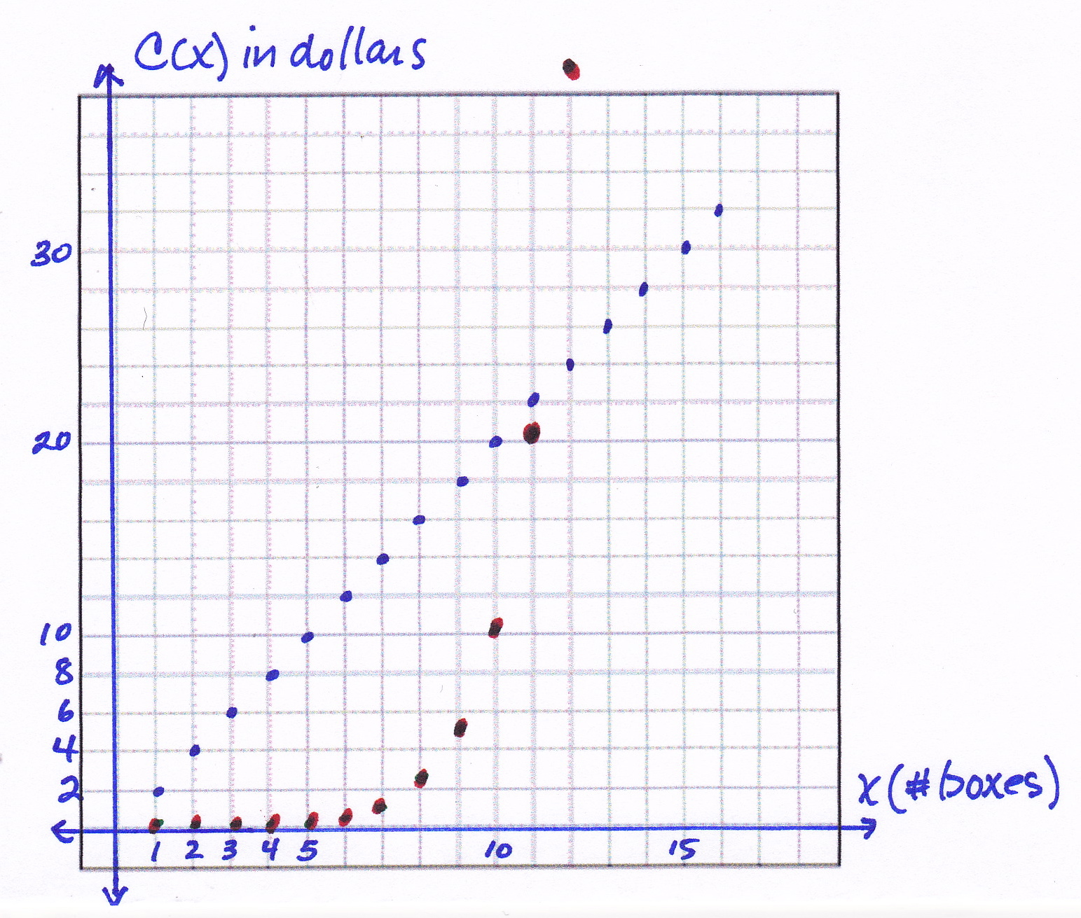

When graphing both functions on the same coordinate plane, it is important to remember to use the same units for both equations and that the graph will be discrete.

1. The table shows the average sale price, ,of a house in New York City, for various years, ,since 1960.

|  |  |  |  |  |  |  |  |
| --- | --- | --- | --- | --- | --- | --- | --- |
| Years since 1960, |  |  |  |  |  |  |  |
| Average sale price (in thousands of dollars), |  |  |  |  |  |  |  |

* 1. What type of function most appropriately represents this set of data? Explain your reasoning.

Quadratic – The first differences are not the same, but the second differences are the same.

* 1. In what year is the price at the lowest? Explain how you know.

The lowest price was when t = 5 or 1965. The lowest price in the data set is $20,000; this is the vertex/minimum.

* 1. Write a function to represent the data. Show your work.

We use the general vertex form: f(t) = a (t – h)2 + k …

f(t) = a (t – 5)2 + 20

Substituting an ordered pair that we know, (0, 45), we get

45 = a(–5)2 + 20

45 = 25a + 20

25 = 25a

a = 1

So, f(t) = (t – 5)2 + 20.

* 1. Can this function ever be equal to zero? Explain why or why not.

No, the lowest price is at the vertex: $20,000.

* 1. Mr. Samuels bought his house in New York City in 1970. If the trend continued, how much was he likely to have paid? Explain and provide mathematical evidence to support your answer.

1970 would be when t = 10. If we substitute 10 into the function equation in part (c), we get f(10) = (5)2 + 20 = 25 + 20 = 45. So, he would have paid $45,000 for his house.

1. Veronica’s physics class is analyzing the speed of a dropped object just before it hits the ground when it is dropped from different heights. They are comparing the final velocity, in feet/second, versus the height, in feet, from which the object was dropped. The class comes up with the following graph.   
   1. Use transformations of the parent function*, ,* to write an algebraic equation that represents this graph. Describe the domain in terms of the context.

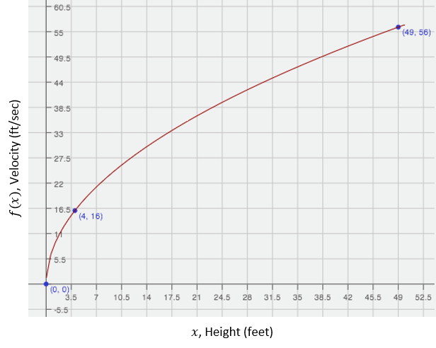

The graph represents a square root function. The parent function of the square root function is f(x) = . From the image of the graph I can tell the graph hasn’t shifted left or right but from the points given it has been stretched. I will use the point (4,16) to find the symbolic representation of the graph and then use the point (49,56) to check that my function is correct. The domain is the set of all real numbers greater than or equal to 0. However, realistically there is a limit to how big the numbers can go since there are limits to the heights from which an object can be dropped.

f(x) = , 🡪 16 = 🡪 16 = 2 🡪 16/2 = 🡪 8 = 🡪 64 = a  
(Note: Starting with f(x) = a , will reach the same end result.)

Check:

f(x) = 🡪 f(x) = 8 🡪 56 = 8, 🡪 56 = 8(7) 🡪 56 = 56 ✓   
f(x) = 8, (x ≥ 0)

* 1. Veronica and her friends are planning to go cliff diving at the end of the school year. If she dives from a position that is above the water, at what velocity will her body be moving right before she enters the water? Show your work and explain the level of precision you chose for your answer.

f(165) = 8, ≈ 102.8 ft/sec or 103 ft/sec. Since the information in the problem is given to the nearest whole number of feet and seconds, I decided to do the same for my answer.

* 1. Veronica’s friend, Patrick, thinks that if she were able to dive from a - position, she would experience a velocity that is twice as fast. Is he correct? Explain why or why not.

He is not correct. Patrick is describing the relationship between the velocity and the height as if it were a linear function, but it is not. The graph that represents the relationship between the two is a square root, which has average rates of change on different intervals that is different from a linear function. I rounded to the nearest whole number because this is a model and only approximates a real-world phenomenon.

f(330) = 8 🡪 = 145.3 or 145 ft/secwhich is not double the 103 ft/sec speed calculated before.

1. Suppose that Peculiar Purples and Outrageous Oranges are two different and unusual types of bacteria. Both types multiply through a mechanism in which each single bacterial cell splits into four. However, they split at different rates: Peculiar Purples split every minutes, while Outrageous Oranges split every minutes.
   1. If the multiplication rate remains constant throughout the hour and we start with three bacterial cells of each, after one hour, how many bacterial cells will there be of each type? Show your work and explain your answer.

Let n = the number of 10-minute or 12-minute time intervals. Then P(n) represents the number of Purples and O(n) represents the number of Oranges at the end of any time period. The tables below show the number of bacterial cells after 1 hour for each:

|  |  |
| --- | --- |
| n | P(n) |
| 0 | 3 |
| 1 (12 min) | 12 |
| 2 (24 min) | 48 |
| 3 (36 min) | 192 |
| 4 (48 min) | 768 |
| **5 (60 min)** | **3072** |

|  |  |
| --- | --- |
| n | O(n) |
| 0 | 3 |
| 1 (10 min) | 12 |
| 2 (20 min) | 48 |
| 3 (30 min) | 192 |
| 4 (50 min) | 768 |
| 5 (50 min) | 3072 |
| **6 (60 min)** | **12,288** |

* 1. If the multiplication rate remains constant for two hours, which type of bacteria is more abundant? What is the difference between the numbers of the two bacterial types after two hours?

Continuing the table from part (a) we find that the Oranges will have one more split in the first hour, so two more after two hours. The Oranges will have 47,185,920 more bacterial cells than the Purples. (At 2 hours, Oranges = 50,331,648 and   
Purples = 3,145,728.)

* 1. Write a function to model the growth of Peculiar Purples and explain what the variable and parameters represent in the context.

P (n) = 3 (4n), where n represents the number of 12-minute splits, 3 is the initial value, and 4 is the number of Purples created for each split.

* 1. Use your model from part (c) to determine how many Peculiar Purples there will be after three splits, i.e., at time minutes.  Do you believe your model has made an accurate prediction?  Why or why not?

P (3) = 3 (43) = 3 (64) = 192. Yes, this matches the values I found in the table for part (a).

* 1. Write an expression to represent a different type of bacterial growth with an unknown initial quantity but in which each cell splits into at each interval of time.

F (n) = a (2n), where *n* represents the number of time interval and a represents the initial number of bacterial cells.

1. In a study of the activities of dolphins, a marine biologist made a slow-motion video of a dolphin swimming and jumping in the ocean with a specially equipped camera that recorded the dolphin’s position with respect to the slow-motion time in seconds. Below is a piecewise quadratic graph, made from the slow-motion dolphin video, which represents a dolphin’s vertical height (in feet, from the surface of the water) while swimming and jumping in the ocean, with respect to the slow-motion time (in seconds). Use the graph to answer the questions. (Note: The numbers in this graph are not necessarily real numbers from an actual dolphin in the ocean.)



* 1. Given the vertex , write a function to represent the piece of the graph where the dolphin is underwater. Identify your variables and define the domain and range for your function.

Using the vertex form for a quadratic function equation: h(t) = a (t – h)2 + k, we know the vertex (h, K) to be (11,-50). Now, to find the leading coefficient, we can substitute a point we know, say (6, 0), and solve for a:

So, h(t) = 2 (t – 11)2 – 50

Domain (interval of time in seconds): [6, 16]

Range (distance from the surface): [0, -50]

* 1. Calculate the average rate of change for the interval from to seconds. Show your work and explain what your answer means in the context of this problem.

Average rate of change:

The dolphin is moving downward at an average rate of 16 feet per second.

* 1. Calculate the average rate of change for the interval from to seconds. Show your work and explain what your answer means in the context of this problem.

Average rate of change:

The dolphin is moving upward at a rate of 16 feet per second.

* 1. Compare your answers for parts (b) and (c). Explain why the rates of change are different in the context of the problem.

The two average rates show that the dolphin’s rate is the same for each interval except that in the first it is moving downward and in the second upward. They are different because of the symmetric nature of the quadratic graph. The intervals chosen are symmetric, so they will have the same y-values.

1. The tables below represent values for two functions, and , one absolute value and one quadratic.
   1. Label each function as either absolute value or quadratic. Then explain mathematically how you identified each type of function.

g(x): quadratic

|  |  |
| --- | --- |
|  |  |
| –3 | 4.5 |
| –2 | 2 |
| –1 | 0.5 |
| 0 | 0 |
| 1 | 0.5 |
| 2 | 2 |
| 3 | 4.5 |

f(x): absolute value

|  |  |
| --- | --- |
|  |  |
| –3 | 1.5 |
| –2 | 1 |
| –1 | 0.5 |
| 0 | 0 |
| 1 | 0.5 |
| 2 | 1 |
| 3 | 1.5 |

In the first table (f(x)) the rates on any interval on the same side of the vertex (0, 0) is   
, and on the other side of the vertex the rates of change are all .

In the second table (g(x)) the rates vary on each side of the vertex: The intervals closest to the vertex have average rates of and , but the next intervals have –1.5 and +1.5, then -2.5 and +2.5, etc.

For this reason the first is absolute value (linear piecewise) and the second is quadratic.

* 1. Represent each function graphically. Identify and label the key features of each in your graph   
     (e.g., vertex, intercepts, axis of symmetry, etc.).

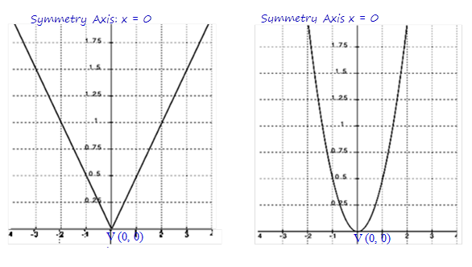

* 1. Represent each function algebraically.

f(x) = │x│ OR

g(x) = a(x – h)2 + k with V(0, 0)

So, g(x) = ax2.

Substituting an ordered pair we know, (2, 2):

2 = a(2)2

a =

So, g(x) = x2,

(Note: Since it is obvious that the quadratic function is not translated, the equation could be found by using y = ax2 in the first step.)