Table of Contents
GRADE 2 • MODULE 5
Addition and Subtraction Within 1,000 with Word Problems to 100

Module Overview i

Topic A: Strategies for Adding and Subtracting Within 1,000 5.A.1

Topic B: Strategies for Composing Tens and Hundreds Within 1,000 5.B.1

Topic C: Strategies for Decomposing Tens and Hundreds Within 1,000 5.C.1

Topic D: Student Explanations for Choice of Solution Methods 5.D.1

Module Assessments 5.S.1

Grade 2 • Module 5
Addition and Subtraction Within 1,000 with Word Problems to 100
OVERVIEW
In Module 4, students developed addition and subtraction fluency within 100 and began developing conceptual understanding of the standard algorithm by means of place value strategies. In Module 5, students build upon their mastery of renaming place value units and extend their work with conceptual understanding of the addition and subtraction algorithms to numbers within 1,000, always with the option
of modeling with materials or drawings. Throughout the module, students continue to focus on strengthening and deepening conceptual understanding and fluency.
Topic A focuses on place value strategies to add and subtract within 1,000 (2.NBT.7). Students relate
100 more and 100 less to addition and subtraction of 100 (2.NBT.8). They add and subtract multiples of 100, including counting on to subtract (e.g., for 650 – 300, they start at 300 and think, “300 more gets me to 600, and 50 more gets me to 650, so… 350”). Students also use simplifying strategies for addition and subtraction: they extend the make a ten strategy to make a hundred, mentally decomposing one addend to make a hundred with the other (e.g., 299 + 6 becomes 299 + 1 + 5, or 300 + 5, which equals 305), and use compensation to subtract from three-digit numbers (e.g., for 376 – 59, add 1 to each, 377 – 60 = 317).
The topic ends with students sharing and critiquing solution strategies for addition and subtraction problems. Throughout the topic, students use place value language and properties of operations to explain why their strategies work (2.NBT.9).
In Topics B and C, students continue to build on Module 4’s work, now composing and decomposing tens and hundreds within 1,000 (2.NBT.7). As each topic begins, students relate manipulative representations to the algorithm, and then transition to creating math drawings in place of the manipulatives. As always, students use place value reasoning and properties of operations to explain their work.
Throughout Module 5, students maintain addition and subtraction fluency within 100 as they use these skills during their daily application work to solve one- and two-step word problems of all types (2.NBT.5, 2.OA.1). The Application Problem precedes fluency activities in most lessons of Module 5 because this work with smaller numbers does not flow directly into the Concept Development. The focus of the Concept Development is adding and subtracting within 1,000: using concrete models or drawings and strategies based on place value, properties of operations, and/or the relationship between addition and subtraction, and relating strategies to a written method (2.NBT.7). Note that a written method can include number bonds, chip models, arrow notation, the algorithm, or tape diagrams. Many students will need to record these strategies to solve correctly. The lessons are designed to provide ample time for discussions that center on student reasoning, explaining why their addition and subtraction strategies work (2.NBT.9). For example, students may use the relationship between addition and subtraction to demonstrate why their subtraction solution is correct.

The module culminates with Topic D, wherein students synthesize their understanding of addition and subtraction strategies and choose which strategy is most efficient for given problems. They defend their choices using place value language and their understanding of the properties of operations (2.NBT.9).
Note that, beginning in Topic C, and for the remainder of the year, each day’s Fluency Practice includes an opportunity for review and mastery of the sums and differences with totals through 20 by means of the Core Fluency Practice Sets or Sprints.
The Mid-Module Assessment follows Topic B. The End-of-Module Assessment follows Topic D.
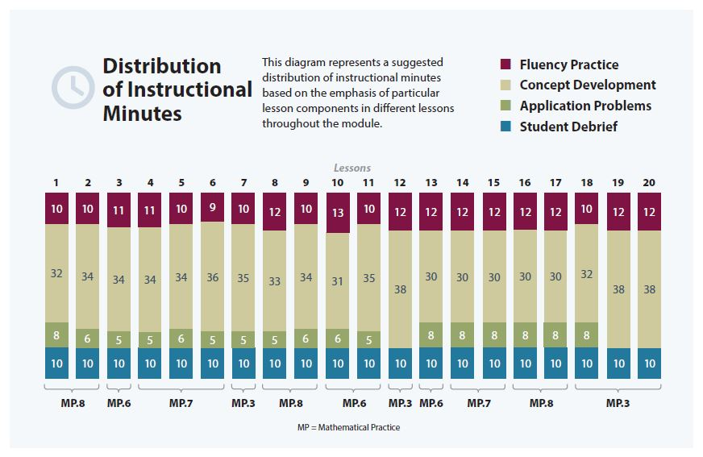

Focus Grade Level Standards
Use place value understanding and properties of operations to add and subtract.
2.NBT.7 Add and subtract within 1000, using concrete models or drawings and strategies based on place value, properties of operations, and/or the relationship between addition and subtraction; relate the strategy to a written method. Understand that in adding or subtracting three-digit numbers, one adds or subtracts hundreds and hundreds, tens and tens, ones and ones; and sometimes it is necessary to compose or decompose tens or hundreds.
2.NBT.8 Mentally add 10 or 100 to a given number 100–900, and mentally subtract 10 or 100 from a given number 100–900.
2.NBT.9 Explain why addition and subtraction strategies work, using place value and the properties of operations. (Explanations may be supported by drawings or objects.)
Foundational Standards
1.OA.3 Apply properties of operations as strategies to add and subtract. Examples: If 8 + 3 = 11 is known, then 3 + 8 = 11 is also known. (Commutative property of addition.) To add 2 + 6 + 4, the second two numbers can be added to make a ten, so 2 + 6 + 4 = 2 + 10 = 12. (Associative property of addition.)
1.OA.4 Understand subtraction as an unknown-addend problem. For example, subtract 10 – 8 by finding the number that makes 10 when added to 8.
1.NBT.5 Given a two-digit number, mentally find 10 more or 10 less than the number, without having to count; explain the reasoning used.
1.NBT.6 Subtract multiples of 10 in the range 10–90 from multiples of 10 in the range 10–90 (positive or zero differences), using concrete models or drawings and strategies based on place value, properties of operations, and/or the relationship between addition and subtraction; relate the strategy to a written method and explain the reasoning used.
2.NBT.1 Understand that the three digits of a three-digit number represent amounts of hundreds, tens, and ones; e.g., 706 equals 7 hundreds, 0 tens, and 6 ones. Understand the following as special cases:
a. 100 can be thought of as a bundle of ten tens—called a “hundred.”
b. The numbers 100, 200, 300, 400, 500, 600, 700, 800, 900 refer to one, two, three, four, five, six, seven, eight, or nine hundreds (and 0 tens and 0 ones).
2.NBT.2 Count within 1000; skip-count by 5s, 10s, and 100s.
2.NBT.3 Read and write numbers to 1000 using base-ten numerals, number names, and expanded form.
2.NBT.5 Fluently add and subtract within 100 using strategies based on place value, properties of operations, and/or the relationship between addition and subtraction.
Focus Standards for Mathematical Practice
MP.3 Construct viable arguments and critique the reasoning of others. Students use place value reasoning to explain how each step in their drawing relates to a step in the algorithm. They choose and explain various solution strategies such as number bonds, chip models, vertical form, arrow notation, and tape diagrams. They critique the reasoning of others when they listen to peers explain their strategies for solving problems, and then discuss the efficacy of those strategies.
MP.6 Attend to precision. Students attend to precision when they use place value language to explain their math drawings and calculations. They articulate the arithmetic properties they use to solve a variety of problems. For example, when adding 825 + 80, a student may show understanding of the associative property by saying, “I know that 20 + 80 equals 100, so I added 800 + 100 + 5, which equals 905.”
MP.7 Look for and make use of structure. Students look for and make use of the base ten structure when composing and decomposing. They extend their understanding from Module 4, viewing 10 tens as forming a new unit called a hundred, just as they understand that 10 ones forms 1 ten. They apply this understanding of base ten structure when adding and subtracting three-digit numbers, repeatedly bundling and unbundling groups of ten. Students also make use of structure when they use simplifying strategies, such as compensation, to create a multiple of ten or a hundred.
MP.8 Look for and express regularity in repeated reasoning. As students repeatedly manipulate models and record the work abstractly, they recognize the cyclic pattern of the addition or subtraction of like units and the subsequent potential composition or decomposition of units through the place values. They see that the vertical form represents the same cycle they use with the manipulatives.
Overview of Module Topics and Lesson Objectives
Standards | Topics and Objectives |  | Days
2.NBT.7  2.NBT.8  2.NBT.9 | A | Strategies for Adding and Subtracting Within 1,000  Lesson 1: Relate 10 more, 10 less, 100 more, and 100 less to addition and subtraction of 10 and 100.  Lesson 2: Add and subtract multiples of 100, including counting on to subtract.  Lesson 3: Add multiples of 100 and some tens within 1,000.  Lesson 4: Subtract multiples of 100 and some tens within 1,000.  Lesson 5: Use the associative property to make a hundred in one addend.  Lesson 6: Use the associative property to subtract from three-digit numbers and verify solutions with addition.  Lesson 7: Share and critique solution strategies for varied addition and subtraction problems within 1,000. | 7
2.NBT.7  2.NBT.9 | B | Strategies for Composing Tens and Hundreds Within 1,000  Lessons 8–9: Relate manipulative representations to the addition algorithm.  Lessons 10–11: Use math drawings to represent additions with up to two compositions and relate drawings to the addition algorithm.  Lesson 12: Choose and explain solution strategies and record with a written addition method. | 5
 |  | Mid-Module Assessment: Topics A–B (assessment 1/2 day, return 1/2 day, remediation or further applications 1 day) | 2
2.NBT.7  2.NBT.9 | C | Strategies for Decomposing Tens and Hundreds Within 1,000  Lesson 13: Relate manipulative representations to the subtraction algorithm, and use addition to explain why the subtraction method works.  Lessons 14–15: Use math drawings to represent subtraction with up to two decompositions, relate drawings to the algorithm, and use addition to explain why the subtraction method works.  Lessons 16–17: Subtract from multiples of 100 and from numbers with zero in the tens place.  Lesson 18: Apply and explain alternate methods for subtracting from multiples of 100 and from numbers with zero in the tens place. | 6
2.NBT.7  2.NBT.8  2.NBT.9 | D | Student Explanations for Choice of Solution Methods  Lessons 19–20: Choose and explain solution strategies and record with a written addition or subtraction method. | 2
 |  | End-of-Module Assessment: Topics A–D (assessment 1/2 day, return 1/2 day, remediation or further applications 1 day) | 2
Total Number of Instructional Days |  |  | 24
Terminology
New or Recently Introduced Terms
- Compensation (simplifying strategy where students add or subtract the same amount to or from both numbers to create an equivalent, but simpler, problem)
Familiar Terms and Symbols
- Addend
- Addition
- Algorithm
- Bundle
- Compose
- Decompose
- Difference
- Equation
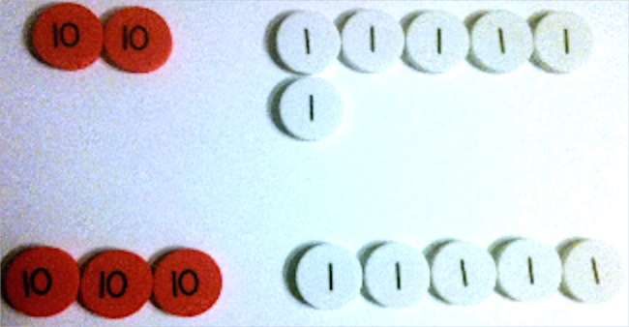
- New groups below
Place Value Disks
- Number bond
- Place value
- Place value chart (pictured to the right)
- Place value or number disk (pictured to the right)
Place Value Chart Without Headings
(use with place value disks)
- Rename
- Simplifying strategy
- Subtraction
- Tape diagram
- Total
Place Value Chart with Headings
(use with numbers and chips)
hundreds tens ones
2
7
6
- Unbundle
- Units of ones, tens, hundreds
Suggested Tools and Representations
- Arrow notation, arrow way
- Chip model (pictured below)
- Hide Zero cards
- Number bond
- Personal white boards
- Place value charts (pictured above to the right)
- Place value disk sets (19 ones, 19 tens, 10 hundreds, 1 one thousand per set)
- Tape diagram
Note: Students work through a progression of models to represent the addition and subtraction algorithm. Following the use of actual place value disks, students learn to draw the disks to represent numbers. This model provides an added level of support in that students write the value on each disk (pictured below to the left). Because the value is on the disk, there is no need to label the place value chart. Next, students learn the chip model, drawing dots on a labeled place value chart (pictured below to the right). While still pictorial, this model is more abstract because the value of the chip derives from its placement on the chart.
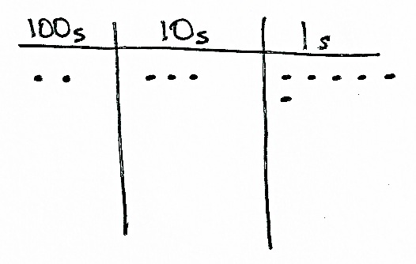
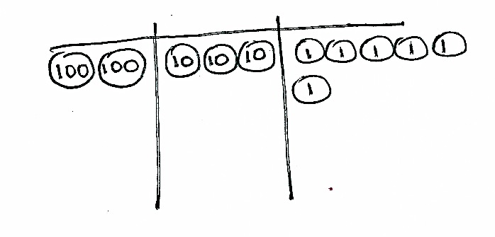

Chip Model
Place Value Disk Drawing

Scaffolds
The scaffolds integrated into A Story of Units give alternatives for how students access information as well as express and demonstrate their learning. Strategically placed margin notes are provided within each lesson elaborating on the use of specific scaffolds at applicable times. They address many needs presented by English language learners, students with disabilities, students performing above grade level, and students performing below grade level. Many of the suggestions are organized by Universal Design for Learning (UDL) principles and are applicable to more than one population. To read more about the approach to differentiated instruction in A Story of Units, please refer to “How to Implement A Story of Units.”
Assessment Summary
Type | Administered | Format | Standards Addressed
Mid-Module Assessment Task | After Topic B | Constructed response with rubric | 2.NBT.7  2.NBT.8  2.NBT.9
End-of-Module Assessment Task | After Topic D | Constructed response with rubric | 2.NBT.7  2.NBT.8  2.NBT.9

The balance of this cluster is addressed in Modules 1 and 4.
These are terms and symbols students have seen previously.
Students with disabilities may require Braille, large print, audio, or special digital files. Please visit the website www.p12.nysed.gov/specialed/aim for specific information on how to obtain student materials that satisfy the National Instructional Materials Accessibility Standard (NIMAS) format.

