Name Date
- Color the shapes using the key. Write how many of each shape there are on the line.
a. YELLOW Circles: ______
b. RED Rectangles: ______
c. BLUE Triangles: ______
d. GREEN Trapezoids: ______
e. BLACK Hexagons: ______
f. ORANGE Rhombuses: ______

- Is the shape a triangle?
______________________

______________________

If it is, write YES on the line. If it is not, explain why it is not a triangle on the line.
______________________

______________________

a. b.

______________________

______________________

c. d.
______________________

______________________

- a. Circle the attributes that are used to describe all cylinders.
Cylinders can roll. | Cylinders are hollow.
Cylinders are made of paper. | Cylinders have 2 flat surfaces made of circles or ovals.

- Circle the attributes that are used to describe all rectangular prisms.
Rectangular prisms can roll. | The faces of a rectangular prism are rectangles.
Rectangular prisms have 6 faces. | Rectangular prisms are made of wood.

4. Use your triangle pattern blocks to cover the shapes below. Draw lines to show how you formed the shape with your triangles.
a. | b.
c. | d.

- Here are the pieces that Dana is putting together to create a shape.

Which of the following shows what Dana’s shape might look like when she combines her smaller shapes?

- Match the time to the correct clock.
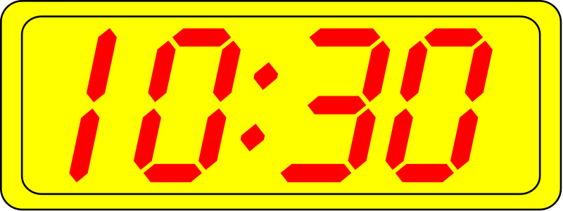
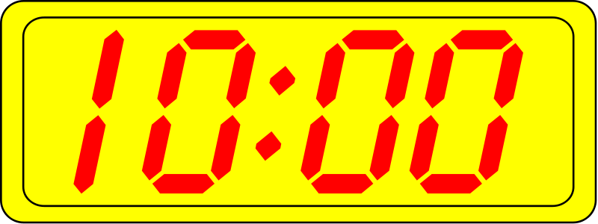
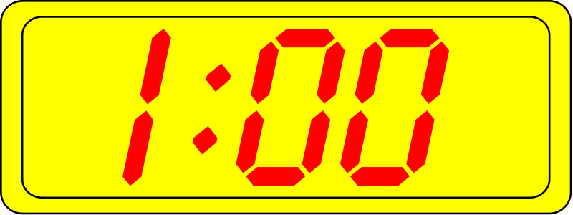
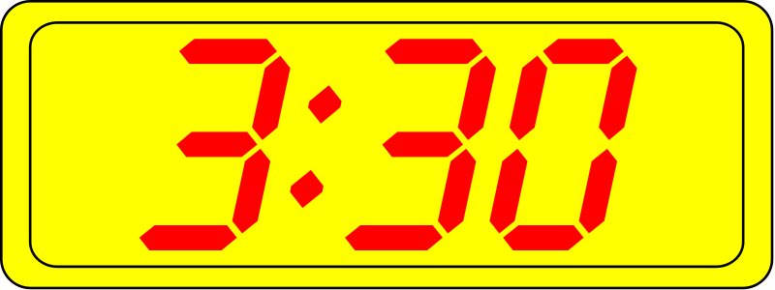
- ten o’clock

- ten thirty

- one o’clock

- three thirty

- Write the time on the line.
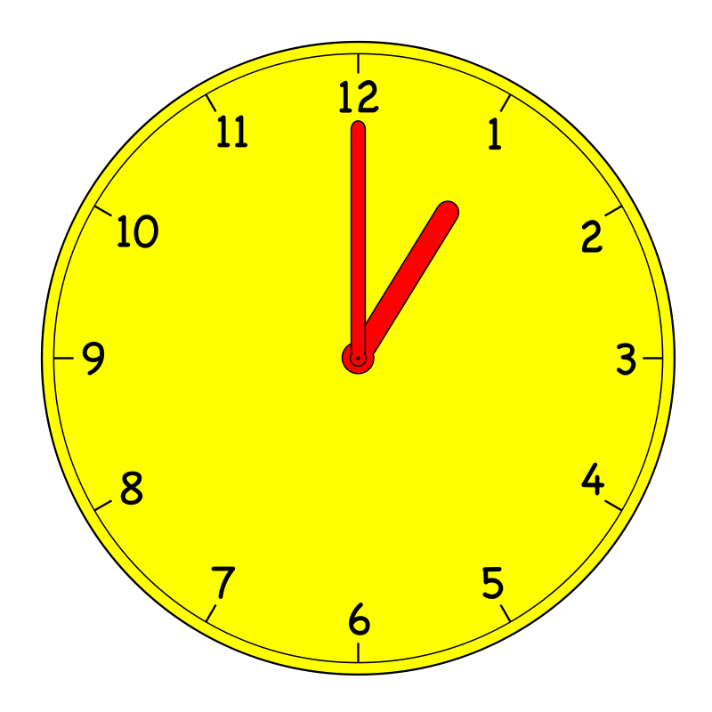
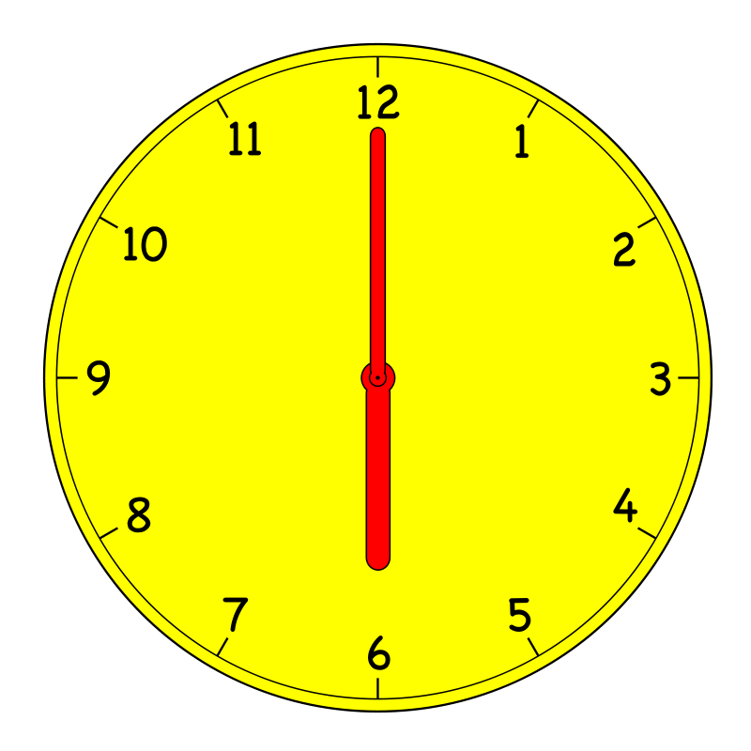
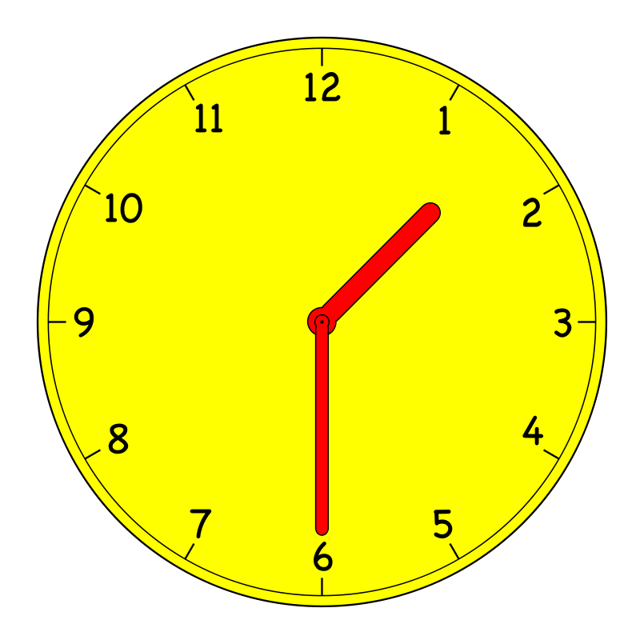
a. __________________
b. __________________
c. __________________

- Circle the clock that shows half past 5 o’clock.
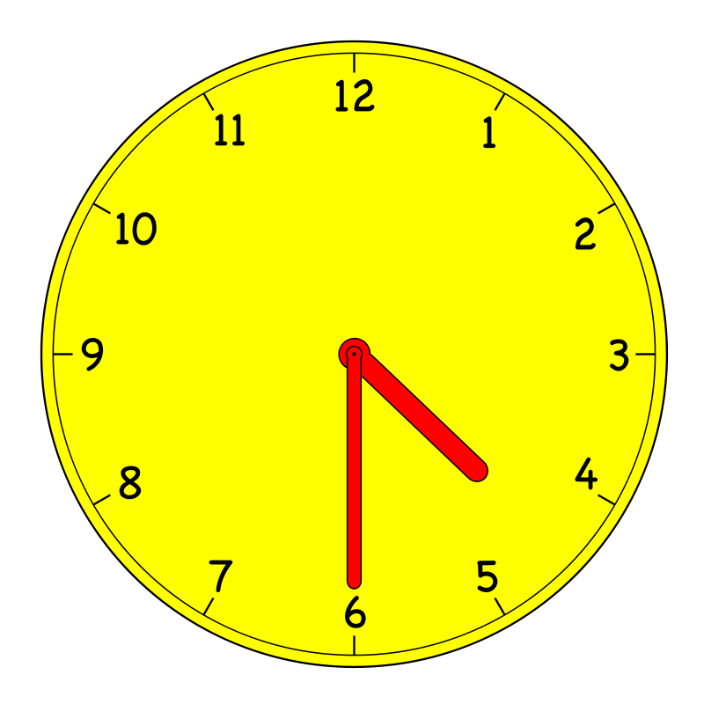
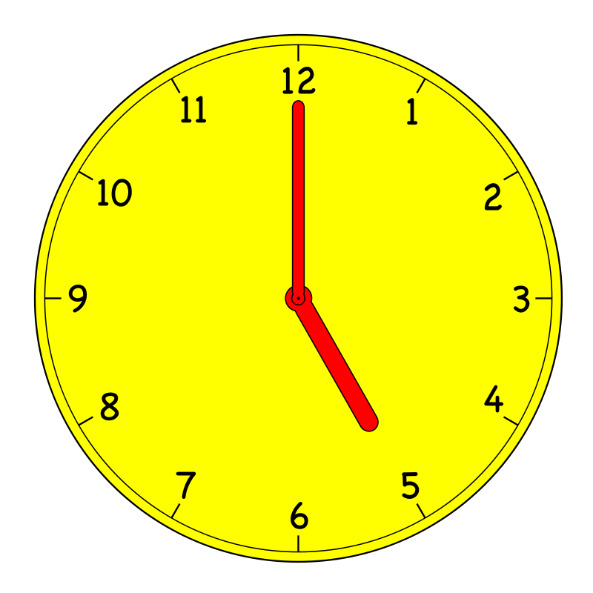
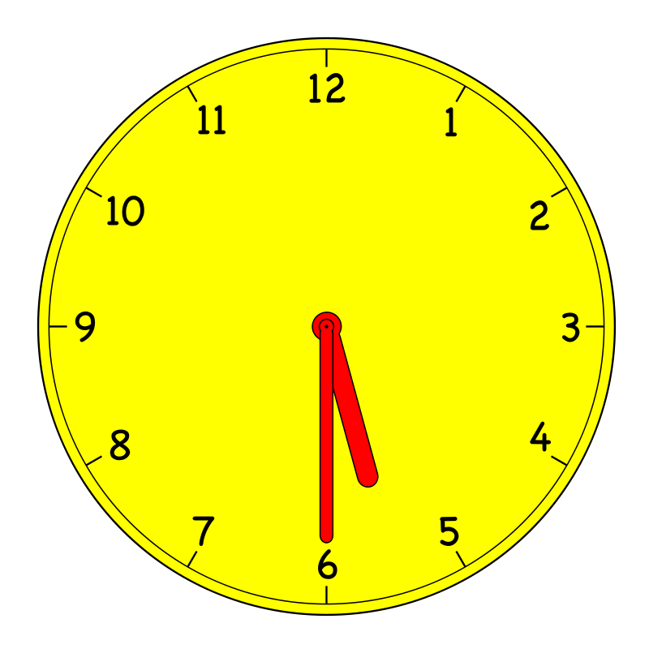

- Draw the minute hand so that the clock shows the time written above it.
b. 5:00
a. 4:30

- Draw one line to make this rectangle into two squares that are the same size.

- Circle the words that make the sentence true.
One square makes up (one half / one quarter) of the rectangle above.

- Color one half of the rectangle. What shapes were used to make the rectangle?

______________________________

- Color one fourth of the rectangle. What shapes were used to make the rectangle?
______________________________
- Color one fourth of the circle. The dot is in the center.
End-of-Module Assessment Task Topics A–D
Standards Addressed
Tell and write time and money.
1.MD.3 Tell and write time in hours and half-hours using analog and digital clocks. Recognize and identify coins, their names, and their values.
Reason with shapes and their attributes.
1.G.1 Distinguish between defining attributes (e.g., triangles are closed and three-sided) versus non-defining attributes (e.g., color, orientation, overall size); build and draw shapes to possess defining attributes.
1.G.2 Compose two-dimensional shapes (rectangles, squares, trapezoids, triangles, half-circles, and quarter-circles) or three-dimensional shapes (cubes, right rectangular prisms, right circular cones, and right circular cylinders) to create a composite shape, and compose new shapes from the composite shape. (Students do not need to learn formal names such as “right rectangular prism.”)
1.G.3 Partition circles and rectangles into two and four equal shares, describe the shares using the words halves, fourths, and quarters, and use the phrases half of, fourth of, and quarter of. Describe the whole as two of, or four of the shares. Understand for these examples that decomposing into more equal shares creates smaller shares.
Evaluating Student Learning Outcomes
A Progression Toward Mastery is provided to describe steps that illuminate the gradually increasing understandings that students develop on their way to proficiency. In this chart, this progress is presented from left (Step 1) to right (Step 4). The learning goal for students is to achieve Step 4 mastery. These steps are meant to help teachers and students identify and celebrate what the students CAN do now and what they need to work on next.

A Progression Toward Mastery
Assessment  Task Item  and  Standards Assessed | STEP 1  Little evidence of reasoning without a correct answer.  (1 Point) | STEP 2  Evidence of some reasoning without a correct answer.  (2 Points) | STEP 3  Evidence of some reasoning with a correct answer or evidence of solid reasoning with an incorrect answer.  (3 Points) | STEP 4  Evidence of solid reasoning with a correct answer.  (4 Points)
1  1.G.1 | The student identifies the correct number for fewer than four of the six shapes. | The student identifies the correct number for at least four of the six shapes. | The student identifies the correct number for five of the six shapes. | The student correctly colors and provides the following counts:  - Circles: 2  - Rectangles: 3  - Triangles: 2  - Trapezoids: 2  - Hexagons: 1  - Rhombuses: 1* (*Some students may include square as well.)
2  1.G.1 | The student does not identify (a) and (d) as triangles. | The student correctly identifies (a) and (d) as triangles but does not clearly explain why both of the other two shapes are not triangles. | The student correctly identifies (a) and (d) as triangles but only explains why one of the other two shapes is not a triangle. | The student correctly writes:  - Yes.  - It has more than three sides.  - It is not closed. Or, it has less than three sides.  - Yes.
3  1.G.1 | The student circles three or more incorrect sentences. Or, the student circles fewer than two correct answers. | The student correctly circles at least two of the four correct answers and may circle one or two incorrect sentences. | The student circles at least three of the four correct answers and only circles one incorrect sentence. | The student correctly circles the following choices:  - Cylinders can roll. Cylinders have two flat surfaces made of circles or ovals.  - Rectangular prisms have 6 faces. The faces of a rectangular prism are rectangles.
4  1.G.2 | The student is unable to demonstrate understanding of accurately composing the given shape using triangles and did not choose the middle image for Part (e). | The student correctly draws partitions for one or two parts. The student may have chosen the middle image for Part (e). | The student is able to correctly draw partitions for at least three parts and chooses the middle image for Part (e). | The student draws lines to show:  - 2 triangles  - 4 triangles  - 6 triangles  - 3 triangles  The student chooses the middle image.
5  1.MD.3 | The student is unable to demonstrate understanding of telling time from a digital clock and is unable to match any of the times. | The student demonstrates limited understanding of telling time from a digital clock, matching one time correctly. | The student demonstrates understanding of telling either the hour or the minutes from a digital clock, matching two or three times correctly. | The student correctly matches:  - 10:00  - 10:30  - 1:00  - 3:30
6  1.MD.3 | The student is unable to demonstrate understanding of telling time from an analog clock, answering none or one part correctly. | The student demonstrates understanding of telling time to the hour from an analog clock, answering one or two parts correctly. | The student demonstrates understanding of telling time to the hour from an analog clock and some ability to tell time to the half hour, answering three parts correctly OR correctly stating the numerals for all times but missing o’clock in (a) and (b). | The student correctly writes:  - One o’clock  - Six o’clock  - One thirty  - Choice 3  (Spelling is not being assessed. Students may write the time using digital notation, as shown in the sample, or as written above.)
7  1.MD.3  1.G.1  1.G.2  1.G.3 | The student answers none to two of the seven parts correctly. | The student is able to complete at least three of the seven parts correctly. | The student is able to complete at least five of the seven parts correctly, OR has up to three slight errors in approximating halves or fourths when coloring. | The student correctly:  - Draws a minute hand pointing to 6.  - Draws a minute hand pointing to 12.  - Draws a line to create two squares.  - Circles one half.  - Colors a triangle and writes triangle.  - Colors one rectangle and writes rectangle (or rectangles and squares).  - Colors one fourth of the circle.

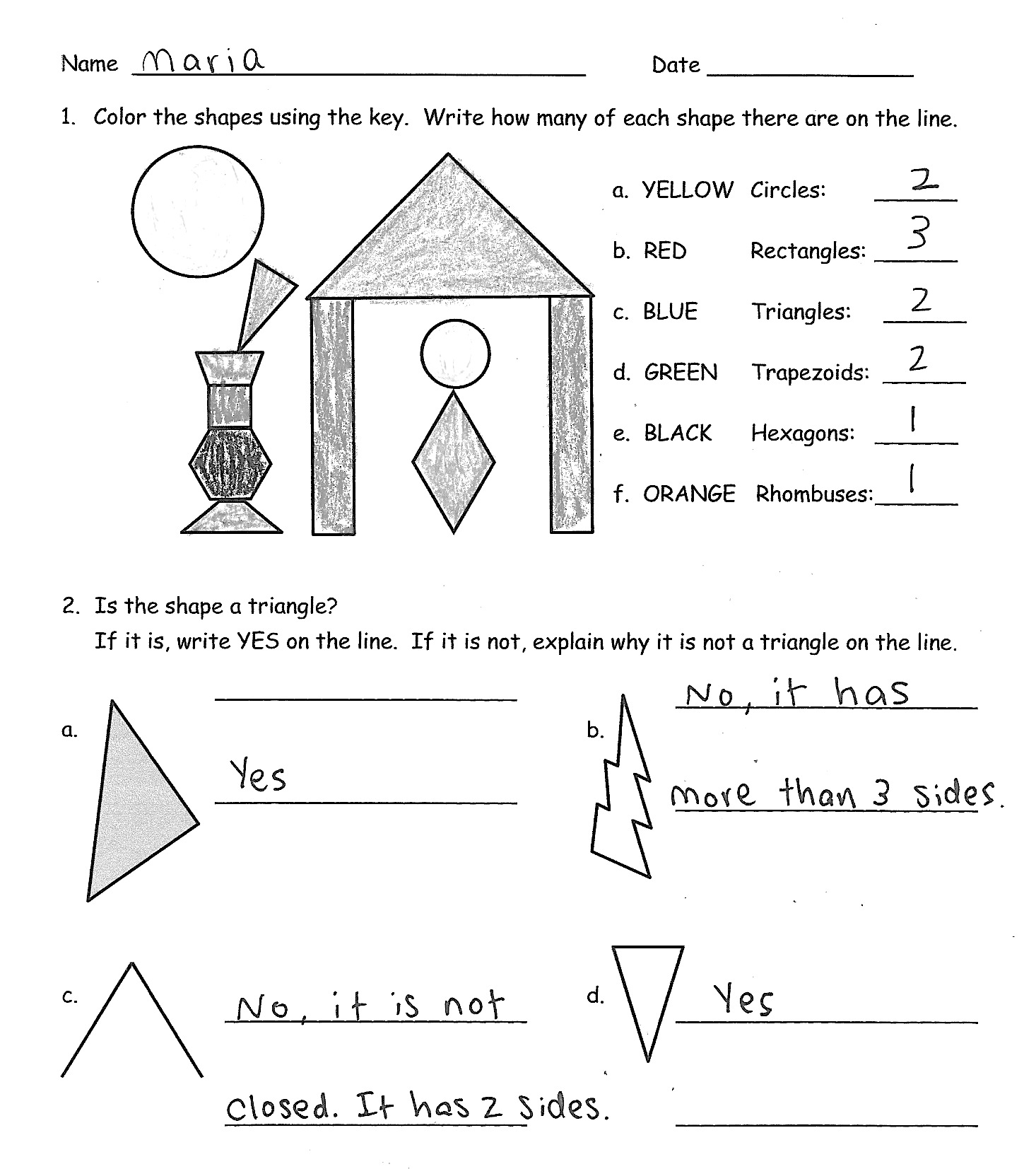
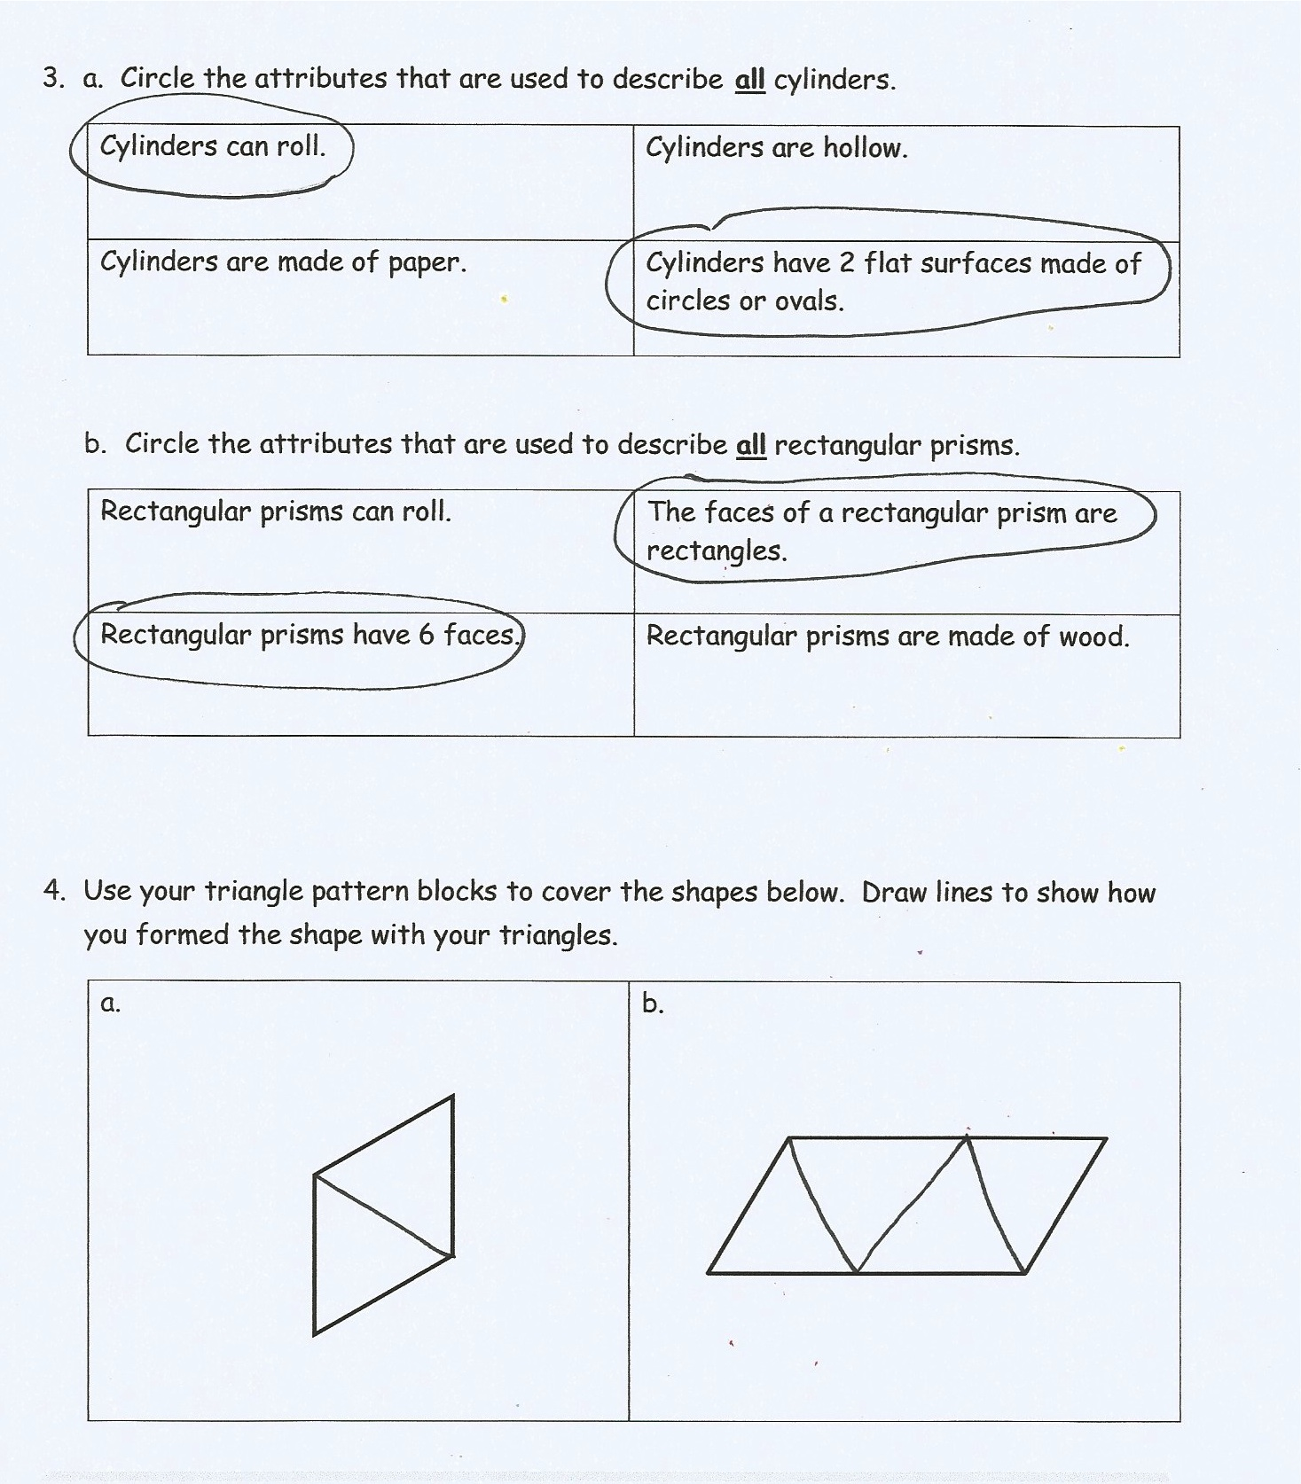
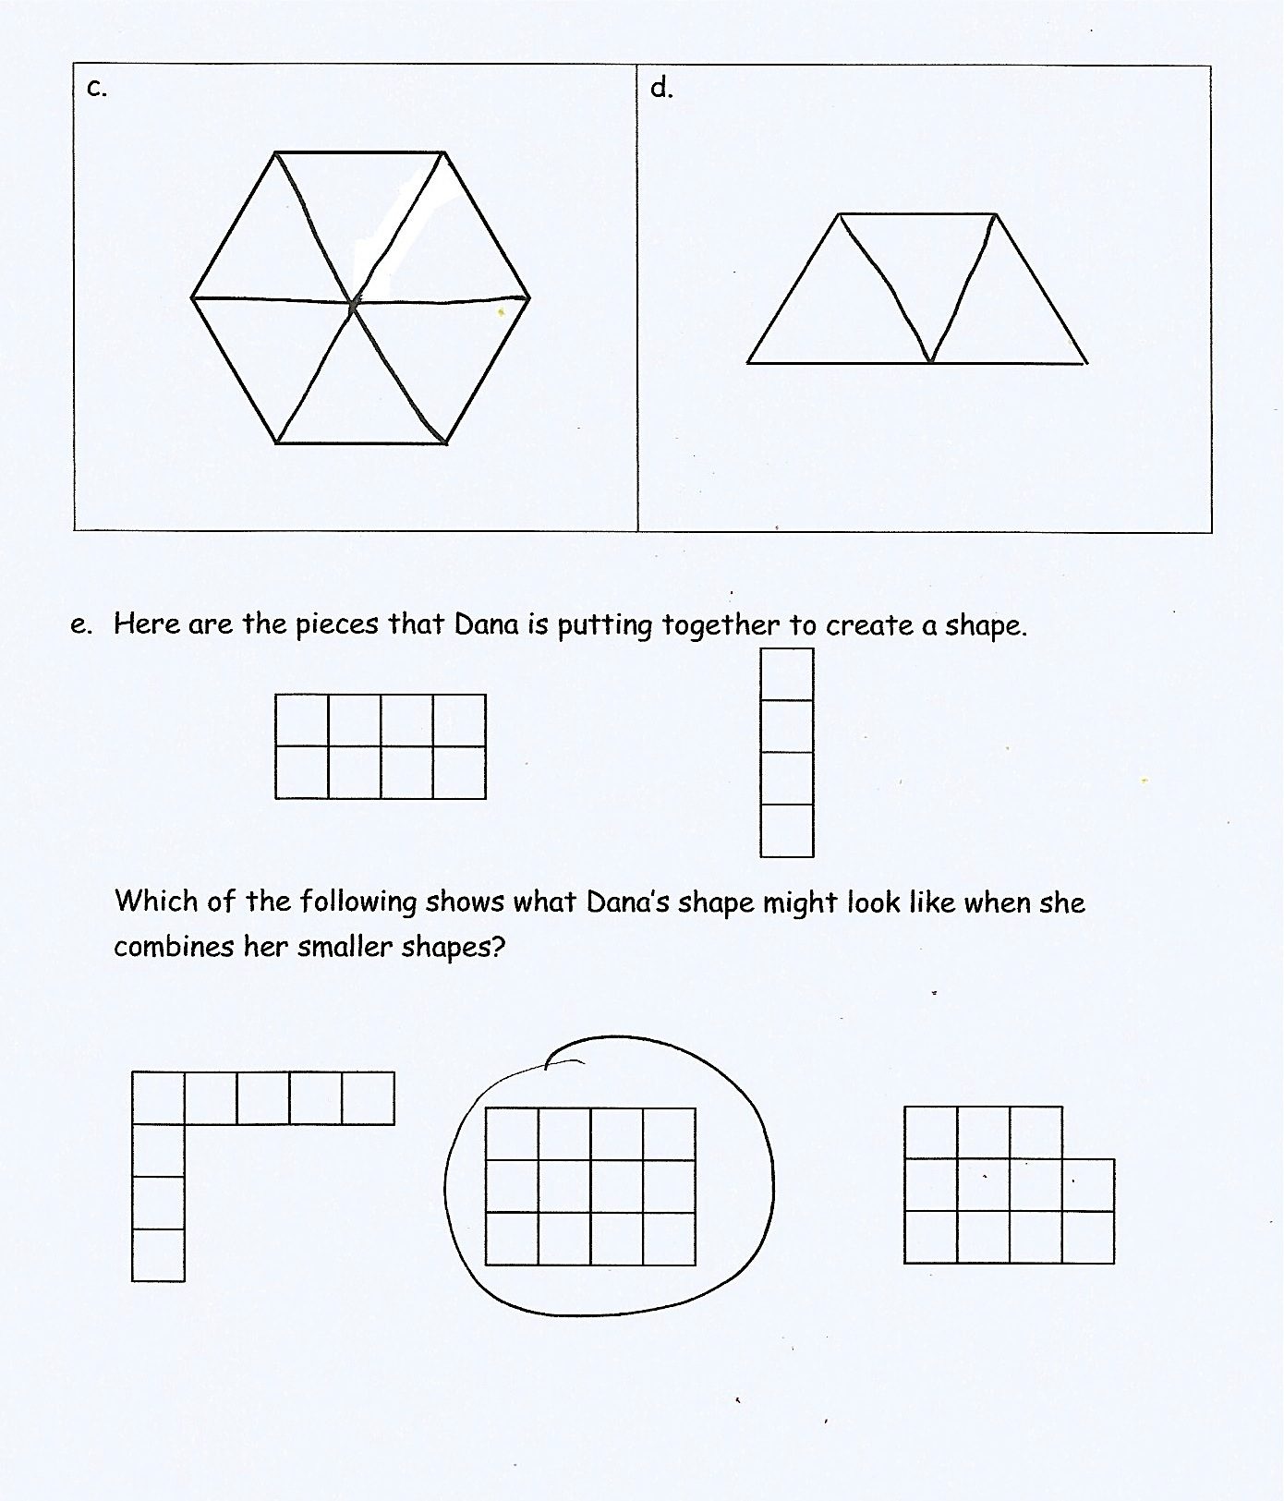
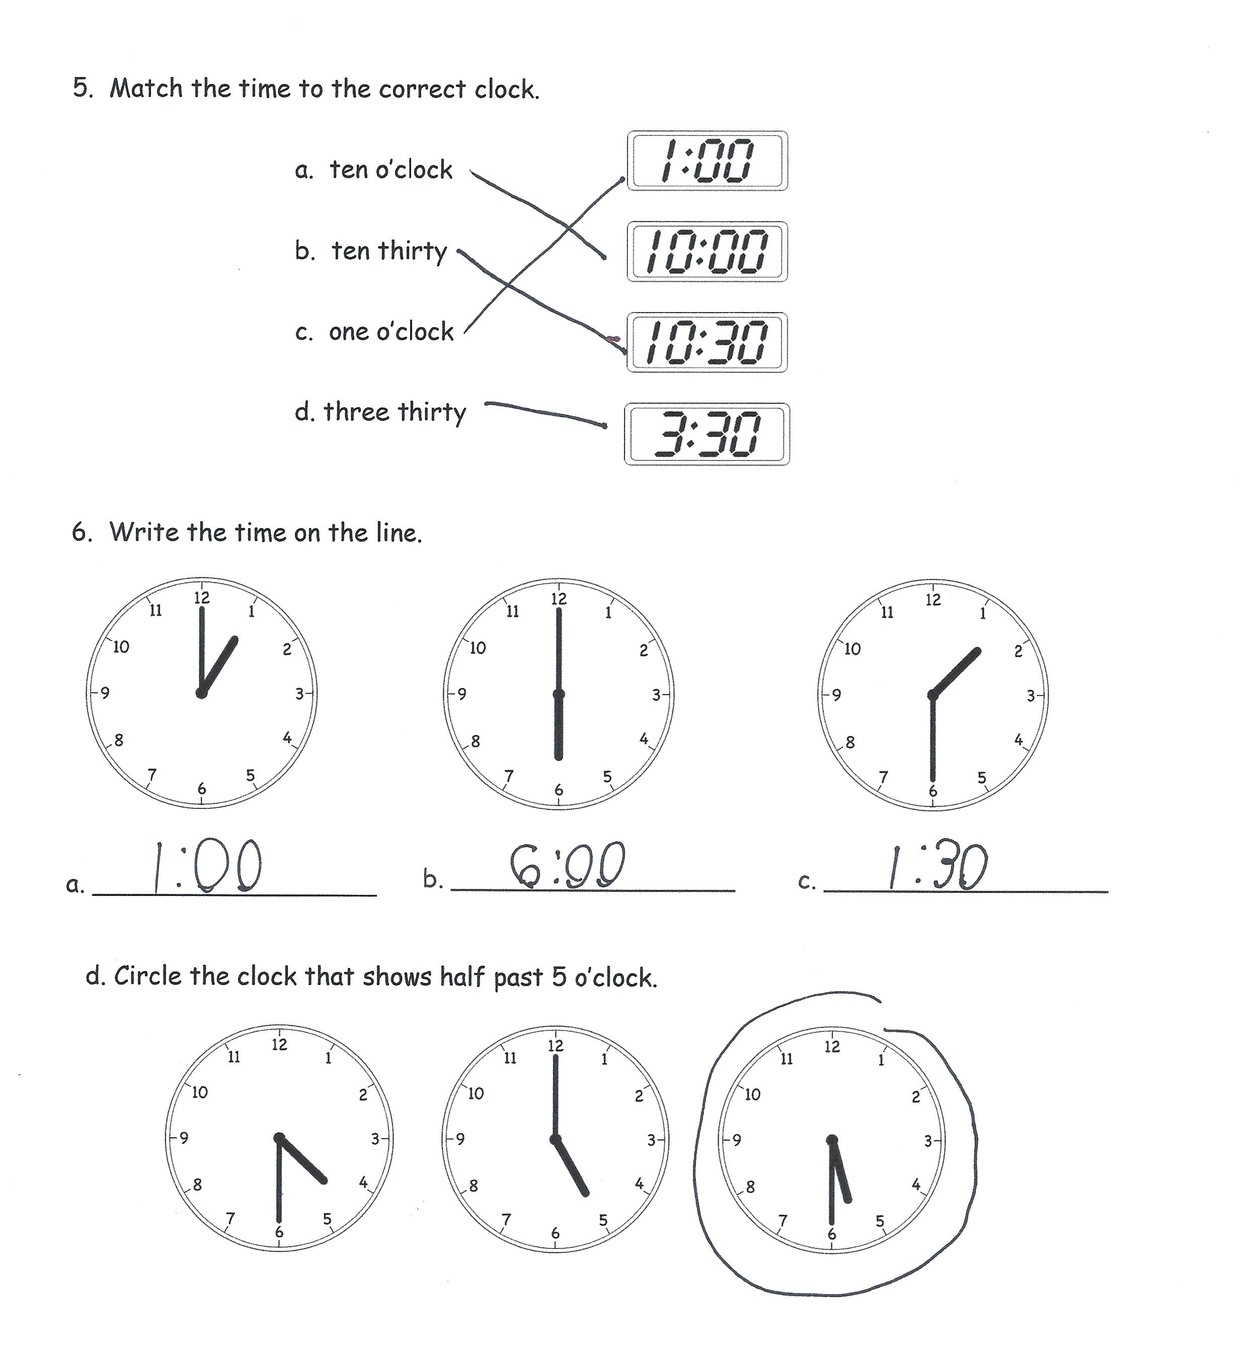
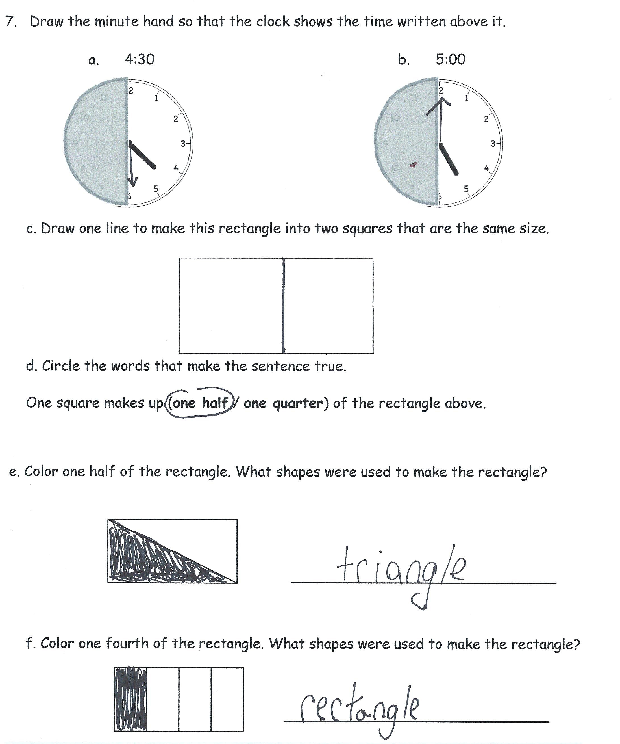
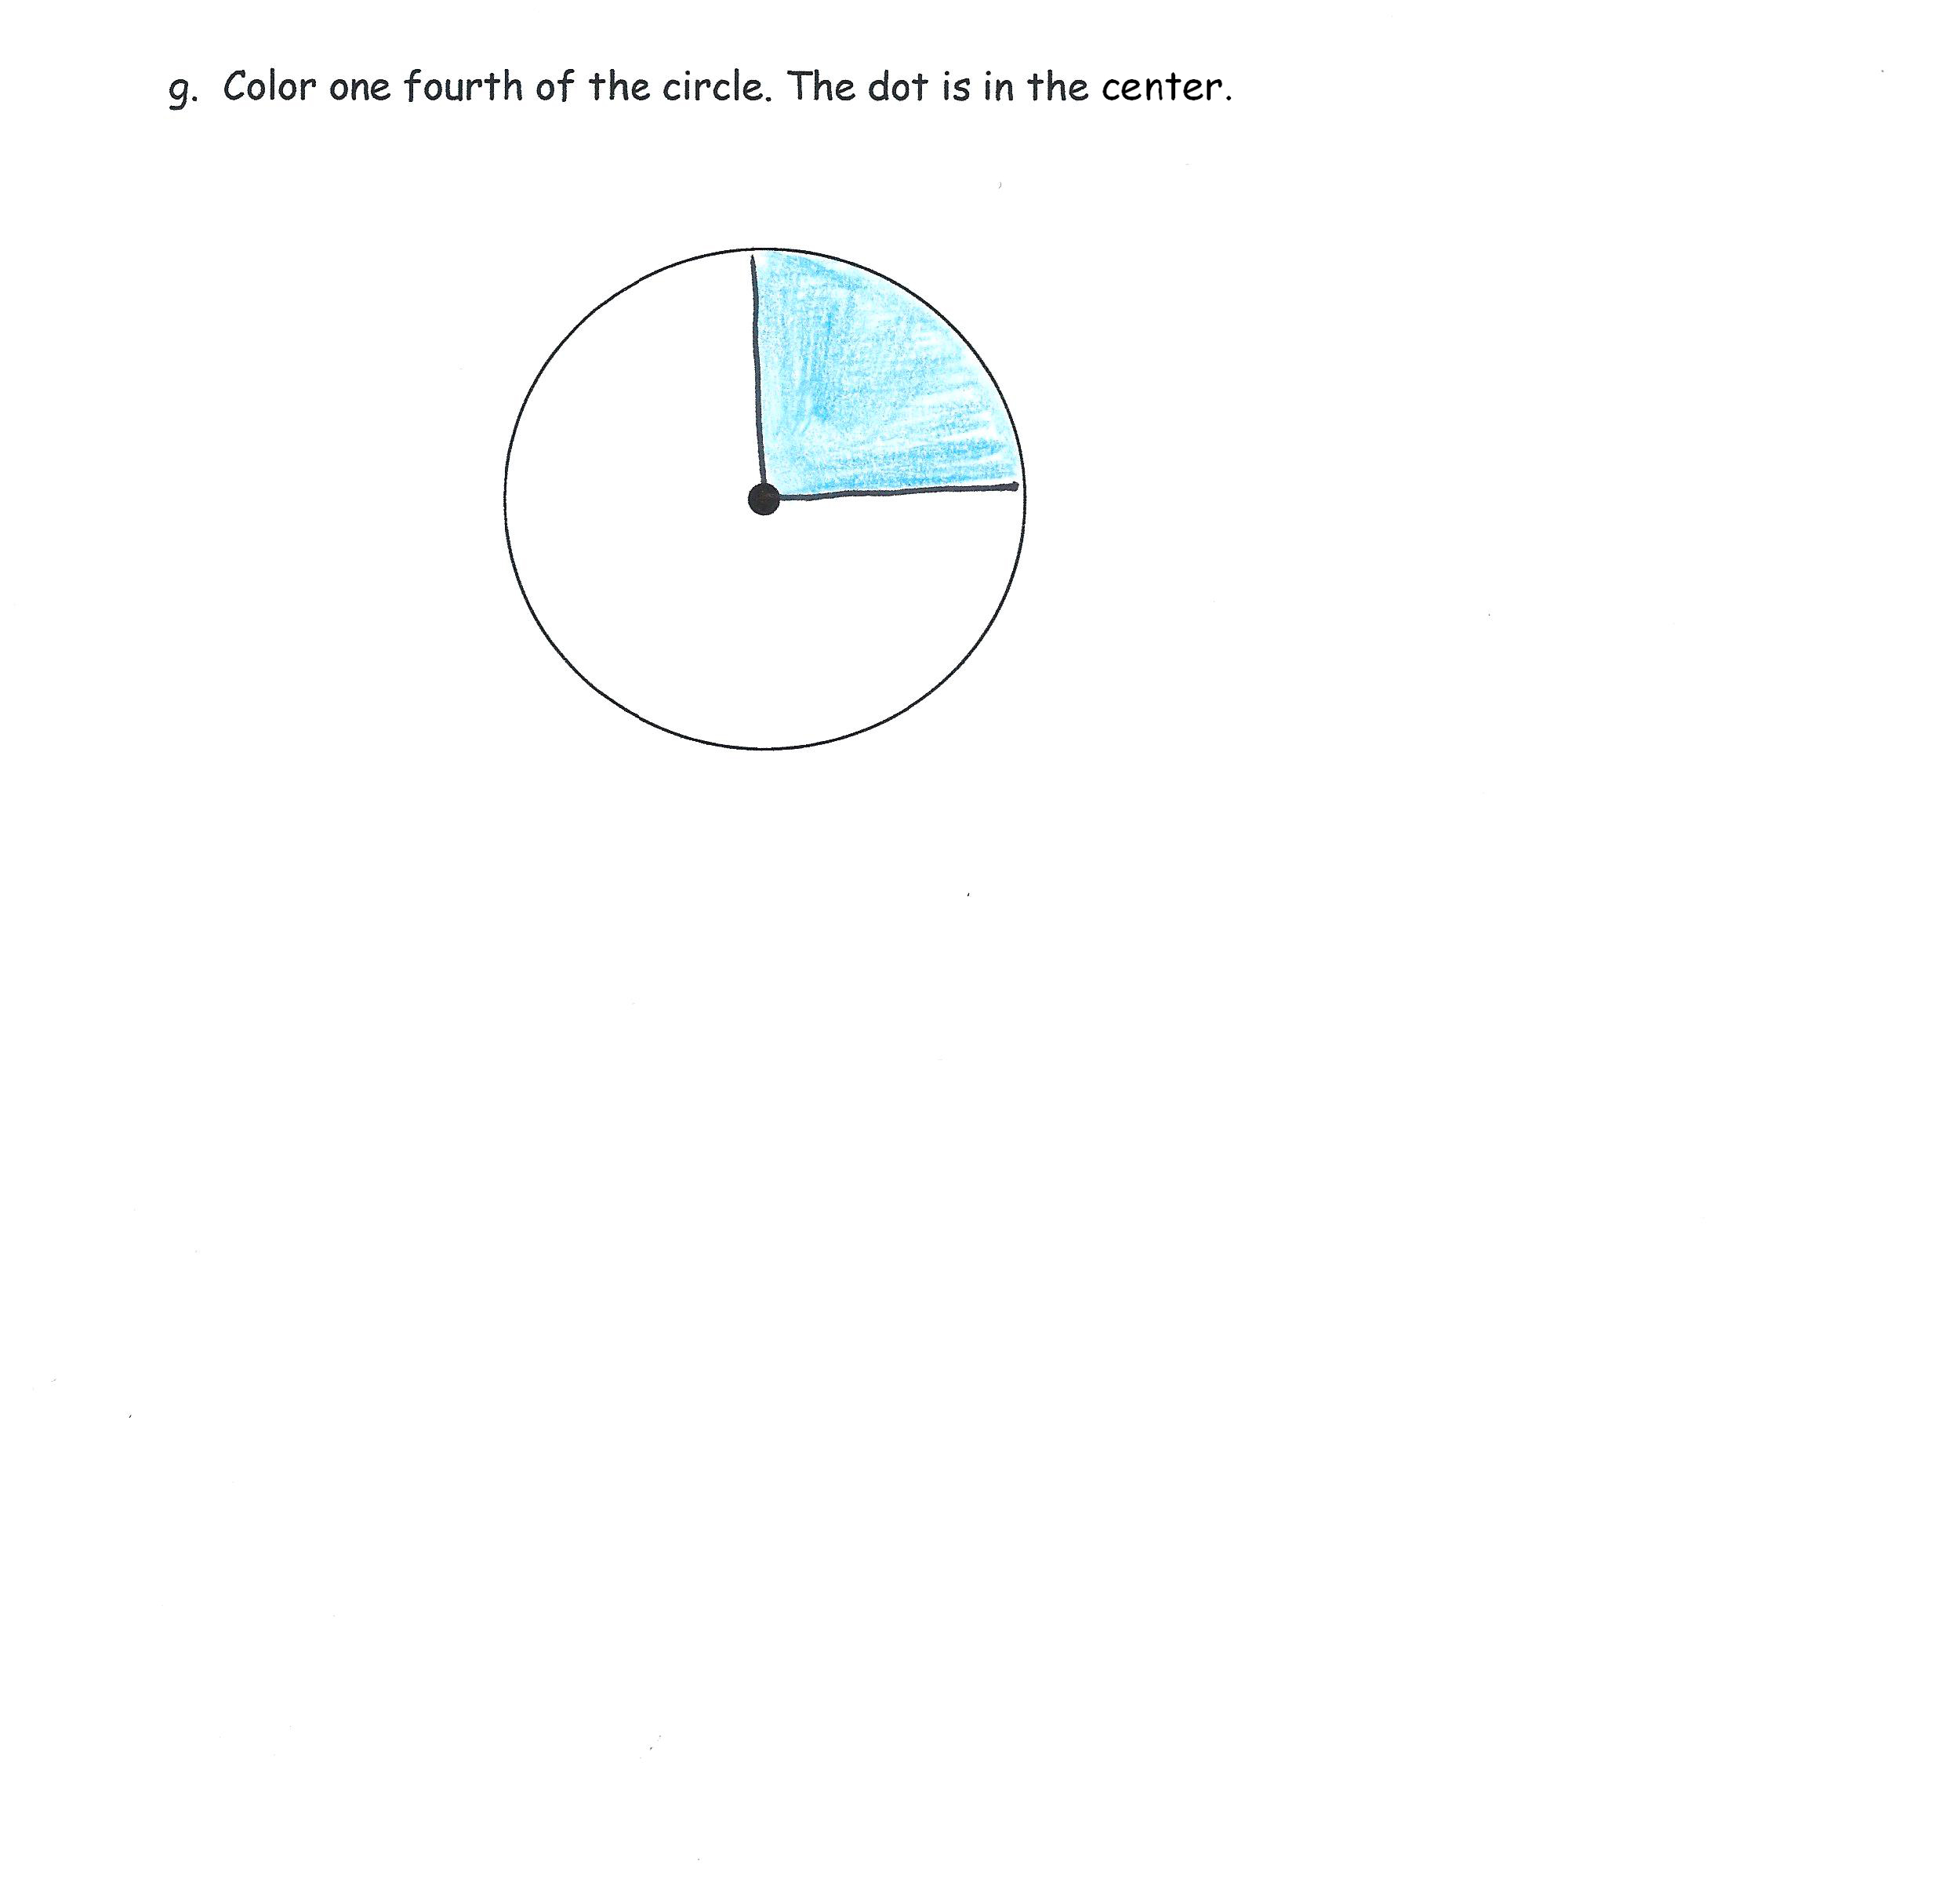

Time alone is addressed in this module. Money is addressed in Module 6.

