Table of Contents
GRADE 3 • MODULE 4
Multiplication and Area

Module Overview i

Topic A: Foundations for Understanding Area 4.A.1

Topic B: Concepts of Area Measurement 4.B.1

Topic C: Arithmetic Properties Using Area Models 4.C.1

Topic D: Applications of Area Using Side Lengths of Figures 4.D.1

Module Assessments 4.S.1

NOTE: Student sheets should be printed at 100% scale to preserve the intended size of figures for accurate measurements. Adjust copier or printer settings to actual size and set page scaling to none.

Grade 3 • Module 4
Multiplication and Area

OVERVIEW
In this 20-day module, students explore area as an attribute of two-dimensional figures and relate it to their prior understandings of multiplication. In Grade 2, students partitioned a rectangle into rows and columns of same-sized squares and found the total number by both counting and adding equal addends represented by the rows or columns (2.G.2, 2.OA.4).
2 by 6
3 by 4
4 by 3
In Topic A, students begin to conceptualize area as the amount of two-dimensional surface that is contained within a plane figure. They come to understand that the space can be tiled with unit squares without gaps or overlaps (3.MD.5). Students decompose paper strips into square inches and square centimeters, which they use to tile 3 by 4, 4 by 3, and 2 by 6 rectangles. They compare rectangles tiled with like units and notice different side lengths but equal areas. Topic A provides students’ first experience with tiling from which they learn to distinguish between length and area by placing a ruler with the same size units (inches or centimeters) next to a tiled array. They discover that the number of tiles along a side corresponds to the length of the side (3.MD.6).
In Topic B, students progress from using square tile manipulatives to drawing their own area models. Anticipating the final structure of an array, they complete rows and columns in figures such as the example shown to the right. Students connect their extensive work with rectangular arrays and multiplication to eventually discover the area formula for a rectangle, which is formally introduced in Grade 4 (3.MD.7a).
In Topic C, students manipulate rectangular arrays to concretely demonstrate the arithmetic properties in anticipation of the lessons that follow. They do this by cutting rectangular grids and rearranging the parts into new wholes using the properties to validate that area stays the same, despite the new dimensions. They apply tiling and multiplication skills to determine all whole number possibilities for the side lengths of rectangles given their areas (3.MD.7b).
2 cm
5 cm
2 cm
8 cm
Topic D creates an opportunity for students to solve problems involving area (3.MD.7b). Students decompose or compose composite regions, such as the one shown to the right—into non-overlapping rectangles, find the area of each region, and then add or subtract to determine the total area of the original shape. This leads students to find the areas of rooms in a given floor plan (3.MD.7d).
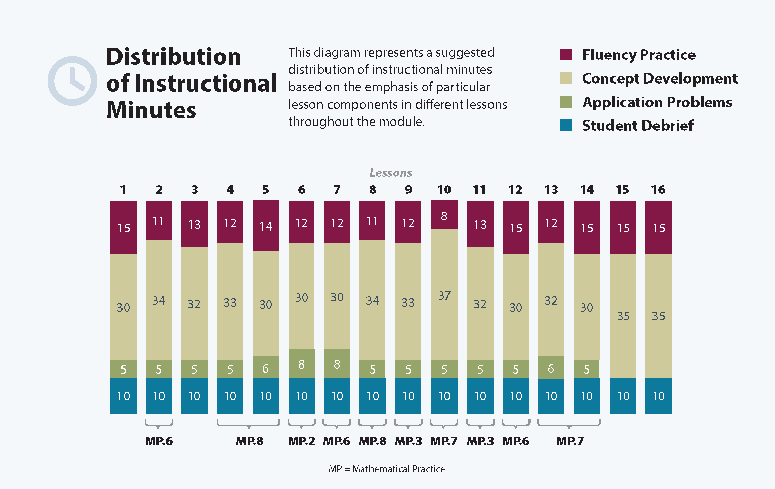

Focus Grade Level Standards
Geometric measurement: understand concepts of area and relate area to multiplication and to addition.
3.MD.5 Recognize area as an attribute of plane figures and understand concepts of area measurement:
a. A square with side length 1 unit, called “a unit square,” is said to have “one square unit” of area, and can be used to measure area.
b. A plane figure which can be covered without gaps or overlaps by n unit squares is said to have an area of n square units.
3.MD.6 Measure areas by counting unit squares (square cm, square m, square in, square ft, and improvised units).
3.MD.7 Relate area to the operations of multiplication and addition.
a. Find the area of a rectangle with whole-number side lengths by tiling it, and show that the area is the same as would be found by multiplying the side lengths.
b. Multiply side lengths to find areas of rectangles with whole-number side lengths in the context of solving real world and mathematical problems, and represent whole-number products as rectangular areas in mathematical reasoning.
c. Use tiling to show in a concrete case that the area of a rectangle with whole-number side lengths a and b + c is the sum of a × b and a × c. Use area models to represent the distributive property in mathematical reasoning.
d. Recognize area as additive. Find the areas of rectilinear figures by decomposing them into non-overlapping rectangles and adding the areas of the non-overlapping parts, applying this technique to solve real world problems.
Foundational Standards
2.MD.1 Measure the length of an object by selecting and using appropriate tools such as rulers, yardsticks, meter sticks, and measuring tapes.
2.MD.2 Measure the length of an object twice, using length units of different lengths for the two measurements; describe how the two measurements relate to the size of the unit chosen.
2.G.2 Partition a rectangle into rows and columns of same-size squares and count to find the total number of them.
2.OA.4 Use addition to find the total number of objects arranged in rectangular arrays with up to 5 rows and up to 5 columns; write an equation to express the total as a sum of equal addends.
Focus Standards for Mathematical Practice
MP.2 Reason abstractly and quantitatively. Students build toward abstraction, starting with tiling a rectangle, and then gradually move to finish incomplete grids and drawing grids of their own. Students then eventually work purely in the abstract, imaging the grid as needed.
MP.3 Construct viable arguments and critique the reasoning of others. Students explore their conjectures about area by cutting to decompose rectangles and then recomposing them in different ways to determine if different rectangles have the same area. When solving area problems, students learn to justify their reasoning and determine whether they have found all possible solutions, when multiple solutions are possible.
MP.6 Attend to precision. Students precisely label models and interpret them, recognizing that the unit impacts the amount of space a particular model represents, even though pictures may appear to show equal-sized models. They understand why, when side lengths are multiplied, the result is given in square units.
MP.7 Look for and make use of structure. Students relate previous knowledge of the commutative and distributive properties to area models. They build from spatial structuring to understanding the number of area-units as the product of number of units in a row and number of rows.
MP.8 Look for and express regularity in repeated reasoning. Students use increasingly sophisticated strategies to determine area throughout the course of the module. As students analyze and compare strategies, they eventually realize that area can be found by multiplying the number in each row by the number of rows.
Overview of Module Topics and Lesson Objectives
Standards | Topics and Objectives |  | Days
3.MD.5  3.MD.6  3.MD.7 | A | Foundations for Understanding Area  Lesson 1: Understand area as an attribute of plane figures.  Lesson 2: Decompose and recompose shapes to compare areas.  Lesson 3: Model tiling with centimeter and inch unit squares as a strategy to measure area.  Lesson 4: Relate side lengths with the number of tiles on a side. | 4
3.MD.5  3.MD.6  3.MD.7a  3.MD.7b  3.MD.7d | B | Concepts of Area Measurement  Lesson 5: Form rectangles by tiling with unit squares to make arrays.  Lesson 6: Draw rows and columns to determine the area of a rectangle given an incomplete array.  Lesson 7: Interpret area models to form rectangular arrays.  Lesson 8: Find the area of a rectangle through multiplication of the side lengths. | 4
 |  | Mid-Module Assessment: Topics A–B (assessment 1 day, return ½ day, remediation or further applications ½ day) | 2
3.MD.5  3.MD.7a  3.MD.7b  3.MD.7c  3.MD.7d | C | Arithmetic Properties Using Area Models  Lesson 9: Analyze different rectangles and reason about their area.  Lesson 10: Apply the distributive property as a strategy to find the total area of a large rectangle by adding two products.  Lesson 11: Demonstrate the possible whole number side lengths of rectangles with areas of 24, 36, 48, or 72 square units using the associative property. | 3
3.MD.6  3.MD.7a  3.MD.7b  3.MD.7c  3.MD.7d  3.MD.5 | D | Applications of Area Using Side Lengths of Figures  Lesson 12: Solve word problems involving area.  Lessons 13–14: Find areas by decomposing into rectangles or completing composite figures to form rectangles.  Lessons 15–16: Apply knowledge of area to determine areas of rooms in a given floor plan. | 5
 |  | End-of-Module Assessment: Topics A–D (assessment 1 day, return ½ day, remediation or further applications ½ day) | 2
Total Number of Instructional Days |  |  | 20
Terminology
New or Recently Introduced Terms
- Area (the amount of two-dimensional space in a bounded region)
- Area model (a model for multiplication that relates rectangular arrays to area)

Module 1 and Module 3
Module 4

- Square unit (a unit of area—specifically square centimeters, inches, feet, and meters)
- Tile (to cover a region without gaps or overlaps)
- Unit square (e.g., given a length unit, it is a 1 unit by 1 unit square)
- Whole number (an integer, i.e., a number without fractions)
Familiar Terms and Symbols
- Array (a set of numbers or objects that follow a specific pattern: a matrix)
- Commutative property (e.g., rotate a rectangular array 90 degrees to demonstrate that factors in a multiplication sentence can switch places)
- Distribute (e.g., 2 × (3 + 4) = 2 × 3 + 2 × 4)
- Geometric shape (a two-dimensional object with a specific outline or form)
- Length (the straight-line distance between two points)
- Multiplication (e.g., 5 × 3 = 15)
- Rows and columns (e.g., in reference to rectangular arrays)
Suggested Tools and Representations
- Area model
- Array
- Grid paper (inch and centimeter)
- Rulers (both centimeter and inch measurements)
- Unit squares in both inch and centimeter lengths (e.g., square tiles used for measuring area—can be made out of paper if plastic or wood tiles are not available)
Scaffolds
The scaffolds integrated into A Story of Units give alternatives for how students access information as well as express and demonstrate their learning. Strategically placed margin notes are provided within each lesson elaborating on the use of specific scaffolds at applicable times. They address many needs presented by English language learners, students with disabilities, students performing above grade level, and students performing below grade level. Many of the suggestions are organized by Universal Design for Learning (UDL) principles and are applicable to more than one population. To read more about the approach to differentiated instruction in A Story of Units, please refer to “How to Implement A Story of Units.”
Assessment Summary
Type | Administered | Format | Standards Addressed
Mid-Module Assessment Task | After Topic B | Constructed response with rubric | 3.MD.5  3.MD.6  3.MD.7abd
End-of-Module Assessment Task | After Topic D | Constructed response with rubric | 3.MD.5  3.MD.6  3.MD.7a–d

These are terms and symbols students have seen previously.
Students with disabilities may require Braille, large print, audio, or special digital files. Please visit the website, www.p12.nysed.gov/specialed/aim, for specific information on how to obtain student materials that satisfy the National Instructional Materials Accessibility Standard (NIMAS) format.

