Table of Contents

GRADE 5 • MODULE 3
Addition and Subtraction of Fractions

Module Overview i

Topic A: Equivalent Fractions 3.A.1

Topic B: Making Like Units Pictorially 3.B.1

Topic C: Making Like Units Numerically 3.C.1

Topic D: Further Applications 3.D.1

Module Assessments 3.S.1

Grade 5 • Module 3
Addition and Subtraction of Fractions

OVERVIEW
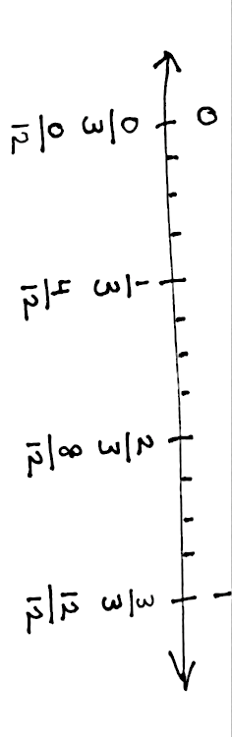
In Module 3, students’ understanding of addition and subtraction of fractions extends from earlier work with fraction equivalence and decimals. This module marks a significant shift away from the elementary grades’ centrality of base ten units to the study and use of the full set of fractional units from Grade 5 forward, especially as applied to algebra.
In Topic A, students revisit the foundational Grade 4 standards addressing equivalence. When equivalent, fractions represent the same amount of area of a rectangle and the same point on the number line. These equivalencies can also be represented symbolically.
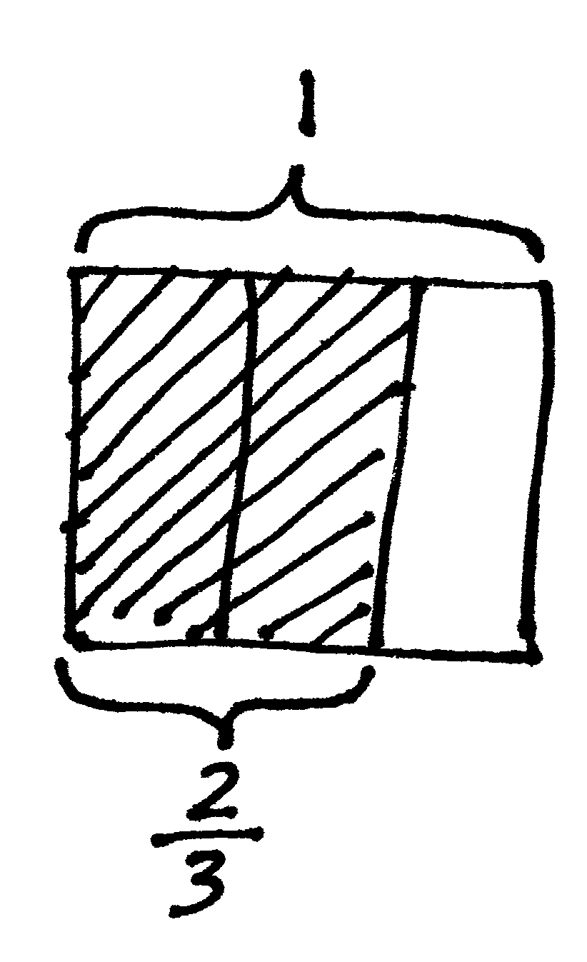
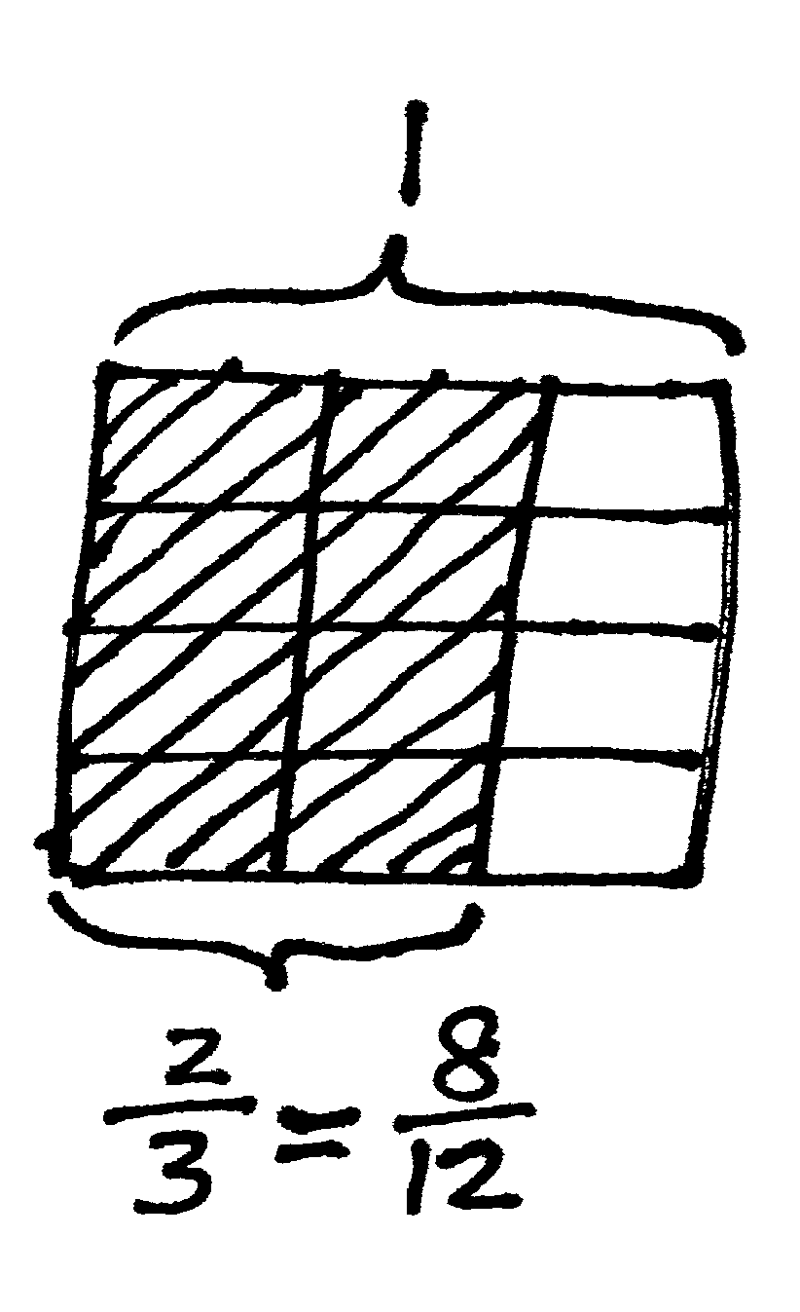
$\frac{2}{3}=\frac{2 × 4}{3 × 4}=\frac{8}{12}$

Furthermore, equivalence is evidenced when adding fractions with the same denominator. The sum may be decomposed into parts (or recomposed into an equal sum). An example is shown as follows:

$$\frac{2}{3}=\frac{1}{3}+\frac{1}{3}$$

$$\frac{7}{8}=\frac{3}{8}+\frac{3}{8}+\frac{1}{8}$$

$$\frac{6}{2}=\frac{2}{2}+\frac{2}{2}+\frac{2}{2}=1+1+1=3$$

$$\frac{8}{5}=\frac{5}{5}+\frac{3}{5}=1\frac{3}{5}$$

$$\frac{7}{3}=\frac{6}{3}+\frac{1}{3}=2 ×\frac{3}{3}+\frac{1}{3}=2+\frac{1}{3}=2\frac{1}{3}$$

This also carries forward work with decimal place value from Modules 1 and 2, confirming that like units can be composed and decomposed.

5 tenths + 7 tenths = 12 tenths = 1 and 2 tenths
5 eighths + 7 eighths = 12 eighths = 1 and 4 eighths
In Topic B, students move forward to see that fraction addition and subtraction are analogous to whole number addition and subtraction. Students add and subtract fractions with unlike denominators (5.NF.1) by replacing different fractional units with an equivalent fraction or like unit.

1 fourth + 2 thirds = 3 twelfths + 8 twelfths = 11 twelfths

$$\frac{1}{4}+\frac{2}{3}=\frac{3}{12}+\frac{8}{12}=\frac{11}{12}$$

This is not a new concept, but certainly a new level of complexity. Students have added equivalent or like units since kindergarten, adding frogs to frogs, ones to ones, tens to tens, etc.

1 boy + 2 girls = 1 child + 2 children = 3 children

1 liter – 375 mL = 1,000 mL – 375 mL = 625 mL

Throughout the module, a concrete to pictorial to abstract approach is used to convey this simple concept. Topic A uses paper strips and number line diagrams to clearly show equivalence. After a brief concrete experience with folding paper, Topic B primarily uses the rectangular fractional model because it is useful for creating smaller like units by means of partitioning (e.g., thirds and fourths are changed to twelfths to create equivalent fractions as in the diagram below.) In Topic C, students move away from the pictorial altogether as they are empowered to write equations clarified by the model.

$$\frac{1}{4}+\frac{2}{3}=\left(\frac{1 × 3}{4 × 3}\right)+\left(\frac{2 × 4}{3 × 4}\right)=\frac{3}{12}+\frac{8}{12}=\frac{11}{12}$$
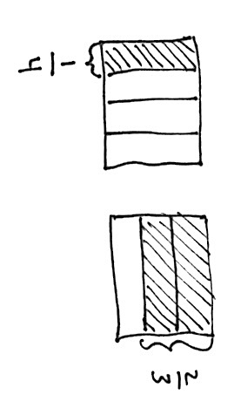
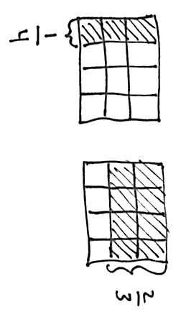

Topic C also uses the number line when adding and subtracting fractions greater than or equal to 1 so that students begin to see and manipulate fractions in relation to larger whole numbers and to each other. The number line allows the students to pictorially represent larger whole numbers. For example, “Between which two whole numbers does the sum of 1 $\frac{3}{4}$ and $5\frac{3}{5}$ lie?”

____ < $1\frac{3}{4}$ + $5\frac{3}{5}$ < ____

This leads to an understanding of and skill with solving more complex problems, which are often embedded within multi-step word problems:

Cristina and Matt’s goal is to collect a total of $3\frac{1}{2}$ gallons of sap from the maple trees. Cristina collected $1\frac{3}{4}$ gallons. Matt collected $5\frac{3}{5}$ gallons. By how much did they beat their goal?
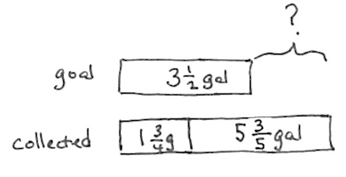
$$1\frac{3}{4} gal+5\frac{3}{5} gal-3\frac{1}{2} gal=3+\left(\frac{3 × 5}{4 × 5}\right)+\left(\frac{3 × 4}{5 × 4}\right)-\left(\frac{1 × 10}{2 × 10}\right)$$

$$=3+\frac{15}{20}+\frac{12}{20}-\frac{10}{20}=3\frac{17}{20} gal.$$

Cristina and Matt beat their goal by $3\frac{17}{20}$ gallons.

Word problems are a part of every lesson. Students are encouraged to draw tape diagrams, which encourage them to recognize part–whole relationships with fractions that they have seen with whole numbers since Grade 1.
In Topic D, students strategize to solve multi-term problems and more intensely assess the reasonableness of their solutions to equations and word problems with fractional units (5.NF.2).
“I know my answer makes sense because the total amount of sap they collected is about 7 and a half gallons. Then, when we subtract 3 gallons, that is about 4 and a half. Then, 1 half less than that is about 4. $3\frac{17}{20}$ is just a little less than 4.”

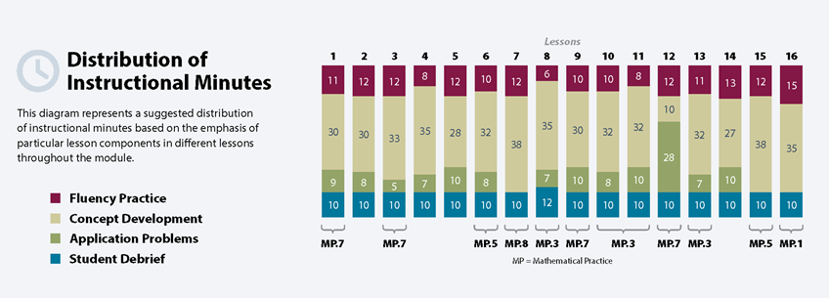
The Mid-Module Assessment follows Topic B. The End-of-Module Assessment follows Topic D.

Focus Grade Level Standards

Use equivalent fractions as a strategy to add and subtract fractions.
5.NF.1 Add and subtract fractions with unlike denominators (including mixed numbers) by replacing given fractions with equivalent fractions in such a way as to produce an equivalent sum or difference of fractions with like denominators. For example, 2/3 + 5/4 = 8/12 + 15/12 = 23/12. (In general, a/b + c/d = (ad + bc)/bd.)
5.NF.2 Solve word problems involving addition and subtraction of fractions referring to the same whole, including cases of unlike denominators, e.g., by using visual fraction models or equations to represent the problem. Use benchmark fractions and number sense of fractions to estimate mentally and assess the reasonableness of answers. For example, recognize an incorrect result 2/5 + 1/2 = 3/7, by observing that 3/7 < 1/2.

Foundational Standards
4.NF.1 Explain why a fraction a/b is equivalent to a fraction (n x a)/(n x b) by using visual fraction models, with attention to how the number and size of the parts differ even though the two fractions themselves are the same size. Use this principle to recognize and generate equivalent fractions.
4.NF.3 Understand a fraction a/b with a > 1 as a sum of fractions 1/b.
a. Understand addition and subtraction of fractions as joining and separating parts referring to the same whole.
b. Decompose a fraction into a sum of fractions with the same denominator in more than one way, recording each decomposition by an equation. Justify decompositions, e.g., by using a visual fraction model. Examples: 3/8 = 1/8 + 1/8 + 1/8; 3/8 = 1/8 + 2/8; 2 1/8 = 1 + 1 + 1/8 = 8/8 + 8/8 + 1/8.
c. Add and subtract mixed numbers with like denominators, e.g., by replacing each mixed number with an equivalent fraction, and/or by using properties of operations and the relationship between addition and subtraction.
d. Solve word problems involving addition and subtraction of fractions referring to the same whole and having like denominators, e.g., by using visual fraction models and equations to represent the problem.

Focus Standards for Mathematical Practice
MP.2 Reason abstractly and quantitatively. Mathematically proficient students make sense of quantities and their relationships in problem situations. They bring two complementary abilities to bear on problems involving quantitative relationships: the ability to decontextualize—to abstract a given situation and represent it symbolically and manipulate the representing symbols as if they have a life of their own, without necessarily attending to their referents—and the ability to contextualize, to pause as needed during the manipulation process to probe into the referents for the symbols involved. Quantitative reasoning entails habits of creating a coherent representation of the problem at hand; considering the units involved; attending to the meaning of quantities, not just how to compute them; and knowing and flexibly using different properties of operations and objects.
MP.3 Construct viable arguments and critique the reasoning of others. Mathematically proficient students understand and use stated assumptions, definitions, and previously established results in constructing arguments. They make conjectures and build a logical progression of statements to explore the truth of their conjectures. They are able to analyze situations by breaking them into cases, as well as recognize and use counterexamples. They justify their conclusions, communicate them to others, and respond to the arguments of others. They reason inductively about data, making plausible arguments that consider the context from which the data arose. Mathematically proficient students are also able to compare the effectiveness of two plausible arguments, distinguish correct logic or reasoning from that which is flawed, and—if there is a flaw in the argument—explain what it is. Elementary students can construct arguments using concrete referents such as objects, drawings, diagrams, and actions. Such arguments can make sense and be correct, even though they are not generalized or made formal until later grades. Later, students learn to determine domains to which an argument applies. Students at all grade levels can listen or read the arguments of others, decide whether they make sense, and ask useful questions to clarify or improve the arguments.
MP.4 Model with mathematics. Mathematically proficient students can apply the mathematics they know to solve problems arising in everyday life, society, and the workplace. In early grades, this might be as simple as writing an addition equation to describe a situation. In middle grades, a student might apply proportional reasoning to plan a school event or analyze a problem in the community. By high school, a student might use geometry to solve a design problem or use a function to describe how one quantity of interest depends on another. Mathematically proficient students who can apply what they know are comfortable making assumptions and approximations to simplify a complicated situation, realizing that these may need revision later. They are able to identify important quantities in a practical situation and map their relationships using such tools as diagrams, two-way tables, graphs, flowcharts, and formulas. They can analyze those relationships mathematically to draw conclusions. They routinely interpret their mathematical results in the context of the situation and reflect on whether the results make sense, possibly improving the model if it has not served its purpose.

MP.5 Use appropriate tools strategically. Mathematically proficient students consider the available tools when solving a mathematical problem. These tools might include pencil and paper, concrete models, a ruler, a protractor, a calculator, a spreadsheet, a computer algebra system, a statistical package, or dynamic geometry software. Proficient students are sufficiently familiar with tools appropriate for their grade or course to make sound decisions about when each of these tools might be helpful, recognizing both the insight to be gained and their limitations. For example, mathematically proficient high school students analyze graphs of functions and solutions generated using a graphing calculator. They detect possible errors by strategically using estimation and other mathematical knowledge. When making mathematical models, they know that technology can enable them to visualize the results of varying assumptions, explore consequences, and compare predictions with data. Mathematically proficient students at various grade levels are able to identify relevant external mathematical resources, such as digital content located on a website, and use them to pose or solve problems. They are able to use technological tools to explore and deepen their understanding of concepts.
MP.6 Attend to precision. Mathematically proficient students try to communicate precisely to others. They try to use clear definitions in discussion with others and in their own reasoning. They state the meaning of the symbols they choose, including using the equal sign consistently and appropriately. They are careful about specifying units of measure, and labeling axes to clarify the correspondence with quantities in a problem. They calculate accurately and efficiently, express numerical answers with a degree of precision appropriate for the problem context. In the elementary grades, students give carefully formulated explanations to each other. By the time they reach high school they have learned to examine claims and make explicit use of definitions.
MP.7 Look for and make use of structure. Mathematically proficient students look closely to discern a pattern or structure. Young students, for example, might notice that three and seven more is the same amount as seven and three more, or they may sort a collection of shapes according to how many sides the shapes have. Later, students will see 7 × 8 equals the well remembered 7 × 5 + 7 × 3, in preparation for learning about the distributive property. In the expression x² + 9x + 14, older students can see the 14 as 2 × 7 and the 9 as 2 + 7. They recognize the significance of an existing line in a geometric figure and can use the strategy of drawing an auxiliary line for solving problems. They also can step back for an overview and shift perspective. They can see complicated things, such as some algebraic expressions, as single objects or as being composed of several objects. For example, they can see 5 – 3(x – y)² as 5 minus a positive number times a square and use that to realize that its value cannot be more than 5 for any real numbers x and y.

Overview of Module Topics and Lesson Objectives
Standards | Topics and Objectives |  | Days
4.NF.1  4.NF.3c  4.NF.3d | A | Equivalent Fractions  Lesson 1: Make equivalent fractions with the number line, the area model, and numbers.  Lesson 2: Make equivalent fractions with sums of fractions with like denominators. | 2
5.NF.1  5.NF.2 | B | Making Like Units Pictorially  Lesson 3: Add fractions with unlike units using the strategy of creating equivalent fractions.  Lesson 4: Add fractions with sums between 1 and 2.  Lesson 5: Subtract fractions with unlike units using the strategy of creating equivalent fractions.  Lesson 6: Subtract fractions from numbers between 1 and 2.  Lesson 7: Solve two-step word problems. | 5
 |  | Mid-Module Assessment: Topics A–B (assessment ½ day, return ½ day, remediation or further applications 2 days) | 3
5.NF.1  5.NF.2 | C | Making Like Units Numerically  Lesson 8: Add fractions to and subtract fractions from whole numbers using equivalence and the number line as strategies.  Lesson 9: Add fractions making like units numerically.  Lesson 10: Add fractions with sums greater than 2.  Lesson 11: Subtract fractions making like units numerically.  Lesson 12: Subtract fractions greater than or equal to one. | 5
5.NF.1  5.NF.2 | D | Further Applications  Lesson 13: Use fraction benchmark numbers to assess reasonableness of addition and subtraction equations.  Lesson 14: Strategize to solve multi-term problems.  Lesson 15: Solve multi-step word problems; assess reasonableness of solutions using benchmark numbers.  Lesson 16: Explore part-to-whole relationships. | 4
 |  | End-of-Module Assessment: Topics A–D (assessment ½ day, return ½ day, remediation or further applications 2 days) | 3
Total Number of Instructional Days |  |  | 22

Terminology

New or Recently Introduced Terms
- Benchmark fraction (e.g., $\frac{1}{2}$ is a benchmark fraction when comparing $\frac{1}{3}$ and $\frac{3}{5}$)
- Like denominators (e.g., $\frac{1}{8}$ and $\frac{5}{8}$)
- Unlike denominators (e.g., $\frac{1}{8}$ and $\frac{1}{7}$)

Familiar Terms and Symbols
- Between (e.g., $\frac{1}{2}$ is between $\frac{1}{3}$ and $\frac{3}{5}$)
- Denominator (denotes the fractional unit: fifths in 3 fifths, which is abbreviated as the 5 in $\frac{3}{5}$)
- Equivalent fraction (e.g., $\frac{3}{5}=\frac{6}{10}$)
- Fraction (e.g., 3 fifths or $\frac{3}{5}$)
- Fraction greater than or equal to 1 (e.g., $\frac{7}{3}$ , $3\frac{1}{2}$, an abbreviation for 3 + $\frac{1}{2}$)
- Fraction written in the largest possible unit (e.g., $\frac{3}{6}=\frac{1 × 3}{2 × 3}=\frac{1}{2}$ or 1 three out of 2 threes = $\frac{1}{2}$)
- Fractional unit (e.g., the fifth unit in 3 fifths denoted by the denominator 5 in $\frac{3}{5}$)
- Hundredth ($\frac{1}{100}$ or 0.01)
- Kilometer, meter, centimeter, liter, milliliter, kilogram, gram, mile, yard, foot, inch, gallon, quart, pint, cup, pound, ounce, hour, minute, second
- More than halfway and less than halfway
- Number sentence (e.g., “Three plus seven equals ten.” Usually written as “3 + 7 = 10.”)
- Numerator (denotes the count of fractional units: 3 in 3 fifths or 3 in $\frac{3}{5}$)
- One tenth of (e.g., $\frac{1}{10}$ × 250)
- Tenth ($\frac{1}{10}$ or 0.1)
- Whole unit (e.g., any unit that is partitioned into smaller, equally sized fractional units)
- < , > , =

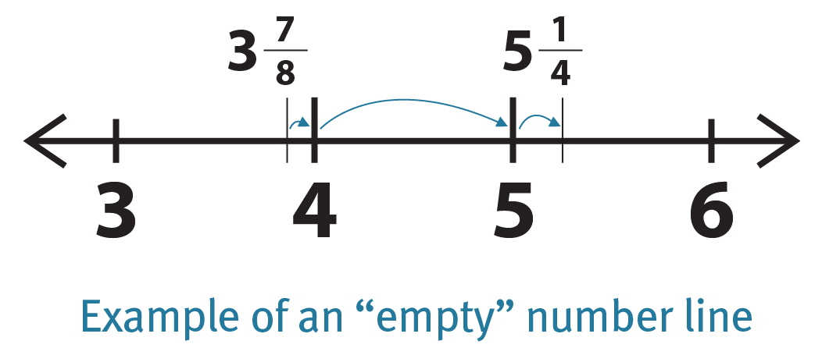
Suggested Tools and Representations
- Fraction strips
- Number line (a variety of templates)
- Paper strips (for modeling equivalence)
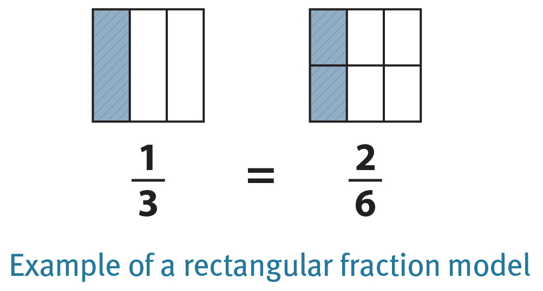
- Rectangular fraction model
1
1
- Tape diagrams
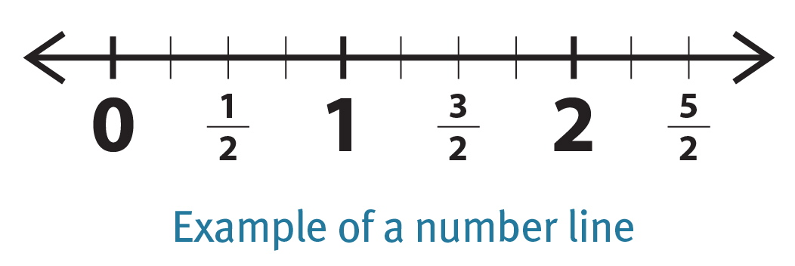

Scaffolds
The scaffolds integrated into A Story of Units give alternatives for how students access information as well as express and demonstrate their learning. Strategically placed margin notes are provided within each lesson elaborating on the use of specific scaffolds at applicable times. They address many needs presented by English language learners, students with disabilities, students performing above grade level, and students performing below grade level. Many of the suggestions are organized by Universal Design for Learning (UDL) principles and are applicable to more than one population. To read more about the approach to differentiated instruction in A Story of Units, please refer to “How to Implement A Story of Units.”

Assessment Summary
Assessment Type | Administered | Format | Standards Addressed
Mid-Module Assessment Task | After Topic B | Constructed response with rubric | 5.NF.1  5.NF.2
End-of-Module Assessment Task | After Topic D | Constructed response with rubric | 5.NF.1  5.NF.2

Examples in this module also include tenths and hundredths in fraction and decimal form.
These are terms and symbols students have seen previously.
Students with disabilities may require Braille, large-print, audio, or special digital files. Please visit the website, www.p12.nysed.gov/specialed/aim, for specific information on how to obtain student materials that satisfy the National Instructional Materials Accessibility Standard (NIMAS) format.

