Table of Contents
GRADE 1 • MODULE 4
Place Value, Comparison, Addition and Subtraction to 40

Module Overview i

Topic A: Tens and Ones 4.A.1

Topic B: Comparison of Pairs of Two-Digit Numbers 4.B.1

Topic C: Addition and Subtraction of Tens 4.C.1

Topic D: Addition of Tens or Ones to a Two-Digit Number 4.D.1

Topic E: Varied Problem Types Within 20 4.E.1

Topic F: Addition of Tens and Ones to a Two-Digit Number 4.F.1

Module Assessments 4.S.1

Grade 1 • Module 4
Place Value, Comparison, Addition and Subtraction to 40

OVERVIEW
Module 4 builds upon Module 2’s work with place value within 20, now focusing on the role of place value in the addition and subtraction of numbers to 40.
The module opens with Topic A, where students study, organize, and manipulate numbers within 40. Having worked with creating a ten and some ones in Module 2, students now recognize multiple tens and ones. Students use fingers, linking cubes, dimes, and pennies to represent numbers to 40 in various ways—from all ones to tens and ones (1.NBT.2). They use a place value chart to organize units. The topic closes with the identification of 1 more, 1 less, 10 more, and 10 less as students learn to add or subtract like units (1.NBT.5).
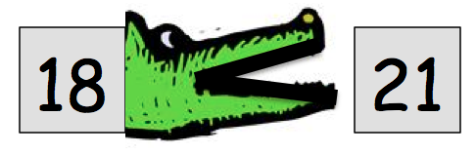
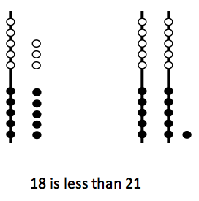
In Topic B, students compare quantities and begin using the symbols for greater than (>) and less than (<) (1.NBT.3). Students demonstrate their understanding of place value when they recognize that 18 is less than 21 since 2 tens already have a greater value than 1 ten 8 ones. To support understanding, the first lesson in the topic focuses on identifying the greater or lesser amount. With this understanding, students label each of the quantities being compared and compare from left to right. Finally, students are introduced to the mathematical symbols using the story of the alligator whose hungry mouth always opens toward the greater number. The abstract symbols are introduced after the conceptual foundation has been laid.
Topic C focuses on addition and subtraction of tens (1.NBT.4, 1.NBT.6). Having used concrete models in Topic A to represent 10 more and 10 less, students now recognize that just as 3 + 1 = 4, 3 tens + 1 ten = 4 tens. With this understanding, students add and subtract a multiple of 10 from another multiple of 10. The topic closes with the addition of multiples of 10 to numbers less than 40 (e.g., 12 + 30).
In Topic D, students use familiar strategies to add two-digit and single-digit numbers within 40. Students apply the Level 2 strategy of counting on and use the Level 3 strategy of making ten, this time making the next ten (1.NBT.4). For instance, when adding 28 + 5, students break 5 into 2 and 3 so that 28 and 2 can make the next ten, which is 30, or 3 tens, and then add 3 to make 33. The topic closes with students sharing and critiquing peer strategies.
In Topic E, students consider new ways to represent larger quantities when approaching put together/take apart with total or addend unknown and add to with result or change unknown word problems. Students begin labeling drawings with numerals and eventually move to tape diagrams to represent the problems pictorially (1.OA.1). Throughout this topic, students continue developing their skills with adding single-digit and double-digit numbers (introduced in Topic D) during fluency activities.
The module closes with Topic F, focusing on adding like place value units as students add two-digit numbers. The topic begins with interpreting two-digit numbers in varied combinations of tens and ones
(e.g., 34 = 34 ones = 3 tens 4 ones = 2 tens 14 ones = 1 ten 24 ones). This flexibility in representing a given number prepares students for addition with regrouping (e.g., 12 + 8 = 1 ten 10 ones = 2 tens or 18 + 16 = 2 tens 14 ones = 3 tens 4 ones). To close the module, students add pairs of numbers with varied sums in the ones place to support flexibility in thinking.
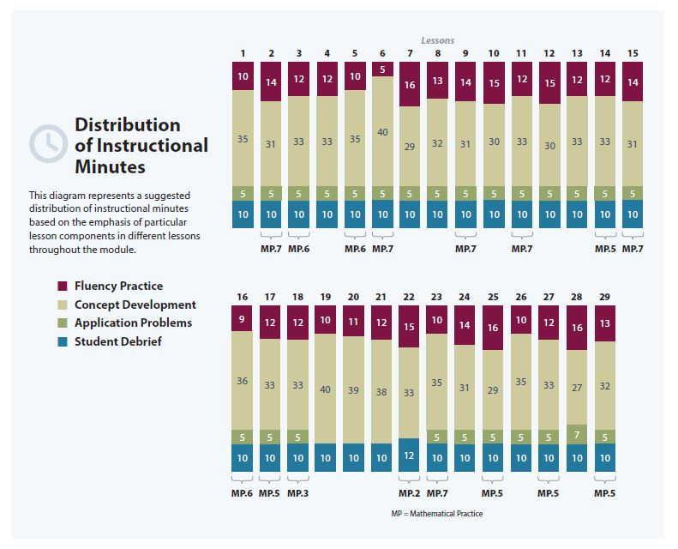

Focus Grade Level Standards
Represent and solve problems involving addition and subtraction.
1.OA.1 Use addition and subtraction within 20 to solve word problems involving situations of adding to, taking from, putting together, taking apart, and comparing, with unknowns in all positions, e.g., by using objects, drawings, and equations with a symbol for the unknown number to represent the problem. (See CCLS Glossary, Table 1.)
Extend the counting sequence.
1.NBT.1 Count to 120, starting at any number less than 120. In this range, read and write numerals and represent a number of objects with a written numeral.
Understand place value.
1.NBT.2 Understand that the two digits of a two-digit number represent amounts of tens and ones. Understand the following as special cases:
a. 10 can be thought of as a bundle of ten ones—called a “ten.”
c. The numbers 10, 20, 30, 40, 50, 60, 70, 80, 90 refer to one, two, three, four, five, six, seven, eight, or nine tens (and 0 ones).
1.NBT.3 Compare two two-digit numbers based on meaning of the tens and ones digits, recording the results of comparisons with the symbols >, =, and <.
Use place value understanding and properties of operations to add and subtract.
1.NBT.4 Add within 100, including adding a two-digit number and a one-digit number, and adding a two-digit number and a multiple of 10, using concrete models or drawings and strategies based on place value, properties of operations, and/or the relationship between addition and subtraction; relate the strategy to a written method and explain the reasoning used. Understand that in adding two-digit numbers, one adds tens and tens, ones and ones; and sometimes it is necessary to compose a ten.
1.NBT.5 Given a two-digit number, mentally find 10 more or 10 less than the number, without having to count; explain the reasoning used.
1.NBT.6 Subtract multiples of 10 in the range 10–90 from multiples of 10 in the range 10–90 (positive or zero differences), using concrete models or drawings and strategies based on place value, properties of operations, and/or relationship between addition and subtraction; relate the strategy to a written method and explain the reasoning used.
Foundational Standards
K.OA.3 Decompose numbers less than or equal to 10 into pairs in more than one way, e.g., by using objects or drawings, and record each decomposition by a drawing or equation (e.g., 5 = 2 + 3 and 5 = 4 + 1).
K.OA.4 For any number from 1 to 9, find the number that makes 10 when added to the given number, e.g., by using objects or drawings, and record the answer with a drawing or equation.
K.NBT.1 Compose and decompose numbers from 11 to 19 into ten ones and some further ones, e.g., by using objects or drawings, and record each composition or decomposition by a drawing or equation (e.g., 18 = 10 + 8); understand that these numbers are composed of ten ones and one, two, three, four, five, six, seven, eight, or nine ones.
Focus Standards for Mathematical Practice
MP.3 Construct viable arguments and critique the reasoning of others. Students describe and explain their strategies for adding within 40. They critique and adjust student samples to more efficiently solve addition problems.
MP.5 Use appropriate tools strategically. After learning varied representations and strategies for adding and subtracting pairs of two-digit numbers, students choose their preferred methods for representing and solving problems efficiently. Students may represent their computations using arrow notation, number bonds, quick ten drawings, and linking cubes. As they share their strategies, students explain their choice of counting on, making ten, adding tens and then ones, or adding ones and then tens.
MP.6 Attend to precision. Students recognize and distinguish between units, demonstrating an understanding of the difference between 3 tens and 3 ones. They use this understanding to compare numbers and add like place value units.
MP.7 Look for and make use of structure. Students are introduced to the place value chart, deepening their understanding of the structure within the number system. Throughout the module, students use this structure as they add and subtract within 40. They recognize the similarities between 2 tens + 2 tens = 4 tens and 2 + 2 = 4 and use their understanding of tens and ones to explain the connection.

Overview of Module Topics and Lesson Objectives
Standards | Topics and Objectives |  | Days
1.NBT.1  1.NBT.2  1.NBT.5 | A | Tens and Ones  Lesson 1: Compare the efficiency of counting by ones and counting by tens.  Lesson 2: Use the place value chart to record and name tens and ones within a two-digit number.  Lesson 3: Interpret two-digit numbers as either tens and some ones or as all ones.  Lesson 4: Write and interpret two-digit numbers as addition sentences that combine tens and ones.  Lesson 5: Identify 10 more, 10 less, 1 more, and 1 less than a two-digit number.  Lesson 6: Use dimes and pennies as representations of tens and ones. | 6
1.NBT.3  1.NBT.2 | B | Comparison of Pairs of Two-Digit Numbers  Lesson 7: Compare two quantities, and identify the greater or lesser of the two given numerals.  Lesson 8: Compare quantities and numerals from left to right.  Lessons 9–10: Use the symbols >, =, and < to compare quantities and numerals. | 4
1.NBT.4  1.NBT.6 | C | Addition and Subtraction of Tens  Lesson 11: Add and subtract tens from a multiple of 10.  Lesson 12: Add tens to a two-digit number. | 2
 |  | Mid-Module Assessment: Topics A–C (assessment 1 day, return 1 day, remediation or further applications 1 day) | 3
1.NBT.4 | D | Addition of Tens or Ones to a Two-Digit Number  Lessons 13–14: Use counting on and the make ten strategy when adding across a ten.  Lesson 15: Use single-digit sums to support solutions for analogous sums to 40.  Lessons 16–17: Add ones and ones or tens and tens.  Lesson 18: Share and critique peer strategies for adding two-digit numbers. | 6
Standards | Topics and Objectives |  | Days
1.OA.1 | E | Varied Problem Types Within 20  Lesson 19: Use tape diagrams as representations to solve put together/take apart with total unknown and add to with result unknown word problems.  Lessons 20–21: Recognize and make use of part–whole relationships within tape diagrams when solving a variety of problem types.  Lesson 22: Write word problems of varied types. | 4
1.NBT.4  1.NBT.2 | F | Addition of Tens and Ones to a Two-Digit Number  Lesson 23: Interpret two-digit numbers as tens and ones, including cases with more than 9 ones.  Lessons 24–25: Add a pair of two-digit numbers when the ones digits have a sum less than or equal to 10.  Lessons 26–27: Add a pair of two-digit numbers when the ones digits have a sum greater than 10.  Lessons 28–29: Add a pair of two-digit numbers with varied sums in the ones. | 7
 |  | End-of-Module Assessment: Topics A–F (assessment 1 day, return 1 day, remediation or further applications 1 day) | 3
Total Number of Instructional Days |  |  | 35
Terminology
New or Recently Introduced Terms
- > (greater than)
- < (less than)
- Place value (quantity represented by a digit in a particular place within a number)
Familiar Terms and Symbols
- = (equal)
- Numerals
- Ones
- Tens
Suggested Tools and Representations
- Arrow notation
Arrow Notation
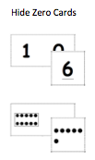
- Comparison symbols: >, <, =
Hide Zero Cards
- Dime
- Hide Zero cards
- Hundred chart
- Number bond
- Penny
- Place value chart
- Quick Ten
- Rekenrek
- Tape diagram
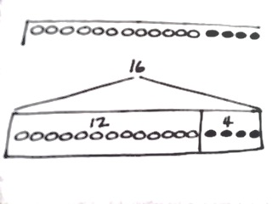
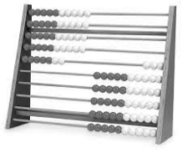
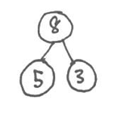
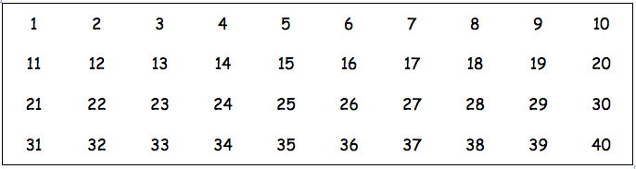
Tape Diagram
Rekenrek
Quick Ten
tens
ones
4
3
Place Value Chart
Number Bond
part
part
whole
Hundred Chart to 40
Scaffolds
The scaffolds integrated into A Story of Units give alternatives for how students access information as well as express and demonstrate their learning. Strategically placed margin notes are provided within each lesson elaborating on the use of specific scaffolds at applicable times. They address many needs presented by English language learners, students with disabilities, students performing above grade level, and students performing below grade level. Many of the suggestions are applicable to more than one population. The charts included in Module 1 provide a general overview of the lesson-aligned scaffolds, organized by Universal Design for Learning (UDL) principles. To read more about the approach to differentiated instruction in A Story of Units, please refer to “How to Implement A Story of Units.”
Assessment Summary
Type | Administered | Format | Standards Addressed
Mid-Module Assessment Task | After Topic C | Constructed response with rubric | 1.NBT.1  1.NBT.2  1.NBT.3  1.NBT.4  1.NBT.5  1.NBT.6
End-of-Module Assessment Task | After Topic F | Constructed response with rubric | 1.OA.1  1.NBT.1  1.NBT.2  1.NBT.3  1.NBT.4  1.NBT.5  1.NBT.6

While the use of pennies and dimes will be used throughout the module, 1.MD.3 is not a focus grade level standard in Module 4. Instead, this standard will become a focal standard in Module 6, when all coins are introduced and used.
The balance of this cluster is addressed in Module 2.
Focus on numbers to 40.
Focus on numbers to 40; 1.NBT.2b is addressed in Module 2.
Focus on numbers to 40.
These are terms and symbols students have seen previously.
Students with disabilities may require Braille, large print, audio, or special digital files. Please visit the website www.p12.nysed.gov/specialed/aim for specific information on how to obtain student materials that satisfy the National Instructional Materials Accessibility Standard (NIMAS) format.

