Name Date
- Fill in the missing numbers in the sequence.
16, ____, 18, ____, ____
39, 38, ____, 36, ____, ____

23, 22, ____, ____, ____
36, ____, ____, 39, ____

- Write the number as tens and ones in the place value chart, or use the place value chart to write the number.
a. 31
tens
ones

b. 19
tens
ones

c. _____
tens
ones
6
2
d. _____
tens
ones
5
1

- Some numbers have been placed below in order from 0 to 40.
3 22 19 29 35
  - Place the numbers from the rectangle in order between the tens.

0 10 20 30 40

  - Shade in the tens or the ones on the place value charts below to show which digit you looked at to help you put the pair of numbers in order from least to greatest.
tens
ones
2
2
tens
ones
9
2
tens
ones
9
2
tens
ones
5
3

- Complete each sentence.
c. 2 tens and 3 ones is the same as ______ ones.
b. 40 = ____ tens ____ ones.
a. 39 is ____ tens and ____ ones.

- Match the equal amounts.

  - 21 40 ones

  - 4 tens 3 tens 6 ones

  - 36 ones 1 ten 2 ones

  - 12 ones 2 tens 1 one

  - Circle the number in each pair that is greater.
32 40
33 28
36 20

  - Circle the number in each pair that is less.
21 12

- Use <, =, or > to compare the pairs of numbers.
b. 30 3
a. 3 tens 5 ones 2 tens 8 ones
c. 23 32
d. 19 21

- Erik thinks 32 is greater than 19. Is he correct? Draw and write about tens and ones to explain your thinking.

- Find the mystery numbers. Use the arrow way to explain how you know.
b. 10 less than 19 is _______.
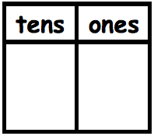

d. 1 less than 19 is ________.

- 10 more than 19 is _______.

- 1 more than 19 is ________.

- Beth said 30 – 20 is the same as 3 tens – 2 tens. Is she correct? Explain your thinking.

- Solve for each unknown number. Use the space provided to draw quick tens, a number bond, or the arrow way to show your work.
a. 30 + 6 = _____ | b. 3 tens - _______________ = 1 ten
c. 11 + 10 = _____ | d. 40 – 30 = _____
e. 17 + 20 = _____ | f. 20 + _____ = 40
g. 15 + _____ = 35 | h. 2 tens + 1 ten 2 ones = ____________________

Mid-Module Assessment Task  Standards Addressed | Topics A–C
Extend the counting sequence.^{0F}
1.NBT.1 Count to 120, starting at any number less than 120. In this range, read and write numerals and represent a number of objects with a written numeral.
Understand place value.1F
1.NBT.2 Understand that the two digits of a two-digit number represent amounts of tens and ones. Understand the following as special cases:
a. 10 can be thought of as a bundle of ten ones—called a “ten.”
c. The numbers 10, 20, 30, 40, 50, 60, 70, 80, 90 refer to one, two, three, four, five, six, seven, eight, or nine tens (and 0 ones).
1.NBT.3 Compare two two-digit numbers based on meaning of the tens and ones digits, recording the results of comparisons with the symbols >, =, and <.
Use place value understanding and properties of operations to add and subtract.2F
1.NBT.4 Add within 100, including adding a two-digit number and a one-digit number, and adding a two-digit number and a multiple of 10, using concrete models or drawings and strategies based on place value, properties of operations, and/or the relationship between addition and subtraction; relate the strategy to a written method and explain the reasoning used. Understand that in adding two-digit numbers, one adds tens and tens, ones and ones; and sometimes it is necessary to compose a ten.
1.NBT.5 Given a two-digit number, mentally find 10 more or 10 less than the number, without having to count; explain the reasoning used.
1.NBT.6 Subtract multiples of 10 in the range 10–90 from multiples of 10 in the range 10–90 (positive or zero differences), using concrete models or drawings and strategies based on place value, properties of operations, and/or the relationship between addition and subtraction; relate the strategy to a written method and explain the reasoning used.
Evaluating Student Learning Outcomes
A Progression Toward Mastery is provided to describe steps that illuminate the gradually increasing understandings that students develop on their way to proficiency. In this chart, this progress is presented from left (Step 1) to right (Step 4). The learning goal for students is to achieve Step 4 mastery. These steps are meant to help teachers and students identify and celebrate what the students CAN do now and what they need to work on next.
A Progression Toward Mastery
Assessment  Task Item  and  Standards Assessed | STEP 1  Little evidence of reasoning without a correct answer.  (1 Point) | STEP 2  Evidence of some reasoning without a correct answer.  (2 Points) | STEP 3  Evidence of some reasoning with a correct answer or evidence of solid reasoning with an incorrect answer.  (3 Points) | STEP 4  Evidence of solid reasoning with a correct answer.  (4 Points)
1  1.NBT.1 | The student is unable to complete any one sequence of numbers. | The student completes at least one sequence. | The student completes at least one sequence, as well as at least two numbers in each additional sequence.  OR  The student completes two or more sequences correctly. | The student identifies all numbers in the sequences:  - 16, 17, 18, 19, 20  - 39, 38, 37, 36, 35, 34  - 36, 37, 38, 39, 40  - 23, 22, 21, 20, 19
2  1.NBT.2 | The student does not demonstrate understanding of tens and ones and is unable to complete more than one answer correctly. | The student demonstrates inconsistent understanding of tens and ones, completing only two answers correctly. | The student demonstrates some understanding of most aspects of tens and ones, completing at least three answers correctly. | The student completes all correctly:  - 3–1 (or 2–11; 0–31)  - 1–9 (or 0–19)  - 26  - 15
3  1.NBT.3 | The student demonstrates little or no understanding of number sequence and orders one number.  OR  The student shaded at least one of the two pairs for Part (b) correctly. | The student demonstrates limited understanding of the sequence of numbers as greater or less than each multiple of 10, ordering at least two numbers correctly.  Or, for Part (b), the student shaded at least one of the two pairs correctly. | The student demonstrates some understanding of the sequence of numbers as greater or less than each multiple of 10, correctly ordering three or four numbers.  For Part (b), the student shaded at least one of the two pairs correctly. | The student correctly orders numerals:  - 0 3 10 19 20 22 29 30 35 40  - Accurately shaded  - 2 and 9 (ones)  - 2 and 3 (tens)
4  1.NBT.2 | The student does not demonstrate understanding of tens and ones within a given number and is unable to complete any section correctly. | The student demonstrates inconsistent understanding of tens and ones within a given number, answering one section correctly. | The student demonstrates understanding of most aspects of tens and ones within a given number, answering at least two sections correctly. | The student identifies any correct interpretation of each quantity. For example, Part (a) is accurate with answers such as 0 tens 39 ones, 2 tens 19 ones, etc. Typical answers may be as follows:  - 3 tens 9 ones  - 4 tens 0 ones  - 23 ones
5  1.NBT.2 | The student does not demonstrate understanding of the equivalent representations of tens and ones and is unable to match any equal amounts. | The student demonstrates limited understanding of the equivalent representations of tens and ones, matching one equal amount. | The student demonstrates some understanding of the equivalent representations of tens and ones, matching two equal amounts. | The student matches all four equal amounts as follows:  - 21 = 2 tens  1 one  - 4 tens = 40 ones  - 36 ones = 3 tens 6 ones  - 12 ones = 1 ten 2 ones
6  1.NBT.3 | The student demonstrates limited ability to compare numbers, correctly comparing one or none of the four sets of numbers. | The student demonstrates some ability to compare numbers, (e.g., identifying greater but not less), correctly comparing two of the four sets of numbers. | The student demonstrates the ability to compare most numbers, correctly comparing three of the four comparisons. | The student correctly identifies the following:  - The greater numbers as  40 33  - The lesser numbers as  20 12
7  1.NBT.2  1.NBT.3 | The student is unable to use symbols to compare numbers and is unable to correctly answer any of the four comparisons. | The student has limited ability to use symbols to compare numbers, correctly answering one of the four comparisons. | The student has some ability to use symbols to compare numbers, correctly answering two or three of the four comparisons. | The student correctly answers:  - >  - >  - <  - <
8  1.NBT.2  1.NBT.3 | The student demonstrates little to no understanding of comparing numbers based on tens and ones, answering incorrectly. There is no evidence of reasoning. | The student uses drawings or words to accurately depict at least one of the two numbers, demonstrating limited understanding of the use of place value to compare numbers. | The student demonstrates some understanding of using place value to compare numbers.  The student correctly identifies the greater number but does not fully explain reasoning using place value.  OR  The student answers incorrectly because of an error such as transcription but demonstrates strong understanding of place value through drawing or words. | The student correctly does the following:  - Uses drawings or words that depict place value to accurately explain that 32 is greater than 19.
9  1.NBT.5 | The student demonstrates little or no understanding of mentally adding or subtracting 10. Answers are incorrect, and there is no evidence of reasoning. | The student demonstrates limited understanding of mentally adding or subtracting 10, identifying at least two correct mystery numbers but does not complete any charts accurately. | The student demonstrates ability to mentally add or subtract 10, correctly identifying four mystery numbers, but reasoning is unclear because no charts have been completed accurately.  OR  The student accurately completes charts but makes an error in mental calculation on one or two of (a), (b), (c), or (d). | The student identifies 29, 9, 20, and 18 and accurately completes the charts to depict the arrow way.
10  1.NBT.2 | The student’s answer is incorrect, and there is no evidence of reasoning. | The student’s answer includes some indication of understanding either the connection between 30 and 3 tens or 20 and 2 tens, but the student does not follow through with this thinking to correctly answer the question. | The student’s answer is correct, but there is no explanation.  OR  The student’s explanation is mathematically correct and rooted in an understanding of place value, but there is an error in the student’s transcription of the numerals or other calculation error that leads to an incorrect explanation. | The student correctly does the following:  - Draws or writes to explain that Beth is correct.  - Demonstrates that 30 = 3 tens and  20 = 2 tens.
11  1.NBT.4  1.NBT.6 | The student demonstrates little or no ability to add or subtract two-digit numbers to 40, answering two or fewer questions correctly. | The student demonstrates some ability to add (or subtract) two-digit numbers, answering at least four of eight correctly, and demonstrates misunderstandings in place value. | The student demonstrates the ability to add (and subtract) two-digit numbers, answering at least six of eight correctly, or uses sound process throughout with, at most, four calculation errors. | The student correctly:  - Solves  - 36  - 2 tens  - 21  - 10  - 37  - 20  - 20  - 3 tens 2 ones  (or 32)  - Represents process to accurately solve through drawings, number bonds, or the arrow way. The notation demonstrates use of a sound strategy for adding or subtracting.

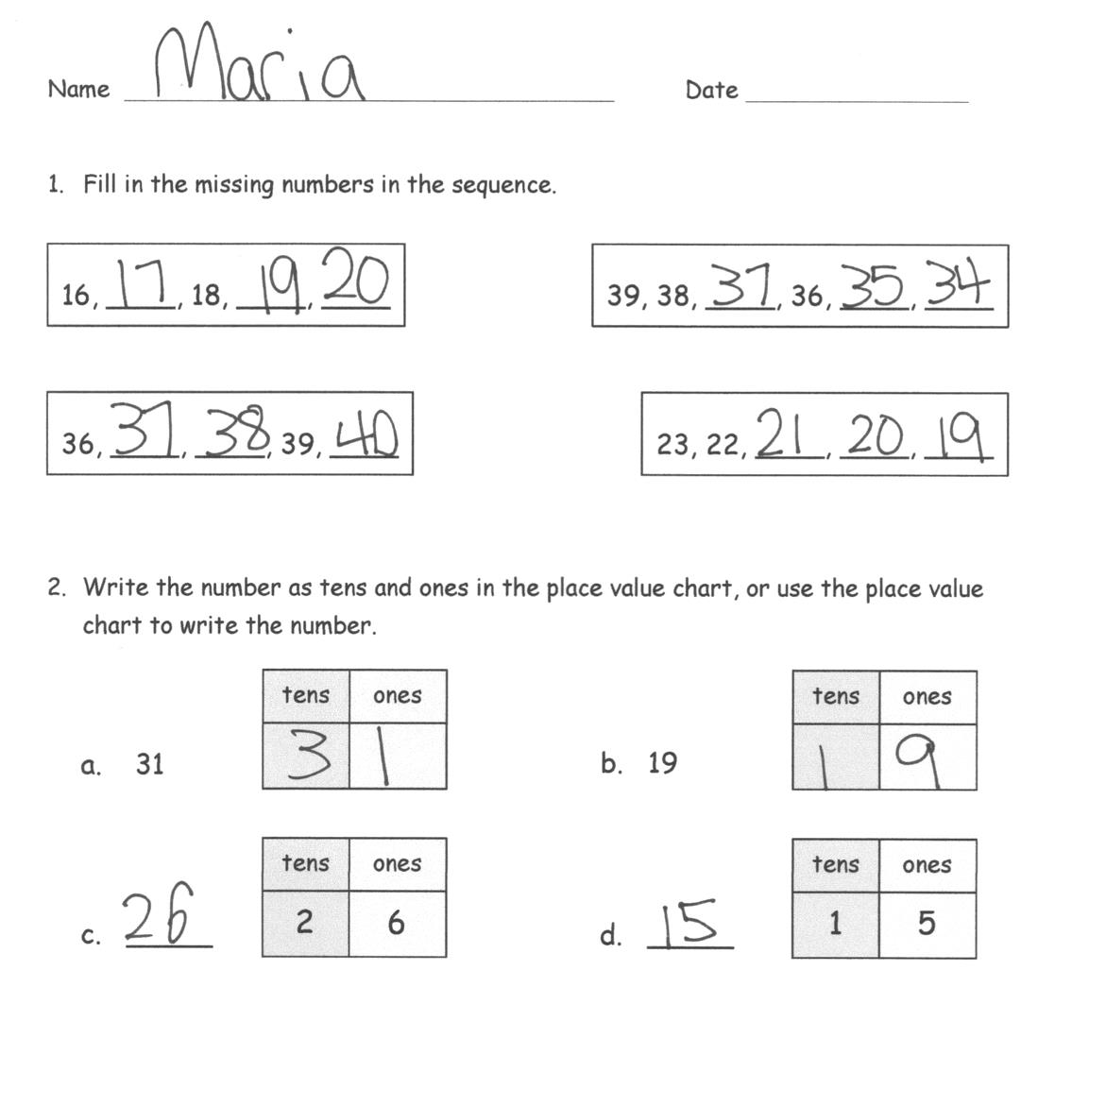
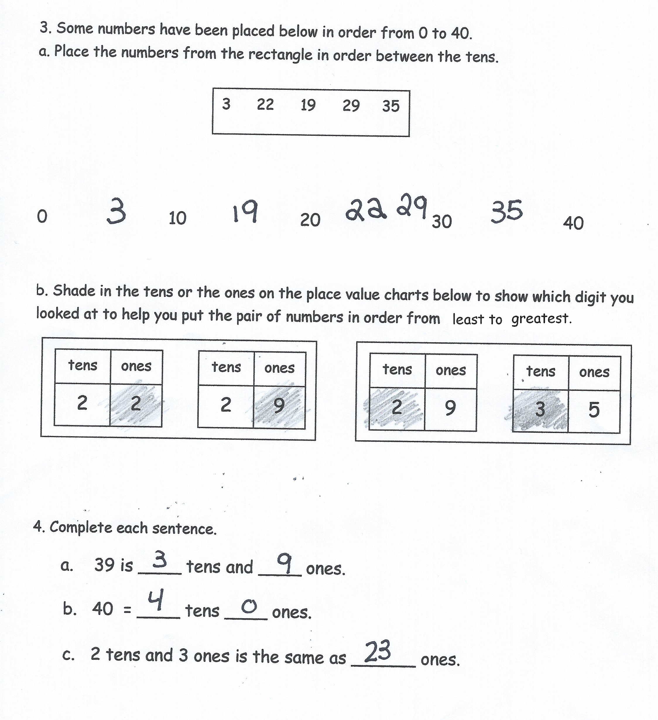
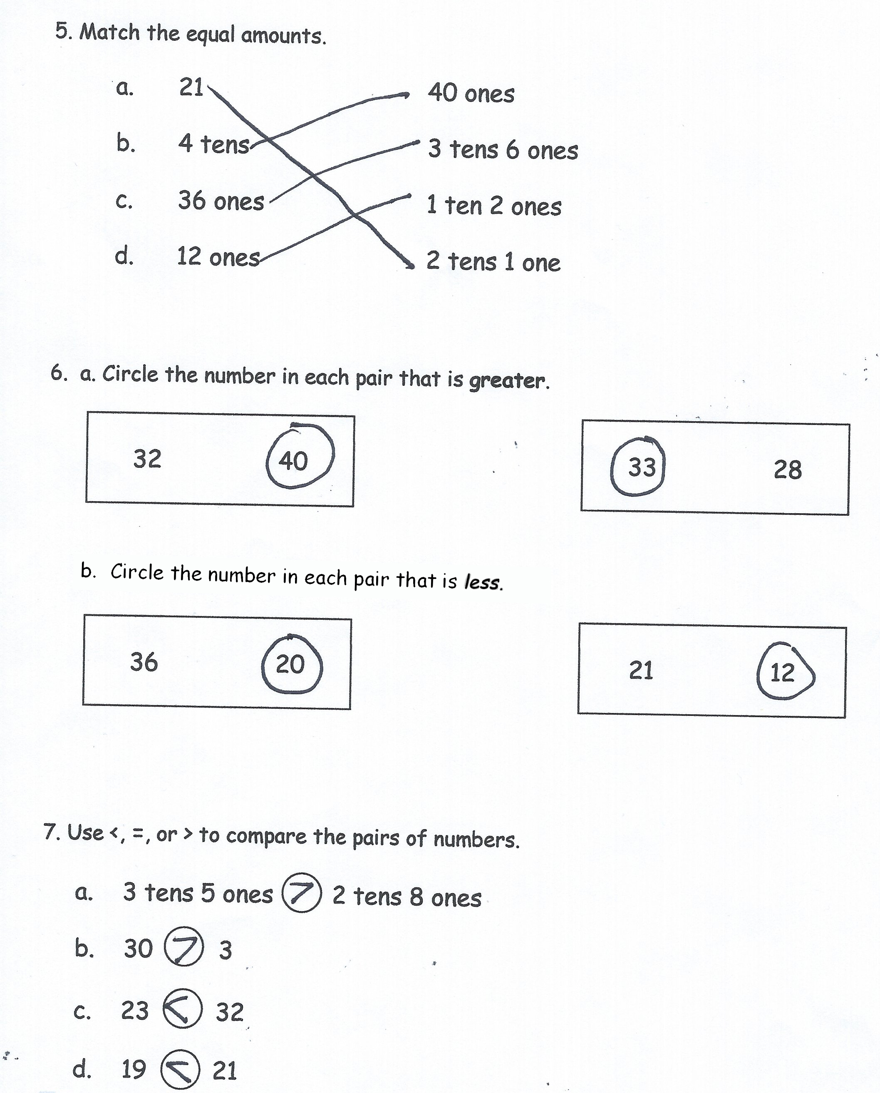
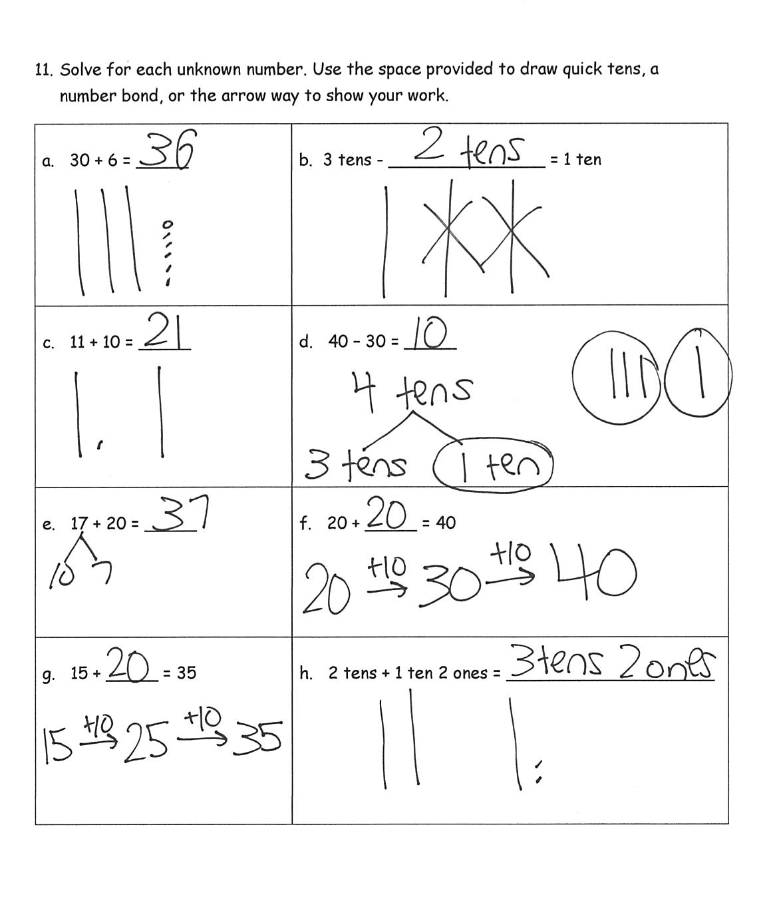
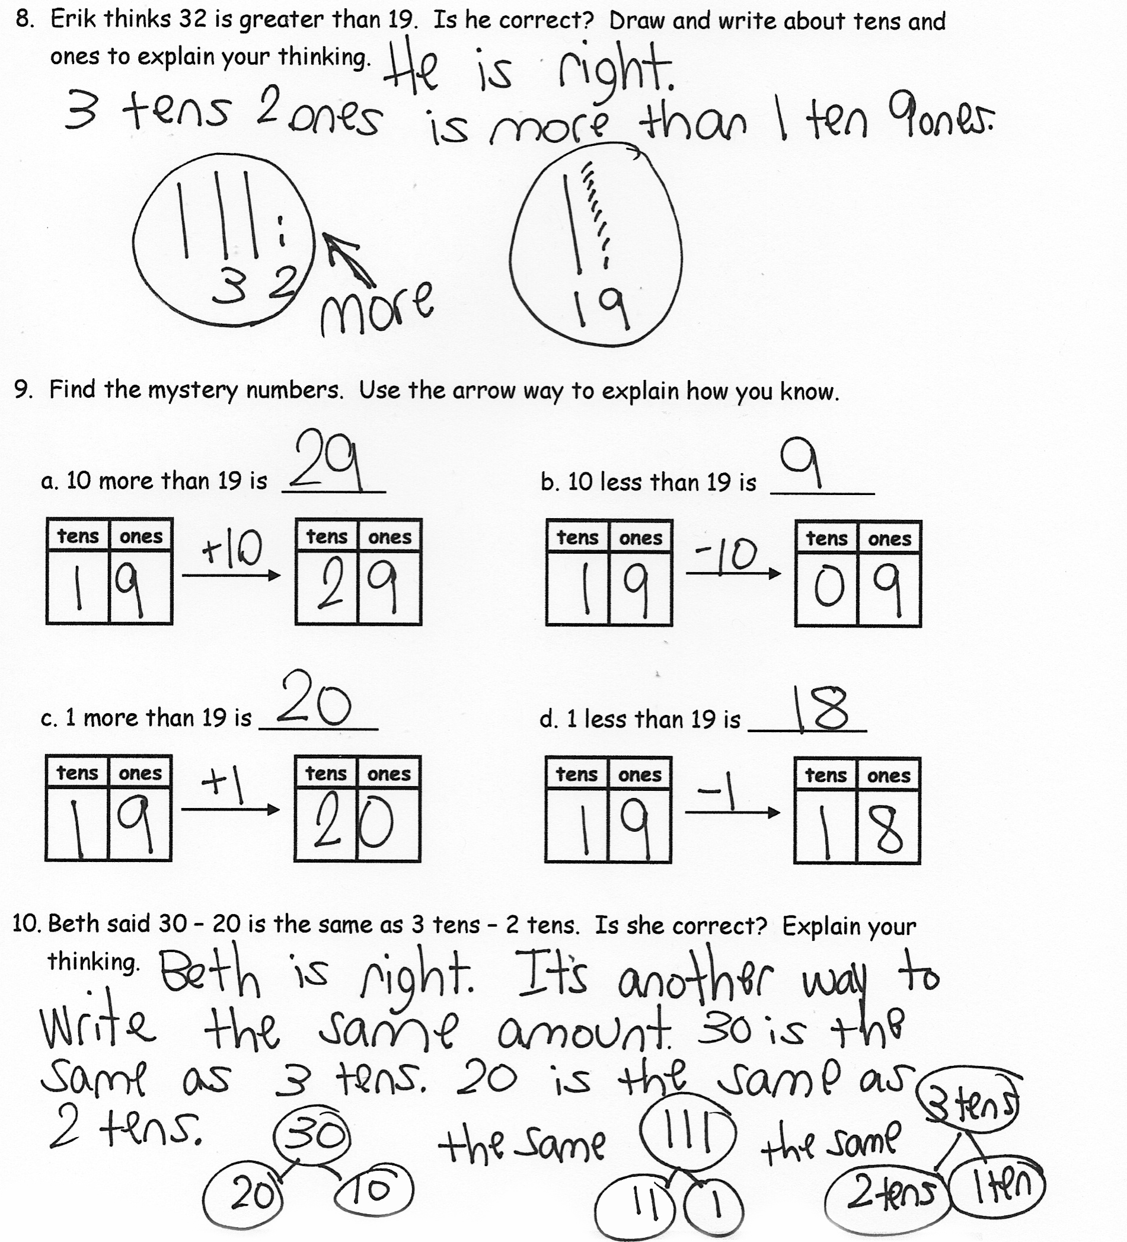

Focus on numbers to 40.
Focus on numbers to 40
Focus on numbers to 40.

