Name Date
- Use the RDW process to solve the following problems. Write the answer in the place value chart.
- Maria is having a party for 17 of her friends. She already invited some friends. She has 12 more invitations to send. How many friends has she already invited?

tens
ones

Maria already invited _____ friends.

- Maria bought 11 red balloons and 8 white balloons. How many balloons did she buy?

Maria bought _____ balloons.
tens
ones

- Maria had 17 friends at her party. Some of them went outside to see the piñata. There were 4 friends remaining in the room. How many friends went outside?

_____ friends went outside.
tens
ones

- Fill in the missing numbers in each sequence:

  - 27, 28, _____, _____, _____, 32 b. _____, 17, _____, 19, _____

  - Mark says that 34 is the same as 2 tens and 14 ones. Suki says that 34 is the same as 34 ones. Are they correct? Explain your thinking.

  - Use <, =, or > to compare the pairs of numbers.
i. 3 tens 25 ones
30 3
ii. 1 tens 14 ones 2 tens 4 ones
iii. 33 2 tens 12 ones
iv. 26 1 ten 25 ones

  - Find the mystery numbers. Use the place value charts to show how you know.
10 less than 29 is ________.
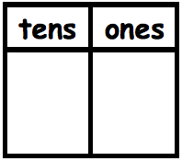

1 less than 29 is ________.
10 more than 29 is _______.

1 more than 29 is _______.

- Solve for each unknown number. Use the space provided to draw quick tens, a number bond, or the arrow way to show your work. You may use your kit of
ten-sticks if needed.
a. 18 + 3 = ____ | b. 28 + 10 = ____ | c. 40 - 30 = ____
d. 28 + 2 = ____ | e. 28 + 6 = ____ | f. 28 + 12 = ____
g. 15 + 15 = ____ | h. 19 + 14 = ____ | i. 16 + 18 = ____

End-of-Module Assessment Task  Standards Addressed | Topics A–F
Represent and solve problems involving addition and subtraction.
1.OA.1 Use addition and subtraction within 20 to solve word problems involving situations of adding to, taking from, putting together, taking apart, and comparing, with unknowns in all positions, e.g., by using objects, drawings, and equations with a symbol for the unknown number to represent the problem. (See CCLS Glossary, Table 1.)
Extend the counting sequence.
1.NBT.1 Count to 120, starting at any number less than 120. In this range, read and write numerals and represent a number of objects with a written numeral.
Understand place value.
1.NBT.2 Understand that the two digits of a two-digit number represent amounts of tens and ones. Understand the following as special cases:
a. 10 can be thought of as a bundle of ten ones—called a “ten.”
c. The numbers 10, 20, 30, 40, 50, 60, 70, 80, 90 refer to one, two, three, four, five, six, seven, eight, or nine tens (and 0 ones).
1.NBT.3 Compare two two-digit numbers based on meaning of the tens and ones digits, recording the results of comparisons with the symbols >, =, and <.
Use place value understanding and properties of operations to add and subtract.
1.NBT.4 Add within 100, including adding a two-digit number and a one-digit number, and adding a two-digit number and a multiple of 10, using concrete models or drawings and strategies based on place value, properties of operations, and/or the relationship between addition and subtraction; relate the strategy to a written method and explain the reasoning used. Understand that in adding two-digit numbers, one adds tens and tens, ones and ones; and sometimes it is necessary to compose a ten.
1.NBT.5 Given a two-digit number, mentally find 10 more or 10 less than the number, without having to count; explain the reasoning used.
1.NBT.6 Subtract multiples of 10 in the range 10–90 from multiples of 10 in the range 10–90 (positive or zero differences), using concrete models or drawings and strategies based on place value, properties of operations, and/or relationship between addition and subtraction; relate the strategy to a written method and explain the reasoning used.

Evaluating Student Learning Outcomes
A Progression Toward Mastery is provided to describe steps that illuminate the gradually increasing understandings that students develop on their way to proficiency. In this chart, this progress is presented from left (Step 1) to right (Step 4). The learning goal for students is to achieve Step 4 mastery. These steps are meant to help teachers and students identify and celebrate what the students CAN do now and what they need to work on next.
A Progression Toward Mastery
Assessment  Task Item  and  Standards Assessed | STEP 1  Little evidence of reasoning without a correct answer.  (1 Point) | STEP 2  Evidence of some reasoning without a correct answer.  (2 Points) | STEP 3  Evidence of some reasoning with a correct answer or evidence of solid reasoning with an incorrect answer.  (3 Points) | STEP 4  Evidence of solid reasoning with a correct answer.  (4 Points)
1  1. OA.1  1. NBT. 2 | The student’s answers are incorrect, and there is no evidence of reasoning. | The student’s answers are incorrect, but there is evidence of reasoning. For example, the student is able to write a number sentence. | The student’s answers are correct, but the responses are incomplete (e.g., may be missing labels for the drawing, an addition sentence, or an explanation). The student’s work is essentially strong. | The student correctly does the following:  - Solves each word problem.  - Maria already invited 5 friends.  - Maria bought 19 balloons.  - 13 friends went outside.  - Labels drawing and includes number sentence and statement.  - Completes place value charts  - 0–5  - 1–9  - 1–3
2  1.NBT.1 | The student is unable to complete any sequence of numbers. | The student completes at least part of one sequence. | The student completes at least one sequence, as well as at least one number in the additional sequence. | The student identifies all numbers in the sequences:  - 27, 28, 29, 30, 31, 32  - 16, 17, 18, 19, 20
3  1.NBT.2  1.NBT.3  1.NBT.5 | The student does not demonstrate understanding of comparing numbers based on tens and ones. Fewer than one section is correctly answered. | The student demonstrates inconsistent understanding of tens and ones, answering a few of the parts correctly within a section, but showing errors in understanding in at least two of the three sections. | The student demonstrates understanding of tens and ones and is able to generally compare the quantities. The student correctly answers all parts of two out of the three sections. | The student correctly does the following:  - Uses drawings or words to explain that they are both correct. 1 ten and 24 ones is the same as 34 ones.  - Answers  - >  - =  - >  - <  - Identifies mystery numbers as 39, 19, 30, 28, respectively, and accurately completes the charts to depict the arrow way.
4  1.NBT.4  1.NBT.6 | The student answers two or fewer questions correctly. | The student answers at least three of nine correctly and demonstrates misunderstandngs of place value. | The student answers at least six of nine correctly.  OR  The student uses sound process throughout with calculation errors. | The student correctly does the following:  - Solves  - 21  - 38  - 10  - 30  - 34  - 40  - 30  - 33  - 34  - Represents process to accurately solve through drawings, number bonds, or the arrow way. The notation demonstrates use of a sound strategy for adding or subtracting.

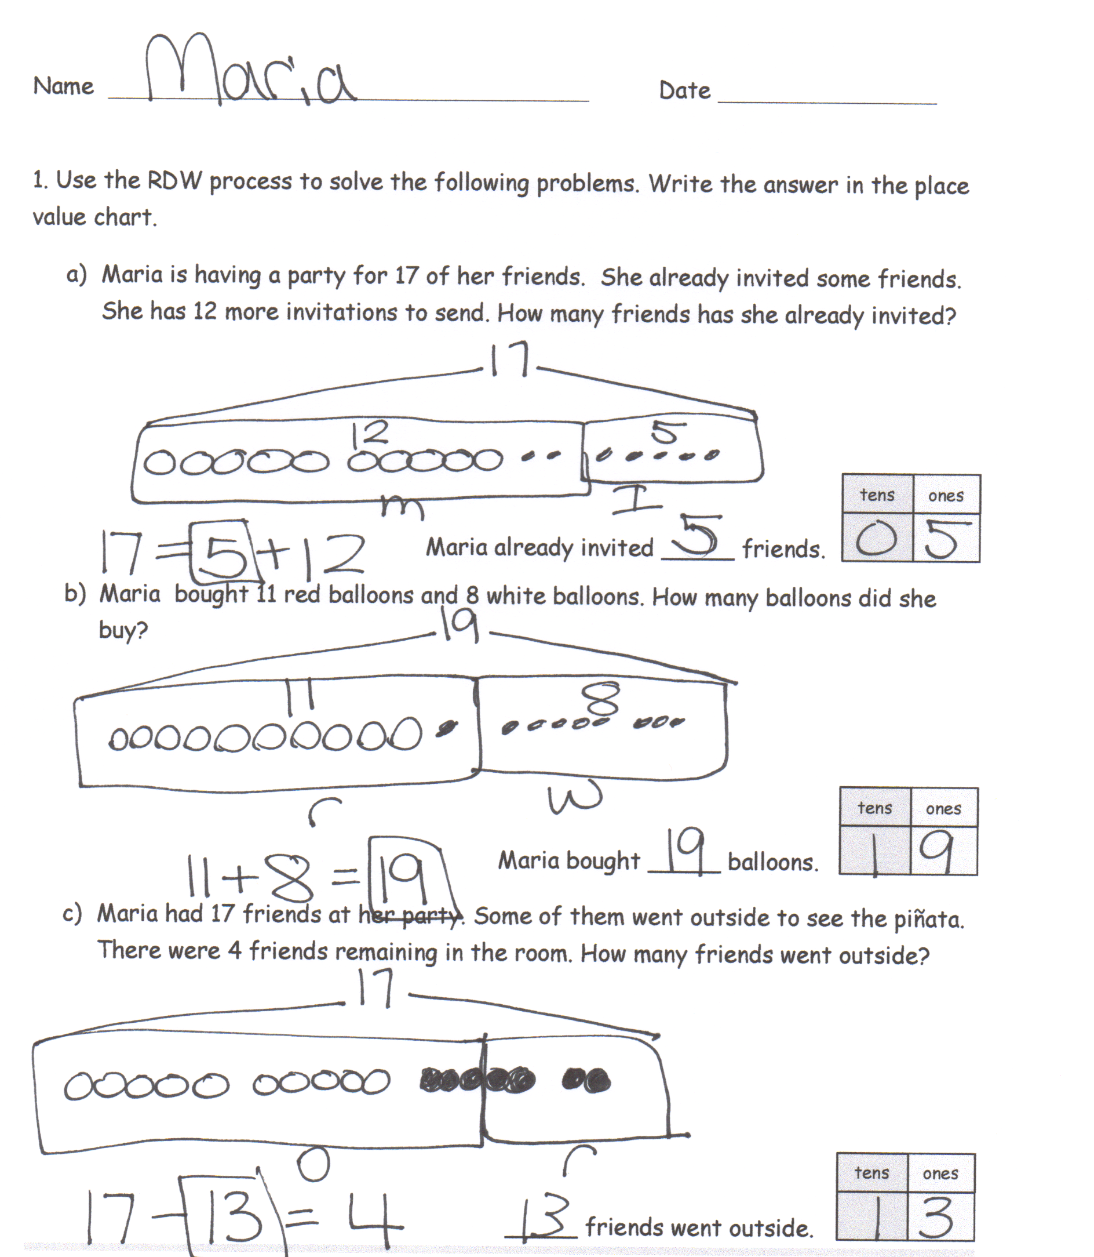
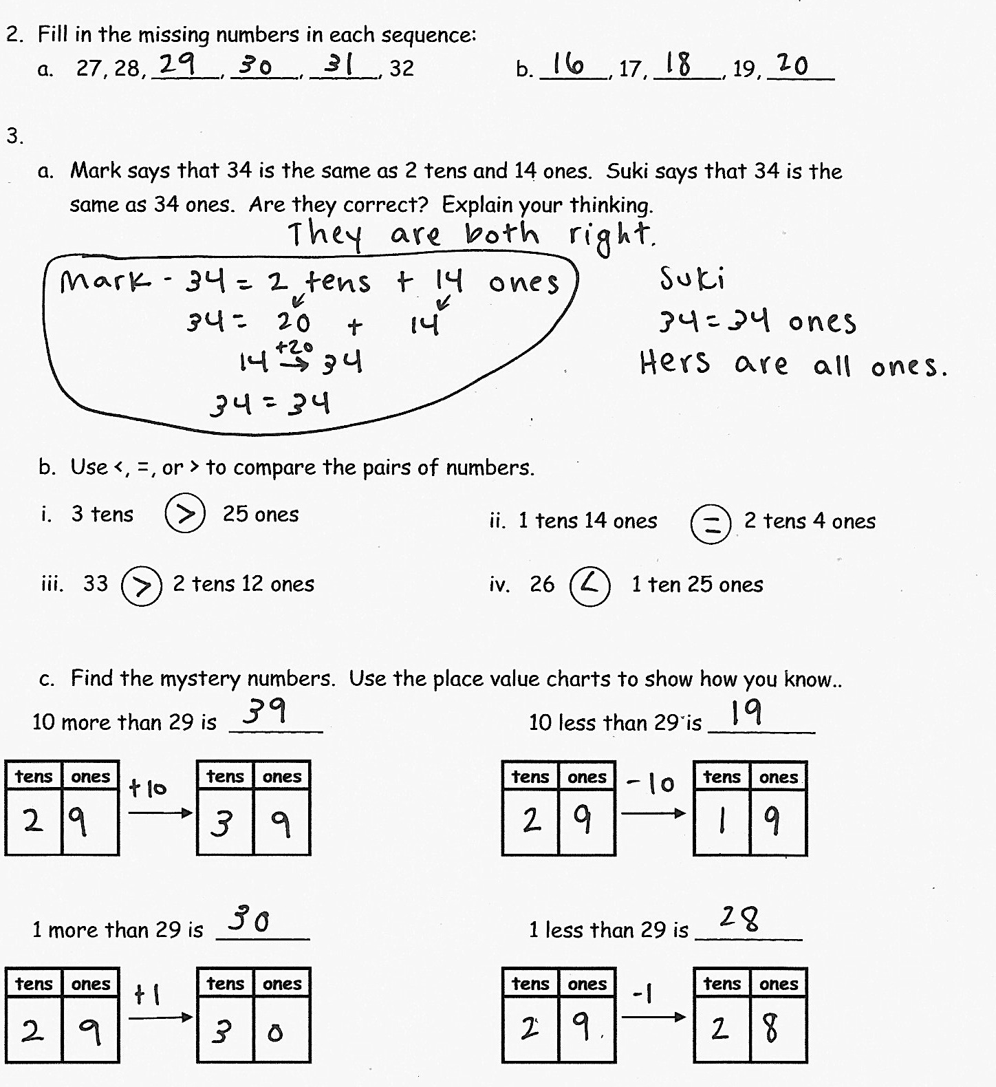
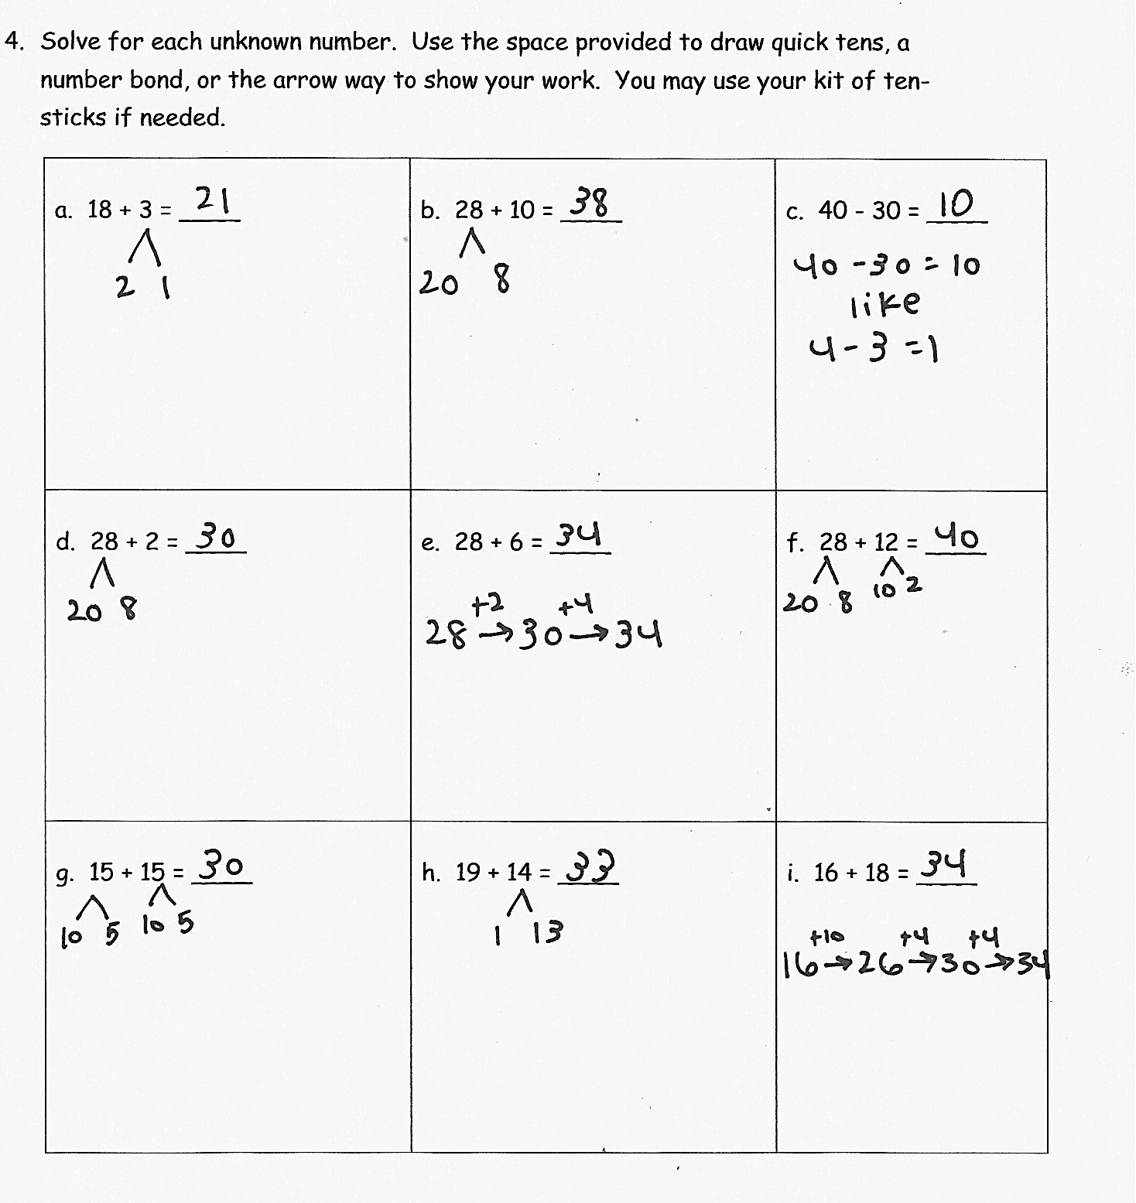

Focus on numbers to 40.
Focus on numbers to 40
Focus on numbers to 40.

