Name Date
- $△ABC≅ △A'B'C'$. Use the picture to answer the question below.

A
B
C
B’
A’
C’

Describe a sequence of rigid motions that would prove a congruence between $△ABC$ and $△A'B'C'$.

- Use the diagram to answer the question below.
$$k||l$$
$$k$$
$$l$$
$$A$$
$$B$$
$$C$$
$$D$$
$$E$$

Line $k$ is parallel to line $l$. $m ∠ EDC=41°$ and $m ∠ ABC=32°$. Find the $m ∠ BCD$. Explain in detail how you know you are correct. Add additional lines and points as needed for your explanation.

- Use the diagram below to answer the questions that follow. Lines $L_{1}$ and $L_{2}$ are parallel, $L_{1}∥L_{2}$. Point $N$ is the midpoint of segment $GH$.
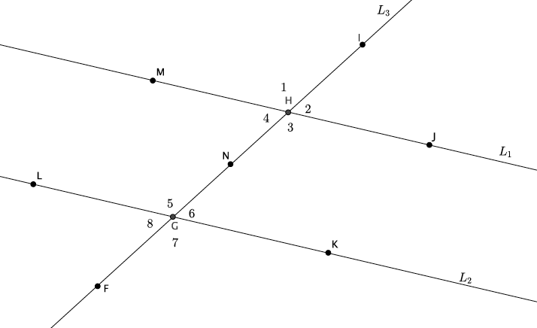

  - If $∠IHM=125°$, what is the measure of $∠IHJ$? $∠JHN$? $∠NHM$?

  - What can you say about the relationship between $∠4$ and $∠6$? Explain using a basic rigid motion. Name another pair of angles with this same relationship.

  - What can you say about the relationship between $∠1$ and $∠5$? Explain using a basic rigid motion. Name another pair of angles with this same relationship.

A Progression Toward Mastery
Assessment  Task Item |  | STEP 1  Missing or incorrect answer and little evidence of reasoning or application of mathematics to solve the problem. | STEP 2  Missing or incorrect answer but evidence of some reasoning or application of mathematics to solve the problem. | STEP 3  A correct answer with some evidence of reasoning or application of mathematics to solve the problem, or an incorrect answer with substantial evidence of solid reasoning or application of mathematics to solve the problem. | STEP 4  A correct answer supported by substantial evidence of solid reasoning or application of mathematics to solve the problem.
1 | 8.G.A.2 | Student is s unable to respond to the question or left item blank. Student does not describe a sequence.  Student shows no reasoning or application of mathematics to solve the problem. | Student identifies an incorrect sequence of rigid motions. Student uses little or no mathematical vocabulary or notation in sequence.  Some evidence of mathematical reasoning is used in sequence. | Student identifies a correct sequence of rigid motions but lacks precision. Student may or may not use mathematical vocabulary or notation sequence. Some evidence of mathematical reasoning is used in sequence. | Student identifies a correct sequence of rigid motions with precision.  Student uses mathematical vocabulary and notation in sequence. Substantial evidence of mathematical reasoning is used in sequence.
2 | 8.G.A.5 | Student is unable to respond to the questions or leaves items blank. Student shows no reasoning or application of mathematics to solve the problem. | Student calculates the measurement of the angle but makes calculation errors.  Student attempts to use auxiliary lines to solve the problem. Student shows little or no reasoning in written explanation.  Student does not use any theorem in written explanation. | Student calculates the measurement of the angle but makes calculation errors. Student uses auxiliary lines to solve the problem. Student shows some reasoning in written explanation.  Student may or may not use the correct theorem in the written explanation. | Student calculates the measurement of the angle correctly as $73°$. Student uses auxiliary lines to solve the problem. Student shows substantial reasoning in written explanation including information about congruent angles being equal, straight angles having $180°$, triangle sum being $180°$, sum of remote interior angles equal to exterior angle of a triangle, etc.
3 | a  8.G.A.5 | Student is unable to respond to the questions or leaves items blank.  Student shows no reasoning or application of mathematics to solve the problem. | Student makes calculation errors.  Student answers part of the question correctly, i.e., $∠IHM=∠JHN=125°$ but omits  $∠IHJ=∠NHM=55°$ or answers with all four angles as the same measure. | Student shows some application of mathematics to solve the problem.  Student makes calculation errors.  Student reverses the answers, i.e.,  $∠IHM=∠JHN=55°$ or  $$∠IHJ=∠NHM=125°.$$ | Student answers correctly with  $$∠IHM=∠JHN=125°$$  and  $∠IHJ=∠NHM=55°$  for measures of ALL four angles.
 | b  8.G.A.5 | Student is unable to respond to the questions or leaves items blank. Student shows no reasoning or application of mathematics to solve the problem. Student does not include a written explanation. | Student answers the name of the angles incorrectly. Student incorrectly identifies the other angles with the same relationship.  Student includes a written explanation. Student references a rigid motion, translation, rotation, reflection.  Written explanation is not mathematically based, e.g., “they look the same.” | Student may answer the name of the angles incorrectly but correctly identifies the other angles with the same relationship.  Student uses some mathematical vocabulary in written explanation. Student references rotation but may not reference all of the key points in written explanation. | Student answers correctly by calling the angles Alternate Interior Angles. Student names $∠3$ and $∠5$ as angles with the same relationship. Student uses mathematical vocabulary in written explanation.  Student references ALL of the following key points: $N$ is the midpoint of $HG$, rotation of $180°$ around $N$, and rotation is angle-preserving in the written explanation. Written explanation is thorough and complete.
 | c  8.G.A.5 | Student is unable to respond to the questions or leaves items blank. Student shows no reasoning or application of mathematics to solve the problem. Student does not include a written explanation. | Student ma answers the name of the angles incorrectly. Student incorrectly identifies the other angles with the same relationship.  Student includes a written explanation. Student references a rigid motion, translation, rotation, reflection.  Written explanation is not mathematically based, e.g., “they look the same.” | Student identifies the name of the angles incorrectly but does correctly identify the other angles with the same relationship.  Student uses some mathematical vocabulary in written explanation. Student references translation but may not reference all of the key points in written explanation. | Student answers correctly by calling the angles corresponding angles. Student names $∠2$ and $∠6$ (or $∠3$ and $∠7$ or $∠4$ and $∠8$) as angles with the same relationship. Student uses mathematical vocabulary in written explanation. Student references ALL of the following key points: translation along vector $HG$, translation maps parallel lines to parallel lines, and translation is angle-preserving in written explanation.  Written explanation is thorough and complete.
Name Date
- $△ABC≅ △A'B'C'$. Use the picture to answer the question below.

Describe a sequence of rigid motions that would prove a congruence between $△ABC$ and $△A'B'C'$.

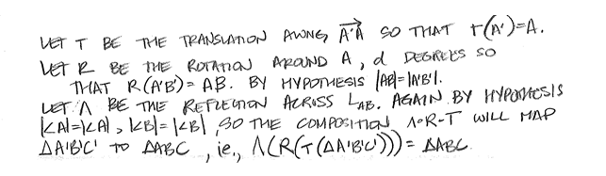

- Use the diagram to answer the question below.
$$k||l$$

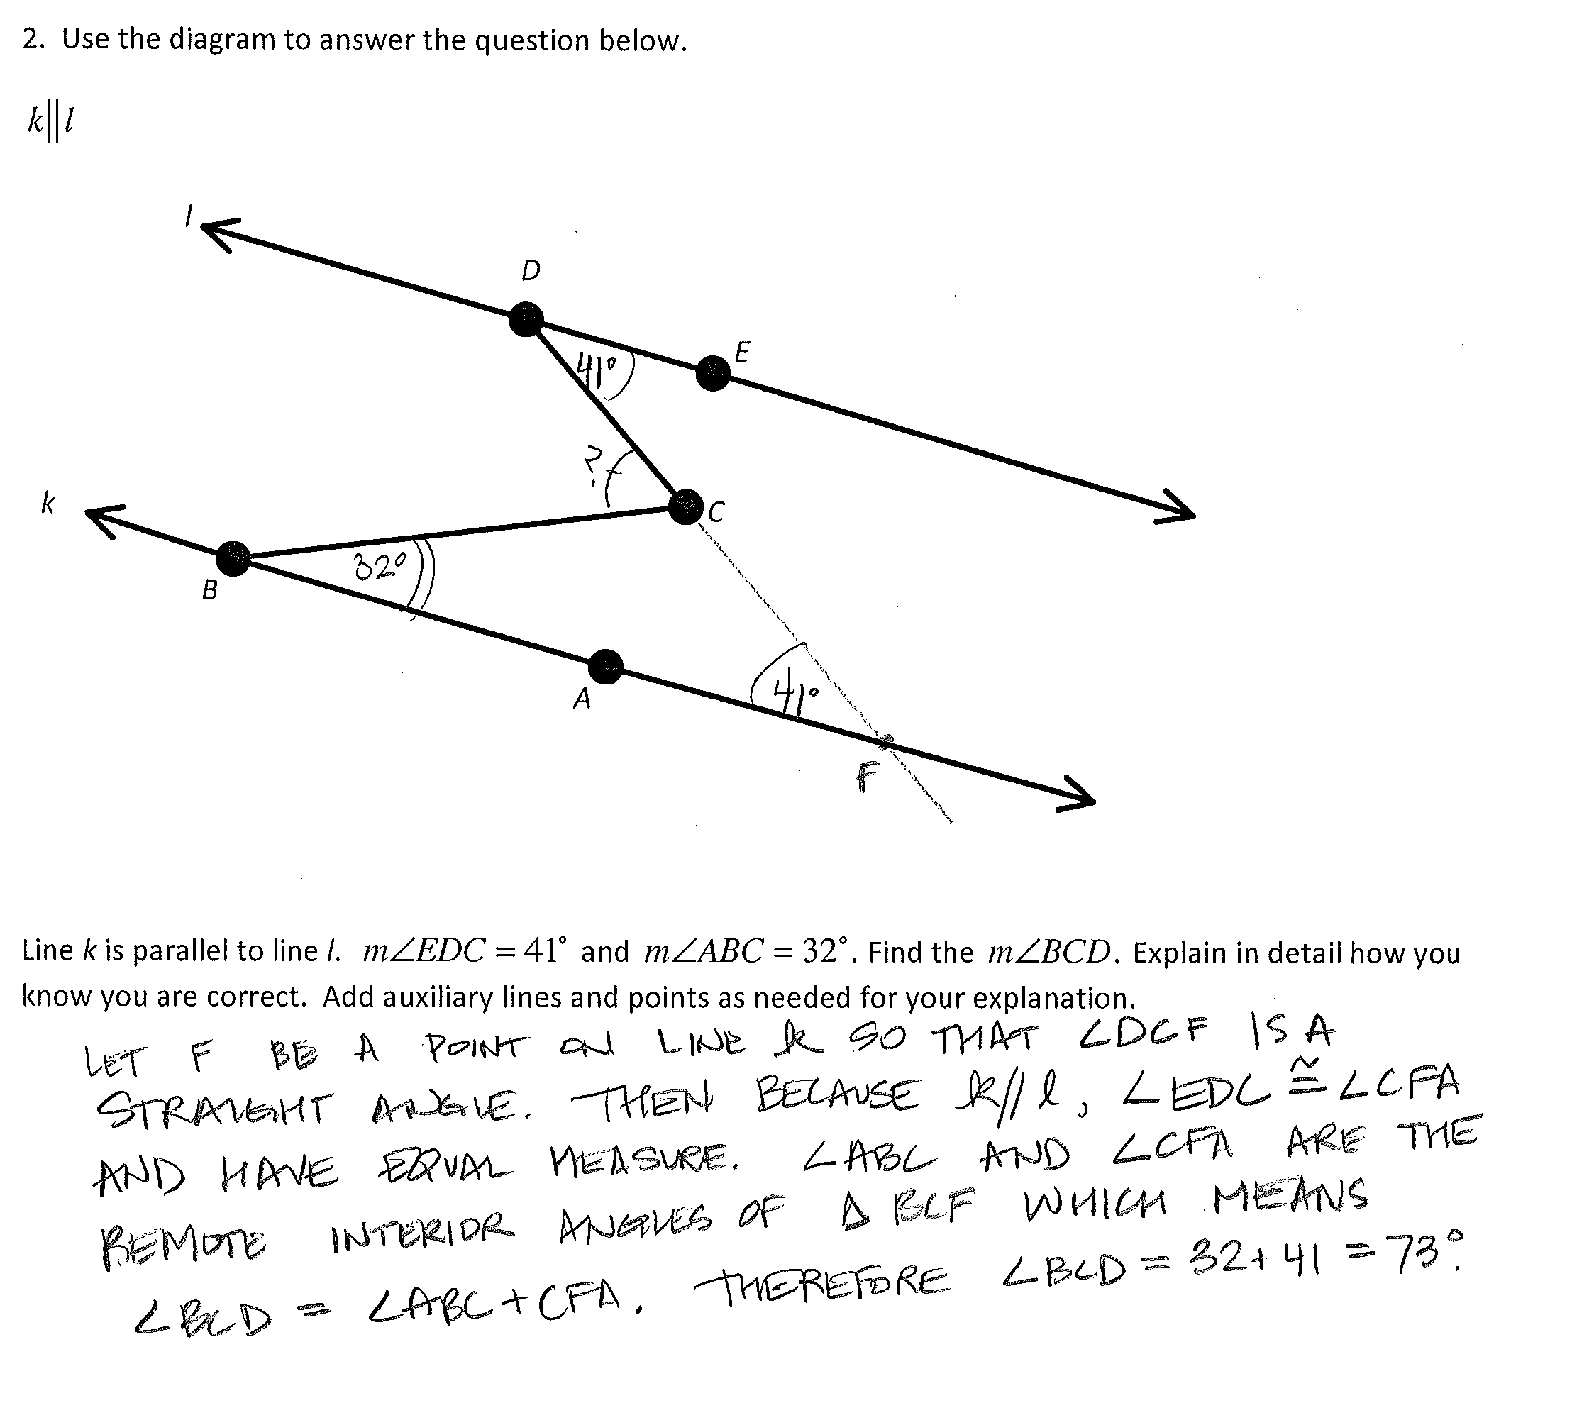

Line $k$ is parallel to line $l$. $m ∠ EDC=41°$ and $m ∠ ABC=32°$. Find the $m ∠ BCD$. Explain in detail how you know you are correct. Add additional lines and points as needed for your explanation.

- Use the diagram below to answer the questions that follow. Lines $L_{1}$ and $L_{2}$ are parallel, $L_{1}∥L_{2}$. Point $N$ is the midpoint of segment $GH$.
  - If $∠IHM=125°$, what is the measure of $∠IHJ$? $∠JHN$? $∠NHM$?

  - What can you say about the relationship between $∠4$ and $∠6$? Explain using a basic rigid motion. Name another pair of angles with this same relationship.

  - What can you say about the relationship between $∠1$ and $∠5$? Explain using a basic rigid motion. Name another pair of angles with this same relationship.

