Table of Contents

GRADE 4 • MODULE 3
Multi-Digit Multiplication and Division

Module Overview i

Topic A: Multiplicative Comparison Word Problems 3.A.1

Topic B: Multiplication by 10, 100, and 1,000 3.B.1

Topic C: Multiplication of up to Four Digits by Single-Digit Numbers 3.C.1

Topic D: Multiplication Word Problems 3.D.1

Topic E: Division of Tens and Ones with Successive Remainders 3.E.1

Topic F: Reasoning with Divisibility 3.F.1

Topic G: Division of Thousands, Hundreds, Tens, and Ones 3.G.1

Topic H: Multiplication of Two-Digit by Two-Digit Numbers 3.H.1

Module Assessments 3.S.1

Grade 4 • Module 3
Multi-Digit Multiplication and Division
OVERVIEW
In this 43-day module, students use place value understanding and visual representations to solve multiplication and division problems with multi-digit numbers. As a key area of focus for Grade 4, this module moves slowly but comprehensively to develop students’ ability to reason about the methods and models chosen to solve problems with multi-digit factors and dividends.
Students begin in Topic A by investigating the formulas for area and perimeter. They then solve multiplicative comparison problems including the language of times as much as with a focus on problems using area and perimeter as a context (e.g., “A field is 9 feet wide. It is 4 times as long as it is wide. What is the perimeter of the field?”). Students create diagrams to represent these problems as well as write equations with symbols for the unknown quantities (4.OA.1). This is foundational for understanding multiplication as scaling in Grade 5 and sets the stage for proportional reasoning in Grade 6. This Grade 4 module, beginning with area and perimeter, allows for new and interesting word problems as students learn to calculate with larger numbers and interpret more complex problems (4.OA.2, 4.OA.3, 4.MD.3).
In Topic B, students use place value disks to multiply single-digit numbers by multiples of 10, 100, and 1,000 and two-digit multiples of 10 by two-digit multiples of 10 (4.NBT.5). Reasoning between arrays and written numerical work allows students to see the role of place value units in multiplication (as pictured below). Students also practice the language of units to prepare them for multiplication of a single-digit factor by a factor with up to four digits and multiplication of two two-digit factors.
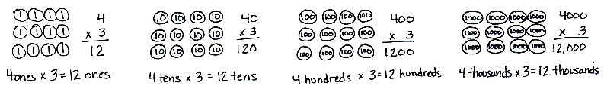

In preparation for two-digit by two-digit multiplication, students practice the new complexity of multiplying two two-digit multiples of 10. For example, students have multiplied 20 by 10 on the place value chart and know that it shifts the value one place to the left, 10 × 20 = 200. To multiply 20 by 30, the associative property allows for simply tripling the product, 3 × (10 × 20), or multiplying the units, 3 tens × 2 tens = 6 hundreds (alternatively, (3 × 10) × (2 × 10) = (3 × 2) × (10 × 10)). Introducing this early in the module allows students to practice during fluency so that, by the time it is embedded within the two-digit by two-digit multiplication in Topic H, understanding and skill are in place.
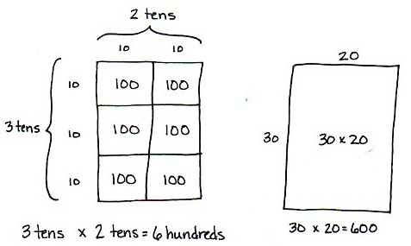
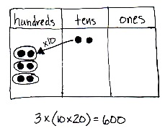

Building on their work in Topic B, students begin in Topic C decomposing numbers into base ten units in order to find products of single-digit by multi-digit numbers. Students use the distributive property and multiply using place value disks to model. Practice with place value disks is used for two-, three-, and four-digit by one-digit multiplication problems with recordings as partial products. Students bridge partial products to the recording of multiplication via the standard algorithm. Finally, the partial products method, the standard algorithm, and the area model are compared and connected by the distributive property (4.NBT.5).

1,423 x 3
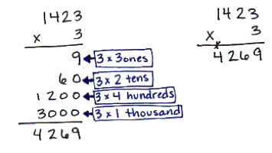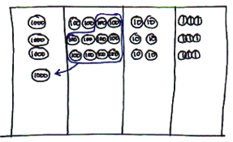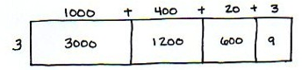

Topic D gives students the opportunity to apply their new multiplication skills to solve multi-step word problems (4.OA.3, 4.NBT.5) and multiplicative comparison problems (4.OA.2). Students write equations from statements within the problems (4.OA.1) and use a combination of addition, subtraction, and multiplication to solve.
In Topic E, students synthesize their Grade 3 knowledge of division types (group size unknown and number of groups unknown) with their new, deeper understanding of place value.
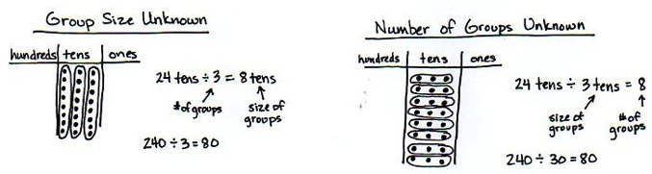

Students focus on interpreting the remainder within division problems, both in word problems and long division (4.OA.3). A remainder of 1, as exemplified below, represents a leftover flower in the first situation and a remainder of 1 ten in the second situation.
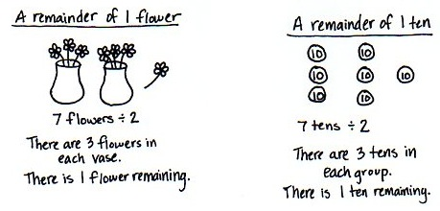

While we have no reason to subdivide a remaining flower, there are good reasons to subdivide a remaining ten. Students apply this simple idea to divide two-digit numbers unit by unit: dividing the tens units first, finding the remainder (the number of tens unable to be divided), and decomposing remaining tens into ones to then be divided. Students represent division with single-digit divisors using arrays and the area model before practicing with place value disks. The standard division algorithm is practiced using place value knowledge, decomposing unit by unit. Finally, students use the area model to solve division problems, first with and then without remainders (4.NBT.6).

In Topic F, armed with an understanding of remainders, students explore factors, multiples, and prime and composite numbers within 100 (4.OA.4), gaining valuable insights into patterns of divisibility as they test for primes and find factors and multiples. This prepares them for Topic G’s work with multi-digit dividends.
Topic G extends the practice of division with three- and four-digit dividends using place value understanding. A connection to Topic B is made initially with dividing multiples of 10, 100, and 1,000 by single-digit numbers. Place value disks support students visually as they decompose each unit before dividing. Students then practice using the standard algorithm to record long division. They solve word problems and make connections to the area model as was done with two-digit dividends (4.NBT.6, 4.OA.3).
The module closes as students multiply two-digit by two-digit numbers. Students use their place value understanding and understanding of the area model to empower them to multiply by larger numbers (as pictured to the right). Topic H culminates at the most abstract level by explicitly connecting the partial products appearing in the area model to the distributive property and recording the calculation vertically (4.NBT.5). Students see that partial products written vertically are the same as those obtained via the distributive property: 4 twenty-sixes + 30 twenty-sixes = 104 + 780 = 884.
As students progress through this module, they are able to apply the multiplication and division algorithms because of their in-depth experience with the place value system and multiple conceptual models. This helps to prepare them for fluency with the multiplication algorithm in Grade 5 and the division algorithm in Grade 6. Students are encouraged in Grade 4 to continue using models to solve when appropriate.
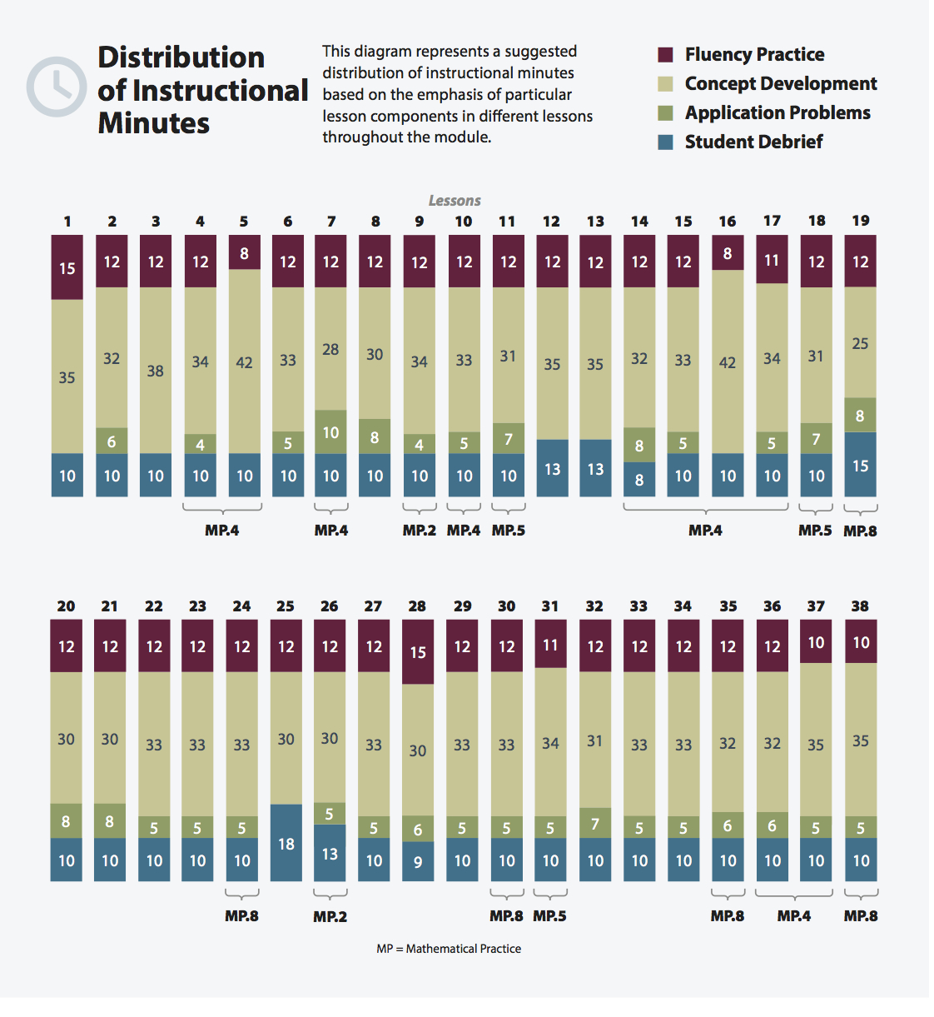

Focus Grade Level Standards
Use the four operations with whole numbers to solve problems.
4.OA.1 Interpret a multiplication equation as a comparison, e.g., interpret 35 = 5 × 7 as a statement that 35 is 5 times as many as 7 and 7 times as many as 5. Represent verbal statements of multiplicative comparisons as multiplication equations.
4.OA.2 Multiply or divide to solve word problems involving multiplicative comparison, e.g., by using drawings and equations with a symbol for the unknown number to represent the problem, distinguishing multiplicative comparison from additive comparison. (See CCLS Glossary, Table 2.)
4.OA.3 Solve multistep word problems posed with whole numbers and having whole-number answers using the four operations, including problems in which remainders must be interpreted. Represent these problems using equations with a letter standing for the unknown quantity. Assess the reasonableness of answers using mental computation and estimation strategies including rounding.
Gain familiarity with factors and multiples.
4.OA.4 Find all factor pairs for a whole number in the range 1–100. Recognize that a whole number is a multiple of each of its factors. Determine whether a given whole number in the range 1–100 is a multiple of a given one-digit number. Determine whether a given whole number in the range 1–100 is prime or composite.
Use place value understanding and properties of operations to perform multi-digit arithmetic.
4.NBT.5 Multiply a whole number of up to four digits by a one-digit whole number, and multiply two two-digit numbers, using strategies based on place value and the properties of operations. Illustrate and explain the calculation by using equations, rectangular arrays, and/or area models.
4.NBT.6 Find whole-number quotients and remainders with up to four-digit dividends and one-digit divisors, using strategies based on place value, the properties of operations, and/or the relationship between multiplication and division. Illustrate and explain the calculation by using equations, rectangular arrays, and/or area models.
Solve problems involving measurement and conversion of measurements from a larger unit to a smaller unit.
4.MD.3 Apply the area and perimeter formulas for rectangles in real world and mathematical problems. For example, find the width of a rectangular room given the area of the flooring and the length, by viewing the area formula as a multiplication equation with an unknown factor.
Foundational Standards
3.OA.3 Use multiplication and division within 100 to solve word problems in situations involving equal groups, arrays, and measurement quantities, e.g., by using drawings and equations with a symbol for the unknown number to represent the problem. (See CCLS Glossary, Table 2.)
3.OA.4 Determine the unknown whole number in a multiplication or division equation relating three whole numbers. For example, determine the unknown number that makes the equation true in each of the equations 8 × ? = 48, 5 = _ ÷ 3, 6 × 6 = ?.
3.OA.5 Apply properties of operations as strategies to multiply and divide. (Students need not use formal terms for these properties.) Examples: If 6 × 4 = 24 is known, then 4 × 6 = 24 is also known. (Commutative property of multiplication.) 3 × 5 × 2 can be found by 3 × 5 = 15, then 15 × 2 = 30, or by 5 × 2 = 10, then 3 × 10 = 30. (Associative property of multiplication.) Knowing that 8 × 5 = 40 and 8 × 2 = 16, one can find 8 × 7 as 8 × (5 + 2) = (8 × 5) + (8 × 2) = 40 + 16 = 56. (Distributive property.)
3.OA.6 Understand division as an unknown-factor problem. For example, find 32 ÷ 8 by finding the number that makes 32 when multiplied by 8.
3.OA.7 Fluently multiply and divide within 100, using strategies such as the relationship between multiplication and division (e.g., knowing that 8 × 5 = 40, one knows 40 ÷ 5 = 8) or properties of operations. By the end of Grade 3, know from memory all products of two one-digit numbers.
3.OA.8 Solve two-step word problems using the four operations. Represent these problems using equations with a letter standing for the unknown quantity. Assess the reasonableness of answers using mental computation and estimation strategies including rounding. (This standard is limited to problems posed with whole numbers and having whole-number answers; students should know how to perform operations in the conventional order when there are no parentheses to specify a particular order, i.e., Order of Operations.)
3.NBT.3 Multiply one-digit whole numbers by multiples of 10 in the range 10–90 (e.g., 9 × 80, 5 × 60) using strategies based on place value and properties of operations.
3.MD.7 Relate area to the operations of multiplication and addition.
3.MD.8 Solve real world and mathematical problems involving perimeters of polygons, including finding the perimeter given the side lengths, finding an unknown side length, and exhibiting rectangles with the same perimeter and different areas or with the same area and different perimeters.

Focus Standards for Mathematical Practice
MP.2 Reason abstractly and quantitatively. Students solve multi-step word problems using the four operations by writing equations with a letter standing in for the unknown quantity.
MP.4 Model with mathematics. Students apply their understanding of place value to create area models and rectangular arrays when performing multi-digit multiplication and division. They use these models to illustrate and explain calculations.
MP.5 Use appropriate tools strategically. Students use mental computation and estimation strategies to assess the reasonableness of their answers when solving multi-step word problems. They draw and label bar and area models to solve problems as part of the RDW process. Additionally, students select an appropriate place value strategy when solving multiplication and division problems.
MP.8 Look for and express regularity in repeated reasoning. Students express the regularity they notice in repeated reasoning when they apply place value strategies in solving multiplication and division problems. They move systematically through the place values, decomposing or composing units as necessary, applying the same reasoning to each successive unit.
Overview of Module Topics and Lesson Objectives
Standards | Topics and Objectives |  | Days
4.OA.1  4.OA.2  4.MD.3  4.OA.3 | A | Multiplicative Comparison Word Problems  Lesson 1: Investigate and use the formulas for area and perimeter of rectangles.  Lesson 2: Solve multiplicative comparison word problems by applying the area and perimeter formulas.  Lesson 3: Demonstrate understanding of area and perimeter formulas by solving multi-step real world problems. | 3
4.NBT.5  4.OA.1  4.OA.2  4.NBT.1 | B | Multiplication by 10, 100, and 1,000  Lesson 4: Interpret and represent patterns when multiplying by 10, 100, and 1,000 in arrays and numerically.  Lesson 5: Multiply multiples of 10, 100, and 1,000 by single digits, recognizing patterns.  Lesson 6: Multiply two-digit multiples of 10 by two-digit multiples of 10 with the area model. | 3

Standards | Topics and Objectives |  | Days
4.NBT.5  4.OA.2  4.NBT.1 | C | Multiplication of up to Four Digits by Single-Digit Numbers  Lesson 7: Use place value disks to represent two-digit by one-digit multiplication.  Lesson 8: Extend the use of place value disks to represent three- and four-digit by one-digit multiplication.  Lessons 9–10: Multiply three- and four-digit numbers by one-digit numbers applying the standard algorithm.  Lesson 11: Connect the area model and the partial products method to the standard algorithm. | 5
4.OA.1  4.OA.2  4.OA.3  4.NBT.5 | D | Multiplication Word Problems  Lesson 12: Solve two-step word problems, including multiplicative comparison.  Lesson 13: Use multiplication, addition, or subtraction to solve multi-step word problems. | 2
 |  | Mid-Module Assessment: Topics A–D (review 1 day, assessment ½ day, return ½ day) | 2
4.NBT.6  4.OA.3 | E | Division of Tens and Ones with Successive Remainders  Lesson 14: Solve division word problems with remainders.  Lesson 15: Understand and solve division problems with a remainder using the array and area models.  Lesson 16: Understand and solve two-digit dividend division problems with a remainder in the ones place by using place value disks.  Lesson 17: Represent and solve division problems requiring decomposing a remainder in the tens.  Lesson 18: Find whole number quotients and remainders.  Lesson 19: Explain remainders by using place value understanding and models.  Lesson 20: Solve division problems without remainders using the area model.  Lesson 21: Solve division problems with remainders using the area model. | 8

4.OA.4 | F | Reasoning with Divisibility  Lesson 22: Find factor pairs for numbers to 100, and use understanding of factors to define prime and composite.  Lesson 23: Use division and the associative property to test for factors and observe patterns.  Lesson 24: Determine if a whole number is a multiple of another number.  Lesson 25: Explore properties of prime and composite numbers to 100 by using multiples. | 4
4.OA.3  4.NBT.6  4.NBT.1 | G | Division of Thousands, Hundreds, Tens, and Ones  Lesson 26: Divide multiples of 10, 100, and 1,000 by single-digit numbers.  Lesson 27: Represent and solve division problems with up to a three-digit dividend numerically and with place value disks requiring decomposing a remainder in the hundreds place.  Lesson 28: Represent and solve three-digit dividend division with divisors of 2, 3, 4, and 5 numerically.  Lesson 29: Represent numerically four-digit dividend division with divisors of 2, 3, 4, and 5, decomposing a remainder up to three times.  Lesson 30: Solve division problems with a zero in the dividend or with a zero in the quotient.  Lesson 31: Interpret division word problems as either number of groups unknown or group size unknown.  Lesson 32: Interpret and find whole number quotients and remainders to solve one-step division word problems with larger divisors of 6, 7, 8, and 9.  Lesson 33: Explain the connection of the area model of division to the long division algorithm for three- and four-digit dividends. | 8
4.NBT.5  4.OA.3  4.MD.3 | H | Multiplication of Two-Digit by Two-Digit Numbers  Lesson 34: Multiply two-digit multiples of 10 by two-digit numbers using a place value chart.  Lesson 35: Multiply two-digit multiples of 10 by two-digit numbers using the area model.  Lesson 36: Multiply two-digit by two-digit numbers using four partial products.  Lessons 37–38: Transition from four partial products to the standard algorithm for two-digit by two-digit multiplication. | 5
 |  | End-of-Module Assessment: Topics A–H (review 1 day, assessment ½ day, return ½ day, remediation or further application 1 day) | 3
Total Number of Instructional Days |  |  | 43
Terminology
New or Recently Introduced Terms
- Associative property (e.g., 96 = 3 × (4 × 8) = (3 × 4) × 8)
- Composite number (positive integer having three or more whole number factors)
- Distributive property (e.g., 64 × 27 = (60 × 20) + (60 × 7) + (4 × 20) + (4 × 7))
- Divisible
- Divisor (the number by which another number is divided)
- Formula (a mathematical rule expressed as an equation with numbers and/or variables)
- Long division (process of dividing a large dividend using several recorded steps)
- Partial product (e.g., 24 × 6 = (20 × 6) + (4 × 6) = 120 + 24)
- Prime number (positive integer greater than 1 having whole number factors of only 1 and itself)
- Remainder (the number left over when one integer is divided by another)
Familiar Terms and Symbols
- Algorithm (steps for base ten computations with the four operations)
- Area (the amount of two-dimensional space in a bounded region)
- Area model (a model for multiplication and division problems that relates rectangular arrays to area, in which the length and width of a rectangle represent the factors for multiplication, and for division the width represents the divisor and the length represents the quotient)
- Array (a set of numbers or objects that follow a specific pattern, a matrix)
- Bundling, grouping, renaming, changing (compose or decompose a 10, 100, etc.)
- Compare (to find the similarity or dissimilarity between)
- Distribute (decompose an unknown product in terms of two known products to solve)
- Divide, division (e.g., 15 ÷ 5 = 3)
- Equation (a statement that the values of two mathematical expressions are equal using the = sign)
- Factors (numbers that can be multiplied together to get other numbers)
- Mixed units (e.g., 1 ft 3 in, 4 lb 13 oz)
- Multiple (product of a given number and any other whole number)
- Multiply, multiplication (e.g., 5 × 3 = 15)
- Perimeter (length of a continuous line forming the boundary of a closed geometric figure)
- Place value (the numerical value that a digit has by virtue of its position in a number)
- Product (the result of multiplication)
- Quotient (the result of division)
- Rectangular array (an arrangement of a set of objects into rows and columns)
- Rows, columns (e.g., in reference to rectangular arrays)
- ___ times as many ___ as ___ (multiplicative comparative sentence frame)
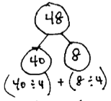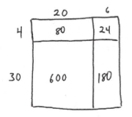Suggested Tools and Representations
Number Bond
Area Model
- Area model
- Grid paper
- Number bond
- Place value disks: suggested minimum of 1 set per pair of students (18 ones, 18 tens, 18 hundreds, 18 thousands, 1 ten thousand)
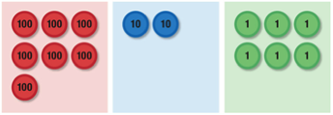
Place Value Disks
Thousands Place Value Chart
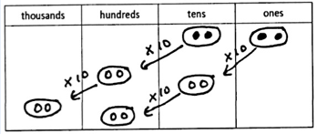

- Tape diagram
- Ten thousands place value chart (Lesson 7 Template)
- Thousands place value chart (Lesson 4 Template)
Scaffolds
The scaffolds integrated into A Story of Units give alternatives for how students access information as well as express and demonstrate their learning. Strategically placed margin notes are provided within each lesson elaborating on the use of specific scaffolds at applicable times. They address many needs presented by English language learners, students with disabilities, students performing above grade level, and students performing below grade level. Many of the suggestions are organized by Universal Design for Learning (UDL) principles and are applicable to more than one population. To read more about the approach to differentiated instruction in A Story of Units, please refer to “How to Implement A Story of Units.”

Assessment Summary
Type | Administered | Format | Standards Addressed
Mid-Module Assessment Task | After Topic D | Constructed response with rubric | 4.OA.1  4.OA.2  4.OA.3  4.NBT.5  4.MD.3
End-of-Module Assessment Task | After Topic H | Constructed response with rubric | 4.OA.1  4.OA.2  4.OA.3  4.OA.4  4.NBT.5  4.NBT.6  4.MD.3

Students become fluent with the standard algorithm for multiplication in Grade 5 (5.NBT.5). Grade 4 students are introduced to the standard algorithm in preparation for fluency and as a general method for solving multiplication problems based on place value strategies, alongside place value disks, partial products, and the area model. Students are not assessed on the standard algorithm in Grade 4.
Note that care must be taken in the interpretation of remainders. Consider the fact that 7 ÷ 3 is not equal to 5 ÷ 2 because the remainder of 1 is in reference to a different whole amount ($2\frac{1}{3}$ is not equal to $2\frac{1}{2}$).
Students become fluent with the standard division algorithm in Grade 6 (6.NS.2). For adequate practice in reaching fluency, students are introduced to, but not assessed on, the division algorithm in Grade 4 as a general method for solving division problems.
4.NBT.4 is addressed in Module 1 and is then reinforced throughout the year.
4.MD.1 is addressed in Modules 2 and 7; 4.MD.2 is addressed in Modules 2, 5, 6, and 7.
These are terms and symbols students have used or seen previously.
Students with disabilities may require Braille, large print, audio, or special digital files. Please visit the website www.p12.nysed.gov/specialed/aim for specific information on how to obtain student materials that satisfy the National Instructional Materials Accessibility Standard (NIMAS) format.

