Name Date
- Draw an area model to solve the following. Find the value of the following expressions.

- 30 × 60

- 3 × 269

- Use any place value strategy to multiply.

- 3 × 68
- 4 × 371

- 7 × 1,305
- 6,034 × 5

Solve using a model or equation. Show your work and write your answer as a statement.
- A movie theater has two rooms. Room A has 9 rows of seats with 18 seats in each row. Room B has three times as many seats as Room A. How many seats are there in both rooms?

- The high school art teacher has 9 cases of crayons with 52 boxes in each case. The elementary school art teacher has 6 cases of crayons with 104 boxes in each case. How many total boxes of crayons do both teachers have? Is your answer reasonable? Explain.

- Last year, Mr. Petersen’s rectangular garden had a width of 5 meters and an area of 20 square meters. This year, he wants to make the garden three times as long and two times as wide.

  - Solve for the length of last year’s garden using the area formula. Then, draw and label the measurements of this year’s garden.

Last Year This Year
20 square meters

5 m

_____ m

  - How much area for planting will Mr. Petersen have in the new garden?

  - Last year, Mr. Petersen had a fence all the way around his garden. He can reuse all of the fence he had around the garden last year, but he needs to buy more fencing to go around this year’s garden. How many more meters of fencing is needed for this year’s garden than last year’s?

  - Last year, Mr. Petersen was able to plant 4 rows of carrots with 13 plants in each row. This year, he plans to plant twice as many rows with twice as many carrot plants in each. How many carrot plants will he plant this year? Write a multiplication equation to solve. Assess the reasonableness of your answer.
Mid-Module Assessment Task  Standards Addressed | Topics A–D
Use the four operations with whole numbers to solve problems.
4.OA.1 Interpret a multiplication equation as a comparison, e.g., interpret 35 = 5 × 7 as a statement that 35 is 5 times as many as 7 and 7 times as many as 5. Represent verbal statements of multiplicative comparisons as multiplication equations.
4.OA.2 Multiply or divide to solve word problems involving multiplicative comparison, e.g., by using drawings and equations with a symbol for the unknown number to represent the problem, distinguishing multiplicative comparison from additive comparison.
4.OA.3 Solve multistep word problems posed with whole numbers and having whole-number answers using the four operations, including problems in which remainders must be interpreted. Represent these problems using equations with a letter standing for the unknown quantity. Assess the reasonableness of answers using mental computation and estimation strategies including rounding.
Use place value understanding and properties of operations to perform multi-digit arithmetic.
4.NBT.5 Multiply a whole number of up to four digits by a one-digit whole number, and multiply two two-digit numbers, using strategies based on place value and the properties of operations. Illustrate and explain the calculation by using equations, rectangular arrays, and/or area models.
Solve problems involving measurement and conversion of measurements from a larger unit to a smaller unit.
4.MD.3 Apply the area and perimeter formulas for rectangles in real world and mathematical problems. For example, find the width of a rectangular room given the area of the flooring and the length, by viewing the area formula as a multiplication equation with an unknown factor.
Evaluating Student Learning Outcomes
A Progression Toward Mastery is provided to describe steps that illuminate the gradually increasing understandings that students develop on their way to proficiency. In this chart, this progress is presented from left (Step 1) to right (Step 4). The learning goal for each student is to achieve Step 4 mastery. These steps are meant to help teachers and students identify and celebrate what the student CAN do now, and what they need to work on next.
A Progression Toward Mastery
Assessment  Task Item | STEP 1  Little evidence of reasoning without a correct answer.  (1 Point) | STEP 2  Evidence of some reasoning without a correct answer.  (2 Points) | STEP 3  Evidence of some reasoning with a correct answer or evidence of solid reasoning with an incorrect answer.  (3 Points) | STEP 4  Evidence of solid reasoning with a correct answer.  (4 Points)
1  4.NBT.5 | The student is unable to complete both area models with correct calculations. | The student correctly solves one part using the area model. | The student correctly solves both parts but has an error in one of the area models, or the student represents both area models correctly but miscalculates for one part. | The student correctly completes all components—draws area model for each problem with correct answer:  - 1,800  - 807
2  4.NBT.5 | The student is unable to solve more than one problem correctly. | The student correctly solves at least two of the four problems with evidence of some place value knowledge. | The student correctly solves at least three of the problems showing reasoning through a place value strategy, or the student correctly answers four problems, only showing solid reasoning for three problems. | Student correctly answers all parts, showing all work using area models, partial products, or the general method:  - 204  - 1,484  - 9,135  - 30,170
3  4.OA.1  4.OA.2  4.OA.3  4.NBT.5 | The student answers incorrectly with little attempt at solving the problem. | The student attempts to use an equation or model, resulting in an incorrect answer. | The student solves using an equation or model but with an incorrect answer, or answers correctly showing only some reasoning. | The student correctly answers 648 seats in an answer statement and uses an equation or model correctly to solve.
4  4.NBT.5  4.OA.1  4.OA.3 | The student answers incorrectly and provides little or no evidence of reasoning through estimation. | The student answers incorrectly but shows some evidence in reasoning through estimation. | The student correctly answers 1,092 boxes using a model or equation accurately but is unable to clearly reason using estimation, or the student provides clear reasoning and an attempt at solving but provides an incorrect answer. | The student correctly answers 1,092 boxes in an answer statement, uses an area model or equation to solve, and validates the reasonableness of his answer through estimation.
5  4.NBT.5  4.OA.1  4.OA.2  4.OA.3  4.MD.3 | The student shows little to no reasoning and answers more than two parts incorrectly. | The student correctly answers two of four parts, showing little reasoning in Part (d) and little evidence of place value understanding. | The student answers three of the four parts correctly, or answers all four parts correctly with unclear reasoning in Part (d), or doesn’t show solid evidence of place value understanding in all solutions. | The student correctly answers:  - 5 m × 4 m = 20 square meters and expresses length as 4 m; draws a rectangle; labels the width as 10 meters and length as 12 meters.  - 120 square meters.  - 26 meters.  - 208 plants; shows a written equation and reasons correctly through estimation.

Name Date
- Draw an area model to solve the following. Find the value of the following expressions.

- 30 × 60

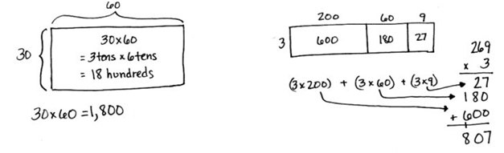
- 3 × 269

- Use any place value strategy to multiply.

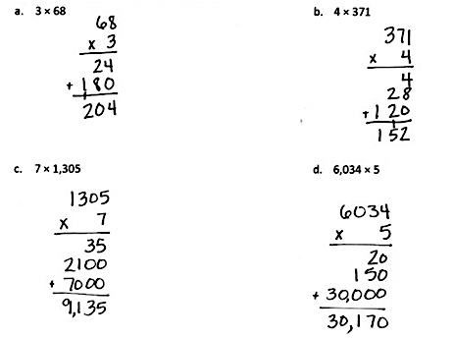
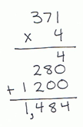

Solve using a model or equation. Show your work and write your answer as a statement.
- A movie theater has two rooms. Room A has 9 rows of seats with 18 seats in each row. Room B has three times as many seats as Room A. How many seats are there in both rooms?
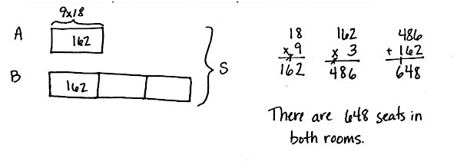

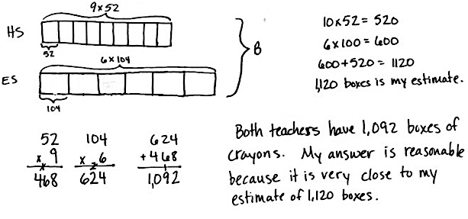
- The high school art teacher has 9 cases of crayons with 52 boxes in each case. The elementary school art teacher has 6 cases of crayons with 104 boxes in each case. How many total boxes of crayons do both teachers have? Is your answer reasonable? Explain.

- Last year, Mr. Petersen’s rectangular garden had a width of 5 meters and an area of 20 square meters. This year, he wants to make the garden three times as long and two times as wide.

  - Solve for the length of last year’s garden using the area formula. Then, draw and label the measurements of this year’s garden.
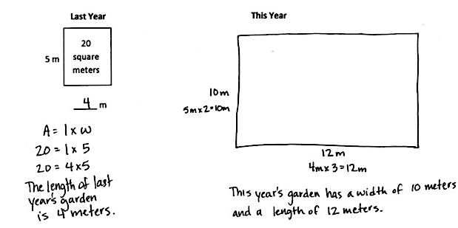

  - How much area for planting will Mr. Petersen have in the new garden?

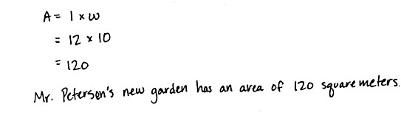

  - Last year, Mr. Petersen had a fence all the way around his garden. He can reuse all of the fence he had around the garden last year, but he needs to buy more fencing to go around this year’s garden. How many more meters of fencing is needed for this year’s garden than last year’s?

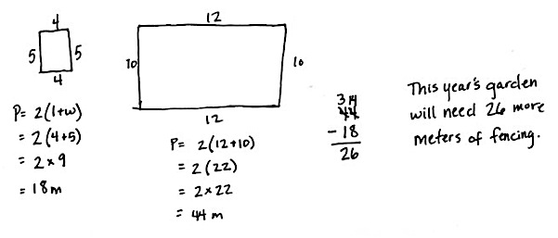

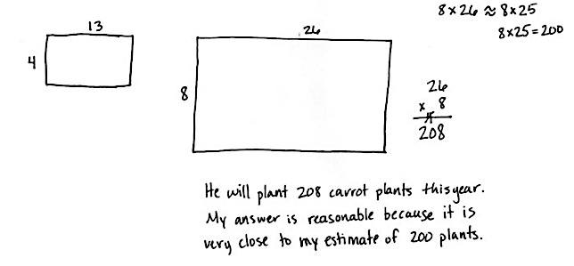
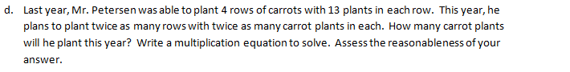
  - Last year Mr. Petersen was able to plant 4 rows of carrots with 13 plants in each row. This year he plans to plant twice as many rows with twice as many carrot plants in each. How many carrot plants will he plant this year? Write a multiplication equation to solve. Assess the reasonableness of your answer.

