Name Date
- A parabola is defined as the set of points in the plane that are equidistant from a fixed point (called the focus of the parabola) and a fixed line (called the directrix of the parabola).

Consider the parabola with focus point $\left(1, 1\right)$ and directrix the horizontal line $y=-3$.

- What are the coordinates of the vertex of the parabola?

- Plot the focus and draw the directrix on the graph below. Then draw a rough sketch of the parabola.

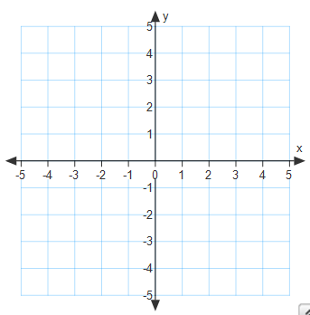

- Find the equation of the parabola with this focus and directrix.

- What is the $y$-intercept of this parabola?

- Demonstrate that your answer from part (d) is correct by showing that the $y$-intercept you identified is indeed equidistant from the focus and the directrix.

- Is the parabola in this question (with focus point $\left(1, 1\right)$ and directrix$y=-3$) congruent to a parabola with focus $\left(2, 3\right)$ and directrix $y=-1$? Explain.

- Is the parabola in this question (with focus point $(1, 1)$ and directrix$y=-3$) congruent to the parabola with equation given by $y=x^{2}$? Explain.

- Are the two parabolas from part (g) similar? Why or why not?

- The graph of the polynomial function $f\left(x\right)=x^{3}+4x^{2}+6x+4$ is shown below.
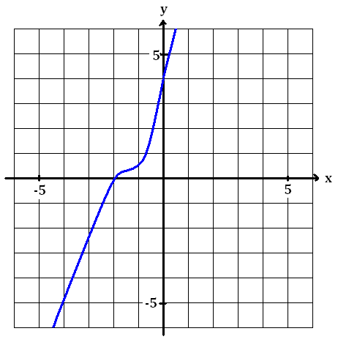

- Based on the appearance of the graph, what does the real solution to the equation
$x^{3}+4x^{2}+6x+4=0$ appear to be? Jiju does not trust the accuracy of the graph. Prove to her algebraically that your answer is in fact a zero of$y=f(x)$.

- Write $f$ as a product of a linear factor and a quadratic factor, each with real-number coefficients.

- What is the value of $f(10)$? Explain how knowing the linear factor of $f$ establishes that $f(10)$ is a multiple of $12$.

- Find the two complex-number zeros of $y=f(x)$.

- Write $f$ as a product of three linear factors.

- A line passes through the points $\left(-1, 0\right)$ and $P=\left(0, t\right)$ for some real number $t$ and intersects the circle $x^{2}+y^{2}=1$ at a point $Q$ different from $\left(-1, 0\right)$.

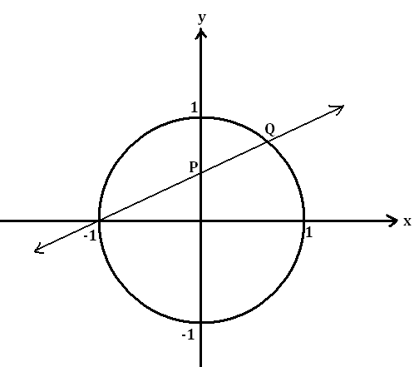

- If$t=\frac{1}{2}$, so that the point $P$ has coordinates $\left(0, \frac{1}{2}\right)$, find the coordinates of the point $Q$.

A Pythagorean triple is a set of three positive integers $a$, $b$, and $c$ satisfying $a^{2}+b^{2}=c^{2}$. For example, setting $a=3$, $b=4$, and $c=5$ gives a Pythagorean triple.
- Suppose that $\left(\frac{a}{c},\frac{b}{c}\right)$ is a point with rational-number coordinates lying on the circle $x^{2}+y^{2}=1$. Explain why then $a$, $b$, and $c$ form a Pythagorean triple.

- Which Pythagorean triple is associated with the point $Q=\left(\frac{5}{13},\frac{12}{13}\right)$ on the circle?

- If $Q=\left(\frac{5}{13},\frac{12}{13}\right)$, what is the value of $t$ so that the point $P$ has coordinates $\left(0,t\right)$?

- Suppose we set $x=\frac{1-t^{2}}{1+t^{2}}$ and $y=\frac{2t}{1+t^{2}}$, for a real number $t$. Show that $\left(x,y\right)$ is then a point on the circle $x^{2}+y^{2}=1$.

- Set $t=\frac{3}{4}$ in the formulas $x=\frac{1-t^{2}}{1+t^{2}}$ and $y=\frac{2t}{1+t^{2}}$. Which point on the circle $x^{2}+y^{2}=1$ does this
give? What is the associated Pythagorean triple?

- Suppose $t$ is a value greater than $1$, $P=\left(0,t\right)$, and $Q$ is the point in the second quadrant (different from $\left(-1, 0\right)$) at which the line through $\left(-1, 0\right)$ and $P$ intersects the circle $x^{2}+y^{2}=1$. Find the coordinates of the point $Q$ in terms of $t$.

- Write a system of two equations in two variables where one equation is quadratic and the other is linear such that the system has no solution. Explain, using graphs, algebra, and/or words, why the system has no solution.

- Prove that $x=\sqrt{-5x-6}$ has no solution.

- Does the following system of equations have a solution? If so, find one. If not, explain why not.

$$2x+y+z=4 \\ x-y+3z=-2 \\ -x+y+z=-2$$

A Progression Toward Mastery
Assessment  Task Item |  | STEP 1  Missing or incorrect answer and little evidence of reasoning or application of mathematics to solve the problem. | STEP 2  Missing or incorrect answer but evidence of some reasoning or application of mathematics to solve the problem. | STEP 3  A correct answer with some evidence of reasoning or application of mathematics to solve the problem or an incorrect answer with substantial evidence of solid reasoning or application of mathematics to solve the problem. | STEP 4  A correct answer supported by substantial evidence of solid reasoning or application of mathematics to solve the problem.
1 | a–c  N-Q.A.2  F-IF.C.7c  G-GPE.A.2 | (a) Student provides incorrect vertex coordinates.  (b) Student sketches a parabola that does not open up or a parabola that is horizontal.  (c) Student provides an equation that is not in the form of a vertical parabola. | (a) Student provides either an incorrect $x$- or $y$-coordinate.  (b) Student provides a sketch of a parabola that opens up but with little or no scale or labels.  (c) Student provides an incorrect equation using the vertex from part (a); $a$-value is incorrect due to conceptual errors. | (a) Student provides the correct vertex.  (b) Student provides a sketch of a parabola that opens up with correct vertex. The sketch may be incomplete or lack sufficient labels or scale.  (c) Student provides a parabola equation with correct vertex. Work showing $a$-value calculation may contain minor errors. | (a) Student provides the correct vertex.  (b) Student provides a well-labeled and accurate sketch of a parabola that opens up and includes the focus, directrix, and vertex.  (c) Student provides the correct parabola equation in vertex or standard form with or without work showing how $a=\frac{1}{8}$.
 | d–e  N-Q.A.2  F-IF.C.7c  G-GPE.A.2 | (d) Student provides incorrect $y$-intercept. No work is shown or a conceptual error is made.  (e) Student makes no attempt or provides two incorrect distances. | (d) Student provides incorrect $y$-intercept. No work is shown or a conceptual error is made (e.g., $y=0$ instead of $x=0$).  (e) Student provides one correct distance but not both, using student’s incorrect $y$-intercept and the given focus and directrix.  OR  Student provides the correct $y$-intercept in part (d), but the student is unable to compute one or both distances between the $y$-intercept and the given focus and directrix. | (d) Student substitutes $x=0$ to determine the $y$-intercept, but may make a minor calculation error.  (e) Student provides the correct distance to the directrix using student’s $y$-intercept. Student provides the correct distance between focus and $y$-intercept using student’s $y$-intercept.  Note that if these are not equal, the student solution should indicate that they should be based on the definition of a parabola. | (d) Student correctly identifies the $y$-intercept.  (e) Student correctly identifies the distance to directrix and applies the distance formula to calculate the distance from focus and $y$-intercept. Both are equal to $\frac{17}{8}$.
 | f–h  N-Q.A.2  F-IF.C.7c  G-GPE.A.2 | Student incorrectly answers two or more parts with no justification in all three parts.  OR  Student incorrectly answers all three parts with faulty or no justification. | Student incorrectly answers two or more parts. Minimal justification is provided that includes a reference to the $a$-value. | Student correctly answers all three parts with no justification.  OR  Student correctly answers two out of three parts with correct justification. | Student correctly answers all three parts. Justification states that parabolas with equal $a$-values are congruent, but all parabolas are similar.
2 | a–b  A-SSE.A.2  A-APR.A.1 A-APR.B.2  A-APR.B.3 A-REI.A.1 A-REI.B.4b  F-IF.C.7c | (a) Student concludes that $x=-2$ is NOT a zero due to conceptual or major calculation errors (e.g., incorrect application of division algorithm)  OR  Student shows no work at all.  (b) Student does not provide factored form or it is incorrect. | (a) Student concludes that $x=-2$ is NOT a zero due to minor calculation errors and provides limited justification for the solution.  (b) Student does not provide factored form or it is incorrect. | (a) Student concludes that $x=-2$ is a zero, but may not support this mathematically or verbally.  (b) Student correctly identifies both factors, but the polynomial may not be written in factored form $\left(\left(x+2\right)\left(x^{2}+2x+2\right)\right)$. | (a) Student concludes that $x=-2$ is a zero by showing $f(-2)=0$ or using division and getting a remainder equal to $0$. Work or written explanation supports conclusion.  (b) Student writes $f$ in correct factored form and provides work to support the solution.  Note that the work may be done in part (a).
 | c  A-SSE.A.2  A-APR.B.2  A-APR.B.3 A-REI.A.1 A-REI.B.4b  F-IF.C.7c | Student provides an incorrect value of $f(10)$ and a conclusion regarding $12$ being a factor is missing or unsupported by any mathematical work or explanation. | Student provides an incorrect value of $f(10)$ and an incorrect factored form of $f$. The student does not attempt to find the numerical factors of $f(10)$ or divide $f(10)$ by $12$ to see if the remainder is $0$. | Student provides a complete solution, but the solution may contain minor calculation errors on the value of $f(10)$.  OR  Student concludes that $12$ is NOT a factor of $f(10)$ because the student used an incorrectly factored form of $f$ in the first place or an incorrect value for $f(10)$. | Student correctly identifies the solution as $f(10)=1464$.  The explanation clearly communicates that $12$ is a factor of $f(10)$, i.e., when $x=10$, $(x+2)$ is $12$.
 | d–e  A-SSE.A.2  A-APR.A.1 A-APR.B.2  A-APR.B.3 A-REI.A.1 A-REI.B.4b  F-IF.C.7c | (d) Student does not use quadratic formula or uses incorrect formula.  (e) Student provides incorrect complex roots and the solution is not a cubic equivalent to  $(x+2)(x-r_{1})(x-r_{2})$, where $r_{1}$ and $r_{2}$ are complex conjugates. | (d) Student makes minor errors in the quadratic formula and provides incorrect roots.  (e) Student uses the incorrect roots from (d), but the solution is a cubic equivalent to $(x+2)(x-r_{1})(x-r_{2})$, where $r_{1}$ and $r_{2}$ are the student solutions to (d). | (d) Student provides the correct complex roots using the quadratic formula (does not have to be in simplest form).  (e) Student provides a cubic polynomial using $-2$ and complex roots from (d). May contain minor errors (e.g., leaving out parentheses on $\left(x-\left(1+i\right)\right)$ or a multiplication error when writing the polynomial in standard form. | (d) Student provides the correct complex roots expressed as $(-1±i)$.  (e) Student provides a cubic polynomial equivalent to  $\left(x+2\right)\left(x-\left(1+i\right)\right)\left(x-\left(1-i\right)\right)$. It is acceptable to leave it in factored form.
3 | a  A-APR.C.4 A-APR.D.6 A-APR.D.7 A-REI.A.2 A-REI.C.6 A-REI.C.7 | Student provides an incorrect equation of the line and makes major mathematical errors in attempting to solve a system of a linear and non-linear equation. | Student provides an incorrect equation of the line, but the solution shows substitution of the student’s linear equation into the circle equation. The solution to the system may also contain minor calculation errors.  OR  Student provides a correct equation of the line, but the student is unable to solve the system due to major mathematical errors. | Student provides the correct equation of the line. The solution to the system may contain minor calculation errors.  The correct solution is not expressed as an ordered pair or the solution only includes a correct $x$- or $y$-value for point $Q$. | Student provides the correct equation of the line and the correct solution to the system of equations. The solution is expressed as an ordered pair, $Q\left(\frac{3}{5},\frac{4}{5}\right)$.
 | b–c  A-APR.C.4 A-APR.D.6 A-APR.D.7 A-REI.A.2 A-REI.C.6 A-REI.C.7 | (b) Student does not provide an answer or the answer is incorrect showing limited understanding of they were asked to do.  (c) Student does not provide a triple or it is incorrect. | (b) Student substitutes $\left(\frac{a}{c},\frac{b}{c}\right)$ into the equation of the circle, but fails to show that this equation is equivalent to $a^{2}+b^{2}=c^{2}$.  (c) Student provides an incorrect triple. | (b) Student provides an almost-complete solution (i.e., student substitutes $\left(\frac{a}{c},\frac{b}{c}\right)$ into the equation of the circle and states that the point satisfies the Pythagorean Triple condition but doesn’t show why). The solution may contain minor algebra mistakes.  (c) Student identifies $5$, $12$, $13$ as the triple. | (b) Student provides a correct solution showing substitution of $\left(\frac{a}{c},\frac{b}{c}\right)$ into the equation of a circle. The work clearly demonstrates this equation is equivalent to $a^{2}+b^{2}=c^{2}$.  (c) Student identifies $5$, $12$, $13$ as the triple.
 | d–f  A-APR.C.4 A-APR.D.6 A-APR.D.7 A-REI.A.2 A-REI.C.6 A-REI.C.7 | Student does not provide a solution or provides an incomplete solution to (d), (e), and (f) with major mathematical errors. | (d) Student provides correct slope of the line but fails to identify correct value of t.  (e) Student substitutes coordinates into $x^{2}+y^{2}=1$, but makes major errors in attempt to show they satisfy the equation.  (f) Student substitutes $\frac{3}{4}$ for $t$, but the solution is incorrect. | (d) Student provides the correct slope and equation of the line but fails to identify the correct value of $t$.  (e) Student substitutes coordinates into $x^{2}+y^{2}=1$ and simplifies to show they satisfy the equation.  (f) Student identifies point $Q$ and the triple correctly.  Note that one or more parts may contain minor calculation errors. | (d) Student provides the correct slope and equation of the line and correctly identifies the $t$-value.  (e) Student substitutes coordinates into $x^{2}+y^{2}=1$ and simplifies to show they satisfy the equation.  (f) Student identifies point $Q$ and the triple correctly.  Note that all solutions use proper mathematical notation and clearly demonstrate student understanding.
 | g  A-APR.C.4 A-APR.D.6 A-APR.D.7 A-REI.A.2 A-REI.C.6 A-REI.C.7 | Student does not provide a solution or provides an incomplete solution with major mathematical errors. | The solution may include an accurate sketch and the equation of the line $y=tx+t$ but little additional work. | Student attempts to solve the system by substituting $y=tx+t$ into the circle equation and recognizes the need to apply the quadratic equation to solve for $x$. May contain algebraic errors. | Student provides a complete and correct solution, showing sufficient work and calculation of both the $x$- and $y$-coordinate of the point.
4 | a  A-REI.A.2  A-REI.B.4b  A-REI.C.6  A-REI.C.7 | Student does not provide work or it is incomplete. System does not include a linear and quadratic equation. | Student provides a system that has a solution, but student work indicates understanding that the graphs of the equations should not intersect or that algebraically the system has no real number solutions. | Student provides a system that does not have a solution, but the justification may reveal minor errors in student’s thought process. If a graphical justification is the only one provided the graph must be scaled sufficiently to provide a convincing argument that the two equations do not intersect. | Student provides a system that does not have a solution. Justification includes a graphical, verbal explanation, or algebraic explanation that clearly demonstrates student thinking.
 | b–c  A-REI.A.2  A-REI.B.4b  A-REI.C.6  A-REI.C.7 | Student provides incorrect solutions with little or no supporting work shown. | Student provides incorrect solutions to parts (b) and (c). Solutions are limited and reveal major mathematical errors in the solution process. | Student provides incorrect solutions to part (b) or part (c). Solutions show considerable understanding of the processes, but may contain minor errors. | Student provides correct solutions with sufficient work shown.  AND  Mathematical work  or verbal explanation show why $-2$ and $-3$ are NOT solutions to part (b).

Name Date
- A parabola is defined as the set of points in the plane that are equidistant from a fixed point (called the focus of the parabola) and a fixed line (called the directrix of the parabola).

Consider the parabola with focus point $\left(1, 1\right)$ and directrix the horizontal line $y=-3$.

- What are the coordinates of the vertex of the parabola?

- Plot the focus and draw the directrix on the graph below. Then draw a rough sketch of the parabola.

- Find the equation of the parabola with this focus and directrix.

- What is the $y$-intercept of this parabola?

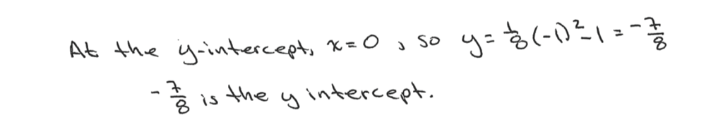

- Demonstrate that your answer from part (d) is correct by showing that the $y$-intercept you identified is indeed equidistant from the focus and the directrix.

- Is the parabola in this question (with focus point $\left(1, 1\right)$ and directrix$y=-3$) congruent to a parabola with focus $\left(2, 3\right)$ and directrix $y=-1$? Explain.

- Is the parabola in this question (with focus point $(1, 1)$ and directrix$y=-3$) congruent to the parabola with equation given by $y=x^{2}$? Explain.

- Are the two parabolas from part (g) similar? Why or why not?

- The graph of the polynomial function $f\left(x\right)=x^{3}+4x^{2}+6x+4$ is shown below.

- Based on the appearance of the graph, what does the real solution to the equation
$x^{3}+4x^{2}+6x+4=0$ appear to be? Jiju does not trust the accuracy of the graph. Prove to her algebraically that your answer is in fact a zero of$y=f(x)$.

- Write $f$ as a product of a linear factor and a quadratic factor, each with real-number coefficients.

- What is the value of $f(10)$? Explain how knowing the linear factor of $f$ establishes that $f(10)$ is a multiple of $12$.

- Find the two complex-number zeros of $y=f(x)$.

- Write $f$ as a product of three linear factors.

- A line passes through the points $\left(-1, 0\right)$ and $P=\left(0, t\right)$ for some real number $t$ and intersects the circle $x^{2}+y^{2}=1$ at a point $Q$ different from $\left(-1, 0\right)$.

- If$t=\frac{1}{2}$, so that the point $P$ has coordinates $\left(0, \frac{1}{2}\right)$, find the coordinates of the point $Q$.
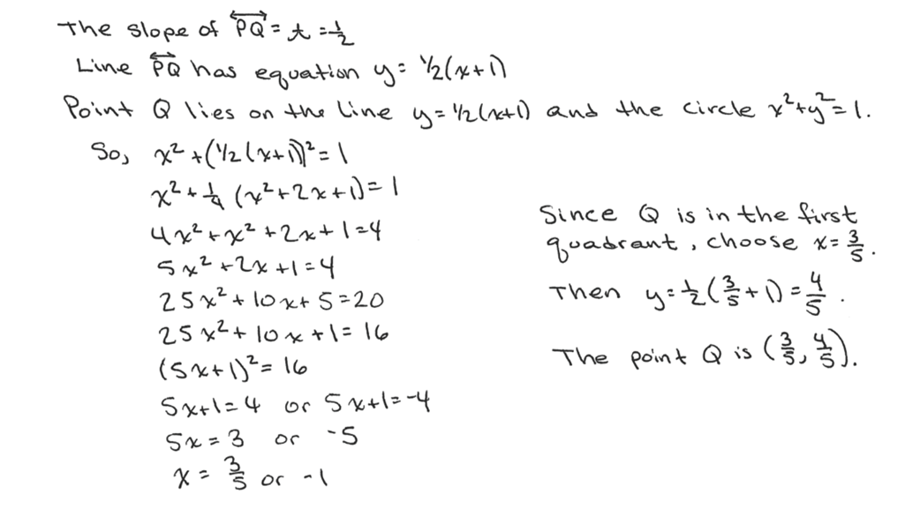

A Pythagorean triple is a set of three positive integers $a$, $b$, and $c$ satisfying $a^{2}+b^{2}=c^{2}$. For example, setting $a=3$, $b=4$, and $c=5$ gives a Pythagorean triple.
- Suppose that $\left(\frac{a}{c},\frac{b}{c}\right)$ is a point with rational-number coordinates lying on the circle $x^{2}+y^{2}=1$. Explain why then $a$, $b$, and $c$ form a Pythagorean triple.

- Which Pythagorean triple is associated with the point $Q=\left(\frac{5}{13},\frac{12}{13}\right)$ on the circle?

- If $Q=\left(\frac{5}{13},\frac{12}{13}\right)$, what is the value of $t$ so that the point $P$ has coordinates $\left(0,t\right)$?

- Suppose we set $x=\frac{1-t^{2}}{1+t^{2}}$ and $y=\frac{2t}{1+t^{2}}$, for a real number $t$. Show that $\left(x,y\right)$ is then a point on the circle $x^{2}+y^{2}=1$.

- Set $t=\frac{3}{4}$ in the formulas $x=\frac{1-t^{2}}{1+t^{2}}$ and $y=\frac{2t}{1+t^{2}}$. Which point on the circle $x^{2}+y^{2}=1$ does this
give? What is the associated Pythagorean triple?

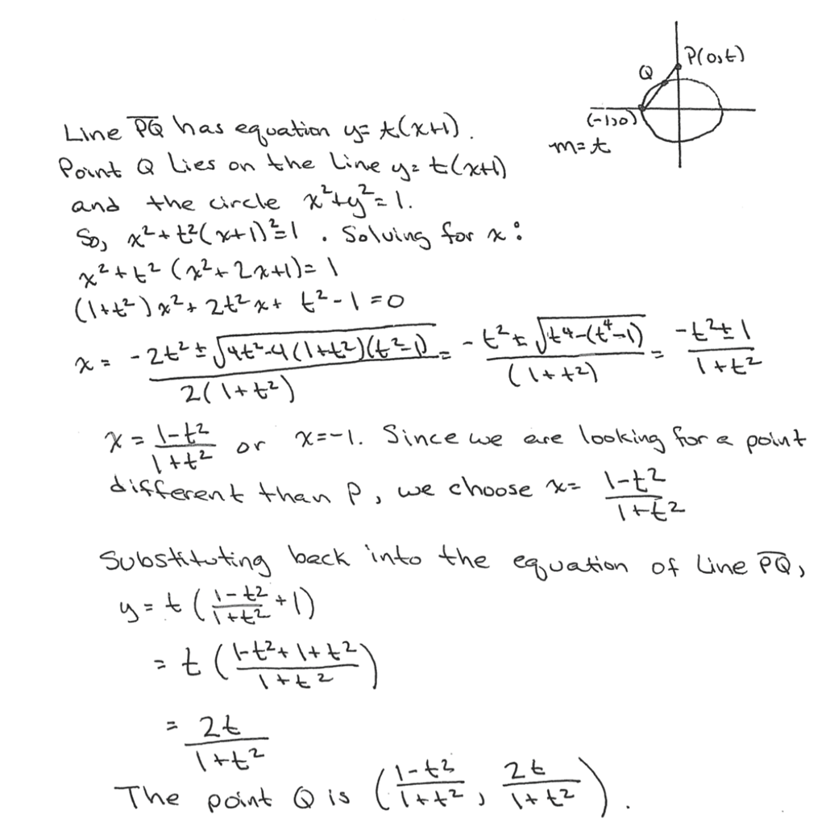
- Suppose $t$ is a value greater than $1$, $P=\left(0,t\right)$, and $Q$ is the point in the second quadrant (different from $\left(-1, 0\right)$) at which the line through $\left(-1, 0\right)$ and $P$ intersects the circle $x^{2}+y^{2}=1$. Find the coordinates of the point $Q$ in terms of $t$.

- Write a system of two equations in two variables where one equation is quadratic and the other is linear such that the system has no solution. Explain, using graphs, algebra, and/or words, why the system has no solution.

- Prove that $x=\sqrt{-5x-6}$ has no solution.

- Does the following system of equations have a solution? If so, find one. If not, explain why not.

$$2x+y+z=4 \\ x-y+3z=-2 \\ -x+y+z=-2$$

