Expert Pack: Our Solar System and Earth’s Place In It

Submitted by: Center City Public Charter Schools, Washington, DC
Grade: 1 Date: March 2015

Topic/Subject: Our Solar System and Earth’s Place In It
Essential Questions:
- What do we know about the Earth and the Solar System?
- What are the characteristics of the planets and sun in our Solar System?
- What makes Earth unique?
Texts/ Resources
Books
- National Geographic Reader: Planets by Elizabeth Carney
- On Earth by G. Brian Karas
- Introducing Planet Earth byReading A-Z

Articles
- What is the Solar System?
- Explore Space
- What’s Up in Space?

Video/Interactive
- Astronomy: Our Place in Space
- Turtle Diary: Solar System
- Interactive Earth Rotation
- ESA Space for Kids [Interactive Website]
Rationale and Suggested Sequence for Reading
The purpose of this series of texts is for students to begin with an understanding of the Solar System as a whole, as well as Earth’s place within the Solar System. The texts eventually zoom in on Earth and its unique ability to host life. The first text, What Is the Solar System? offers a broad overview of the Solar System as a whole and its composition. Next, What’s Up in Space is a brief text that defines the composition of the Sun and planets. In Explore Space, students will then be presented with more specific information about each planet’s characteristics. Ending the broader study of the Solar System is the National Geographic Reader - Planets. It offers the most in-depth information on all of our planets. This series of texts orients students to the general workings of the Solar System, as well as Earth’s position in it. These texts also set students up with the basic vocabulary they will need as they move forward in the unit. Once students have built this necessary knowledge, they are ready to examine more closely our planet using the book On Earth. This book focuses on the rotation and revolution of the Earth and how that impacts its daily and yearly cycles. It will provide students with information about how day and night works as well as the seasons. Students will be able to identify what living on Earth is like because of how it rotates and revolves, as well as how it is different from other planets. Finally, Introducing Planet Earth will be used to further pinpoint what makes life on Earth unique from the other planets in the Solar System. The last article, “Not too Hot, Not too Cold” (found under Recommended Texts) is quite complex but sheds scientific light on the discovery of another planet that is similar to Earth and helps students to consider the vast number of planets and possibilities in the larger galaxy and universe. Note to instructors: New articles emerge daily on our quest to find “new life” in space, please feel free to explore new discoveries as they are made.
The Common Core Shifts for ELA/Literacy

- Regular practice with complex text and its academic language.
- Reading, writing, and speaking grounded in evidence from text, both literary and informational.
- Building knowledge through content-rich nonfiction.
College and Career Readiness Anchor Standards for Reading Literacy and/or Informational Texts
- Read closely to determine what the text says explicitly and to make logical inferences from it; cite specific textual evidence when writing or speaking to support conclusions drawn from the text.
- Determine central ideas of themes of a text and analyze their development; summarize the key supporting details and ideas.
- Read and comprehend complex literary and informational texts independently and proficiently.
Annotated Bibliography

320L What is the Solar System?
Author: ReadWorks
Genre: Nonfiction article
Length: 81 words
Synopsis: Provides a brief overview of the objects found in the Solar System and how the planets move. Includes information about the Earth’s rotation causing day and night.
Citation: What is the Solar System? Retrieved January 11, 2015, from http://www.readworks.org/passages/what-solar-system
Cost/Access: $0.00 ReadWorks http://www.readworks.org/passages/what-solar-system
Recommended Student Activity: Wonderings

670L What’s Up in Space?
Author: ReadWorks
Genre: Nonfiction article
Length: 263 words
Synopsis: This very brief article (with one visual) describes the difference between the objects that make up the Solar System: Planets, moons and stars.
Citation: What's Up in Space? Retrieved January 11, 2015, from http://www.readworks.org/passages/whats-space
Cost/Access: $0.00 ReadWorks http://www.readworks.org/passages/whats-space
Recommended Student Activity: Accompanying questions, Quiz Maker

450L Explore Space
Author: ReadWorks
Genre: Nonfiction article
Length: 277 words
Synopsis: This article provides an overview of the Solar System including the Sun and eight major planets listing characteristics of each.
Citation: Explore Space. Retrieved January 11, 2015, from http://www.readworks.org/passages/explore-space
Cost/Access: $0.00 ReadWorks http://www.readworks.org/passages/explore-space
Recommended Student Activity: Accompanying Questions, Quiz Maker

640L National Geographic Readers: Planets
Author: Elizabeth Carney
Genre: Nonfiction children’s book
Length: 32 pages
Synopsis: This book taps into children's natural curiosity about the vast world of space. This “level two” reader, (written in simple language that is easy for young readers to understand), introduces children to our Solar System, including all of the planets and dwarf planets and includes many fascinating facts.
Citation: Carney, E. (2012). Planets. Washington, D.C.: National Geographic.
Cost/Access: $3.99, Amazon.com
Recommended Student Activity: A Picture of Knowledge

N/A Turtle Diary: Solar System
Author: Turtle Diary
Genre: Interactive Video and Website
Synopsis: This website is mainly an animated video that shows students the planets in the Solar System, and explains more complex ideas like solar gravity. At the end, there are three activities/exercises for students to complete. In the first, students name and place the planets correctly in the Solar System. In the second, students use ordinal numbers to describe the planets. The third exercise is a quiz.
Citation: Solar System. Retrieved February 6, 2015 from http://www.turtlediary.com/grade-1-games/science-games/solar-system.html
Cost/Access: $0.00
Recommended Student Activity: Quiz on website, pair with the National Geographic text read previously.

660L On Earth
Author: Brian Karas
Genre: Nonfiction children’s book
Length: 32 pages
Synopsis: This book narrates and illustrates the effects of the Earth’s orbit around the Sun and its daily rotations that cause night and day. The illustrations in this book are vivid and detailed, which helps students understand these difficult concepts.
Citation: Karas, G. (2005). On Earth. New York: G.P. Putnam's Sons.
Cost/Access: $7.44, Amazon.com
Recommended Student Activity: Quiz Maker

N/A Interactive Earth Rotation
Author: BBC
Genre: Interactive Online Tool
Synopsis: Use this tool to explore the rotation and revolution of the Earth while manipulating the amount of time shown in the model. Labels and quiz included.
Citation: Earth, Sun, and Moon. (2014, December 29). Retrieved January 11, 2015, from http://www.bbc.co.uk/schools/scienceclips/ages/9_10/earth_sun_moon.shtml
Cost/Access: $0.00 BBC Schools http://www.bbc.co.uk/schools/scienceclips/ages/9_10/earth_sun_moon.shtml
Recommended Student Activity: Online quiz provided

550L Introducing Planet Earth
Author: Celeste Fraser
Genre: Nonfiction (however, it is told from the ‘point of view’ of a planet Earth that has come to life)
Length: 16 brief pages, including a glossary
Synopsis: This book, told from the point of view of planet Earth, is about how Earth is perfectly suited for life. It covers the fact that Earth is a planet that humans can trust to rotate every 24 hours, orbit the sun every year, supply oxygen and other gases, as well as the perfect amount of sunlight and water to keep us alive. The book includes graphics and illustrations to go along with its content.
Citation: Fraser, Celeste. Introducing Planet Earth. Learning A-Z.
Cost/Access: Reading A-Z [district or school subscription required], OR can be accessed at: http://gcsdstaff.org/kittl/wp-content/uploads/2014/05/Introducing-the-Earth-L.pdf
Recommended Student Activity: Included comprehension questions, Quiz Maker

N/A Astronomy: Our Place in Space
Author: American Museum of Natural History
Genre: Interactive Website
Synopsis: This is an interactive website about astronomy. There are many different activities for students to explore independently; students can research planets, complete writing pieces, take quizzes, learn and listen to songs, and many others. This is a good resource for the end of the unit when students have built up their knowledge of the Solar System and Earth.
Citation: Astronomy: Our Place in Space. Retrieved February 6, 2015, from http://www.amnh.org/explore/ology/astronomy

Recommended Additional Resources
These texts are recommended as extra resources for students to explore during centers or independent exploration, and can also be paired with resources in the main text set.

N/A Study Jams: A Day On Earth
Author: Scholastic Study Jams
Genre: Video
Synopsis: This short video shows the cycle of day and night on Earth, as caused by the rotation of the Earth. It also includes a quiz at the end.
Citation: Study Jams: A Day on Earth. Retrieved February 6, 2015 from http://studyjams.scholastic.com/studyjams/jams/science/solar-system/day-on-earth.htm
Cost: $0.00
Recommended Use: Use with the text “On Earth”

710L National Geographic Kids First Big Book of Space
Author: Catherine D. Hughes
Genre: Nonfiction children’s book
Length: 128 pages
Synopsis: This book is the latest addition to the National Geographic Little Kids First Big Book series. These colorful pages will introduce young children to the wonders of space with colorful illustrations by David Aguilar. It provides readers with a simple text that is perfect for beginning readers or for reading aloud.
Citation: Hughes, C., & Aguilar, D. (2012). First big book of space. Washington, D.C.: National Geographic.
Cost/Access: $9.60 Amazon

N/A Planet Earth
Author: Mike Goldsmith
Genre: Nonfiction children’s book
Length: 32 pages
Synopsis: In Flip The Flaps: Planet Earth by Dr. Mike Goldsmith, illustrated by Nicki Palin, children zoom up through protective layers of the atmosphere from the surface to outer space, following the Earth as it makes its yearly journey around the Sun.
Citation: Goldsmith, M., & Palin, N. (2010). Planet Earth. New York: Kingfisher.
Cost/Access: $6.99 Amazon

N/A Space Encyclopedia: A Tour of the Solar System
Genre: Nonfiction children’s book
Length: 192 pages
Synopsis: This is a quite large reference book for children, and it includes many topics related to our Solar System. Topics in this book go beyond the scope of this text set, but can reinforce and expand student knowledge. This book addresses planets, stars, galaxies, moons, planetary composition, and many other topics, all accompanied by real photos and illustrations.
Citation: Aguilar, D., & Pulliam, C. (2013). Space encyclopedia: A tour of our solar system and beyond. National Geographic.
Cost/Access: $19.50 Amazon

740L Chance to Fly to Mars
Author: NewsELA
Genre: Nonfiction article
Length: 573 words
Synopsis: The article focuses on one man’s decision to become one of the first people to live on Mars. It describes the process of training to live on Mars, what life would be like on the planet, and what one would have to give up on Earth to move there.
Citation:Dallas Morning News; Newsela (2014, May 22). Many people have signed up for a chance to fly to Mars. Retrieved January 11, 2015, from https://newsela.com/articles/moveto-mars/id/4074/
Cost/Access: Newsela https://newsela.com/articles/moveto-mars/id/4074/

N/A Not too Hot, Not too Cold
Author: Dogon News
Genre: Informational Article
Length: 371 words
Lexile/Level: N/A
Synopsis: Article discusses the discovery of a possible Earth-like planet that may have the conditions necessary to support life in the same way Earth does.
Citation: Dolasia, M. (2010, October 10). Not Too Hot, Not Too Cold - Have Scientists Finally Found The 'Goldilocks' Planet? Retrieved January 11, 2015, from http://www.dogonews.com/2010/10/1/not-too-hot-not-too-cold-have-scientists-finally-found-the-goldilocks-planet
Cost/Access: $0.00 Dogonews http://www.dogonews.com/2010/10/1/not-too-hot-not-too-cold-have-scientists-finally-found-the-goldilocks-planet
Recommended Student Activity: Wonderings

Recommended Apps
These apps can be bought in the Apple iTunes store and used on various Apple devices.

Explorium – Space For Kids
Explanation: Facts about space, and mini-games that reinforce knowledge.
Cost: $2.99

Astronaut Trainer
Explanation: A journey where students are traveling through space, learning, playing games to reinforce learning, and earning rewards.
Cost: $0.99

iLearn Solar System HD
Explanation: Lessons about space are given by the cartoon Astronaut Ashley. Students can then look at models, interact with information, and then take quizzes to see how much they learned.
Cost: $2.99

Supports for Struggling Students

By design, the gradation of complexity within each Expert Pack is a technique that provides struggling readers the opportunity to read more complex texts. Listed below are other measures of support that can be used when necessary.

- Provide a brief student-friendly glossary of some of the academic vocabulary (tier 2) and domain vocabulary (tier 3) essential to understanding the text

- Download the Wordsmyth widget to classroom computers/tablets for students to access student-friendly definitions for unknown words. http://www.wordsmyth.net/?mode=widget

- Provide brief student friendly explanations of necessary background knowledge

- Include pictures or videos related to the topic within and in addition to the set of resources in the pack

- Select a small number of texts to read aloud with some discussion about vocabulary work and background knowledge

- Provide audio recordings of the texts being read by a strong reader (teacher, parent, etc.)

- Chunk the text and provide brief questions for each chunk of text to be answered before students go on to the next chunk of text

- Pre-reading activities that focus on the structure and graphic elements of the text

- Provide volunteer helpers from the school community during independent reading time.

Text Complexity Guide: What’s Up in Space?
Lexile Measure : 670L

Qualitative Features:
Meaning/Purpose | Structure
The purpose of this article is to set a broad context for the components of our Solar System. The article explains the placement of the Sun, the placement of the Earth and other planets, as well as the orbit of our moon around the Earth. | The structure of the text is organized with subtitles and simple sentence structure leading to key vocabulary, such as “In the Center,” “Around the Sun,” and “Around the Earth.”
Language | Knowledge Demands
The text is short with simple sentences. However, there are many sentences that will need to be broken down within the text and there are many vocabulary words that will need to be introduced and explored before reading. Examples of complex phrases include: “May look as though,” “make up,” and “gives off.” Examples of new vocabulary are: Gas, orbit, crater and reflect. | The subject matter should be slightly familiar to students reading the text in the Expert Pack due to the preceding text about the Solar System. This is an opportunity for them to stretch their knowledge and get deeper into the particulars of planets and stars.

Reader and Task Considerations
- Consider reformatting text into ‘chunks’ or smaller pieces for students.
- Script your guiding questions that lead students into the big understanding. Use these questions as a check for understanding.
- Include visualization techniques for prepositional and measurement words such as center, closer, and farther.

Expert Pack: Our Solar System and Earth’s Place In It

Submitted by: Center City Public Charter Schools, Washington, DC
Grade: 1 Date: March 2015

Learning Worth Remembering
Cumulative Activities – The following activities should be completed and updated after reading each resource in the set. The purpose of these activities is to capture knowledge building from one resource to the next, and to provide a holistic snapshot of central ideas of the content covered in the expert pack. It is recommended that students are required to complete one of the Cumulative Activities (Rolling Knowledge Journal or Rolling Vocabulary) for this Expert Pack.

- Rolling Knowledge Journal
- Read each selection in the set, one at a time.
- After you read each resource, stop and think what the big learning was. What did you learn that was new and important about the topic from this resource? Write, draw, or list what you learned from the text about (topic).
- Then write, draw, or list how this new resource added to what you learned from the last resource(s).
Sample Student Response
Title | Write, Draw, or List
 | New and important learning about the topic | How does this resource add to what I learned already?
- What is the Solar System? | There are 8 planets in our Solar System and they all revolve around the Sun. There are also moons, and the Sun is a star. Earth is the third planet from the sun. | This text introduces students to the Solar System as a whole.
- What’s Up in Space? | Planets, moons and stars, are all different things and move in different ways. There are all three in our Solar System. | This text differentiates between planets, moons, and stars, such as their composition and how they move. It adds to my general knowledge of the different objects in space.
- Explore Space | Each planet has unique characteristics. | This text zooms in on the unique characteristic of each planet. It discusses the names, compositions, sizes, and movement of each particular planet.
- National Geographic Readers: Planets | There are dwarf planets in our Solar System. | This adds the knowledge that even within the category of planets, there are different types.
- Turtle Diary: Solar System | Gives a visual of the planets rotating on their own axes while revolving around the Sun in their actual places in the Solar System. | Adds to knowledge by giving a concrete visual representation of movement within the Solar System.
- On Earth | The Earth’s rotation on its axis is what causes night and day. The Earth is moving, not the sun. | Zooms in on the specific movement of planet earth and how it affects us on Earth.
- Interactive Earth Rotation | Gives a visual representation of only the Earth rotating around the Sun. Includes a visual of the ‘day’ side of the Earth and the ‘night’ side of the Earth at any given point in time. | Gives a visual specific to the rotation and revolution of the Earth, instead of all of the planets at once.
- Introducing Planet Earth | Planet Earth is a unique place that is able to host life. It is a perfect planet for humans to live. | Uses information that we have learned about temperature, sunlight, and atmosphere to discuss why Earth is inhabitable.
- Astronomy: Our Place in Space | In-depth information about various topics regarding the Solar System, including planets, stars, Earth’s position in the Solar System, etc. | Gives an opportunity to explore topics that were not already explored in-depth in the text set; students should be equipped with the knowledge and vocabulary to learn from this resource.

- Rolling Vocabulary: “Fantastic Four”
- Read each resource then determine the 4 words from each text that most exemplify the central idea of the text.
- Next use your 4 words to write about the most important idea of the text. You should have as many sentences as you do words.
- Continue this activity with EACH selection in the Expert Pack.
- After reading all the selections in the Expert Pack, go back and review your words.
- Now select the “Fantastic Four” words from ALL the word lists.
- Use the “Fantastic Four” words to summarize the most important learning from this Expert Pack.
Sample Student Response
Title | Four Vocabulary Words & Sentences
What is the Solar System? | Planet: We live on the planet Earth.  System: The solar system has many different planets and parts that work together.  Earth: Earth is the third planet from the Sun.  Sun: The planets revolve around the Sun, which is at the center of the Solar System.
What’s Up in Space? | Planet: There are nine planets in our Solar System.  Moon: A moon is an object made of rock that goes around a planet.  Million: The other planets are millions of miles away from Earth.  Objects: There are many different kinds of objects in Space.
Explore Space | Center: The Sun is at the center of the Solar System.  Star: The Sun is a star at the center of our Solar System.  Discover: Scientists are still discovering different stars and planets.  Planet: Each planet in our Solar System revolves around the Sun.
Planets | Planet: Each planet is unique.  Rings: Some planets have rings made of rocks and other debris.  Gas: Some planets are made of gas, like Jupiter, Saturn, and Uranus.  Dwarf: Pluto is different because it is a dwarf planet.
Turtle Diary: Solar System | Survive: Humans are able to survive on Earth.  Body: A planet is a body that moves in the Solar System.  Gravity: Gravity is what keeps the planets revolving around the Sun instead of floating in space.  Force: Gravity is a force that pulls things toward larger objects and bodies in space.
On Earth | Cycle: The day and night cycle is 24 hours long.  Axis: The Earth spins on its axis as it goes around the Sun.  Revolve: The Earth revolves in a circular pattern around the Sun.  Rotate: The Earth rotates around its axis through the North and South poles.
Interactive Earth Rotation | Spherical: The Earth and other planets are spherical like a ball.  Cycle: The Earth’s cycle of day and night is 24 hours long.  Revolve: It takes 365 days for the Earth to revolve around the Sun.  Axis: The Earth spins on its axis as it revolves around the Sun.
Introducing Planet Earth | Support: The Earth is able to support life.  Perfect: The Earth is a perfect planet for humans and animals to live because it is not too hot or too cold.  Oxygen: Planet Earth has plenty of oxygen for humans to breathe.  Water: Planet Earth has enough water to keep animals and humans alive.
Astronomy: Our Place in Space | Astronomy: Astronomy is the study of the planets, stars, and other bodies in space.  Cosmic: Planets, stars, and asteroids are all examples of cosmic bodies.  Universe: There are many different planets and stars in the Universe.  Galaxy: Our Solar System is only a small part of our galaxy, the Milky Way.
Fantastic Four | Axis, Rotate, Revolve, Support
Summary:
While there are many planets in the Solar System and millions of objects in space, the Earth is most special. Its position is not too far and not too close as it revolves around the Sun. Its rotation on its axis makes sure that no spot gets too hot. Overall, Earth is special because it is the only planet that can support human, animal, and plant life.

Learning Worth Remembering
Singular Activities – the following activities can be assigned for each resource in the set. The purpose of these activities is to check for understanding, capture knowledge gained, and provide variety of ways for students to interact with each individual resource. Students may complete some or none of the suggested singular activities for each text. Singular activities should be assigned at the discretion of the teacher.

- Quiz Maker (Recommended for “What’s Up In Space?”, “Explore Space,” “On Earth,” “Introducing Planet Earth”)
- Make a list of # questions that would make sure another student understood the information.
- Your classmates should be able to find the answer to the question from the resource.
- Include answers for each question.
- Include where you can find the answer in the resource.

Question | Answer
1.
2.
3.

- Wonderings (Recommended for “What is the Solar System?”, “Astronomy: Our Place in Space”)
On the left, track things you don’t understand from the article as you read.
On the right side, list some things you still wonder (or wonder now) about this topic.
I’m a little confused about: | This made me wonder:

- A Picture of Knowledge (Recommended for National Geographic Readers: Planets, On Earth)
- Take a piece of paper and fold it two times: once across and once top to bottom so that it is divided into 4 quadrants.

- Draw these shapes in the corner of each quadrant.
- Square
- Triangle
- Circle
- Question Mark
?

- Write!

Square: What one thing did you read that was interesting to you?
Triangle: What one thing did you read that taught you something new?
Circle: What did you read that made you want to learn more?
Question Mark: What is still confusing to you? What do you still wonder about?

- Find at least one classmate who has read [selection] and talk to each other about what you put in each quadrant.

Expert Pack: Our Solar System and Earth’s Place In It

Submitted by: Center City Public Charter Schools, Washington, DC
Grade: 1 Date: March 2015

Expert Pack Glossary
“What is the Solar System?”
Word | Student-Friendly Definition
planet | A large mass of rock, liquid, or gas that revolves around the sun in our Solar System  We live on the planet Earth.
system | A group of things or parts that work together as a whole  The solar system has many different planets and parts that work together.

“What’s Up in Space?”
Word | Student-Friendly Definition
travel | Travel means to go from one place to another by moving.  The planets all travel around the sun.
asteroids | Small, rocky, planet-like bodies that circle the sun.  When spaceships travel into space, they need to be careful not to get hit by asteroids, large rocks that could crash into them.
objects | Things that have a shape or take up space.  Scissors, pencils, and glue are all examples of objects that we have in our classroom. Planets, asteroids, and stars are all examples of objects in our Solar System.
tiny | Very small  The planet Earth is tiny when compared to the Sun.
path | A narrow road or way  The planets follow a circular path around the Sun.
reflects | To bounce back  The Sun’s light reflects off of the moon, which is why it looks bright to us.
moons | An object that orbits around a planet  The moon that we see in the sky at night is always orbits around the Earth.
million | 1,000,000  There are about one million people living and working in Washington, DC.

“Explore Space”
Word | Student-Friendly Definition
center | The area or part of something that forms the middle  My nose is in the center of my face.
star | A ball of gas in space that burns  When I look up into the sky at night, I see many bright stars.
crater | a hollow area shaped like the inside of a bowl  When I stepped in the sand, my foot left a small crater where it had been.
covered | Spread over  After the storm, snow covered all of the grass and roads in my neighborhood.
largest | The biggest  The eighth graders are the largest students in the school.
discover | To learn or find out about something  Scientists discovered dinosaur bones buried under the ground.

“National Geographic Reader: Planets”

Word | Student-Friendly Definition
dwarf | Very small or tiny  Pluto is a dwarf planet because it is much smaller than the other planets.
rings | A round-shaped object  The planet Jupiter has a ring around it made of small rocks, dust, and asteroids.
gas | Matter that does not keep its shape and cannot be seen  The air around us is actually filled with gas, like oxygen, to help us breathe.

“On Earth”

Word | Student-Friendly Definition
axis | An imaginary line through the middle of the earth.  The earth spins around its axis once every day.
Revolution/revolve | To move in circles around another object  The earth revolves around the sun once each year.
cycle | A pattern that repeats itself over and over  The seasonal cycle repeats itself every year: spring, summer, fall, winter, and then it starts again.
rotation | The act of spinning around in circles on an axis, while staying in place  When I spin a globe, it rotates around its axis.
motion | Movement, not staying still  The Earth is always in motion around the sun; it never stays still.

“Introducing Planet Earth”

Word | Student-Friendly Definition
tilted | Leaned to one side  The earth is slightly tilted on its axis.
continent | A large area of land  The United States, Mexico, and Canada are all part of the continent of North America.
creatures | Living people or animals  Cats, spiders, elephants, and humans are all different creatures who live on the Earth.
support | To provide for or give necessary things  The Earth is able to support life because it is not to hot and not too cold.
half | One of two equal parts  If we cut the Earth along the Equator, we would get two equal halves of the same size and shape.
northern | Referring to the top half of Earth  The United States is in the northern hemisphere of the Earth.
southern | Referring to the bottom half of Earth  Antarctica is in the southern hemisphere of the earth.
direct | Going in a straight line or on a straight course  When you are in direct sunlight, it is important to wear sunscreen.
equator | The imaginary circle around the middle of the Earth  It is very hot in countries near the equator because they get direct sunlight all year long.

Glossary Image Cards

Orbit  http://www.aerospaceweb.org/question/astronomy/q0262.shtml | 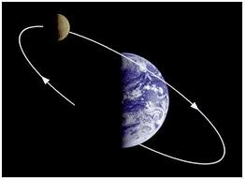
Rotate  http://www.thecolor.com/Coloring/Spinning-Top.aspx | 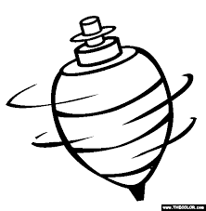
Earth  http://solarviews.com/eng/earth.htm | 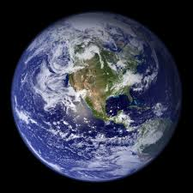
Moon  http://giphy.com/search/moon-gif | 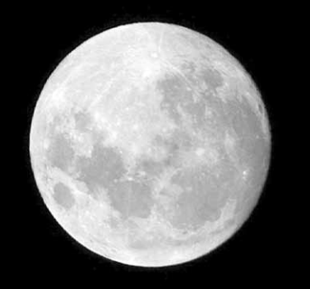
Constellation  http://legendsofthestars.weebly.com/the-big-and-little-dipper.html | 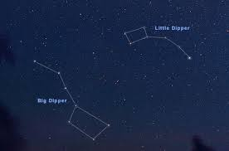
Axis  http://commons.wikimedia.org/wiki/File:Axis_(PSF).png | 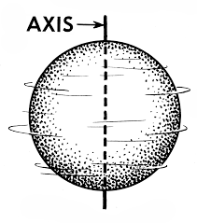
Day  http://ww.itimes.com/poll/day-54772479cf5b4/result | 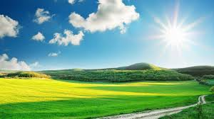
Night  http://www.sodahead.com/fun/would-you-rather-have-daylight-247-or-night-247/question-4534089/ | 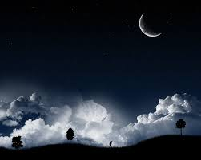
Astronaut  http://astronautrheaseddon.com/rheas_biography/ | 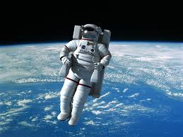
Exploration  http://en.wikipedia.org/wiki/Mars_Exploration_Rover | 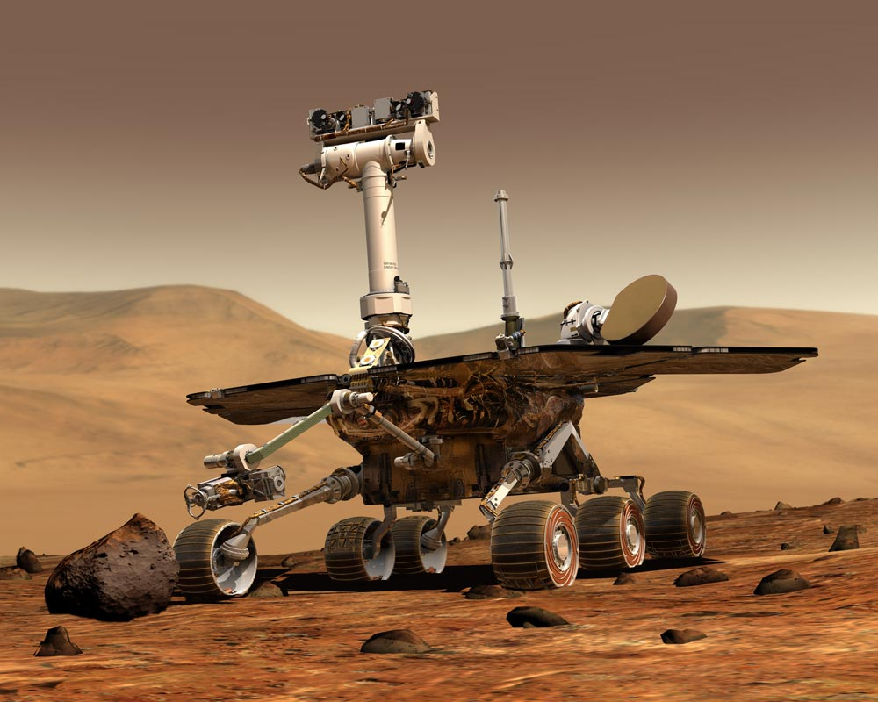
Gravity  http://www.clipartof.com/portfolio/sajem/gravity | 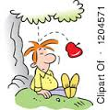
Shadows  http://commons.wikimedia.org/wiki/File:Love_shadows_everything.jpg | 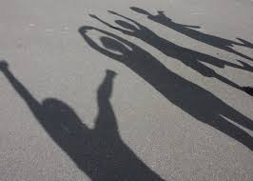
Revolve  http://driverlayer.com/img/revolve/18/?ref=driverlayer.com/image | 