Name Date

- Melanie works in a bakery. She bakes different types of breads. She bakes 18 biscuits on a pan. 3 rows fit on the pan. Draw an array to show the total number of biscuits.

- Fill in the missing factor. Write a sentence telling what it represents.

3 × _______ = 18

- Write a related division sentence to find the number of biscuits in each row.

- Melanie packs the 18 biscuits into bags. She puts two biscuits in each bag.

- Draw a picture to show how many bags of biscuits Melanie packs. How many bags of biscuits does she pack?

- Melanie bakes 18 rolls and packs them into bags of 9. Draw a picture to show how many bags of rolls Melanie packs. How many bags of rolls does she pack?

- Draw an array to represent her biscuits. Draw a second array to represent her rolls. Explain the relationship between the 2 arrays using number sentences and words.

- Melanie bakes cupcakes for a birthday party. They are shown to the right. Twenty are vanilla, and 20 are chocolate. This shows how she calculated the total number of cupcakes:
o o o o o
o o o o o
o o o o o
o o o o o

o o o o o
o o o o o
o o o o o
o o o o o

(4 × 5) + (4 × 5) = 8 × 5
- Use Melanie’s method to find the total. Explain each step with words.

o o o o o
o o o o o
o o o o o
o o o o o
o o o o o
o o o o o

o o o o o
o o o o o

- Melanie burns 2 rows of five cupcakes. Fill in the unknowns below to describe how many are burnt and how many are not burnt.

8 × 5 = _____ × 5 + _____ × 5

- Melanie decides to bake blueberry muffins next. Her recipe calls for 5 blueberries per muffin. She makes 10 muffins.

- Draw a picture and write a multiplication sentence to find the total number of blueberries she uses for 10 muffins.

- Melanie uses the equation 10 = _____ ÷ 5 to figure out how many blueberries she needs. Is her method correct? Why or why not?

- If she has a total of 90 blueberries, how many are left after she makes the 10 muffins?

- Melanie boxes the 10 muffins. Each box fits 2. Draw a picture and write a number sentence to show how many boxes she fills.

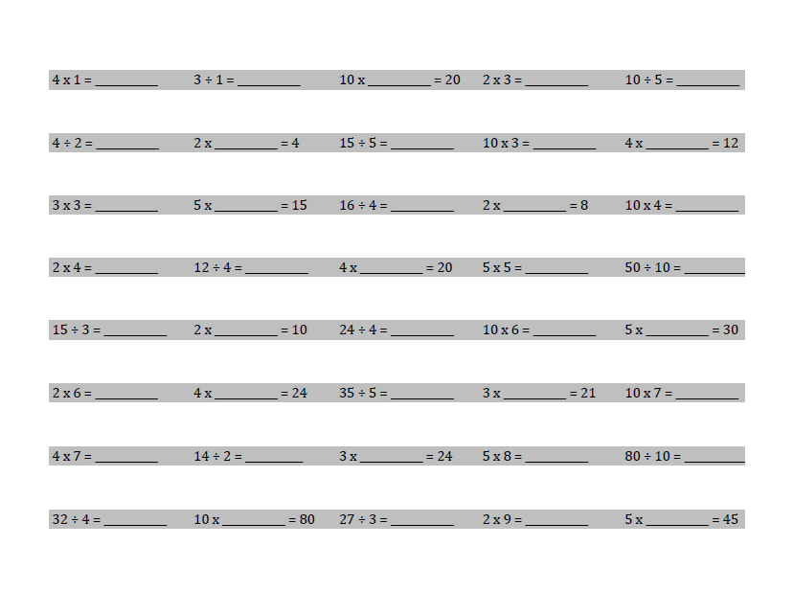
- Complete as many problems as you can in 100 seconds. Your teacher will time you and tell you when to stop.

End-of-Module Assessment Task Topics A–F
Standards Addressed
Represent and solve problems involving multiplication and division.
3.OA.1 Interpret products of whole numbers, e.g., interpret 5 × 7 as the total number of objects in 5 groups of 7 objects each. For example, describe a context in which a total number of objects can be expressed as 5 × 7.
3.OA.2 Interpret whole-number quotients of whole numbers, e.g., interpret 56 ÷ 8 as the number of objects in each share when 56 objects are partitioned equally into 8 shares, or as a number of shares when 56 objects are partitioned into equal shares of 8 objects each. For example, describe a context in which a number of shares or a number of groups can be expressed as 56 ÷ 8.
3.OA.3 Use multiplication and division within 100 to solve word problems in situations involving equal groups, arrays, and measurement quantities, e.g., by using drawings and equations with a symbol for the unknown number to represent the problem. (See Glossary, Table 2.)
3.OA.4 Determine the unknown whole number in a multiplication or division equation relating three whole numbers. For example, determine the unknown number that makes the equation true in each of the equations 8 × ? = 48, 5 = _ ÷ 3, 6 × 6 = ?
Understand properties of multiplication and the relationship between multiplication and division.
3.OA.5 Apply properties of operations as strategies to multiply and divide. (Students need not use formal terms for these properties.) Examples: If 6 × 4 = 24 is known, then 4 × 6 = 24 is also known. (Commutative property of multiplication.) 3 × 5 × 2 can be found by 3 × 5 = 15, then 15 × 2 = 30, or by 5 × 2 = 10, then 3 × 10 = 30. (Associative property of multiplication.) Knowing that 8 × 5 = 40 and 8 × 2 = 16, one can find 8 × 7 as 8 × (5 + 2) = (8 × 5) + (8 × 2) = 40 + 16 = 56. (Distributive property.)
3.OA.6 Understand division as an unknown-factor problem. For example, find 32 ÷ 8 by finding the number that makes 32 when multiplied by 8.
Multiply and divide within 100.
3.OA.7 Fluently multiply and divide within 100, using strategies such as the relationship between multiplication and division (e.g., knowing that 8 x 5 = 40, one knows 40 ÷ 5 = 8) or properties of operations. By the end of Grade 3, know from memory all products of two one-digit numbers.
Solve problems involving the four operations, and identify and explain patterns in arithmetic.
3.OA.8 Solve two-step word problems using the four operations. Represent these problems using equations with a letter standing for the unknown quantity. Assess the reasonableness of answers using the mental computation and estimation strategies including rounding. (This standard is limited to problems posed with whole numbers and having whole-number answers; students should know how to perform operations in the conventional order when there are no parentheses to specify a particular order, i.e., Order of Operations.)

Evaluating Student Learning Outcomes
A Progression Toward Mastery is provided to describe steps that illuminate the gradually increasing understandings that students develop on their way to proficiency. In this chart, this progress is presented from left (Step 1) to right (Step 4) for Problems 1–4. The learning goal for each student is to achieve Step 4 mastery. These steps are meant to help teachers and students identify and celebrate what the student CAN do now, and what they need to work on next. Problem 5 is scored differently since it is a timed assessment of fluency. Students complete as many problems as they can in 2 minutes. Although this page of the assessment contains 40 questions, answering 30 correct within the time limit is considered passing.

A Progression Toward Mastery
Assessment  Task Item and Standards Addressed | STEP 1  Little evidence of reasoning without a correct answer.  (1 Point) | STEP 2  Evidence of some reasoning without a correct answer.  (2 Points) | STEP 3  Evidence of some reasoning with a correct answer or evidence of solid reasoning with an incorrect answer.  (3 Points) | STEP 4  Evidence of solid reasoning with a correct answer.  (4 Points)
1  3.OA.2  3.OA.3  3.OA.4  3.OA.7 | Student is unable to answer any question correctly. The attempt shows the student may not understand the meaning of the questions. | Student answers at least one question correctly. Mistakes may include those listed in the box to the right, and/or  - Writes the incorrect factor in the multiplication equation.  - Does not show understanding of the meaning of the unknown factor.  - Writes an incorrect division sentence. | Student answers at least two questions correctly. Mistakes may include the following:  - Incorrectly writes in the missing factor but understands that it represents the number of biscuits in each row.  - Places the numbers incorrectly in the division sentence. | Student correctly:  - Draws an array.  - Fills in the missing factor (6) and understands what it represents.  - Writes a related division sentence (18 ÷ 3 = 6).
2  3.OA.2  3.OA.3  3.OA.5 | Student attempts to draw the picture. The attempt, however, shows the student may not understand the meaning of the questions. | Student answers at least one question correctly. Mistakes may include those listed in the box to the right, and/or:  - Draws incorrect pictures of the number of bags.  - Attempts to draw the two arrays but inaccurately explains the relationship between them. | Student answers at least two questions correctly. Mistakes may include the following:  - Incorrectly calculates the number of bags either in Part (a) or Part (b).  - Draws the arrays correctly but explanation includes some inaccuracies. | Student answers every question correctly:  - Finds the number of bags Melanie packs for biscuits and rolls.  - Draws two arrays to represent the biscuits and rolls.  - Provides an accurate explanation of the commutative property in Part (c).
3  3.OA.1  3.OA.3  3.OA.5 | Student is unable to answer either question correctly. The attempt shows the student may not understand the meaning of the questions.  (continued) | Student attempts to answer the questions. Mistakes may include those listed in the box to the right, and/or  - Finds the incorrect total number of cupcakes.  - Unable to explain Melanie’s method.  - Incorrectly fills in the unknowns in Part (b). | Student answers at least one question correctly. Mistakes may include the following:  - Finds the total number of cupcakes but explanation in Part (a) includes some inaccuracies.  - Incorrectly fills in the unknowns in Part (b). | Student correctly:  - Explains each step of Melanie’s method in words.  - Calculates the total number of cupcakes as 40.  - Correctly fills in the unknowns in Part (b).
4  3.OA.1  3.OA.2  3.OA.3  3.OA.6  3.OA.8 | Student is unable to answer any question correctly. The attempt shows the student may not understand the meaning of the questions. | Student answers at least one question correctly. Mistakes may include those listed in the box to the right, and/or  - Draws inaccurate pictures.  - Writes incorrect number sentences.  - Incorrectly calculates the number of blueberries in Part (a) and/or boxes in Part (d). | Student answers at least two questions correctly. Mistakes may include the following:  - Incorrectly calculates the numbers of blueberries or boxes used.  - Limited understanding demonstrated in explanation for Part (b).  - Incorrectly calculates how many blueberries are left.  - Uses incorrect numbers to write number sentences. | The student correctly:  - Draws pictures to find the answers in Parts (a) and (d).  - Clearly understands division as an unknown factor problem in Part (b).  - Calculates the correct number of blueberries remaining in Part (c).  - Calculates the total number of blueberries and boxes.  - Writes the correct numbers sentences in all parts.
5  3.OA.7 | Use the attached sample work to correct students’ answers on the fluency page of the assessment.  Students who answer 30 or more questions correctly within the allotted time pass this portion of the assessment. They are ready to move on to the more complicated fluency page given with the Module 2 End-of-Module Assessment. For students who do not pass, you may choose to re-administer this fluency page with each subsequent End-of-Module assessment until they are successful.  Analyze the mistakes students make on this assessment to further guide your fluency instruction. Possible questions to ask as you analyze are:  - Did this student struggle with multiplication, division, or both?  - Did this student struggle with a particular factor?  - Did the student consistently miss problems with the unknown in a particular position?
