Name Date
Mass
3 kg | g
20 kg 300 g | g
1 kg 74 g | g
403 kg 4 g | g
Length
3 km | m
9 km | m
6 km 435 m | m
12 km 12 m | m
- Complete the conversion charts.

Capacity
4 L | mL
48 L 808 mL | mL
2 L 20 mL | mL
639 L 6 mL | mL

- A student completed the problem below. Check his work. Explain how you know if each solution is correct or incorrect.
m

- Find the sum or difference.

- 493 km 43 m + 17 km 57 m

- 25 kg 32 g – 23 kg 83 g

- 100 L 99 mL + 2,999 mL

- Billy is training for a half marathon. For the problems below, use tape diagrams, numbers, and words to explain each answer.

- Each day, Billy runs on the treadmill for 5 kilometers and runs on the outdoor track for 6,000 meters. In all, how many meters does Billy run each day?

- Since Billy has started training, he has also been drinking more water. On Saturday, he drank 2 liters 755 milliliters of water. On Sunday, he drank some more. If Billy drank a total of 4 liters 255 milliliters of water on Saturday and Sunday, how many milliliters of water did Billy drink on Sunday?

- Since he began exercising so much for his half marathon, Billy has been losing weight. In his first week of training, he lost 2 kilograms 530 grams. In the following two weeks of training, he lost 1 kilogram 855 grams each week. Billy now weighs 61 kilograms 760 grams. What was Billy’s weight, in grams, before he started training? Explain your thinking.

End-of-Module Assessment Task  Standards Addressed | Topics A–B
Solve problems involving measurement and conversion of measurements from a larger unit to a smaller unit.
4.MD.1 Know relative sizes of measurement units within one system of units including km, m, cm; kg, g; lb, oz.; l, ml; hr, min, sec. Within a single system of measurement, express measurements in a larger unit in terms of a smaller unit. Record measurement equivalents in a two-column table. For example, know that 1 ft is 12 times as long as 1 in. Express the length of a 4 ft snake as 48 in. Generate a conversion table for feet and inches listing the number pairs (1, 12), (2, 24), (3, 36), …
4.MD.2 Use the four operations to solve word problems involving distances, intervals of time, liquid volumes, masses of objects, and money, including problems involving simple fractions or decimals, and problems that require expressing measurements given in a larger unit in terms of a smaller unit. Represent measurement quantities using diagrams such as number line diagrams that feature a measurement scale.

Evaluating Student Learning Outcomes
A Progression Toward Mastery is provided to describe steps that illuminate the gradually increasing understandings that students develop on their way to proficiency. In this chart, this progress is presented from left (Step 1) to right (Step 4). The learning goal for each student is to achieve Step 4 mastery. These steps are meant to help teachers and students identify and celebrate what the student CAN do now and what they need to work on next.

A Progression Toward Mastery
Assessment  Task Item | STEP 1  Little evidence of reasoning without a correct answer.  (1 Point) | STEP 2  Evidence of some reasoning without a correct answer.  (2 Points) | STEP 3  Evidence of some reasoning with a correct answer or evidence of solid reasoning with an incorrect answer.  (3 Points) | STEP 4  Evidence of solid reasoning with a correct answer.  (4 Points)
1  4.MD.1 | The student correctly completes fewer than six of the twelve conversions. | The student correctly identifies six to nine of the twelve conversions. | The student correctly identifies ten or eleven of the twelve conversions. | The student correctly completes the conversion chart:  - 3,000, 9,000,  6,435, 12,012  - 3,000, 20,300,  1,074, 403,004  - 4,000, 48,808, 2,020, 639,006
2  4.MD.1 | The student correctly identifies fewer than two conversions with no evidence of reasoning. | The student correctly identifies two of the conversions with little evidence of reasoning. | The student correctly identifies that Parts (a) and (b) are correct and Part (c) is incorrect, but does not provide clear reasoning. | The student correctly reasons that Parts (a) and (b) are correct because 1,000 m equals 1 km and 1,000 mL equals 1 L, and Part (c) is incorrect because 1,000 g equals 1 kg, so 38 kg should equal 38,000 g.
3  4.MD.1  4.MD.2 | The student correctly answers fewer than two parts, with multiple computation or conversion errors. | The student correctly answers one of the three parts and makes fewer than two computational and/or conversion errors on the other parts. | The student correctly answers two of the three parts. | The student correctly answers:  - 511 km or 51,100 m  - 1 kg 949 g or 1,949 g  - 103 L 98 mL or 103,098 mL
4  4.MD.1  4.MD.2 | The student correctly answers fewer than two of the three parts. | The student correctly answers two of the three parts, but shows little evidence of reasoning in Part (c). | The student answers three parts correctly, but does not show solid reasoning of understanding metric conversions in Part (c). | The student correctly answers all three parts:  - 11,000 meters  - 1,500 milliliters  - 68,000 grams;  Explains or shows computation of all measurements and the conversion to grams.

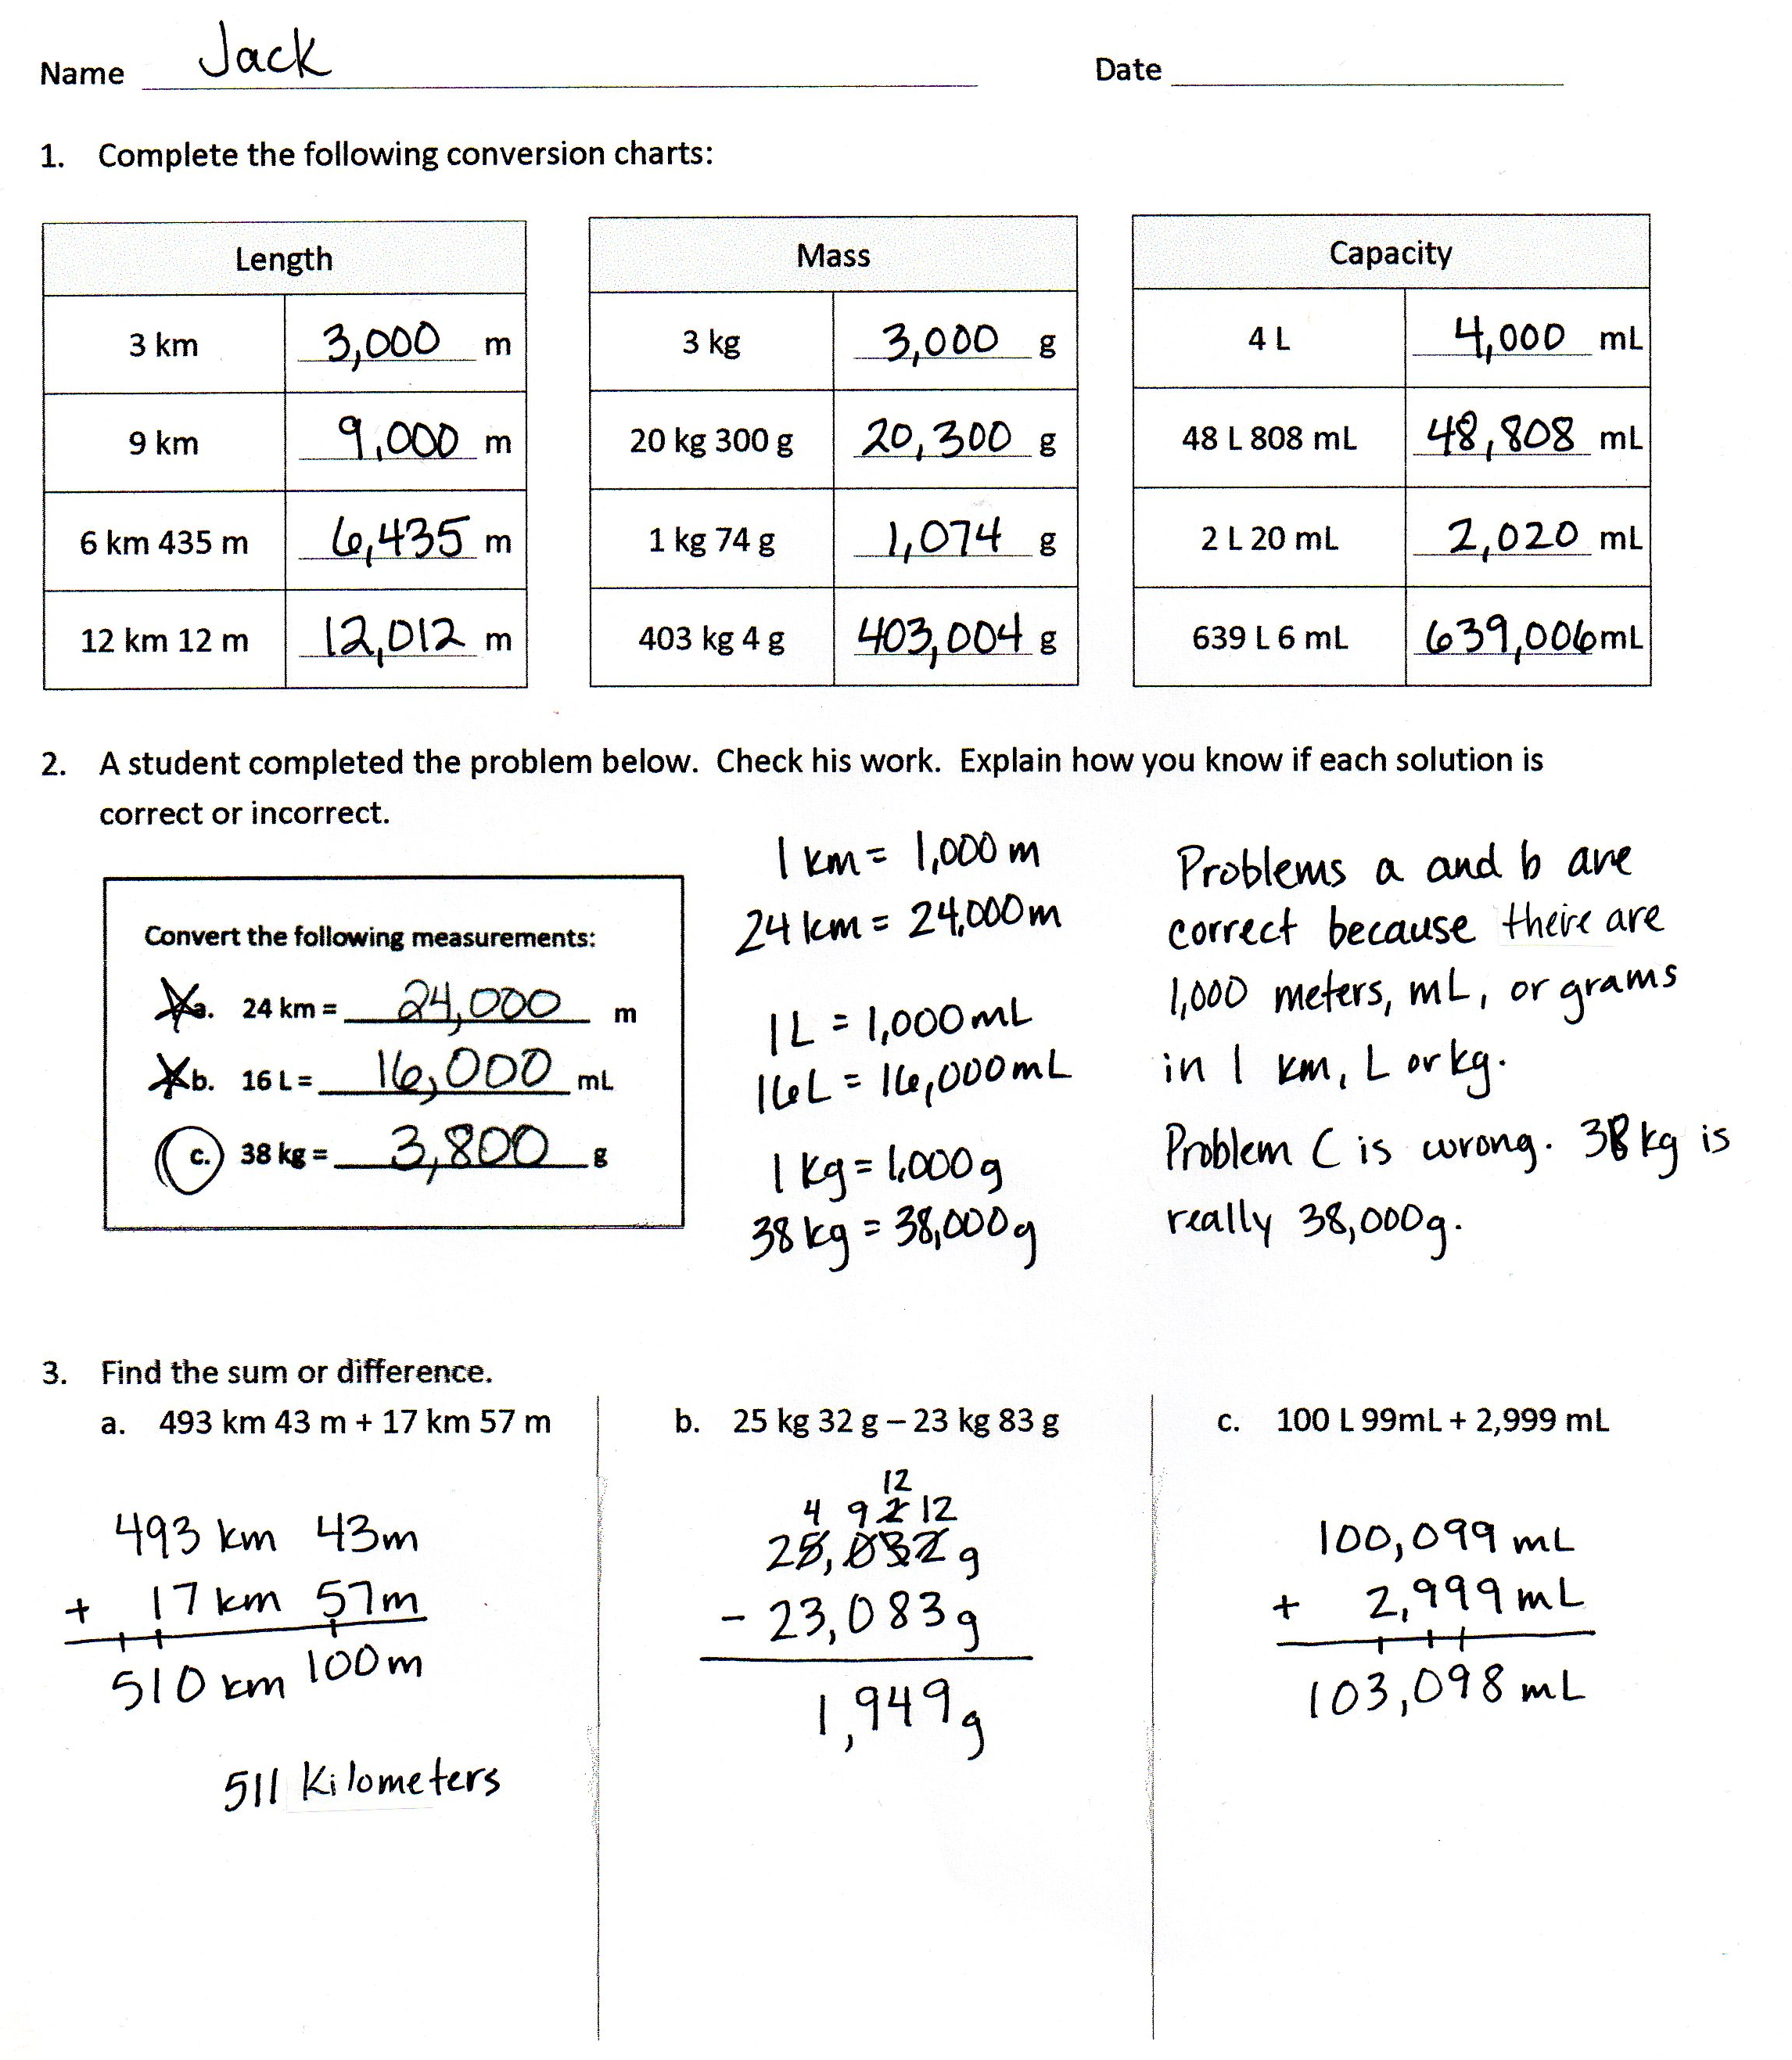
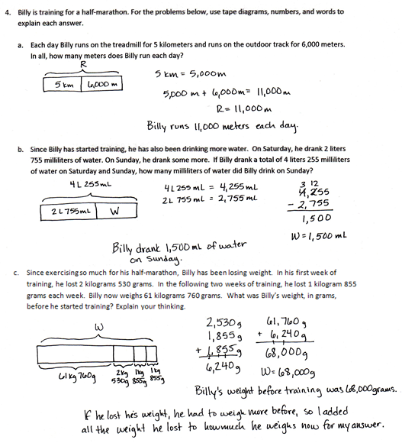

Pounds, ounces, and time are assessed in Module 7.
Time, money, and numbers as fractions or decimals are assessed in Module 7.

