Name Date
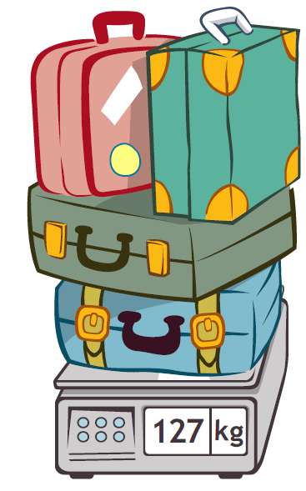
- Paul is moving to Australia. The total weight of his 4 suitcases is shown on the scale to the right. On a number line, round the total weight to the nearest 100 kilograms.

- Paul buys snacks for his flight. He compares cashews to yogurt raisins. The cashews weigh 205 grams, and the yogurt raisins weigh 186 grams. What is the difference between the weight of the cashews and yogurt raisins?

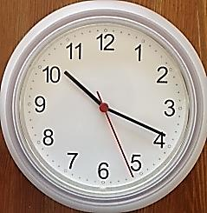
- The clock to the right shows what time it is now.
Time Right Now
  - Estimate the time to the nearest 10 minutes.

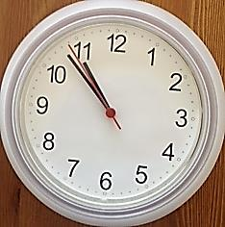
- The clock to the right show Paul’s departure time. Estimate the time to the nearest 10 minutes.
Departure Time

- Use your answers from Parts (a) and (b) to estimate how long Paul has before his flight leaves.

- A large airplane uses about 256 liters of fuel every minute.
- Round to the nearest ten liters to estimate how many liters of fuel get used every minute.

- Use your estimate to find about how many liters of fuel are used every 2 minutes.

- Calculate precisely how many liters of fuel are used every 2 minutes.

- Draw a tape diagram to find the difference between your estimate and the precise calculation.

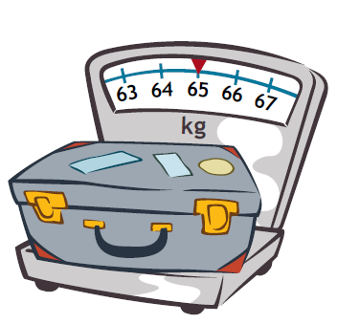
- Baggage handlers lift heavy luggage into the plane. The weight of one bag is shown on the scale to the right.
- One baggage handler lifts 3 bags of the same weight. Round to estimate the total weight he lifts. Then, calculate exactly.

- Another baggage handler lifts luggage that weighs a total of 200 kilograms. Write and solve an equation to show how much more weight he lifts than the first handler in Part (a).

- The baggage handlers load luggage for 18 minutes. If they start at 10:25 p.m., what time do they finish?

- One baggage handler drinks the amount of water shown below every day at work. How many liters of water does he drink during all 7 days of the week?
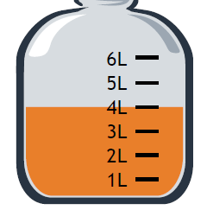

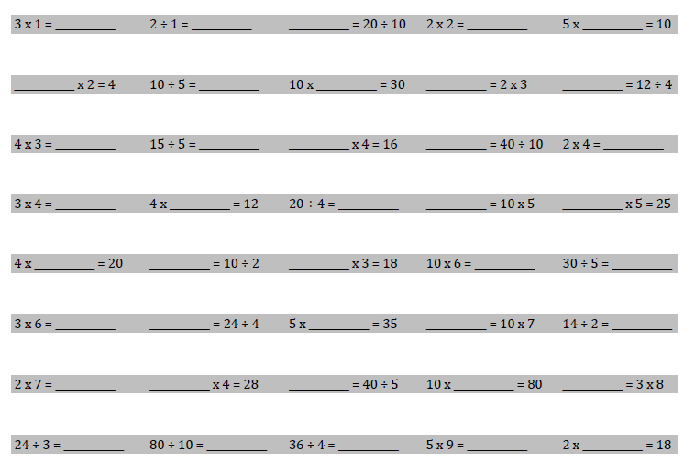
- Complete as many problems as you can in 100 seconds. The teacher will time you and tell you when to stop.

End-of-Module Assessment Task  Standards Addressed | Topics A–F
Use place value understanding and properties of operations to perform multi-digit arithmetic. (A range of algorithms may be used.)
3.NBT.1 Use place value understanding to round whole numbers to the nearest 10 or 100.
3.NBT.2 Fluently add and subtract within 1000 using strategies and algorithms based on place value, properties of operations, and/or the relationship between addition and subtraction.
Solve problems involving measurement and estimation of intervals of time, liquid volumes, and masses of objects.
3.MD.1 Tell and write time to the nearest minute and measure time intervals in minutes. Solve word problems involving addition and subtraction of time intervals in minutes, e.g., by representing the problem on a number line diagram.
3.MD.2 Measure and estimate liquid volumes and masses of objects using standard units of grams (g), kilograms (kg), and liters (l). (Excludes compound units such as cm³ and finding the geometric volume of a container.) Add, subtract, multiply, or divide to solve one-step word problems involving masses or volumes that are given in the same units, e.g., by using drawings (such as a beaker with a measurement scale) to represent the problem. (Excludes multiplicative comparison problems, i.e., problems involving notions of “times as many”; see CCLS Glossary, Table 2.)
Multiply and divide within 100.
3.OA.7 Fluently multiply and divide within 100, using strategies such as the relationship between multiplication and division (e.g., knowing that 8 × 5 = 40, one knows 40 ÷ 5 = 8) or properties of operations. By the end of Grade 3, know from memory all products of two one-digit numbers.

Evaluating Student Learning Outcomes
A Progression Toward Mastery is provided to describe steps that illuminate the gradually increasing understandings that students develop on their way to proficiency. In this chart, this progress is presented from left (Step 1) to right (Step 4) for Problems 1–5. The learning goal for each student is to achieve Step 4 mastery. These steps are meant to help teachers and students identify and celebrate what the student CAN do now and what they need to work on next. Problem 6 is scored differently since it is a timed assessment of fluency. Students complete as many problems as they can in 100 seconds. Although this page of the assessment contains 40 questions, answering 30 correct within the time limit is considered passing.

A Progression Toward Mastery
Assessment  Task Item | STEP 1  Little evidence of reasoning without a correct answer.  (1 Point) | STEP 2  Evidence of some reasoning without a correct answer.  (2 Points) | STEP 3  Evidence of some reasoning with a correct answer or evidence of solid reasoning with an incorrect answer.  (3 Points) | STEP 4  Evidence of solid reasoning with a correct answer.  (4 Points)
1  3.NBT.1  3.MD.2 | Student is unable to answer the question correctly. The attempt shows the student may not understand the meaning of the question. | Student attempts to answer the question. Mistakes may include those listed in the box to the right, and/or misreading the scale, but correctly rounding based on error. | Same criteria as for a 4, but may omit the unit (kg) in one or more parts of the answer. | Student answers the question correctly:  - Accurately reads the scale as 127 kg.  - Rounds on a number line to estimate  100 kg.
2  3.NBT.2 | Student is unable to answer the question correctly. The attempt shows the student may not understand the meaning of the question. | Student attempts to answer the question. Mistakes may include those listed in the box to the right, and/or decomposing the numbers incorrectly. | Student may or may not answer question correctly. Mistakes may include decomposing the numbers correctly but making a calculation error when subtracting. | Student correctly writes and solves 205 g – 186 g = 19 g.
3  3.NBT.1  3.NBT.2  3.MD.1 | Student is unable to answer questions correctly. The attempt shows the student may not understand the meaning of the questions. | Student attempts to answer the questions. Mistakes may include those listed in the box to the right, and/or inaccurately reading one or both of the clocks. | Student answers at least one question correctly. Mistakes may include a rounding error in either Part (a) or (b) affecting Part (c), but solves correctly based on wrong answer. | Student answers every question correctly:  a. Rounds 10:19 to 10:20.  b. Rounds 10:53 to 10:50.  c. Estimates about 30 minutes before the plane leaves.
4  3.NBT.1  3.NBT.2 | Student is unable to answer any of the questions correctly. The attempt shows the student may not understand the meaning of the questions. | Student attempts to answer the questions. Mistakes may include those listed in the box to the right, and/or:  - Either failing to round or calculate exactly in Parts (a–d).  - Omitting the units in any part.  - Incorrectly drawing or labelling a tape diagram. | Student may or may not answer questions correctly. Mistakes may include and arithmetic error in Part (c) affecting Part (d), but draws and labels tape diagram correctly based on wrong answer. | Student answers every question correctly:  - Rounds to estimate 260 liters in Part (a).  - Estimates 520 liters in Part (b).  - Precisely calculates 512 liters in Part (c).  - Draws and labels a tape diagram to show 8 liters as the difference in Part (d).
5  3.NBT.1  3.NBT.2  3.MD.1  3.MD.2 | Student is unable to answer any question correctly. The attempt shows the student may not understand the meaning of the questions. | Student attempts to answer the questions. Mistakes may include those listed in the box to the right, and/or:  - Conceptual rather than calculation error in Parts (a), (b), or (d).  - Either failing to round or calculate exactly in Part (a).  - Omitting the units in any part. | Student may or may not answer questions correctly. Mistakes may include those listed below:  - Arithmetic error in Part (a) affecting Part (b), but solved correctly based on wrong answer.  - Failing to write an equation in Part (b). | Student answers every question correctly:  - 65 + 65 + 65 = 195 kg, and 70 + 70 + 70 = 210 kg in Part (a).  - Writes and solves 200 – 195 = 5 kg in Part (b).  - Calculates end time of 10:43 p.m. in Part (c).  - May use multiplication or addition to answer 28 liters in Part (d).
6  3.OA.7 | Use the attached sample work to correct students’ answers on the fluency page of the assessment.  Students who answer 30 or more questions correctly within the allotted time pass this portion of the assessment. They are ready to move on to the more complicated fluency page given with the Module 3 End-of-Module Assessment. For students who do not pass, you may choose to re-administer this fluency page with each subsequent End-of-Module assessment until they are successful.  Analyze the mistakes students make on this assessment to further guide your fluency instruction. Possible questions to ask as you analyze are given below:  - Did this student struggle with multiplication, division, or both?  - Did this student struggle with a particular factor?  - Did the student consistently miss problems with the unknown in a particular position?
