Table of Contents
GRADE 1 • MODULE 1
Sums and Differences to 10

Module Overview i

Topic A: Embedded Numbers and Decompositions 1.A.1

Topic B: Counting On from Embedded Numbers 1.B.1

Topic C: Addition Word Problems 1.C.1

Topic D: Strategies for Counting On 1.D.1

Topic E: The Commutative Property of Addition and the Equal Sign 1.E.1

Topic F: Development of Addition Fluency Within 10 1.F.1

Topic G: Subtraction as an Unknown Addend Problem 1.G.1

Topic H: Subtraction Word Problems 1.H.1

Topic I: Decomposition Strategies for Subtraction 1.I.1

Topic J: Development of Subtraction Fluency Within 10 1.J.1
Module Assessments 1.S.1

Grade 1 • Module 1
Sums and Differences to 10
OVERVIEW
In this first module of Grade 1, students make significant progress towards fluency with addition and subtraction of numbers to 10 (1.OA.6) as they are presented with opportunities intended to advance them from counting all to counting on, which leads many students then to decomposing and composing addends and total amounts. In Kindergarten, students achieved fluency with addition and subtraction facts to 5. This means they can decompose 5 into 4 and 1, 3 and 2, and 5 and 0. They can do this without counting all. They perceive the 3 and 2 embedded within the 5.
Topic A continues the work of developing this ability with all the numbers within 10 in put together situations (1.OA.1), with a special focus on the numbers 6, 7, 8 and 9, since recognizing how much a number needs to make 10 is part of the Kindergarten standards (K.OA.4) and easier for most children. Students decompose numbers into two sets, or conceptually subitize, in Lessons 1 and 2 and record their decompositions as number bonds.
T: How many dots do you see?
S: 8!
T: What two parts do you see?
S: I see 5 and 3.
T: Did you need to count all the dots?
S: No! I could see the top row was a full five, so I just said 6, 7, 8.
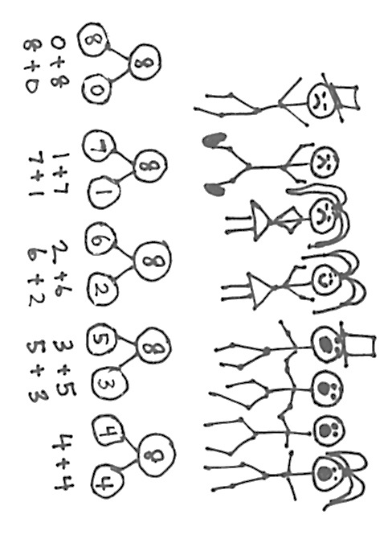
In Lesson 3, students see and describe 1 more as + 1. They use the structure of the first addend rather than its cardinality, just as the student speaking in the above vignette used the five. The number is a unit to which they can add one, or count on by one, without recounting. All three lessons in Topic A prepare students to solve addition problems by counting on rather than counting all (1.OA.5).
Topic B continues the process of having the students compose and decompose. They describe put together situations (pictured to the right) with number bonds and count on from the first part to totals of 6, 7, 8, 9, and 10 (1.OA.1, 1.OA.5). As they represent all the partners of a number, they reflect and see the decompositions, “Look at all these ways to make 8! I can see connections between them.”
Through dialogue, they engage in seeing both the composition invited by the put together situation, and the decomposition invited by the number bonds. Expressions are another way to model both the stories and the bonds, the compositions and the decompositions (1.OA.1).
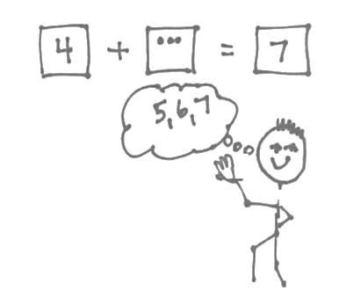
In Topic C, students interpret the meaning of addition from adding to with result unknown or putting together with result unknown story problems by drawing their own pictures and generating solution equations. Advancing beyond the Kindergarten word problem types, students next solve add to with change unknown problems such as, “Ben has 5 pencils. He got some more from his mother. Now, he has 9 pencils. How many pencils did Ben get from his mother?” These problems set the foundation early in the module for relating addition to subtraction in Topic G (1.OA.4).

In Topic D, students work outside the context of stories for three days, to further their understanding of and skill with counting on using 5-group cards. The first addend is represented with a numeral card, symbolizing the structure to count on from. The number to be added is represented using the dot side of the 5-group card. Students count on from the first addend. They learn to replace counting the dots by tracking the count on their fingers to find the solution (1.OA.5). In Lesson 16, they solve problems such as 4 + ___ = 7 by tracking the number of counts as they say, “5, 6, 7” (1.OA.8).
In Topic E, in the context of addition to 10, students expand their knowledge of two basic ideas of mathematics: equality and the commutativity of addition (1.OA.3 and 1.OA.7). The lesson on the equal sign precedes the lessons on commutativity in order to allow students to later construct true number sentences such as 4 + 3 = 3 + 4 without misunderstanding the equal sign to mean that the numbers are the same. Students apply their new generalization about the position of the addends to count on from the larger number. For example, “I can count on 2 from 7 when I solve 2 + 7!”
Like Topic E, Topic F leads students to make more generalizations that support their deepening understanding of addition within 10. They learn to recognize doubles and doubles plus 1. They analyze the addition chart for repeated reasoning and structures (such as 5-groups, plus ones, doubles, sums equal to 10, etc.) that can help them to better understand relationships and connections between different addition facts.
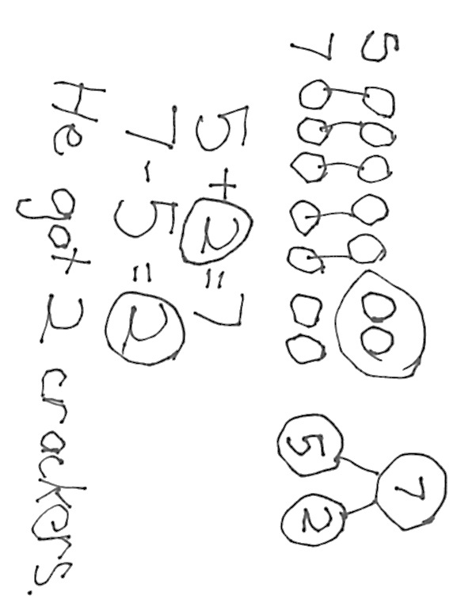Following the Mid-Module Assessment, Topic G relates addition to subtraction. Since Module 4 in Kindergarten, students have been very familiar with subtraction as “take away.” During Fluency Practice in the lessons in Topics A through F, students have had opportunities to remember their Kindergarten work with subtraction. Therefore, Topic G starts immediately with the concept of subtraction as a missing addend, just as Grade 3 students learn division as a missing factor in a multiplication problem.
“Ben had 5 crackers. He got some more. Now he has 7. How many crackers did Ben get?”

Having already worked with add to with change unknown problems earlier in the module, students revisit this familiar problem type, reinterpreting it as subtraction (1.OA.1, 1.OA.4). The topic then uses the strategies of counting with both 5-group cards and the number path to solve subtraction problems (1.OA.5, 1.OA.6).
Topic H is analogous to Topic C. Students interpret the meaning of subtraction as they solve different problem types involving subtraction (1.OA.1). Throughout Module 1, rather than using formal drawings or tape diagrams, students are encouraged to make math drawings that flow from their understanding of the stories. They engage in dialogue to relate their drawings to number sentences and explain the meaning of the subtraction symbol.
Topic I follows a week of intensive work with story problems to work on a more abstract level by visiting methods for subtraction involving special cases, subtracting 0 and 1, subtracting the whole number, and subtracting one less than the whole number. These two lessons are followed by three lessons in which students use familiar decompositions (5-groups and partners of 10) to conceptualize subtraction as finding a missing part (1.OA.6).
Finally, in Topic J, students analyze the addition chart for repeated reasoning and structures that support their journey towards fluency with subtraction within 10. The module closes with a lesson wherein students create sets of related addition and subtraction facts and use dialogue to explain their found connections (e.g., 7 = 4 + 3, 7 – 4 = 3, 4 + 3 = 3 + 4, 4 = 7 – 3, etc.). They began the module with very basic counting on, and end the module both with the skill to count on and significant movement towards the goal of fluency, achieved as the second addend does not need to be counted or can be counted very quickly.
Please note that the assessments should be read aloud to Grade 1 students.

Focus Grade Level Standards
Represent and solve problems involving addition and subtraction.
1.OA.1 Use addition and subtraction within 20 to solve word problems involving situations of adding to, taking from, putting together, taking apart and comparing, with unknowns in all positions, e.g., by using objects, drawings and equations with a symbol for the unknown number to represent the problem.
Understand and apply properties of operations and the relationship between addition and subtraction.
1.OA.3 Apply properties of operations as strategies to add and subtract. (Students need not use formal terms for these properties.) Examples: If 8 + 3 = 11 is known, then 3 + 8 = 11 is also known. (Commutative property of addition.) To add 2 + 6 + 4, the second two numbers can be added to make a ten, so 2 + 6 + 4 = 2 + 10 = 12. (Associative property of addition.)
1.OA.4 Understand subtraction as an unknown-addend problem. For example, subtract 10 – 8 by finding the number that makes 10 when added to 8.
Add and subtract within 20.
1.OA.5 Relate counting to addition and subtraction (e.g., by counting on 2 to add 2).
1.OA.6 Add and subtract within 20, demonstrating fluency for addition and subtraction within 10. Use strategies such as counting on; making ten (e.g., 8 + 6 = 8 + 2 + 4 = 10 + 4 = 14); decomposing a number leading to a ten (e.g., 13 – 4 = 13 – 3 – 1 = 10 – 1 = 9); using the relationship between addition and subtraction (e.g., knowing that 8 + 4 = 12, one knows 12 – 8 = 4); and creating equivalent but easier or known sums (e.g., adding 6 + 7 by creating the known equivalent 6 + 6 + 1 = 12 + 1 = 13).
Work with addition and subtraction equations.
1.OA.7 Understand the meaning of the equal sign, and determine if equations involving addition and subtraction are true or false. For example, which of the following equations are true and which are false? 6 = 6, 7 = 8 – 1, 5 + 2 = 2 + 5, 4 + 1 = 5 + 2.
1.OA.8 Determine the unknown whole number in an addition or subtraction equation relating three whole numbers. For example, determine the unknown number that makes the equation true in each of the equations 8 + ? = 11, 5 = ☐ – 3, 6 + 6 = ☐.
Foundational Standards
K.CC.2 Count forward beginning from a given number within the known sequence (instead of having to begin at 1).
K.CC.4b Understand that the last number name said tells the number of objects counted. The number of objects is the same regardless of their arrangement or the order in which they were counted.
K.CC.4c Understand that each successive number name refers to a quantity that is one larger.
K.OA.3 Decompose numbers less than or equal to 10 into pairs in more than one way, e.g., by using objects or drawings, and record each decomposition by a drawing or equation (e.g., 5 = 2 + 3 and 5 = 4 + 1).
K.OA.4 For any number from 1 to 9, find the number that makes 10 when added to the given number, e.g., by using objects or drawings, and record the answer with a drawing or equation.
K.OA.5 Fluently add and subtract within 5.
Focus Standards for Mathematical Practice
MP.2 Reason abstractly and quantitatively. Students make sense of quantities and their relations as they reason about two new problem types in Grade 1: change unknown and addend unknown. They write an addition sentence that corresponds to the situation and then reason to see that a subtraction number sentence also can be used to solve for the unknown.
Furthermore, in Topic D, students decontextualize addition from stories and work on strategies for computing.
MP.6 Attend to precision. Students clarify the meaning of the commutative property as they represent the same stories with repositioned addends. Students also state the meaning of the equal sign when they represent one amount with two different expressions connected by the equal sign.
MP.7 Look for and make use of structure. Students use the structure of embedded numbers or a known part from which to count on to find a total. After studying the commutative property, the larger addend becomes a structure from which to count on. Also, they analyze the addition chart for repeated reasoning and structures (such as 5-groups, plus ones, doubles, sums equal to 10, etc.) that can help them to better understand relationships and connections between different addition facts.
MP.8 Look for and express regularity in repeated reasoning. Students recognize when they are adding they are counting on by the same amount (e.g., + 2 or + 3 is the same as counting on by 2 or 3). Therefore, they apply the same strategy to solve other problems, recognizing the repetition of the reasoning.
Overview of Module Topics and Lesson Objectives
Standards | Topics and Objectives |  | Days
1.OA.1  1.OA.5 | A | Embedded Numbers and Decompositions  Lesson 1: Analyze and describe embedded numbers (to 10) using  5-groups and number bonds.  Lesson 2: Reason about embedded numbers in varied configurations using number bonds.  Lesson 3: See and describe numbers of objects using 1 more within  5-group configurations. | 3
1.OA.1  1.OA.5  1.OA.6 | B | Counting On from Embedded Numbers  Lessons 4–5: Represent put together situations with number bonds. Count on from one embedded number or part to totals of 6 and 7, and generate all addition expressions for each total.  Lessons 6–7: Represent put together situations with number bonds. Count on from one embedded number or part to totals of 8 and 9, and generate all expressions for each total.  Lesson 8: Represent all the number pairs of 10 as number bonds from a given scenario, and generate all expressions equal to 10. | 5
1.OA.1  1.OA.6  1.OA.5 | C | Addition Word Problems  Lesson 9: Solve add to with result unknown and put together with result unknown math stories by drawing, writing equations, and making statements of the solution.  Lesson 10: Solve put together with result unknown math stories by drawing and using 5-group cards.  Lesson 11: Solve add to with change unknown math stories as a context for counting on by drawing, writing equations, and making statements of the solution.  Lesson 12: Solve add to with change unknown math stories using 5-group cards.  Lesson 13: Tell put together with result unknown, add to with result unknown, and add to with change unknown stories from equations. | 5
1.OA.5  1.OA.8  1.OA.6 | D | Strategies for Counting On  Lessons 14–15: Count on up to 3 more using numeral and 5-group cards and fingers to track the change.  Lesson 16: Count on to find the unknown part in missing addend equations such as 6 + __ = 9. Answer, “How many more to make 6, 7, 8, 9, and 10?” | 3
1.OA.3  1.OA.7 | E | The Commutative Property of Addition and the Equal Sign  Lessons 17–18: Understand the meaning of the equal sign by pairing equivalent expressions and constructing true number sentences.  Lesson 19: Represent the same story scenario with addends repositioned (the commutative property).  Lesson 20: Apply the commutative property to count on from a larger addend. | 4
1.OA.3  1.OA.6 | F | Development of Addition Fluency Within 10  Lesson 21: Visualize and solve doubles and doubles plus 1 with 5-group cards.  Lesson 22: Look for and make use of repeated reasoning on the addition chart by solving and analyzing problems with common addends.  Lesson 23: Look for and make use of structure on the addition chart by looking for and coloring problems with the same total.  Lesson 24: Practice to build fluency with facts to 10. | 4
 |  | Mid-Module Assessment: Topics A–F (assessment 1 day, return 1 day, remediation or further applications 1 day) | 3
1.OA.1  1.OA.4  1.OA.5 | G | Subtraction as an Unknown Addend Problem  Lesson 25: Solve add to with change unknown math stories with addition, and relate to subtraction. Model with materials, and write corresponding number sentences.  Lessons 26–27: Count on using the number path to find an unknown part. | 3
1.OA.1  1.OA.4  1.OA.5  1.OA.8 | H | Subtraction Word Problems  Lesson 28: Solve take from with result unknown math stories with math drawings, true number sentences, and statements, using horizontal marks to cross off what is taken away.  Lesson 29: Solve take apart with addend unknown math stories with math drawings, equations, and statements, circling the known part to find the unknown.  Lesson 30: Solve add to with change unknown math stories with drawings, relating addition and subtraction.  Lesson 31: Solve take from with change unknown math stories with drawings.  Lesson 32: Solve put together/take apart with addend unknown math stories. | 5
1.OA.5  1.OA.6  1.OA.4 | I | Decomposition Strategies for Subtraction  Lesson 33: Model 0 less and 1 less pictorially and as subtraction number sentences.  Lesson 34: Model n – n and n – (n – 1) pictorially and as subtraction sentences.  Lesson 35: Relate subtraction facts involving fives and doubles to corresponding decompositions.  Lesson 36: Relate subtraction from 10 to corresponding decompositions.  Lesson 37: Relate subtraction from 9 to corresponding decompositions. | 5
1.OA.6 | J | Development of Subtraction Fluency Within 10  Lesson 38: Look for and make use of repeated reasoning and structure, using the addition chart to solve subtraction problems.  Lesson 39: Analyze the addition chart to create sets of related addition and subtraction facts. | 2
 |  | End-of-Module Assessment: Topics A–J (assessment 1 day, return 1 day, remediation or further applications 1 day) | 3
Total Number of Instructional Days |  |  | 45

Terminology
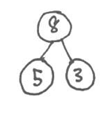New or Recently Introduced Terms
Number Bond
part
part
whole
- Count on (count up from one addend to the total)
- Track (use different objects to track the count on from one addend to the total)
- Expression (e.g., 2 + 1 or 5 – 3)
- Addend (one of the numbers being added)
- 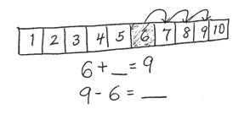Doubles (e.g., 3 + 3 or 4 + 4)
Number Path
- Doubles plus 1 (e.g., 3 + 4 or 4 + 5)
Familiar Terms and Symbols
- Part (e.g., “What is the unknown part? 3 + ___ = 8”)
- 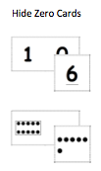Total and whole (use interchangeably instead of sum; e.g., “What is the total when we add 3 and 5?”)
Hide Zero Cards
- Label (using letters or words on a math drawing to indicate the referents from the story’s context)
- Addition, equal, and subtraction signs
- 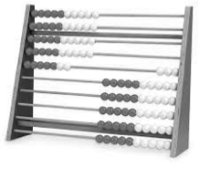Equation and number sentence (used interchangeably throughout the module)
Rekenrek
- Number bond (graphic showing part–part–whole)
- Equal sign (=)
- 5-groups (as pictured in the dot cards below), 2 rows of 5
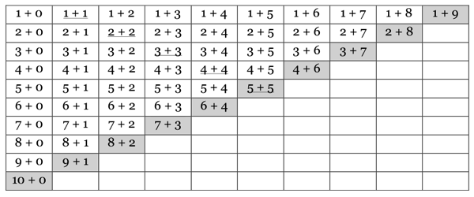Suggested Tools and Representations
Addition Chart
- Number bonds
5-Group Cards
Numerals

5-Groups
- Addition chart
- Rekenrek
- Counters
- Number path
- 5-Group cards
- Hide Zero cards

Suggested Methods of Instructional Delivery
Directions for Administration of Sprints
Sprints are designed to develop fluency. They should be fun, adrenaline-rich activities that intentionally build energy and excitement. A fast pace is essential. During Sprint administration, teachers assume the role of athletic coaches. A rousing routine fuels students’ motivation to do their personal best. Student recognition of increasing success is critical, and so every improvement is celebrated.
One Sprint has two parts with closely related problems on each. Students complete the two parts of the Sprint in quick succession with the goal of improving on the second part, even if only by one more.
With practice, the following routine takes about 9 minutes.
Sprint A
Pass Sprint A out quickly, face down on student desks with instructions to not look at the problems until the signal is given. (Some Sprints include words. If necessary, prior to starting the Sprint, quickly review the words so that reading difficulty does not slow students down.)
T: You will have 60 seconds to do as many problems as you can. I do not expect you to finish all of them. Just do as many as you can, your personal best. (If some students are likely to finish before time is up, assign a number to count by on the back.)
T: Take your mark! Get set! THINK!
Students immediately turn papers over and work furiously to finish as many problems as they can in 60 seconds. Time precisely.
T: Stop! Circle the last problem you did. I will read just the answers. If you got it right, call out “Yes!” If you made a mistake, circle it. Ready?
T: (Energetically, rapid-fire call the first answer.)
S: Yes!
T: (Energetically, rapid-fire call the second answer.)
S: Yes!
Repeat to the end of Sprint A or until no student has a correct answer. If needed, read the count-by answers in the same way you read Sprint answers. Each number counted-by on the back is considered a correct answer.
T: Fantastic! Now, write the number you got correct at the top of your page. This is your personal goal for Sprint B.
T: How many of you got one right? (All hands should go up.)
T: Keep your hand up until I say the number that is one more than the number you got correct. So, if you got 14 correct, when I say 15, your hand goes down. Ready?
T: (Continue quickly.) How many got two correct? Three? Four? Five? (Continue until all hands are down.)
If the class needs more practice with Sprint A, continue with the optional routine presented below.
T: I’ll give you one minute to do more problems on this half of the Sprint. If you finish, stand behind your chair.
As students work, the student who scored highest on Sprint A might pass out Sprint B.
T: Stop! I will read just the answers. If you got it right, call out “Yes!” If you made a mistake, circle it. Ready? (Read the answers to the first half again as students stand.)
Movement
To keep the energy and fun going, always do a stretch or a movement game in between Sprints A and B. For example, the class might do jumping jacks while skip-counting by 5 for about 1 minute. Feeling invigorated, students take their seats for Sprint B, ready to make every effort to complete more problems this time.
Sprint B
Pass Sprint B out quickly, face down on student desks with instructions to not look at the problems until the signal is given. (Repeat the procedure for Sprint A up through the show of hands for how many right.)
T: Stand up if you got more correct on the second Sprint than on the first.
S: (Stand.)
T: Keep standing until I say the number that tells how many more you got right on Sprint B. If you got three more right on Sprint B than you did on Sprint A, when I say three, you sit down. Ready? (Call out numbers starting with one. Students sit as the number by which they improved is called. Celebrate the students who improved most with a cheer.)
T: Well done! Now, take a moment to go back and correct your mistakes. Think about what patterns you noticed in today’s Sprint.
T: How did the patterns help you get better at solving the problems?
T: Rally Robin your thinking with your partner for 1 minute. Go!
Rally Robin is a style of sharing in which partners trade information back and forth, one statement at a time per person, for about 1 minute. This is an especially valuable part of the routine for students who benefit from their friends’ support to identify patterns and try new strategies.
Students may take Sprints home.

Personal White Boards
Materials Needed for Personal White Boards
1 heavy duty clear sheet protector
1 piece of stiff red tag board 11" × 8 ¼"
1 piece of stiff white tag board 11" × 8 ¼"
1 3" × 3" piece of dark synthetic cloth for an eraser (e.g., felt)
1 low odor blue dry erase marker, fine point
Directions for Creating Personal White Boards
Cut your white and red tag to specifications. Slide into the sheet protector. Store your eraser on the red side. Store markers in a separate container to avoid stretching the sheet protector.
Frequently Asked Questions About Personal White Boards
Why is one side red and one white?
The white side of the board is the “paper.” Students generally write on it, and if working individually, turn the board over to signal to the teacher they have completed their work. The teacher then says, “Show me your boards,” when most of the class is ready.
What are some of the benefits of a personal white board?
- The teacher can respond quickly to a gap in student understandings and skills. “Let’s do some of these on our personal white boards until we have more mastery.”
- Students can erase quickly so that they do not have to suffer the evidence of their mistake.
- They are motivating. Students love both the drill and thrill capability and the chance to do story problems with an engaging medium.
- Checking work gives the teacher instant feedback about student understanding.
What is the benefit of this personal white board over a commercially purchased dry erase board?
- It is much less expensive.
- Templates such as place value charts, number bond mats, hundreds boards, and number lines can be stored between the two pieces of tag board for easy access and reuse.
- Worksheets, story problems, and other problem sets can be done without marking the paper so that students can work on the problems independently at another time.
- Strips with story problems, number lines, and arrays can be inserted and still have a full piece of paper on which to write.
- The red versus white side distinction clarifies your expectations. When working collaboratively, there is no need to use the red. When working independently, the students know how to keep their work private.
- The tag board can be removed so that student work can be projected on an overhead.

Scaffolds
The scaffolds integrated into A Story of Units give alternatives for how students access information as well as express and demonstrate their learning. Strategically placed margin notes are provided within each lesson elaborating on the use of specific scaffolds at applicable times. They address many needs presented by English language learners, students with disabilities, students performing above grade level, and students performing below grade level. Many of the suggestions are organized by Universal Design for Learning (UDL) principles and are applicable to more than one population. To read more about the approach to differentiated instruction in A Story of Units, please refer to “How to Implement A Story of Units.”

Assessment Summary
Type | Administered | Format | Standards Addressed
Mid-Module Assessment Task | After Topic F | Constructed response with rubric | 1.OA.1  1.OA.3  1.OA.5  1.OA.6  1.OA.7  1.OA.8
End-of-Module Assessment Task | After Topic J | Constructed response with rubric | 1.OA.1  1.OA.3  1.OA.4  1.OA.5  1.OA.6  1.OA.7  1.OA.8

For an analysis of addition and subtraction word problem types used in Grades K–2, please refer to the Counting and Cardinality Progression, pages 7 and 9, and the Standards, page 88.
In this module, work is limited to within 10.
1.OA.2 is addressed in Module 2.
These are terms and symbols students have used or seen previously.
Students with disabilities may require Braille, large print, audio, or special digital files. Please visit the website, www.p12.nysed.gov/specialed/aim, for specific information on how to obtain student materials that satisfy the National Instructional Materials Accessibility Standard (NIMAS) format.

