Name Date

- There are 9 ducks swimming along in a line. There are 2 grown-up ducks, and the rest are babies. How many of the ducks are babies?
  - Explain your thinking using pictures, numbers, or words.

  - Write a number sentence that shows how you solved the problem.

_____________________________

- Jennifer says you can use addition to solve subtraction.

She says to solve 9 – 6 = , just add 9 + 6.
Explain how Jennifer is right and wrong using words, pictures, and numbers.

- Jeremy is confused about this problem: ___ = 10 – 8. Be his teacher. Write two addition number sentences that might help him understand and solve it. Explain to Jeremy using words, pictures, or numbers, too.

- At the park, there are 6 friends playing baseball. Some more friends come. Now, there are 10 friends playing.
  - How many friends come to play with the first 6 friends? Explain your thinking using a math drawing, numbers, and words.

- Write an addition sentence and a subtraction sentence to match the story.

___________________________ _____________________________

- Write the addition sentence you found when solving the problem, and use the same 3 numbers to write 3 more number sentences:

___________________________ _____________________________

___________________________ _____________________________
End-of-Module Assessment Task Topics A–J
Standards Addressed
Represent and solve problems involving addition and subtraction.
1.OA.1 Use addition and subtraction within 20 to solve word problems involving situations of adding to, taking from, putting together, taking apart, and comparing, with unknowns in all positions, e.g., by using objects, drawings, and equations with a symbol for the unknown number to represent the problem. (See Glossary, Table 1.)
Understand and apply properties of operations and the relationship between addition and subtraction.
1.OA.3 Apply properties of operations as strategies to add and subtract. (Students need not use formal terms for these properties.) Example: If 8 + 3 = 11 is known, then 3 + 8 = 11 is also known. (Commutative property of addition.) To add 2 + 6 + 4, the second two numbers can be added to make a ten, so 2 + 6 + 4 = 2 + 10 = 12. (Associative property of addition.)
1.OA.4 Understand subtraction as an unknown-addend problem. For example, subtract 10 – 8 by finding the number that makes 10 when added to 8.
Add and subtract within 20.
1.OA.5 Relate counting to addition and subtraction (e.g., by counting on 2 to add 2).
1.OA.6 Add and subtract within 20, demonstrating fluency for addition and subtraction within 10. Use strategies such as counting on; making ten (e.g., 8 + 6 = 8 + 2 + 4 = 10 + 4 = 14); decomposing a number leading to a ten (e.g., 13 – 4 = 13 – 3 – 1 = 10 – 1 = 9); using the relationship between addition and subtraction (e.g., knowing that 8 + 4 = 12, one knows 12 – 8 = 4); and creating equivalent but easier or known sums (e.g., adding 6 + 7 by creating the known equivalent 6 + 6 + 1 = 12 + 1 = 13).
Work with addition and subtraction equations.
1.OA.7 Understand the meaning of the equal sign, and determine if equations involving addition and subtraction are true or false. For example, which of the following equations are true and which are false? 6 = 6, 7 = 8 – 1, 5 + 2 = 2 + 5, 4 + 1 = 5 + 2.
1.OA.8 Determine the unknown whole number in an addition or subtraction equation relating three whole numbers. For example, determine the unknown number that makes the equation true in each of the equations 8 + ? = 11, 5 = ☐ – 3, 6 + 6 = ☐.
Evaluating Student Learning Outcomes
A Progression Toward Mastery is provided to describe steps that illuminate the gradually increasing understandings that students develop on their way to proficiency. In this chart, this progress is presented from left (Step 1) to right (Step 4). The learning goal for each student is to achieve Step 4 mastery. These steps are meant to help teachers and students identify and celebrate what the student can do now, and what they need to work on next.

A Progression Toward Mastery
Assessment  Task Item | STEP 1  Little evidence of reasoning without a correct answer.  (1 Point) | STEP 2  Evidence of some reasoning without a correct answer.  (2 Points) | STEP 3  Evidence of some reasoning with a correct answer or evidence of solid reasoning with an incorrect answer.  (3 Points) | STEP 4  Evidence of solid reasoning with a correct answer.  (4 Points)
1  1.OA.1  1.OA.4  1.OA.6  1.OA.8 | The student demonstrates a limited ability to both explain his thinking and answer accurately. | The student demonstrates a beginning concept of how to solve an addend unknown relationship problem using pictures, words, or numbers by attempting to show her thinking, but provides an inaccurate answer. | The student correctly solves the addend unknown relationship problem and writes a corresponding equation, but cannot explain his thinking in pictures, words, or numbers.  Or, the student explains her thinking using pictures, words, or numbers, but is unable to write an accurate equation. | The student correctly:  - Solves the addend unknown relationship problem and determines that 7 ducks are babies.  - Explains thinking by drawing a picture, writing numbers or equations, or words.  - Writes an equation that corresponds with her solution process (addition or subtraction).
2  1.OA.4  1.OA.5  1.OA.7  1.OA.8 | The student shows little evidence of understanding how addition and subtraction differ, or is unable to complete the task. | The student shows evidence of beginning to understand how addition and subtraction differ through his explanation, but demonstrates incomplete reasoning or an incorrect answer. | The student identifies that Jennifer is incorrect, but cannot fully support the claim or explain his thinking clearly. | The student correctly  identifies that Jennifer is correct, that addition can be used to solve a subtraction problem, and that she is incorrect in adding 9 and 6 to solve 9 – 6. The student shows her thinking using words, pictures, or numbers.
3  1.OA.5  1.OA.4  1.OA.7  1.OA.8 | The student demonstrates little to no understanding of concept of the connection between addition and subtraction and is unable to explain her thinking. | The student demonstrates a beginning understanding of the connection between addition and subtraction, but does not answer accurately. | The student correctly writes two accurate equations using 8, 2, and 10, but is unable to explain her thinking.  Or, the student is able to explain her thinking, somehow citing the connection between addition and subtraction, but is unable to write two accurate equations. | The student correctly:  - Writes two accurate addition equations using 8, 2, and 10.  - Explains her thinking using pictures, numbers, or words, and cites the connection between addition and subtraction in her explanation.
4  1.OA.1  1.OA.3  1.OA.4  1.OA.6  1.OA.7  1.OA.8  1.OA.5 | The student shows very little understanding of how to solve the add to with change unknown problem and cannot write corresponding equations. | The student shows a beginning understanding of how to solve the add to with change unknown problem, but lacks reasoning or equation writing skills. | The student correctly answers the add to with change unknown problem (4 friends came to play), writes accurate addition and subtraction equations, including those that demonstrate an understanding of the commutative property, but is unable to explain his thinking.  Or, the student writes addition and subtraction equations correctly and clearly explains his thinking, but does not answer accurately (something other than 4 friends came to play).  Or, the student solves the problem (4 friends came to play) and explains thinking clearly, but does not write all addition and subtraction sentences accurately. | The student clearly:  - Solves the add to with change unknown problem, determines that 4 friends came to play, and explains his thinking.  - Writes addition and subtraction equations which correspond to the problem.  - Applies the commutative property and knowledge of the equal sign to write three additional equations  (10 = 6 + 4;  4 + 6 = 10;  10 – 4 = 6; etc.).

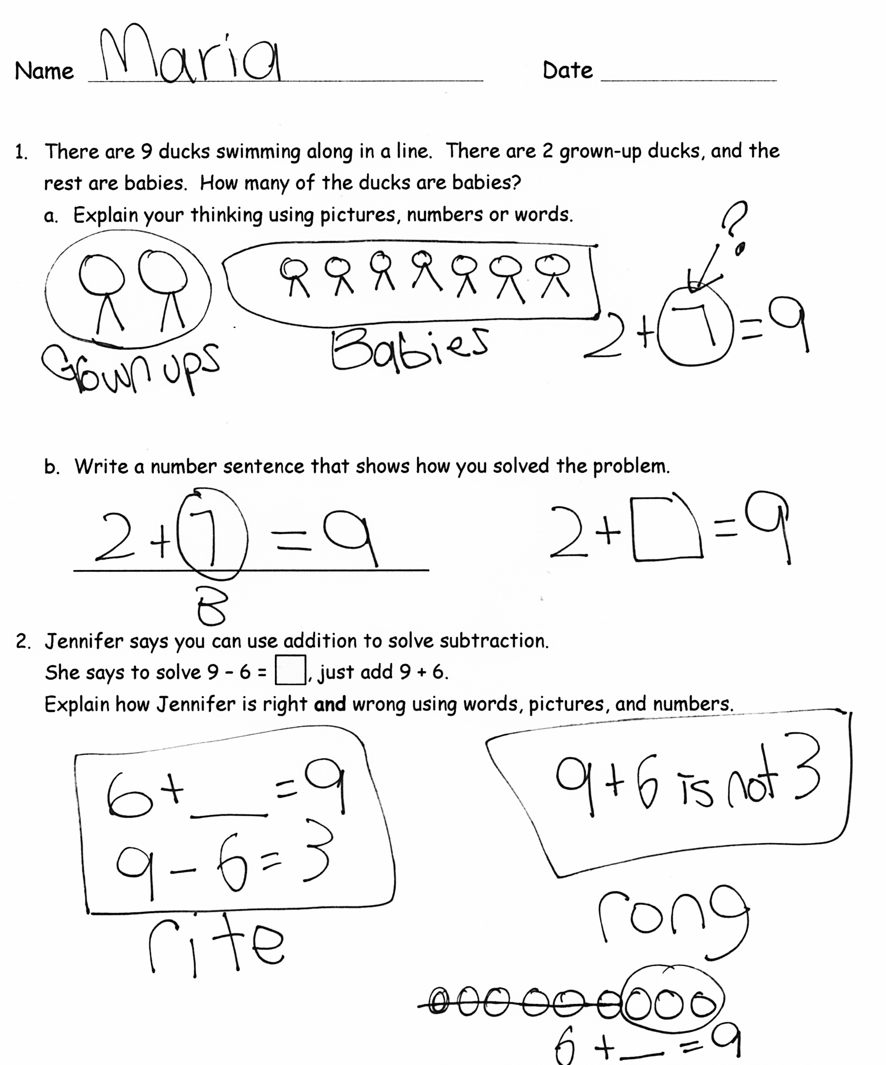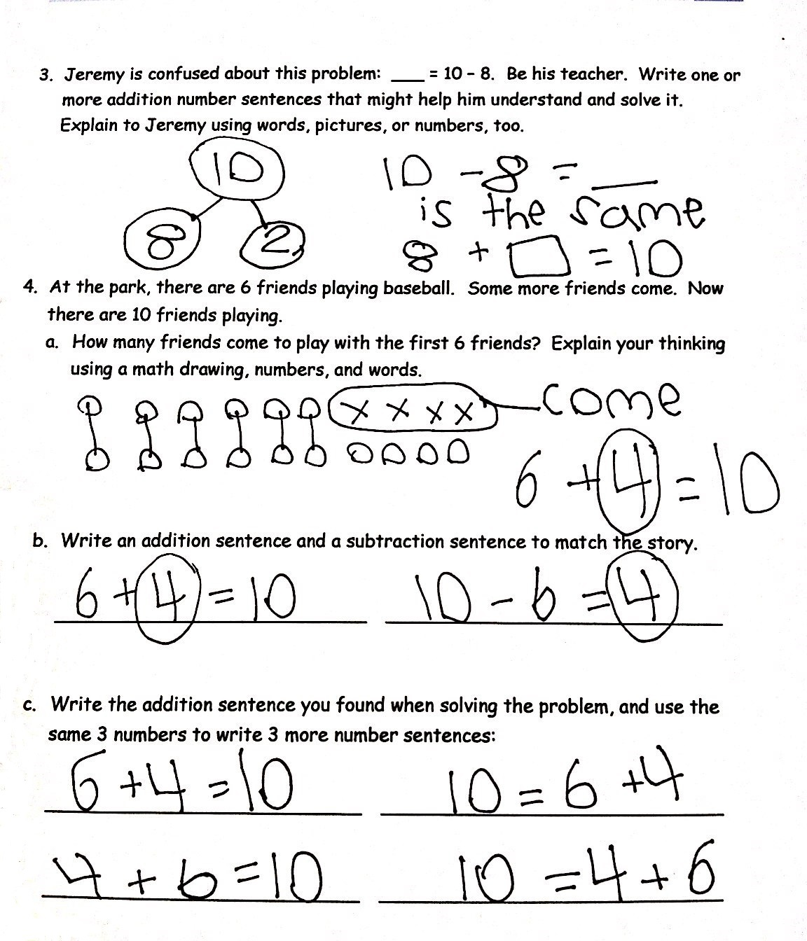
two

