Argument Visual Handout
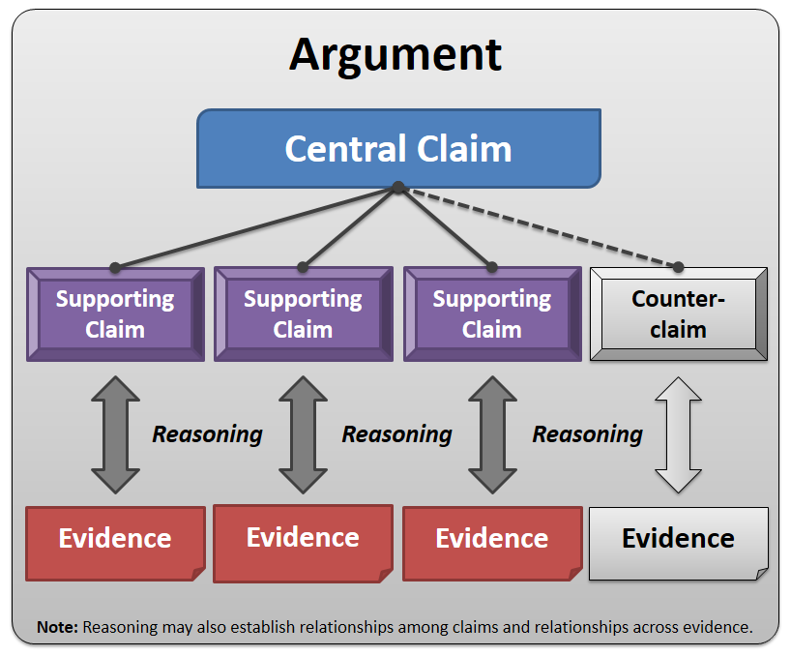

- Argument: The composition of precise claims about an issue, including relevant and sufficient evidence and valid reasoning
- Central Claim: An author or speaker’s main point about an issue in an argument
- Supporting Claim: Smaller, related points that reinforce or advance the central claim
- Counterclaim: A claim that is opposed to an author’s central claim
- Evidence: The topical and textual facts, events, and ideas from which the claims of an argument arise, and which are cited to support those claims
- Reasoning: The logical relationships among ideas, including relationships among claims and relationships across evidence

