Table of Contents

GRADE 2 • MODULE 1

Sums and Differences to 20

**Module Overview** i

Topic A: Foundations for Addition and Subtraction Within 20 1.A.1

Topic B: Mental Strategies for Addition and Subtraction Within 20 1.B.1

Topic C: Strategies for Addition and Subtraction Within 100 1.C.1

**Module Assessment** 1.S.1

Grade 2 • Module 1

Sums and Differences to 20

OVERVIEW

Module 1 sets the foundation for students to master sums and differences to 20 (**2.OA.2**). Students subsequently apply these skills to fluently add one-digit to two-digit numbers at least through 100 using place value understanding, properties of operations, and the relationship between addition and subtraction (**2.NBT.5**). In Grade 1, students worked extensively with numbers to 10 and developed Level 2 and Level 3 mental strategies to add and subtract within 20 (**1.OA.1**) and 100 (**1.NBT.4–6**).

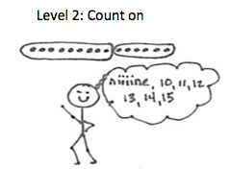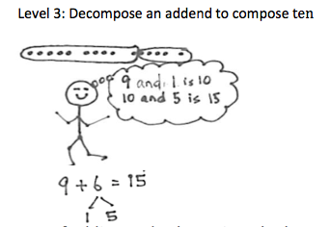

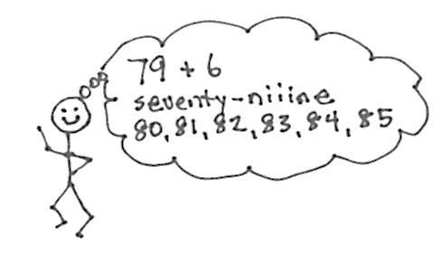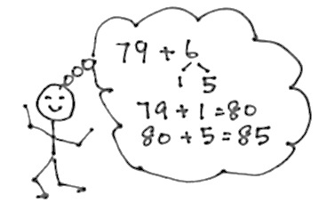

For example, to solve 12 + 3 students might make an equivalent but easier problem by decomposing 12 as 10 and 2 and composing 2 with 3 to make 5. Students can use this knowledge to solve related problems such as 92 + 3. They also apply this skill using smaller numbers to subtract problems with larger numbers: 12 – 8 = 10 – 8 + 2 = 2 + 2, just as 72 – 8 = 70 – 8 + 2 = 62 + 2.

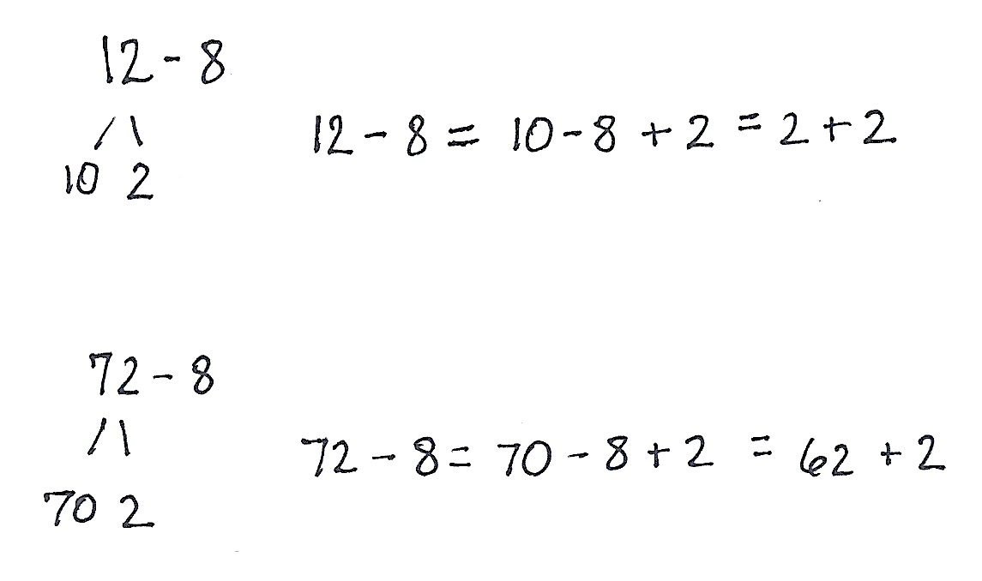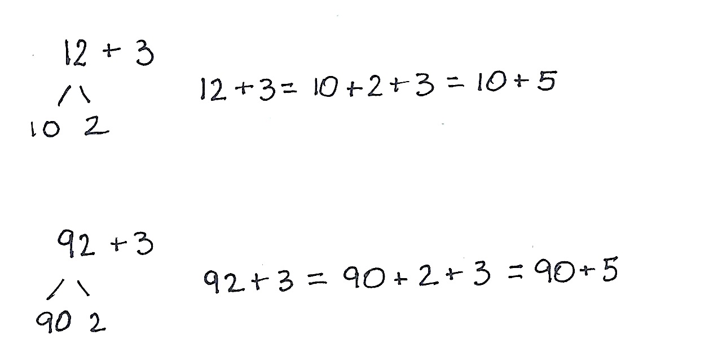

Daily fluency activities provide sustained practice to help students attain fluency within 20. This fluency is essential to the work of later modules and future grade levels, where students must efficiently recompose place value units to work adeptly with the four operations. Activities such as Say Ten counting, Take from Ten, and the use of ten-frame and Hide Zero cards solidify student fluency. Because the amount of practice required by each student to achieve mastery will vary, a motivating, differentiated fluency program needs to be established in these first weeks to set the tone for the rest of the year.

Throughout the module, students will represent and solve one-step word problems through the daily Application Problem (**2.OA.1**). Note that one-step problems may have multiple parts that are separated by bullets or letters. Each part requires only one operation. These multi-part problems serve as a stepping-stone toward multi-step problems. Application Problems can precede a lesson to act as the lead-in to a concept, allowing students to discover through problem-solving the logic and usefulness of a strategy before that strategy is formally presented. Or, they can follow the Concept Development so that students connect and apply their learning to real-world situations. This latter structure can also serve as a bridge between teacher-directed work and students solving problems independently on Problem Sets and at home. In either case, problem-solving begins as a guided activity, with the goal being to move students to independent problem-solving, wherein they reason through the relationships of the problem and choose an appropriate strategy to solve. In Module 1, Application Problems follow Concept Development.

Topic A reactivates students’ Kindergarten and Grade 1 learning as they practice prerequisite skills for Level 3 decomposition and composition methods: partners to 10 and decompositions for all numbers within 10.[1] Students move briskly from concrete to pictorial to abstract as they remember their make ten facts. They use ten-frame cards to visualize 10, and they write the number bonds of 10 from memory. They use those facts to see relationships in larger numbers (e.g., 28 needs how many to make 30?). The number bond is also used to represent related facts within 10.

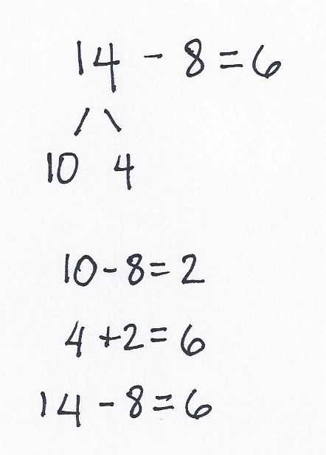Topic B also moves from concrete to pictorial to abstract, as students use decomposing strategies to add and subtract within 20. By the end of Grade 1 Module 2, students learned to form ten as a unit. Hence, the phrase *make ten* now transitions to *make a ten.* Students use the ten-structure to reason about making a ten to add to the teens, and they use this pattern and math drawings to solve related problem sets (e.g., 9 + 4, 9 + 5, 9 + 6). Students reason about the relationship between problems such as 19 + 5 and 20 + 4 to 9 + 5 and 10 + 4. They use place value understanding to add and subtract within 20 by adding to and subtracting from the ones. The topic ends with a lesson in which students subtract from 10. The goal in making a 10 and taking from 10 is for students to master mental math.

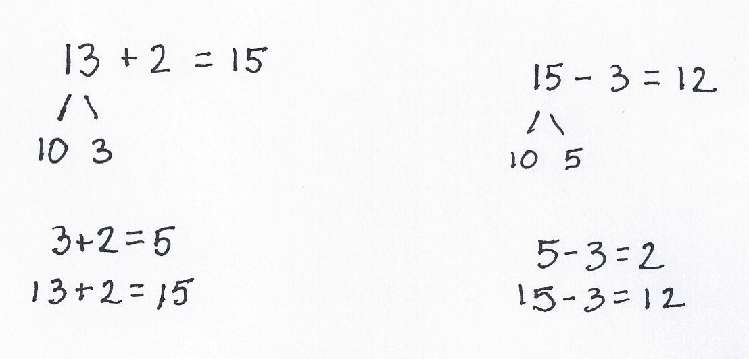

**Take from 10**

**Add and subtract ones**

Topic C calls on students to review strategies to add and subtract within 100 (**1.NBT.4–6**) to set the foundation for Grade 2’s work towards mastery of fluency with the same set of problems (**2.NBT.5**). They use basic facts and place value understanding to add and subtract within multiples of 10 without crossing the multiple (e.g., 7 – 5 = 2, so 47 – 5 = 42). This segues into the use of basic facts and properties of addition to cross multiples of 10 (e.g., 26 + 9 = 20 + 6 + 4 + 5). In the final lesson, students decompose to make a ten and then subtract from numbers that have both tens and ones.

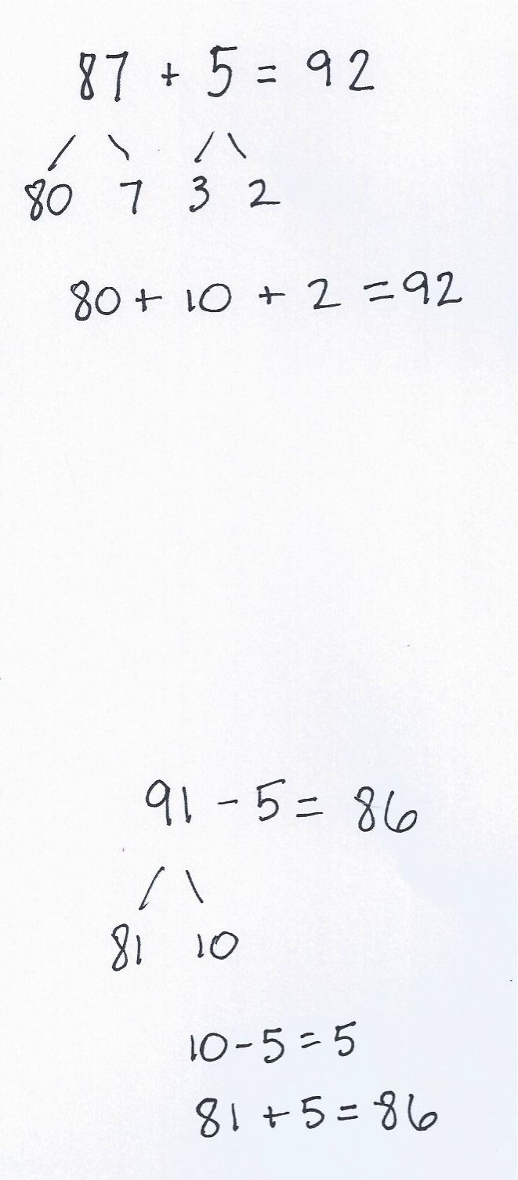



**Add basic facts to cross multiples of 10**

**Decompose and subtract from the 10**

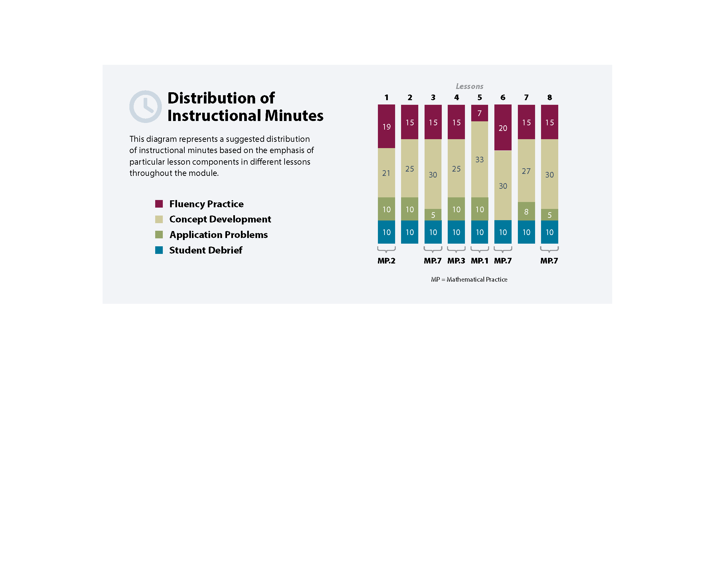

Focus Grade Level Standards

Sample

Represent and solve problems involving addition and subtraction.[2]

2.OA.1 Use addition and subtraction within 100 to solve one- and two-step word problems involving situations of adding to, taking from, putting together, taking apart, and comparing, with unknowns in all positions, e.g., by using drawings and equations with a symbol for the unknown number to represent the problem. (See CCLS Glossary, Table 1.)

Add and subtract within 20.[3]

2.OA.2 Fluently add and subtract within 20 using mental strategies. (See standard 1.OA.6 for a list of mental strategies.) By end of Grade 2, know from memory all sums of two one-digit numbers.

Use place value understanding and properties of operations to add and subtract.[4]

2.NBT.5 Fluently add and subtract within 100 using strategies based on place value, properties of operations, and/or the relationship between addition and subtraction.

Foundational Standards

K.OA.3 Decompose numbers less than or equal to 10 into pairs in more than one way, e.g., byusing objects or drawings, and record each decomposition by a drawing or equation (e.g.,5 = 2 + 3 and 5 = 4 + 1).

K.OA.4 For any number from 1 to 9, find the number that makes 10 when added to the givennumber, e.g., by using objects or drawings, and record the answer with a drawing orequation.

K.NBT.1 Compose and decompose numbers from 11 to 19 into ten ones and some further ones,e.g., by using objects or drawings, and record each composition or decomposition by adrawing or equation (e.g., 18 = 10 + 8); understand that these numbers are composed often ones and one, two, three, four, five, six, seven, eight, or nine ones.

1.OA.6 Add and subtract within 20, demonstrating fluency for addition and subtraction within10. Use strategies such as counting on; making ten (e.g., 8 + 6 = 8 + 2 + 4 = 10 + 4 = 14);decomposing a number leading to a ten (e.g., 13 – 4 = 13 – 3 – 1 = 10 – 1 = 9); using therelationship between addition and subtraction (e.g., knowing that 8 + 4 = 12, one knows12 – 8 = 4); and creating equivalent but easier or known sums (e.g., adding 6 + 7 by creating the known equivalent 6 + 6 = 1 = 12 + 1 = 13).

1.NBT.4 Add within 100, including adding a two-digit number and a one-digit number, and adding a two-digit number and a multiple of 10, using concrete models or drawings and strategies based on place value, properties of operations, and/or the relationship between addition and subtraction; relate the strategy to a written method and explain the reasoning used. Understand that in adding two-digit numbers, one adds tens and tens, ones and ones; and sometimes it is necessary to compose a ten.

1.NBT.5 Given a two-digit number, mentally find 10 more or 10 less than the number, without having to count; explain the reasoning used.

1.NBT.6 Subtract multiples of 10 in the range 10–90 from multiples of 10 in the range 10–90 (positive or zero differences), using concrete models or drawings and strategies based on place value, properties of operations, and/or the relationship between addition and subtraction; relate the strategy to a written method and explain the reasoning used.

Focus Standards for Mathematical Practice

MP.1 **Make sense of problems and persevere in solving them.** Students make math drawings and use recomposing strategies to reason through the relationships in word problems. They write equations and word sentences to explain their solutions.

MP.2 **Reason abstractly and quantitatively.**  Students decompose numbers and use the associative property to create equivalent but easier problems, e.g., 25 + 6 = 20 + 5 + 5 + 1. They reason abstractly when they relate subtraction to addition and change 13 – 8 = ___ into an unknown addend, 8 + ___ = 13, to solve.

MP.**3** **Construct viable arguments and critique the reasoning of others.** Students explain their reasoning to prove that 9 + 5 = 10 + 4. They communicate how simpler problems embedded within more complex problems enable them to solve mentally, e.g., 8 + 3 = 11, so 68 + 3 = 71.

**MP.7 Look for and make use of structure.**  Students use the structure of ten to add and subtract within 20, and later, within 100, e.g., 12 – 8 = 10 – 8 + 2 = 2 + 2, and 92 + 3 = 90 + 2 + 3 = 90 + 5.

Overview of Module Topics and Lesson Objectives

|  |  |  |  |
| --- | --- | --- | --- |
| **Standards** | **Topics and Objectives** | | **Days** |
| **2.OA.1**  **2.OA.2**  K.OA.3  K.OA.4  K.NBT.1  1.OA.6 | A | Foundations for Addition and Subtraction Within 20  Lesson 1: Make number bonds of ten.  Lesson 2: Make number bonds through ten with a subtraction focus and apply to one-step word problems. | 2 |
| **2.OA.1**  **2.OA.2** | B | Mental Strategies for Addition and Subtraction Within 20  Lesson 3: Make a ten to add within 20.  Lesson 4: Make a ten to add and subtract within 20.  Lesson 5: Decompose to subtract from a ten when subtracting within 20 and apply to one-step word problems. | 3 |
| **2.OA.1**  **2.NBT.5**  2.OA.2  1.NBT.4  1.NBT.5  1.NBT.6 | C | Strategies for Addition and Subtraction Within 100  Lesson 6: Add and subtract within multiples of ten based on understanding place value and basic facts.  Lesson 7: Add within 100 using properties of addition to make a ten.  Lesson 8: Decompose to subtract from a ten when subtracting within 100 and apply to one-step word problems. | 3 |
|  |  | End-of-Module Assessment: Topics A–C (assessment ½ day, return ½ day, remediation or further applications 1 day) | 2 |
| **Total Number of Instructional Days** | | | **10** |

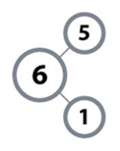Terminology

**Number bond**

Familiar Terms and Symbols

* Expression (e.g., 2 + 1, 13 – 6)
* Make ten and subtract from ten (e.g., 8 + 3 = 8 + 2 + 1 and 15 – 7 = 10 – 7 + 5 = 3 + 5)
* Number bond (e.g., 5 + 1 = 6, 1 + 5 = 6, 6 – 1 = 5, 6 – 5 = 1)
* 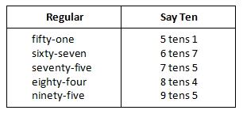Say Ten counting (e.g., 11 is “1 ten 1,” 12 is “1 ten 2,” 20 is “2 tens,” 27 is “2 tens 7,” 35 is “3 tens 5,” 100 is “1 hundred,” 146 is “1 hundred 4 tens 6”)
* Ten plus (e.g., 10 + 3 = 13, 30 + 5 = 35, 70 + 8 = 78)

Suggested Tools and Representations

* Dice
* Hide Zero cards (Lesson 2 Template 1)

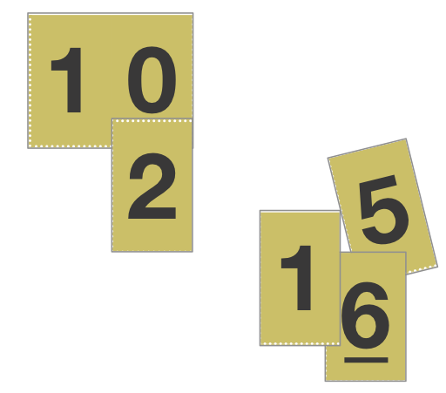

Hide Zero cards

* Linking cubes
* Personal white boards
* Rekenrek
* Ten-frame cards, 1 set per student (Lesson 1 Template 1)
  + 1 each of 1–4 and 6–9
  + 2 fives
  + 10 tens
  + Blank frame
* Ten-frame cards large set for teacher
* Ten-strip (Lesson 4 Template)
* Two-sided counters for each student (e.g., large white beans spray painted red on one side)

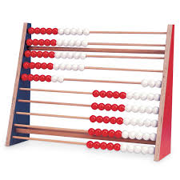

Rekenrek

Ten-strip

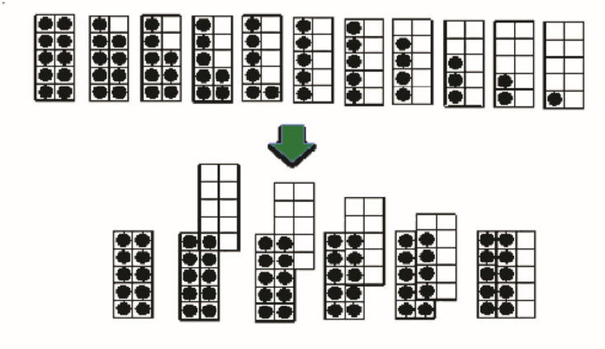

Ten-frame cards

Suggested Methods of Instructional Delivery

Directions for Administration of Sprints

Sprints are designed to develop fluency. They should be fun, adrenaline-rich activities that intentionally build energy and excitement. A fast pace is essential. During Sprint administration, teachers assume the role of athletic coaches. A rousing routine fuels students’ motivation to do their personal best. Student recognition of increasing success is critical, and so every improvement is celebrated.

One Sprint has two parts with closely related problems on each. Students complete the two parts of the Sprint in quick succession with the goal of improving on the second part, even if only by one more.

With practice the following routine takes about 8 minutes.

Sprint A

Pass *Sprint A* out quickly, face down on student desks with instructions to not look at the problems until the signal is given. (Some Sprints include words. If necessary, prior to starting the Sprint quickly review the words so that reading difficulty does not slow students down.)

T: You will have 60 seconds to do as many problems as you can.

T: I do not expect you to finish all of them. Just do as many as you can, your personal best. (If some students are likely to finish before time is up, assign a number to *count by* on the back.)

T: Take your mark! Get set! THINK! (When you say THINK, students turn their papers over and work furiously to finish as many problems as they can in 60 seconds. Time precisely.)

T: Stop! Circle the last problem you did. I will read just the answers. If you got it right, call out “Yes!” If you made a mistake, circle it. Ready?

T: (Energetically, rapid-fire call the first answer.)

S: Yes!

T: (Energetically, rapid-fire call the second answer.)

S: Yes!

Repeat to the end of *Sprint A*, or until no one has any more correct. If need be, read the *count by* answers in the same way you read Sprint answers. Each number *counted by* on the back is considered a correct answer.

T: Fantastic! Now write the number you got correct at the top of your page. This is your personal goal for Sprint B.

T: How many of you got 1 right? (All hands should go up.)

T: Keep your hand up until I say the number that is 1 more than the number you got right. So, if you got 14 correct, when I say 15 your hand goes down. Ready?

T: (Quickly.) How many got 2 correct? 3? 4? 5? (Continue until all hands are down.)

Optional routine, depending on whether or not your class needs more practice with *Sprint A*:

T: I’ll give you one minute to do more problems on this half of the Sprint. If you finish, stand behind your chair. (As students work you might have the person who scored highest on *Sprint A* pass out *Sprint B*.)

T: Stop! I will read just the answers. If you got it right, call out “Yes!” If you made a mistake, circle it. Ready? (Read the answers to the first half again as students stand.)

Movement

To keep the energy and fun going, always do a stretch or a movement game in between Sprint A and B. For example, the class might do jumping jacks while skip counting by 5 for about 1 minute. Feeling invigorated, students take their seats for *Sprint B,* ready to make every effort to complete more problems this time.

Sprint B

Pass *Sprint B* out quickly, face down on student desks with instructions to not look at the problems until the signal is given. (Repeat the procedure for *Sprint A* up through the show of hands for how many right.)

T: Stand up if you got more correct on the second Sprint than on the first.

S: (Stand.)

T: Keep standing until I say the number that tells how many more you got right on Sprint B. So if you got 3 more right on Sprint B than you did on Sprint A, when I say 3 you sit down. Ready? (Call out numbers starting with 1. Students sit as the number by which they improved is called. Celebrate the students who improved most with a cheer.)

T: Well done! Now take a moment to go back and correct your mistakes. Think about what patterns you noticed in today’s Sprint.

T: How did the patterns help you get better at solving the problems?

T: Rally Robin your thinking with your partner for 1 minute. Go!

Rally Robin is a style of sharing in which partners trade information back and forth, one statement at a time per person, for about 1 minute. This is an especially valuable part of the routine for students who benefit from their friends’ support to identify patterns and try new strategies.

Students may take Sprints home.

RDW or Read, Draw, Write (a Number Sentence and a Statement)

Mathematicians and teachers suggest a simple process applicable to all grades:

1) Read.

2) Draw and label.

3) Write a number sentence (equation).

4) Write a word sentence (statement).

The more students participate in reasoning through problems with a systematic approach, the more they internalize those behaviors and thought processes.

* What do I see?
* Can I draw something?
* What conclusions can I make from my drawing?

|  |  |  |
| --- | --- | --- |
| **Modeling with Interactive Questioning** | **Guided Practice** | **Independent Practice** |
| The teacher models the whole process with interactive questioning, some choral response, and talk such as “What did Monique say, everyone?” After completing the problem, students might reflect with a partner on the steps they used to solve the problem. “Students, think back on what we did to solve this problem. What did we do first?” Students might then be given the same or a similar problem to solve for homework. | Each student has a copy of the question. Though guided by the teacher, they work independently at times and then come together again. Timing is important. Students might hear, “You have 2 minutes to do your drawing.” Or, “Put your pencils down. Time to work together again.” The Debrief might include selecting different student work to share. | The students are given a problem to solve and possibly a designated amount of time to solve it. The teacher circulates, supports, and is thinking about which student work to show to support the mathematical objectives of the lesson. When sharing student work, students are encouraged to think about the work with questions such as, “What do you notice about Jeremy’s work?” “What is the same about Jeremy’s work and Sara’s work?” |

Personal White Boards

Materials Needed for Personal White Boards

1 heavy duty, clear sheet protector

1 piece of stiff red tag board 11″ × 8 ¼″

1 piece of stiff white tag board 11″ × 8 ¼″

1 3″× 3″ piece of dark synthetic cloth for an eraser

1 low odor dry erase marker: fine point

Directions for Creating Personal White Boards

Cut your white and red tag to specifications. Slide into the sheet protector. Store your eraser on the red side. Store markers in a separate container to avoid stretching the sheet protector.

Frequently Asked Questions About Personal White Boards

*Why is one side red and one white?*

The white side of the board is the “paper.” Students generally write on it and if working individually then turn the board over to signal to the teacher they have completed their work. The teacher then says, “Show me your boards,” when most of the class is ready.

*What are some of the benefits of a personal white board?*

* The teacher can respond quickly to a gap in student understandings and skills. “Let’s do some of these on our personal boards until we have more mastery.”
* Student can erase quickly so that they do not have to suffer the evidence of their mistake.
* They are motivating. Students love both the drill and thrill capability and the chance to do story problems with an engaging medium.
* Checking work gives the teacher instant feedback about student understanding.

*What is the benefit of this personal white board over a commercially purchased dry erase board?*

* It is much less expensive.
* Templates such as place value charts, number bond mats, hundreds boards, and number lines can be stored between the two pieces of tag for easy access and reuse.
* Worksheets, story problems, and other problem sets can be done without marking the paper so that students can work on the problems independently at another time.
* Strips with story problems, number lines, and arrays can be inserted and still have a full piece of paper to write on.
* The red versus white side distinction clarifies your expectations. When working collaboratively, there is no need to use the red. When working independently, the students know how to keep their work private.
* The sheet protector can be removed so that student work can be projected on an overhead.

Scaffolds[5]

The scaffolds integrated into *A Story of Units* give alternatives for how students access information as well as express and demonstrate their learning. Strategically placed margin notes are provided within each lesson elaborating on the use of specific scaffolds at applicable times. They address many needs presented by English language learners, students with disabilities, students performing above grade level, and students performing below grade level. Many of the suggestions are organized by Universal Design for Learning (UDL) principles and are applicable to more than one population. To read more about the approach to differentiated instruction in *A Story of Units,* please refer to “How to Implement *A Story of Units*.”

Assessment Summary

|  |  |  |  |
| --- | --- | --- | --- |
| **Type** | **Administered** | **Format** | **Standards Addressed** |
| End-of-Module Assessment Task | After Topic C | Constructed response with rubric | 2.OA.1  2.OA.2  2.NBT.5 |

1. K.OA.4 and K.OA.3
2. In this module, word problems focus primarily on result unknown and change unknown situations.
3. From this point forward, fluency practice with addition and subtraction to 20 is part of the students’ ongoing experience.
4. The balance of this cluster is addressed in Modules 4 and 5.
5. Students with disabilities may require Braille, large print, audio, or special digital files. Please visit the website,

   www.p12.nysed.gov/specialed/aim, for specific information on how to obtain student materials that satisfy the National Instructional Materials Accessibility Standard (NIMAS) format.