Table of Contents
GRADE 1 • MODULE 2
Introduction to Place Value Through Addition and Subtraction Within 20

Module Overview i

Topic A: Counting On or Making Ten to Solve Result Unknown and
Total Unknown Problems 2.A.1

Topic B: Counting On or Taking from Ten to Solve Result Unknown and Total Unknown Problems 2.B.1
Topic C: Strategies for Solving Change or Addend Unknown Problems 2.C.1

Topic D: Varied Problems with Decompositions of Teen Numbers as 1 Ten
and Some Ones 2.D.1

Module Assessments 2.S.1

Grade 1 • Module 2
Introduction to Place Value Through Addition and Subtraction Within 20
OVERVIEW
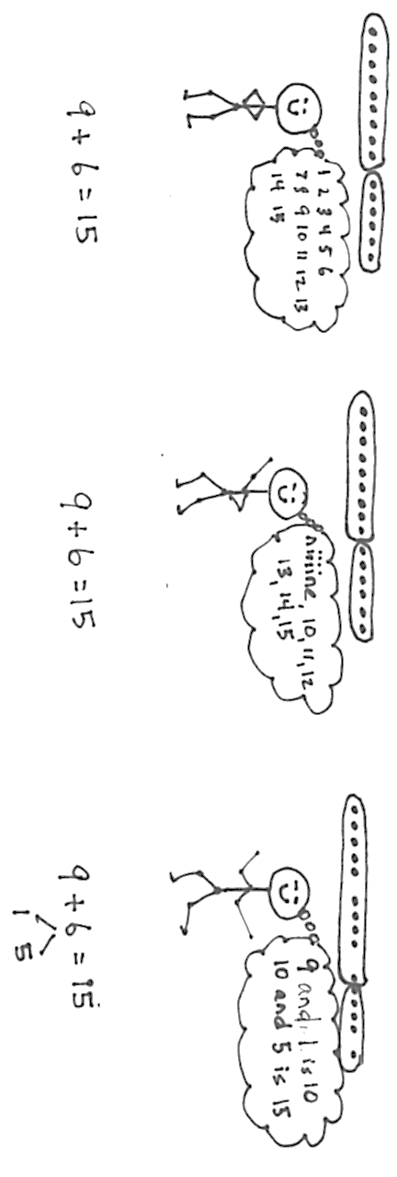
Module 2 serves as a bridge from problem solving within 10 to work within 100 as students begin to solve addition and subtraction problems involving teen numbers (1.NBT.2ab). In Module 1, students were encouraged to move beyond the Level 1 strategy of counting all to the more efficient counting on. Now, they go beyond Level 2 to learn Level 3 decomposition and composition strategies, informally called make ten or take from ten.
Level 1: Count all
Level 2: Count on
Level 3: Decompose an addend to compose ten

Though many students may continue to count on as their primary means of adding and subtracting, the larger purpose of composing and decomposing ten is to lay the foundation for the role of place value units in addition and subtraction. Meanwhile, from the beginning of the year, fluency activities have focused on the three prerequisite skills for the Level 3 decomposition and composition methods:
- Partners to ten (K.OA.4).
- Decompositions for all numbers within 10 (K.OA.3).
- Representations of teen numbers as 10 + n (K.NBT.1 and 1.NBT.2b). For example, students practice counting the Say Ten way (i.e., ten 1, ten 2…) from Kindergarten on.
To introduce students to the make ten strategy, in Topic A, students solve problems with three addends (1.OA.2) and realize it is sometimes possible to use the associative and commutative properties to compose ten, e.g., “Maria made 1 snowball. Tony made 5, and their father made 9. How many snowballs did they make in all?” 1 + 5 + 9 = (9 + 1) + 5 = 10 + 5 = 15. Since we can add in any order, we can pair the 1 with the 9 to make a ten first. Having seen how to use partners to ten to simplify addition, students next decompose a second addend in order to compose a ten from 9 or 8, e.g., “Maria has 9 snowballs and Tony has 6. How many do they have in all?” 9 + 6 = 9 + (1 + 5) = (9 + 1) + 5 = 10 + 5 = 15 (1.OA.3). Between the intensive work with addends of 8 and 9 is a lesson exploring commutativity so that students realize they can compose ten from the larger addend.

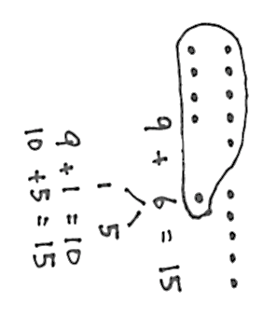
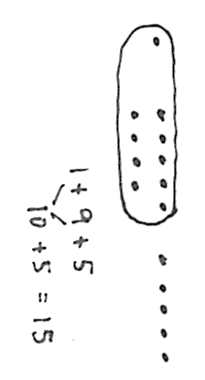
Throughout Topic A, students also count on to add. Students begin by modeling the situations with concrete materials, move to representations of 5-groups, and progress to modeling with number bonds. The representations and models make the connection between the two strategies clear. For example, using the 5-groups pictured above, students can simply count on from 9 to 15, tracking the number of counts on their fingers just as they did in Module 1. They repeatedly compare and contrast counting on with making ten, seeing that the latter is a convenient shortcut. Many start to make the important move from counting on, a Level 2 strategy, to make ten, a Level 3 strategy, persuaded by confidence in their increasing skill and the joy of the shortcut. This is a critical step in building flexible part–whole thinking whereby students see numbers as parts and wholes rather than as discrete counts or one part and some ones. Five-groups soon begin to be thought of as ten-frames, focusing on the usefulness of trying to group 10 when possible. This empowers students in later modules and future grade levels to compose and decompose place value units and work adeptly with the four operations. For example, in Grade 1, this is applied in later modules to solve problems such as 18 + 6, 27 + 9, 36 + 6, 49 + 7, etc. (1.OA.3).
To introduce students to the take from ten strategy, Topic B opens with questions such as, “Mary has two plates of cookies, one with 10 and one with 2. At the party, 9 cookies were eaten from the plate with 10 cookies. How many cookies were left after the party?” 10 – 9 = 1 and 1 + 2 = 3. Students then reinterpret the story to see its solution can also be written as 12 – 9.
Level 3: Decompose ten and
compose with the ones
Level 2: Count on

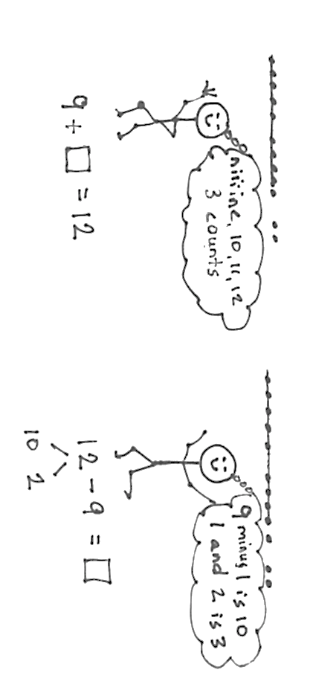

Students relate counting on and subtraction as pictured above. Notice the model is identical, but the thinking is very different.
S: To solve 12 – 9, I count on from 9 to 12, niiiine, 10, 11, 12, three counts. To solve 12 – 9, I make 12 into 10 and 2 and subtract 9 from ten. 1 + 2 = 3.
Students practice a pattern of action, take from ten and add the ones, as they face different contexts in word problems (MP.8), e.g., “Maria has 12 snowballs. She threw 8 of them. How many does she have left?” (1.OA.3). This is important foundational work for decomposing in the context of subtraction problem solving in Grade 2, e.g., “Hmmm. 32 – 17, do I take 7 ones from 2 ones or from a ten?” Grade 1 students begin using horizontal linear models of 5-groups or ten-frames to begin the transition towards a unit of ten, as shown in the above image.
Topic C presents students with opportunities to solve varied add to with change unknown, take from with change unknown, put together with addend unknown, and take apart with addend unknown word problems. These situations give ample time for exploring strategies for finding an unknown. The module so far has focused on counting on and subtracting by decomposing and composing (1.OA.1). These lessons open up the possibilities to include other Level 3 strategies, e.g., 12 – 3 = 12 – 2 - 1. Teachers can include or adjust such strategy use dependent on whether they feel it enhances understanding or rather undermines or overwhelms. The topic closes with a lesson to further solidify student understanding of the equal sign as it has been applied throughout the module. Students match equivalent expressions to construct true number sentences and explain their reasoning using words, pictures, and numbers, e.g., 12 – 7 = 3 + 2, 10 + 5 = 9 + 6 (1.OA.7).
a ten
represented
as a 5-group column
In Topic D, after all the work with 10, the module culminates with naming a ten (1.NBT.2a). Familiar representations of teen numbers, such as two 5-groups, the Rekenrek, and 10 fingers, are all renamed as a ten and some ones (1.NBT2b) rather than 10 ones and some more ones (K.NBT.1). The ten is shifting to being one unit, a structure from which students can compose and decompose teen numbers (1.NBT.2b, MP.7). This significant step forward sets the stage for understanding all the numbers within 100 as composed of a number of units of ten and some ones (1.NBT.2b). The horizontal linear
5-group modeling of 10 is moved to a vertical representation in preparation for this next stage, in Module 4, as shown in the image on the right. This topic’s work is done while solving both abstract equations and contextualized word problems.

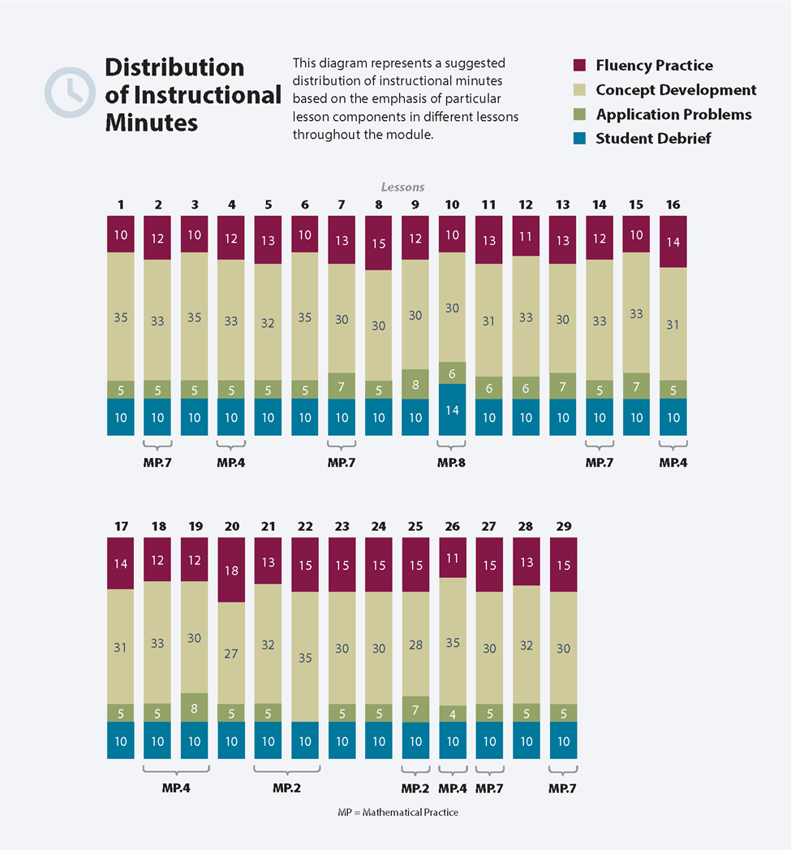
Focus Grade Level Standards
Represent and solve problems involving addition and subtraction.
1.OA.1 Use addition and subtraction within 20 to solve word problems involving situations of adding to, taking from, putting together, taking apart, and comparing, with unknowns in all positions, e.g., by using objects, drawings, and equations with a symbol for the unknown number to represent the problem.
1.OA.2 Solve word problems that call for addition of three whole numbers whose sum is less than or equal to 20, e.g., by using objects, drawings, and equations with a symbol for the unknown number to represent the problem.
Understand and apply properties of operations and the relationship between addition and subtraction.
1.OA.3 Apply properties of operations as strategies to add and subtract. (Students need not use formal terms for these properties.) Examples: If 8 + 3 = 11 is known, then 3 + 8 = 11 is also known. (Commutative property of addition.) To add 2 + 6 + 4, the second two numbers can be added to make a ten, so 2 + 6 + 4 = 2 + 10 = 12. (Associative property of addition.)
1.OA.4 Understand subtraction as an unknown-addend problem. For example, subtract 10 – 8 by finding the number that makes 10 when added to 8.
Add and subtract within 20.
1.OA.6 Add and subtract within 20, demonstrating fluency for addition and subtraction within 10. Use mental strategies such as counting on; making ten (e.g., 8 + 6 = 8 + 2 + 4 = 10 + 4 = 14); decomposing a number leading to a ten (e.g., 13 – 4 = 13 – 3 – 1 = 10 – 1 = 9); using the relationship between addition and subtraction (e.g., knowing that 8 + 4 = 12, one knows 12 – 8 = 4); and creating equivalent but easier or known sums (e.g., adding 6 + 7 by creating the known equivalent 6 + 6 + 1 = 12 + 1 = 13).
Understand place value.
1.NBT.2 Understand that the two digits of a two-digit number represent amounts of tens and ones. Understand the following as special cases:
a. 10 can be thought of as a bundle of ten ones—called a “ten.”
b. The numbers from 11 to 19 are composed of a ten and one, two, three, four, five, six, seven, eight, or nine ones.

Foundational Standards
K.OA.3 Decompose numbers less than or equal to 10 into pairs in more than one way, e.g., by using objects or drawings, and record each decomposition by a drawing or equation (e.g., 5 = 2 + 3 and 5 = 4 + 1).
K.OA.4 For any number from 1 to 9, find the number that makes 10 when added to the given number, e.g., by using objects or drawings, and record the answer with a drawing or equation.
K.NBT.1 Compose and decompose numbers from 11 to 19 into ten ones and some further ones, e.g., by using objects or drawings, and record each composition or decomposition by a drawing or equation (e.g., 18 = 10 + 8); understand that these numbers are composed of ten ones and one, two, three, four, five, six, seven, eight, or nine ones.
Focus Standards for Mathematical Practice
MP.2 Reason abstractly and quantitatively. Students solve change unknown problem types such as, “Maria has 8 snowballs. Tony has 15 snowballs. Maria wants to have the same number of snowballs as Tony. How many more snowballs does Maria need to have the same number as Tony?” They write the equation 8 + __ = 15 to describe the situation, make ten or count on to 15 to find the answer of 7, and reason abstractly to make a connection to subtraction, that the same problem can be solved using 15 – 8 = __.
MP.4 Model with mathematics. Students use 5-groups, number bonds, and equations to represent decompositions when both subtracting from the teens and adding to make teens when crossing the ten.
MP.7 Look for and make use of structure. This module introduces students to the unit ten. Students use the structure of the ten to add within the teens, to add to the teens, and to subtract from the teens. For example, 14 + 3 = 10 + 4 + 3 = 17, 8 + 5 = 8 + 2 + 3 = 10 + 3 and conversely, 13 – 5 = 10 – 5 + 3 = 5 + 3.
MP.8 Look for and make use of repeated reasoning. Students realize that when adding 9 to a number 1–9, they can complete the ten by decomposing the other addend into “1 and __.” They internalize the commutative and associative properties, looking for ways to make ten within situations and equations.

Overview of Module Topics and Lesson Objectives
Standards | Topics and Objectives |  | Days
1.OA.1  1.OA.2  1.OA.3  1.OA.6 | A | Counting On or Making Ten to Solve Result Unknown and Total Unknown Problems  Lesson 1: Solve word problems with three addends, two of which make ten.  Lesson 2: Use the associative and commutative properties to make ten with three addends.  Lessons 3–4: Make ten when one addend is 9.  Lesson 5: Compare efficiency of counting on and making ten when one addend is 9.  Lesson 6: Use the commutative property to make ten.  Lessons 7–8: Make ten when one addend is 8.  Lesson 9: Compare efficiency of counting on and making ten when one addend is 8.  Lesson 10: Solve problems with addends of 7, 8, and 9.  Lesson 11: Share and critique peer solution strategies for put together with total unknown word problems. | 11
 |  | Mid-Module Assessment: Topic A (assessment 1 day, return 1 day, remediation or further applications 1 day) | 3
1.OA.1  1.OA.3  1.OA.4  1.OA.6  1.OA.5  1.OA.7 | B | Counting On or Taking from Ten to Solve Result Unknown and Total Unknown Problems  Lessons 12–13: Solve word problems with subtraction of 9 from 10.  Lessons 14–15: Model subtraction of 9 from teen numbers.  Lesson 16: Relate counting on to making ten and taking from ten.  Lessons 17–18: Model subtraction of 8 from teen numbers.  Lesson 19: Compare efficiency of counting on and taking from ten.  Lesson 20: Subtract 7, 8, and 9 from teen numbers.  Lesson 21: Share and critique peer solution strategies for take from with result unknown and take apart with addend unknown word problems from the teens. | 10

Standards | Topics and Objectives |  | Days
1.OA.1  1.OA.4  1.OA.6  1.OA.5  1.OA.7  1.OA.8 | C | Strategies for Solving Change or Addend Unknown Problems  Lesson 22: Solve put together/take apart with addend unknown word problems, and relate counting on to the take from ten strategy.  Lesson 23: Solve add to with change unknown problems, relating varied addition and subtraction strategies.  Lesson 24: Strategize to solve take from with change unknown problems.  Lesson 25: Strategize and apply understanding of the equal sign to solve equivalent expressions. | 4
1.OA.1  1.NBT.2a  1.NBT.2b  1.NBT.5 | D | Varied Problems with Decompositions of Teen Numbers as 1 Ten and Some Ones  Lesson 26: Identify 1 ten as a unit by renaming representations of 10.  Lesson 27: Solve addition and subtraction problems decomposing and composing teen numbers as 1 ten and some ones.  Lesson 28: Solve addition problems using ten as a unit, and write two-step solutions.  Lesson 29: Solve subtraction problems using ten as a unit, and write two-step solutions. | 4
 |  | End-of-Module Assessment: Topics A–D (assessment 1 day, return 1 day, remediation or further applications 1 day) | 3
Total Number of Instructional Days |  |  | 35

Terminology
a ten
represented
as a 5-group column
New or Recently Introduced Terms
- A ten (a group, or unit, consisting of 10 items)
- Ones (individual units, 10 of which become a ten)
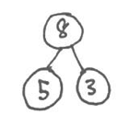
Familiar Terms and Symbols
Number Bond
part
part
whole
- 5-Groups
- Add
- Equals
- Number bonds
- Partners to ten
- Subtract
- Teen numbers
Suggested Tools and Representations
- 5-group formations: 5-groups (and 5-group cards), 5-group rows, 5-group column
- Hide Zero cards
- Number bonds
5-Group Cards
Numerals

5-Groups
- Number path
5-Group Rows
- Rekenrek
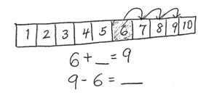
Number Path
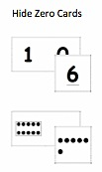
Hide Zero Cards
5-Group Column
Rekenrek

Scaffolds
The scaffolds integrated into A Story of Units give alternatives for how students access information as well as express and demonstrate their learning. Strategically placed margin notes are provided within each lesson, elaborating on the use of specific scaffolds at applicable times. They address many needs presented by English language learners, students with disabilities, students performing above grade level, and students performing below grade level. Many of the suggestions are organized by Universal Design for Learning (UDL) principles and are applicable to more than one population. To read more about the approach to differentiated instruction in A Story of Units, please refer to “How to Implement A Story of Units.”
Assessment Summary
Type | Administered | Format | Standards Addressed
Mid-Module Assessment Task | After Topic A | Constructed response with rubric | 1.OA.1  1.OA.2  1.OA.3  1.OA.6
End-of-Module Assessment Task | After Topic D | Constructed response with rubric | 1.OA.1  1.OA.2  1.OA.3  1.OA.4  1.OA.6  1.NBT.2a  1.NBT.2b

See Progressions Document "Counting and Cardinality: Operations and Algebraic Thinking," p. 6.
See Progressions Document “Counting and Cardinality: Operations and Algebraic Thinking,” p. 14.
The balance of this cluster is addressed in Module 1.
The focus in this module is on numbers to 20. The balance of this cluster is addressed in Modules 4 and 6.
These are terms and symbols students have seen previously.
Students with disabilities may require Braille, large print, audio, or special digital files. Please visit the website www.p12.nysed.gov/specialed/aim for specific information on how to obtain student materials that satisfy the National Instructional Materials Accessibility Standard (NIMAS) format.

