Name Date
- Mr. Baggy owns a pet store.
He counted 10 goldfish in a big tank and 5 goldfish in a small tank. He sold 8 goldfish out of the big tank. How many goldfish did he have left in all? Explain your answer using a labeled math drawing and a number sentence.

Mr. Baggy had ______ goldfish.

- Write the numbers that make the number sentences true.
11 – 8 = _____
12 – 9 = _____
a. _____
15 – 6 = ____

12 = ____ + 7

b._____
8 + ____ = 12
9 + ____ = 13

c. Write a related subtraction fact for each of the three problems in the last row in the spaces below.
_________________ _________________ _________________

- Write a number bond in each number sentence to show how to use ten to subtract. Draw 5-groups and some ones to show each subtraction sentence.
a. 13 – 9 = 4
b. 12 – 8 = 4

c. Use your pictures and numbers to explain how both subtraction problems equal 4.

- Mr. Baggy also has 9 birds, 15 snakes, and 12 turtles.
- Show the number of snakes as a ten and some ones with a number bond, a 5-group drawing, and a number sentence.

- Mr. Baggy sold some snakes. Now, he has 5. How many snakes did he sell? Explain your solution using a number bond or a math drawing. Write a number sentence. Complete the statement.

Mr. Baggy sold ______ snakes.

- Mr. Baggy sold 8 turtles. How many turtles does he have left? Explain your solution using a number bond or a math drawing. Write a number sentence. Complete the statement.

Mr. Baggy has ______ turtles left.

- Mr. Baggy’s daughter says she can find the number of turtles Mr. Baggy has left using subtraction or addition. Show two ways Mr. Baggy’s daughter can solve this problem.

- As Mr. Baggy gets ready to close his pet store for the day, he needs to know how many animals he has altogether. How many birds, snakes, and turtles does Mr. Baggy have left in his store altogether? Explain your solution using number bonds or math drawings. Write a number sentence. Complete the statement.

Mr. Baggy has ______ animals left.

- True or false: You will get a different answer if you add 9 and 5 first, then add 4, than if you add 9 and 4 first, then add 5. (Circle one.) True False
Use pictures or words to show how you know.

End-of-Module Assessment Task  Standards Addressed | Topics A–D
Represent and solve problems involving addition and subtraction.
1.OA.1 Use addition and subtraction within 20 to solve word problems involving situations of adding to, taking from, putting together, taking apart, and comparing, with unknowns in all positions, e.g., by using objects, drawings, and equations with a symbol for the unknown number to represent the problem.
1.OA.2 Solve word problems that call for addition of three whole numbers whose sum is less than or equal to 20, e.g., by using objects, drawings, and equations with a symbol for the unknown number to represent the problem.
Understand and apply properties of operations and the relationship between addition and subtraction.
1.OA.3 Apply properties of operations as strategies to add and subtract. (Students need not use formal terms for these properties.) Examples: If 8 + 3 = 11 is known, then 3 + 8 = 11 is also known. (Commutative property of addition.) To add 2 + 6 + 4, the second two numbers can be added to make a ten, so 2 + 6 + 4 = 2 + 10 = 12. (Associative property of addition.)
1.OA.4 Understand subtraction as an unknown-addend problem. For example, subtract 10 – 8 by finding the number that makes 10 when added to 8.
Add and subtract within 20.
1.OA.6 Add and subtract within 20, demonstrating fluency for addition and subtraction within 10. Use strategies such as counting on; making ten (e.g., 8 + 6 = 8 + 2 + 4 = 10 + 4 = 14); decomposing a number leading to a ten (e.g., 13 – 4 = 13 – 3 – 1 = 10 – 1 = 9); using the relationship between addition and subtraction (e.g., knowing that 8 + 4 = 12, one knows 12 – 8 = 4); and creating equivalent but easier or known sums (e.g., adding 6 + 7 by creating the known equivalent 6 + 6 + 1 = 12 + 1 = 13).
Understand place value.
1.NBT.2 Understand that the two digits of a two-digit number represent amounts of tens and ones. Understand the following as special cases:
a. 10 can be thought of as a bundle of ten ones—called a "ten."
b. The numbers from 11 to 19 are composed of a ten and one, two, three, four, five, six, seven, eight, or nine ones.
Evaluating Student Learning Outcomes
A Progression Toward Mastery is provided to describe steps that illuminate the gradually increasing understandings that students develop on their way to proficiency. In this chart, this progress is presented from left (Step 1) to right (Step 4). The learning goal for each student is to achieve Step 4 mastery. These steps are meant to help teachers and students identify and celebrate what the student CAN do now and what they need to work on next.
A Progression Toward Mastery
Assessment  Task Item | STEP 1  Little evidence of reasoning without a correct answer.  (1 Point) | STEP 2  Evidence of some reasoning without a correct answer.  (2 Points) | STEP 3  Evidence of some reasoning with a correct answer or evidence of solid reasoning with an incorrect answer.  (3 Points) | STEP 4  Evidence of solid reasoning with a correct answer.  (4 Points)
1  1.OA.1 | The student’s drawing and number sentence are completely unrelated to the problem, showing no understanding of the problem. | The student has the incorrect answer but shows some understanding through drawings or number sentences. | The student answers correctly (7) but is missing the drawing or the number sentence. Or, the student draws a picture or number sentences to show her thinking but has an incorrect answer. | The student correctly:  - Answers 7.  - Explains using a drawing and any number sentence that matches their work (e.g., 15 – 8 = 7 or 2 + 5 = 7).
2  1.OA.3  1.OA.4  1.OA.6 | The student answers one to two problems correctly, demonstrating a limited understanding of the problems. | For each problem, the student:  - Subtracts from a teen number,  - Finds the missing addend,  - Writes the corresponding subtraction sentences,  with three or four calculation errors. | For each problem, the student:  - Subtracts from a teen number,  - Finds the missing addend,  - Writes the corresponding subtraction sentences,  with one or two calculation errors. | For each problem, the student correctly:  - Subtracts from a teen number: 3, 3, 9  - Finds the missing addend: 4, 4, 5  - Writes the corresponding subtraction sentences:  - 13 – 9 = 4  - 12 – 8 = 4  - 12 – 7 = 5
3  1.OA.3  1.OA.6 | The student is not able to correctly accomplish any component of the task, demonstrating a lack of understanding of the problems. | The student may show some understanding and skill with 5-group drawings but is unable to execute the bonds or explain his thinking. Or, the student is able to show the bonds, but is unable to draw the 5-groups or explain appropriately. | The student draws the bonds and 5-groups but is unable to explain how both have an answer of 4. Or, the student explains well, and draws 5-groups well, but does not execute the bonds accurately. | The student correctly:  - Models the number bonds and 5-group drawings.  - Explains how both problems equal 4 using pictures or numbers  (i.e., 1 + 3 = 2 + 2).
4  1.OA.1  1.OA.2  1.OA.3  1.OA.4  1.OA.6  1.NBT.2a  1.NBT.2b | Answers one or fewer questions correctly and is unable to show work, thus demonstrating a lack of understanding of the concepts. | Answers two of the questions correctly with all accompanying models but demonstrates inconsistent understanding of the take from ten strategy, the connection between addition and subtraction, or the associative property. | Answers three of the four questions correctly and with all requested models and number sentences.  Computes and explains the final question, but may have errors in previous computations that impact accuracy (i.e., 1 or 2 off). | The student correctly:  - Represents 15 with a number bond, 5-group drawing, and number sentence.  - Explains that 10 snakes were sold.  - Explains that 4 turtles are left.  - Writes both an addition and subtraction equation  12 – 8 = 4 and  8 + 4 = 12.  - Explains that 18 animals are left altogether.  - Identifies the statement as false and explains why, citing the associative property with pictures or words (no formal terms necessary).

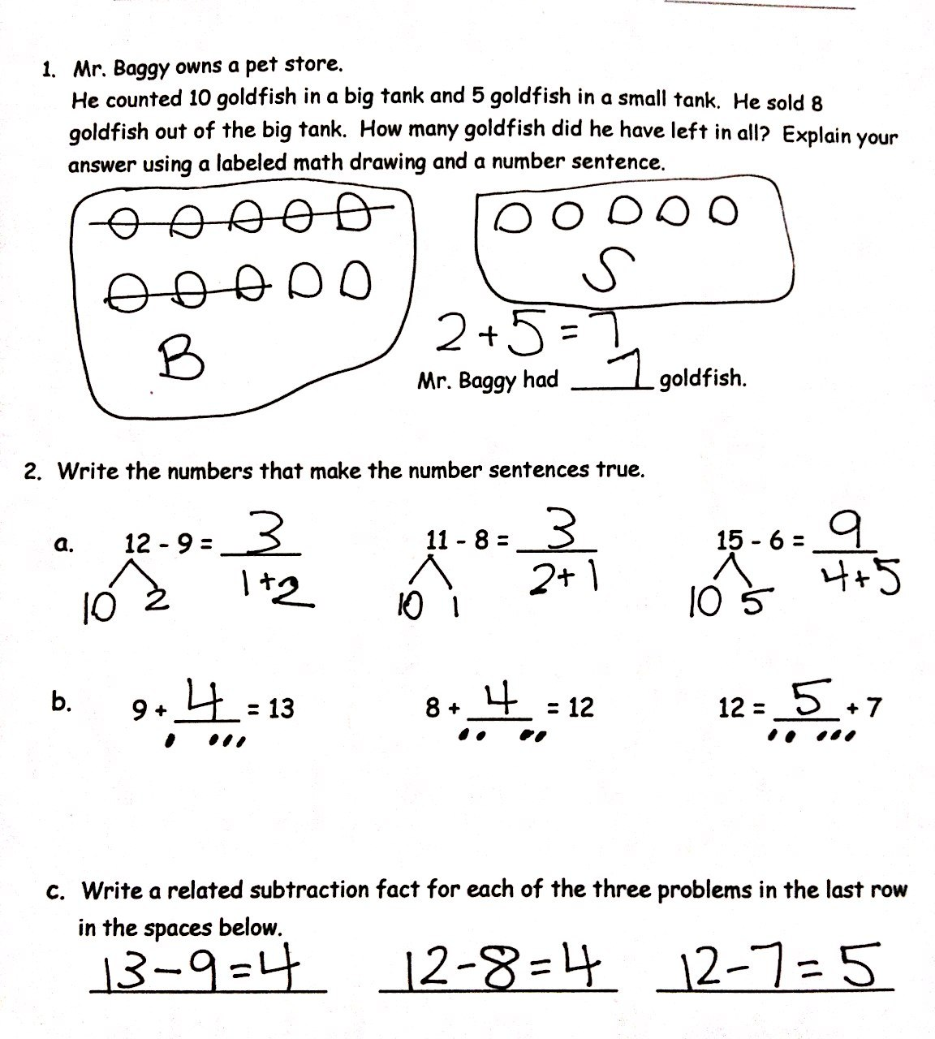
Name Date
