Table of Contents
GRADE 1 • MODULE 3
Ordering and Comparing Length Measurements as Numbers

Module Overview i

Topic A: Indirect Comparison in Length Measurement 3.A.1

Topic B: Standard Length Units 3.B.1

Topic C: Non-Standard and Standard Length Units 3.C.1

Topic D: Data Interpretation 3.D.1

Module Assessment 3.S.1
NOTE: Student sheets should be printed at 100% scale to preserve the intended size of figures for accurate measurements. Adjust copier or printer settings to actual size and set page scaling to none.

NOTE: Student sheets should be printed at 100% scale to preserve the intended size of figures for accurate measurements. Adjust copier or printer settings to actual size and set page scaling to none.

Grade 1 • Module 3
Ordering and Comparing Length Measurements as Numbers
OVERVIEW
Grade 1 Module 3 opens in Topic A by extending students’ Kindergarten experiences with direct length comparison to the new learning of indirect comparison whereby the length of one object is used to compare the lengths of two other objects (1.MD.1). “My string is longer than your book. Your book is longer than my pencil. That means my string is longer than my pencil!” Students use the same transitivity, or indirect comparison, to compare short distances within the classroom in order to find the shortest path to their classroom door, which is helpful to know for lining up and for emergencies. Students place one endpoint of a length of string at their desks and then extend the string towards the door to see if it will reach. After using the same piece of string from two students’ desks, they make statements such as, “Maya’s path is shorter than the string. Bailey’s path is longer than the string. That means Bailey’s path to the door is longer than Maya’s path.”
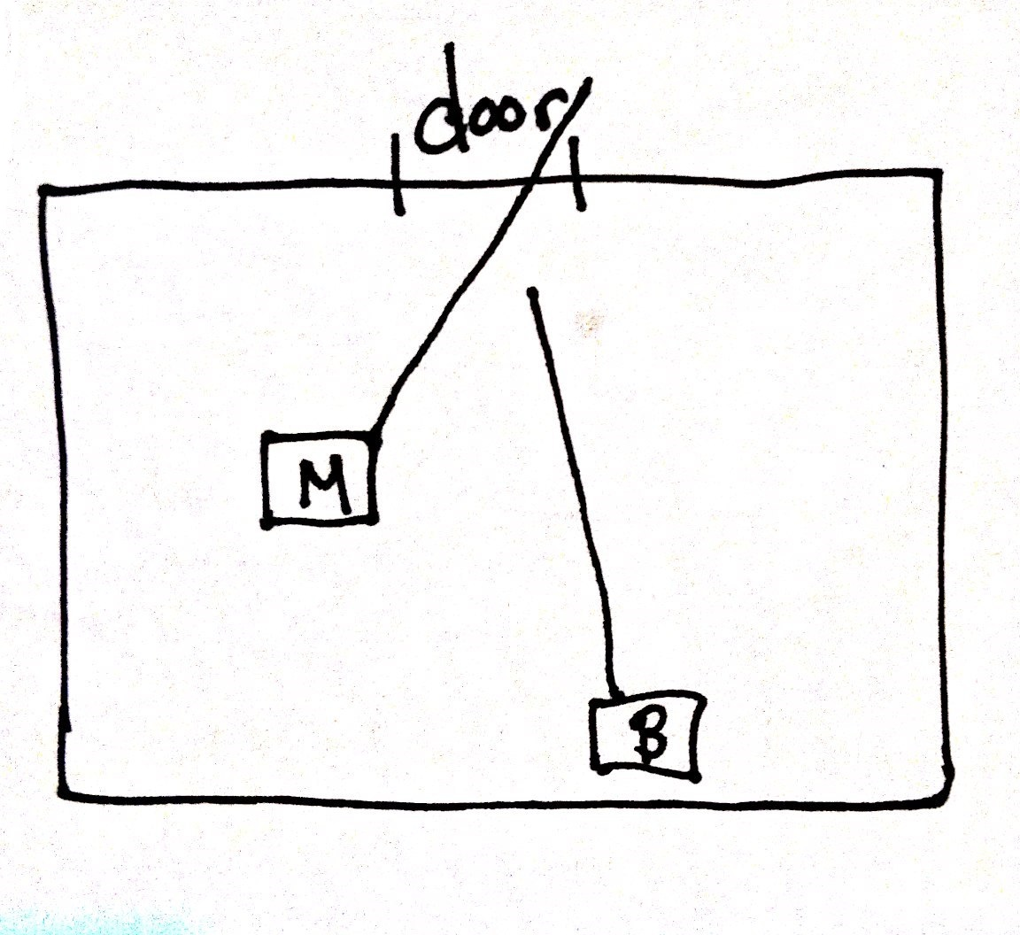
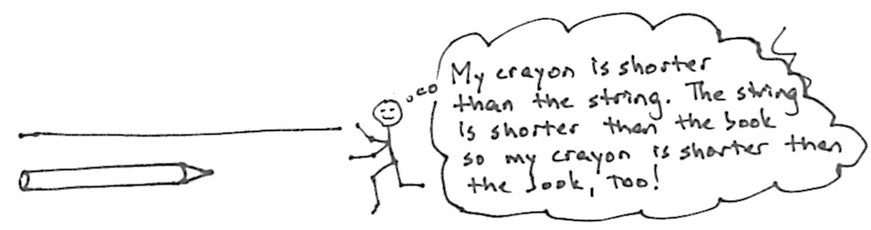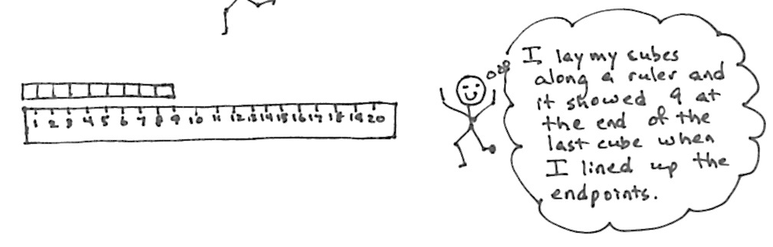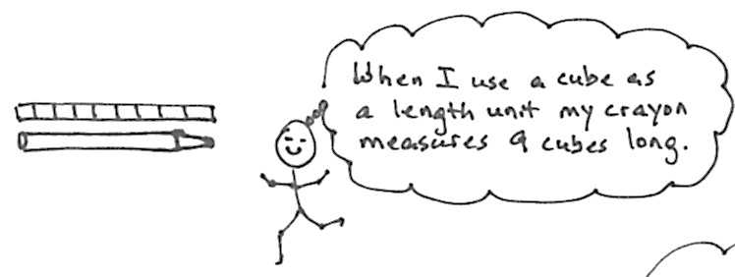

Topic B takes longer than and shorter than to a new level of precision by introducing the idea of a length unit. Centimeter cubes are laid alongside the length of an object as students learn that the total number of cubes laid end to end with no gaps or overlaps represents the length of that object (1.MD.2). The Geometric Measurement Progressions Document expresses the research indicating the importance of teaching standard units to Grade 1 students before non-standard units. Thus, Grade 1 students learn about the centimeter before exploring non-standard units of measurement in this module. Simply lining the cubes up to the ruler allows students to see that they are using units which relate to a tool used around the world. One of the primary reasons why we recognize standard units is because they are ubiquitous, used on rulers at Grandma’s house in the Bronx, in school, and in local shops. Students ask and answer the question, “Why would we use a standard unit to measure?” The topic closes with students measuring and comparing sets of three items using centimeter cubes. They return to the statements of Topic A, but now with more sophisticated insights, such as, “The pencil measures 10 centimeters. The crayon measures 6 centimeters. The book measures 20 centimeters. I can put them in order from shortest to longest: the crayon, the pencil, the book. The book is longer than the pencil, and the pencil is longer than the crayon, so the book is longer than the crayon” (1.MD.1).
Topic C explores the usefulness of measuring with similar units. Students measure the same objects from Topic B using two different non-standard units, toothpicks and small paper clips, simultaneously to measure one object and answer the question, “Why do we measure with same-sized length units?” (1.MD.2). They realize that using iterations of the same unit will yield consistent measurement results. Similarly, students explore what it means to use a different unit of measurement from their classmates. It becomes obvious to students that if we want to have discussions about the lengths of objects, we must measure with the same units. Students answer the question, “If Bailey uses paper clips and Maya uses toothpicks, and they both measure things in our classroom, will they be able to compare their measurements?” With this new understanding of consistent measurement, Topic C closes with students solving compare with difference unknown problems. Students use standard units to answer such questions as, “How much longer is the pencil than the marker?” (1.OA.1).
Topic D closes the module as students represent and interpret data (1.MD.4). They collect data about their classmates and sort that information into three categories. Using same-sized pictures on squares, students represent this sorted data so that it can be easily compared and described. Students interpret information presented in the graphs by first determining the number of data points in a given category, e.g., “How many students like carrots the best?” Then, students combine categories, e.g., “How many total students like carrots or broccoli the best?” The module closes with students asking and answering varied questions about data sets, such as, “How many students were polled in all?” (put together with result unknown) and, “How many more students preferred broccoli to string beans?” (compare with difference unknown) (1.OA.1). Their work with units representing data points is an application of the students’ earlier work with length as they observe that each square can be lightly interpreted as a length unit, which helps them analyze the data.

Focus Grade Level Standards
Represent and solve problems involving addition and subtraction.
1.OA.1 Use addition and subtraction within 20 to solve word problems involving situations of adding to, taking from, putting together, taking apart, and comparing, with unknowns in all positions, e.g., by using objects, drawings, and equations with a symbol for the unknown number to represent the problem.
Measure lengths indirectly and by iterating length units.
1.MD.1 Order three objects by length; compare the lengths of two objects indirectly by using a third object.
1.MD.2 Express the length of an object as a whole number of length units, by laying multiple copies of a shorter object (the length unit) end to end; understand that the length measurement of an object is the number of same-size length units that span it with no gaps or overlaps. Limit to contexts where the object being measured is spanned by a whole number of length units with no gaps or overlaps.
Represent and interpret data.
1.MD.4 Organize, represent, and interpret data with up to three categories; ask and answer questions about the total number of data points, how many in each category, and how many more or less are in one category than in another.
Foundational Standards
K.CC.5 Count to answer “how many?” questions about as many as 20 things arranged in a line, a rectangular array, or a circle, or as many as 10 things in a scattered configuration; given a number from 1–20, count out that many objects.
K.CC.6 Identify whether the number of objects in one group is greater than, less than, or equal to the number of objects in another group, e.g., by using matching and counting strategies. (Include groups with up to ten objects.)
K.CC.7 Compare two numbers between 1 and 10 presented as written numerals.
K.MD.1 Describe measureable attributes of objects, such as length or weight. Describe several measurable attributes of a single object.
K.MD.2 Directly compare two objects with a measurable attribute in common, to see which object has “more of”/”less of” the attribute, and describe the difference. For example, directly compare the heights of two children and describe one child as taller/shorter.
Focus Standards for Mathematical Practice
MP.2 Reason quantitatively and abstractly. Students describe and compare lengths using longer than and shorter than and numerically represent relationships among and between lengths. This takes place in the context of comparing sets within data collection as well as comparing objects with different length units. For example, students compare the number of peers who enjoy one hobby with the number of peers who enjoy a different hobby. Students also compare the length of one object, in centimeter cubes, with the length of a second object, in centimeter cubes.
MP.3 Construct viable arguments and critique the reasoning of others. Students describe and explain their process of finding accurate length measurements and challenge each other to measure precisely.
MP.6 Attend to precision. Students use measuring tools, such as centimeter cubes, precisely and explain precisely the cause of errors in using the tools.
MP.7 Look for and make use of structure. Students use transitivity to compare multiple objects. "My string is longer than the pencil. My string is shorter than the book. That means the book is longer than the pencil." In this case, the students use the string as the structure to compare the book and the pencil.

Overview of Module Topics and Lesson Objectives
Standards | Topics and Objectives |  | Days
1.MD.1 | A | Indirect Comparison in Length Measurement  Lesson 1: Compare length directly and consider the importance of aligning endpoints.  Lesson 2: Compare length using indirect comparison by finding objects longer than, shorter than, and equal in length to that of a string.  Lesson 3: Order three lengths using indirect comparison. | 3
1.MD.1  1.MD.2 | B | Standard Length Units  Lesson 4: Express the length of an object using centimeter cubes as length units to measure with no gaps or overlaps.  Lesson 5: Rename and measure with centimeter cubes, using their standard unit name of centimeters.  Lesson 6: Order, measure, and compare the length of objects before and after measuring with centimeter cubes, solving compare with difference unknown word problems. | 3
1.OA.1  1.MD.2 | C | Non-Standard and Standard Length Units  Lesson 7: Measure the same objects from Topic B with different non-standard units simultaneously to see the need to measure with a consistent unit.  Lesson 8: Understand the need to use the same units when comparing measurements with others.  Lesson 9: Answer compare with difference unknown problems about lengths of two different objects measured in centimeters. | 3
1.OA.1  1.MD.4 | D | Data Interpretation  Lessons 10–11: Collect, sort, and organize data, then ask and answer questions about the number of data points.  Lessons 12–13: Ask and answer varied word problem types about a data set with three categories. | 4
 |  | End-of-Module Assessment: Topics A–D (assessment ½ day, return ½ day, remediation or further applications 1 day) | 2
Total Number of Instructional Days |  |  | 15
Terminology
New or Recently Introduced Terms
- Centimeter (standard length unit within the metric system)
- Centimeter cube (pictured right, also used as a length unit in this module)
- Centimeter ruler (measurement tool using length units of centimeters)
- Data (collected information)
- Endpoint (the end of an object, referenced when aligning for measurement purposes)
- Height (measurement of vertical distance of an object)
- Length unit (measuring the length of an object with equal-sized units)
- Poll (survey)
- Table or graph (organized charts visually representing data)
Familiar Terms and Symbols
- Less than
- Longer than/taller than
- More than
- Shorter than
- Tally marks
Suggested Tools and Representations
- Centimeter cubes
- Centimeter rulers (simply for the purpose of naming the centimeter)
- Non-standard units (toothpicks, small and large paper clips)
- String lengths of about 25 centimeters
- Tally marks

Scaffolds
The scaffolds integrated into A Story of Units give alternatives for how students access information as well as express and demonstrate their learning. Strategically placed margin notes are provided within each lesson elaborating on the use of specific scaffolds at applicable times. They address many needs presented by English language learners, students with disabilities, students performing above grade level, and students performing below grade level. Many of the suggestions are organized by Universal Design for Learning (UDL) principles and are applicable to more than one population. To read more about the approach to differentiated instruction in A Story of Units, please refer to “How to Implement A Story of Units.”
Assessment Summary
Type | Administered | Format | Standards Addressed
End-of-Module Assessment Task | After Topic D | Constructed response with rubric | 1.OA.1  1.MD.1  1.MD.2  1.MD.4

The balance of this cluster is addressed in Module 2.
These are terms and symbols students have seen previously.
Students with disabilities may require Braille, large print, audio, or special digital files. Please visit the website, www.p12.nysed.gov/specialed/aim, for specific information on how to obtain student materials that satisfy the National Instructional Materials Accessibility Standard (NIMAS) format.

