11.3.2 | Lesson 4

Introduction
In this lesson, students continue to develop their research skills as they learn how to read important sources closely for selected inquiry questions using annotation and note taking.
Students begin the lesson with a research project check-in during which they review the Student Research Plan by journaling about their own research progress and next steps. Then, they participate in a discussion and modeling of how to use an inquiry question to annotate for information and how to record notes using the Taking Notes Tool. Independently, students continue to practice annotating and recording key information in the Taking Notes Tool. Student learning is assessed via the Synthesizing Notes Tool.
For homework, students annotate a source and take notes on the Taking Notes Tool for two additional sources identified in the Potential Sources Tool from 11.3.2 Lesson 3. Students also continue to record vocabulary from these preliminary searches in the vocabulary journal.

Standards
Assessed Standard(s)
W.11-12.8 | Gather relevant information from multiple authoritative print and digital sources, using advanced searches effectively; assess the strengths and limitations of each source in terms of the task, purpose, and audience; integrate information into the text selectively to maintain the flow of ideas, avoiding plagiarism and overreliance on any one source and following a standard format for citation.
Addressed Standard(s)
W.11-12.7 | Conduct short as well as more sustained research projects to answer a question (including a self-generated question) or solve a problem; narrow or broaden the inquiry when appropriate; synthesize multiple sources on the subject, demonstrating understanding of the subject under investigation.

Assessment
Assessment(s)
Student learning is assessed via the Synthesizing Notes Tool.
- Refer to the Model Synthesizing Notes Tool at the end of the lesson.
High Performance Response(s)
A High Performance Response should:
- Cite an annotation (e.g., an underline beneath the sentence “Belgian peacekeepers, under the United Nations flag, watched as the carnage unfolded” (par. 2), and its corresponding Taking Notes Tool entry).
- Identify a specific inquiry question (e.g., Who is responsible for preventing genocide?).
- Discuss the connection(s) between the annotation, the Taking Notes Tool entry, and the specific inquiry question (e.g., Standing passively by, the U.N. and the rest of the world failed to do anything to stop the Rwandan genocide. The major members (the United States, Britain, and France) were the ones responsible for this peacekeeping mission. This information answers the question of who was responsible for preventing genocide in Rwanda: the U.N. forces were there but they were unable to do anything to help.).

Vocabulary
Vocabulary to provide directly (will not include extended instruction)
- None.*
Vocabulary to teach (may include direct word work and/or questions)
- None.*
Additional vocabulary to support English Language Learners (to provide directly)
- None.*
*In their research and reading, students will encounter domain-specific vocabulary related to their individual research questions/problems. Students will track some of this vocabulary in their vocabulary journals when conducting independent searches during class and for homework.

Lesson Agenda/Overview
Student-Facing Agenda | % of Lesson
Standards & Text:
- Standards: W.11-12.8, W.11-12.7
- Model Source Text: “When The U.N. Fails, We All Do” by Fareed Zakaria

Learning Sequence:  - Introduction of Lesson Agenda  - Homework Accountability and Research Check-In  - Annotating Sources and Taking Notes Discussion  - Annotating Sources and Taking Notes Activity  - Quick Write  - Closing | - 5%  - 15%  - 35%  - 30%  - 10%  - 5%

Materials
- Student copies of the Potential Sources Tool (refer to 11.3.2 Lesson 3)
- Student copies of the Assessing Sources Handout (refer to 11.3.2 Lesson 3)
- Research Portfolios (refer to 11.3.2 Lesson 1)
- Student copies of the Student Research Plan (refer to 11.3.2 Lesson 2)
- Copies of the Taking Notes Tool for each student
- Copies of the Synthesizing Notes Tool for each student

Learning Sequence
How to Use the Learning Sequence
Symbol | Type of Text & Interpretation of the Symbol
10% | Percentage indicates the percentage of lesson time each activity should take.
no symbol | Plain text indicates teacher action.
 | Bold text indicates questions for the teacher to ask students.
 | Italicized text indicates a vocabulary word.
 | Indicates student action(s).
 | Indicates possible student response(s) to teacher questions.
 | Indicates instructional notes for the teacher.

Activity 1: Introduction of Lesson Agenda 5%
Begin by reviewing the agenda and the assessed standard for this lesson: W.11-12.8. Explain that students begin the lesson with a research project check-in, during which they review the Student Research Plan by journaling about their own research progress and next steps. Students then observe and discuss a modeling of how to use an inquiry question to annotate for information, including how to record notes using the Taking Notes Tool. Independently, students annotate a model source and record key information by completing a Taking Notes Tool.
- Students look at the agenda.
Activity 2: Homework Accountability and Research Check-In 15%
Instruct students to take out their homework from 11.3.2 Lesson 3 (Continue the preliminary research process using an inquiry question to focus your search. In addition, use the Potential Sources Tool to record and evaluate three more potential sources. On the back of the tool, explain how two of those sources meet the criteria for being credible, accessible, and relevant using the Assessing Sources Handout as a guide. Use this lesson’s vocabulary wherever possible in your written response.) Instruct students to discuss in pairs how two of the additional sources they found meet the criteria for being credible, accessible, and relevant.
- Student responses will vary depending on their individual search experience but should clearly articulate why two sources are high quality based on their ratings on the Potential Sources Tool. Student responses should use the language of the Assessing Sources Handout.
Lead a brief share out of student pair discussions.
- Consider collecting the homework to monitor students’ research progress.

Distribute the assessment and feedback from 11.3.2 Lesson 3. Instruct students to review teacher comments.
- Students examine the teacher’s feedback.
Instruct students to take out the Student Research Plan from their Research Portfolios.
- The Student Research Plan should be located in the front of each student’s Research Portfolio.
Instruct students to review the Student Research Plan Part 2, regarding the finding and assessing sources skills, and examine the part of W.11-12.8 that corresponds to this process: “Gather relevant information from multiple authoritative print and digital sources, using advanced searches effectively; assess the strengths and limitations of each source in terms of the task, purpose, and audience.” Instruct students to use the homework from 11.3.2 Lesson 3 and the language of W.11-12.8.
- Instruct students to continue the Research Journal started in 11.3.2 Lesson 3; students can write on separate sheets of paper or in a notebook and keep the Research Journal in the Research Portfolio.
- Students review the Student Research Plan and language of W.11-12.8.
- Student responses will vary by individual research topic/area of investigation but should use the language of the Student Research Plan Part 2 (finding and assessing sources) and the language of W.11-12.8 when reflecting on their research progress and next steps.
Instruct students to file the Student Research Plan in the front section of the Research Portfolio and organize the tools from 11.3.2 Lesson 3 in Section 2: Gathering and Analyzing Information.
Instruct students to keep their Potential Sources Tools from 11.3.2 Lesson 3 out for further reference.
- Students organize their resources.
Activity 3: Annotating Sources and Taking Notes Discussion 35%
Explain to students that once they identify relevant, credible, and accessible sources, the next step in the research process is to read the sources closely, with an eye toward selecting sources that further their research and help to answer the inquiry question guiding that specific search process.
- Students listen.
Inform students that reading closely for the purpose of gathering and analyzing information and evidence is done in two steps: annotating and taking notes. Both annotating and taking notes aid in further assessing the usefulness of each source.
- Students listen.
- Remind students that a librarian/media specialist can be used as a resource throughout this unit.
Explain that annotating may be different for an informational than a literary text. Inform students that the type of text they are using in this module is informational text for researching argumentation. Annotation for this type of text is similar to that for a literary text but with additional codes.
Instruct students that when annotating informational texts they should look for:
- Key words and concepts
- Information that answers inquiry questions
- Initial impressions of the information
- Areas for possible further exploration
- Connections to other sources
- Students listen.
Explain that the same annotations used in previous modules are used in this module. Review the annotation codes from the previous modules:
- Put a question mark (?) next to a section you are questioning.
- Write in the margin or at the top or bottom of the page to record questions (and perhaps answers) that a passage raises in your mind.
- Use an exclamation point (!) for areas that remind you of another text, strike you in some way, or surprise you.
- Add an arrow () to make connections between points.
- Box words and phrases that you do not know or that you find confusing. Rewrite a word or phrase you might have figured out.
- Star (*) ideas that seem important, or may support your writing later.
- Use the code CI to indicate a central idea.
- Students listen.
- Remind students that in addition to using the codes, it is important that they mark the text with their thoughts as they relate to the codes.
Introduce two new annotation codes specifically for informational text:
- Underline areas that represent major points. If a passage is too long to underline, use vertical lines in the margin.
- Use numbers in the margin to indicate a sequence of points to trace the development of an argument.
- Students listen.
- Consider displaying all annotation codes for students to see.

Display the model source: “When The U.N. Fails, We All Do” by Fareed Zakaria. Read an excerpt of the article aloud from “You have never heard of Paul Rusesabagina” to “The United Nations failed in Rwanda because we failed” (par. 1–3).
- Students follow along, reading silently.
Instruct students to annotate the first three paragraphs of this text excerpt for a specific inquiry question:
Who is responsible for preventing genocide?
Model the annotation by coding and writing thoughts directly on the text, pausing after each annotation and explaining the choice.
- Box around edifying (paragraph 3) because it is a word that may be unfamiliar.
- Box around Rwandan Schindler (paragraph 1) because it is a phrase that is unfamiliar.
- Box around Tutsis and Hutus (paragraph 1) because they are terms that might be unfamiliar.
- Star beside the phrase “Hutu gangs, aided by the Hutu Army, killed almost 1 million Tutsis and moderate Hutus—the fastest genocide in human history,” (paragraph 2) because this phrase explains the amount of casualties and who committed genocide.
- Underline the sentence “It was the major powers—the United States, Britain, France—that determined the exact nature of the peacekeeping mission” (paragraph 3) because it clarifies which countries were in charge of the U.N. forces.
- Question mark next to: “It was they who insisted that the force stay neutral” (paragraph 3). Why did these countries insist the forces stay neutral?
- Exclamation mark beside the phrase “a hotel manager, who was able to shelter and save more than 1,200 people” (paragraph 1), because it is striking and impressive for one person to have saved so many others.
- A question mark next to “France’s actions were even less edifying, since it was reportedly a big supplier of the Hutu army” (paragraph 3), because it is confusing why France would have been involved in arming the Hutus if they were also part of overseeing the peacekeeping mission.
- Differentiation Consideration: Consider using another model source if this one does not fit individual student or class needs.
Instruct students to form small groups of three to four after they have individually read the displayed model text excerpt from “This logic holds even in the messy scandal over the Oil-for-Food Program” to “it is a great asset to the United States” (par. 4–5) and practice annotating the paragraphs. Remind students to mark their thinking directly on the source, next to their coding, and to keep the inquiry question in mind as they annotate for information:
Who is responsible for preventing genocide?
- Students read and annotate using the model inquiry question.
Lead a brief share out of the annotation practice to confirm that students identified important details, recorded initial impressions, established connections, and identified other areas of research.
- Student responses may include:
  - Underline the sentence “The United Nations is not simply a reflection of its major members, but a vast organization with a distinct culture and code—one in desperate need of repair” (paragraph 5), which describes the United Nations as a group that must reevaluate their practices.
  - Star beside the sentence “For its part, the United States should stop sitting on the sidelines, enjoying the U.N.'s troubles. Only an active American involvement with reform will make it happen” (paragraph 5). These sentences represent the onus and power of the United States to ensure the U.N.’s success in international affairs.

Explain that the next step in the research process is note taking. Using their annotations as guides, students organize and record information relevant to their research using the Taking Notes Tool.
- Students listen.
Distribute the Taking Notes Tool to each student. Encourage students to examine it and then ask:
What is important about the three-column organization of this tool?
- The three columns help to organize and make the information from the annotations easily accessible for later research.
- It may be helpful to explain that in the first column, “Ref” is short for “reference.”
Explain to students that the richest or most relevant annotations have corresponding entries on the Taking Notes Tool. Instruct students to follow along and fill in their tool while the Taking Notes Tool is modeled.
- Students follow along and enter the richest or most relevant information on their copy of the Taking Notes Tool.
At the top of the tool, instruct students to write the inquiry question: “Who is responsible for preventing genocide?” Instruct students to record the source number just as it appears on their Potential Sources Tool under the column marked “Ref.” Explain that, in addition to the Potential Sources Tool source number, the reference column should include precise information about where the annotation is located in the actual text. Model this for students by writing “Source #1 and Paragraph #1” (paragraph may be abbreviated “par.”) in the reference column. Remind students that when writing research papers, they have to cite sources. Having precise information about an annotation, including the page where it was found, makes the citation work in 11.3.3 much easier.
- Students follow along, recording the model information on their Taking Notes Tool.
Explain the next two columns of the tool by modeling how to record notes on the Taking Notes Tool. The Details column is used to record direct information from the text. For example, share with students that one rich and interesting detail stemming from the inquiry question (“Who is responsible for preventing genocide?”) came from the section describing how the United Nations had failed to take any action to stop the genocide in Rwanda even though there were peacekeepers in the country. Model for students by writing this textual detail in the Details column.
- Students follow along, recording the model information on their Taking Notes Tool.
Explain that the Comments section is for personal reactions and insights, as well as analysis about how a given source relates to the inquiry question or the overarching research topic/area of investigation. Based on the information already entered in the Detail column of the Model Taking Notes Tool, share with students comments such as, “This is an important detail because it outlines who was responsible for preventing genocide in Rwanda and references the failure of Western countries in the U.N. to take any action.”
- Students follow along, recording the model information on their Taking Notes Tool.
- Differentiation Consideration: Consider providing students with the following definition: analysis (from of the word analyze) means “to examine carefully and critically in detail so as to bring out the essential elements or give the essence of.”
- Students write the definition of analysis in a vocabulary journal.
Using their annotated model text, instruct each student group to complete another row on their Taking Notes Tool, addressing each of the three columns. When finished, direct student groups to discuss their entries.
- See the Model Taking Notes Tool for sample student responses.
- Explain to students that not every annotation needs to be recorded on the Taking Notes Tool. This two-step process of annotation and note taking provides students with an opportunity to choose the research information that is the most relevant or useful to the selected inquiry question. Some of the annotation, once it is read again, might not be as relevant or useful to the inquiry question as previously thought. Encourage students to choose the most relevant and useful annotations to record on the Taking Notes Tool.
- A copy of a completed Model Taking Notes Tool is available at the end of the lesson.
- Differentiation Consideration: Consider reminding students of the definition of relevant: “relating to a subject in an appropriate way.” Remind students of their work with this word in Module 11.2.
- Students write the definition of relevant in a vocabulary journal.
Activity 4: Annotating Sources and Taking Notes Activity 30%
Instruct students to independently continue reading the rest of the displayed model excerpt from “But real reform means realistic reform, not more fantasies” to “let us at least not lie to them” (par. 6–7), annotating and taking notes as they read closely. Reading and analysis of the source should be driven by the inquiry question: “Who is responsible for preventing genocide?”
- Students individually annotate the model text.
- Student responses may include:
  - Numbering the sequence of the author’s suggestions about “realistic reform” (par. 6) for the U.N. peacekeeping forces: Number 1 by “If countries will not sanction a force robust enough to do the job, then the U.N. should have the courage to refuse the mission” (par. 6); Number 2 by “the United Nations is offering hope–and it is cruel to offer false hope” (par. 7).
  - Star beside the phrase “too big to hide and too small to succeed” (par. 6), because it addresses why the U.N. forces are offering “false hope” (par. 7).
  - A question mark beside the sentence “What exactly are U.N. forces doing in Congo?” (par. 6), as a reminder to continue to research what the author is referencing and whether it is also an example of genocide.
  - Underline the sentence “U.N. peacekeeping in particular needs fundamental rethinking” (par. 6), because it represents a major point that the role of the United Nations in international conflict needs to be improved or at least changed.
  - Question mark next to “rules of engagement” (par. 7).
- When finished, students transfer their most relevant and useful annotations to their Taking Notes Tool.
- Student responses will vary depending on individual research. See the Model Taking Notes Tool for student response formatting and examples.
- Circulate to ensure students are annotating and selecting relevant and useful annotations to record on the tool.
- Remind students to keep all annotated sources and the Taking Notes Tools in section 2 of the Research Portfolio.
- Remind students that annotating sources and taking notes is also part of the research aspect of W.11-12.7.
Activity 5: Quick Write 10%
Display and distribute the Synthesizing Notes Tool. Explain to students that the Synthesizing Notes Tool is the assessment in this lesson. The purpose of this tool is to begin making connections between their annotations, comments, and inquiry questions. Remind students to use their Taking Notes Tool and their annotations as they complete the Synthesizing Notes Tool.
- Students listen and review the Synthesizing Notes Tool.
- Display the prompt for students to see, or provide the prompt in hard copy.
Transition to the independent completion of the Synthesizing Notes Tool.
- Students independently complete the tool, using evidence from the annotated source and Taking Notes Tool.
- See the High Performance Response at the beginning of this lesson.
Activity 6: Closing 5%
Display and distribute the homework assignment. Distribute additional copies of the Taking Notes Tool to each student. For homework, instruct students to annotate and take notes on a Taking Notes Tool for two more sources from the Potential Sources Tool in 11.3.2 Lesson 3. Additionally, students continue to record vocabulary from these preliminary searches in their vocabulary journals.
- Students follow along.
- Advise students to obtain hard copies of at least two of their potential sources found in the homework from 11.3.2 Lesson 3.
- Differentiation Consideration: Some of the topics students are researching may yield complex or inaccessible texts. To address this concern, consider recommending that students make use of free databases accessible through http://novelnewyork.org/ such as Grolier, Gale, and ProQuest; these databases allow searches by subject/keyword and students may filter the searches so that only texts within certain Lexile ranges are returned. Consider collaborating with a librarian or media specialist to access these databases and create filtered searches that support students’ reading levels.

Homework
Annotate and take notes on your Taking Notes Tools for two sources identified in the Potential Sources Tool from 11.3.2 Lesson 3. Continue to record vocabulary from these preliminary searches in your vocabulary journal.
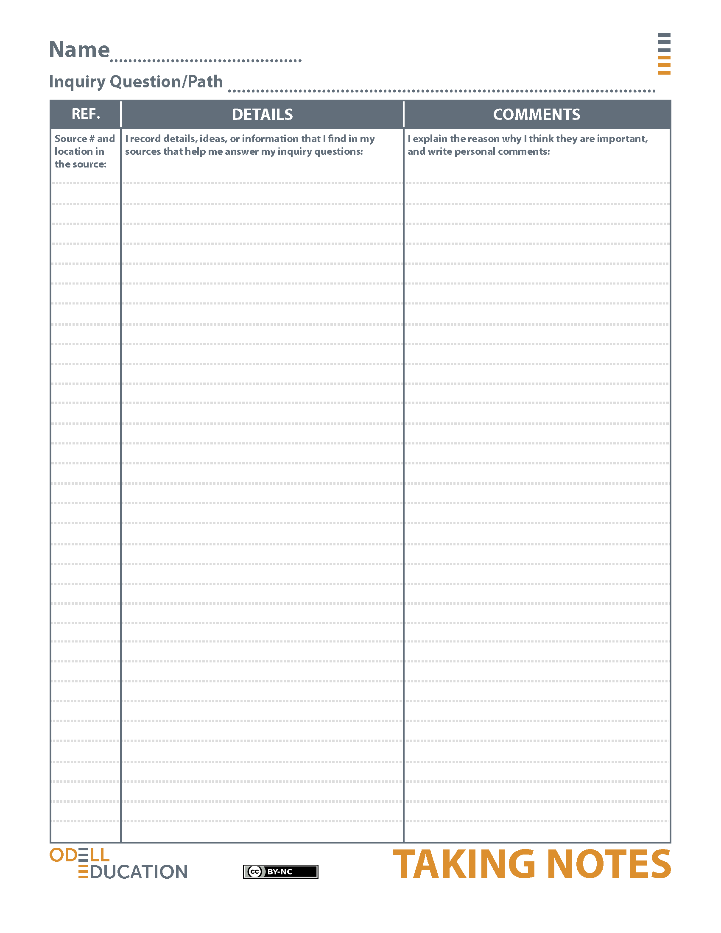
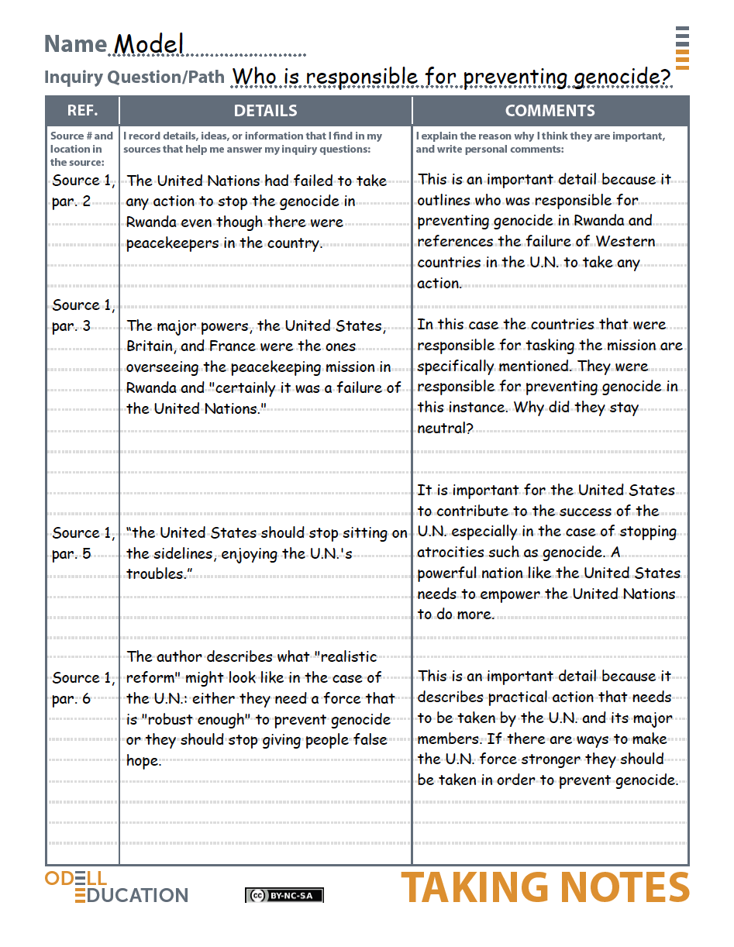

Synthesizing Notes Tool
Name: |  | Class: |  | Date:
Directions: Choose one of your independent annotations from the model source and the corresponding entry on the Taking Notes Tool. Discuss how the information in the source and tool address a specific inquiry question in the “Synthesis” portion of the tool.
Independent Annotation:

Entry from the Taking Notes Tool:

Synthesis:

From Odell Education Researching to Deepen Understanding Framework, by Odell Education, www.odelleducation.com. Copyright (2012–2013) by Odell Education. Adapted with permission under an Attribution-NonCommercial 3.0 Unported license: http://creativecommons.org/licenses/by-nc/3.0/.
Model Synthesizing Notes Tool
Name: |  | Class: |  | Date:

Directions: Choose one of your independent annotations from the model source and the corresponding entry on the Taking Notes Tool. Discuss how the information in the source and tool address a specific inquiry question in the “Synthesis” portion of the tool.

Independent Annotation:
An underline beneath the sentence “Belgian peacekeepers, under the United Nations flag, watched as the carnage unfolded” (paragraph 2).

Entry from the Taking Notes Tool:
This is an important detail because it outlines who was responsible for preventing genocide in Rwanda and references the failure of Western countries in the U.N. to take any action.

Synthesis:
By standing by and watching, the U.N. as well as the rest of the world failed to do anything to stop the Rwandan genocide. It is important to note that the major members, the United States, Britain, and France were the ones responsible for this peacekeeping mission. This answers the question of who was responsible for preventing genocide in Rwanda: the U.N. forces were there but they were unable to do anything to help.

From Odell Education Researching to Deepen Understanding Framework, by Odell Education, www.odelleducation.com. Copyright (2012–2013) by Odell Education. Adapted with permission under an Attribution-NonCommercial 3.0 Unported license: http://creativecommons.org/licenses/by-nc/3.0/.

