Table of Contents
GRADE K • MODULE 3
Comparison of Length, Weight, Capacity, and Numbers to 10

Module Overview i

Topic A: Comparison of Length and Height 3.A.1

Topic B: Comparison of Length and Height of Linking Cube Sticks Within 10 3.B.1

Topic C: Comparison of Weight 3.C.1

Topic D: Comparison of Volume 3.D.1

Topic E: Are There Enough? 3.E.1

Topic F: Comparison of Sets Within 10 3.F.1

Topic G: Comparison of Numerals 3.G.1

Topic H: Clarification of Measurable Attributes 3.H.1

Module Assessments 3.S.1

Grade K• Module 3
Comparison of Length, Weight, Capacity, and Numbers to 10
OVERVIEW
Having observed, analyzed, and classified objects by shape into predetermined categories in Module 2, students now compare and analyze length, weight, capacity, and, finally, numbers in Module 3. Students use language such as longer than, shorter than, as long as; heavier than, lighter than, as heavy as; and more than, less than, the same as. “8 is more than 5. 5 is less than 8.” “5 is the same as 5.” “2 and 3 is also the same as 5.”
Topics A and B focus on comparison of length, Topic C on comparison of weight, and Topic D on comparison of volume (K.MD.2). Each of these topics opens with an identification of the attribute being compared within the natural context of the lesson (K.MD.1). For example, in Topic A, before exploring length, students realize they could have chosen to compare by a different attribute: weight, length, volume, or numbers (K.MD.1).
T: Students, when you compare and say it is bigger, let’s think about what you mean. (After each question, allow students to have a lively, brief discussion.)
T: Do you mean that it is bigger, like this book is heavier than this ribbon? (Dramatize the weight of the book and ribbon.)
T: Do you mean that it is longer, like this ribbon is longer than this book? (Dramatize the length of the ribbon.)
T: Do you mean that it takes up more space, like this book takes up more space than this ribbon when it is all squished together? (Dramatize.)
T: Do you mean to compare the number of things, like the number of books and ribbons? (Dramatize a count.)
T: So, we can compare things in different ways! Today, let’s compare by thinking about longer than, taller than, or shorter than. (Dramatize.)
After the Mid-Module Assessment, Topic E begins with an analysis using the question, “Are there enough?” This leads naturally from exploring when and if there is enough space to seeing whether there are enough chairs for a small set of students: “There are fewer chairs than students!” This bridges into Topics F and G, which present a sequence building toward the comparison of numerals (K.CC.7). Topic F begins with counting and matching sets to compare (K.CC.6). The module culminates in a three-day exploration, one day devoted to each attribute: length, weight, and volume (K.MD.2). The module closes with a culminating task devoted to distinguishing between the measurable attributes of a set of objects: a water bottle, cup, dropper, and juice box (K.MD.1).

The module supports students’ understanding of amounts and their developing number sense. For example, counting how many small cups of rice are contained within a larger quantity provides a foundational concept of place value: Within a larger amount are smaller equal units, which together make up the whole. “4 cups of rice is the same as 1 mug of rice.” Compare that statement to “10 ones is the same as 1 ten” (1.NBT.2a). As students become confident directly comparing the length of a pencil and a crayon with statements such as “The pencil is longer than the crayon” (K.MD.2), they will be ready in later grades to indirectly compare using length units with statements such as “The pencil is longer than the crayon because 7 cubes is more than 4 cubes” (1.MD.2).
Additional foundational work for later grades is as follows:
- Foundational work with equivalence. The length of a stick with 5 linking cubes is the same as the length of my cell phone. A pencil weighs the same as a stick with 5 linking cubes. Each module component on measurement closes with a focus on the same as.
- Foundational work for the precise use and understanding of rulers and number lines. The module opens with lessons pointing out the importance of aligning endpoints to measure length.
- 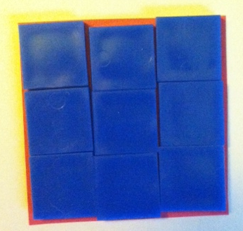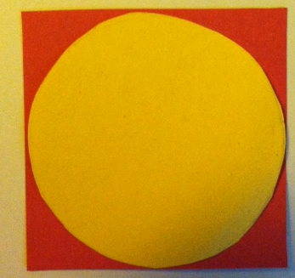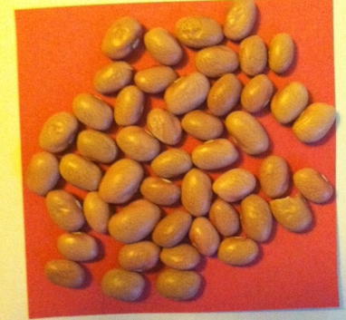Foundational understanding of area. At the opening of the second half of the module, students informally explore area as they see whether a yellow circle fits inside a red square. They then see how many small blue squares will fit inside the red square and, finally, that many beans will cover the same area (pictured to the right).
- Foundational understanding of comparison. As students count to compare the length of linking cube sticks, they are laying the foundation for answering how many more…than/less…than questions in Grade 1 (1.MD.2).

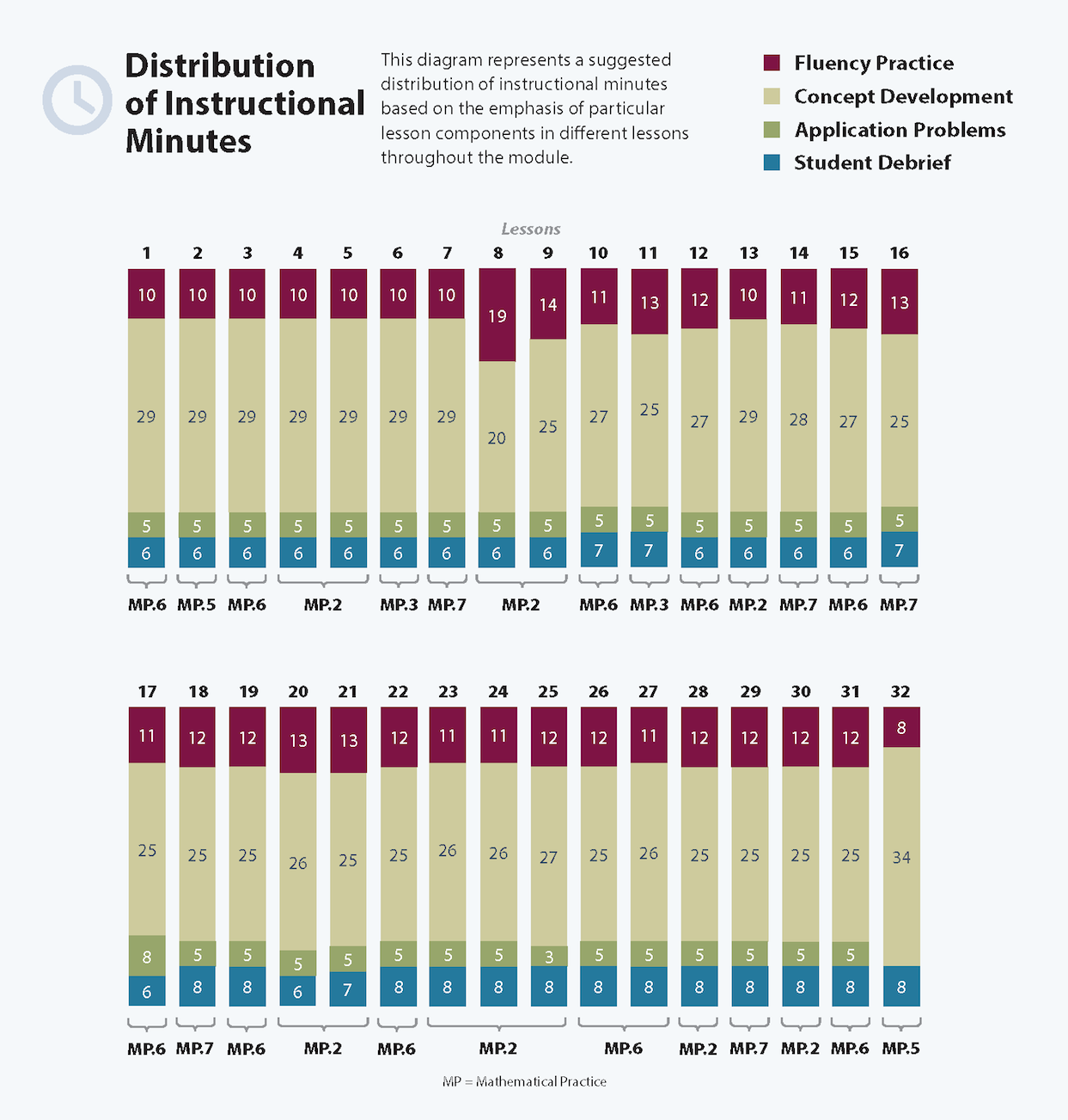

Focus Grade Level Standards
Compare numbers.
K.CC.6 Identify whether the number of objects in one group is greater than, less than, or equal to the number of objects in another group, e.g., by using matching and counting strategies. (Include groups with up to 10 objects.)
K.CC.7 Compare two numbers between 1 and 10 presented as written numerals.
Describe and compare measurable attributes.
K.MD.1 Describe measurable attributes of objects, such as length or weight. Describe several measurable attributes of a single object.
K.MD.2 Directly compare two objects with a measurable attribute in common, to see which object has “more of”/”less of” the attribute, and describe the difference. For example, directly compare the heights of two children and describe one child as taller/shorter.
Foundational Standards
PK.CC.5 Identify whether the number of objects in one group is more, less, greater than, fewer, and/or equal to the number of objects in another group, e.g., by using matching and counting strategies.
PK.CC.6 Identify “first” and “last” related to order or position.
PK.MD.1 Identify measurable attributes of objects, such as length and weight. Describe them using correct vocabulary (e.g., small, big, short, tall, empty, full, heavy, and light).
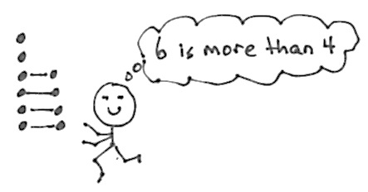
Focus Standards for Mathematical Practice
MP.2 Reason quantitatively and abstractly. Students compare quantities by drawing objects in columns and matching the objects one to one to see that one column has more than another and draw the conclusion that 6 is more than 4 because 2 objects do not have a match.
MP.3 Construct viable arguments and critique the reasoning of others. Students describe measurable attributes of a single object and reason about how to compare its length, weight, and volume to that of another object.
MP.5 Use appropriate tools strategically. During the culminating task and End-of-Module Assessment, students might choose to use a scale to compare weight, linking cube sticks to compare length and rice and cups to compare volume.
MP.6 Attend to precision. Students attend to precision by aligning endpoints when comparing lengths. They are also precise when weighing an object with cubes (or units) on a balance scale. Adding 1 more makes the cubes too heavy when the goal is to see how many cubes have the same weight as the object.
MP.7 Look for and make use of structure. Students use structure to see that the amount of rice in 1 container is equal to the amount in 4 smaller containers. The smaller unit is a structure, as is the larger unit.

Overview of Module Topics and Lesson Objectives
Standards | Topics and Objectives |  | Days
K.MD.1  K.MD.2 | A | Comparison of Length and Height  Lesson 1: Compare lengths using taller than and shorter than with aligned and non-aligned endpoints.  Lesson 2: Compare length measurements with string.  Lesson 3: Make a series of longer than and shorter than comparisons. | 3
K.MD.1  K.MD.2  K.CC.4c  K.CC.5  K.CC.6 | B | Comparison of Length and Height of Linking Cube Sticks Within 10  Lesson 4: Compare the length of linking cube sticks to a 5-stick.  Lesson 5: Determine which linking cube stick is longer than or shorter than the other.  Lesson 6: Compare the length of linking cube sticks to various objects.  Lesson 7: Compare objects using the same as. | 4
K.MD.1  K.MD.2 | C | Comparison of Weight  Lesson 8: Compare using heavier than and lighter than with classroom objects.  Lesson 9: Compare objects using heavier than, lighter than, and the same as with balance scales.  Lesson 10: Compare the weight of an object to a set of unit weights on a balance scale.  Lesson 11: Observe conservation of weight on the balance scale.  Lesson 12: Compare the weight of an object with sets of different objects on a balance scale. | 5
K.MD.1  K.MD.2 | D | Comparison of Volume  Lesson 13: Compare volume using more than, less than, and the same as by pouring.  Lesson 14: Explore conservation of volume by pouring.  Lesson 15: Compare using the same as with units. | 3
 |  | Mid-Module Assessment: Topics A–D (Interview style assessment: 3 days) | 3
K.CC.6 | E | Are There Enough?  Lesson 16: Make informal comparison of area.  Lesson 17: Compare to find if there are enough.  Lesson 18: Compare using more than and the same as.  Lesson 19: Compare using fewer than and the same as. | 4
K.CC.6  K.CC.7  K.CC.4c  K.MD.2 | F | Comparison of Sets Within 10  Lesson 20: Relate more and less to length.  Lesson 21: Compare sets informally using more, less, and fewer.  Lesson 22: Identify and create a set that has the same number of objects.  Lesson 23: Reason to identify and make a set that has 1 more.  Lesson 24: Reason to identify and make a set that has 1 less. | 5
K.CC.6  K.CC.7  K.CC.4c | G | Comparison of Numerals  Lesson 25: Match and count to compare a number of objects. State which quantity is more.  Lesson 26: Match and count to compare two sets of objects. State which quantity is less.  Lesson 27: Strategize to compare two sets.  Lesson 28: Visualize quantities to compare two numerals. | 4
K.MD.1  K.MD.2  K.CC.6  K.CC.7 | H | Clarification of Measurable Attributes  Lesson 29: Observe cups of colored water of equal volume poured into a variety of container shapes.  Lesson 30: Use balls of clay of equal weights to make sculptures.  Lesson 31: Use benchmarks to create and compare rectangles of different lengths to make a city.  Lesson 32: Culminating task—describe measurable attributes of single objects. | 4
 |  | End-of-Module Assessment: Topics E–H (Interview style assessment: 3 days) | 3
Total Number of Instructional Days |  |  | 38

Terminology
New or Recently Introduced Terms
- Balance scale (tool for weight measurement)
- Capacity (with reference to volume)
- Compare (specifically using direct comparison)
- Endpoint (with reference to alignment for direct comparison)
- Enough/not enough (comparative term)
- Heavier than/lighter than (weight comparison)
- Height (vertical distance measurement from bottom to top)
- Length (distance measurement from end to end; in a rectangular shape, length can be used to describe any of the four sides)
- Longer than/shorter than (length comparison)
- More than/fewer than (discrete quantity comparison)
- More than/less than (volume, area, and number comparisons)
- Taller than/shorter than (height comparison)
- The same as (comparative term)
- Weight (heaviness measurement)
Familiar Terms and Symbols
- Match (group items that are the same or that have the same given attribute)
- Numbers 1–10
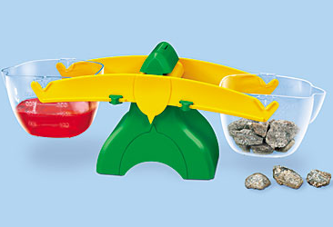
Suggested Tools and Representations
- Balance scales (as pictured to the right)
- Centimeter cubes
- Clay
- Linking cubes in sticks with a color change at the five

- Plastic cups and containers for measuring volume

Scaffolds
The scaffolds integrated into A Story of Units give alternatives for how students access information as well as express and demonstrate their learning. Strategically placed margin notes are provided within each lesson elaborating on the use of specific scaffolds at applicable times. They address many needs presented by English language learners, students with disabilities, students performing above grade level, and students performing below grade level. Many of the suggestions are organized by Universal Design for Learning (UDL) principles and are applicable to more than one population. To read more about the approach to differentiated instruction in A Story of Units, please refer to “How to Implement A Story of Units.”
Assessment Summary
Type | Administered | Format | Standards Addressed
Mid-Module Assessment Task | After Topic D | Constructed response with rubric | K.MD.1  K.MD.2
End-of-Module Assessment Task | After Topic H | Constructed response with rubric | K.CC.6  K.CC.7  K.MD.1  K.MD.2
Culminating Task | Lesson 32 | Determining the attribute to be measured | K.MD.1  K.MD.2

Up to 5 objects.
These are terms and symbols students have seen previously.
Students with disabilities may require Braille, large-print, audio, or special digital files. Please visit the website www.p12.nysed.gov/specialed/aim for specific information on how to obtain student materials that satisfy the National Instructional Materials Accessibility Standard (NIMAS) format.

