Lesson 1: The General Multiplication Rule

Classwork
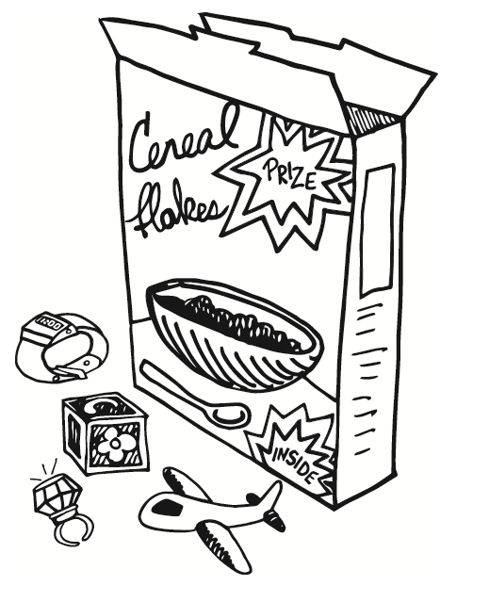
Example 1: Independent Events
Do you remember when breakfast cereal companies placed prizes in boxes of cereal? Possibly you recall that when a certain prize or toy was particularly special to children, it increased their interest in trying to get that toy. How many boxes of cereal would a customer have to buy to get that toy? Companies used this strategy to sell their cereal.
One of these companies put one of the following toys in its cereal boxes: a block ($B$), a toy watch ($W$), a toy ring ($R$), and a toy airplane ($A$). A machine that placed the toy in the box was programmed to select a toy by drawing a random number of $1$ to $4$. If a $1$ was selected, the block (or $B$) was placed in the box; if a $2$ was selected, a watch (or $W$) was placed in the box; if a $3$ was selected, a ring (or $R$) was placed in the box; and if a $4$ was selected, an airplane (or $A$) was placed in the box. When this promotion was launched, young children were especially interested in getting the toy airplane.

Exercises 1–8
- If you bought one box of cereal, what is your estimate of the probability of getting the toy airplane? Explain how you got your answer.

- If you bought a second box of cereal, what is your estimate of the probability of getting the toy airplane in the second box? Explain how you got your answer.

- If you bought two boxes of cereal, does your chance of getting at least one airplane increase or decrease? Explain your answer.

- Do you think the probability of getting at least one airplane from two boxes is greater than $0.5?$ Again, explain your answer.

- List all of the possibilities of getting two toys from two boxes of cereals. (Hint: Think of the possible outcomes as ordered pairs. For example, BA would represent a block from the first box and an airplane from the second box.)

- Based on the list you created, what do you think is the probability of each of the following outcomes if two cereal boxes are purchased?
  - One (and only one) airplane

  - At least one airplane

  - No airplanes

- Consider the purchase of two cereal boxes.
  - What is the probability of getting an airplane in the first cereal box? Explain your answer.

  - What is the probability of getting an airplane in the second cereal box?

  - What is the probability of getting airplanes in both cereal boxes?

$P(A and B)$ is the probability that Events $A$ and $B$ both occur and is the probability of the intersection of $A$ and $B$. The probability of the intersection of Events $A$ and $B$ is sometimes also denoted by $P(A ∩ B)$.

Multiplication Rule for Independent Events
If $A$ and $B$ are independent events, $P\left(A and B\right)= P\left(A\right)∙P\left(B\right)$
This rule generalizes to more than two independent events, for example:
$P(A and B and C)$ or $P\left(A intersect B intersect C\right)=P\left(A\right)∙P\left(B\right)∙P\left(C\right)$

- Based on the multiplication rule for independent events, what is the probability of getting an airplane in both boxes? Explain your answer.

Example 2: Dependent Events
Do you remember the famous line, “Life is like a box of chocolates,” from the movie Forrest Gump? When you take a piece of chocolate from a box, you never quite know what the chocolate will be filled with. Suppose a box of chocolates contains $15$ identical-looking pieces. The $15$ are filled in this manner: $3$ caramel, $2$ cherry cream, $2$ coconut, $4$ chocolate whip, and $4$ fudge.

Exercises 9–14
- If you randomly select one of the pieces of chocolate from the box, what is the probability that the piece will be filled with fudge?

- If you randomly select a second piece of chocolate (after you have eaten the first one, which was filled with fudge), what is the probability that the piece will be filled with caramel?

The events, picking a fudge-filled piece on the first selection and picking a caramel-filled piece on the second selection, are called dependent events.
Two events are dependent if knowing that one has occurred changes the probability that the other occurs.

Multiplication Rule for Dependent Events
$$P(A and B) = P(A)∙P(B|A)$$

Recall from your previous work with probability in Algebra II that $P(B|A)$ is the conditional probability of event $B$ given that event $A$ occurred. If event $A$ is picking a fudge-filled piece on the first selection and event $B$ is picking a caramel-filled piece on the second selection, then $P(B|A)$ represents the probability of picking a caramel-filled piece second knowing that a fudge-filled piece was selected first.

- If $A1$ is the event picking a fudge-filled piece on the first selection and $B2$ is the event picking a caramel-filled piece on the second selection, what does $P(A1 and B2)$ represent? Find $P(A1 and B2)$.

- What does $P(B1 and A2)$ represent? Calculate this probability.

- If $C$ represents selecting a coconut-filled piece of chocolate, what does $P(A1 and C2)$ represent? Find this probability.

- Find the probability that both the first and second pieces selected are filled with chocolate whip.

Exercises 15–17
- For each of the following, write the probability as the intersection of two events. Then, indicate whether the two events are independent or dependent, and calculate the probability of the intersection of the two events occurring.
  - The probability of selecting a $6$ from the first draw and a $7$ on the second draw when two balls are selected without replacement from a container with $10$ balls numbered $1$ to $10$.

  - The probability of selecting a $6$ on the first draw and a $7$ on the second draw when two balls are selected with replacement from a container with $10$ balls numbered $1$ to $10$.

  - The probability that two people selected at random in a shopping mall on a very busy Saturday both have a birthday in the month of June. Assume that all $365$ birthdays are equally likely and ignore the possibility of a February $29$ leap-year birthday.

  - The probability that two socks selected at random from a drawer containing $10$ black socks and $6$ white socks will both be black.

- A gumball machine has gumballs of $4$ different flavors: sour apple ($A$), grape ($G$), orange ($O$), and cherry ($C$). There are six gumballs of each flavor. When $50¢$ is put into the machine, two random gumballs come out. The event $C1$ means a cherry gumball came out first, the event $C2$ means a cherry gumball came out second, the event $A1$ means sour apple gumball came out first, and the event $G2$ means a grape gumball came out second.
  - What does $P(C2|C1)$ mean in this context?

  - Find $P(C1 and C2)$.

  - Find $P(A1 and G2)$.

- Below are the approximate percentages of the different blood types for people in the United States.
Type $O$ $44\%$
Type $A$ $42\%$
Type $B$ $10\%$
Type $AB$ $4\%$
Consider a group of $100$ people with a distribution of blood types consistent with these percentages. If two people are randomly selected with replacement from this group, what is the probability that
  - both people have type $O$ blood?

  - the first person has type $A$ blood and the second person has type $AB$ blood?

Lesson Summary
- Two events are independent if knowing that one occurs does not change the probability that the other occurs.
- Two events are dependent if knowing that one occurs changes the probability that the other occurs.
- General Multiplication Rule:
$$P(A and B) = P(A)∙P(B|A)$$
If $A$ and $B$ are independent events then $P(B|A) = P(B)$.

Problem Set

- In a game using the spinner below, a participant spins the spinner twice. If the spinner lands on red both times, the participant is a winner.
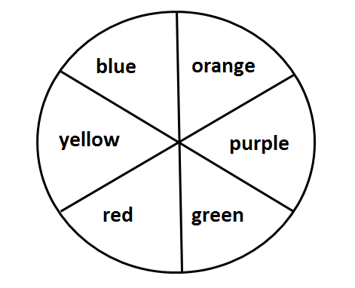

  - The event participant is a winner can be thought of as the intersection of two events. List the two events.
  - Are the two events independent? Explain.
  - Find the probability that a participant wins the game.

- The overall probability of winning a prize in a weekly lottery is $\frac{1}{32}$. What is the probability of winning a prize in this lottery three weeks in a row?

- A Gallup poll reported that $28\%$ of adults (age $18$ and older) eat at a fast food restaurant about once a week. Find the probability that two randomly selected adults would both say they eat at a fast food restaurant about once a week.

- In the game Scrabble, there are a total of $100$ tiles. Of the $100$ tiles, $42$ tiles have the vowels A, E, I, O, and U printed on them, $56$ tiles have the consonants printed on them, and $2$ tiles are left blank.
  - If tiles are selected at random, what is the probability that the first tile drawn from the pile of $100$ tiles is a vowel?
  - If tiles drawn are not replaced, what is the probability that the first two tiles selected are both vowels?
  - Event $A$ is drawing a vowel, event $B$ is drawing a consonant, and event $C$ is drawing a blank tile. $A1$ means a vowel is drawn on the first selection, $B2$ means a consonant is drawn on the second selection, and $C2$ means a blank tile is drawn on the second selection. Tiles are selected at random and without replacement.
    - Find $P(A1 and B2)$
    - Find $P\left(A1 and C2\right)$
    - Find $P\left(B1 and C2\right)$

- To prevent a flooded basement, a homeowner has installed two special pumps that work automatically and independently to pump water if the water level gets too high. One pump is rather old and does not work $28\%$ of the time, and the second pump is newer and does not work $9\%$ of the time. Find the probability that both pumps will fail to work at the same time.

- According to a recent survey, approximately $77\%$ of Americans get to work by driving alone. Other methods for getting to work are listed in the table below.

Method of getting to work | Percent of Americans  using this method
Taxi | $$0.1\%$$
Motorcycle | $$0.2\%$$
Bicycle | $$0.4\%$$
Walk | $$2.5\%$$
Public Transportation | $$4.7\%$$
Car Pool | $$10.7\%$$
Drive Alone | $$77\%$$
Work at Home | $$3.7\%$$
Other | $$0.7\%$$

  - What is the probability that a randomly selected worker drives to work alone?
  - What is the probability that two workers selected at random with replacement both drive to work alone?

- A bag of M&Ms contains the following distribution of colors:
$9$ blue
$6$ orange
$5$ brown
$5$ green
$4$ red
$3$ yellow

Three M&Ms are randomly selected without replacement. Find the probabilities of the following events.
  - All three are blue.
  - The first one selected is blue, the second one selected is orange, and the third one selected is red.
  - The first two selected are red, and the third one selected is yellow.

- Suppose in a certain breed of dog, the color of fur can either be tan or black. Eighty-five percent of the time, a puppy will be born with tan fur, while $15\%$ of the time, the puppy will have black fur. Suppose in a future litter, six puppies will be born.
  - Are the events having tan fur and having black fur independent? Explain.
  - What is the probability that one puppy in the litter will have black fur and another puppy will have tan fur?
  - What is the probability that all six puppies will have tan fur?
  - Is it likely for three out of the six puppies to be born with black fur? Justify mathematically.

- Suppose that in the litter of six puppies from Exercise 8, five puppies are born with tan fur, and one puppy is born with black fur.
  - You randomly pick up one puppy. What is the probability that puppy will have black fur?
  - You randomly pick up one puppy, put it down, and randomly pick up a puppy again. What is the probability that both puppies will have black fur?
  - You randomly pick up two puppies, one in each hand. What is the probability that both puppies will have black fur?
  - You randomly pick up two puppies, one in each hand. What is the probability that both puppies will have tan fur?

