Lesson 4: An Appearance of Complex Numbers

Student Outcomes
- Students solve quadratic equations with complex solutions.
- Students understand the geometric origins of the imaginary unit $i$ in terms of 90-degree rotations. Students use this understanding to see why $i^{2}=-1$.

Lesson Notes
This lesson begins with an exploration of an equation that arose in Lesson 1 in the context of studying linear transformations. To check the solutions to this equation, students need a variety of skills involving the arithmetic of complex numbers. The purpose of this phase of the lesson is to point to the need to review and extend students’ knowledge of complex number arithmetic. This phase of the lesson continues with a second example of a quadratic equation with complex solutions, which is solved by completing the square.
The second phase of the lesson involves a review of the theory surrounding complex numbers. In particular, $i$ is introduced as a multiplier that induces a 90-degree rotation of the coordinate plane and which satisfies the equation
$i^{2}=-1$.

Classwork
Scaffolding:
If students need help answering the question in the Opening Exercise, ask them, “What are the properties of a linear transformation?” If necessary, cue them to check whether or not
$R\left(a+b\right)=R\left(a\right)+R(b)$.
Opening Exercise (2 minutes)
Opening Exercise
MP.3
Is $R\left(x\right)=\frac{1}{x}$ a linear transformation? Explain how you know.
$R\left(2+3\right)=R\left(5\right)=\frac{1}{5}$, but $R\left(2\right)+R\left(3\right)=\frac{1}{2}+\frac{1}{3}=\frac{5}{6}$, which is not the same as $\frac{1}{5}$. This means that the reciprocal function does not preserve addition, and so it is not a linear transformation.

Example 1 (8 minutes)
- Apparently, it is not true in general that $R\left(2+x\right)=R\left(2\right)+R(x)$, since this statement is false when $x=3$. But, this does not mean that there are no values of $x$ that make the equation true. Let’s see if we can produce at least one solution.
- Solve the equation $\frac{1}{2+x}=\frac{1}{2}+\frac{1}{x}$.
- What is the first step in solving this equation?
  - We can multiply both sides by $2x(2+x)$:
$$2x=x\left(2+x\right)+2\left(2+x\right)$$

- How might we continue?
  - We can apply the distributive property:
$$2x=2x+x^{2}+4+2x$$
- Evidently, we are dealing with a quadratic equation. What are some techniques you know for solving quadratic equations?
  - We could try factoring, we could complete the square, or we could use the quadratic formula.
- Let’s solve this equation by completing the square. Work on this problem until you have a perfect square equal to a number, and then stop.
Circulate throughout the class, monitoring students’ work and providing assistance as needed.
Scaffolding:
An area diagram can be used to help students understand why it was necessary to add $1$ to both sides of the equation to create a perfect square.
$$-4=x^{2}+2x \\ 1-4=x^{2}+2x+1 \\ -3=({x+1)}^{2}$$
 | $$x$$ | $$1$$
$$x$$ | $$x^{2}$$ | $$x$$
$$1$$ | $$x$$ | $$?$$

- Do you notice anything unusual about the equation at this point?
  - We have a quantity whose square is equal to a negative number.
- What does that tell you about the solutions to the equation?
  - No real number can satisfy the equation, so the solutions must be complex numbers.
- Go ahead and find the solutions.
$$\sqrt{({x+1)}^{2}}=\sqrt{-3} \\ x+1=±i\sqrt{3} \\ x=-1±i\sqrt{3}$$
- Do these solutions satisfy the original equation $R\left(2+x\right)=R\left(2\right)+R(x)$? How can we tell?
  - We need to check to see whether or not $\frac{1}{2+(-1+i\sqrt{3})}=\frac{1}{2}+\frac{1}{-1+i\sqrt{3}}$.
- In order to ascertain whether or not these two expressions are equal, we will need to review and extend the things we learned about complex numbers in Algebra II. But first, let’s do some additional work with quadratics that have complex solutions.

Example 2 (13 minutes)
- Solve the equation $3x^{2}+5x+7=1$.
- Recall that we can use an area diagram to help us visualize the process of completing the square. A first attempt might look something like this:
 | ? | ? |  |  |  | $$\sqrt{3}x$$ | $$?$$
? | $$3x^{2}$$ | $$\frac{5}{2}x$$ |  |  | $$\sqrt{3}x$$ | $$3x^{2}$$ | $$\frac{5}{2}x$$
? | $$\frac{5}{2}x$$ | $$?$$ |  |  | $$?$$ | $$\frac{5}{2}x$$ | $$?$$
- Do you notice anything awkward about this initial diagram?
  - The square roots and the fractions are a bit awkward to work with.
- How can we get around these awkward points? What would make this problem easier to handle?
  - If the coefficient of $x^{2}$ were a perfect square, then we would not have a radical to contend with. If the coefficient of $x$ were even, then we would not have a fraction to contend with.
- We can multiply both sides of the equation by any number we choose. Let’s be strategic about this. What multiplier could we choose that would create a perfect square for the $x^{2}$-term?
  - If we multiply both sides of the equation by $3$, the leading coefficient becomes $9$, a perfect square.
- Go ahead and multiply by $3$, and see what you get.
$$3x^{2}+5x+7=1 \\ 3\left({3x}^{2}+5x+7\right)=3\left(1\right) \\ 9x^{2}+15x+21=3$$
- Now let’s deal with the $x$-term. What multiplier could we choose that would make the $x$-term even, without disturbing the requirement about having a perfect square in the leading term?
  - We could multiply both sides of the equation by $4$, which is both even and a perfect square.
- Go ahead and multiply by $4$ and see what you get.
$$9x^{2}+15x+21=3 \\ 4\left(9x^{2}+15x+21\right)=4\left(3\right) \\ {36}^{2}+60x+84=12 \\ {36}^{2}+60x+84=12$$
- Because we took the simple steps of multiplying by $3$ and then by $4$, the algebra will now be much easier to handle.
- Go ahead and complete the square now. Use an area diagram to help you do this. Then, solve the equation completely.
 | ? | ? |  |  |  | $$6x$$ | $$5$$
? | $$36x^{2}$$ | $$30x$$ |  |  | $$6x$$ | $$36x^{2}$$ | $$30x$$
? | $$30x$$ | $$?$$ |  |  | $$5$$ | $$30x$$ | $$?$$

$$36x^{2}+60x+84=12 \\ 36x^{2}+60x=12-84=-72 \\ 36x^{2}+60x+25=-72+25 \\ {\left(6x+5\right)}^{2}=-47 \\ 6x+5=±i\sqrt{47} \\ x=\frac{-5±i\sqrt{47}}{6} \\ x=-\frac{5}{6}±i\frac{\sqrt{47}}{6}$$
- Quickly answer the following question in your notebook:
When you want to complete the square of a quadratic expression $ax^{2}+bx+c$, what conditions on $a$ and $b$ make the process go smoothly?
  - It is desirable to convert $a$ into a perfect square and to convert $b$ into an even number.
- Let’s generalize the work we did with the example above.
- Take the expression $ax^{2}+bx+c$, and multiply each term by $4a$. What do you get?
  - $4a\left(ax^{2}+bx+c\right)=4a^{2}x^{2}+4abx+4ac$
- How does this connect to the summary point you wrote in your notebook?
  - $4a^{2}={\left(2a\right)}^{2}$, so it is a perfect square. Also, $4ab=2\left(2ab\right)$, so it is even.
- You may also recognize that the expression $4ac$ is a component from the general quadratic formula. Using $4a$ as a multiplier is useful indeed.

Exercise 1 (4 minutes)
Exercises
- Solve $5x^{2}-3x+17=9$.
 | $$10x$$ | $$-3$$
$$10x$$ | $${100x}^{2}$$ | $$-30x$$
$$-3$$ | $$-30x$$ | $$?$$
$$5x^{2}-3x+17=9 \\ 5x^{2}-3x=9-17=-8 \\ 20\left(5x^{2}-3x\right)=20\left(-8\right) \\ 100x^{2}-60x=-160 \\ 100x^{2}-60x+9=-160+9 \\ {\left(10x-3\right)}^{2}=-151 \\ x=\frac{3±i\sqrt{151}}{10}=\frac{3}{10}±i\frac{\sqrt{151}}{10}$$

- Take about 30 seconds to write down what you have learned so far today, and then share what you wrote with another student.
- Now that we have practiced solving a few equations with complex solutions, we are going to conduct a general review of things we know about complex numbers, starting with the definition of $i$.

Discussion (5 minutes): The Geometry of Multiplication by $i$
Recall that multiplying by $-1$ rotates the number line about the origin through $180$ degrees.
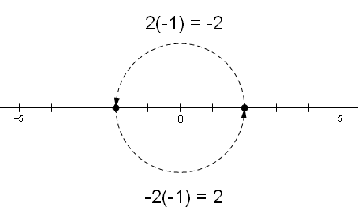

- You may remember that the number $i$ is the multiplier that rotates the number line through $90$ degrees.
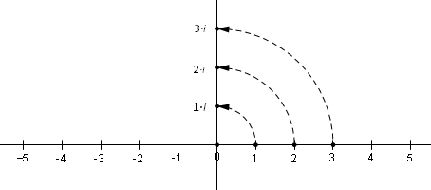
- If we take a point on the vertical axis and multiply it by $i$, what would you expect to see geometrically?
  - This should produce another $90$-degree rotation.
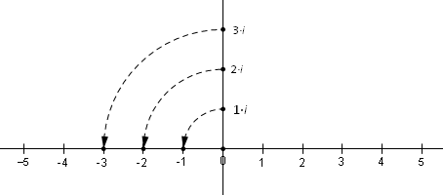
- Now we have performed two $9$0-degree rotations, which is the same as a $180$-degree rotation. This means that multiplying a number by $i$ twice is the same as multiplying the number by $-1$.
- Knowing that $i∙ix=i^{2}∙x$, what do the above observations suggest must be true about the number $i$?
  - If $x$ is any real number, we have $i^{2}∙x=-1∙x$, which means that $i^{2}=-1$.

Example 3 (2 minutes)
- We know that multiplying by $i$ rotates a point through $90$ degrees, and multiplying by $i^{2}$ rotates a point through $180$ degrees. What do you suppose multiplying by $i^{3}$ does? What about $i^{4}$?
  - It would seem as though this should produce three $90$-degree rotations, which is $270$degrees. If multiplying by $i^{4}$ is the same as doing four $90$-degree rotations, then that would make $360$ degrees.
- So, $i^{4}$ takes a point back to where it started. In light of the fact that $i^{2}=-1$, does this make sense?
  - Yes, because $i^{4}=i^{2}∙i^{2}$, which is $(-1)(-1)$, which is just $1$. Multiplying by $1$ takes a point to itself, so the $360$-degree rotation does indeed make sense.

Exercises 2–4 (3 minutes)
Ask students to work independently on these problems, and then discuss them as a whole class.

- Use the fact that $i^{2}=-1$ to show that $i^{3}=-i$. Interpret this statement geometrically.
We have $i^{3}=i^{2}∙i=\left(-1\right)∙i=-i$. Multiplying by $i$ rotates a point through $90$ degrees, and multiplying by $-1$ rotates it $180$ degrees further. This makes sense with our earlier conjecture that multiplying by $i^{3}$ would induce a $270$-degree rotation.

- Calculate $i^{6}$.
$$i^{6}=i^{2}∙i^{2}∙i^{2}=\left(-1\right)\left(-1\right)\left(-1\right)=\left(1\right)\left(-1\right)=-1$$

- Calculate $i^{5}$.
$$i^{5}=i^{2}∙i^{2}∙i=\left(-1\right)\left(-1\right)(i)=\left(1\right)\left(i\right)=i$$

Closing (3 minutes)
Ask students to write responses to the following questions, and then have them share their responses in pairs. Then briefly discuss the responses as a whole class.
- What is important to know about $i$ from a geometric point of view?
  - Multiplication by $i$ rotates a point in the plane counterclockwise about the origin through $90$ degrees.
- What is important to know about $i$ from an algebraic point of view?
  - The number $i$ satisfies the equation $i^{2}=-1$.

Exit Ticket (5 minutes)

Name Date
Lesson 4: An Appearance of Complex Numbers

Exit Ticket

- Solve the equation below.
$$2x^{2}-3x+9=4$$

- What is the geometric effect of multiplying a number by $i^{4}$? Explain your answer using words or pictures, and then confirm your answer algebraically.

Exit Ticket Sample Solutions

- Solve the equation below.
$$2x^{2}-3x+9=4$$
$$2x^{2}-3x=-5 \\ 16x^{2}-24x=-40 \\ 16x^{2}-24x+9=-40+9 \\ {\left(4x-3\right)}^{2}=-31 \\ 4x-3=±i\sqrt{31} \\ x=\frac{3±i\sqrt{31}}{4}=\frac{3}{4}±i\frac{\sqrt{31}}{4}$$

- What is the geometric effect of multiplying a number by $i^{4}$? Explain your answer using words or pictures, and then confirm your answer algebraically.
If you multiply a number by $i$ four times, you would expect to see four $90$-degree rotations. This amounts to a$360$-degree rotation. In other words, each point is mapped back to itself. This makes sense algebraically as well since the work below shows that $i^{4}=1$.
$$i^{4}=i^{2}∙i^{2}=-1∙-1=1$$
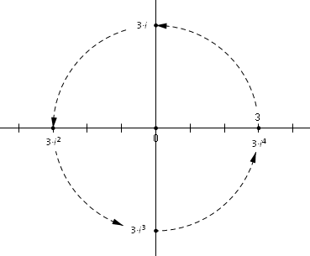

Problem Set Sample Solutions

- Solve the equation below.
$$5x^{2}-7x+8=2$$
$$5x^{2}-7x=-6 \\ 100x^{2}-140x=-120 \\ 100x^{2}-140x+49=-120+49 \\ {\left(10x-7\right)}^{2}=-71 \\ x=\frac{7±i\sqrt{71}}{10}=\frac{7}{10}±i\frac{\sqrt{71}}{10}$$
- Consider the equation $x^{3}=8$.
  - What is the first solution that comes to mind?
It is easy to see that $2^{3}=8$, so $2$ is a solution.

  - It may not be easy to tell at first, but this equation actually has three solutions. To find all three solutions, it is helpful to consider $x^{3}-8=0$, which can be rewritten as $\left(x-2\right)\left(x^{2}+2x+4\right)=0$ (check this for yourself). Find all of the solutions to this equation.
$$x^{2}+2x+4=0 \\ x^{2}+2x=-4 \\ x^{2}+2x+1=-4+1 \\ {\left(x+1\right)}^{2}=-3 \\ x=-1±i\sqrt{3}$$
The solutions to $x^{3}-8=0$ are $2$, $-1+i\sqrt{3}$, and $-1-i\sqrt{3}$.

- Make a drawing that shows the first $5$ powers of $i$ (i.e., $i^{1}, i^{2}, …,i^{5}$), and then confirm your results algebraically.
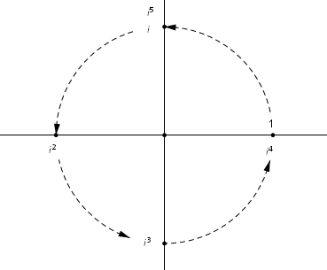

$$i^{1}=i$$
$$i^{2}=-1$$
$$i^{3}=i^{2}∙i=-1∙i=-i$$
$$i^{4}=i^{2}∙i^{2}=-1∙-1=1$$
$$i^{5}=i^{4}∙i=1∙i=i$$

- What is the value of $i^{99}$? Explain your answer using words or drawings.
Multiplying by $i$ four times is equivalent to rotating through $4∙90=360$ degrees, which is a complete rotation. Since $99=4∙24+3$, multiplying by $i$ for$99$ times is equivalent to performing $24$ complete rotations, followed by three $90$-degree rotation. Thus, $i^{99}=-i$.

- What is the geometric effect of multiplying a number by $-i$? Does your answer make sense to you? Give an explanation using words or drawings.
If we multiply a number by $i$ and then by $-1$, we get a quarter turn followed by a half turn. This is equivalent to a three-quarters turn in the counterclockwise direction, which is the same as a quarter turn in the clockwise direction. This makes sense because we would expect multiplication by $-i$ to have the opposite effect as multiplication by $i$, and so it feels right to say that multiplying by $-i$ rotates a point in the opposite direction by the same amount.
