Lesson 20: Inverses of Logarithmic and Exponential Functions

Student Outcomes
- In order to demonstrate understanding of the inverse relationship between exponents and logarithms, students construct the inverse of exponential and logarithmic functions from a table, graph, or algebraic representation.
- Students compose functions to verify that exponential functions and logarithmic functions are inverses.

Lesson Notes
This lesson focuses on logarithmic and exponential functions. Students have worked with exponential functions since Algebra I, and logarithmic functions were introduced and studied extensively in Algebra II. The inverse of an exponential function was first defined in Algebra II as students solved equations of the form $a∙b^{cx}=d$ and came to understand that the solution to this type of equation is a logarithm (F-LE.B.5). In this lesson, we review what students learned in Algebra II about the inverse relationship between exponents and logarithms (F-BF.B.5) and use composition to verify that a logarithmic function and an exponential function are inverses (F-BF.B.4d).
Depending on how much your students recall from Algebra II, you may need to provide some review and practice for working with exponential and logarithmic expressions and rewriting them using their definitions, identities, and properties. Pertinent vocabulary and definitions are included at the end of this lesson.
This lesson is greatly enhanced by the use of technology. Students should have access to graphing calculators or other graphing utilities. If access is limited, then teacher demonstrations can be utilized instead at those points where technology is infused in the lesson.

Classwork
Opening (2 minutes)
Explain briefly to students that we are going to continue working to understand the inverses of other functions that they have studied in the past.
- What are some of the different types of functions we have studied so far this year and in past years?
  - We have studied polynomial, rational, exponential, logarithmic, and trigonometric functions to name a few.
Tell them that the focus of this lesson will be on exponential and logarithmic functions and that in Module 4 we will consider the inverse functions of trigonometric functions as well.
Opening Exercise (5 minutes)
Students should complete the Opening Exercise individually and then compare their answers with a partner. How students do on these problems will give you insight into how much re-teaching and reviewing may be necessary during this lesson. For example, if a majority of students do not recognize quickly that the inverse of $f\left(x\right)=2^{x}$ is a logarithmic function, you will need to provide additional support as you move through this lesson. Be careful not to jump in too quickly though. Give students time to think through and recall what they have already learned.
Opening Exercise
Let $f\left(x\right)=2^{x}$.
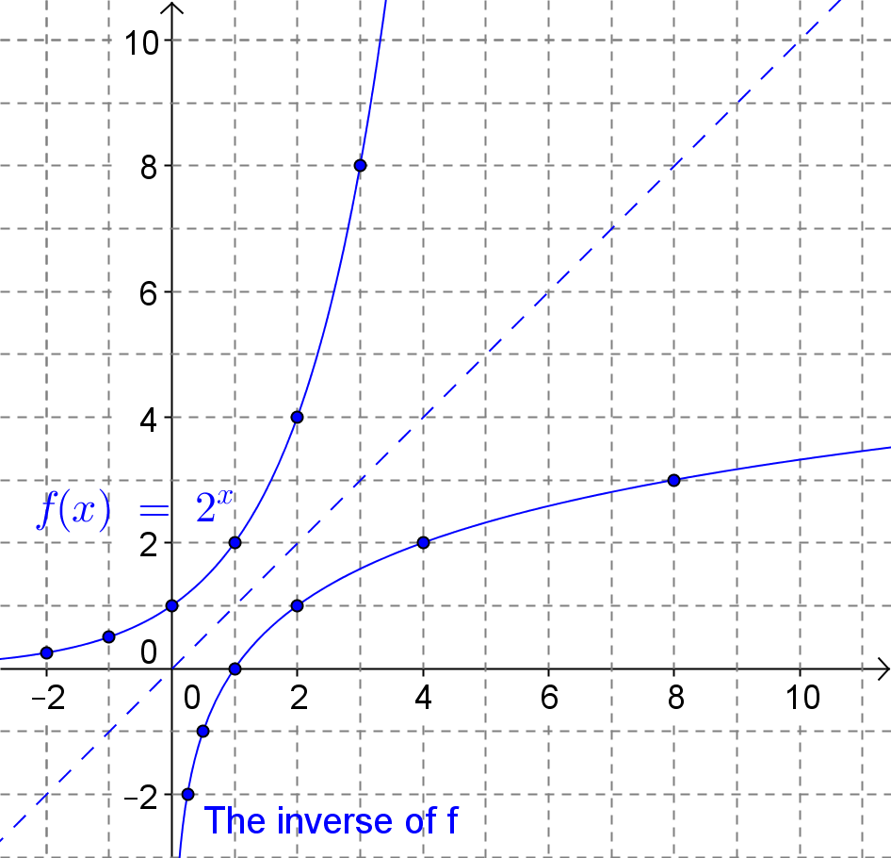
  - Complete the table, and use the points $(x,f\left(x\right))$ to create a sketch of the graph of $y=f(x)$.
$$x$$ | $$f(x)$$
$$-2$$ | $$\frac{1}{4}$$
$$-1$$ | $$\frac{1}{2}$$
$$0$$ | $$1$$
$$1$$ | $$2$$
$$2$$ | $$4$$
$$3$$ | $$8$$

  - Create a table of values for the function $f^{-1}$, and sketch the graph of $y=f^{-1}(x)$ on the grid above.
The inverse is sketched above.
$$x$$ | $$f^{-1}(x)$$
$$\frac{1}{4}$$ | $$-2$$
$$\frac{1}{2}$$ | $$-1$$
$$1$$ | $$0$$
$$2$$ | $$1$$
$$4$$ | $$2$$
$$8$$ | $$3$$

  - What type of function is $f^{-1}$? Explain how you know.
MP.2 & MP.7
It appears to be a logarithmic function. We are plotting powers of $2$ on the horizontal axis and the corresponding exponents on the vertical axis. This is how we define a logarithmic function.

Example 1 (5 minutes)
This example is intended to show students that the inverse of $f\left(x\right)=2^{x}$ really is a logarithm. If students readily recalled that the inverse of the function in the Opening Exercise should be the graph of a logarithmic function, then students could work Example 1 in small groups. Use the discussion as needed to help your students recall the definition of a logarithm from Algebra II. The definition of a logarithm is stated below:
Logarithm: If three numbers $L$, $b,$ and $x$ are related by $x=b^{L}$, then $L$ is the logarithm base $b$ of $x$, and we write $\log_{b}{(x)}$. That is, the value of the expression $L=\log_{b}{(x)}$ is the power of $b$ needed to obtain $x$. Further, $b$ must be a real number such that $0<b<1$ or $b>1$

Use these questions to guide students on this Example.
- How do we algebraically find the inverse of a function?
  - Replace $f(x)$ with $y$, exchange the $x$ and $y$ symbols, and solve for $y$.
- How do we undo an exponentiation?
  - You need to write the equation in logarithm form.
- What is the definition of a logarithm?
Scaffolding:
To provide a more concrete approach, give students specific numeric examples.
- Show by composition that the following pairs of functions are inverses:
- $f\left(x\right)=2^{x}$ and $g\left(x\right)=\log_{2}{(x)}$ ,
- $f\left(x\right)=3^{x}$ and $g\left(x\right)=\log_{3}{(x)}$,
- $f\left(x\right)=2x+1$ and $g\left(x\right)=\frac{1}{2}(x-1)$.
- Then have them show that the general form of a linear function $f\left(x\right)=mx+b$ and $g\left(x\right)=\frac{1}{m}\left(x-b\right)$are inverses.

  - For three numbers $L$, $b,$ and $x$, $x=b^{L}$ if and only if $L=\log_{b}{(x)}$.
Example 1
Given $f\left(x\right)=2^{x}$, use the definition of the inverse of a function and the definition of a logarithm to write a formula for $f^{-1}(x)$.
$$y=2^{x}$$
If $g$ is the inverse of $f$, then $y=f(x)$ implies that $g\left(y\right)=x$, so you exchange the $x$ and $y$ variables.
$$x=2^{y}$$
We use this definition of logarithm to rewrite $x=2^{y}$to be
$$\log_{2}{(x)}=y$$
$$y=\log_{2}{(x)}$$
$$f^{-1}\left(x\right)=\log_{2}{(x)}$$

You may want to have students use a graphing calculator or other graphing utility to verify that the values in the table in the Opening Exercise part (b) correspond to points on the graph of $y=\log_{2}{(x)}$.

Exercises 1–10 (15 minutes)
In Algebra II, students did not know about function composition. Here they use the definition of logarithm to prove the inverse relationship between logarithms and exponents. We begin with numeric exercises.
Exercises
- Find the value of $y$ in each equation. Explain how you determined the value of $y$.
  - $y=\log_{2}\left(2^{2}\right)$
$y=2$ because the logarithm of $2^{2}$ is the exponent to which you would raise $2$ to get $2^{2}$.

  - $y=\log_{2}\left(2^{5}\right)$
$y=5$ because the logarithm of $2^{5}$ is the exponent to which you would raise $2$ to get $2^{5}$.

  - $y=\log_{2}{(2^{-1})}$
$y=-1$ because the logarithm of $2^{-1}$ is the exponent to which you would raise $2$ to get $2^{-1}$.

  - $y=\log_{2}\left(2^{x}\right)$
$y=x$ because the logarithm of $2^{x}$ is the exponent to which you would raise $2$ to get $2^{x}$.

- Let $f\left(x\right)=\log_{2}\left(x\right)$ and $g\left(x\right)=2^{x}$.
  - What is $f\left(g\left(x\right)\right)?$
$$f\left(g\left(x\right)\right)=\log_{2}\left(2^{x}\right)$$
Thus, $f\left(g\left(x\right)\right)=x$

  - Based on the results of part (a), what can you conclude about the functions $f$ and $g$?
The two functions would be inverses.

- Find the value of $y$ in each equation. Explain how you determined the value of $y$?
  - $y=3^{\log_{3}{(3)}}$
$y=3$ because $\log_{3}\left(3\right)=1,$ and by substituting, we get $y=3^{1}=3$.

  - $y=3^{\log_{3}\left(9\right)}$
$y=9$ because $\log_{3}\left(9\right)=2,$ and by substituting, we get $y=3^{2}=9$.

  - $y=3^{\log_{3}\left(81\right)}$
$y=81$ because $\log_{3}\left(81\right)=4,$ and by substituting, we get $y=3^{4}=81$.

  - $y=3^{\log_{3}{(x)}}$
$y=x$ because if we rewrite the equation in logarithm form, we get $\log_{3}{(y)}=\log_{3}{(x)}$, which shows
that $y=x$.
- Let $f\left(x\right)=\log_{3}{(x)}$ and $g\left(x\right)=3^{x}$.
  - What is $g\left(f\left(x\right)\right)?$
$$g\left(f\left(x\right)\right)=3^{\log_{3}{(x)}}$$
Thus, $g\left(f\left(x\right)\right)=x$

  - Based on the results in part (a), what can you conclude about the functions $f$ and $g$?
The functions $f$ and $g$ are inverses.

- Verify by composition that the functions $f\left(x\right)=b^{x}$ and $g\left(x\right)=\log_{b}{(x)}$ for $b>0$ are inverses of one another.
MP.3
We need to show that $f\left(g\left(x\right)\right)=b^{{\text{log}}_{b}{(x)}}=x$.
Let
$$y=b^{\log_{b}\left(x\right)}.$$
Then using the definition of logarithm,
$$\log_{b}\left(y\right)=\log_{b}{(x)},$$
which means that $y=x$. Substituting into the equation above,
$$x=b^{\log_{b}\left(x\right)}.$$
We also need to show that $g\left(f\left(x\right)\right)=\log_{b}{(b^{x})}=x$.
Let
$$y=\log_{b}\left(b^{x}\right).$$
Then using the definition of logarithm,
$$b^{y}=b^{x},$$
which means that $y=x$. Substituting into the equation above,
$$x=\log_{b}{(b^{x}}).$$

- The graph of $y=f(x)$, a logarithmic function, is shown below.
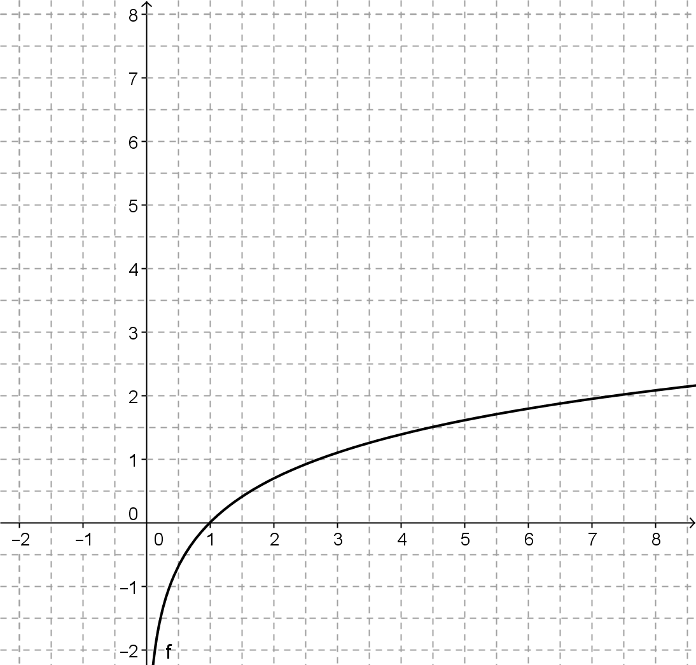

  - Construct the graph of $y=f^{-1}(x)$.
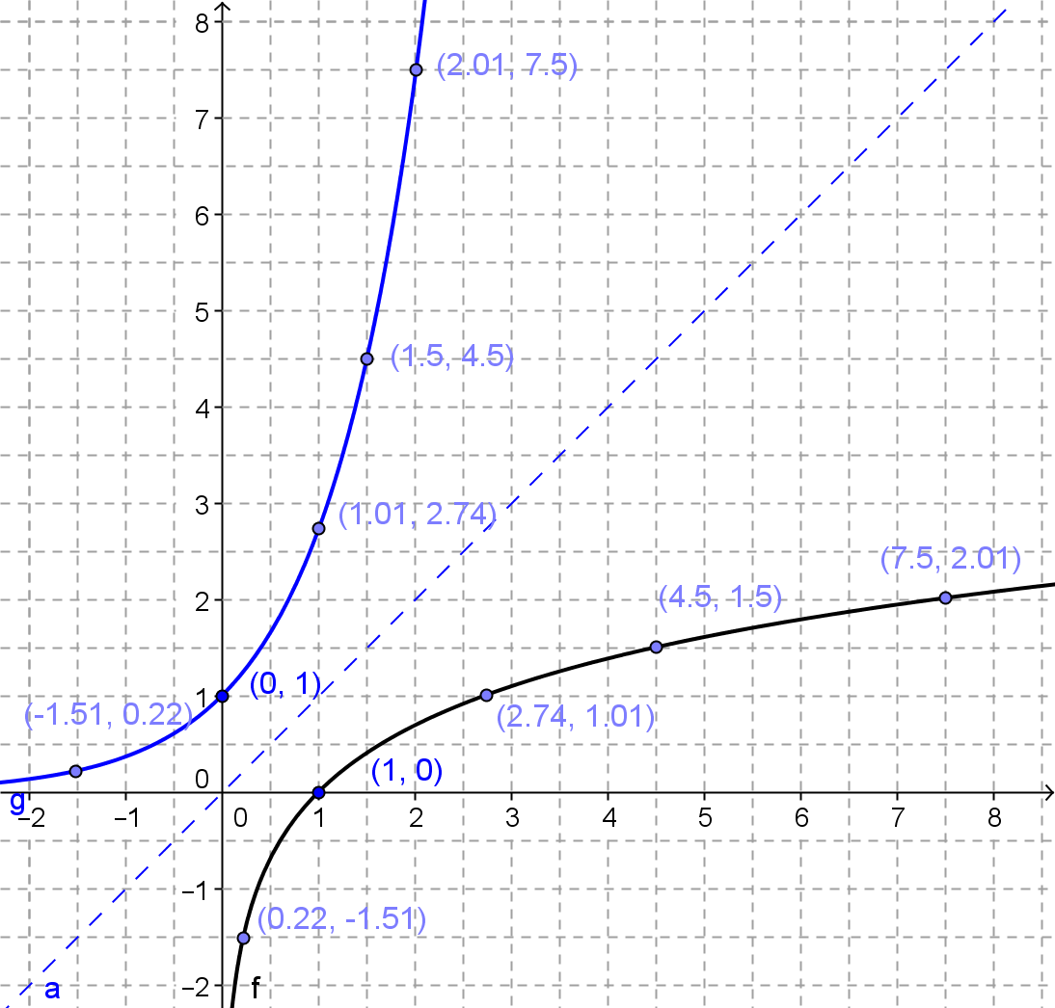

  - Estimate the base $b$ of these functions. Explain how you got your answer.
$f\left(b\right)=1$ gives a value for $b≈2.75$. Thus, the base appears to be about $2.75$ because $\log_{b}{b}=1$ for any base $b$. You can see on the exponential graph that $x$ is $1$, and the corresponding $y$-value is $2.75$.

The graph of the logarithmic function provided in the student materials is the graph of $y=ln(x)$, and the graph of the solution shown above is the graph of $y=e^{x}$. Do not share this information with your students yet; they will investigate the base of these two functions in the next few exercises by comparing the value of $e$ from their calculators with the base they estimated in Exercise 6 part (b). Then they will graph the functions $y=e^{x}$ and $y=ln(x)$ on their calculators and graph the composition of these two functions, which is $y=x$.
If access to technology is limited in your classroom, the next four exercises can be done as a demonstration. After each exercise, allow time for students to respond to and process what they are seeing as you demonstrate the problems on a graphing calculator or using other graphing technology. Have them share their responses with a partner or small group before discussing the answers with the whole class.
The information below is provided for additional teacher background information or as an extension to this lesson.

You can also estimate the value of $e$ using a series. The number $e$ is equivalent to the infinite series shown below. This formula comes from the Maclaurin Series for $e^{x}$ that students will see if they continue on to study calculus. If your students are unfamiliar with the factorial notation, briefly introduce it. By summing the first several terms of this series, you can get an estimate for the value of $e$.
An infinite series can be used to define the irrational number.
$$e=1+1+\frac{1}{2} +\frac{1}{6}+\frac{1}{24}+…+\frac{1}{n!}+…$$
where $n$ is a whole number.
Note: For positive integers $n$, the value of $n$ factorial denoted $n!$ is $n\left(n-1\right)\left(n-2\right)\left(n-3\right)…(1)$. Thus, $3!=3∙2∙1=6$, and $5!=5∙4∙3∙2∙1=120$.
In the series above, since $n$ is a whole number, the first term would be $\frac{1}{0!}$ which is equal to $1$ because $0!$ is defined to be $1$. Interestingly, $1!$ is also equal to $1$.
To approximate $e$ using this series on a graphing calculator, students can quickly generate a table of values for the first $n$ terms of this series equal to $e$ by typing in
$Y1=sum(seq(1/X!,X,0,X,1))$ into a graphing calculator and viewing the values of $Y1$ in the table feature of the calculator.

- Use a calculator to get a very accurate estimate of irrational number $e$.
On the calculator, $e≈2.71828182846$.

- Is the graph of $y=f^{-1}(x)$ in Exercise 6 a good approximation of the function $g\left(x\right)=e^{x}$? Explain your reasoning.
Scaffolding:
For struggling learners, create a summary chart of the properties of logarithms and exponents that can be found in Algebra II Module 3 Lesson 4 and Lesson 12.
Provide fluency practice with rewriting expressions using the properties. You can use a rapid white board technique to do this. Work on expanding expressions (e.g., $\log\left(\frac{2x}{x-1}\right)=\log\left(2\right)+\log\left(x\right)-log(x-1)$) as well as condensing expressions
(e.g., ${\left(2^{3}∙2^{x}\right)}^{2}=2^{6+2x}$).
We estimated that the base was $2.75$, so it is close to the value of $e$.

- Show that $f(x)=ln(x)$ and $g(x)=e^{x}$ are inverse functions by graphing $y=f(g\left(x\right))$ and $y=g(f\left(x\right))$ on a graphing calculator. Explain how your graphs support the fact that these two functions are indeed inverses of one another.
When graphed, the graphs of $y=f(g\left(x\right))$ and $y=g(f\left(x\right))$ are the same as the graph of $y=x$ for all values of $x$.

On a graphing calculator, if students enter the following into $xY =$ x
$$Y1=ln(x)$$
$$Y2=e^(x)$$
$$Y3=Y1(Y2(x))$$
$$Y4=Y2(Y1(x))$$

and then graph these equations, they will see that the graphs of $Y3$ and $Y4$ are the graph of the equation $y=x$, which verifies by composition that these two functions are inverses of one another.

- What is the base of the natural logarithm function $f\left(x\right)=ln(x)$? Explain how you know.
Based on the results of Exercise 9, we can conclude that the base of the natural logarithm function is the irrational number $e$.

Exercises 11–12 (10 minutes)
In these problems, students work with exponential and logarithmic functions to algebraically find a formula for the inverse of each function. Exercise 12 asks them to verify by graphing that the functions are inverses. If access to technology is limited, take time to model different solutions as a whole class. Be sure to demonstrate at least one incorrect response so students can see that the reflection property does not hold.
The same process we used to algebraically find the inverse of a function in Lessons 18 and 19 can be applied to find the inverses of exponential and logarithmic functions.
- How is this definition similar to the definition of inverse functions?
  - They both involve switching the $x$ and the $y$ in a way.

- Find the inverse of each function.
  - $f\left(x\right)=2^{x-3}$
$$y=2^{x-3} \\ x=2^{y-3} \\ \log_{2}\left(x\right)=y-3 \\ y=3+\log_{2}{(x)} \\ f^{-1}\left(x\right)=3+\log_{2}{(x)}$$

  - $g\left(x\right)=2log(x-1)$
$$y=2log(x-1) \\ x=2\log\left(y-1\right) \\ \frac{x}{2}=\log\left(y-1\right) \\ 10^{\frac{x}{2}}=y-1 \\ y=10^{\frac{x}{2}}+1 \\ g^{-1}\left(x\right)=10^{\frac{x}{2}}+1$$

  - $h\left(x\right)=\ln\left(x\right)-ln(x-1)$
$$y=\ln\left(x\right)-\ln\left(x-1\right) \\ x=\ln\left(y\right)-\ln\left(y-1\right) \\ x=\ln\left(\frac{y}{y-1}\right) \\ e^{x}=\frac{y}{y-1} \\ e^{x}\left(y-1\right)=y \\ e^{x}y-y=e^{x} \\ y\left(e^{x}-1\right)=e^{x} \\ y=\frac{e^{x}}{e^{x}-1} \\ h^{-1}\left(x\right)=\frac{e^{x}}{e^{x}-1}$$

  - $k\left(x\right)=5-3^{-\frac{x}{2}}$
$$y=5-3^{-\frac{x}{2}} \\ x=5-3^{-\frac{y}{2}} \\ 5-x=3^{-\frac{y}{2}} \\ \log_{3}{(5-x)}=-\frac{y}{2} \\ -2\log_{3}\left(5-x\right)=y \\ k^{-1}\left(x\right)=-2\log_{3}{(5-x)}$$

- Check your solutions to Exercise 11 by graphing the functions and the inverses that you found and verifying visually that the reflection property holds.
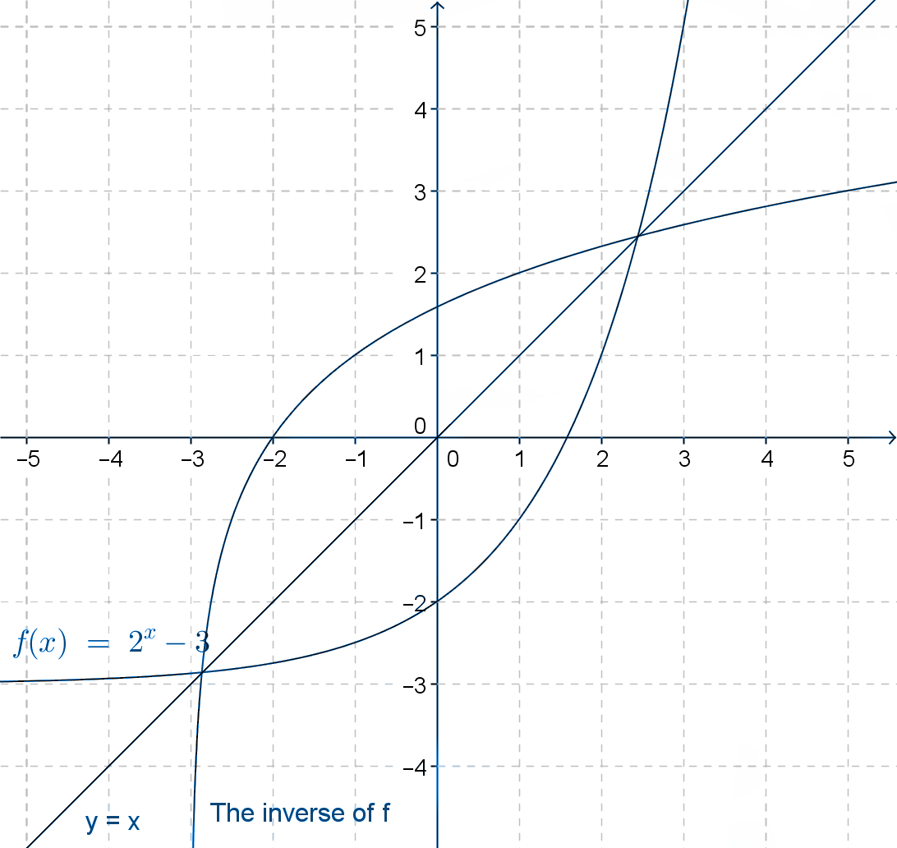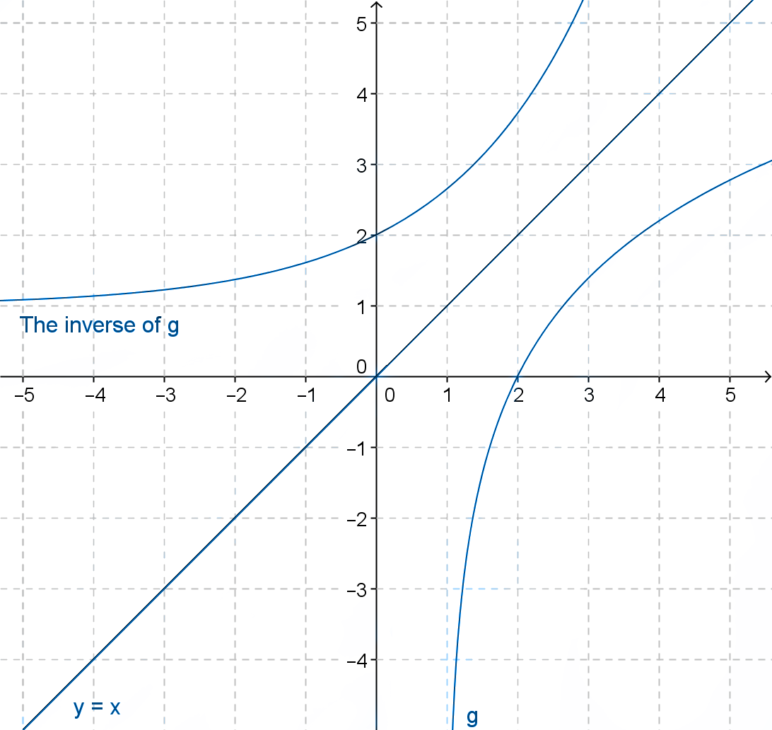
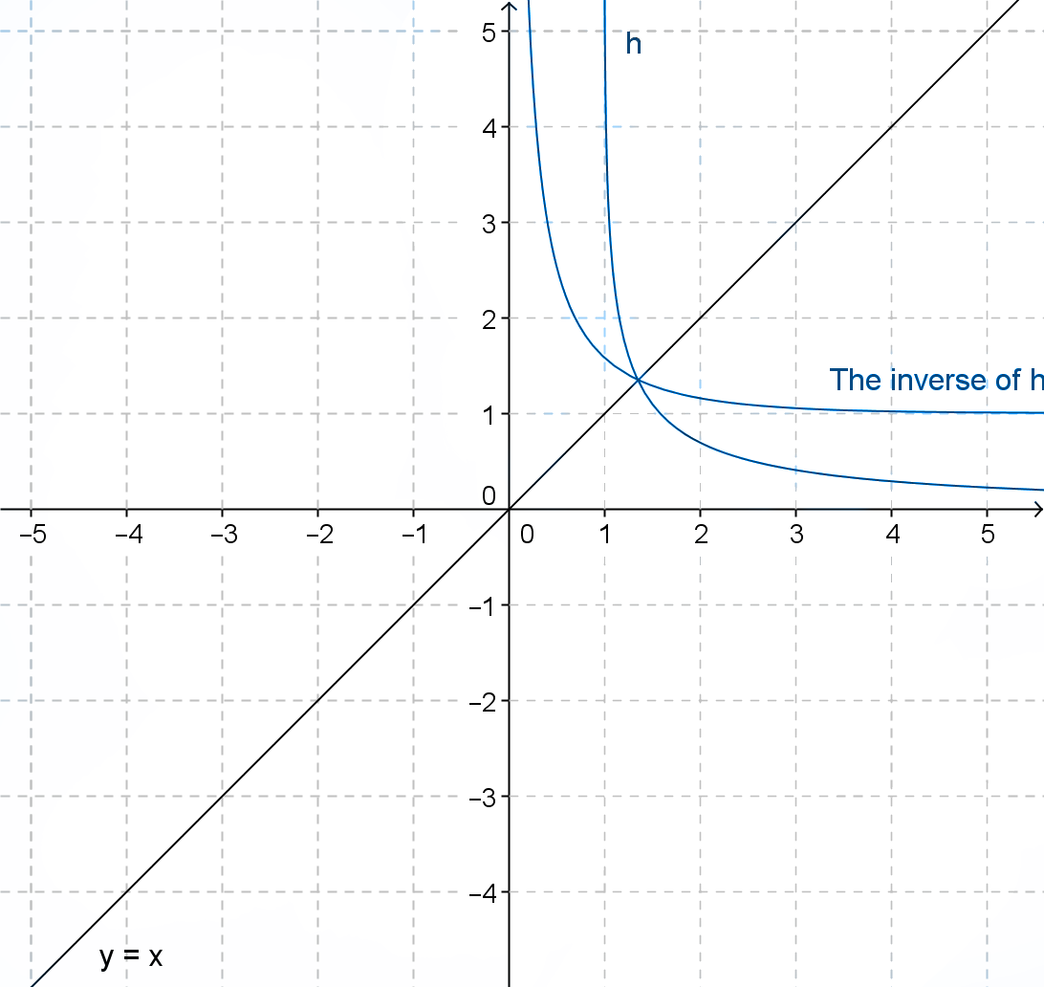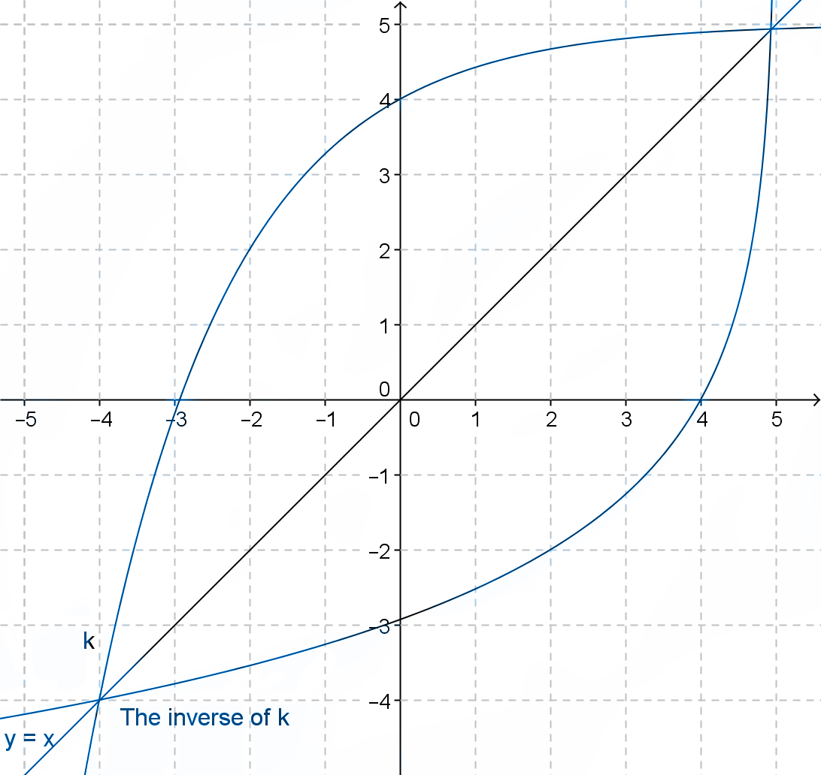

Students should use technology to check the graphs in Exercise 12. If none is available, have them check their solutions by selecting a few values of $x$ and finding the corresponding range element $y$ and then showing that if $(x,y)$ is on the graph of the function, then $(y,x)$ would be on the graph of the inverse.

Closing (3 minutes)
To close this lesson, have students respond in writing or with a partner to the questions below.
- Explain using concepts of inverse functions why $b^{\log_{b}{(x)}}=x$ and $\log_{b}{(b^{x})}=x$.
  - Since the functions $f\left(x\right)=b^{x}$ and $g\left(x\right)=\log_{b}{(x)}$ are inverses of one another, when you compose them you will simply get $x$. The identities above represent the composition of these functions, and due to the inverse nature of logarithms and exponents, the resulting composition of the two functions will be equal to $x$.
- Explain why all exponential functions of the form $f\left(x\right)=b^{x}$ are invertible.
  - These functions have exactly one $y$-value for each $x$-value, so when the domain and range sets are exchanged, the inverses will also have exactly one $x$-value in the domain for each $y$-value in the range and, therefore, will be a function without having to restrict the domain and range of the original function.
- Explain why all logarithmic functions of the form $f\left(x\right)=\log_{b}{(x)}$ are invertible.
  - These functions have exactly one $y$-value for each $x$-value, so when the domain and range sets are exchanged, the inverses will also have exactly one $x$-valuein the domain for each $y$-value in the range and, therefore, will be a function without having to restrict the domain and range of the original function.
Review relevant vocabulary as needed before starting the Exit Ticket.

Exit Ticket (5 minutes)

Name Date
Lesson 20: Inverses of Logarithmic and Exponential Functions

Exit Ticket

- Find the inverse of each function.
  - $f\left(x\right)=\log_{2}\left(x\right)+2$

  - $g\left(x\right)=e^{x-4}$

  - $h\left(x\right)=3\log{(2+3x)}$

- Verify by composition that the given functions are inverses.
  - $f\left(x\right)=2-\log\left(3y+2\right); g\left(x\right)=\frac{1}{3}(100⋅{10}^{-x}-2)$

  - $f\left(x\right)=\ln\left(x\right)-\ln\left(x+1\right); g\left(x\right)=\frac{e^{x}}{1-e^{x}}$

Exit Ticket Sample Solutions

- Find the inverse of each function.
  - $f\left(x\right)=\log_{2}\left(x\right)+2$
$$f^{-1}\left(x\right)=2^{x-2}$$

  - $g\left(x\right)=e^{x-4}$
$$g^{-1}\left(x\right)=\ln{(x)}+4$$

  - $h\left(x\right)=3\log{(2+3x)}$
$$h^{-1}\left(x\right)=\frac{1}{3}\left(10^{\frac{x}{3}}-2\right)$$

- Verify by composition that the given functions are inverses.
  - $f\left(x\right)=2-\log\left(3x+2\right); g\left(x\right)=\frac{1}{3}(100⋅{10}^{-x}-2)$
$$f\left(g\left(x\right)\right)=f\left(\frac{1}{3}\left(100⋅10^{-x}-2\right)\right) \\ =2-\log\left(3\left(\frac{1}{3}\left(100⋅10^{-x}-2\right)\right)+2\right) \\ =2-\log\left(100⋅10^{-x}-2+2\right) \\ =2-\log\left(10^{2-x}\right) \\ =2-\left(2-x\right) \\ =x$$
$$g\left(f\left(x\right)\right)=\frac{1}{3}\left(100⋅10^{-\left(2-\log\left(3x+2\right)\right)}-2\right) \\ =\frac{1}{3}\left(100⋅\frac{3x+2}{100}-2\right) \\ =\frac{1}{3}\left(3x+2-2\right) \\ =\frac{1}{3}\left(3x\right) \\ =x$$

  - $f\left(x\right)=ln(x)-ln(x+1); g\left(x\right)=\frac{e^{x}}{1-e^{x}}$
$$f\left(g\left(x\right)\right)=\ln\left(\frac{e^{x}}{1-e^{x}}\right)-\ln\left(\frac{e^{x}}{1-e^{x}}+1\right) \\ =\ln\left(e^{x}\right)-\ln\left(1-e^{x}\right)-\ln\left(\frac{e^{x}}{1-e^{x}}+\frac{1-e^{x}}{1-e^{x}}\right) \\ =x-\ln\left(1-e^{x}\right)-\ln\left(\frac{1}{1-e^{x}}\right) \\ =x-\ln\left(1-e^{x}\right)-\ln\left(1\right)+\ln\left(1-e^{x}\right) \\ =x$$
Note that $f\left(x\right)=\ln\left(\frac{x}{x+1}\right)$.
$$g\left(f\left(x\right)\right)=\frac{e^{\ln\left(\frac{x}{x+1}\right)}}{1-e^{\ln\left(\frac{x}{x+1}\right)}} \\ =\frac{\frac{x}{x+1}}{1-\frac{x}{x+1}} \\ =\frac{\frac{x}{x+1}}{\frac{x+1}{x+1}-\frac{x}{x+1}} \\ =\frac{\frac{x}{x+1}}{\frac{1}{x+1}} \\ =\frac{x}{x+1}⋅\frac{x+1}{1} \\ =x$$

Problem Set Sample Solutions
Note that any exponential function’s inverse can be described in terms of the natural logarithm or the common logarithm. Depending on how students like to solve exponential functions, any answer involving logarithms can be expressed in a different base.

- Find the inverse of each function.
  - $f\left(x\right)=3^{x}$
$$f^{-1}\left(x\right)=\log_{3}{(x)}$$

  - $f\left(x\right)={\left(\frac{1}{2}\right)}^{x}$
$$f^{-1}\left(x\right)=\log_{0.5}\left(x\right)$$
Or students may rewrite this as $f\left(x\right)=2^{-x}$and then exchange $x$ and $y$ and solve for $y$ getting $f^{-1}\left(x\right)=-\log_{2}{(x)}$.

  - $g\left(x\right)=\ln{(x-7)}$
$$g^{-1}\left(x\right)=e^{x}+7$$

  - $h\left(x\right)=\frac{\log_{3}\left(x+2\right)}{\log_{3}\left(5\right)}$
By rewriting using the change of base property, $h\left(x\right)=\log_{5}\left(x+2\right)$, so
$h^{-1}\left(x\right)=5^{x}-2$.

  - $f\left(x\right)=3{\left(1.8\right)}^{0.2x}+3$
$$f^{-1}\left(x\right)=5\log_{(1.8)}\left(\frac{x-3}{3}\right)$$

  - $g\left(x\right)=\log_{2}\left(\sqrt[3]{x-4}\right)$
$$g^{-1}\left(x\right)={\left(2^{x}\right)}^{3}+4 \\ =2^{3x}+4$$

  - $h\left(x\right)=\frac{5^{x}}{5^{x}+1}$
$$x\left(5^{y}+1\right)=5^{y} \\ x⋅5^{y}+x=5^{y} \\ x⋅5^{y}-5^{y}=-x \\ 5^{y}\left(x-1\right)=-x \\ 5^{y}=-\frac{x}{x-1} \\ h^{-1}\left(x\right)=\log_{5}\left(-\frac{x}{x-1}\right)$$

  - $f\left(x\right)=2^{-x+1}$
$$f^{-1}\left(x\right)=-\log_{2}{(x)}+1$$

  - $g\left(x\right)=\sqrt{\ln\left(3x\right)}$
$$g^{-1}\left(x\right)=\frac{1}{3}e^{\left(x^{2}\right)}$$

  - $h\left(x\right)=e^{\frac{1}{5}x+3}-4$
$$h^{-1}\left(x\right)=5\ln\left(x+4\right)-15$$

- Consider the composite function $f∘g$, composed of invertible functions $f$ and $g$.
  - Either $f^{-1}∘g^{-1}$ or $g^{-1}∘f^{-1}$ is the inverse of the composite function. Which one is it? Explain.
$g^{-1}∘f^{-1}$ is the inverse of the composite function. In this order, the $g$ and $g^{-1}$ will match up, or the $f$ and $f^{-1}$ will match up.

  - Show via composition of functions that your choice of ${\left(f∘g\right)}^{-1}$ was the correct choice. (Hint: function composition is associative.)
$$\left(g^{-1}∘f^{-1}\right)∘\left(f∘g\right)=g^{-1}∘\left(f^{-1}∘f\right)∘g \\ =g^{-1}∘g$$
$$\left(f∘g\right)∘\left(g^{-1}∘f^{-1}\right)=f∘\left(g∘g^{-1}\right)∘f^{-1} \\ =f∘f^{-1}$$
Each time we were able to group the base functions and their inverses together, the result is the identity function. Alternatively, we could have applied the functions to a point $x$ and used the same argument to have a final result of $x$.

- Let $m\left(x\right)=\frac{x}{x-1}$.
  - Find the inverse of $m$.
$$x=\frac{y}{y-1} \\ x\left(y-1\right)=y \\ xy-x=y \\ xy-y=x \\ y\left(x-1\right)=x \\ y=\frac{x}{x-1}$$
The function is its own inverse.

  - Graph $m$. How does the graph of $m$ explain why this function is its own inverse?
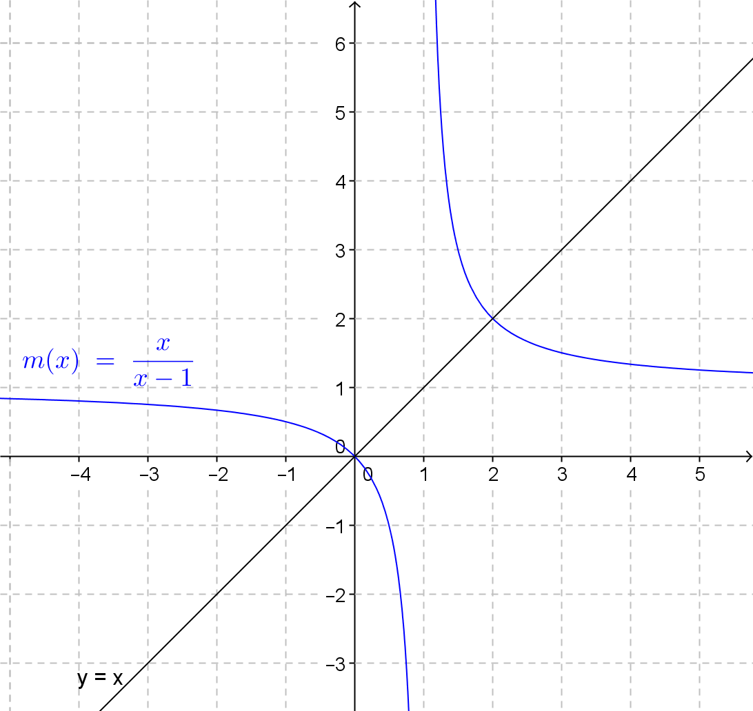

Each point on the graph of $m$ will reflect to another point on the graph of $m$ when reflected about the
line $y=x$.

  - Think of another function that is its own inverse.
$f\left(x\right)=\frac{1}{x}$ has this same reflective property.

Extension
- One of the definitions of $e$ involves the infinite series $1+1+\frac{1}{2}+\frac{1}{6}+\frac{1}{24}+⋯+\frac{1}{n!}+⋯$. A generalization exists to define $e^{x}:$
$$e^{x}=1+x+\frac{x^{2}}{2}+\frac{x^{3}}{6}+\frac{x^{4}}{24}+⋯+\frac{x^{n}}{n!}+⋯$$This series definition of $e^{x}$ allows us to approximate powers of the transcendental number $e$ using strictly rational numbers. This definition is accurate for all real numbers.
  - Verify that the formula given for $e$ can be obtained by plugging in $x=1$ into the formula for $e^{x}$.
$$e^{1}=1+\left(1\right)+\frac{{\left(1\right)}^{2}}{2}+\frac{{\left(1\right)}^{3}}{6}+\frac{{\left(1\right)}^{4}}{24}+⋯+\frac{{\left(1\right)}^{n}}{n!}+⋯$$
  - Use the first seven terms of the series to calculate $e$, $e^{2}$, and $e^{3}$.
$$e≈1+1+\frac{1^{2}}{2}+\frac{1^{3}}{6}+\frac{1^{4}}{24}+\frac{1^{5}}{120}+\frac{1^{6}}{720}=2.7180\overline{5}$$
$$e^{2}≈1+2+\frac{2^{2}}{2}+\frac{2^{3}}{6}+\frac{2^{4}}{24}+\frac{2^{5}}{120}+\frac{2^{6}}{720}=6.3\overline{5}$$
$$e^{3}≈1+3+\frac{3^{2}}{2}+\frac{3^{3}}{6}+\frac{3^{4}}{24}+\frac{3^{5}}{120}+\frac{3^{6}}{720}=17.1625$$

  - Use the inverse of $y=e^{x}$ to see how accurate your answer to part (b) is.
$$\ln{(6.3\overline{5})}≈1.849$$
$$\ln{(17.1625)}≈2.843$$

  - Newer calculators and computers use these types of series carried out to as many terms as needed to produce their results for operations that are not otherwise obvious. It may seem cumbersome to calculate these by hand knowing that computers can calculate hundreds and thousands of terms of these series in a single second. Use a calculator or computer to compare how accurate your results from part (b) were to the value given by your technology.
$$e^{2}≈7.389$$
$$e^{3}≈20.086$$
We were off by about $1\frac{1}{2}$ and by about $3$.

  - $ln\left(\frac{x}{x-1}\right)=\frac{1}{x}+\frac{1}{2x^{2}}+\frac{1}{3x^{3}}+\frac{1}{4x^{4}}+⋯+\frac{1}{nx^{n}}+⋯$ for $\left|x\right|>1$. What does your response to Exercise 3 part a tell you that $\ln{(x)}$ is equal to?
Since $y=\frac{x}{x+1}$ is its own inverse, you can compose it inside the logarithm to get $ln(x)$. That means substituting the expression $\frac{x}{x+1}$ for each $x$ in both sides of the equation will result in
$$ln\left(x\right)=\frac{1}{\frac{x}{x-1}}+\frac{1}{2{\left(\frac{x}{x-1}\right)}^{2}}+… \\ =\frac{1}{\frac{x}{x-1}}+\frac{1}{2}∙\frac{1}{{\left(\frac{x}{x-1}\right)}^{2}}+\frac{1}{3}∙\frac{1}{{\left(\frac{x}{x-1}\right)}^{3}}+…\frac{1}{n}∙\frac{1}{{\left(\frac{x}{x-1}\right)}^{n}}+… \\ =\frac{x-1}{x}+\frac{1}{2}{\left(\frac{x-1}{x}\right)}^{2}+⋯\frac{1}{n}{\left(\frac{x-1}{x}\right)}^{n}+⋯.$$

