Lesson 20: Inverses of Logarithmic and Exponential Functions

Classwork
Opening Exercise
Let $f\left(x\right)=2^{x}$.
  - Complete the table, and use the points $(x,f\left(x\right))$ to create a sketch of the graph of $y=f(x)$.
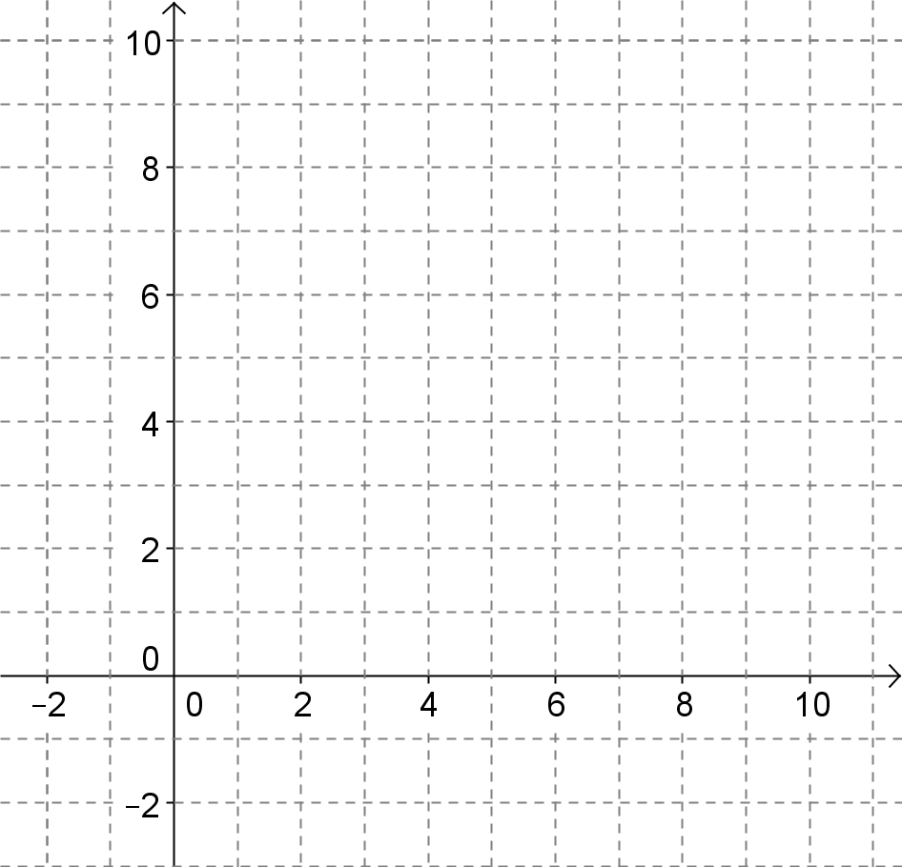
$$x$$ | $$f(x)$$
$$-2$$
$$-1$$
$$0$$
$$1$$
$$2$$
$$3$$

  - Create a table of values for the function $f^{-1}$, and sketch the graph of $y=f^{-1}(x)$ on the grid above.

  - What type of function is $f^{-1}$? Explain how you know.

Example 1
Given $f\left(x\right)=2^{x}$, use the definition of the inverse of a function and the definition of a logarithm to write a formula for $f^{-1}(x)$.

Exercises
- Find the value of $y$ in each equation. Explain how you determined the value of $y$.
  - $y=\log_{2}\left(2^{2}\right)$

  - $y=\log_{2}\left(2^{5}\right)$

  - $y=\log_{2}{(2^{-1})}$

  - $y=\log_{2}\left(2^{x}\right)$

- Let $f\left(x\right)=\log_{2}\left(x\right)$ and $g\left(x\right)=2^{x}$.
  - What is $f\left(g\left(x\right)\right)$?

  - Based on the results of part (a), what can you conclude about the functions $f$ and $g$?

- Find the value of $y$ in each equation. Explain how you determined the value of $y$?
  - $y=3^{\log_{3}{(3)}}$

  - $y=3^{\log_{3}\left(9\right)}$

  - $y=3^{\log_{3}\left(81\right)}$

  - $y=3^{\log_{3}{(x)}}$

- Let $f\left(x\right)=\log_{3}{(x)}$ and $g\left(x\right)=3^{x}$.
  - What is $g\left(f\left(x\right)\right)?$

  - Based on the results in part (a), what can you conclude about the functions $f$ and $g$?

- Verify by composition that the functions $f\left(x\right)=b^{x}$ and $g\left(x\right)=\log_{b}{(x)}$ for $b>0$ are inverses of one another.

- The graph of $y=f(x)$, a logarithmic function, is shown below.
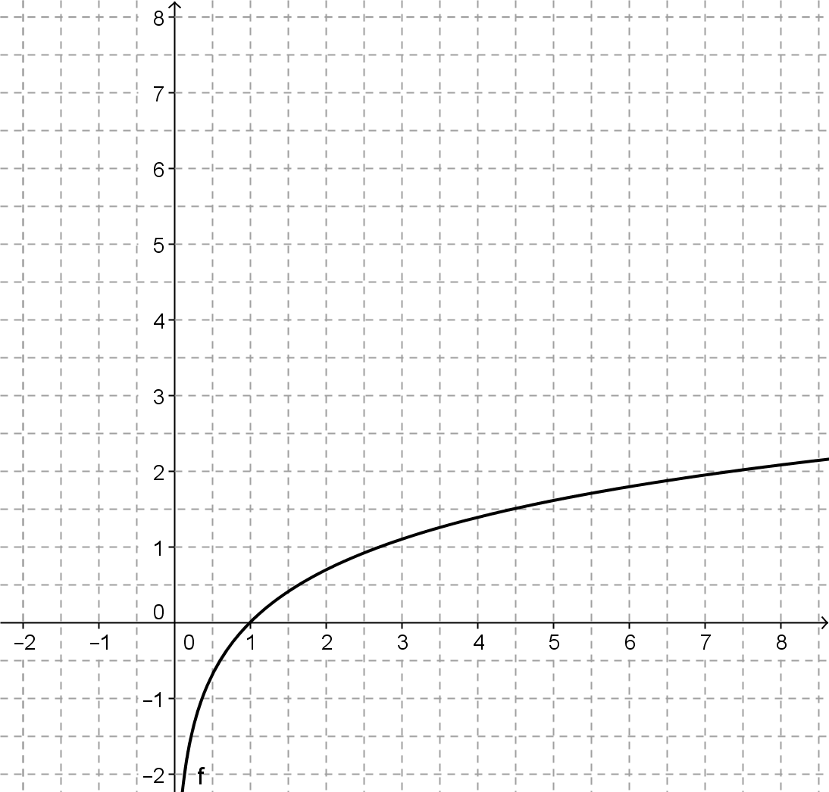

  - Construct the graph of $y=f^{-1}(x)$.

  - Estimate the base $b$ of these functions. Explain how you got your answer.

- Use a calculator to get a very accurate estimate of irrational number $e$.

- Is the graph of $y=f^{-1}(x)$ in Exercise 6 a good approximation of the function $g\left(x\right)=e^{x}$? Explain your reasoning.

- Show that $f(x)=ln(x)$ and $g(x)=e^{x}$ are inverse functions by graphing $y=f(g\left(x\right))$ and $y=g(f\left(x\right))$ on a graphing calculator. Explain how your graphs support the fact that these two functions are indeed inverses of one another.

- What is the base of the natural logarithm function $f\left(x\right)=ln(x)$? Explain how you know.

- Find the inverse of each function.
  - $f\left(x\right)=2^{x-3}$

  - $g\left(x\right)=2log(x-1)$

  - $h\left(x\right)=\ln\left(x\right)-ln(x-1)$

  - $k\left(x\right)=5-3^{-\frac{x}{2}}$

- Check your solutions to Exercise 11 by graphing the functions and the inverses that you found and verifying visually that the reflection property holds.

Problem Set

- Find the inverse of each function.
  - $f\left(x\right)=3^{x}$
  - $f\left(x\right)={\left(\frac{1}{2}\right)}^{x}$
  - $g\left(x\right)=\ln{(x-7)}$
  - $h\left(x\right)=\frac{\log_{3}\left(x+2\right)}{\log_{3}\left(5\right)}$
  - $f\left(x\right)=3{\left(1.8\right)}^{0.2x}+3$
  - $g\left(x\right)=\log_{2}\left(\sqrt[3]{x-4}\right)$
  - $h\left(x\right)=\frac{5^{x}}{5^{x}+1}$
  - $f\left(x\right)=2^{-x+1}$
  - $g\left(x\right)=\sqrt{\ln\left(3x\right)}$
  - $h\left(x\right)=e^{\frac{1}{5}x+3}-4$

- Consider the composite function $f∘g$, composed of invertible functions $f$ and $g$.
  - Either $f^{-1}∘g^{-1}$ or $g^{-1}∘f^{-1}$ is the inverse of the composite function. Which one is it? Explain.
  - Show via composition of functions that your choice of ${\left(f∘g\right)}^{-1}$ was the correct choice. (Hint: function composition is associative.)

- Let $m\left(x\right)=\frac{x}{x-1}$.
  - Find the inverse of $m$.
  - Graph $m$. How does the graph of $m$ explain why this function is its own inverse?
  - Think of another function that is its own inverse.

Extension
- One of the definitions of $e$ involves the infinite series $1+1+\frac{1}{2}+\frac{1}{6}+\frac{1}{24}+⋯+\frac{1}{n!}+⋯$. A generalization exists to define $e^{x}:$
$$e^{x}=1+x+\frac{x^{2}}{2}+\frac{x^{3}}{6}+\frac{x^{4}}{24}+⋯+\frac{x^{n}}{n!}+⋯$$This series definition of $e^{x}$ allows us to approximate powers of the transcendental number $e$ using strictly rational numbers. This definition is accurate for all real numbers.
  - Verify that the formula given for $e$ can be obtained by plugging in $x=1$ into the formula for $e^{x}$.
  - Use the first seven terms of the series to calculate $e$, $e^{2}$, and $e^{3}$.
  - Use the inverse of $y=e^{x}$ to see how accurate your answer to part (b) is.
  - Newer calculators and computers use these types of series carried out to as many terms as needed to produce their results for operations that are not otherwise obvious. It may seem cumbersome to calculate these by hand knowing that computers can calculate hundreds and thousands of terms of these series in a single second. Use a calculator or computer to compare how accurate your results from part (b) were to the value given by your technology.
  - $ln\left(\frac{x}{x-1}\right)$=$\frac{1}{x}+\frac{1}{2x^{2}}+\frac{1}{3x^{3}}+\frac{1}{4x^{4}}+⋯+\frac{1}{nx^{n}}+⋯$ for $\left|x\right|>1$. What does your response to Exercise 3 part (a) tell you that $\ln{(x)}$ is equal to?

