Lesson 19: Restricting the Domain

Student Outcomes
- Students continue to read the inverse values of a function from a table and graph. They create the inverse of a function by solving an equation of the form $f\left(x\right)=y$.
- Students verify that two functions are inverses by composing them.
- Students choose a suitable domain to create an invertible function.

Lesson Notes
In this lesson, students work with functions and their inverses represented numerically, graphically, and algebraically. Lesson 18 helped students recall the meaning of the inverse of a function and the properties of inverse functions. This lesson builds on student understanding by providing several exercises that require students to create the inverse of a function by reading values from a table or a graph (F-BF.B.4c). Students consider that not every function has an inverse that is also a function. They consider how to restrict the domain of a function to produce an invertible function
(F-BF.B.4d), setting the stage for the definition of the inverse trigonometric functions in Module 4. The lesson defines the adjective invertible as it applies to functions and provides practice for students to verify by composition that two functions are inverses (F-BF.B.4b).
Students should have access to graphing calculators or other graphing utilities during this lesson to aid their understanding.

Classwork
Scaffolding:
- Create an anchor chart to post on the wall that includes the key information from the Lesson Summary in the previous lesson.
- Lead a short discussion of inverses that students have studied in the past. For example, adding $3$ and subtracting $3$ undo each other. Transformations also undo each other, and students studied inverse matrices.

Opening Exercise (5 minutes)
Students should work this exercise independently and then compare answers with a partner. As you circulate about the classroom, notice whether you will need to reteach any concepts or vocabulary relating to functions and their inverses.
Students may need to be reminded that a function can be a simple mapping that assigns each element in the domain to a corresponding element in the range. The function $f$ shown below pairs each element in the domain set with one element in the range.
Opening Exercise
The function $f$ with domain $\left\{1,2,3,4,5\right\}$ is shown in the table below.
$$x$$ | $$f(x)$$
$$1$$ | $$7$$
$$2$$ | $$3$$
$$3$$ | $$1$$
$$4$$ | $$9$$
$$5$$ | $$5$$

  - What is $f(1)$? Explain how you know.
$f\left(1\right)=7$. The table shows how the domain values and range values correspond for this function.

  - What is $f^{-1}\left(1\right)?$ Explain how you know.
$f^{-1}\left(1\right)=3$. Since this is the inverse function, the range values of $f$ are the domain values of $f^{-1}$.

  - What is the domain of $f^{-1}$? Explain how you know.
The domain of $f^{-1}$is the range of $f,$ so the domain of $f^{-1}$ is the set of numbers $\left\{1,3,5,7,9\right\}$.

  - Construct a table for the function $f^{-1},$ the inverse of $f$.
$$x$$ | $$f^{-1}(x)$$
$$1$$ | $$3$$
$$3$$ | $$2$$
$$5$$ | $$5$$
$$7$$ | $$1$$
$$9$$ | $$4$$

Exercises 1–5 (10 minutes)
After debriefing the Opening Exercise, have students continue to work in small groups on the next set of problems. If students are struggling to complete the mapping diagrams, you can model how to complete the first row as a whole class. Students may need a reminder about the operation of function composition. The function machine analogy is helpful for problems like these. Notice that the composite machine for a function and its inverse takes you back to the original domain values. Later in the lesson, students will algebraically verify that one function is the inverse of another using function composition.
Exercises 1–9
- Complete the mapping diagram to show that $f\left(f^{-1}\left(x\right)\right)=x$.
Domain Range
$$f^{-1}$$
$$1 \\ 3 \\ 5 \\ 7 \\ 9$$

$$3 \\ 2 \\ 5 \\ 1 \\ 4$$

$$f$$
$$3 \\ 2 \\ 5 \\ 1 \\ 4$$

$$1 \\ 3 \\ 5 \\ 7 \\ 9$$

Domain Range
- Complete the mapping diagram to show that $f^{-1}\left(f\left(x\right)\right)=x$.
Domain Range
$$f$$
$$1 \\ 2 \\ 3 \\ 4 \\ 5$$

$$7 \\ 3 \\ 1 \\ 9 \\ 5$$

$$f^{-1}$$
$$7 \\ 3 \\ 1 \\ 9 \\ 5$$

$$1 \\ 2 \\ 3 \\ 4 \\ 5$$

Domain Range

These next three exercises give students an opportunity to read values of an inverse function from a graph. Students also understand that the domain and range matter when creating the inverse of a function. Students may choose to graph the inverse by simply exchanging the $x$- and $y$-values of coordinates of points on the graph. They should also consider reflecting points across the line $y=x$. Be sure to discuss both approaches when debriefing these exercises.

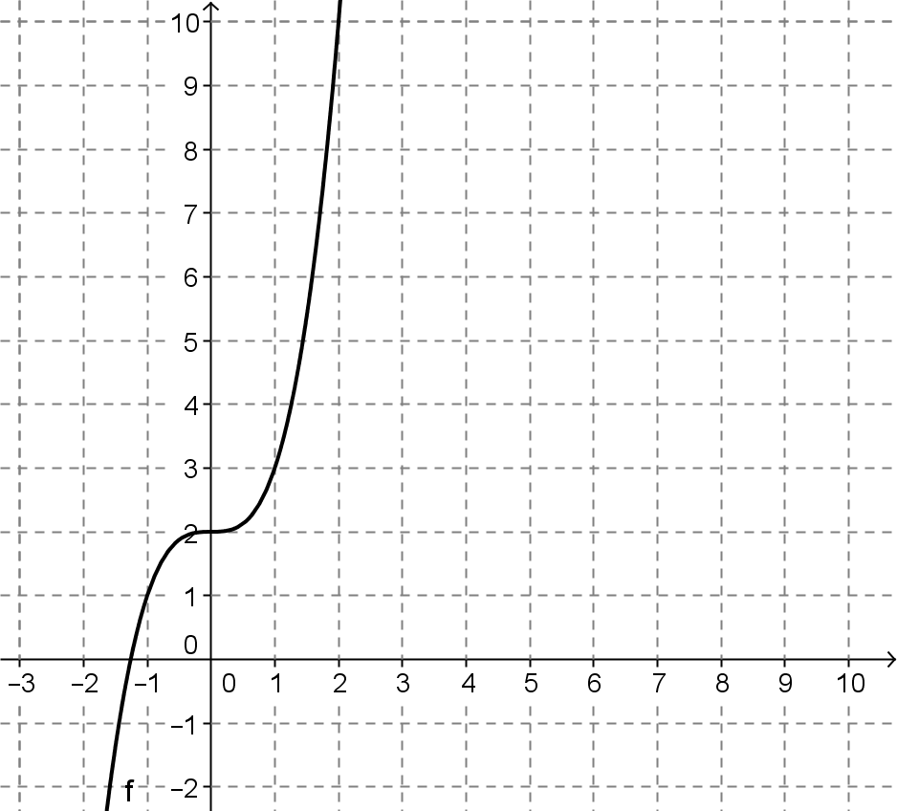
- The graph of $f$ is shown below.

  - Select several ordered pairs on the graph of $f,$ and use those to construct a graph of $f^{-1}$.
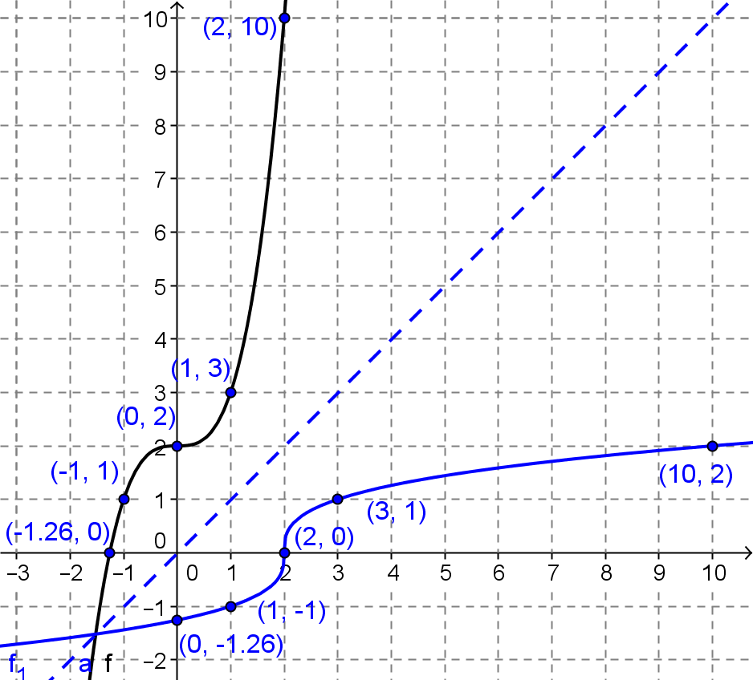
  - Draw the line $y=x$, and use it to construct the graph of $f^{-1}$ below.

  - The algebraic function for $f$ is given by $f\left(x\right)=x^{3}+2$. Is the formula for $f^{-1}\left(x\right)=\sqrt[3]{x}-2$? Explain why or why not.
MP.3
No. The formula for $f^{-1}$ is not correct because you don’t get $0$ when you substitute $2$ into the formula for $f^{-1}$. The correct formula would be $f^{-1}\left(x\right)=\sqrt[3]{x-2}$.

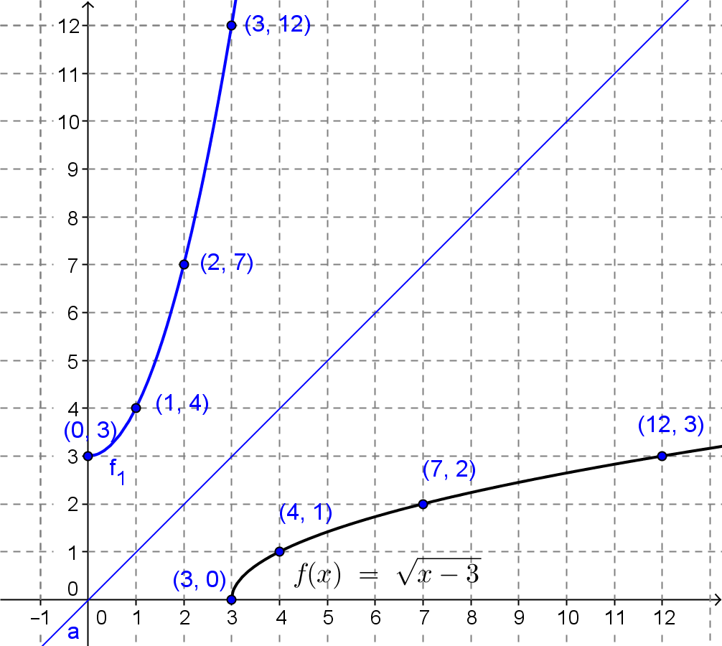
- The graph of $f\left(x\right)=\sqrt{x-3}$ is shown below. Construct the graph of $f^{-1}$.
- Morgan used the procedures learned in Lesson 18 to define $f^{-1}\left(x\right)=x^{2}+3$. How does the graph of this function compare to the one you made in Exercise 5?
The graph of Morgan’s function,$f^{-1}\left(x\right)=x^{2}+3$, is the inverse graph that we drew in Exercise 5. It has a domain that is assumed to be all real numbers. However, the inverse of $f$ must have a domain equal to the range of $f$, which is $f\left(x\right)≥0$. Thus, the inverse’s domain is not all real numbers but is instead restricted to $x≥0$. The graphs of these functions are identical for $x≥0$.

Discussion (5 minutes)
Lead a discussion as students share their thinking about Exercise 5. Many students will not consider that we would assume the domain of a function is all real numbers unless we specify otherwise. In order to define the function that is the inverse of $f$, we must use the range of $f$ for the inverse’s domain. Emphasize the importance of precise descriptions of the domain and range and why those are required by the definition of the inverse of a function given in Lesson 18.
- When we create the inverse of a function, the domain and range are exchanged. What are the domain and range of $f?$
  - The domain is $x≥3$, and the range is $f(x)≥0$.
- What would be the domain and range of $f^{-1}?$
  - The domain of $f^{-1}$would be the range of $f,$ so the domain of $f^{-1}$ is $x≥0$. The range of $f^{-1}$would be the domain of $f,$ so the range of $f^{-1}$is $f(x)≥3$.
- We cannot define the inverse of $f$ algebraically without specifying its domain. The domain of $f^{-1}$ is the range of $f$. Therefore, the domain of $f^{-1}$ is $\left[0,∞\right].$
- How would you define $f^{-1}$ for Exercise 5 algebraically?
MP.6
&
MP.3
  - $f^{-1}\left(x\right)=x^{2}+3, x≥0$
- Do you suppose that every function has an inverse that is a function? Explain your reasoning.
  - If you reflected the graph of $f\left(x\right)=x^{2}+3$ across the line $y=x$ without restricting its domain, the points on the resulting graph would not meet the definition of a function.
- In your own words, how do you define a function?
  - Each element in the domain can be paired with only one element in the range.
- Can you think of an example of a function that, when we exchange the domain and the range, would create a mathematical relationship that is not a function?
  - If we started with $y=x^{2}$ whose graph corresponds to the graph of $f\left(x\right)=x^{2}$, then points on the graph of $x=y^{2}$ would NOT define a function. For example, $\left(1,1\right)$ and $(1,-1)$ satistfy the equation $x=y^{2}$ but could not meet the definition of a function since the domain element $1$ is paired with two range elements, $1$ and $-1$.

Exercises 6–8 (10 minutes)
The next exercises give students an opportunity to process the discussion by practicing with functions that are NOT invertible. In Exercise 7, students begin to distinguish between invertible and non-invertible functions. In Lesson 10, we introduced students to the notion of a well-defined function as one that has a unique output for each input in the domain. Some books define these types of functions as one-to-one functions or strictly increasing or decreasing functions. These type of functions are invertible because there will never be a domain value paired with more than one range value. Typical high school texts often refer to a vertical line test, which is used to determine whether a relation is a function, and a horizontal line test, which is used to determine whether a graph has an inverse that is also a function. This curriculum does not define either line test because the standards do not define relations formally. It may be tempting to help students by providing these tips or memory devices, but often they end up confusing students more than helping them. If you use these line tests, be sure to have students explain why the vertical or horizontal lines helped them to determine whether a graph represented a function or whether the inverse of a function represented graphically would also be a function.

- Construct the inverse of the function $f$ given by the table below. Is the inverse a function? Explain your reasoning.
$$x$$ | $$-3$$ | $$-2$$ | $$-1$$ | $$0$$ | $$1$$ | $$2$$ | $$3$$
$$f(x)$$ | $$4$$ | $$-1$$ | $$-4$$ | $$-5$$ | $$-4$$ | $$-1$$ | $$4$$

$$x$$ | $$4$$ | $$-1$$ | $$-4$$ | $$-5$$ | $$-4$$ | $$-1$$ | $$4$$
Inverse of $f$ | $$-3$$ | $$-2$$ | $$-1$$ | $$0$$ | $$1$$ | $$2$$ | $$3$$
No, the inverse is not a function. Each element in the domain must have only one element in the range assigned to it. You can see that the number $4$ is paired with $-3$ and $3$.

- A function is said to be invertible if its inverse is also a function. Can you think of a quick way to tell whether a function is invertible?
  - If an input value has two or more output values associated with it, then its inverse will not be a function. This is easy to see when the function is graphed because you can look across the graph and see if two or more inputs give you the same output.

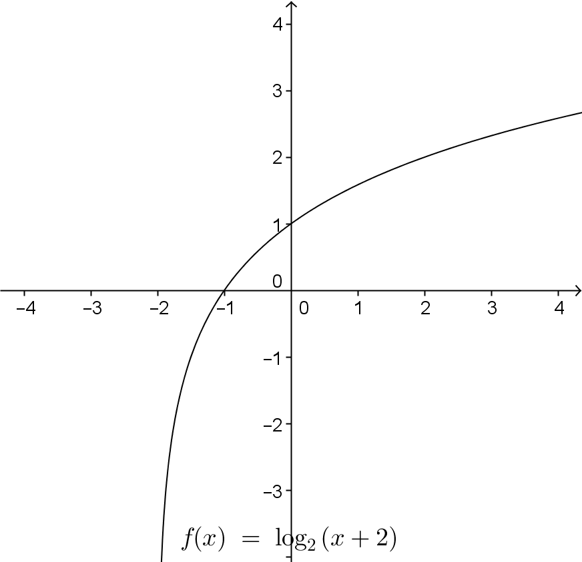
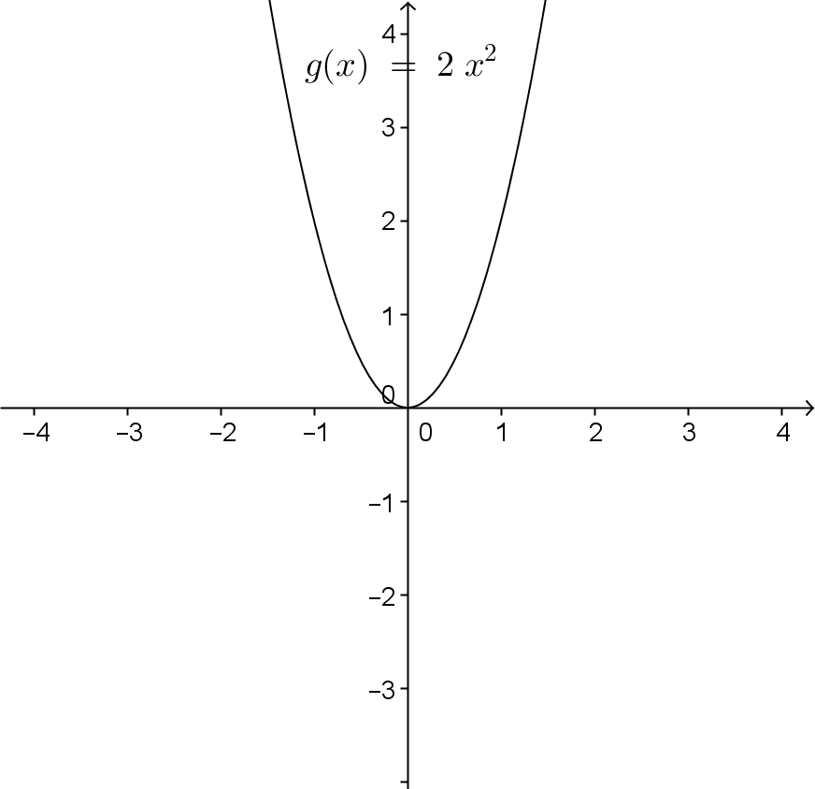
- The graphs of several functions are shown below. Which ones are invertible? Explain your reasoning.
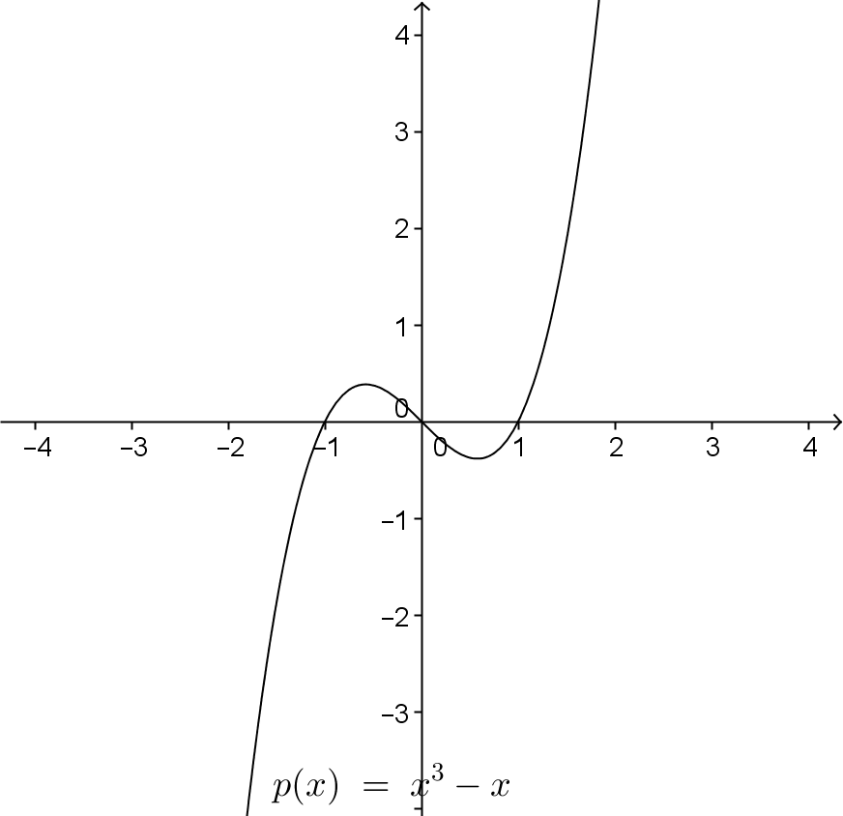
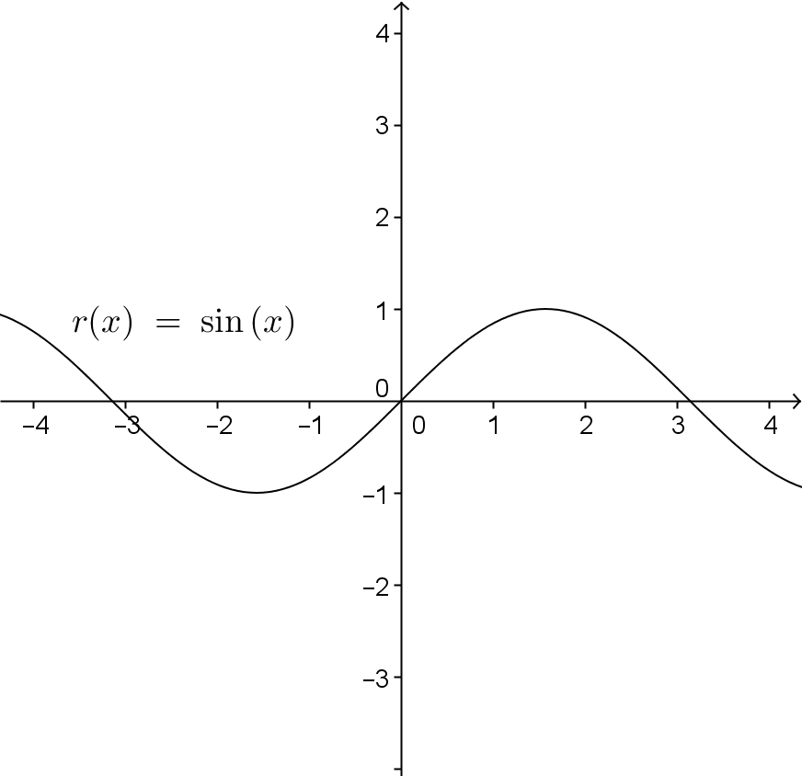
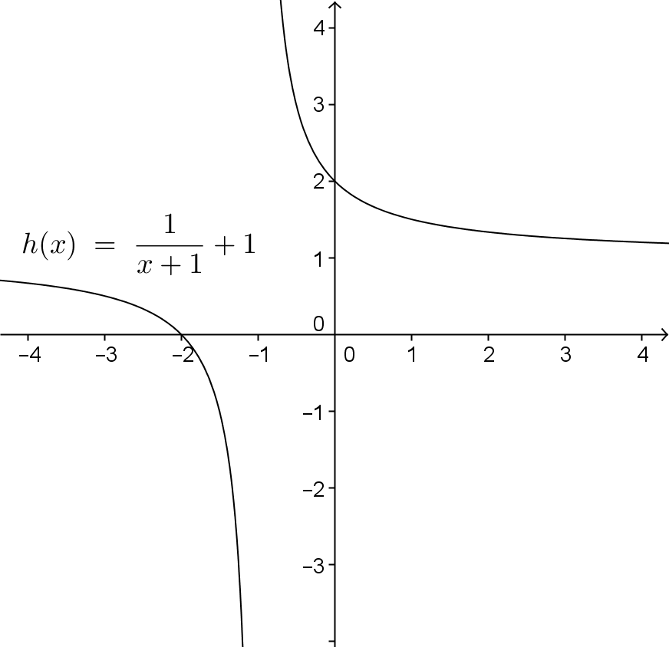
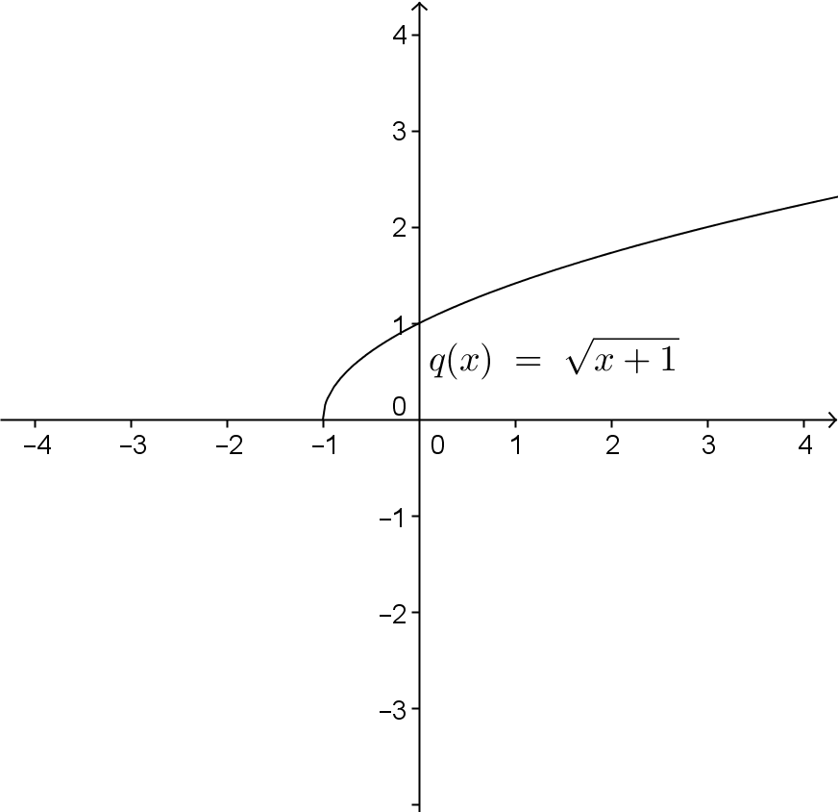
The functions $g$, $p$, and $r$ are not invertible. You can see that multiple elements of the domain are paired with a single range element. When the domain and range are exchanged to form the inverse, the result will not satisfy the definition of a function.

Exercise 8 may provide a challenge for some students. This exercise requires students to select a suitable domain for a function that will make it an invertible function and to create the inverse of the function. Let students wrestle with this problem, and encourage them to sketch the graph by hand or to use appropriate tools to help them such as a graphing calculator. You can suggest that students rewrite the expression in a different form that might make it easier to solve for $x$ when $y$ and $x$ are exchanged. Prompt them to use the vertex form of a quadratic.

- Given the function $f\left(x\right)=x^{2}-4$.
  - Select a suitable domain for $f$ that will make it an invertible function. State the range of $f$.
A graph shows that the function $f$ has a minimum point at $(0,-4)$. One possible domain would start with the $x$-value of the minimum, $x≥0$. The range of $f$ given this domain would be $f\left(x\right)≥-4$.

  - Write a formula for $f^{-1}$. State the domain and range of $f^{-1}$.
Scaffolding:
Have early finishers or students who wish an additional challenge, repeat Exercise 8 with the function
$f\left(x\right)=x^{2}-2x-4$.

Since we know the vertex is $\left(0,-4\right),$ we can rewrite this function in vertex form and then create and solve an equation to find the inverse.
$$f\left(x\right)=x^{2}-4 \\ y=x^{2}-4 \\ x=y^{2}-4 \\ x+4=y^{2}$$
$$y=\sqrt{x+4}\text{ or }y=-\sqrt{x+4}$$
However, select the positive branch because we want the range to be $y≥0$.
$$y=\sqrt{x+4}, x≥-4$$

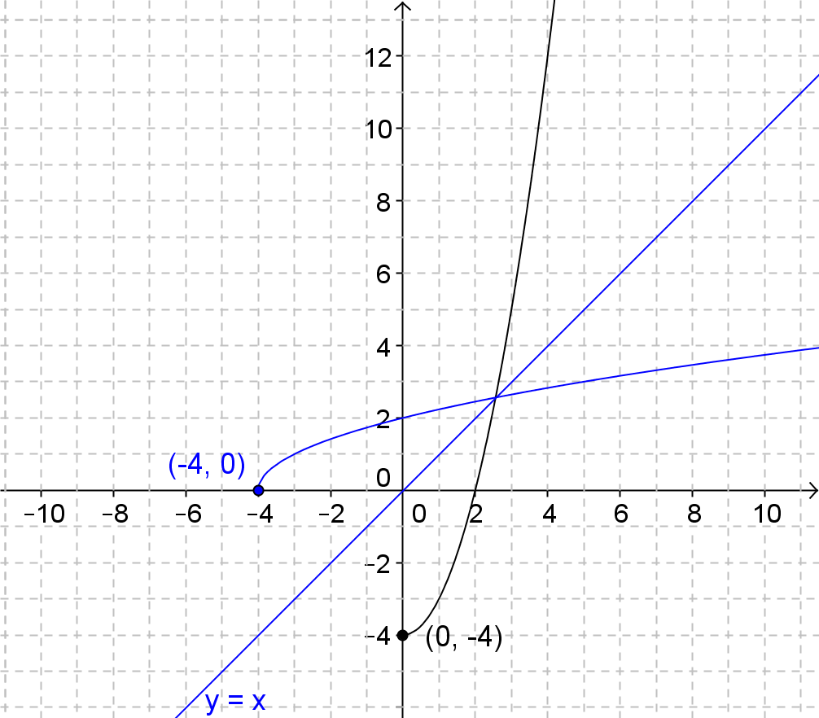
  - Verify graphically that $f$, with the domain you selected, and $f^{-1}$ are indeed inverses.

  - Verify that $f$ and $f^{-1}$ are indeed inverses by showing that $f\left(f^{-1}\left(x\right)\right)=x$ and $f^{-1}\left(f\left(x\right)\right)=x$.
$$f\left(f^{-1}\left(x\right)\right)={\left(\sqrt{x+4}\right)}^{2}-4 \\ =x+4-4 \\ =x$$
$$f^{-1}\left(f\left(x\right)\right)=\sqrt{x^{2}+4-4} \\ =\sqrt{x^{2}} \\ =x,x≥0$$
Discuss the implications of part (d) above before moving on to the last exercises. In Exercise 1 and part (d) of Exercise 8, students verified by composition that one function was the inverse of another. Add this information to the anchor chart if you have one posted. Ask students to add this information to their notes as well.
Composition of a Function and Its Inverse: To verify that two functions are inverses, show that $f\left(g\left(x\right)\right)=x$ and $g\left(f\left(x\right)\right)=x$.

Exercise 9 (8 minutes)
Students work with different types of functions to verify by composition that they are or are not inverses. Some students may approach the problem graphically, but when reviewing the solutions, be sure to explain that the algebraic approach is the preferred way to verify two functions are inverses unless you are proving by contradiction that they are not (e.g., by finding a point $(a,b)$ on the graph of one function such that $(b,a)$ is not a point on the graph of the alleged inverse.)

- Three pairs of functions are given below. For which pairs, are $f$ and $g$ inverses of each other? Show work to support your reasoning. If a domain is not specified, assume it is the set of real numbers.
  - $f\left(x\right)=\frac{x}{x+1}, x≠-1$ and $g\left(x\right)=\frac{-x}{x-1}, x≠1$
$$f\left(g\left(x\right)\right)=\frac{\frac{-x}{x-1}}{\frac{-x}{x-1}+1} \\ =\frac{\frac{-x}{x-1}}{\frac{-x}{x-1}+\frac{x-1}{x-1}} \\ =\frac{-x}{x-1}∙\frac{x-1}{-1} \\ =x$$
$$g\left(f\left(x\right)\right)=\frac{-\frac{x}{x+1}}{\frac{x}{x+1}-1} \\ =\frac{-\frac{x}{x+1}}{\frac{x}{x+1}-\frac{x+1}{x+1}}$$
$$-\frac{x}{x+1}∙\frac{x+1}{-1} \\ =x$$
The two functions are inverses.

  - $f\left(x\right)=\sqrt{x}-1,x≥0$ and $g\left(x\right)={\left(x+1\right)}^{2}$
$$f\left(g\left(x\right)\right)=\sqrt{{\left(x+1\right)}^{2}}-1=x+1-1=x$$
$$g\left(f\left(x\right)\right)={\left(\sqrt{x}-1+1\right)}^{2}={\sqrt{x}}^{2}=x$$
These two functions will be inverses as long as we restrict the domain of $g$ to be $x≥-1$ since the range of $f$ is $f\left(x\right)≥-1$.

  - $f\left(x\right)=-0.75x+1$ and $g\left(x\right)=-\frac{4}{3}x-\frac{4}{3}$
$$f\left(g\left(x\right)\right)=-\frac{3}{4}\left(-\frac{4}{3}x-\frac{4}{3}\right)+1=x+1+1=x+2$$
These two functions are not inverses.

Closing (3 minutes)
Have students respond to the following questions individually, in writing, or with a partner to close this lesson. The question answers are sample student responses.
- What are two things you learned about a function and its inverse function?
  - The two functions undo each other when they are composed. You may need to restrict the domain of a function to make its inverse a function.
- What is a question you still have about a function and its inverse function?
  - Do all functions have inverses? How do you choose a suitable domain for a trigonometric function?
The Lesson Summary can be used to clarify any questions students may still have.
Lesson Summary
Composition of a Function and Its Inverse: To verify that two functions are inverses, show that $f\left(g\left(x\right)\right)=x$ and$g\left(f\left(x\right)\right)=x$.
Invertible Function: The domain of a function$f$ can be restricted to make it invertible.
A function is said to be invertible if its inverse is also a function.

Exit Ticket (4 minutes)
Name Date
Lesson 19: Restricting the Domain

Exit Ticket

Let $f\left(x\right)=x^{2}-3x+2$.
  - Give a restricted domain for $f$ where it is invertible.

  - Find the inverse of $f$ for the domain you gave in part (a).

  - State the domain and range of the function you found in part (b).

  - Verify through function composition that the function you found in part (b) is the inverse of $f$.

  - Graph both functions on the domains specified.

Exit Ticket Sample Solutions

Let $f\left(x\right)=x^{2}-3x+2$.
  - Give a restricted domain for $f$ where it is invertible.
The vertex of this parabola is at $x=\frac{3}{2}$, so either $\left(-∞,\frac{3}{2}\right]$ or $\left[\frac{3}{2},∞\right)$ would be acceptable. The remaining answers will assume $\left[\frac{3}{2}, ∞\right)$ was chosen.

  - Find the inverse of $f$ for the domain you gave in part (a).
$$f\left(x\right)={\left(x-1.5\right)}^{2}-0.25 \\ x={\left(y-1.5\right)}^{2}-0.25 \\ y=±\sqrt{x+0.25}+1.5$$
For $f\left(x\right)$ on the domain $\left[\frac{3}{2},∞\right)$, $f^{-1}\left(x\right)=\sqrt{x+0.25}+1.5$.

  - State the domain and range of the function you found in part (b).
For $f^{-1}$, the domain is all real numbers greater than or equal to $-0.25,$ and the range is all real numbers greater than or equal to $1.5$.

  - Verify through function composition that the function you found in part (b) is the inverse of $f$.
For $x≥-0.25$, we have
$$f\left(f^{-1}\left(x\right)\right)=f\left(\sqrt{x+0.25}+1.5\right) \\ ={\left(\sqrt{x+0.25}+1.5\right)}^{2}-3\left(\sqrt{x+0.25}+1.5\right)+2 \\ =x+0.25+3\sqrt{x+0.25}+2.25-3\sqrt{x+0.25}-4.5+2 \\ =x$$
For $x≥1.5$, we have,
$$f^{-1}\left(f\left(x\right)\right)=f^{-1}\left(x^{2}-3x+2\right) \\ =\sqrt{x^{2}-3x+2+0.25}+1.5 \\ =\sqrt{x^{2}-3x+\frac{9}{4}}+\frac{3}{2} \\ =\sqrt{{\left(x-\frac{3}{2}\right)}^{2}}+\frac{3}{2} \\ =x-\frac{3}{2}+\frac{3}{2} \\ =x$$
Thus, $f\left(f^{-1}\left(x\right)\right)=f^{-1}\left(f\left(x\right)\right)=x$.

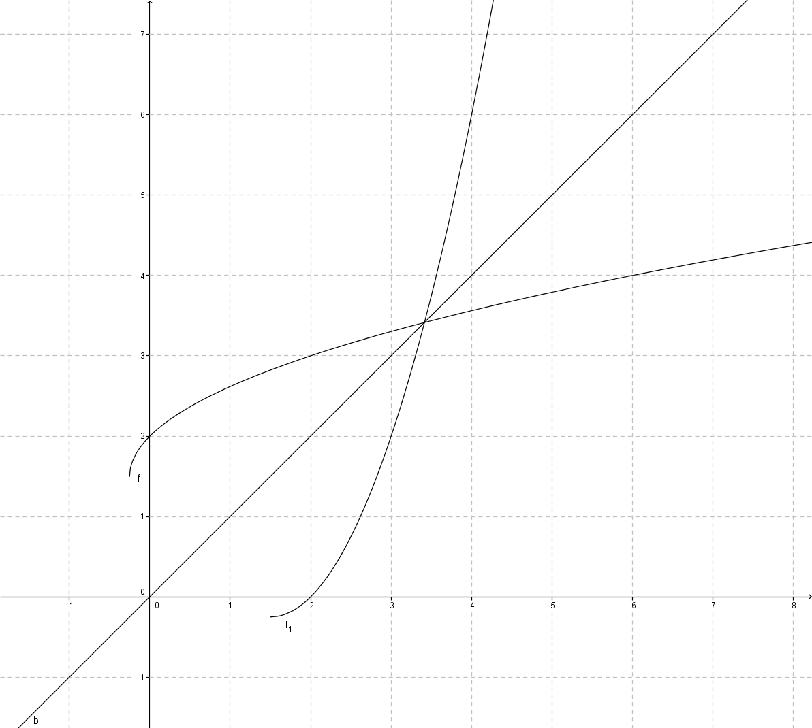
  - Graph both functions on the domains specified.

Problem Set Sample Solutions

- Let $f$ be the function that assigns to each student in your class his or her biological mother.
  - In order for $f$ to have an inverse, what condition must be true about the students in your class?
No students in the class can share the same biological mother.

  - If we enlarged the domain to include all students in your school, would this larger domain function have an inverse? Explain.
Probably not. Most schools contain siblings.

- Consider a linear function of the form $f\left(x\right)=mx+b,$ where $m$ and $b$ are real numbers, and $m≠0$..
  - Explain why linear functions of this form always have an inverse this is also a function.
The graphs of these functions are lines. When a line is reflected over the line $y=x$, the image will also be a line and, therefore, can be represented as a linear function.

  - State the general form of a line that does not have an inverse.
$y=k$ for some real number $k$. That is, only linear functions whose graphs are horizontal lines do not have inverse functions.

  - What kind of function is the inverse of an invertible linear function (e.g., linear, quadratic, exponential, logarithmic, rational, etc.)?
The inverse of an invertible linear function would also be a linear function.

  - Find the inverse of a linear function of the form $f\left(x\right)=mx+b$, where $m$ and $b$ are real numbers, and $m≠0$.
$$x=my+b \\ y=\frac{x-b}{m}$$
So $f^{-1}\left(x\right)=\frac{x-b}{m}$ for any linear function $f\left(x\right)=mx+b$, with $m≠0$.
- Consider a quadratic function of the form $f\left(x\right)={b\left(\frac{x-h}{a}\right)}^{2}+k$ for real numbers $a,b,h,k$, and $a,b≠0$.
  - Explain why quadratic functions never have an inverse without restricting the domain.
Every quadratic function is represented by the graph of a parabola, which will always reflect over the $y=x$ line in such a way that one input will map to two outputs, violating the definition of a function. Thus, a quadratic function could only have an inverse if its domain is restricted.

  - What are the coordinates of the vertex of the graph of $f$?
$$\left(h,k\right)$$

  - State the possible domains you can restrict $f$ on so that it will have an inverse.
The function $f$ on the domains $\left(-∞,h\right]$ and $\left[h,∞\right)$ is invertible.

  - What kind of function is the inverse of a quadratic function on an appropriate domain?
The inverse of a quadratic function on an appropriate domain is a square root function.

  - Find $f^{-1}$ for each of the domains you gave in part (c).
$$x=b{\left(\frac{y-h}{a}\right)}^{2}+k \\ \frac{x-k}{b}={\left(\frac{y-h}{a}\right)}^{2} \\ y=±a\sqrt{\frac{x-k}{b}}+h$$
The inverse function will either be described by $y=a\sqrt{\frac{x-k}{b}}+h$ or $y=-a\sqrt{\frac{x-k}{b}}+h$ depending on which domain is chosen for $f$.

- Show that $f\left(x\right)=mx+b$ for real numbers $m$ and $b$ with $m≠0$ has an inverse that is also a function.
$$y=mx+b$$
$$x=my+b$$
$$x-b=my$$
$$\frac{1}{m}x-\frac{b}{m}=y$$
Thus $f^{-1}\left(x\right)=\frac{1}{m}x-\frac{b}{m}$which is a linear function. One can see from the graph of a line that each input in the domain will be paired with one output.

- Explain why $f\left(x\right)=a{\left(x-h\right)}^{2}+k$ for real numbers $a$, $h$, and $k$ with $a≠0$ does not have an inverse that is a function. Support your answer in at least two different ways (numerically, algebraically, or graphically).
$$y=a{\left(x-h\right)}^{2}+k$$
$$x=a{\left(y-h\right)}^{2}+k$$
$$\frac{x-k}{a}={\left(y-h\right)}^{2}$$
This equation has two solutions when you take the square root:
$$y-h=\sqrt{\frac{x-k}{a}}\text{ or }y-h=-\sqrt{\frac{x-k}{a}}$$
You can see that selecting a single value for $x$ will result in two corresponding values of $y$ for all $x≠k$. Thus, the inverse is not a function.
Graphically, the graph of $f$ is a quadratic function with a vertex at $(h,k)$. The symmetry of this graph means that there will be two domain values with the same range value for all $x≠h$. When the graph of this function is reflected over the line $y=x$, the resulting graph will not meet the definition of a function.

Extension
- Consider the function $f\left(x\right)=sin\left(x\right)$.
  - Graph $y=f\left(x\right)$ on the domain $\left[-2π, 2π\right]$.

  - If we require a restricted domain on $f$ to be continuous and cover the entirety of the range of $f$, how many possible choices for a domain are there in your graph from part (a)? What are they?
There are three possible choices: $\left[-\frac{3π}{2},-\frac{π}{2}\right], \left[-\frac{π}{2},\frac{π}{2}\right], \left[\frac{π}{2},\frac{3π}{2}\right]$.

  - Make a decision on which restricted domain you listed in part (b) makes the most sense to choose. Explain your decision.
Answers may vary, but it is expected most students will choose $\left[-\frac{π}{2},\frac{π}{2}\right]$ since it includes the origin.

  - Use a calculator to evaluate $sin^{-1}\left(0.75\right)$ to three decimal places. How can you use your answer to find other values $ψ$ such that $sin\left(ψ\right)=1$? Verify that your technique works by checking it against your graph in part (a).
$$\sin^{-1}{(0.75)}≈0.848$$
On the unit circle, sine values are equal for supplementary angles of rotation, so $π-0.848$ will give another approximate result. Infinitely many values can be found from these two values by adding integer multiples of $2π$ to either value.

