Lesson 19: Restricting the Domain

Classwork
Opening Exercise
The function $f$ with domain $\left\{1,2,3,4,5\right\}$ is shown in the table below.
$$x$$ | $$f(x)$$
$$1$$ | $$7$$
$$2$$ | $$3$$
$$3$$ | $$1$$
$$4$$ | $$9$$
$$5$$ | $$5$$
  - What is $f(1)$? Explain how you know.

  - What is $f^{-1}\left(1\right)?$ Explain how you know.

  - What is the domain of $f^{-1}$? Explain how you know.

  - Construct a table for the function $f^{-1},$ the inverse of $f$.

Exercises 1–9
- Complete the mapping diagram to show that $f\left(f^{-1}\left(x\right)\right)=x$.
Domain Range
$$f^{-1}$$
$$1 \\ 3 \\ 5 \\ 7 \\ 9$$

$$f$$
Domain Range

- Complete the mapping diagram to show that $f^{-1}\left(f\left(x\right)\right)=x$.
Domain Range
$$f^{-1}$$
$$1 \\ 2 \\ 3 \\ 4 \\ 5$$

$$f$$
Domain Range

- The graph of $f$ is shown below.
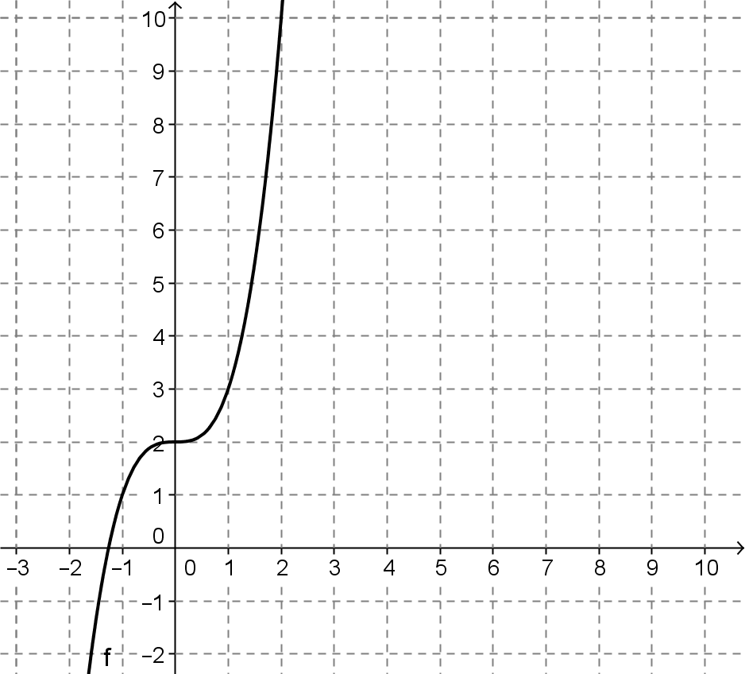
  - Select several ordered pairs on the graph of $f,$ and use those to construct a graph of $f^{-1}$.

  - Draw the line $y=x$, and use it to construct the graph of $f^{-1}$ below.
  - The algebraic function for $f$ is given by $f\left(x\right)=x^{3}+2$. Is the formula for $f^{-1}\left(x\right)=\sqrt[3]{x}-2$? Explain why or why not.

- The graph of $f\left(x\right)=\sqrt{x-3}$ is shown below. Construct the graph of $f^{-1}$.
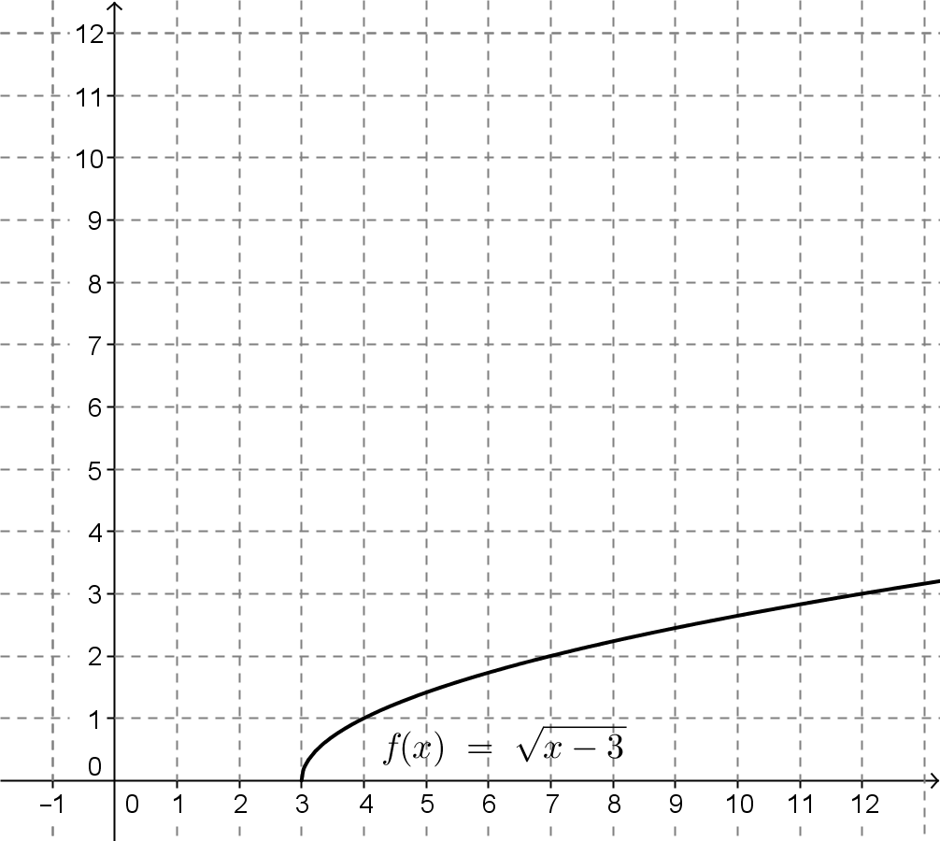

- Morgan used the procedures learned in Lesson 18 to define $f^{-1}\left(x\right)=x^{2}+3$. How does the graph of this function compare to the one you made in Exercise 5?

- Construct the inverse of the function $f$ given by the table below. Is the inverse a function? Explain your reasoning.
$$x$$ | $$-3$$ | $$-2$$ | $$-1$$ | $$0$$ | $$1$$ | $$2$$ | $$3$$
$$f(x)$$ | $$4$$ | $$-1$$ | $$-4$$ | $$-5$$ | $$-4$$ | $$-1$$ | $$4$$

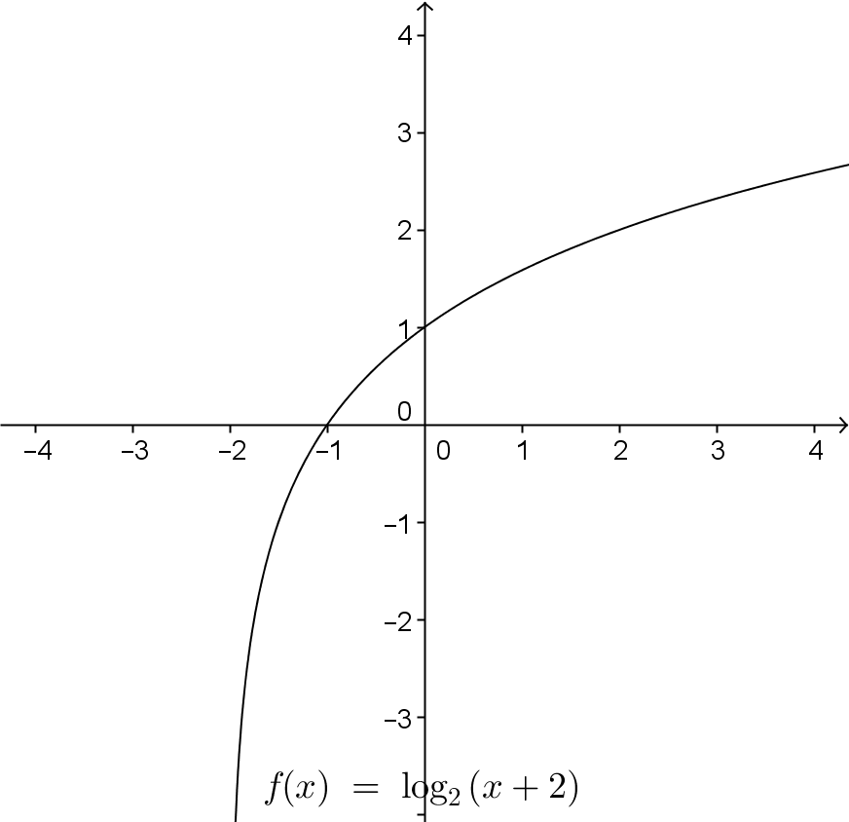
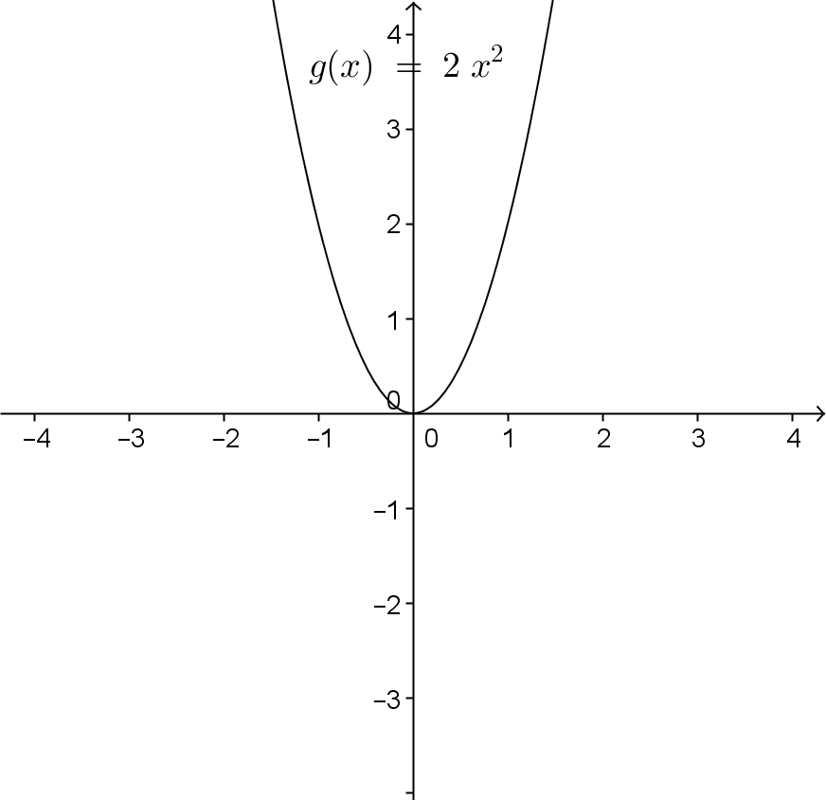
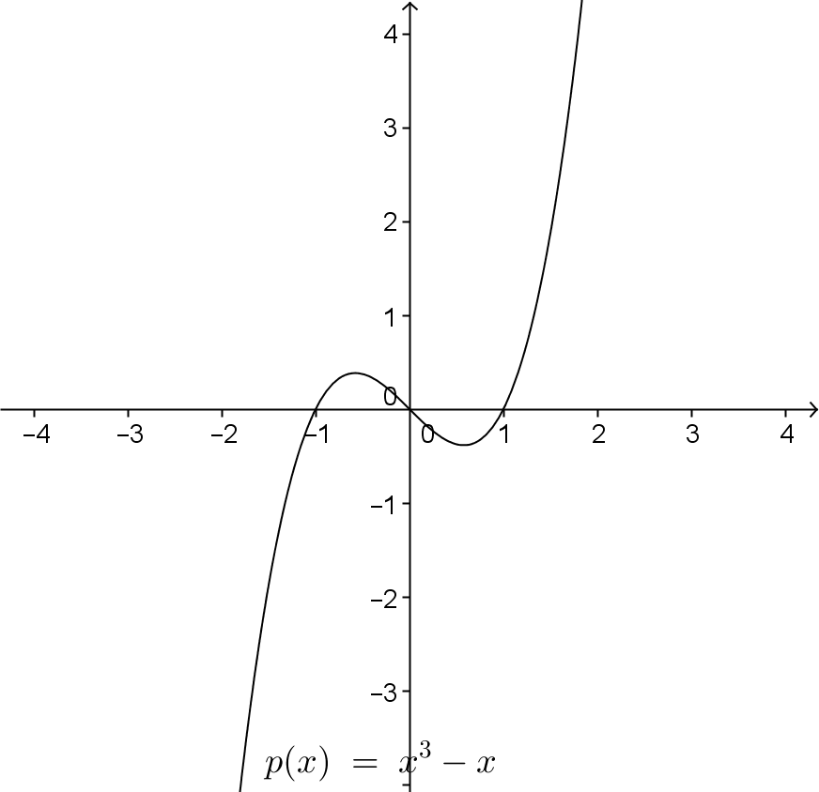
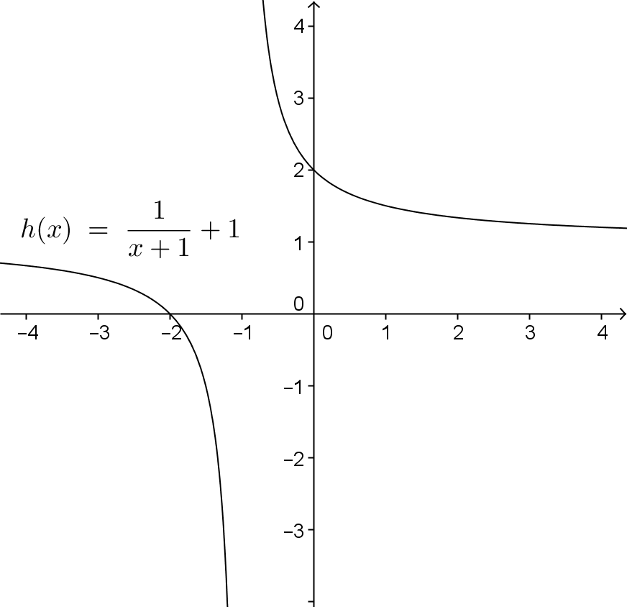
- The graphs of several functions are shown below. Which ones are invertible? Explain your reasoning.
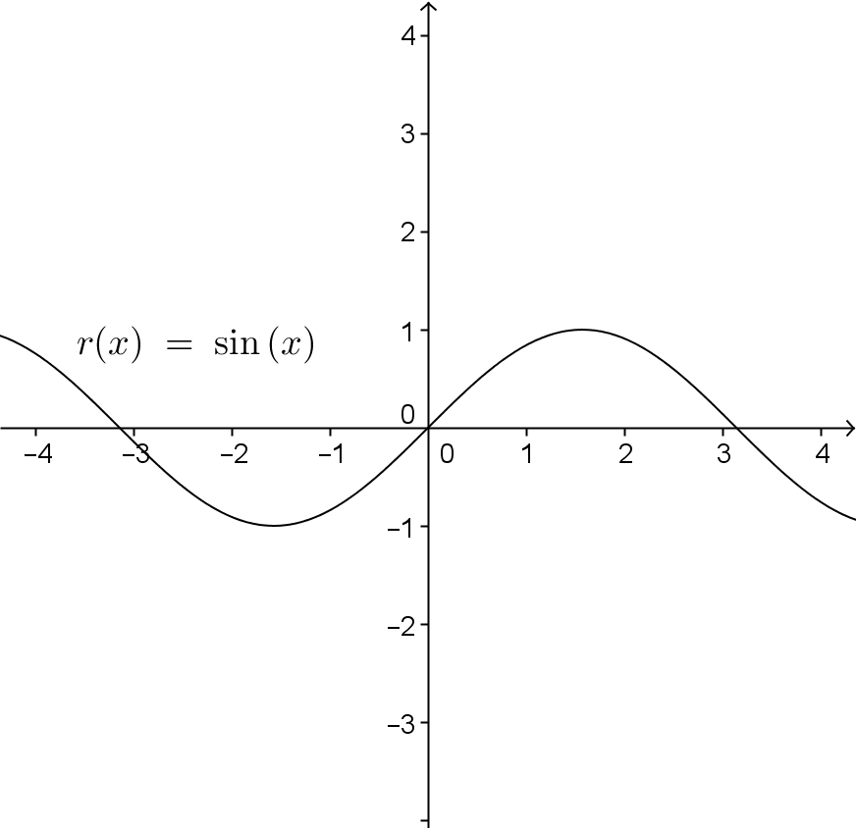
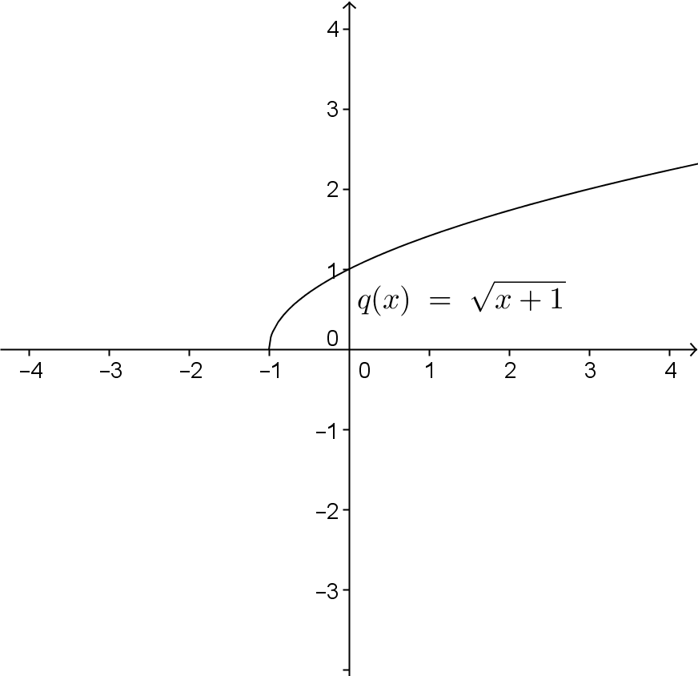

- Given the function $f\left(x\right)=x^{2}-4$.
  - Select a suitable domain for $f$ that will make it an invertible function. State the range of $f$.

  - Write a formula for $f^{-1}$. State the domain and range of $f^{-1}$.

  - Verify graphically that $f$, with the domain you selected, and $f^{-1}$ are indeed inverses.

  - Verify that $f$ and $f^{-1}$ are indeed inverses by showing that $f\left(f^{-1}\left(x\right)\right)=x$ and $f^{-1}\left(f\left(x\right)\right)=x$.

- Three pairs of functions are given below. For which pairs, are $f$ and $g$ inverses of each other? Show work to support your reasoning. If a domain is not specified, assume it is the set of real numbers.
  - $f\left(x\right)=\frac{x}{x+1}, x≠-1$ and $g\left(x\right)=\frac{-x}{x-1}, x≠1$

  - $f\left(x\right)=\sqrt{x}-1,x≥0$ and $g\left(x\right)={\left(x+1\right)}^{2}$

  - $f\left(x\right)=-0.75x+1$ and $g\left(x\right)=-\frac{4}{3}x-\frac{4}{3}$

Lesson Summary
Composition of a Function and Its Inverse: To verify that two functions are inverses, show that $f\left(g\left(x\right)\right)=x$ and$g\left(f\left(x\right)\right)=x$.
Invertible Function: The domain of a function$f$ can be restricted to make it invertible.
A function is said to be invertible if its inverse is also a function.

Problem Set

- Let $f$ be the function that assigns to each student in your class his or her biological mother.
  - In order for $f$ to have an inverse, what condition must be true about the students in your class?
  - If we enlarged the domain to include all students in your school, would this larger domain function have an inverse? Explain.

- Consider a linear function of the form $f\left(x\right)=mx+b,$ where $m$ and $b$ are real numbers, and $m≠0$..
  - Explain why linear functions of this form always have an inverse this is also a function.
  - State the general form of a line that does not have an inverse.
  - What kind of function is the inverse of an invertible linear function (e.g., linear, quadratic, exponential, logarithmic, rational, etc.)?
  - Find the inverse of a linear function of the form $f\left(x\right)=mx+b$, where $m$ and $b$ are real numbers, and
$m≠0$.

- Consider a quadratic function of the form $f\left(x\right)={b\left(\frac{x-h}{a}\right)}^{2}+k$ for real numbers $a,b,h,k$, and $a,b≠0$.
  - Explain why quadratic functions never have an inverse without restricting the domain.
  - What are the coordinates of the vertex of the graph of $f$?
  - State the possible domains you can restrict $f$ on so that it will have an inverse.
  - What kind of function is the inverse of a quadratic function on an appropriate domain?
  - Find $f^{-1}$ for each of the domains you gave in part (c).

- Show that $f\left(x\right)=mx+b$ for real numbers $m$ and $b$ with $m≠0$ has an inverse that is also a function.

- Explain why $f\left(x\right)=a{\left(x-h\right)}^{2}+k$ for real numbers $a$, $h$, and $k$ with $a≠0$ does not have an inverse that is a function. Support your answer in at least two different ways (numerically, algebraically, or graphically).

Extension
- Consider the function $f\left(x\right)=sin\left(x\right)$.
  - Graph $y=f\left(x\right)$ on the domain $\left[-2π, 2π\right]$.
  - If we require a restricted domain on $f$ to be continuous and cover the entirety of the range of $f$, how many possible choices for a domain are there in your graph from part (a)? What are they?
  - Make a decision on which restricted domain you listed in part (b) makes the most sense to choose. Explain your decision.
  - Use a calculator to evaluate $sin^{-1}\left(0.75\right)$ to three decimal places. How can you use your answer to find other values $ψ$ such that $sin\left(ψ\right)=1$? Verify that your technique works by checking it against your graph in part (a).

