Lesson 18: Inverse Functions

Student Outcomes
- Students read the inverse values of a function from a table and graph. They create the inverse of a function by solving an equation of the form $f\left(x\right)=y$. They understand the definition of the inverse of a function and properties that relate a function to its inverse.

Lesson Notes
This lesson reintroduces the inverse of a function and begins to address the additional standards that are part of F-BF.4. Specifically in this lesson, students create the inverse of a function of the form $f\left(x\right)=y$ (F-BF.B.4a) and read values of an inverse function from a graph or table (F-BF.B.4c). Students consider a simple linear situation in the context of straight-line depreciation of business equipment (MP.4 and MP.2). They work with inverses presented graphically and in tables (F-BF.B.4b).
The inverse of a function and the associated properties of inverses were first introduced in Algebra II Module 3 Lessons 18 and 19. The goals of this lesson are to present inverses in a slightly different context: to help students understand that when you compose a function and its inverse, they undo each other and to review a process for creating the inverse of a function algebraically.
Scaffolding:
- Add unfamiliar words such as asset and depreciation to a word wall. Ask students to brainstorm assets that businesses might have (e.g., computers, equipment, buildings, vehicles, etc.) and construct a simple diagram illustrating straight-line depreciation like the one shown below.
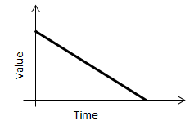
- Depreciation can be represented numerically in a table.
Time | $$0$$ | $$1$$ | $$2$$
Value | $$1000$$ | $$900$$ | $$800$$
- Ask students to explain the meaning of ordered pairs from the table, such as $(0, 1000)$ or $(1, 900)$.

Classwork
Opening (3 minutes)
Ask students to read the opening paragraph silently and highlight any terms that seem unfamiliar to them. Lead a short discussion to access students’ prior knowledge about depreciation.
Businesses must track the value of their assets over time. When a business buys equipment, the value of the equipment is reduced over time. For example, electric companies provide trucks for their workers when they go out into the field to repair electrical lines. These trucks lose value over time but are still part of the business assets. For accounting purposes, many businesses use a technique called straight-line depreciation to calculate the value of equipment over time.

Exercises (7 minutes)
Have students work these exercises with a partner or in small groups. Students have worked with functions extensively in Algebra I and Algebra II and throughout this module, so these exercises should be fairly easy for them. Key words like domain, range, and parameter can be reviewed briefly as necessary. Students should be encouraged to use a calculator as needed for computation and graphing since the object of this lesson is for them to understand the concept of inverse functions, especially in real-world situations.
Exercises
Suppose ABC Electric purchases a new work truck for $\$34,500$. They estimate that the truck’s value will depreciate to $\$0$ over $15$ years. The table below shows the value $v(t)$ of the truck in thousands of dollars depreciated over time $t$ in months using a straight-line depreciation method.
$$t$$ | $$0$$ | $$12$$ | $$24$$ | $$36$$ | $$48$$ | $$60$$ | $$72$$ | $$84$$ | $$96$$
$$v(t)$$ | $$34.5$$ | $$32.2$$ | $$29.9$$ | $$27.6$$ | $$25.3$$ | $$23.0$$ | $$20.7$$ | $$18.4$$ | $$16.1$$

- Does the function $v$ appear to be a linear function? Explain your reasoning.
Yes. Each time the months increase by $12$, the value decreases by $2.3$.

- What is an appropriate domain and range for $v$ in this situation?
The domain would be $\left[0,180\right],$ which represents a time span of $15$ years measured in months. The range would be $\left[0,34.5\right],$ which represents the value of the car over the $15$-year period based on the company’s estimates.

- Write a formula for $v$ in terms of $t,$ the months since the truck was purchased.
$v\left(t\right)=-\frac{2.3}{12}t+34.5$ for $0≤t≤180$.

- What will the truck be worth after $30$ months? $40$ months? $50$ months?
All values are rounded to the hundredths place.
$$v\left(30\right)=28.75$$
$$v\left(40\right)=26.83$$
$$v\left(50\right)=24.92$$

- When will the truck be valued at $\$30,000$? $\$20,000$? $\$10,000?$
$v\left(t\right)=30$ when
$$-\frac{2.3}{12}x+34.5=30$$
To solve for $t$, subtract both sides of the equation by $34.5,$ and then multiply both sides by $–\frac{12}{2.3}$.
$$-\frac{2.3}{12}t+34.5-34.5=30-34.5$$
$$-\frac{2.3}{12}t=-4.5$$
$$-\frac{12}{2.3}\left(-\frac{2.3}{12}t\right)=-\frac{12}{2.3}\left(-4.5\right)$$
$$t≈23.48$$
After approximately $23.5$ months, the truck will be worth $\$30,000$.
Similarly, solving the equations $v\left(t\right)=20000$ and $v\left(t\right)=10000$ will give approximate times for when the truck is worth $\$20,000$ and $\$10,000$. The truck will be worth $\$20,000$ after approximately $75.7$ months, and it will be worth $\$10,000$ after approximately $127.8$ months.

Discussion (3 minutes)
Lead a short discussion to debrief the Exercises 1–5 before moving on to the next few problems.
- What is the meaning of the parameters in the linear function $v$?
MP.2
  - The $34.5$ represents the original price of the truck in thousands of dollars. The $-\frac{2.3}{12}$ is the monthly price decrease due to the straight-line depreciation.
- How did you determine the answers to Exercise 5? Did you notice any similarities as you determined the months for the different dollar amounts?
  - To solve the equation, you subtract $34.5$ each time and then multiply by the reciprocal of $-\frac{2.3}{12}$. You always undo the operations in the reverse order that they would have been applied to the $t$ in the equation to create the expression on the left side of the equation.
- How could you write a formula that would give the time for any dollar amount?
  - You could solve the equation $-\frac{2.3}{12}t+34.5=y$ for $t,$ and that would give you a formula to find the time for any dollar amount.

Exercises 6-10 (5 minutes)
Have students continue with these exercises working either with a partner or in small groups.

- Construct a table that shows the time of depreciation, $t\left(v\right),$ in months as a function of the value of the truck, $v,$ in thousands of dollars.
$$v$$ | $$34.5$$ | $$32.2$$ | $$29.9$$ | $$27.6$$ | $$25.3$$ | $$23.0$$ | $$20.7$$ | $$18.4$$ | $$16.1$$
$$t(v)$$ | $$0$$ | $$12$$ | $$24$$ | $$36$$ | $$48$$ | $$60$$ | $$72$$ | $$84$$ | $$96$$

- Does the function $t$ appear to be a linear function? Explain your reasoning.
Yes. Each time the $v$ values decrease by $2.3$, the $t(v)$ values increase by $12$.

- What is an appropriate domain and range for $t$ in this situation?
The domain and range are the same as for the function $v$, except switched.

- Write a formula for $t$ in terms of the value of the truck, $v$, since it was purchased.
Using the slope of the $t$ function, $-\frac{12}{2.3}$, and a point $\left(34.5,0\right),$ we could create the equation
$t\left(v\right)=-\frac{12}{2.3}\left(v-34.5\right)+0$.

- Explain how you can create the formula for $t$ using the formula for $v$ from Exercise 5.
Solve $v\left(t\right)=y$ for $t,$ and then just change the variables.
$$-\frac{2.3}{12}t+34.5=y$$
$$-\frac{2.3}{12}t=y-34.5$$
$$t=-\frac{12}{2.3}(y-34.5)$$
Thus, $t\left(v\right)=-\frac{12}{2.3}\left(v-34.5\right)$ for $0≤v≤34.5$.

Discussion (5 minutes)
The process that students used in Exercise 5 and then generalized in Exercise 10 is a direct application of F-BF.B.4a. The goal of this discussion is to reactivate students’ previous learning about inverse functions. If students mention the term inverse, then you can tailor the discussion to what your students recall. If the term does not come up, then this discussion can be used to help students recall what they learned in Algebra II.
- What do you notice about the domains and ranges of the functions $v$ and $t$?
  - The domain of $v$ is the range of $t,$ and the range of $v$ is the domain of $t$.
- If a point $(a,b)$ is on the graph of $v,$ then what would be a point on the graph of $t$?
  - Since the domain and range are switched between these two functions, $\left(b,a\right)$ would be a point on the graph of $t$.
- How could you prove that if $(a,b)$ is on the graph of $v$ then $(b,a)$ would be a point on the graph of $t$?
  - If $(a,b)$ is a point on the graph of $v$, then $v\left(a\right)=b,$ which means that $-\frac{2.3}{12}a+34.5=b$. We need to show that $t\left(b\right)=a$. $t\left(b\right)=-\frac{12}{2.3}\left(b-34.5\right)=-\frac{12}{2.3}\left(-\frac{2.3}{12}a+34.5-34.5\right)=a$.
Tell students that the functions $v$ and $t$ are what we call inverse functions. The definition is provided below and is also provided in the Lesson Summary. You can have students record this definition in their notebooks, share the definition in their own words with a neighbor, and come up with a few examples to include in their notebooks. Emphasize which exercises illustrated each part of the definition.
Scaffolding:
Students can create a Frayer model to have as a graphic organizer to summarize the definition and examples.

The Inverse of a Function: Let $f$ be a function with domain set $X$ and range set $Y$. Then $f$ is invertible if there exists a function $g$ with domain $Y$ and range $X$ such that $f$ and $g$ satisfy the property:
For all $x$ in $X$ and $y$ in $Y$, $f(x) = y$ if and only if $g(y)=x$.
The function $g$ is called the inverse of $f$ and is often denoted $f^{-1}$.
If $f$ and $g$ are inverses of each other, then
The domain of $f$ is the same set as the range of $g$.
The range of $f$ is the same set as the domain of $g$.

Exercises 11-13 (5 minutes)
Students can use technology to graph the functions $v$ and $t$. To see the symmetry, make sure that the viewing window of the graphing calculator is set up so the scaling is equal on both axes. Most graphing calculators have a square window setting that can be used to correct the scaling when the LCD screen is rectangular.

- Sketch a graph of the equations $y=v(t)$ and $y=t(v)$ in the Cartesian plane. How do their graphs compare?
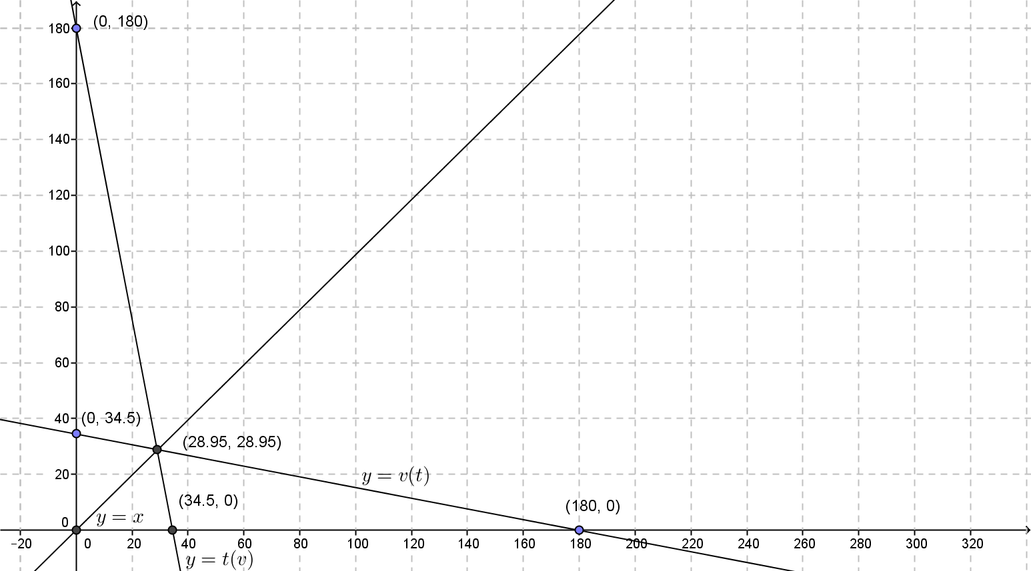
Both graphs are decreasing and they intersect at the point $(28.95,28.95)$

- What is the meaning of the intersection point of the graphs of the two equations?
It is the point where the value of the truck (in thousands of dollars) is equal to the number of months that its value has depreciated since its purchase.

Note to teachers: There is not any significant real-world meaning to this point, but it helps to set up the fact that these functions are a reflection of one another across the line $y=x$.

- Add the graph of $y=x$ to your work in Exercise 11. Describe the relationship between the graphs of $y=v(t)$,
$y=t\left(v\right),$ and $y=x$.
The graphs of $y=v(t)$ and $y=t(v)$ are images of one another across the line $y=x$.

Debrief these exercises by reviewing how to construct the image of a point reflected across a line. The points will be equidistant from the reflection line and located on a line that lies perpendicular to the reflection line. This property was a major focus of Algebra II Module 3 Lesson 18. If students are struggling with this type of transformation, you can review this lesson with them.
Reflection Property of a Function and Its Inverse Function: If two functions whose domain and range are a subset of the real numbers are inverses, then their graphs are reflections of each other across the diagonal line given by $y=x$in the Cartesian plane.

Exercises 14-15 (10 minutes)
Scaffolding:
- To students that finish early, pose the challenge to verify the inverses they found by composing them with the original function.
Students may need to be reminded that this property is expressed in the definition by the statement, “For all $x$ in $X$ and $y$ in $Y$, $f\left(x\right)=y$ if and only if $g\left(y\right)=x$.”
- If students struggle to verify by composition algebraically, have them practice the skill by composing the functions for individual points, for instance, $(3,-8)$ for part (a) and $(1, 250)$ for part (b).
Exercise 14 provides students with the opportunity to work with inverses in a real-world situation again. This time, students are given a formula for a depreciation function. In Exercise 15, students work to find the inverse of an algebraic function. Depending on how much information students recall from Algebra II Module 3 Lesson 19, you may choose to model one of these exercises directly with the entire class.

- ABC Electric uses this formula, $f\left(x\right)=750-10x,$ to depreciate computers, where $f$ is the value of a computer and $x$ is the number of months since its purchase.
  - Calculate$f(36)$. What is the meaning of $f(36)$?
$f\left(36\right)=750-10\left(36\right)=390$. It is the value of a computer $36$ months after the date it is purchased.

  - What is the meaning of $b$ in $f\left(b\right)=60$? What is the value of $b$?
It is the number of months since its purchase date when the computer will be worth $\$60$. Solving $750-10b=60$ gives a value of $b=69$.

  - Write a formula for $f^{-1},$ and explain what it means in this situation.
$$f^{-1}\left(x\right)=\frac{x-750}{-10}$$
This function determines the number of months that have passed since the computer’s date of purchase given the value of the computer, $x$ dollars.

  - When will the depreciated value of a computer be less than $\$400$?
Evaluate $f^{-1}\left(400\right)$. $$f^{-1}\left(x\right)=\frac{400-750}{-10}=\frac{-350}{-10}=35$$
The value of a computer will be less than $\$400$ after $35$ months.

  - What is the meaning of $c$ in $f^{-1}\left(c\right)=60$? What is the value of $c$?
It is the value of the computer $60$ months after its date of purchase.
To find the value of $c$, you can evaluate $f\left(60\right),$ or you can solve the equation $\frac{c-750}{-10}=60$ for $c$.
The value of$c$ is $150$. After $60$ months, the value of the computer is $\$150$.

Have one or two students present their solutions to this problem, and then review the process for finding the inverse of a function algebraically, which was detailed in Module 3 Lesson 19. This review can take place either before or after this exercise is completed, depending on how much you believe your students remember about inverses of functions from Algebra II Module 3. If time permits, let them struggle a bit to work through these exercises, and then bring the class together to describe a process that will work every time for finding an inverse, provided the original function has an inverse that is a function (see the Lesson Summary). All of the functions in this lesson are invertible. Non-invertible functions will be discussed in the next lesson.
- Find the inverses of the following functions.
  - $f\left(x\right)=\frac{2}{3}x-10$
$$y=\frac{2}{3}x-10 \\ x=\frac{2}{3}y-10 \\ x+10=\frac{2}{3}y \\ y=\frac{3}{2}\left(x+10\right) \\ f^{-1}\left(x\right)=\frac{3}{2}(x+10)$$

  - $g\left(x\right)=2{\left(x+4\right)}^{3}$
$$y=2{\left(x+4\right)}^{3} \\ x=2{\left(y+4\right)}^{3} \\ \frac{x}{2}={\left(y+4\right)}^{3} \\ \sqrt[3]{\frac{x}{2}}=y+4 \\ y=\sqrt[3]{\frac{x}{2}}-4 \\ g^{-1}\left(x\right)=\sqrt[3]{\frac{x}{2}}-4$$

  - $h\left(x\right)=\frac{1}{x-2},x≠2$
$$y=\frac{1}{x-2} \\ x=\frac{1}{y-2} \\ x\left(y-2\right)=1 \\ xy-2x=1 \\ xy=1+2x \\ y=\frac{1+2x}{x}, x≠0 \\ h^{-1}\left(x\right)=\frac{1+2x}{x}, x≠0$$

Closing (3 minutes)
Have students respond to the following questions in writing, individually or with a partner, to close this lesson. The question answers are sample student responses.
- What are two things you learned about a function and its inverse function?
  - The domain and range are switched. The graphs are reflections of one another across the line $y=x$.
- What is a question you still have about a function and its inverse function?
  - Do all functions have an inverse? How do I prove that two functions are inverses?
The Lesson Summary can be used to clarify any questions students may still have.
Lesson Summary
- Invertible Function: Let $f$ be a function whose domain is the set $X$ and whose image (range) is the set $Y$. Then $f$ is invertible if there exists a function $g$ with domain $Y$ and image (range) $X$ such that $f$ and $g$ satisfy the property:
For all $x$ in $X$ and $y$ in $Y$, $f(x) = y$ if and only if $g(y)=x$.
The function $g$ is called the inverse of $f$.
- If two functions whose domain and range are a subset of the real numbers are inverses, then their graphs are reflections of each other across the diagonal line given by $y=x$in the Cartesian plane.
- If $f$ and $g$ are inverses of each other, then
  - The domain of $f$ is the same set as the range of $g$.
  - The range of $f$ is the same set as the domain of $g$.
- The inverse of a function $f$ is denoted $f^{-1}$.
- In general, to find the formula for an inverse function $g$ of a given function $f$:
  - Write $y=f(x)$ using the formula for $f$.
  - Interchange the symbols $x$ and $y$ to get $x=f(y)$.
  - Solve the equation for $y$ to write $y$ as an expression in $x$.
  - Then, the formula for $f^{-1}$ is the expression in $x$ found in the previous step.

Exit Ticket (4 minutes)

Name Date
Lesson 18: Inverse Functions

Exit Ticket

The function $f$ is described below in three different ways. For each way, express $f^{-1}$ in the same style.
$$x$$ | $$1$$ | $$2$$ | $$5$$ | $$10$$ | $$15$$ | $$20$$
$$f\left(x\right)$$ | $$19.6$$ | $$19.2$$ | $$18$$ | $$16$$ | $$14$$ | $$12$$

$$f\left(x\right)=-\frac{2}{5}x+20$$

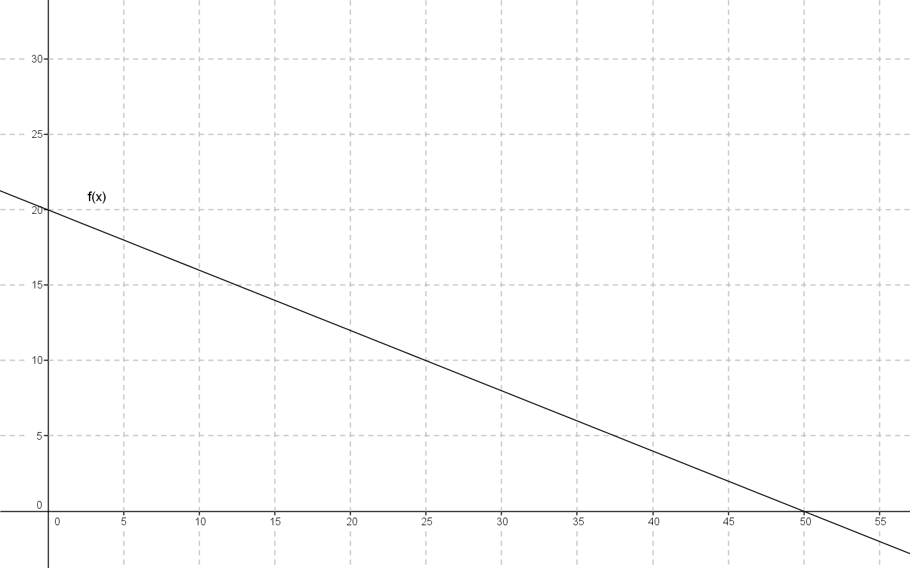
Exit Ticket Sample Solutions
The function $f$ is described below in three different ways. For each way, express $f^{-1}$ in the same style.
$$x$$ | $$1$$ | $$2$$ | $$5$$ | $$10$$ | $$15$$ | $$20$$
$$f\left(x\right)$$ | $$19.6$$ | $$19.2$$ | $$18$$ | $$16$$ | $$14$$ | $$12$$

$$x$$ | $$19.6$$ | $$19.2$$ | $$18$$ | $$16$$ | $$14$$ | $$12$$
$$f^{-1}\left(x\right)$$ | $$1$$ | $$2$$ | $$5$$ | $$10$$ | $$15$$ | $$20$$

$$f\left(x\right)=-\frac{2}{5}x+20$$
$$f^{-1}\left(x\right)=-\frac{5}{2}x+50$$
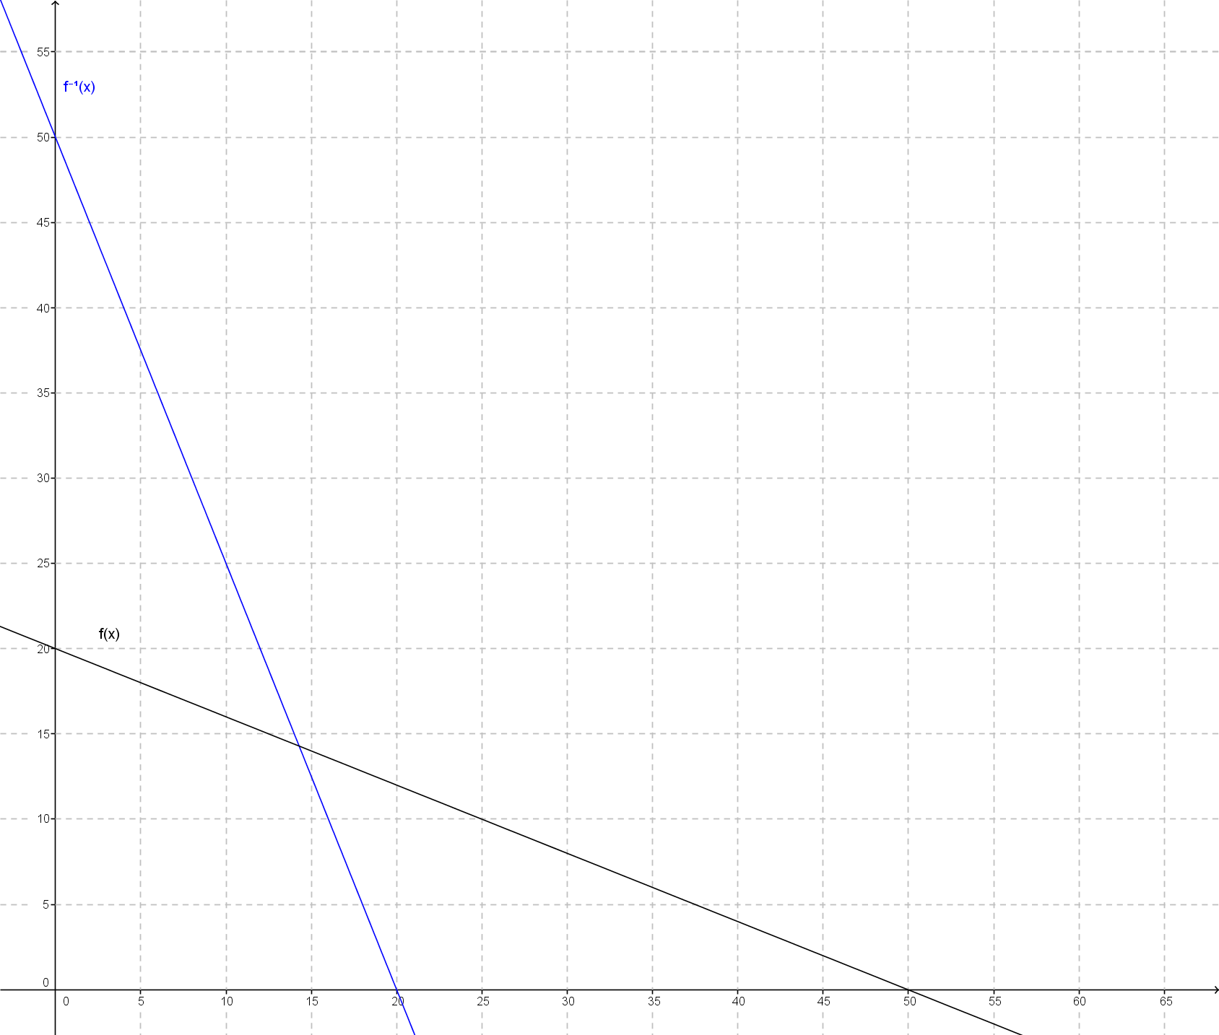

Problem Set Sample Solutions

- For each of the following, write the inverse of the function given.
  - $f=\left\{\left(1,3\right), \left(2,15\right), \left(3,8\right), \left(4,-2\right), \left(5,0\right)\right\}$
$$f^{-1}=\left\{\left(3,1\right),\left(15,2\right),\left(8,3\right), \left(-2,4\right), \left(0,5\right)\right\}$$

  - $g=\left\{\left(0,5\right),\left(2,10\right),\left(4,15\right),\left(6,20\right)\right\}$
$$g^{-1}=\left\{\left(5,0\right), \left(10,2\right), \left(15,4\right), \left(20,6\right)\right\}$$

  - $h=\left\{\left(1,5\right),\left(2,25\right),\left(3,125\right), \left(4,625\right)\right\}$
$$h^{-1}=\left\{\left(5,1\right),\left(25,2\right),\left(125,3\right),\left(625,4\right)\right\}$$

$$x$$ | $$1$$ | $$2$$ | $$3$$ | $$4$$
$$f\left(x\right)$$ | $$3$$ | $$12$$ | $$27$$ | $$48$$

$$x$$ | $$3$$ | $$12$$ | $$27$$ | $$48$$
$$f^{-1}\left(x\right)$$ | $$1$$ | $$2$$ | $$3$$ | $$4$$

$$x$$ | $$-1$$ | $$0$$ | $$1$$ | $$2$$
$$g\left(x\right)$$ | $$3$$ | $$6$$ | $$12$$ | $$24$$

$$x$$ | $$3$$ | $$6$$ | $$12$$ | $$24$$
$$g^{-1}\left(x\right)$$ | $$-1$$ | $$0$$ | $$1$$ | $$2$$

$$x$$ | $$1$$ | $$10$$ | $$100$$ | $$1000$$
$$h(x)$$ | $$0$$ | $$1$$ | $$2$$ | $$3$$

$$x$$ | $$0$$ | $$1$$ | $$2$$ | $$3$$
$$h^{-1}\left(x\right)$$ | $$1$$ | $$10$$ | $$100$$ | $$1000$$

  - $y=2x$
$$y=\frac{1}{2}x$$

  - $y=\frac{1}{3}x$
$$y=3x$$

  - $y=x-3$
$$y=x+3$$

  - $y=-\frac{2}{3}x+5$
$$y=-\frac{3}{2}x+\frac{15}{2}$$

  - $2x-5y=1$
$$2y-5x=1$$

  - $-3x+7y=14$
$$-3y+7x=14$$

  - $y=\frac{1}{3}{\left(x-9\right)}^{3}$
$$y=\sqrt[3]{3x}+9$$

  - $y=\frac{5}{3x-4}, x≠\frac{4}{3}$
$$y=\frac{5}{3x}+\frac{4}{3}$$

  - $y=2x^{7}+1$
$$y=\sqrt[7]{\frac{1}{2}x-\frac{1}{2}}$$

  - $y=\sqrt[5]{x}$
$$y=x^{5}$$

  - $y=\frac{x+1}{x-1}, x≠1$
$$y=\frac{x+1}{x-1}$$

- For each part in Problem 1, state the domain, $D$, and range, $R$, of the inverse function.
- $D=\left\{-2,0,3,8,15\right\}$  $R=\{0,1,2,3,4,5\}$ | - $D=\{5,10,15,20\}$  $R=\{0,2,4,6\}$ | - $D=\left\{5,25,125,625\right\}$  $R=\{1,2,3,4\}$
- $D=\left\{3,12,27,48\right\}R=\left\{1,2,3,4\right\}$ | - $D=\left\{3,6,12,24\right\}$  $R=\left\{-1,0,1,2\right\}$ | - $D=\left\{0,1,2,3\right\}$  $R=\{1,10,100,1000\}$
  - Both domain and range are all real numbers.

  - Both domain and range are all real numbers.

  - Both domain and range are all real numbers.
  - Both domain and range are all real numbers.

  - Both domain and range are all real numbers.

  - Both domain and range are all real numbers.

  - Both domain and range are all real numbers.

  - The domain is all real numbers except $x=0$, and the range is all real numbers except $y=\frac{4}{3}$.

  - Both domain and range are all real numbers.

  - Both domain and range are all real numbers.

  - Both domain and range are all real numbers except $1$.

- Sketch the graph of the inverse function for each of the following functions.

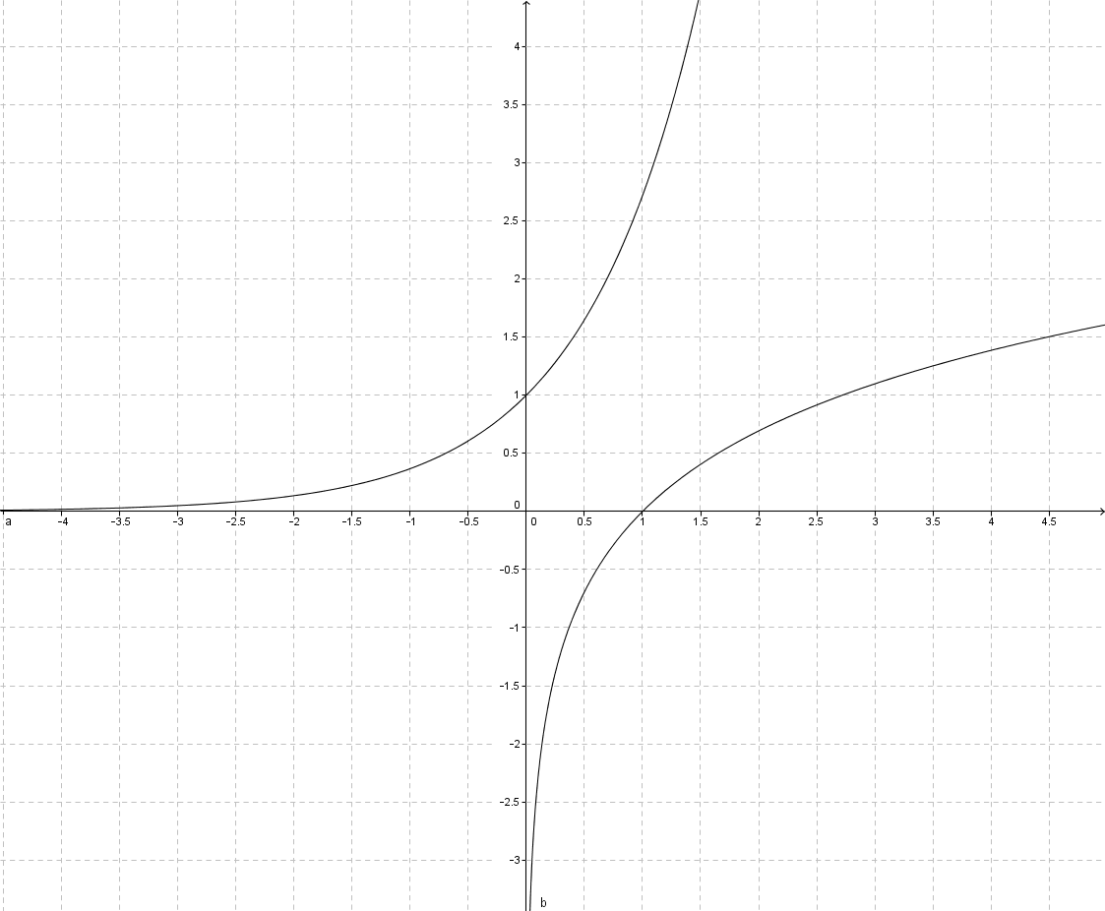

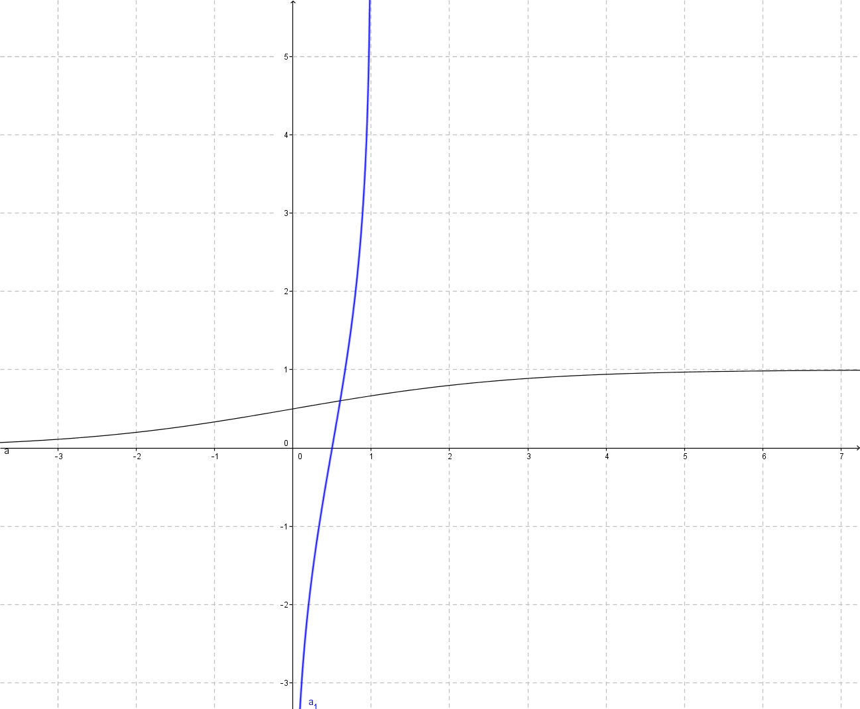

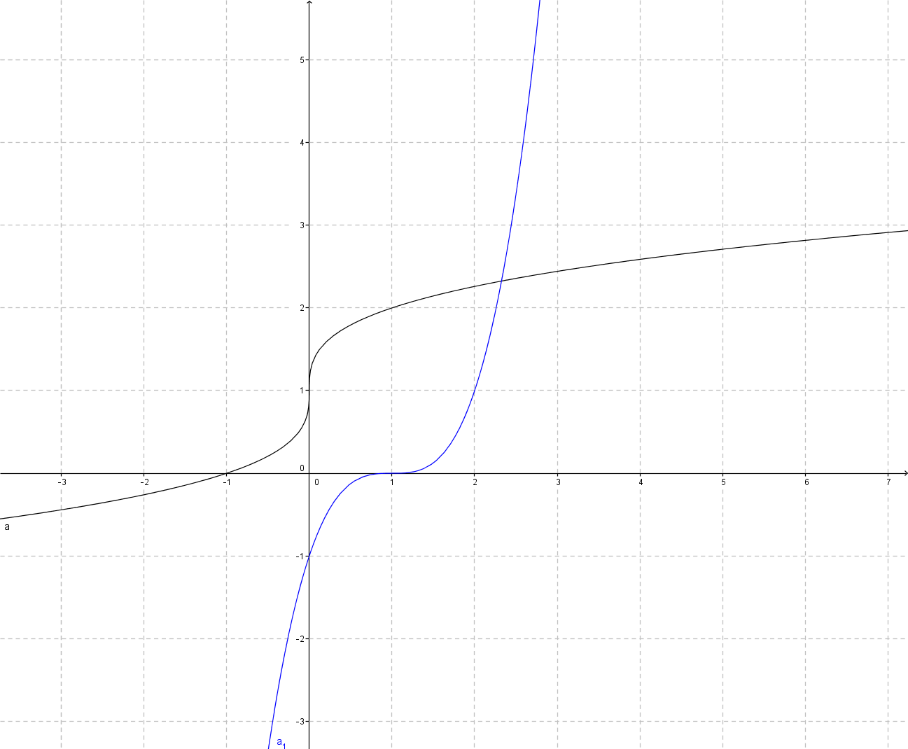

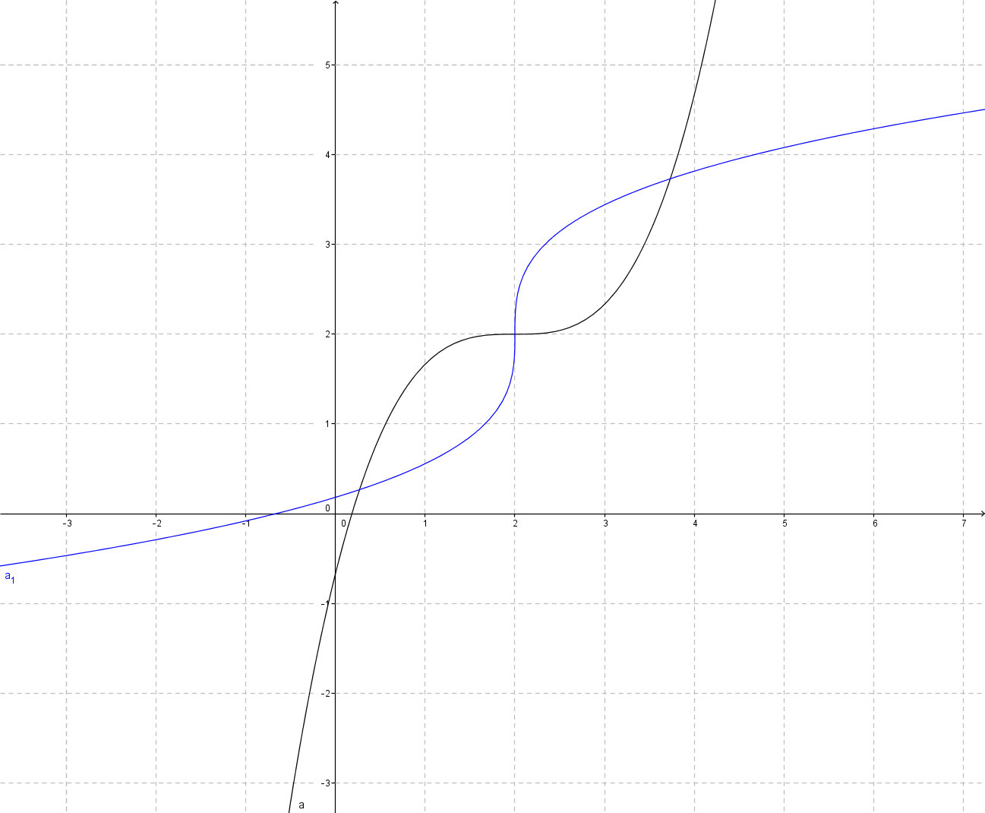

- Natalie thinks that the inverse of $f\left(x\right)=x-5$ is $g\left(x\right)=5-x$. To justify her answer, she calculates $f\left(5\right)=0$ and then finds $g\left(0\right)=5$, which gives back the original input.
  - What is wrong with Natalie’s reasoning?
A single point does not verify that the function is an inverse function. In order to be an inverse of the original function, we must have $f\left(g\left(x\right)\right)=g\left(f\left(x\right)\right)$ for all $x$.

  - Show that Natalie is incorrect by using other examples from the domain and range of $f$.
Any other point will work; for instance, $f\left(0\right)=-5$ and $g\left(-5\right)=10$.

  - Find $f^{-1}(x)$. Where do $f^{-1}\left(x\right)$ and $g\left(x\right)$ intersect?
$f^{-1}\left(x\right)=x+5$. The two functions intersect at the point $\left(0,5\right)$, which explains why Natalie thought $g$ was the inverse of $f$ after she tried that point.

- Sketch a graph of the inverse of each function graphed below by reflecting the graph about the line $y=x$. State whether or not the inverse is a function.

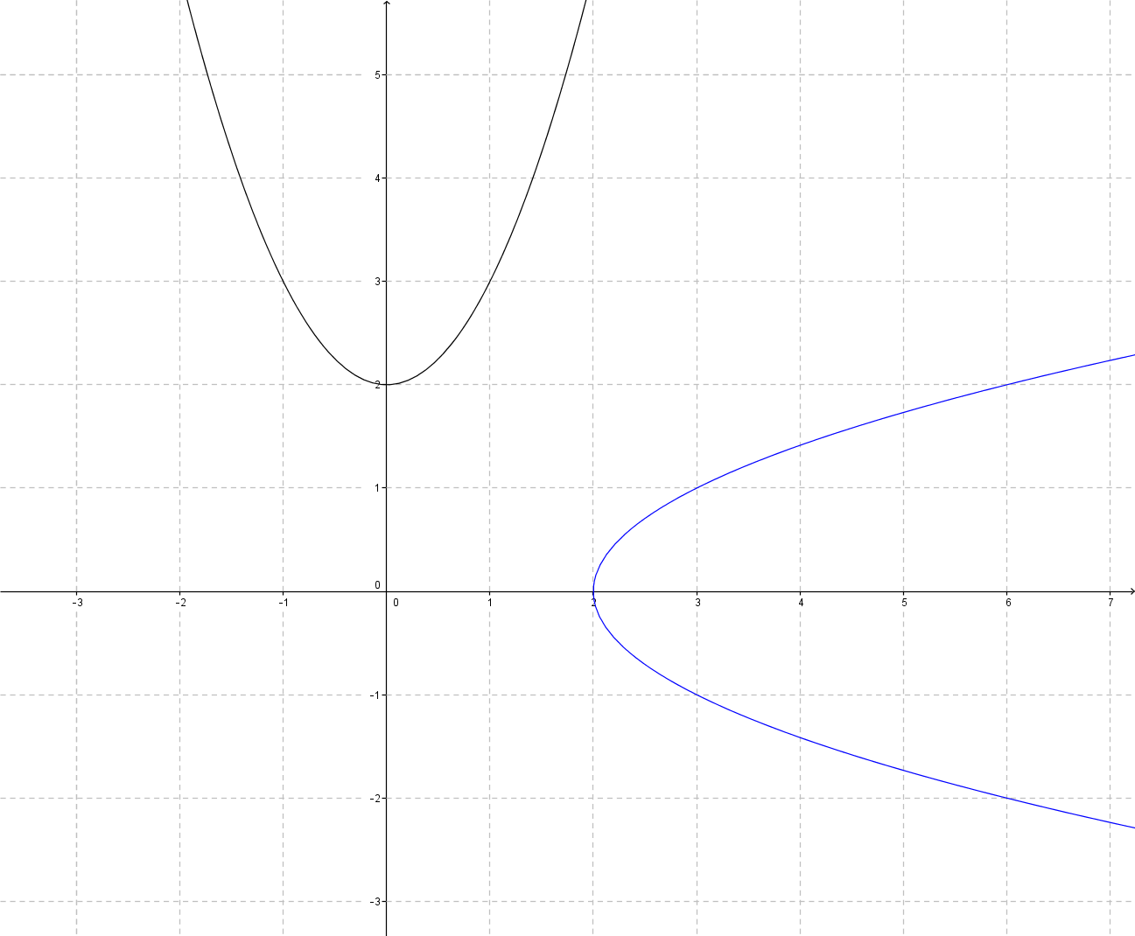
Not a function.

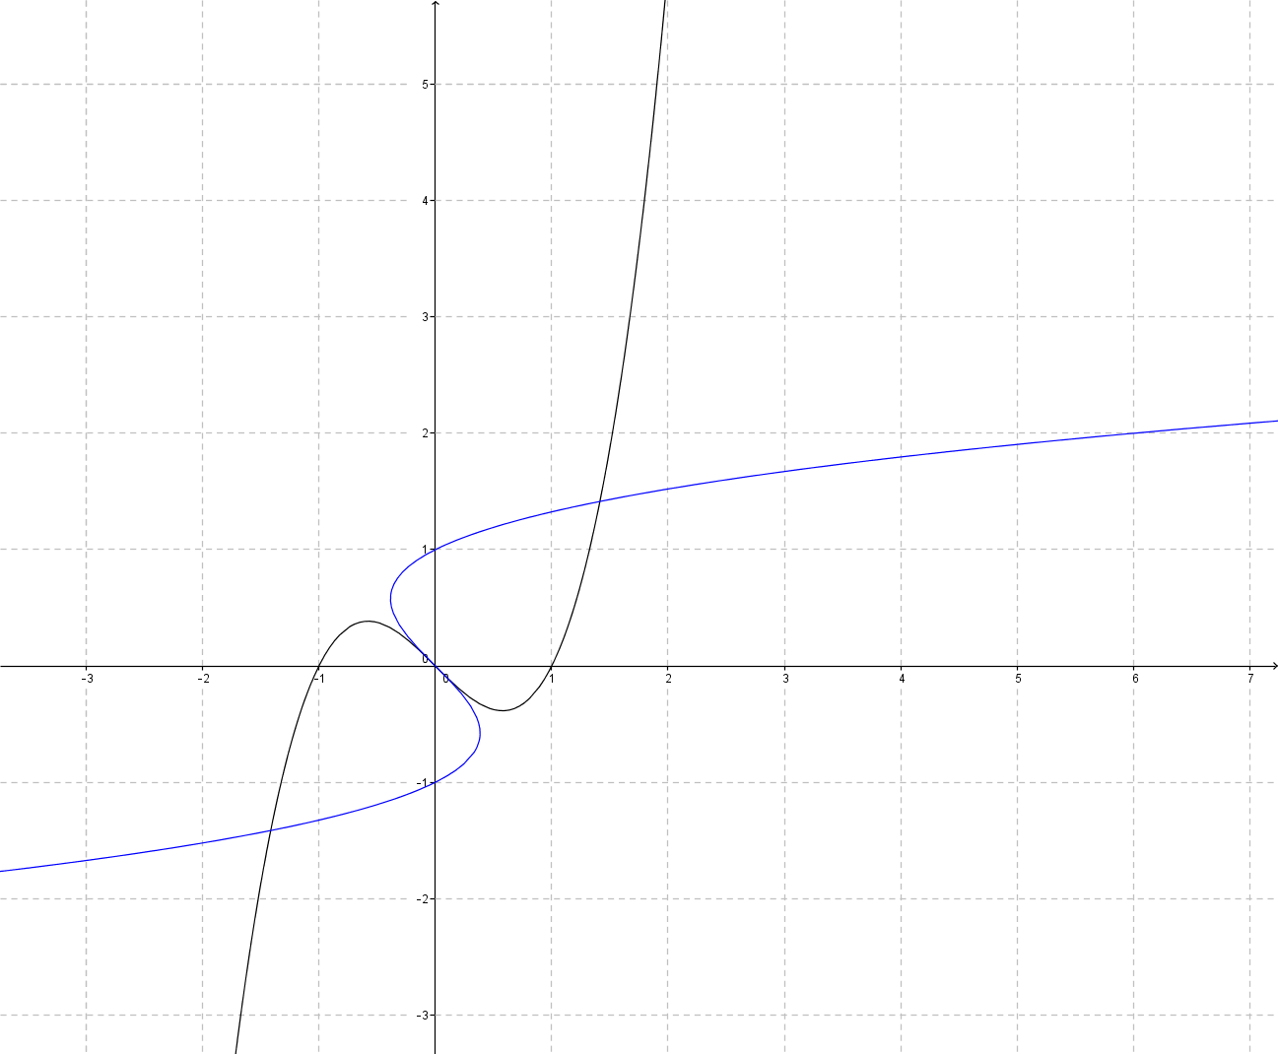
Not a function.

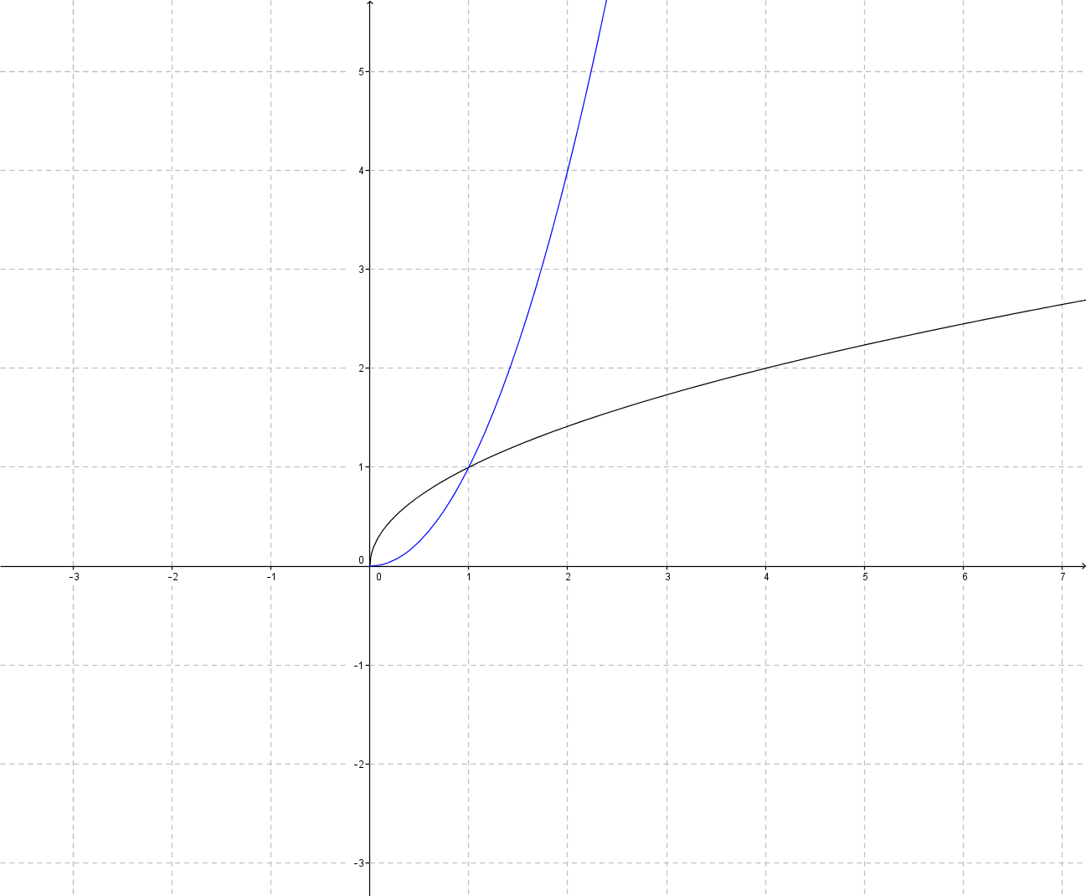
The reflected image is a function.

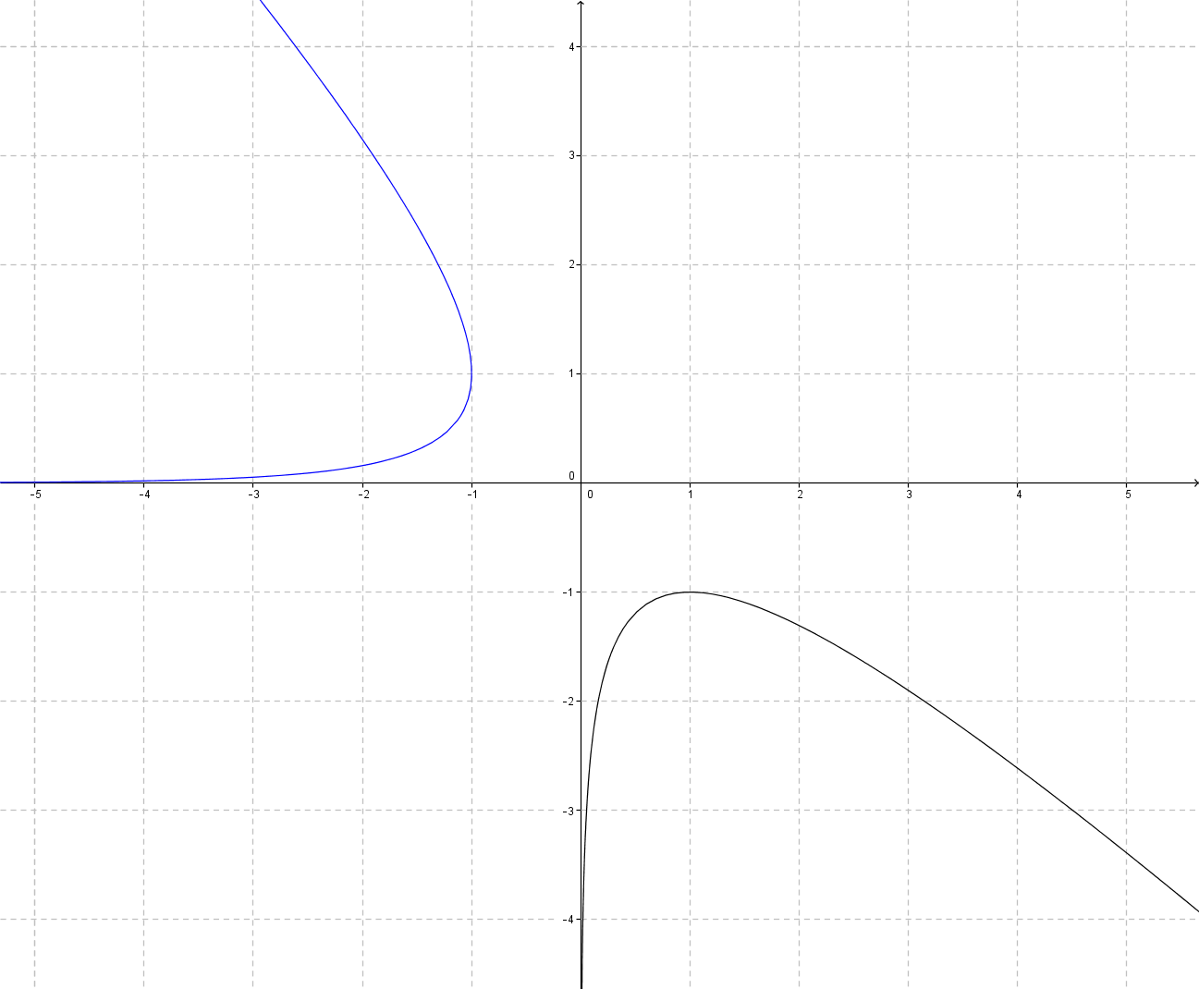
Not a function.

- How can you tell before you reflect a graph over $y=x$ if its reflection will be a function or not?
If the function is not one-to-one, then its reflection will not be a function. Algebraically, if $f\left(x_{1}\right)=f\left(x_{2}\right)$ and $x_{1}≠x_{2}$, then the reflection will not be a function. Visually, this takes on the shape of a horizontal line intersecting the graph at two points. If any horizontal line can intersect the graph of a function at two points, then the reflection of the graph over the line $y=x$ will not be a function.

- After finding several inverses, Callahan exclaims that every invertible linear function intersects its inverse at some point. What needs to be true about the linear functions that Callahan is working with for this to be true? What is true about linear functions that do not intersect their inverses?
The linear functions Callahan is working with must have slopes different from $1$ in order to intersect with their inverses, since this will guarantee that the functions will cross the $y=x$ line and that the inverses will intersect at $y=x,$ if they intersect at all. If a linear function is parallel to $y=x$, then it will not intersect the graph of its inverse function.

- If $f$ is an invertible function such that $f\left(x\right)>x$ for all $x$, then what do we know about the inverse of $f$?
Since the function is always above the line $y=x$, we know that its inverse will always be below the line $y=x$. In other words, $f^{-1}\left(x\right)<x$. We can also see this by substituting $y=f(x)$, which gives us $y>x$. Switching $x$ and $y$ to find the inverse, we get $x>y$ or $x>f^{-1}\left(x\right)$.

- Gavin purchases a new $\$2,995$ computer for his business, and when he does his taxes for the year, he is given the following information for deductions on his computer (this method is called MACRS—Modified Accelerated Cost Recovery System):
Period | Calculation for Deduction | Present Value
First Year | $$D_{1}=P_{0} / 5×200\%×50\%$$ | $$P_{0}-D_{1}=P_{1}$$
Second Year | $$D_{2 }=P_{1} / 5×200\%$$ | $$P_{1}-D_{2}=P_{2}$$
Third Year | $$D_{3}=P_{2} / 5×200\%$$ | $$P_{2}-D_{3}=P_{3}$$
Where $P_{0}$ represents the value of the computer new.
  - Construct a table for the function $D$, giving the deduction Gavin can claim in year $x$ for his computer,
$x=\{1, 2, 3\}$.
$$x$$ | $$1$$ | $$2$$ | $$3$$
$$D(x)$$ | $$599$$ | $$958.40$$ | $$575.04$$

  - Find the inverse of $D$.
$$x$$ | $$599$$ | $$958.40$$ | $$575.04$$
$$D^{-1}\left(x\right)$$ | $$1$$ | $$2$$ | $$3$$

  - Construct a table for the function $P$, giving the present value of Gavin’s computer in year $x$, $x=\{0, 1, 2, 3\}$.
$$x$$ | $$0$$ | $$1$$ | $$2$$ | $$3$$
$$P(x)$$ | $$2995$$ | $$2396$$ | $$1437.60$$ | $$862.56$$

  - Find the inverse of $P$.
$$x$$ | $$2995$$ | $$2396$$ | $$1437.60$$ | $$862.56$$
$$P^{-1}\left(x\right)$$ | $$0$$ | $$1$$ | $$2$$ | $$3$$

- Problem 9 used the MACRS method to determine the possible deductions Gavin could have for the computer he purchased. The straight-line method can be used also. Assume the computer has a salvage value of $\$500$ after $5$ years of use; call this value $S$. Then Gavin would be presented with this information when he does his taxes:
Period | Calculation for Deduction | Present Value
First Year | $$D_{1}=\left(P_{0}-S\right)/ 5×50\%$$ | $$P_{0}-D_{1}=P_{1}$$
Second Year | $$D_{2}=\left(P_{0}-S\right)/ 5$$ | $$P_{1}-D_{2}=P_{2}$$
Third Year | $$D_{3}=\left(P_{0}-S\right)/ 5$$ | $$P_{2}-D_{2}=P_{3}$$
Fourth Year | $$D_{4}=\left(P_{0}-S\right)/ 5$$ | $$P_{3}-D_{3}=P_{4}$$
Fifth Year | $$D_{5}=\left(P_{0}-S\right)/ 5$$ | $$S$$
  - Construct a table for the function $D$, giving the deduction Gavin can claim in year $x$ for his computer in $x=\left\{1,2,3,4,5\right\}$.
$$x$$ | $$1$$ | $$2$$ | $$3$$ | $$4$$ | $$5$$
$$D\left(x\right)$$ | $$249.50$$ | $$499$$ | $$499$$ | $$499$$ | $$499$$

  - What do you notice about the function for deduction in this problem compared to the function in Problem 9?
The deduction values are a lot lower, and after the first year they are constant.

  - If you are given the deduction that Gavin claims in a particular year using the straight-line method, is it possible for you to know what year he claimed it in? Explain. What does this tell us about the inverse of $D$?
Unless it is the first year, you cannot tell the year in which Gavin claimed a particular deduction just by knowing the deduction amount. Gavin should claim $\$499$ as a deduction every year except for the first year.

Extension
- For each function in Problem 1, verify that the functions are inverses by composing the function with the inverse you found (in each case, after applying both functions, you should end up with the original input).
  - $$f^{-1}\left(f\left(1\right)\right)=f^{-1}\left(3\right)=1 \\ f^{-1}\left(f\left(2\right)\right)=f^{-1}\left(15\right)=2 \\ f^{-1}\left(f\left(3\right)\right)=f^{-1}\left(8\right)=3 \\ f^{-1}\left(f\left(4\right)\right)=f^{-1}\left(-2\right)=4 \\ f^{-1}\left(f\left(5\right)\right)=f^{-1}\left(0\right)=5$$

  - $$f f^{-1} \\ 0→5→0 \\ 2→10→2 \\ 4→15→4 \\ 6→20→6$$

  - $$h\left(h^{-1}\left(5\right)\right)=h\left(1\right)=5 \\ h\left(h^{-1}\left(25\right)\right)=h\left(2\right)=25 \\ h\left(h^{-1}\left(125\right)\right)=h\left(3\right)=125 \\ h\left(h^{-1}\left(625\right)\right)=h\left(4\right)=625$$
  - $$f^{-1} f \\ 3→1→3 \\ 12→2→12 \\ 27→3→27 \\ 48→4→48$$

$$x$$ | $$3$$ | $$6$$ | $$12$$ | $$24$$
$$g^{-1}\left(x\right)$$ | $$-1$$ | $$0$$ | $$1$$ | $$2$$
$$g\left(g^{-1}\left(x\right)\right)$$ | $$3$$ | $$6$$ | $$12$$ | $$24$$

$$x$$ | $$1$$ | $$10$$ | $$100$$ | $$1000$$
$$h(x)$$ | $$0$$ | $$1$$ | $$2$$ | $$3$$
$$h^{-1}\left(h\left(x\right)\right)$$ | $$1$$ | $$10$$ | $$100$$ | $$1000$$

  - Let $y=f\left(x\right)$.
$$f^{-1}\left(f\left(x\right)\right)=\frac{1}{2}\left(2x\right) \\ =x$$

  - Let $y=f\left(x\right)$.
$$f^{-1}\left(f\left(x\right)\right)=3\left(\frac{1}{3}x\right) \\ =x$$

  - Let $y=f\left(x\right)$.
$$f^{-1}\left(f\left(x\right)\right)=\left(x-3\right)+3 \\ =x$$

  - Let $y=f\left(x\right)$.
$$f^{-1}\left(f\left(x\right)\right)=-\frac{3}{2}\left(-\frac{2}{3}x+5\right)+\frac{15}{2} \\ =x-\frac{15}{2}+\frac{15}{2} \\ =x$$

  - Let $y=f\left(x\right)$, then $f\left(x\right)=\frac{2}{5}x-\frac{1}{5}$, $f^{-1}\left(x\right)=\frac{5}{2}x+\frac{1}{2}$.
$$f^{-1}\left(f\left(x\right)\right)=\frac{5}{2}\left(\frac{2}{5}x-\frac{1}{5}\right)+\frac{1}{2} \\ =x-\frac{1}{2}+\frac{1}{2} \\ =x$$

  - Let $y=f\left(x\right)$, then $f\left(x\right)=\frac{3}{7}x+2$ and $f^{-1}\left(x\right)=\frac{7}{3}x-\frac{14}{3}$.
$$f^{-1}\left(f\left(x\right)\right)=\frac{7}{3}\left(\frac{3}{7}x+2\right)-\frac{14}{3} \\ =x+\frac{14}{3}-\frac{14}{3} \\ =x$$

  - Let $y=f\left(x\right)$.
$$f^{-1}\left(f\left(x\right)\right)=\sqrt[3]{3(\frac{1}{3}{\left(x-9\right)}^{3}}+9 \\ =\sqrt[3]{\left(1\right){\left(x-9\right)}^{3}}+9 \\ =x-9+9 \\ =x$$

  - Let $y=f\left(x\right)$.
$$f^{-1}\left(f\left(x\right)\right)=\frac{5}{3\left(\frac{5}{3x-4}\right)}+\frac{4}{3} \\ =\frac{5}{3}⋅\frac{3x-4}{5}+\frac{4}{3} \\ =\frac{3x-4}{3}+\frac{4}{3} \\ =\frac{3x-4+4}{3} \\ =\frac{3x}{3} \\ =x$$

  - Let $y=f\left(x\right)$.
$$f^{-1}\left(f\left(x\right)\right)=\sqrt[7]{\frac{1}{2}\left(2x^{7}+1\right)-\frac{1}{2}} \\ =\sqrt[7]{x^{7}+\frac{1}{2}-\frac{1}{2}} \\ =\sqrt[7]{x^{7}} \\ =x$$

  - Let $y=f\left(x\right)$.
$$f^{-1}\left(f\left(x\right)\right)={\left(\sqrt[5]{x}\right)}^{5} \\ =x$$

  - Let $y=f\left(x\right)$.
$$f^{-1}\left(f\left(x\right)\right)=\frac{\frac{x+1}{x-1}+1}{\frac{x+1}{x-1}-1} \\ =\frac{\frac{x+1}{x-1}+\frac{x-1}{x-1}}{\frac{x+1}{x-1}-\frac{x-1}{x-1}} \\ =\frac{x+1+x-1}{x-1}÷\frac{x+1-\left(x-1\right)}{x-1} \\ =\frac{2x}{x-1}⋅\frac{x-1}{2} \\ =x$$

