Lesson 18: Inverse Functions

Classwork
Businesses must track the value of their assets over time. When a business buys equipment, the value of the equipment is reduced over time. For example, electric companies provide trucks for their workers when they go out into the field to repair electrical lines. These trucks lose value over time but are still part of the business assets. For accounting purposes, many businesses use a technique called straight-line depreciation to calculate the value of equipment over time.

Exercises
Suppose ABC Electric purchases a new work truck for $\$34,500$. They estimate that the truck’s value will depreciate to $\$0$ over $15$ years. The table below shows the value $v(t)$ of the truck in thousands of dollars depreciated over time $t$ in months using a straight-line depreciation method.
$$t$$ | $$0$$ | $$12$$ | $$24$$ | $$36$$ | $$48$$ | $$60$$ | $$72$$ | $$84$$ | $$96$$
$$v(t)$$ | $$34.5$$ | $$32.2$$ | $$29.9$$ | $$27.6$$ | $$25.3$$ | $$23.0$$ | $$20.7$$ | $$18.4$$ | $$16.1$$
- Does the function $v$ appear to be a linear function? Explain your reasoning.

- What is an appropriate domain and range for $v$ in this situation?

- Write a formula for $v$ in terms of $t,$ the months since the truck was purchased.

- What will the truck be worth after $30$ months? $40$ months? $50$ months?

- When will the truck be valued at $\$30,000$? $\$20,000$? $\$10,000?$

- Construct a table that shows the time of depreciation, $t\left(v\right),$ in months as a function of the value of the truck, $v,$ in thousands of dollars.

- Does the function $t$ appear to be a linear function? Explain your reasoning.

- What is an appropriate domain and range for $t$ in this situation?

- Write a formula for $t$ in terms of the value of the truck, $v$, since it was purchased.

- Explain how you can create the formula for $t$ using the formula for $v$ from Exercise 5.

- Sketch a graph of the equations $y=v(t)$ and $y=t(v)$ in the Cartesian plane. How do their graphs compare?

- What is the meaning of the intersection point of the graphs of the two equations?

- Add the graph of $y=x$ to your work in Exercise 11. Describe the relationship between the graphs of $y=v(t)$,
$y=t\left(v\right),$ and $y=x$.

- ABC Electric uses this formula, $f\left(x\right)=750-10x,$ to depreciate computers, where $f$ is the value of a computer and $x$ is the number of months since its purchase.
  - Calculate$f(36)$. What is the meaning of $f(36)$?

  - What is the meaning of $b$ in $f\left(b\right)=60$? What is the value of $b$?

  - Write a formula for $f^{-1},$ and explain what it means in this situation.

  - When will the depreciated value of a computer be less than $\$400$?

  - What is the meaning of $c$ in $f^{-1}\left(c\right)=60$? What is the value of $c$?

- Find the inverses of the following functions.
  - $f\left(x\right)=\frac{2}{3}x-10$

  - $g\left(x\right)=2{\left(x+4\right)}^{3}$

  - $h\left(x\right)=\frac{1}{x-2},x≠2$

Lesson Summary
- Invertible Function: Let $f$ be a function whose domain is the set $X$ and whose image (range) is the set $Y$. Then $f$ is invertible if there exists a function $g$ with domain $Y$ and image (range) $X$ such that $f$ and $g$ satisfy the property:
For all $x$ in $X$ and $y$ in $Y$, $f(x) = y$ if and only if $g(y)=x$.
The function $g$ is called the inverse of $f$.
- If two functions whose domain and range are a subset of the real numbers are inverses, then their graphs are reflections of each other across the diagonal line given by $y=x$in the Cartesian plane.
- If $f$ and $g$ are inverses of each other, then
  - The domain of $f$ is the same set as the range of $g$.
  - The range of $f$ is the same set as the domain of $g$.
- The inverse of a function $f$ is denoted $f^{-1}$.
- In general, to find the formula for an inverse function $g$ of a given function $f$:
  - Write $y=f(x)$ using the formula for $f$.
  - Interchange the symbols $x$ and $y$ to get $x=f(y)$.
  - Solve the equation for $y$ to write $y$ as an expression in $x$.
- Then, the formula for $f^{-1}$ is the expression in $x$ found in the previous step.

Problem Set

- For each of the following, write the inverse of the function given.
  - $f=\left\{\left(1,3\right), \left(2,15\right), \left(3,8\right), \left(4,-2\right), \left(5,0\right)\right\}$
  - $g=\left\{\left(0,5\right),\left(2,10\right),\left(4,15\right),\left(6,20\right)\right\}$
  - $h=\left\{\left(1,5\right),\left(2,25\right),\left(3,125\right), \left(4,625\right)\right\}$

$$x$$ | $$1$$ | $$2$$ | $$3$$ | $$4$$
$$f\left(x\right)$$ | $$3$$ | $$12$$ | $$27$$ | $$48$$

$$x$$ | $$-1$$ | $$0$$ | $$1$$ | $$2$$
$$g\left(x\right)$$ | $$3$$ | $$6$$ | $$12$$ | $$24$$

$$x$$ | $$1$$ | $$10$$ | $$100$$ | $$1000$$
$$h(x)$$ | $$0$$ | $$1$$ | $$2$$ | $$3$$
  - $y=2x$
  - $y=\frac{1}{3}x$
  - $y=x-3$
  - $y=-\frac{2}{3}x+5$
  - $2x-5y=1$
  - $-3x+7y=14$
  - $y=\frac{1}{3}{\left(x-9\right)}^{3}$
  - $y=\frac{5}{3x-4}, x≠\frac{4}{3}$
  - $y=2x^{7}+1$
  - $y=\sqrt[5]{x}$
  - $y=\frac{x+1}{x-1}, x≠1$

- For each part in Problem 1, state the domain, $D$, and range, $R$, of the inverse function.

- Sketch the graph of the inverse function for each of the following functions.

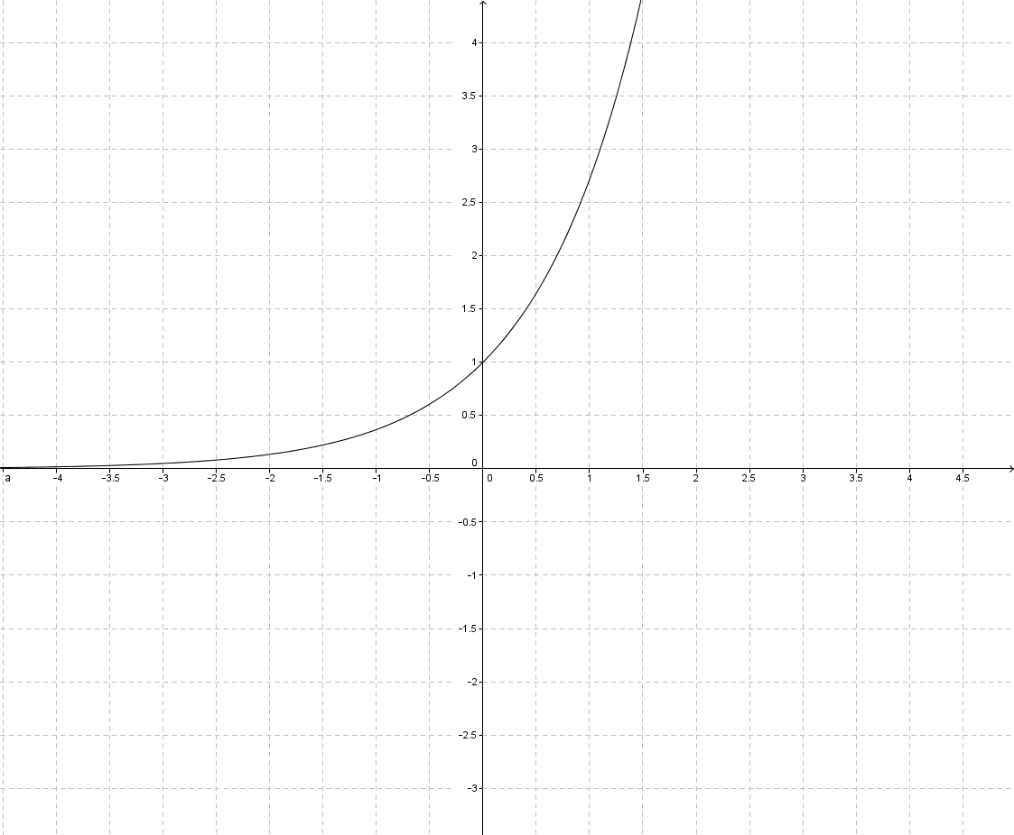

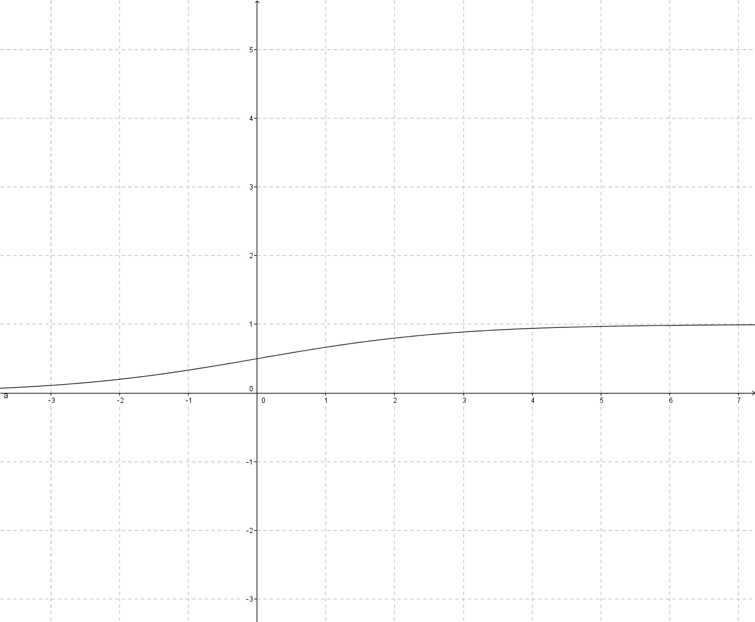

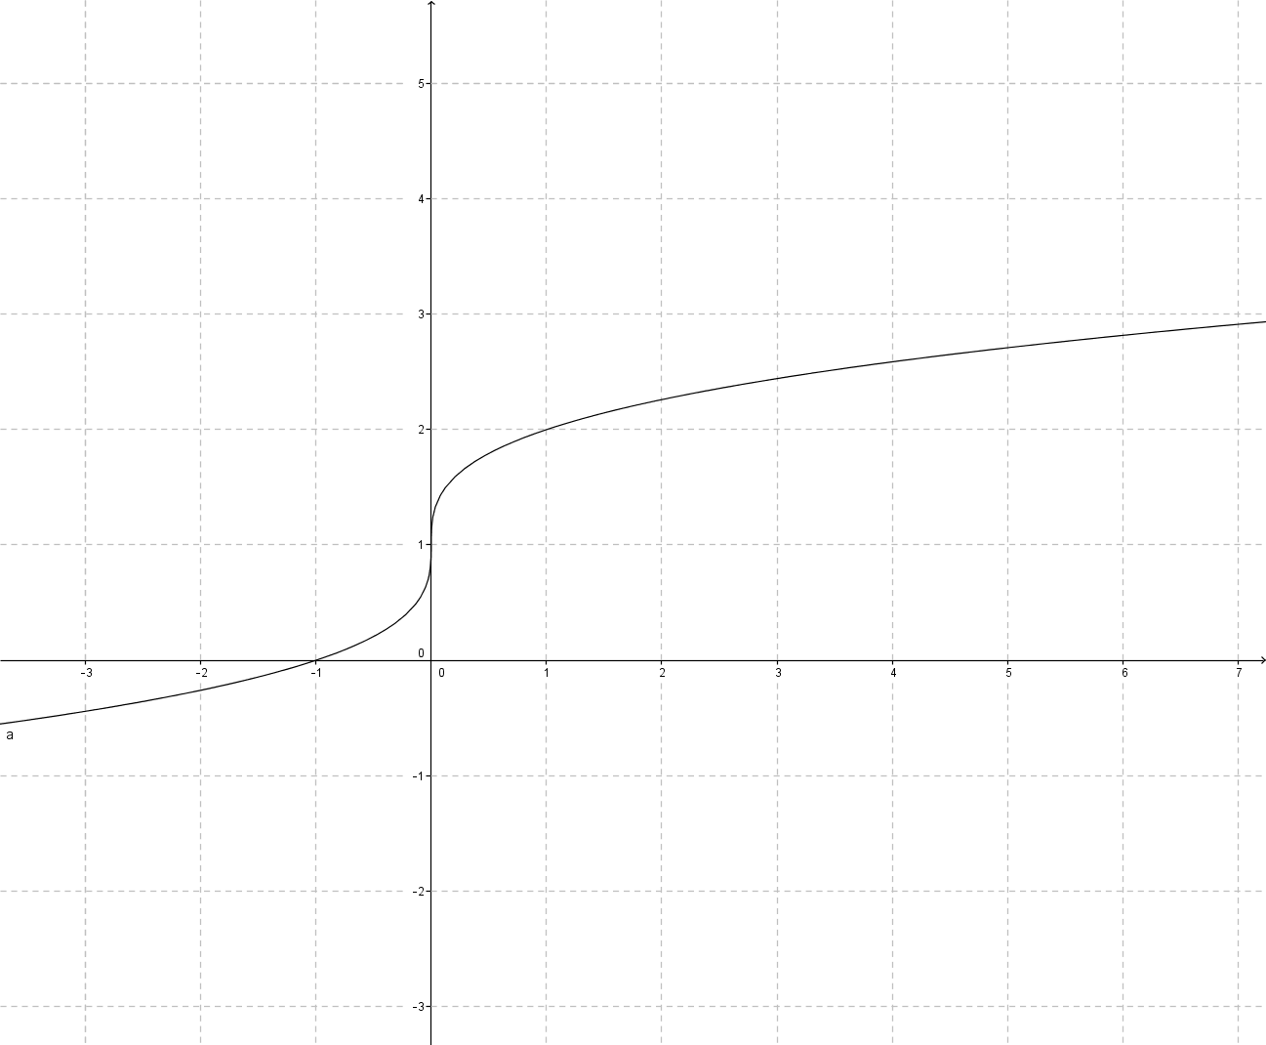

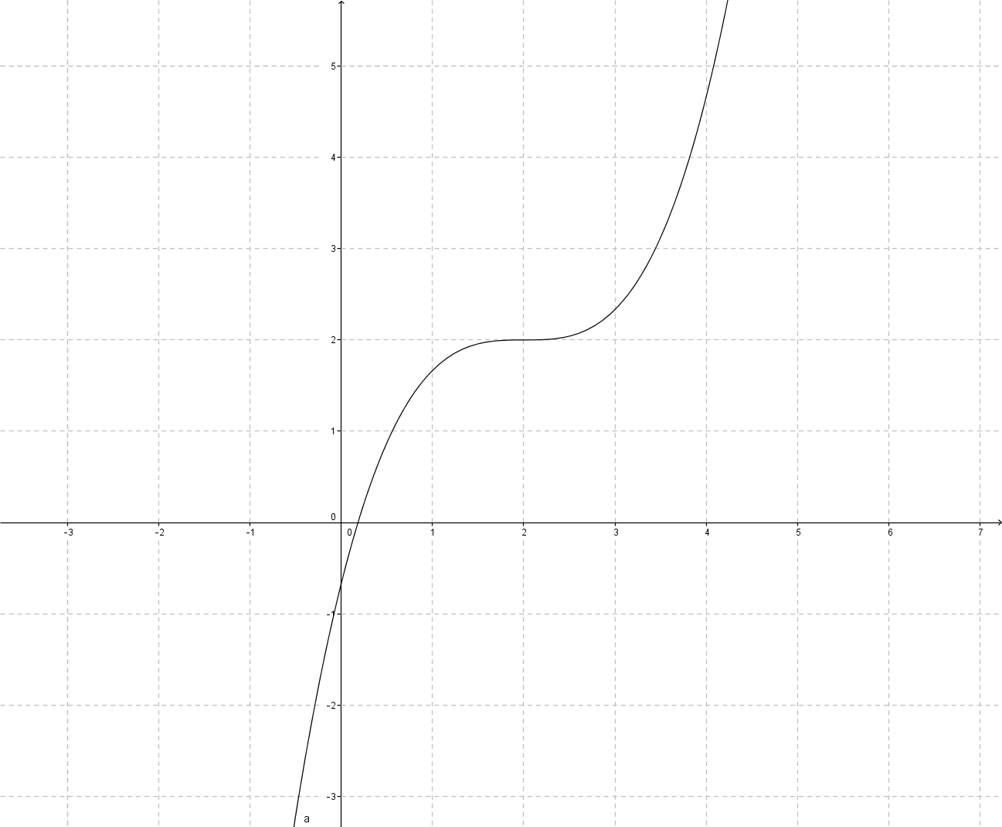

- Natalie thinks that the inverse of $f\left(x\right)=x-5$ is $g\left(x\right)=5-x$. To justify her answer, she calculates $f\left(5\right)=0$ and then finds $g\left(0\right)=5$, which gives back the original input.
  - What is wrong with Natalie’s reasoning?
  - Show that Natalie is incorrect by using other examples from the domain and range of $f$.
  - Find $f^{-1}(x)$. Where do $f^{-1}\left(x\right)$ and $g\left(x\right)$ intersect?

- Sketch a graph of the inverse of each function graphed below by reflecting the graph about the line $y=x$. State whether or not the inverse is a function.

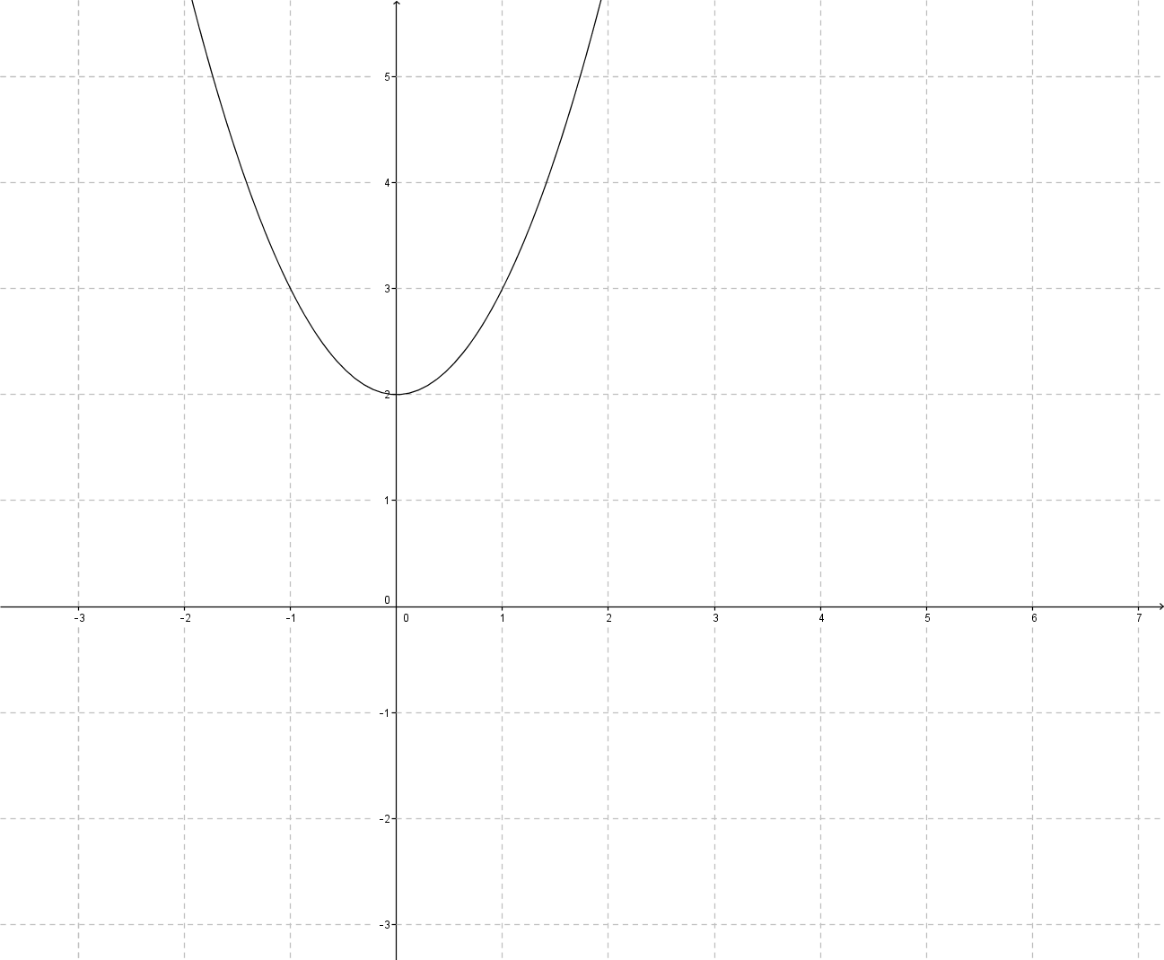

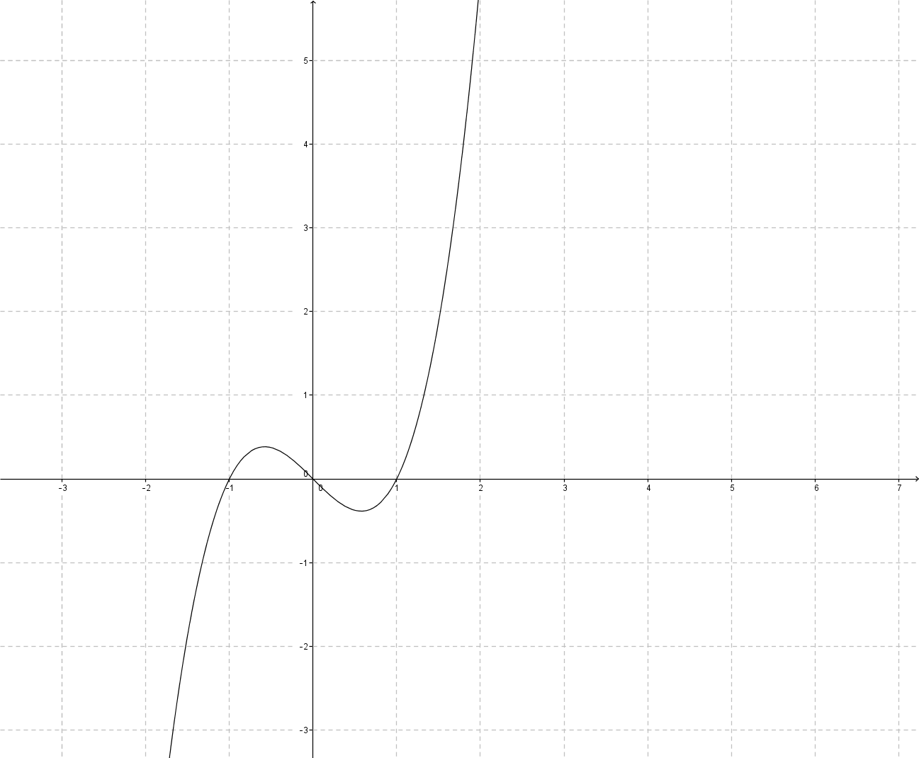

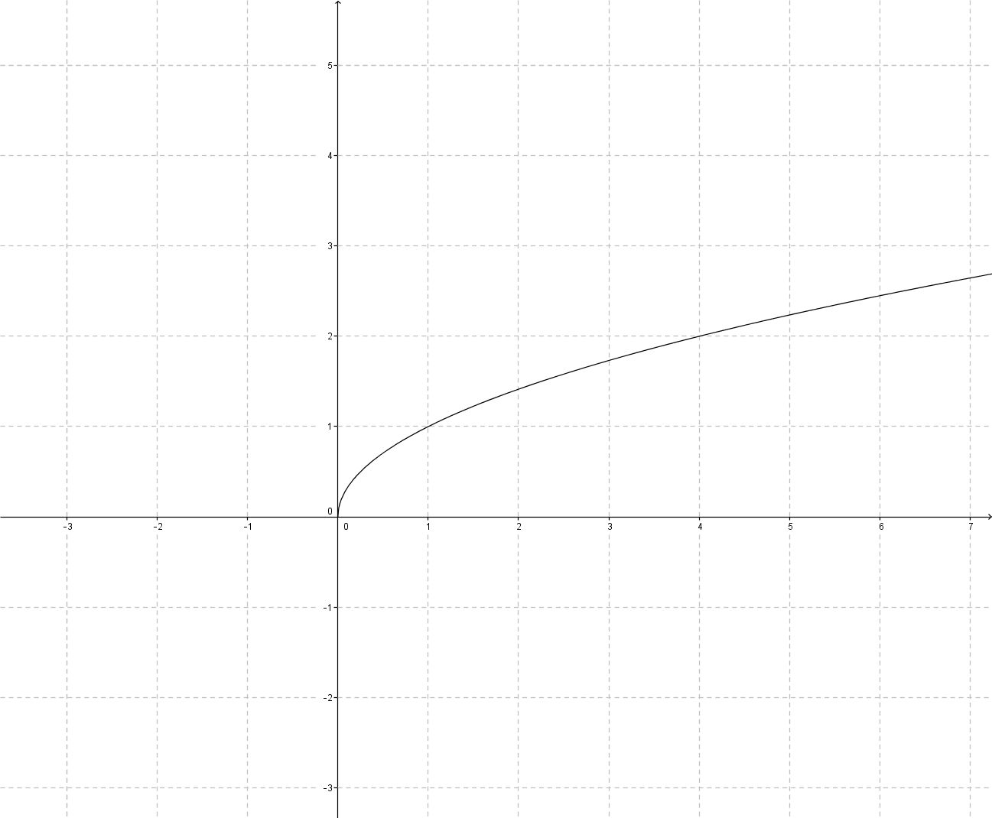

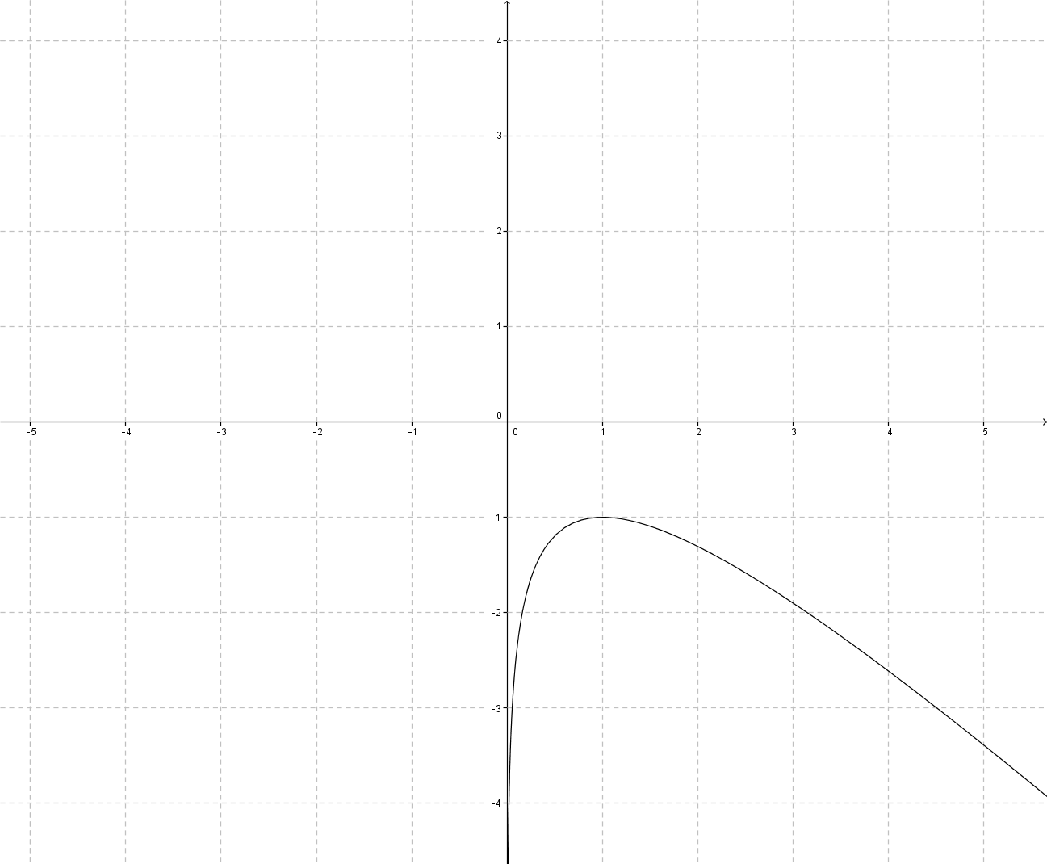

- How can you tell before you reflect a graph over $y=x$ if its reflection will be a function or not?

- After finding several inverses, Callahan exclaims that every invertible linear function intersects its inverse at some point. What needs to be true about the linear functions that Callahan is working with for this to be true? What is true about linear functions that do not intersect their inverses?
- If $f$ is an invertible function such that $f\left(x\right)>x$ for all $x$, then what do we know about the inverse of $f$?

- Gavin purchases a new $\$2,995$ computer for his business, and when he does his taxes for the year, he is given the following information for deductions on his computer (this method is called MACRS—Modified Accelerated Cost Recovery System):
Period | Calculation for Deduction | Present Value
First Year | $$D_{1}=P_{0} / 5×200\%×50\%$$ | $$P_{0}-D_{1}=P_{1}$$
Second Year | $$D_{2 }=P_{1} / 5×200\%$$ | $$P_{1}-D_{2}=P_{2}$$
Third Year | $$D_{3}=P_{2} / 5×200\%$$ | $$P_{2}-D_{3}=P_{3}$$
Where $P_{0}$ represents the value of the computer new.
  - Construct a table for the function $D$, giving the deduction Gavin can claim in year $x$ for his computer, $x=\{1, 2, 3\}$.
  - Find the inverse of $D$.
  - Construct a table for the function $P$, giving the present value of Gavin’s computer in year $x$, $x=\{0, 1, 2, 3\}$.
  - Find the inverse of $P$.

- Problem 9 used the MACRS method to determine the possible deductions Gavin could have for the computer he purchased. The straight-line method can be used also. Assume the computer has a salvage value of $\$500$ after $5$ years of use; call this value $S$. Then Gavin would be presented with this information when he does his taxes:
Period | Calculation for Deduction | Present Value
First Year | $$D_{1}=\left(P_{0}-S\right)/ 5×50\%$$ | $$P_{0}-D_{1}=P_{1}$$
Second Year | $$D_{2}=\left(P_{0}-S\right)/ 5$$ | $$P_{1}-D_{2}=P_{2}$$
Third Year | $$D_{3}=\left(P_{0}-S\right)/ 5$$ | $$P_{2}-D_{2}=P_{3}$$
Fourth Year | $$D_{4}=\left(P_{0}-S\right)/ 5$$ | $$P_{3}-D_{3}=P_{4}$$
Fifth Year | $$D_{5}=\left(P_{0}-S\right)/ 5$$ | $$S$$
  - Construct a table for the function $D$, giving the deduction Gavin can claim in year $x$ for his computer in $x=\left\{1,2,3,4,5\right\}$.
  - What do you notice about the function for deduction in this problem compared to the function in Problem 9?
  - If you are given the deduction that Gavin claims in a particular year using the straight-line method, is it possible for you to know what year he claimed it in? Explain. What does this tell us about the inverse of $D$?

Extension
- For each function in Problem 1, verify that the functions are inverses by composing the function with the inverse you found (in each case, after applying both functions, you should end up with the original input).

