|  |
| --- |
|  |

Lesson 15: Transforming Rational Functions

Student Outcomes

* Students graph transformations of functions in the form

Lesson Notes

This lesson follows the pattern used in both Algebra I and Algebra II: Introduce a new type of function, and then transform it. In this way, a coherent connection is being made between transformational geometry and functions. Students have done this with a variety of functions including linear, quadratic, cubic, square root, cube root, exponential, logarithmic, and trigonometric functions. In this lesson, students will explore transformations of the functions   
with the main emphasis being on the functions and . Students will need to recall how to rewrite rational expressions in an equivalent form which they learned in Algebra II (see Module 1, Lesson 22). Graphing is not as precise as it was in the previous two lessons. The focus here is on the transformations. Students should show the correct vertical and horizontal asymptotes, but it is not necessary for them to show exact points on the graph.

Classwork

Exploratory Challenge/Exercises 1–2 (7 minutes)

Give students time to work on the Exploration in groups. Students can use graphing calculators and change the value of in the function , or if computers are available, students could use a free online graphing calculator. The graph shown below can be created ahead of time and saved, or the students can generate it very quickly. They can then use the slider to explore various values of . Make sure that students have the correct graphs before they move on to the next set of exercises. If technology is not available, students can graph the functions by hand. Assign different groups different values of n in order to produce a variety of functions.

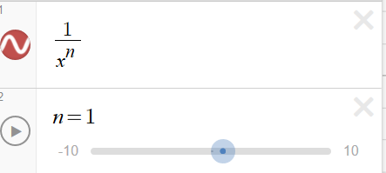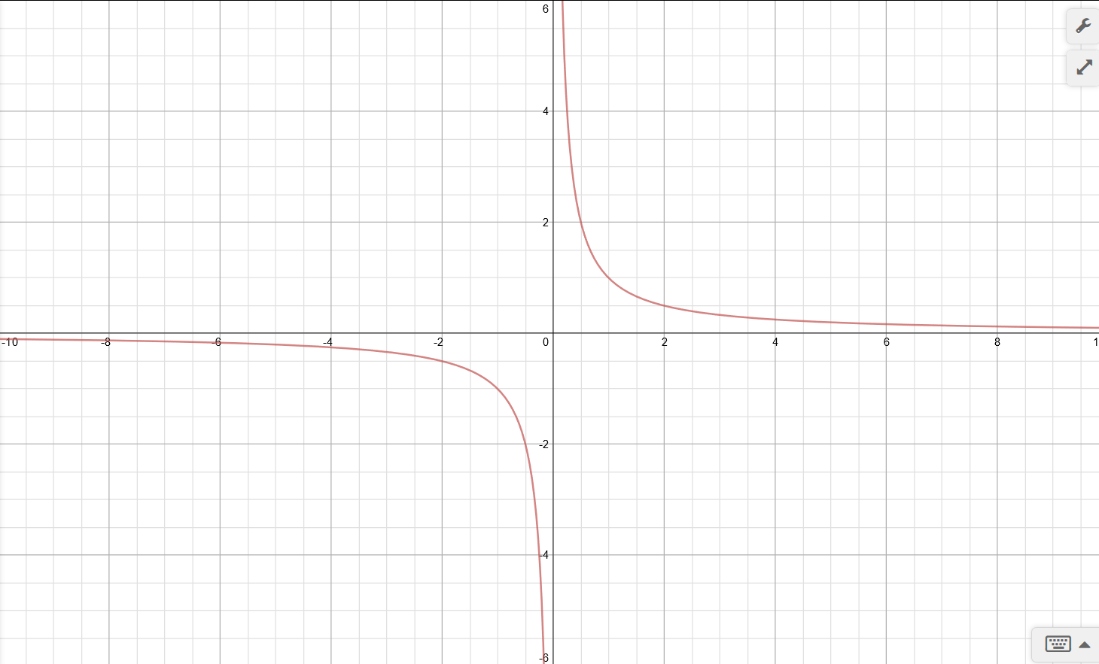

Exercises 1–5

**MP.7**

**&**

**MP.8**

1. Sketch the general shape of the graph of the function for   
   when is an odd number.

*Scaffolding:*

If students are struggling, use dynamic graphing software to explore the effects of the various parameters on the graph of the function.

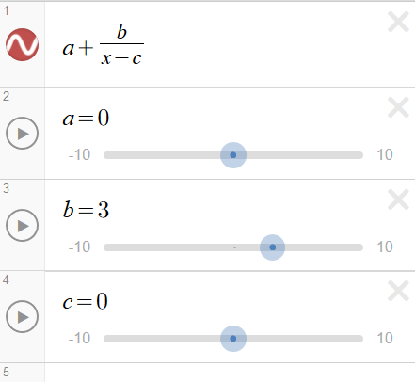

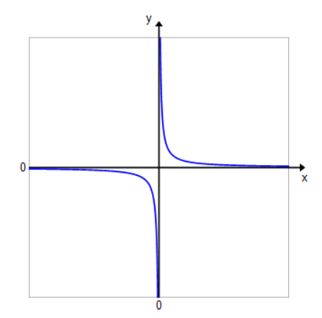

1. Sketch the general shape of the graph of the function for   
   when is an even number.

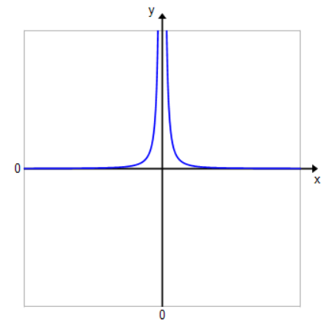

As a challenge opportunity, ask students to explain why they believe these patterns hold.

Exercises 3–5 (10 minutes)

Allow students time to work in groups on the next set of exercises. Consider letting students use a graphing calculator or software to check their graphs, but make sure they are sketching the graphs first without using technology.

1. Sketch the graph of the function . Then, use the graph of to sketch each transformation of showing the vertical and horizontal asymptotes.



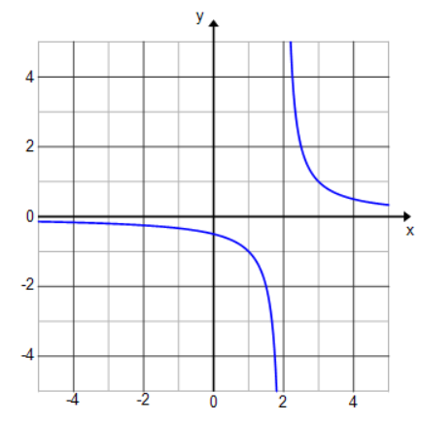

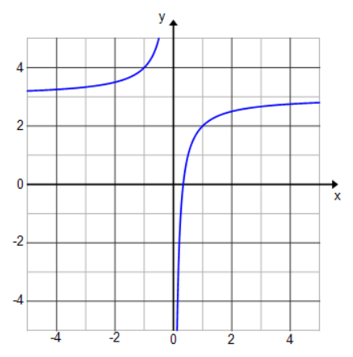

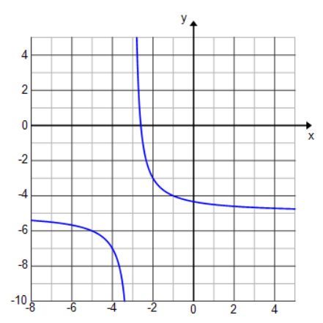

1. Use your results from Exercise 3 to make some general statements about graphs of functions in the form  
   . Describe the effect that changing each parameter has on the graph of

**MP.7**

**&**

**MP.8**

represents the vertical shift. A positive value of will shift the graph up units, and a negative value will shift the graph down units. The horizontal asymptote will be represents the horizontal shift.   
A positive value of will shift the graph right units, and a negative value will shift the graph left units. The vertical asymptote will be represents the vertical scaling. For values of such that , the graph will stretch vertically. For values of such that , the graph will compress vertically. When is negative, the graph will reflect across the -axis.

1. Sketch the graph of the function . Then, use the graph of to sketch each transformation of showing the vertical and horizontal asymptotes.



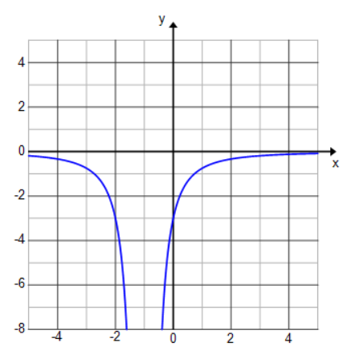

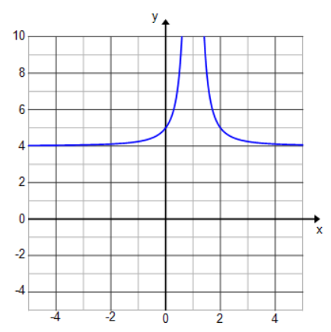

* Since we were not plotting any precise points, what was the easiest way to track the transformations?
* *By shifting the vertical and horizontal asymptotes. The horizontal shift tells us the new vertical asymptote, and the vertical shift tells us the new horizontal asymptote.*

Example 1 (5 minutes)

Lead students through a review of rewriting a rational expression into an equivalent form. Then, have students sketch the graph using transformations of functions.

* Can we use transformations to graph in the form given?
  + *No. It is not in a form where we can use the graph of to graph*
* Could we rewrite into an equivalent form? Lead students to the idea that we want the function to be in the form .

Example 1

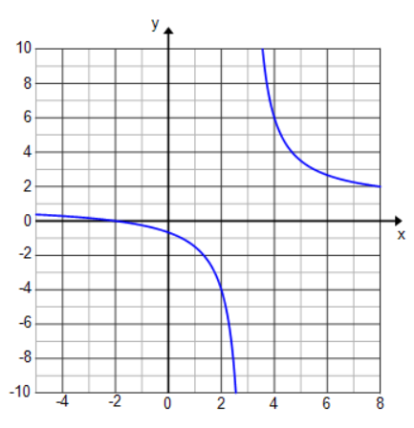Graph the function using transformations of the graph of

Exercises 6–13 (15 minutes)

Allow students time to work in groups on the next set of exercises. Students may need to be reminded about completing the square on Exercise 9.

Exercises 6–13

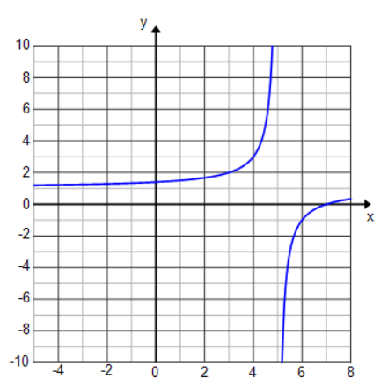Sketch each function by using transformations of the graph of or the graph of . Explain the transformations that are evident in each example.

The graph is shifted right units.

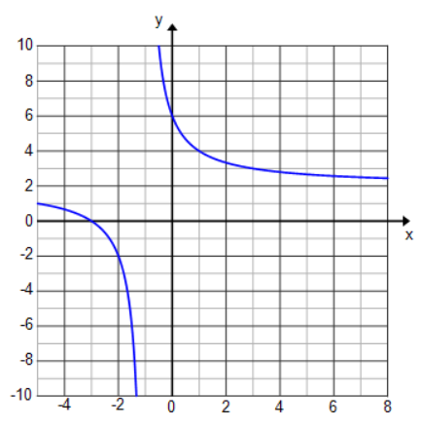

The graph is shifted left unit and up units.

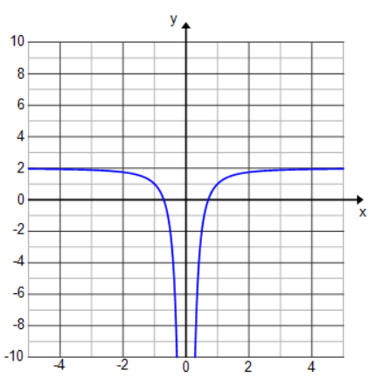The graph is shifted up units, and both branches are going down.

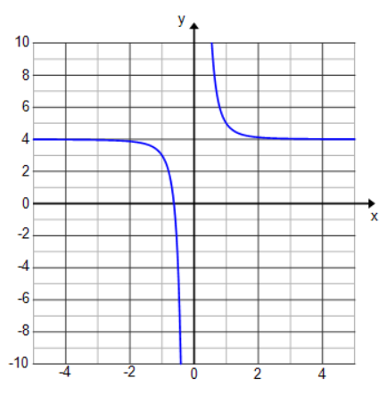

The graph is shifted up units.

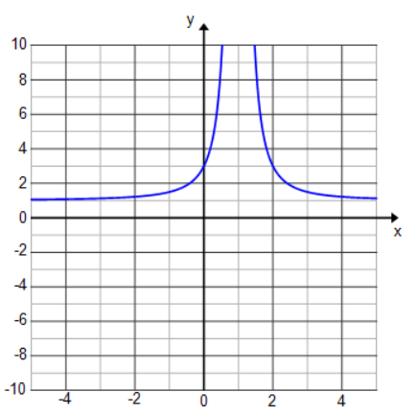

The graph is shifted right unit and up unit. Both branches go up.

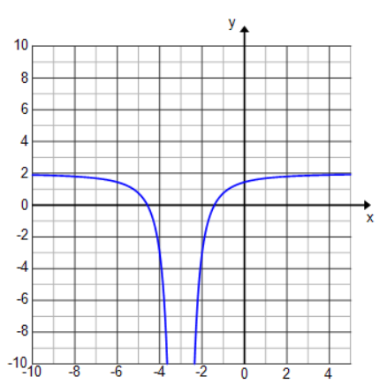

The graph is shifted left units and up units. Both branches go down.

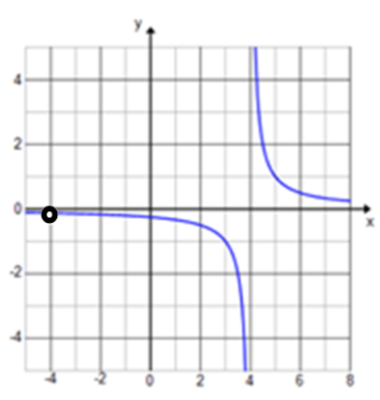

,

The graph is shifted right units, and there is a value missing at .

1. 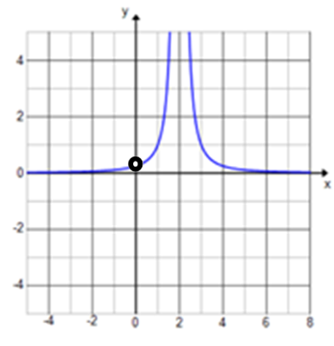

,

The graph is shifted right units, and there is a value missing at .

Both branches go up.

**MP.7**

* What technique did you use to rewrite the function in Exercise 6 so that transformations could be used to sketch the graph? (Note: Show different approaches.)
  + *I used long division. I expanded into .*
* What technique did you use to rewrite the function in Exercise 9?
  + *I completed the square in the numerator so that it was in the form and then separated the expression into two terms.*
* How did Exercises 11 and 12 differ from the other exercises?
  + *They could both be rewritten as a simpler function by reducing the common factors in the numerator and denominator.*

Closing (3 minutes)

* Describe the effect changing each parameter has on the graph of
  + *represents the vertical shift. A positive value of will shift the graph up units, and a negative value will shift the graph down units. The horizontal asymptote will be represents the horizontal shift. A positive value of will shift the graph right units, and a negative value will shift the graph left units. The vertical asymptote will be represents the vertical scaling. For values of such that , the graph will stretch vertically. For values of such that , the graph will compress vertically. When is negative, the graph will reflect across the -axis.*
* Describe the effect of the parameter on the graph of
  + *When is odd, both branches go in opposite directions toward the vertical asymptote. When is even, both branches go in the same direction toward the vertical asymptote.*
* How did the approach we took to graphing rational functions in this lesson differ from the previous two lessons?
  + *We used transformations rather than an analysis of the key features of the graph. We graphed less precisely, using transformations rather than exact points on the graph.*

Exit Ticket (5 minutes)

Name Date

Lesson 15: Transforming Rational Functions

Exit Ticket

Sketch the graph of the function given below by using transformations of . Explain which transformations you used and how you identified them.



Exit Ticket Sample Solutions

Sketch the graph of the function given below by using transformations of . Explain which transformations you used and how you identified them.

By rewriting the function into the form , I saw that the graph was shifted right 3 units, stretched vertically by a factor of 2, and shifted down 3 units.

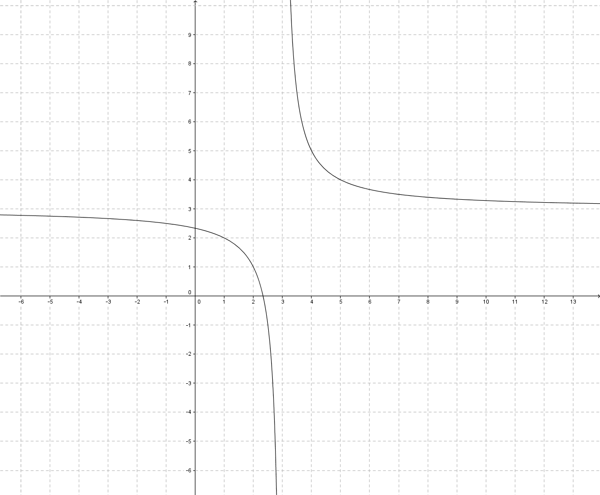

Problem Set Sample Solutions

1. Write each function so that it appears to be a transformation of . Then, explain how the graph of each function relates to the graph of .

The graph would be the graph of shifted left 2units, stretched vertically by a scale factor of 18, reflected across the -axis, and shifted up units.

The graph would be the graph of stretched vertically by a scale factor of , reflected across the -axis, and shifted up 2units.

The graph would be the graph of shifted right units, stretched vertically by a scale factor of , reflected across the -axis, and shifted up unit.

The graph would be the graph of shifted left units and stretched vertically by a scale factor of . The point at would be missing from the graph.

The graph would be the graph of shifted left units, stretched vertically by a scale factor of , reflected across the -axis, and shifted up units.

1. For each function in Problem 1, state how the horizontal and vertical asymptotes are affected from the original graph of .
   1. The horizontal asymptote is moved up ; the vertical asymptote is moved to the left.
   2. The horizontal asymptote is moved up ; the vertical asymptote is unchanged.
   3. The horizontal asymptote is moved up ; the vertical asymptote is moved to the right .
   4. The horizontal asymptote is unchanged; the vertical asymptote is moved to the left .
   5. The horizontal asymptote is moved up ; the vertical asymptote is moved to the left .
2. Sketch a picture of the graph of each function in Problem 1.

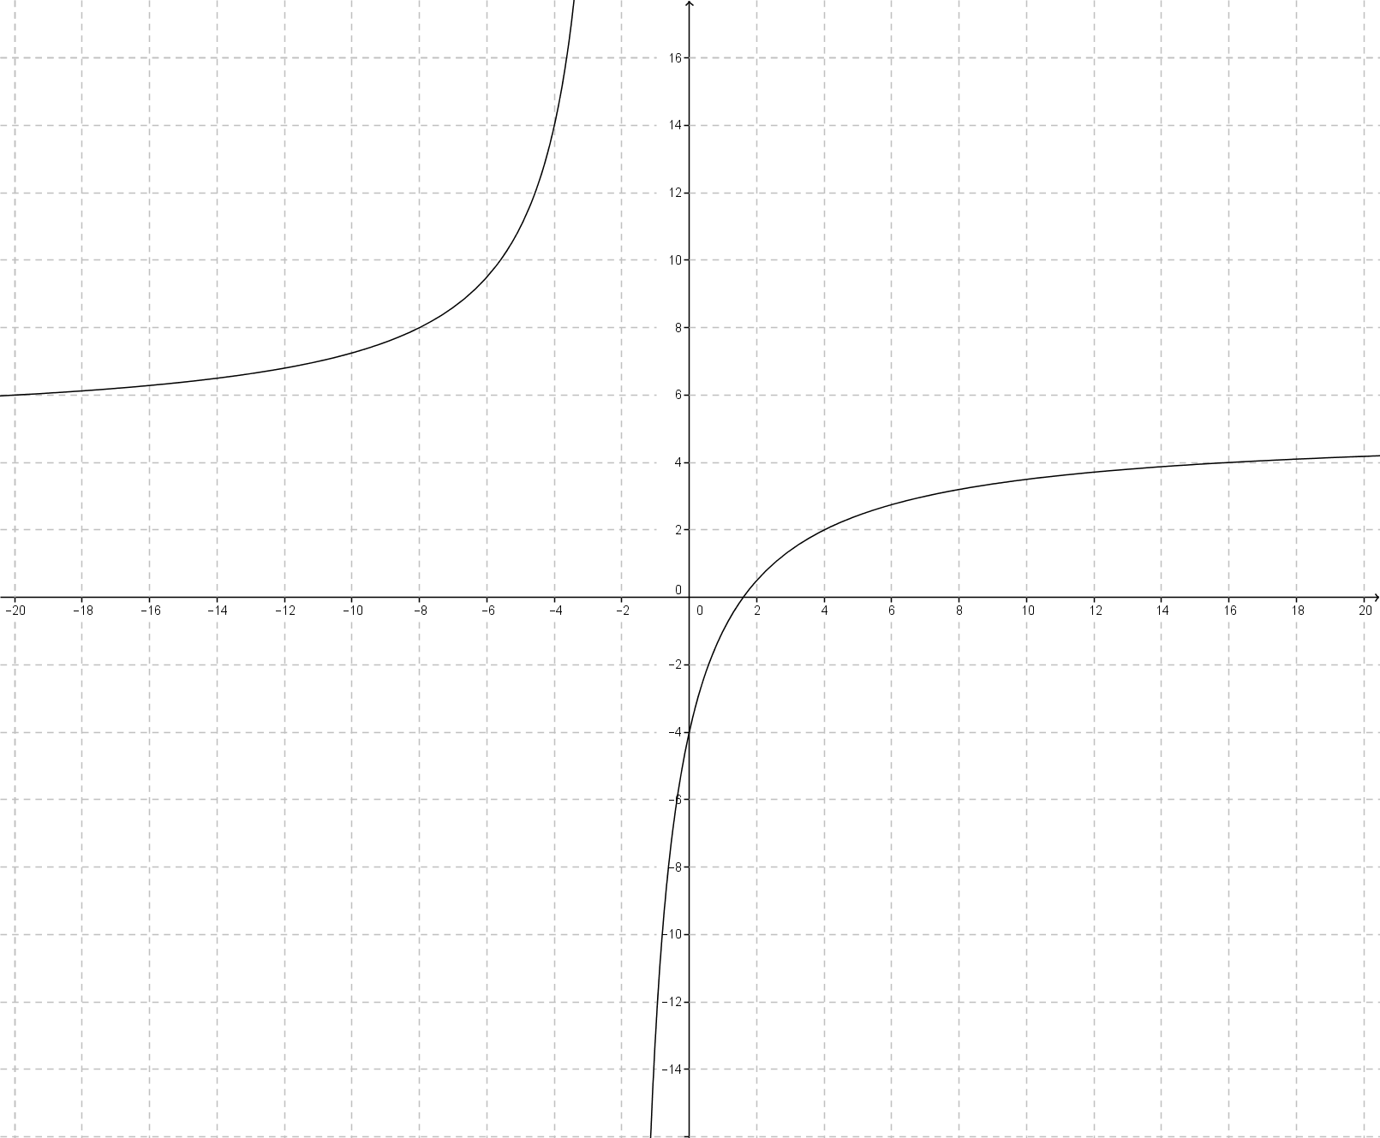

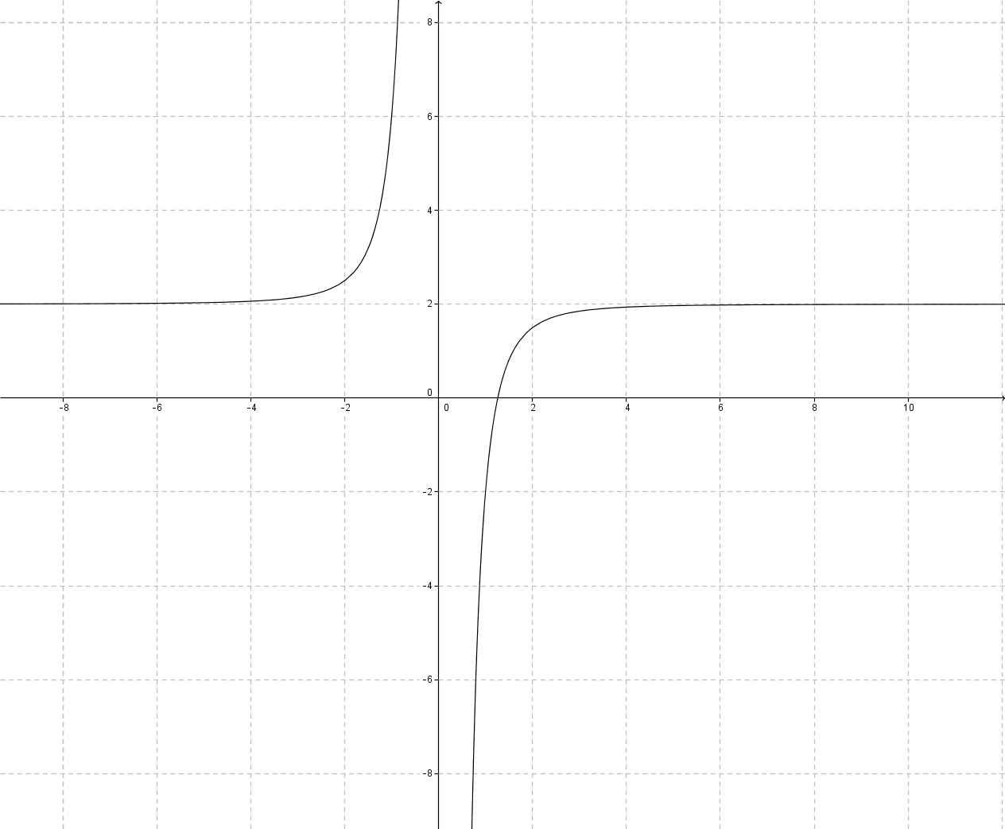

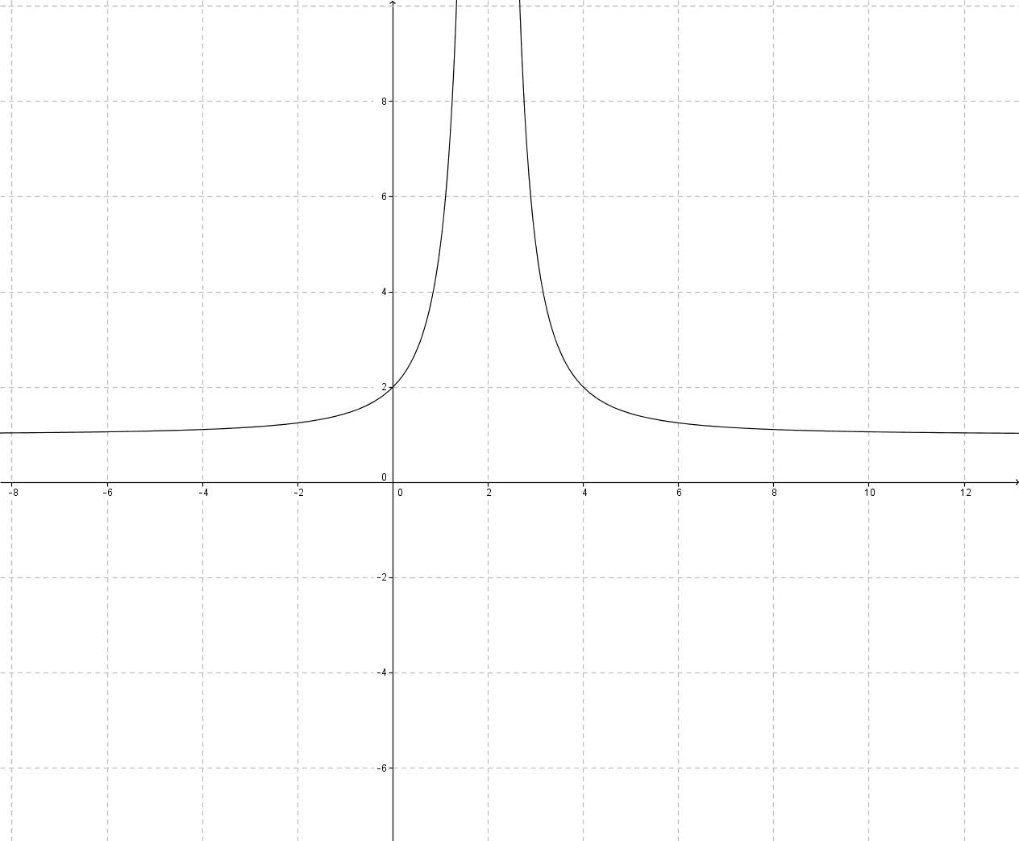

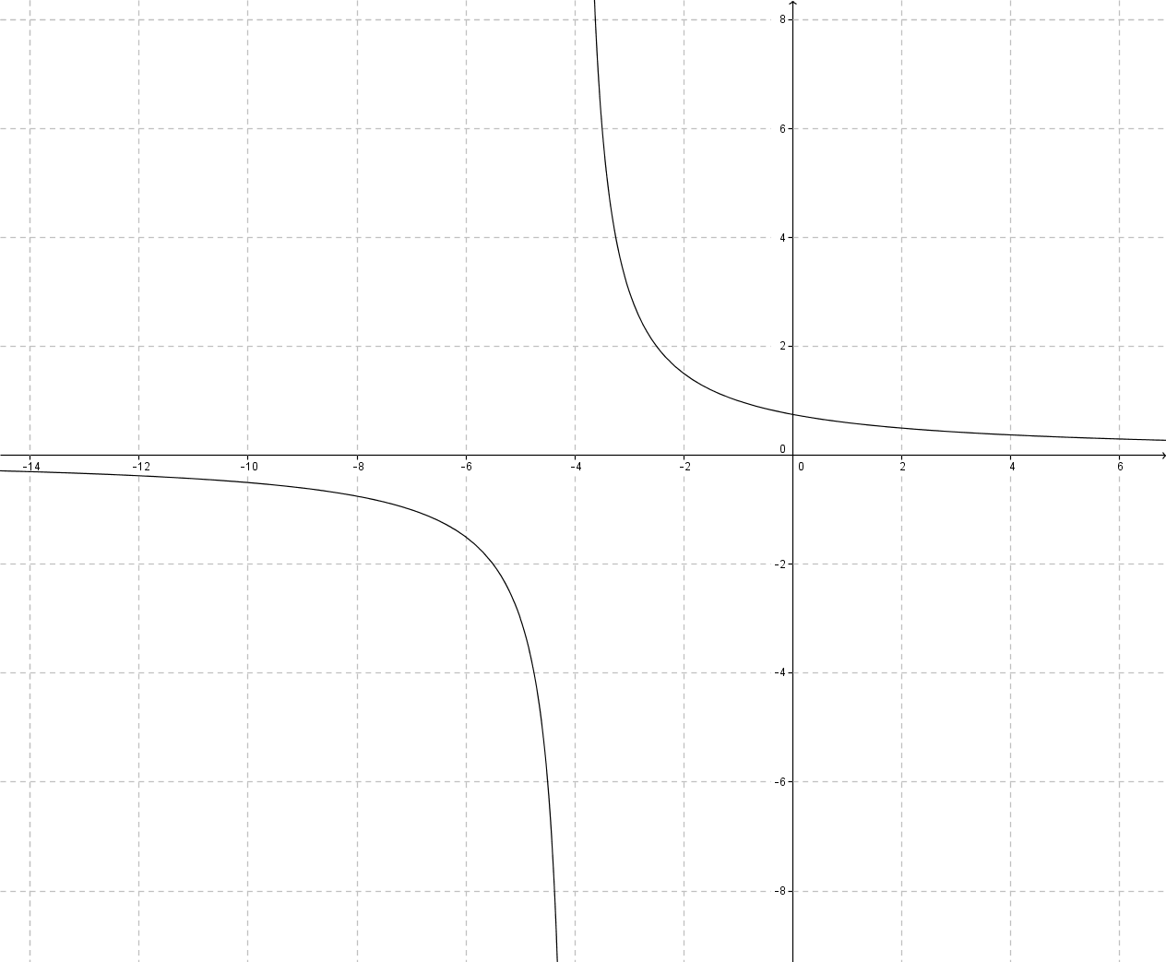

* 1. 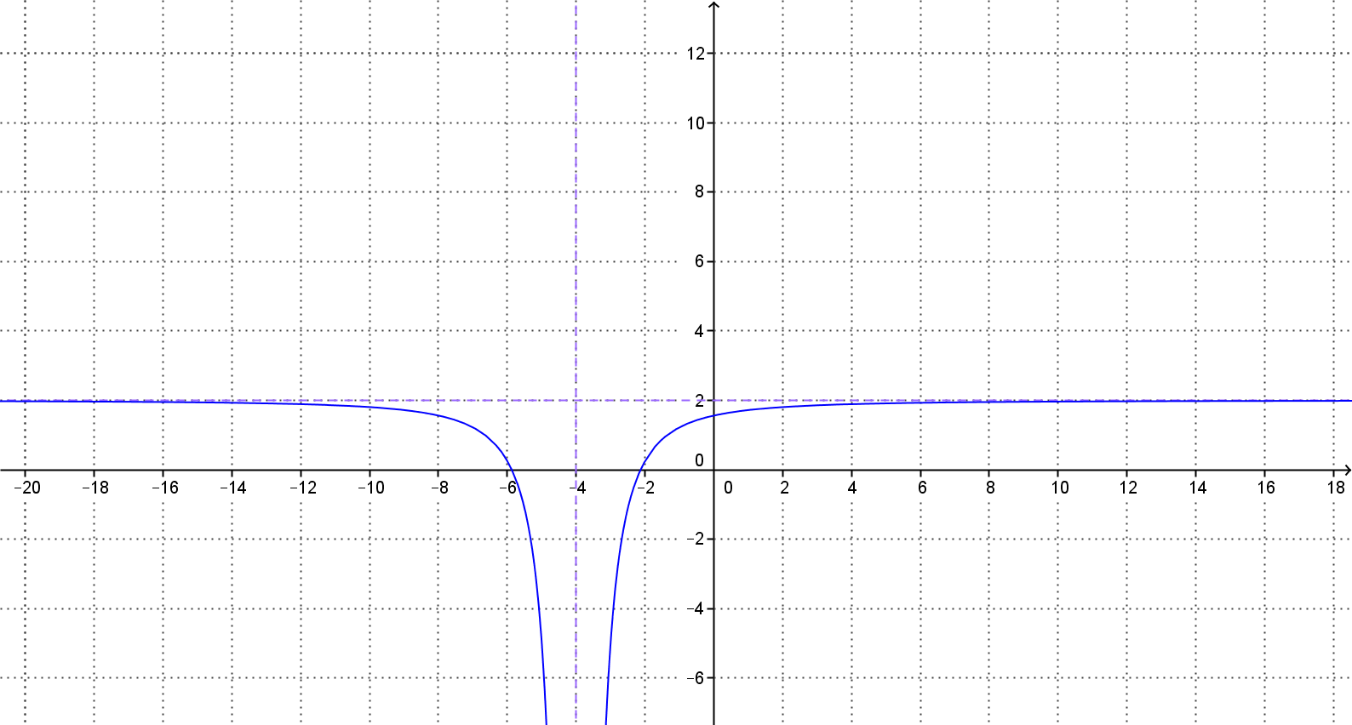

1. What are some indicators that a rational function can be expressed as a transformation of or not?

If the variables in the numerator can be expressed as a part of a multiple of the denominator, then the function will be able to be expressed as a transformation. If it cannot, then there is a variable term in the numerator that cannot be removed that is the result of a composition or product of functions and not from a transformation.

1. Write an equation for a function whose graph is a transformation of the graph . The graph has been shifted right 2 units, stretched vertically by a factor of 2, and been shifted down 3 units.