Lesson 14: Graphing Rational Functions

Student Outcomes
- Students graph rational functions showing intercepts, asymptotes, and end behavior.

Lesson Notes
In this lesson, students continue to explore the key features of the graphs of rational functions and use the intercepts and asymptotes to create graphs of rational functions without using technology (F-IF.C.7d). They will also realize that not all values excluded from the domain of x will result in a vertical asymptote. Emphasize to students that techniques learned in calculus would be needed to produce the finer details of the graph (like the relative maximum point or the changes in the curvature of the graph). However, a general idea of the graph of a rational function can still be produced by using its key features. Students graph some rational functions whose boundary lines are not horizontal, but they are not required to find equations for these asymptotes. Point out that while the graphs are not approaching a particular $y$-value, the graph does approach some boundary line (or curve). However, this is not the focal point of the lesson.

Classwork
Opening Exercise (4 minutes)
Allow students time to complete the Opening Exercise individually, and then discuss results as a class. Consider allowing students to check their answers using technology.
Opening Exercise
State the domain of each of the following functions. Then, determine whether or not the excluded value(s) of $x$ are vertical asymptotes on the graph of the function. Give a reason for your answer.
  - $f\left(x\right)=\frac{x^{2}-3x+2}{x-2}$
D: the set of all real numbers except $x=2$
$x=2$ is not a vertical asymptote on the graph of $f$ because as $x→2$, $f(x)→1$.

  - $f\left(x\right)=\frac{x^{2}+3x+2}{x-2}$
D: the set of all real numbers except $x=2$
$x=2$ is a vertical asymptote on the graph of $f$ because as $x→2$, $f(x)→∞$ on one side and $–∞$ on one side.

- When a value of $x$ is excluded from the domain, is that value always going to correspond to a vertical asymptote on the graph?
  - No. In example 1, $x=2$ is excluded from the domain, but the graph did not have a vertical asymptote at $x=2.$
- How did you decide whether or not the graph had a vertical asymptote at $x=2$?
  - I made a table and filled in values of x that were close to 2.
$x$ | $1.9$ | $1.99$ | $1.999$ | $2$ | $2.001$ | $2.01$ | $2.1$
$f(x)$ | $$0.9$$ | $$0.99$$ | $0.999$ | Undefined | $$1.001$$ | $1.01$ | $1.1$
  - As $x→2$, $f(x)→1$. Therefore, $x=2$ cannot be a vertical asymptote.
If necessary, remind students about the definition of a vertical asymptote. Since $f\left(x\right)$ does not approach $∞$ or $-∞$ as $x$approaches $2$, there cannot be a vertical asymptote at $x=2$.
- Can this function be rewritten as a simpler function?
  - Yes. $f\left(x\right)=\frac{x^{2}-3x+2}{x-2}=\frac{(x-2)(x-1)}{x-2}=x-1, x≠2$
MP.7
- So for every value of $x$ except $2$, $f\left(x\right)=x-1$. What does this graph look like?
  - The graph will be a line with a $y$-intercept of $1$ and an $x$-intercept of $1$.
- What is the only difference between the graph of $f\left(x\right)=\frac{x^{2}-3x+2}{x-2}$ and the graph of $y=x-1$?
  - At $x=2$, the point $(2,1)$ is missing from the graph of $f$.
- These functions are sometimes called “two functions that agree at all but one point.” (Have students graph the function from Exercise 1 either on paper or using the graphing calculator.)
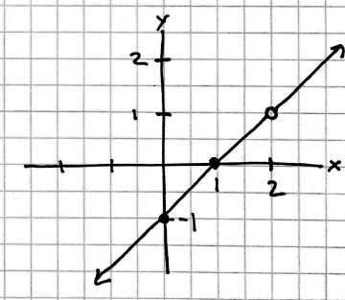

- What was different about Exercise 2?
  - The domain was the same, but this time there was a vertical asymptote at $x=2.$
- How did you know there was a vertical asymptote?
  - I made a table and filled in values of x that were close to 2.
$x$ | $1.9$ | $1.99$ | $1.999$ | $2$ | $2.001$ | $2.01$ | $2.1$
$f(x)$ | $$-113.1$$ | $$-1193$$ | $$-11993$$ | Undefined | $$12007$$ | $$1207$$ | $$127.1$$
  - As $x→2$, $f(x)→∞$ and $-∞$; therefore, there is a vertical asymptote at $x=2$.
- Can this function be reduced to a simpler function?
No. That is why there is a vertical asymptote rather than a point missing from the graph.

Example 1 (7 minutes)
Work through the example with the class giving students time to identify each key feature. Construct the graph as students find each key feature. After students have found the key features, work with the class to complete the graph. Often, students can find the key features but have difficulty producing the graph. Do not allow students to use the graphing calculator to sketch the graph.
- Where should we start?
Scaffolding:
- If students are struggling, consider starting with an easier example such as the following:
$$f(x)=\frac{3x-6}{x-2}$$
  - Identify the domain.
- What do we now know about the graph of $f$?
  - There are vertical asymptotes at $x=-4$ and $x=4$.
- How do we know that these are vertical asymptotes and not points missing from the graph?
  - The function could not be reduced to a simpler function. We can also confirm by determining if $f\left(x\right)→∞$ or $f\left(x\right)→-∞$ as $x→-4$or $4$.
- How can we determine if $f\left(x\right)→∞$ or $f\left(x\right)→-∞$ as $x→-4$or $4?$ What number should we fill in?
  - We need to evaluate the function at numbers close to 4 and $-4$. It does not really matter, but it should be a number close to $-4$ or $4$.
Point out to students that we do not really care about the actual value. We are looking to see if we get a large positive output or a large negative output.
- What else do we need to know?
  - The end behavior and the horizontal asymptote (if the graph of $f$ has one)
- We need some points that lie on the graph. Where should we start?
  - $x$-intercept(s) and $y$-intercept
- Let’s examine what we have at this point. Is this enough information to sketch the graph?
  - We have the broad features of the graph, so we have enough information to make a good guess at the shape of the graph. We could always fill in more test values to find additional points on the graph if we wanted to increase its accuracy.

Example 1
Sketch the graph of the rational function $f\left(x\right)=$ $\frac{2x^{2}-x}{x^{2}-16}$ showing all the key features of the graph. Label the key features on your graph.
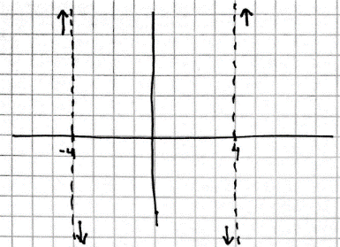
D: set of all real numbers except $x=4,-4$
Vertical asymptotes: $x=4$ and $x=-4$
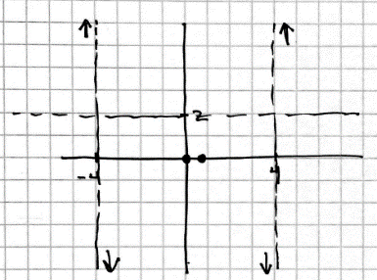
Test values near the vertical asymptotes:
$$x$$ | $$f(x)$$
$$-4.1$$ | $$46.5679$$
$$-4$$ | undefined
$$-3.9$$ | $$-43.443$$
$$3.9$$ | $$-33.5696$$
$$4$$ | undefined
$$4.1$$ | $$36.4444$$
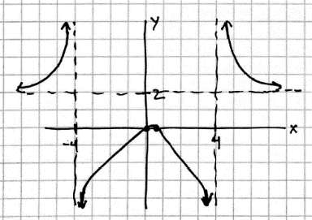
End behavior: As $x→∞, y→2.$
Horizontal asymptote: $y=2$
$x$-intercepts: $2x^{2}-x=0$ $x=0,$ $\frac{1}{2}$ $\left(0,0\right)$ and $(\frac{1}{2}, 0)$
$y$-intercept: $\left(0,0\right)$

Example 2 (7 minutes)
Scaffolding:
- For students who are struggling, consider starting with an easier example such as $f\left(x\right)=\frac{x^{2}-1}{x}$.
- As an extension, students who like a challenge could be asked to find the equation of that boundary line first by estimating and then by dividing to rewrite the function.
$f\left(x\right)=\frac{x^{2}+5x-6}{x+1}=x+4-\frac{10}{x+1}$
As $x→∞,\frac{10}{x+1}→0$, so $f\left(x\right)→x+4.$
The function approaches the line $y=x+4.$
Give students time to analyze the function either individually or in pairs before discussing the graph as a class.
- After analyzing the behavior on either side of the vertical asymptote and plotting the intercepts, do we know the exact shape of the graph?
  - No. We do not know which way to make the graph curve or if there are “bumps” or turning points.
- How can we use the end behavior to complete the graph?
  - Using the fact that as $x→∞, y→∞$, I know the arrow on the right must be pointing up. And $x→-∞, y→-∞$, tells me the arrow on the left must point down.

Have students draw a graph. Share a few samples of student work. Then, either display the graph using a graphing utility, or have students graph the function using a graphing calculator to compare with their graph. Students may see that their graph was not quite right but displayed the correct key features (as shown below).
- Does the graph appear to have some boundary that it is approaching as $x→∞$ or $-∞$?
  - Yes. Even though as $x$ approaches infinity $f(x)$ also approaches infinity, there appears to be some line that the graph of $f$ is approaching as $x$ gets infinitely large.
Example 2
Graph the function $f\left(x\right)=\frac{x^{2}+5x-6}{x+1}$ showing all key features.
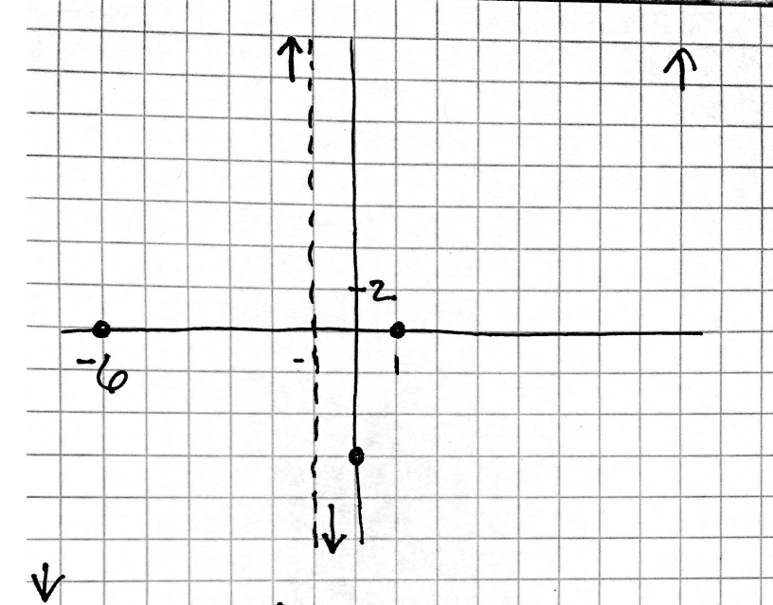
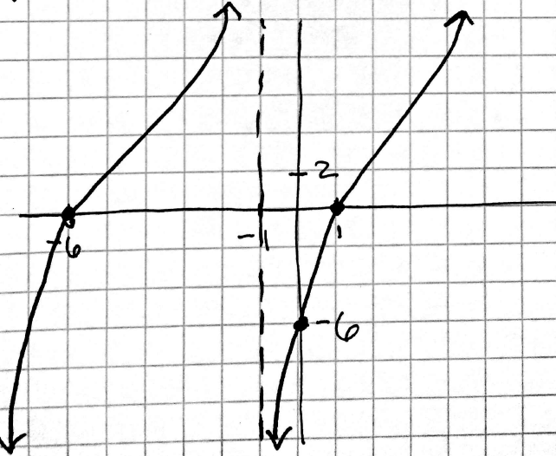
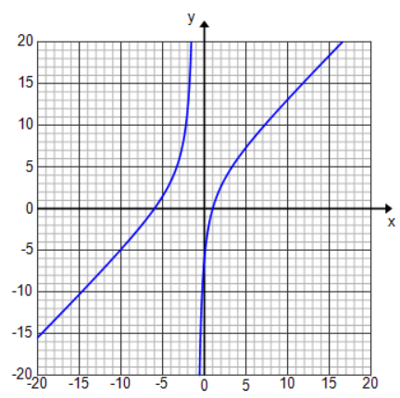

$D$: set of all real numbers except $x=-1$
Vertical asymptote: $x=-1$
Test values near the vertical asymptote:
$$x$$ | $$f(x)$$
$$-1.1$$ | $$102.9$$
$$-1$$ | undefined
$$-0.9$$ | $$-96.9$$
End behavior: As $x→∞, y→∞.$ As $x→-∞, y→-∞.$
$x$-intercepts: $x^{2}+5x-6=0$ $x=-6,1$ $\left(-6,0\right)$and $(1,0)$
$y$-intercept: $\left(0,-6\right)$

Exercises 1–10 (20 minutes)
Allow students time to work in groups on the exercises checking their work as they go using technology. If graphing calculators are not being used, display the graphs as students complete each exercise. Circulate the room providing assistance as needed. If time is short, students need not complete all eight exercises, but it is valuable to see a variety of graphs in order to compare. Assign different groups different exercise numbers ensuring that each group is seeing a variety of graphs. When debriefing, emphasize the structure of the functions and what information that provides about its graph. Compare and contrast graphs of functions whose equations looked similar. Use the questions that follow the exercises as a guide.
MP.7

Exercises 1–10
Sketch the graph of each rational function showing all key features. Verify your graph by graphing the function on the graphing calculator.
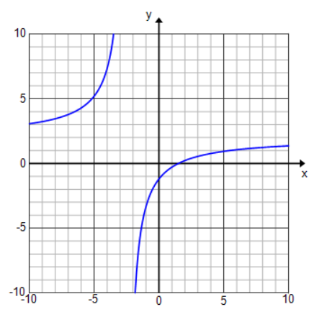
- $f\left(x\right)=\frac{4x-6}{2x+5}$
$D$: set of all real numbers except $x=-\frac{5}{2}$
Vertical asymptotes: $x=-\frac{5}{2}$
End behavior: As $x→∞, y→2.$
Horizontal asymptote: $y=2$
$x$-intercept: $\left(\frac{3}{2},0\right)$
$y$-intercept: $\left(0,-\frac{6}{5}\right)$

- $f\left(x\right)=\frac{\left(3x-6\right)\left(x-4\right)}{x\left(x-4\right)}$
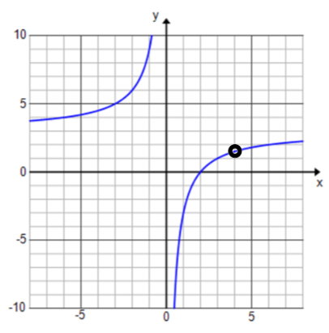
Equivalent form: $f\left(x\right)=$ $\frac{3x-6}{x}$ with $x≠4$
D: set of all real numbers except $x=0,4$
Vertical asymptotes: $x=0$
End behavior: as $x→∞, y→3.$
Horizontal asymptote: $y=3$
$x$-intercept: $\left(2,0\right)$
$y$-intercept: none

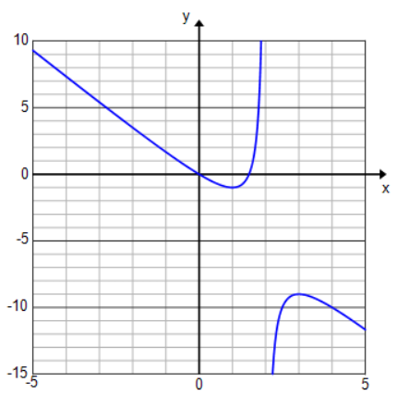
- $f\left(x\right)=\frac{3x-2x^{2}}{x-2}$
D: set of all real numbers except $x=2$
Vertical asymptotes: $x=2$
End behavior: As $x→∞, y→-∞.$ As $x→-∞, y→∞.$
$x$-intercept: $\left(0,0\right)$and $(\frac{3}{2},0)$
$y$-intercept: $\left(0,0\right)$

- $f\left(x\right)=\frac{x-2}{3x-2x^{2}}$
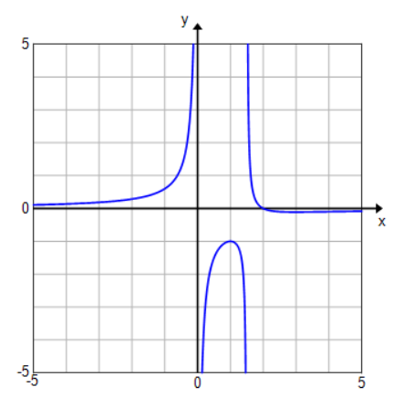
D: set of all real numbers except $x=0,\frac{3}{2}$
Vertical asymptotes: $x=0$ and $x=\frac{3}{2}$
End behavior: As $x→∞, y→0.$
Horizontal asymptote: $y=0$
$x$-intercept: $\left(2,0\right)$
$y$-intercept: none
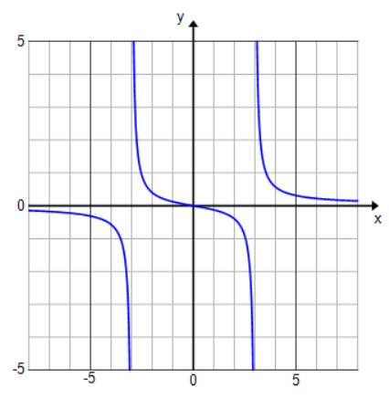
- $f\left(x\right)=\frac{x}{x^{2}-9}$
$D$: set of all real numbers except $x=-3,3$
Vertical asymptotes: $x=-3$ and $x=3$
End behavior: As $x→∞, y→0.$
Horizontal asymptote: $y=0$
$x$-intercept: $\left(0,0\right)$
$y$-intercept: $(0,0)$
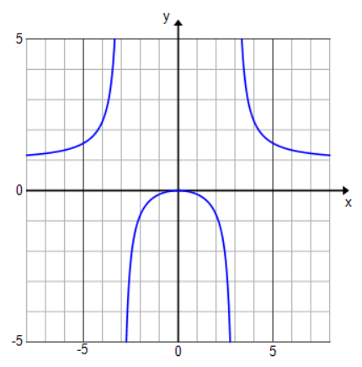
- $f\left(x\right)=\frac{x^{2}}{x^{2}-9}$
$D$: set of all real numbers except $x=-3,3$
Vertical asymptotes: $x=-3$ and $x=3$
End behavior: As $x→∞, y→1.$
Horizontal asymptote: $y=1$
$x$-intercept: $\left(0,0\right)$
$y$-intercept: $(0,0)$
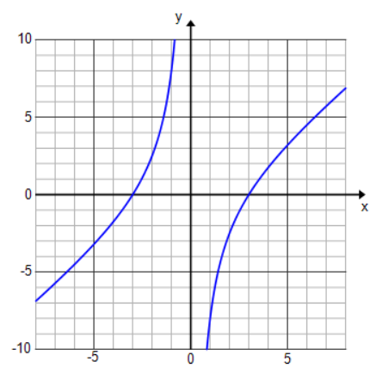
- $f\left(x\right)=\frac{x^{2}-9}{x}$
$D$: set of all real numbers except $x=0$
Vertical asymptotes: $x=0$
End behavior: As $x→∞, y→∞.$ As $x→-∞, y→-∞.$
$x$-intercept: $\left(-3,0\right)$and $(3,0)$
$y$-intercept: none

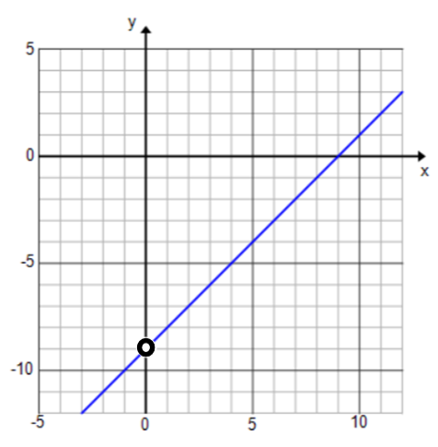
- $f\left(x\right)=\frac{x^{2}-9x}{x}$
$D$: set of all real numbers except $x=0$
Equivalent function: $f\left(x\right)=x-9,x≠0$
End behavior: As $x→∞, y→∞.$ As $x→-∞, y→-∞.$
$x$-intercept: $(9,0)$
$y$-intercept: none
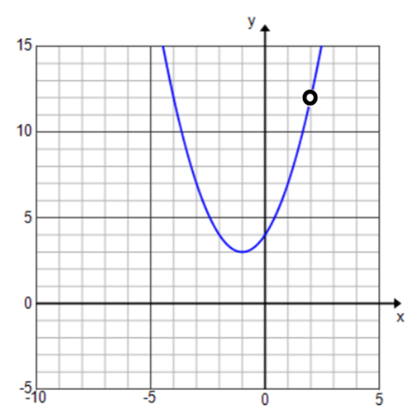
- $f\left(x\right)=\frac{x^{3}-8}{x-2}$
$D$: set of all real numbers except $x=2$
Equivalent function: $f\left(x\right)=x^{2}+2x+4,x≠2$
End behavior: As $x→∞, y→∞.$ As $x→-∞, y→∞.$
$x$-intercept: none
$y$-intercept: $(0,4)$
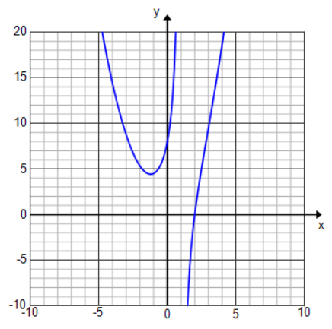
- $f(x)=\frac{x^{3}-8}{x-1}$
D: set of all real numbers except $x=1$
Vertical asymptote: $x=1$
End behavior: As $x→∞, y→∞.$ As $x→-∞, y→-∞.$
$x$-intercept: $(2,0)$
$y$-intercept: $(0,8)$

- For Exercises 1 and 2, how did switching the numerator and denominator change the graph?
  - The x-intercepts from Exercise 1 became the vertical asymptotes for the graph in Exercise 2 and vice versa. The end behavior changed. In Exercise 1, the function increased and decreased without bound as x approached infinity. In Exercise 2, the function approached 0 as x approached infinity.
- Looking at Exercises 3 and 4, the only difference is that the numerator changes from $x$ to $x^{2}$. Compare and contrast these two graphs.
MP.7
  - The two graphs have the same vertical asymptotes and the same intercepts. The horizontal asymptotes are different and the behavior of the function changes as x approaches $-3$ and $3.$.
- For Exercises 5 and 6, the two functions have the same domain. What is different about the two graphs?
  - In Exercise 6, the function could be reduced to a simpler function. Instead of having a vertical asymptote at $x=0$ like in Exercise 5, the graph has a single point missing.

- Looking at the graphs from Exercises 7 and 8, did changing the denominator from $x-2$ to $x-1$ significantly change the graph?
  - Yes. In Exercise 7, the function could be reduced to a quadratic expression, so the graph was a parabola with a single point missing at $x=2$. For Exercise 8, the function could not be reduced, and the graph had a vertical asymptote at $x=1$. Also the intercepts changed and the end behavior was different as x approached negative infinity.
MP.7

Closing (2 minutes)
Have students summarize the key features of the graph of a rational function and the steps taken to graph a rational function either in writing or with a partner. Then, share responses as a class.
- What are the key features of the graph of a rational function?
  - End behavior, vertical and horizontal asymptotes, and $x$- and $y$-intercepts
- How do we use the function to locate these key features?
  - See if the function can be reduced to a simpler function by factoring if possible.
  - Identify the vertical asymptote(s) by determining where the denominator is equal to zero.
  - Use test values on either side of the vertical asymptote to determine the direction of the graph.
  - Analyze the end behavior by analyzing what happens to $f(x)$ as $x$ gets very larger or very small.
  - Identity the horizontal asymptote (if applicable) by looking at the degree of the numerator and denominator and determining what happens as $x$ gets very large or very small.
  - Find the $x-$-intercept(s) by setting $f\left(x\right)=0.$ Find the $y$-intercept by evaluating $f\left(0\right).$

Exit Ticket (5 minutes)
Name Date
Lesson 14: Graphing Rational Functions

Exit Ticket

- Sketch the graph of $y=\frac{x-3}{x^{2}+x-12}$. Label horizontal and vertical asymptotes, and identify any discontinuities,
$x$-intercepts, and the $y$-intercept if they exist. Describe the end behavior of the function.

- Does the graph of the function $f(x)=\frac{x^{2}-8x-9}{x+1}$ have a vertical asymptote or a point missing at $x=-1$? Explain your reasoning, and support your answer numerically.
Exit Ticket Sample Solutions

- Sketch the graph of $y=\frac{x-3}{x^{2}+x-12}$. Label horizontal and vertical asymptotes, and identify any discontinuities,
$x$-intercepts, and the $y$-intercept if they exist. Describe the end behavior of the function.
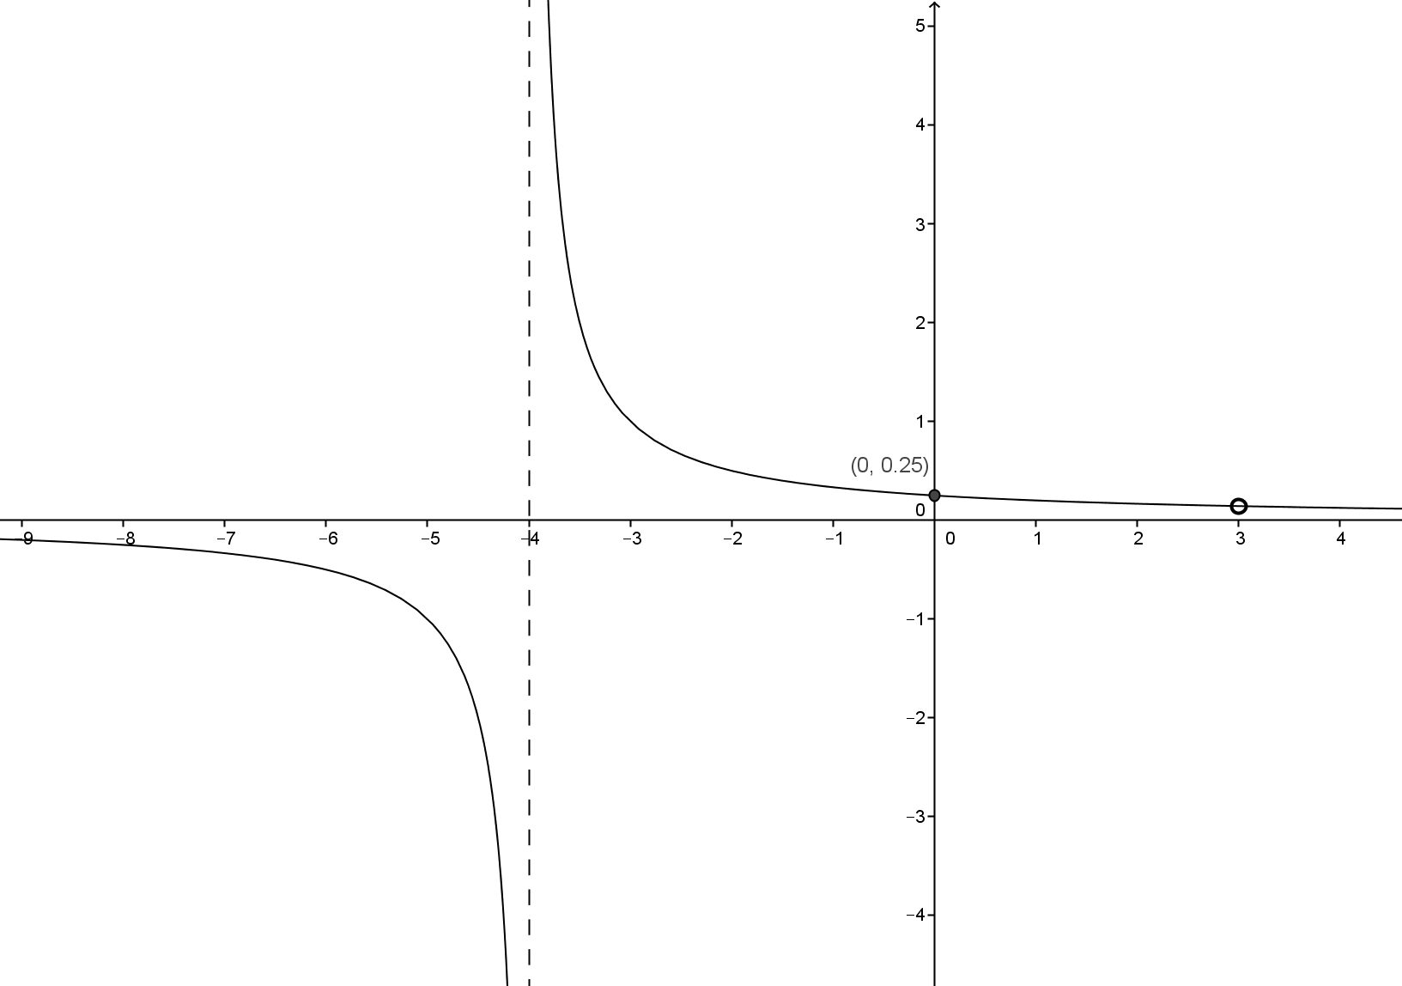
Horizontal asymptote at $y=0$; vertical asymptote at $x=-4$; $y$-intercept at $\left(0,\frac{1}{4}\right)$; no $x$-intercepts; discontinuity at $x=3$; as $x→±∞,y→0$.

- Does the graph of the function $f\left(x\right)=\frac{x^{2}-8x-9}{x+1}$ have a vertical asymptote or a point missing at $x=-1$? Explain your reasoning, and support your answer numerically.
The graph of $f$ has a point missing at $x=-1$. I knew this because the function can reduce to $f\left(x\right)=x-9, x≠-1$ which means the graph will look like the line $y=x-9$ at every $x-$value except $x=-1$. This can also be seen by analyzing a table of values.
$$x$$ | $$-1.01$$ | $$-1.1$$ | $$-0.99$$ | $$-0.9$$
$$f(x)$$ | $$-10.01$$ | $$-10.1$$ | $$-9.99$$ | $$-9.9$$
As $x→-1, f\left(x\right)→-10$. Which means the graph does not have a vertical asymptote at $x=-1.$

Problem Set Sample Solutions

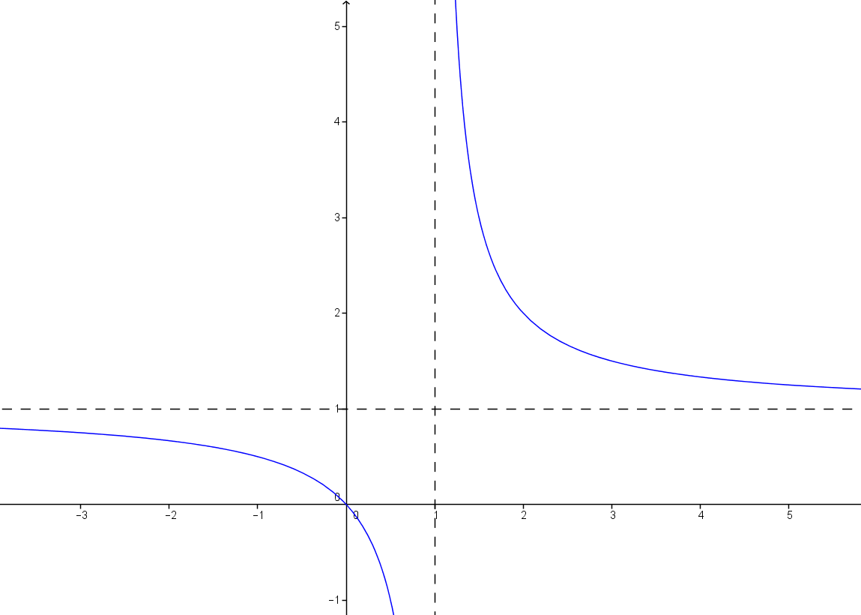
- List all of the key features of each rational function and its graph, and then sketch the graph showing the key features.
  - $y=\frac{x}{x-1}$
$D$: set of all real numbers except $x=1$
Vertical asymptote: $x=1$
End behavior: As $x→∞, y→1.$
Horizontal asymptote: $y=1$
$x$-intercept: $(0,0)$
$y$-intercept: $(0,0)$

  - $y=\frac{x^{2}-7x+6}{x^{2}-36}$
$D$: set of all real numbers except $x=6$ and $x=-6$
Equivalent function: $f\left(x\right)=\frac{x-1}{x+6}$ with $x≠6$
Vertical asymptote: $x=-6$
End behavior: As $x→∞, y→1.$
Horizontal asymptote: $y=1$
$x$-intercept: $(0,0)$
$y$-intercept: $(0,0)$

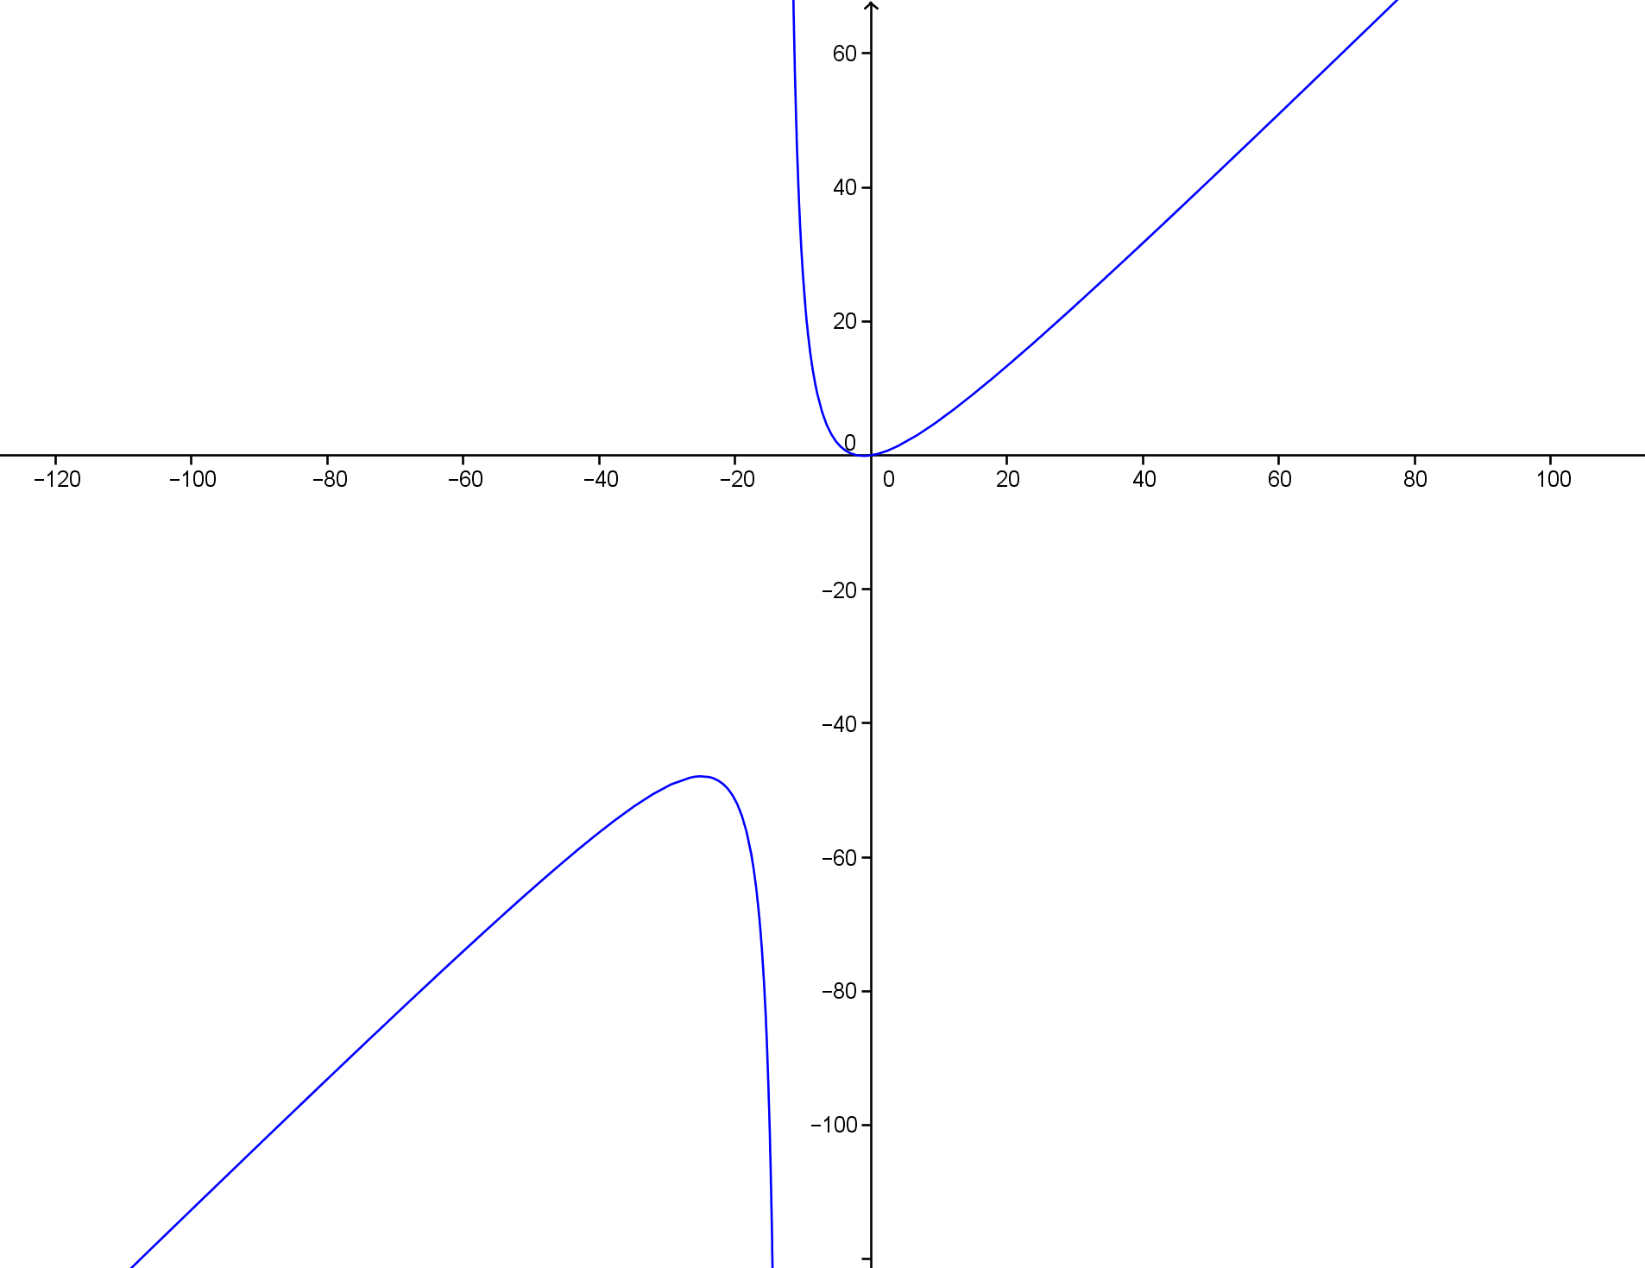
  - $y=\frac{x^{3}-3x^{2}-10x}{x^{2}+8x-65}$
$D$: set of all real numbers except $x=-13$ and $x=5$
Equivalent function: $f\left(x\right)=\frac{x(x+2)}{x+13}$ with $x≠5$
Vertical asymptote: $x=-13$
End behavior: As $x→∞, y→∞.$
Horizontal asymptote: None – there is a slant asymptote
$x$-intercepts: $\left(0,0\right), (-2, 0)$
$y$-intercept: $(0,0)$
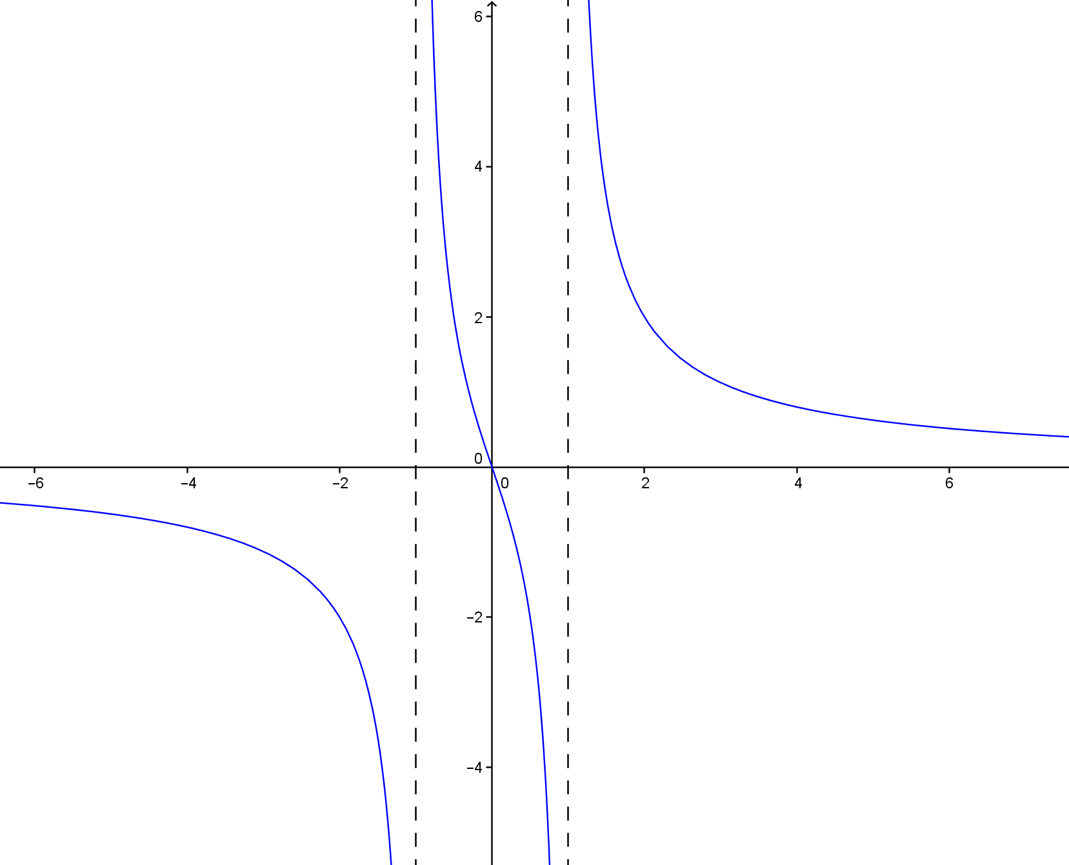
  - $y=\frac{3x}{x^{2}-1}$
$D$: set of all real numbers except $x=-1$ and $x=1$
Vertical asymptotes: $x=-1$ and $x=1$
End behavior: As $x→∞, y→0.$
Horizontal asymptote: $y=0$
$x$-intercept: $\left(0,0\right)$
$y$-intercept: $(0,0)$

- Graph $y=\frac{1}{x^{2}}$ and $y=\frac{1}{x}$. Compare and contrast the two graphs.
$y=\frac{1}{x^{2}}$ $y=\frac{1}{x}$
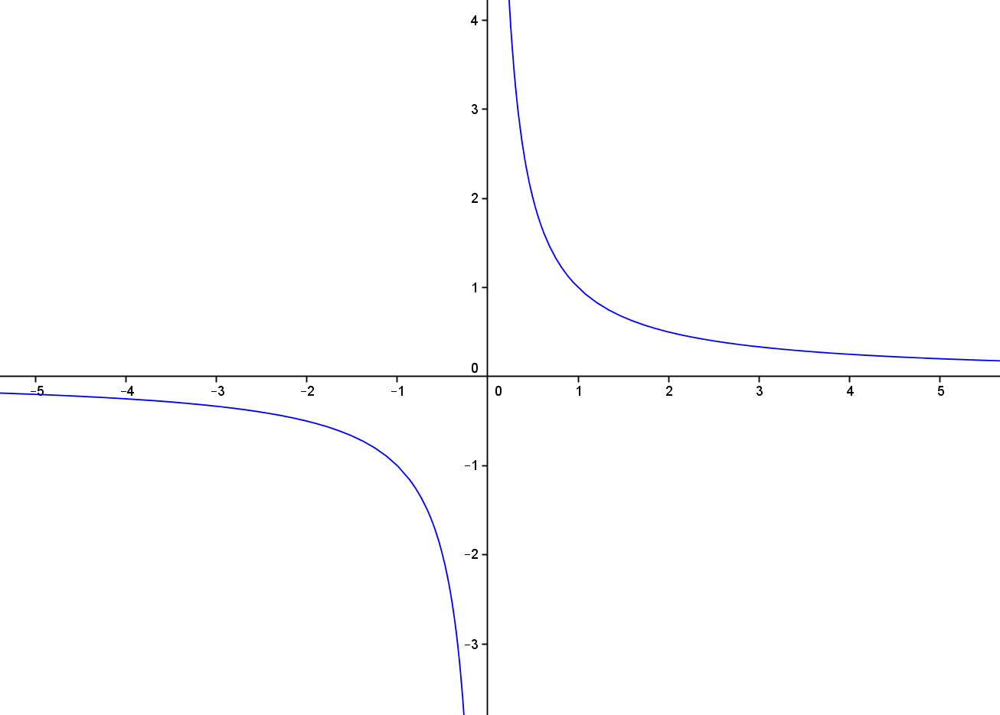

Neither graph has any intercepts. The graphs have the same vertical asymptote ($x=0)$ and horizontal asymptote
($y=0$). The difference is that the graph of $y=\frac{1}{x^{2}}$ is always positive while the graph of $y=\frac{1}{x}$is negative for $x$-values less than 0.

Extension
- Consider the function $f\left(x\right)=\frac{x^{3}+1}{x}$.
  - Use the distributive property to rewrite $f$ as the sum of two rational functions $g$ and $h$.
$$f\left(x\right)=x^{2}+\frac{1}{x}; g\left(x\right)=x^{2}; h\left(x\right)=\frac{1}{x}$$

  - What is the end behavior of $g$? What is the end behavior of $h$?
As $x→±∞$, $g\left(x\right)→∞$. As $x→±∞$, $h\left(x\right)→0$.

  - Graph $y=f(x)$ and $y=x^{2}$ on the same set of axes. What do you notice?
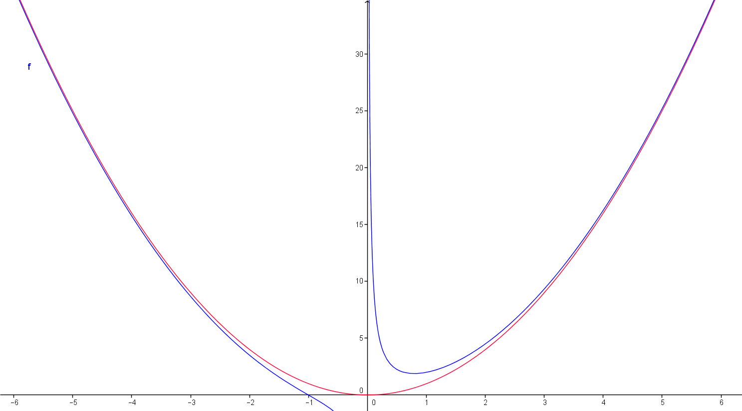

  - Summarize what you have discovered in part (b) and (c).
As $x$ increases without bound, the graph of $f$ approaches the graph of $g$ and similarly, as $x$ decreases without bound.

- Number theory is a branch of mathematics devoted primarily to the study of integers. Some discoveries in number theory involve numbers that are impossibly large such as Skewes’ numbers and Graham’s number. One Skewes’ number is approximately $e^{\left(e^{\left(e^{79}\right)}\right)}$ and Graham’s number is so large that to even write it requires 64 lines of writing with a new operation (one that can be thought of as the shortcut for repeated exponentiation). In fact, both of these numbers are so large that the decimal representation of the numbers would be larger than the known universe and dwarf popular large numbers such as googol and googolplex ($10^{100}$ and $10^{\left(10^{100}\right)}$ respectively). These large numbers, although nearly impossible to comprehend, are still not at the “end” of the real numbers, which have no end. Consider the function $f\left(x\right)=x^{2}-10^{100}$.
  - Consider only positive values of $x$; how long until $f\left(x\right)>0$?
$$x^{2}>10^{100} \\ x>{\left(10^{100}\right)}^{1/2} \\ x>10^{50}$$

  - If your answer to part (a) represented seconds, how many billions of years would it take for $f\left(x\right)>0$? (Note: one billion years is approximately $3.15×10^{16}$ seconds). How close is this to the estimated geological age of the earth ($4.54$ billion years)?
$$10^{50}÷\left(3.15×10^{16}\right)≈3.17×10^{30}$$
It would take $3.17$ thousand billion billion billion years. This is about $3.17$ thousand billion billion billion years older than the earth.

  - Number theorists frequently only concern themselves with the term of a function that has the most influence as $x→∞$. Let $f\left(x\right)=x^{3}+10x^{2}+100x+1000$, and answer the following questions.
    - Fill out the following table:
$$x$$ | $$f\left(x\right)$$ | $$x^{3}$$ | $$\frac{x^{3}}{f\left(x\right)}$$ | $$10x^{2}$$ | $$\frac{10x^{2}}{f\left(x\right)}$$ | $$100x$$ | $$\frac{100x}{f\left(x\right)}$$ | $$\frac{1000}{f\left(x\right)}$$
$$0$$ | $$1,000$$ | $$0$$ | $$0$$ | $$0$$ | $$0$$ | $$0$$ | $$0$$ | $$1.00$$
$$10$$ | $$4,000$$ | $$1,000$$ | $$0.25$$ | $$1,000$$ | $$0.25$$ | $$1,000$$ | $$0.25$$ | $$0.25$$
$$100$$ | $$1,111,000$$ | $$1,000,000$$ | $$0.90$$ | $$100,000$$ | $$0.09$$ | $$10,000$$ | $$0.01$$ | $$0.00$$
$$1000$$ | $$1,010,101,000$$ | $$1,000,000,000$$ | $$0.99$$ | $$10,000,000$$ | $$0.01$$ | $$100,000$$ | $$0.00$$ | $$0.00$$

    - As $x→∞$, which term of $f(x)$ dominates the value of the function?
The term $x^{3}$ grows to dominate the function. By $x=1000$, $x^{3}$ comprises $99\%$ of the function’s value.

    - Find $g\left(x\right)=\frac{f\left(x\right)}{x}$. Which term dominates $g(x)$ as $x→∞$?
$$g\left(x\right)=x^{2}+10x+100+\frac{1000}{x}$$
Again, the leading term dominates the function as $x→∞$.

  - Consider the formula for a general polynomial, $f\left(x\right)=a_{n}x^{n}+a_{n-1}x^{n-1}+⋯+a_{1}x+a_{0}$ for real numbers $a_{i}$, $0≤i≤n$. Which single term dominates the value of $f\left(x\right)$ as $x→∞$.
The leading term will dominate the function as $x→∞$.

