|  |
| --- |
|  |

Lesson 13: Horizontal and Vertical Asymptotes of Graphs of Rational Functions

Student Outcomes

* Students identify vertical and horizontal asymptotes of rational functions.

Lesson Notes

In this lesson, students continue to develop their understanding of the key features of rational functions. Students begin by connecting the algebraic and numeric work they did with end behavior in the previous lesson to the horizontal asymptote on the graph of a rational function. Students will also analyze the behavior of a function as approaches a value restricted from its domain. In this way, both horizontal and vertical asymptotes will be defined. Students will identify vertical and horizontal asymptotes without the use of technology and then use technology to confirm their results (**F-IF.C.7d**). While students have seen graphs of functions that contain a horizontal asymptote (i.e., exponential functions in Module 3 of Algebra I and Module 3 of Algebra II) and graphs of functions that contain vertical asymptotes (i.e., the tangent function in Module 2 of Algebra II and logarithmic functions in Module 3 of Algebra II), this is the first time that horizontal and vertical asymptotes are formally defined.

Classwork

Opening Exercise (5 minutes)

Allow students time to work the Opening Exercise independently. Then have them compare answers with a partner before debriefing as a class.

Opening Exercise

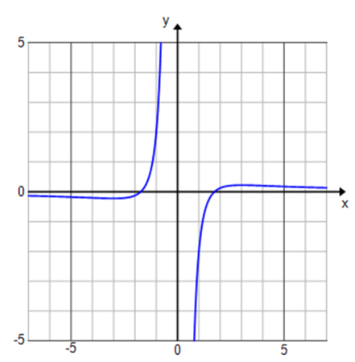Determine the end behavior of each rational function below. Graph each function on the graphing calculator and explain how the graph supports your analysis of the end behavior.



End behavior: As As

Looking at the ends of the graph, as goes to or , gets

closer to

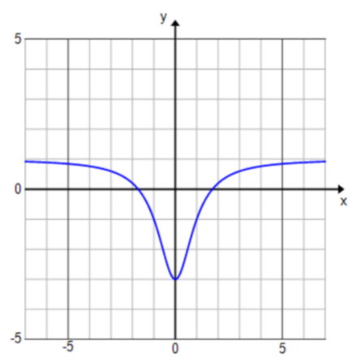

End behavior: As As

Looking at the ends of the graph, as x goes to or , gets

closer to

* 1. 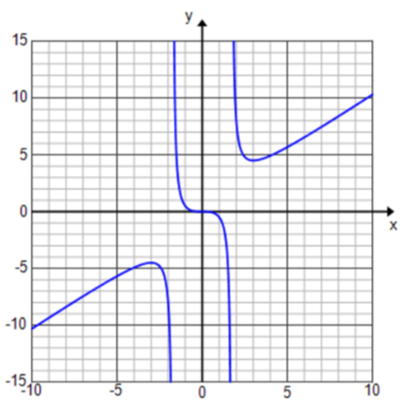

End behavior: As , and as .

Looking at the ends of the graph, as goes to , continues to increase

toward , and as x goes to , continues to decrease toward

**Discussion (5 minutes)**

* How is the end behavior of related to the graph of ?
  + *The end behavior of describes the value that approaches as approaches or .*
* When approaches a particular number, , as approaches or , the line is called a horizontal asymptote on the graph of

**Definition:** Let be a real number. The line given by is a *horizontal asymptote* of the graph of if at least one of the following statements is true.

As , .

As , .

* On a graph, an asymptote is sometimes drawn in as a dashed line. Draw the horizontal asymptotes for Exercises 1 and 2 on the graphs. Using this definition, identify the horizontal asymptote of each graph.
  + *For Exercise 1, the horizontal asymptote is For Exercise 2, the horizontal asymptote is*
* Can the graph of actually cross through a horizontal asymptote?
  + *Looking at Exercise 1, the graph crosses the horizontal asymptote but then continues to approach as approaches or .*

*Scaffolding:*

If students are struggling, consider having them construct a Frayer model and then compare with a partner.



* A graph may cross a horizontal asymptote once or many times, but its distance away from the horizontal asymptote must go to as approaches or .
* Look at the graph from Exercise 3. Why doesn’t this graph have a horizontal asymptote? [Teacher note: We will study these graphs more closely in the next lesson. Students may note that the graph still seems to approach some boundary line, but that line is not horizontal.]
  + *Because as , and as . As gets infinitely large, the also gets infinitely large rather than approaching a particular value.*

**Example 1 (5 minutes)**

Give students time to work the example individually. Go over student responses and use this as an opportunity to check for understanding. Then, have the discussion that follows.

Example 1

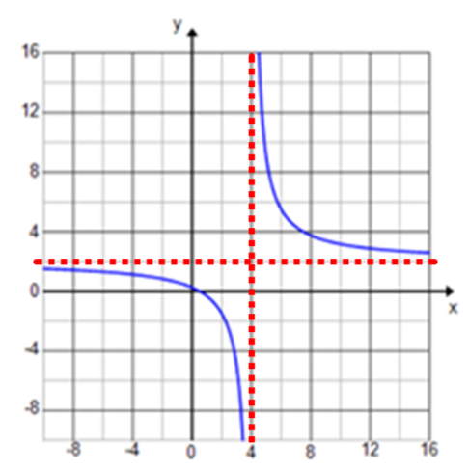Consider the rational function .

* 1. State the domain of .

D: set of all real numbers except .

* 1. Determine the end behavior of

End behavior: As As

* 1. State the horizontal asymptote of the graph of

Horizontal asymptote:

* 1. Graph the function on the graphing calculator and make a sketch on your paper.

**Discussion (5 minutes)**

* How is the domain of related to the graph of ?
  + *The graph did not cross through because that value was removed from the domain of . Since is undefined, the graph of cannot cross .*
* Describe the behavior of as approaches .
  + *As approaches , the function approaches infinity on one side and negative infinity on the other side.*
* The line is called a vertical asymptote of the graph of . Draw the vertical asymptote on your graph.
* In your own words, how would you define a vertical asymptote? [Let students articulate informal definitions either on paper or with a partner and then write the following definition on the board.]

**MP.2**

* + *A line representing a value of that is restricted from the domain of . A vertical line that a graph approaches but never crosses.*

**Definition:** Let be a real number. The line given by is a ***vertical asymptote*** of the graph of if at least one of the following statements is true.

As ,

As , .

* How could we identify that is a vertical asymptote without using the graph?
  + *We could evaluate the function for values close to to determine the behavior of .*

**MP.2**

|  |  |
| --- | --- |
|  |  |
|  |  |
|  | undefined |
|  |  |
|  |  |

* + *As approaches 4 from numbers less than 4, approaches As approaches 4 from numbers greater than 4, y approaches*

Exercises 1–9 (17 minutes)

Allow students time to work in groups on the exercises checking their work as they go using technology. Circulate the room providing assistance as needed. Make sure that students are confirming the location of vertical asymptotes numerically, as this will be a necessary skill when they graph rational functions without using technology. Allow time to share various responses to Exercises 7–9. Show the graphs to verify that the given functions have the correct characteristics.

Exercises 1–9

State the domain and end behavior of each rational function. Identify all horizontal and vertical asymptotes on the graph of each rational function. Then, verify your answer by graphing the function on the graphing calculator.

1. 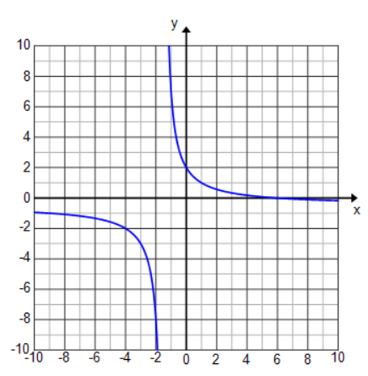

D: set of all real numbers except

Vertical asymptotes:

End behavior: As As

Horizontal asymptote:

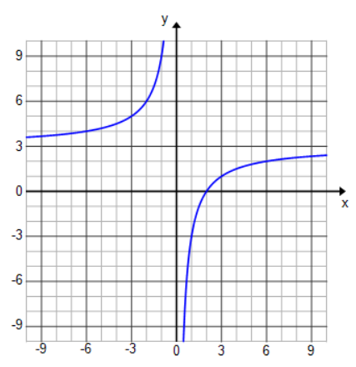

D: set of all real numbers except .

Vertical asymptotes: .

End behavior: As As

Horizontal asymptote: .

1. 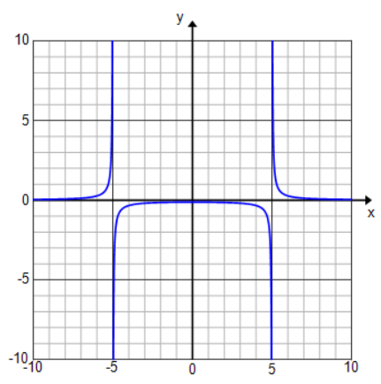

D: set of all real numbers except .

Vertical asymptotes: and .

End behavior: As As

Horizontal asymptote: .

1. 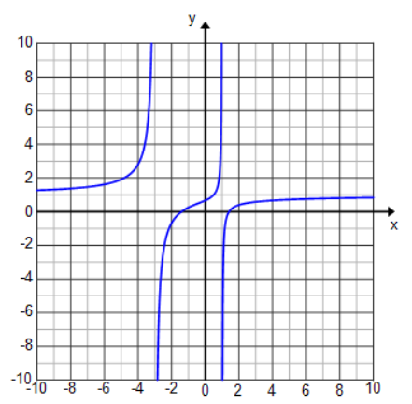

D: set of all real numbers except .

Vertical asymptotes: and .

End behavior: As As

Horizontal asymptote: .

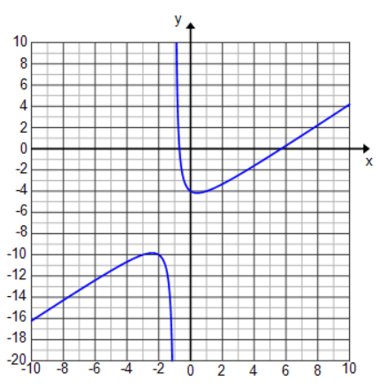

D: set of all real numbers except .

Vertical asymptote: .

End behavior: As As .

Horizontal asymptote: none.

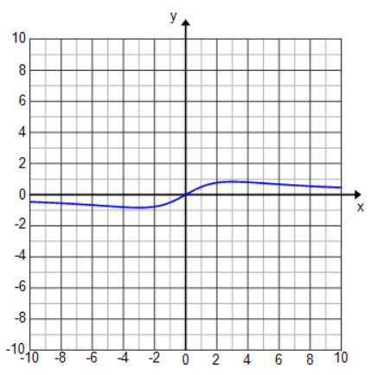

D: set of all real numbers.

Vertical asymptote: none.

End behavior: As As .

Horizontal asymptote: .

Write an equation for a rational function whose graph has the given characteristic. Graph your function on the graphing calculator to verify.

1. A horizontal asymptote of and a vertical asymptote of .

1. A vertical asymptote of and no horizontal asymptote.

1. A horizontal asymptote of and no vertical asymptote.

* When looking at a rational function, how information does the structure of the function give you about the horizontal asymptote of its graph?

**MP.7**

* + *When the numerator has a higher exponent, the graph will not have a horizontal asymptote. When the denominator has a higher exponent, the graph will have a horizontal asymptote of . When the highest exponent in the numerator and denominator is the same, the graph will have a horizontal asymptote where is not zero.*
* What information does the structure of the function give you about the vertical asymptote of its graph?
  + *If the denominator does not equal zero for any real number , then the graph will not have a vertical asymptote.*
* There are many possible answers for exercise 7, what did every function need to have in common?
  + *There needed to be a factor of in the denominator. The leading coefficient in the numerator needed to be .*

Closing (3 minutes)

Use the following questions to review the key points from the lesson.

* For a value outside of the domain of a rational function, what could potentially happen on the graph of the function?
  + *There could be a vertical asymptote.*
* If there is a vertical asymptote at , then as approaches , what must approach?
  + *Either infinity or negative infinity.*

Lesson Summary

* **Let be a real number. The line given by is a *vertical asymptote* of the graph of if at least one of the following statements is true.**
  + **As ,**
  + **As , .**
* **Let be a real number. The line given by is a *horizontal asymptote* of the graph of if at least one of the following statements is true.**
  + **As , .**
  + **As , .**
* How can we tell whether approaches infinity or negative infinity?
  + *By filling in a test value on either side of the vertical asymptote to see if the output value is a large negative number or a large positive number.*
* How can we determine if the graph of a rational function will have a horizontal asymptote?
  + *By examining its end behavior. If the function approaches a particular number as x approaches infinity or negative infintity, then the line is a horizontal asymptote on the graph.*

**Exit Ticket (5 minutes)**

Name Date

Lesson 13: Horizontal and Vertical Asymptotes of Graphs of Rational Functions

Exit Ticket

Consider the function .

1. Looking at the structure of the function, what information can you gather about the graph of ?
2. State the domain of .
3. Determine the end behavior of .
4. State the equations of any vertical and horizontal asymptotes on the graph of

Exit Ticket Sample Solutions

Consider the function .

1. Looking at the structure of the function, what information can you gather about the graph of ?

The graph will have a horizontal asymptote at because the denominator has a higher exponent than the numerator. There are two values of that will cause the denominator to equal zero, so the graph potentially has two vertical asymptotes.

1. State the domain of .

: The set of all real numbers except .

1. Determine the end behavior of .

End behavior: As As .

1. State the equations of any vertical and horizontal asymptotes on the graph of .

Vertical asymptotes: and .

Horizontal asymptote: .

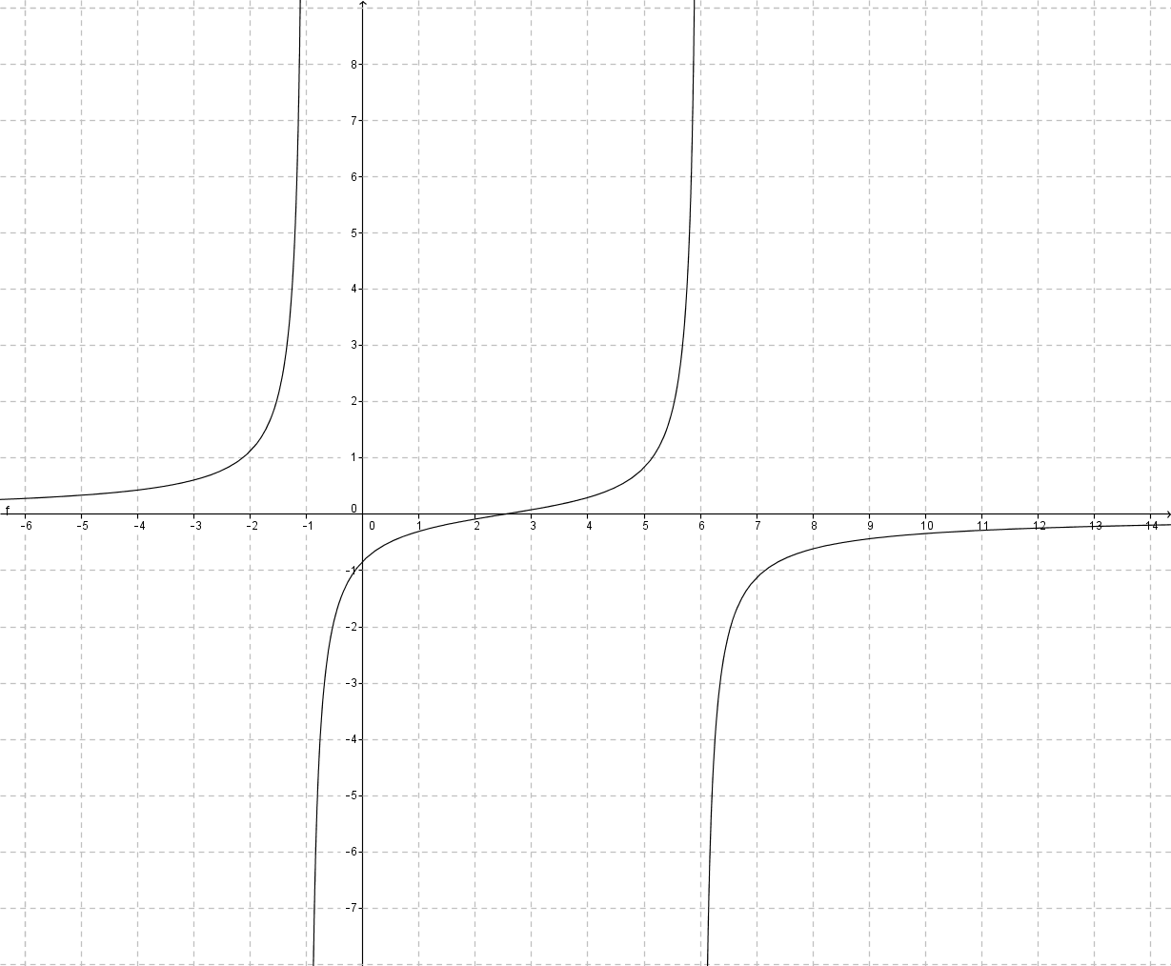

Problem Set Sample Solutions

1. State the domain of each rational function. Identify all horizontal and vertical asymptotes on the graph of each rational function.

The domain is all real numbers except , which is a vertical asymptote. The horizontal asymptote is  
.

The domain is all real numbers except , which is a vertical asymptote. The graph of the function has a horizontal asymptote at .

The domain is all real numbers except , which is a vertical asymptote. The horizontal asymptote occurs at .

The domain is all real numbers except , which are both vertical asymptotes. The horizontal asymptote is .

The domain is all real numbers except , which is a vertical asymptote. The horizontal asymptote is the line .

The domain is all real numbers except and , which are both vertical asymptotes. The horizontal asymptote is the line .

1. Sketch the graph of each function in Exercise 1 with asymptotes and excluded values from the domain drawn on the graph.
   1. 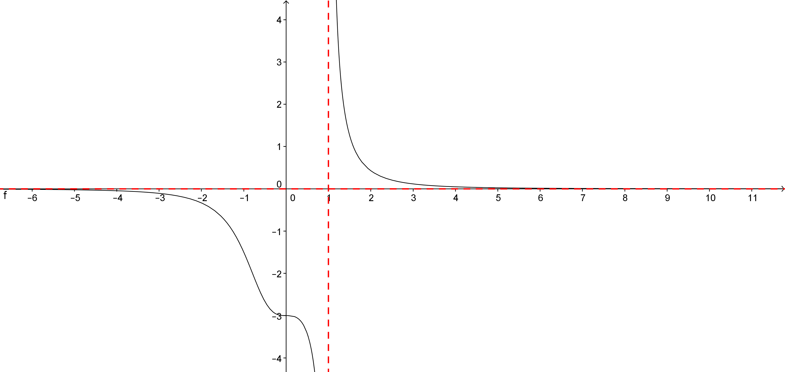
   2. 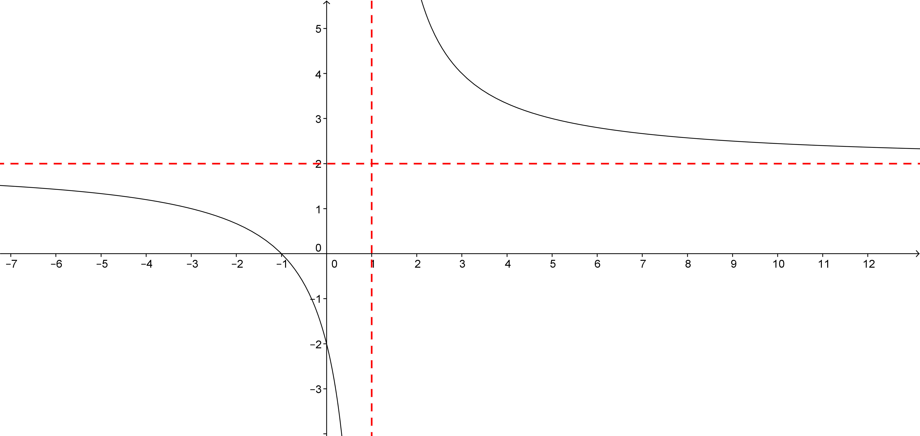
   3. 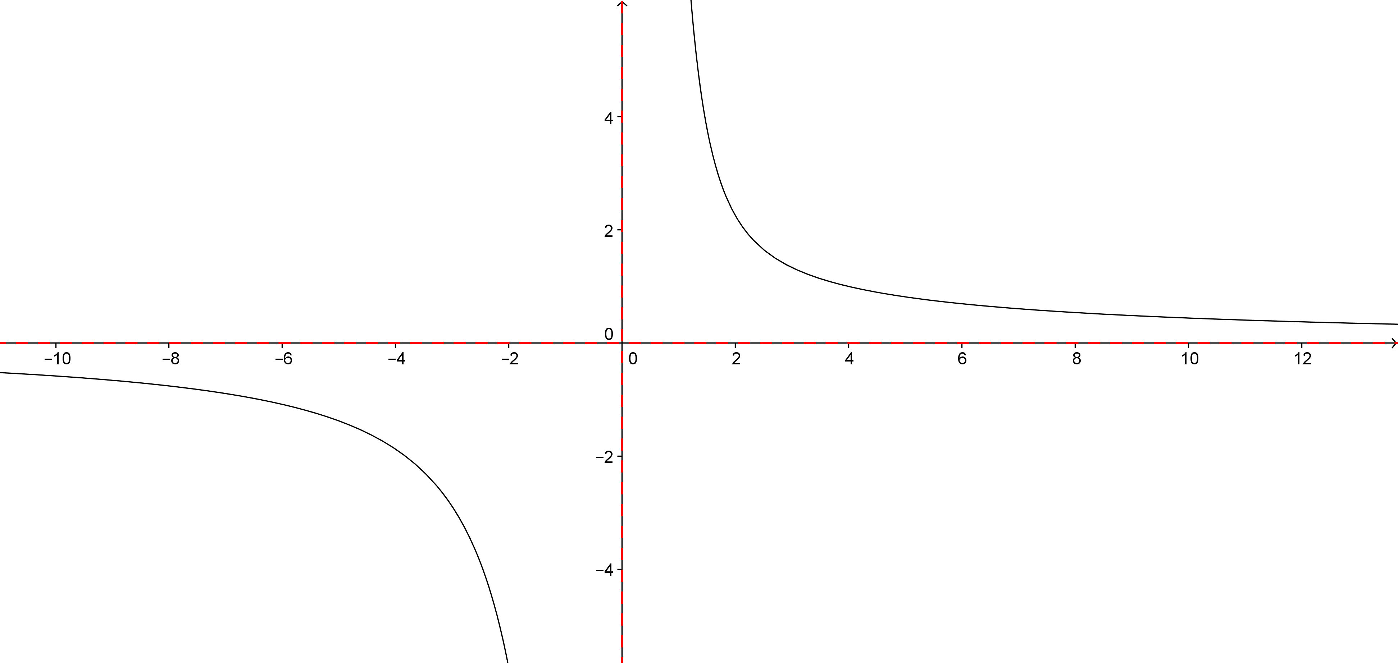
   4. 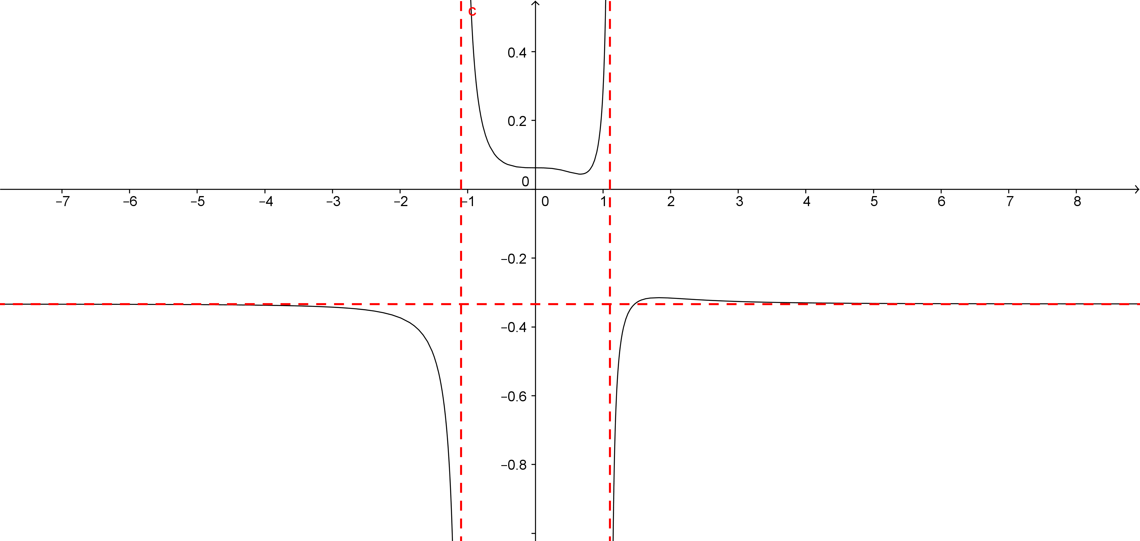
   5. 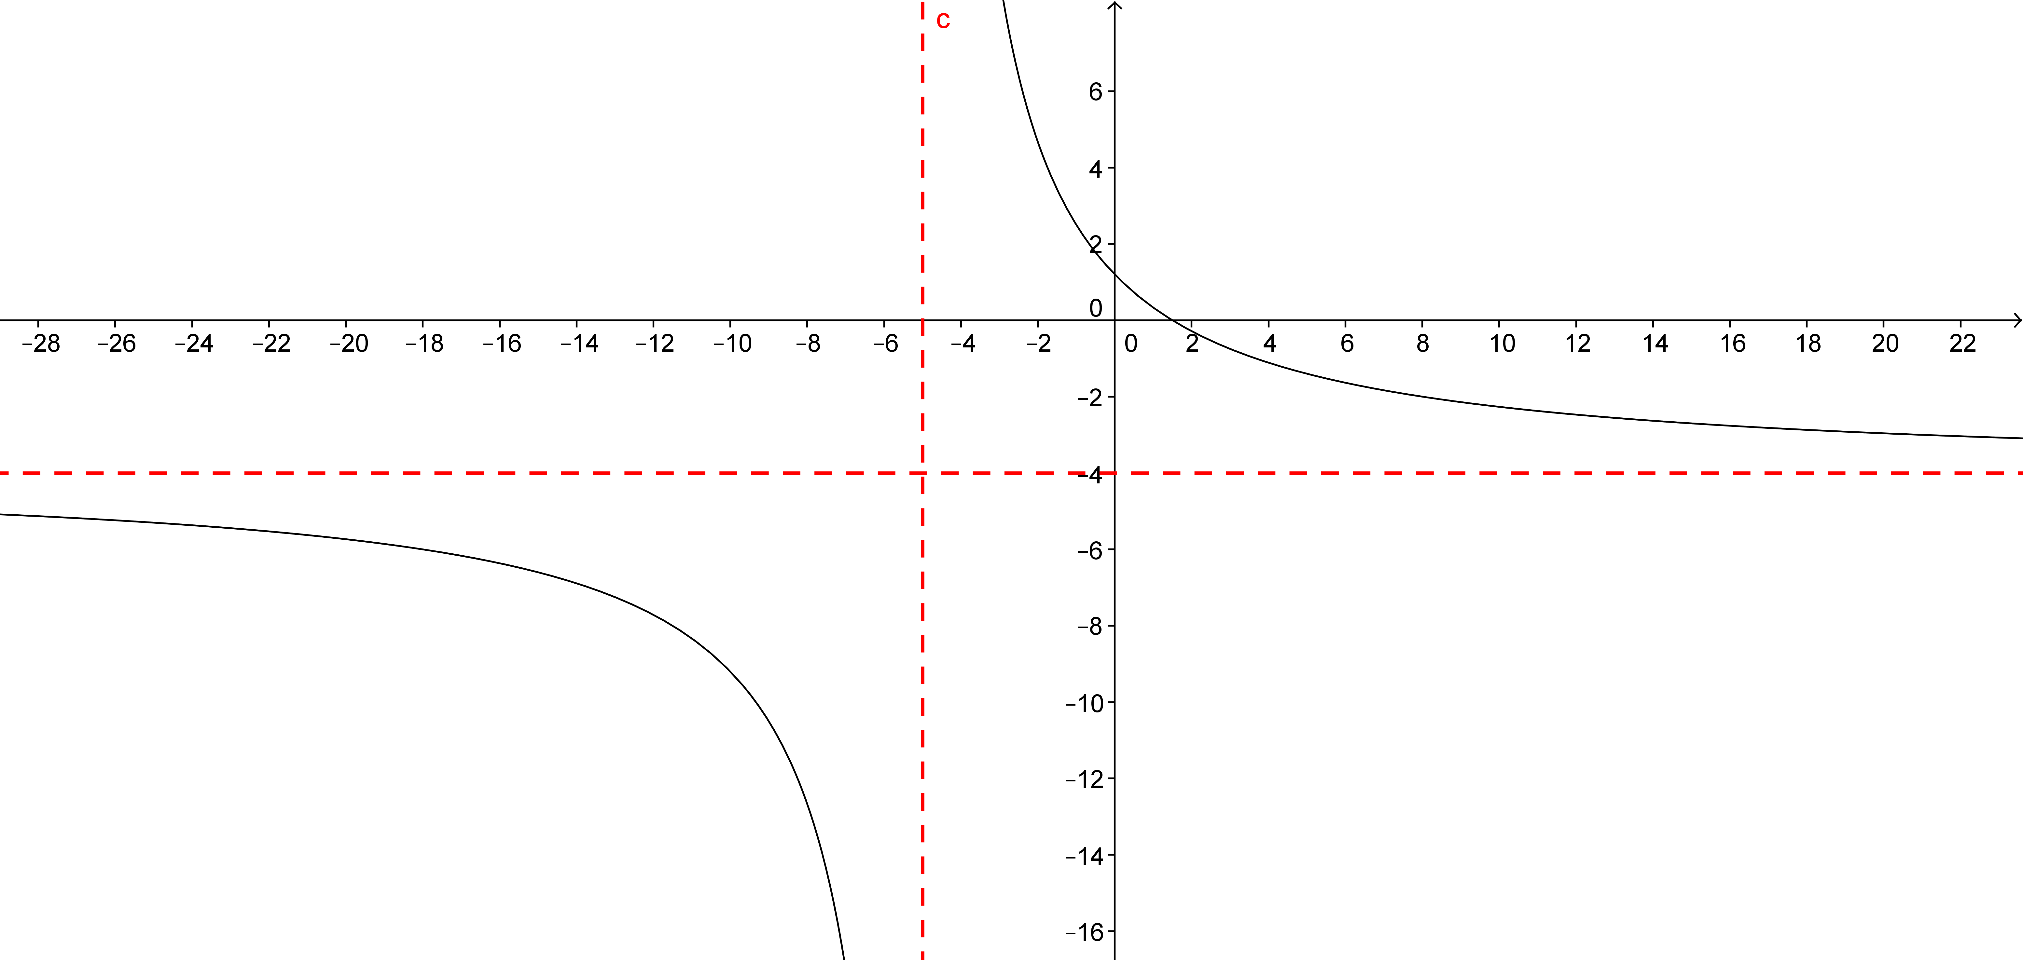
   6. 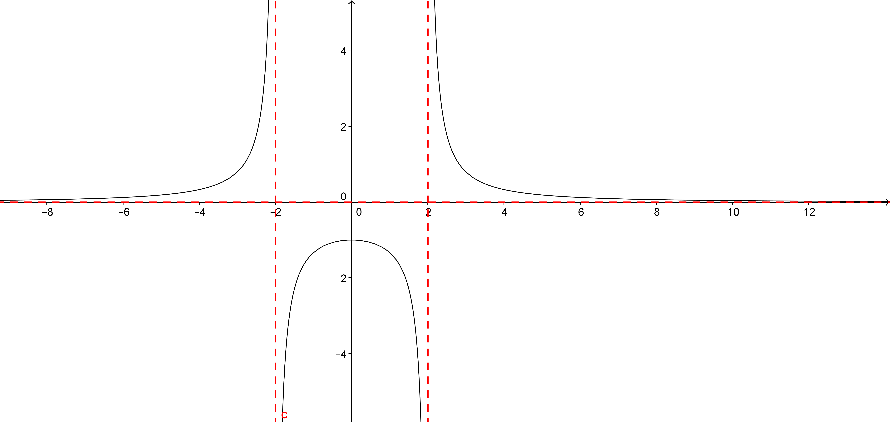
2. Factor out the highest power of in each of the following, and cancel common factors if you can. Assume is nonzero.
3. Describe the end behavior of each function in Exercise 3.
   1. As , .
   2. As , .
   3. As , .
   4. As , .
   5. As , .
4. Using the equations that you wrote in Exercise 3, make some generalizations about how to quickly determine the end behavior of a rational function.

The coefficients on the leading terms always end up being the horizontal asymptotes when the functions have the same power. When the power in the numerator is larger, then the functions either increase or decrease without bound as increases or decreases without bound. When the power in the denominator is larger, then the functions go to zero.

1. Describe how you may be able to use the end behavior of the graphs of rational functions, along with the excluded values from the domain and the equations of any asymptotes, to graph a rational function without technology.

Let be a rational function. The end behavior of the graph of will tell you in what direction the graph of is heading, and the process of finding the end behavior yields a simpler function that gets close to as increases in magnitude. The vertical asymptotes and excluded values from the domain tell you where the graph varies close to the origin. All of this information combined gives you a very good idea of what the graph of will look like without technology.