|  |
| --- |
|  |

Lesson 9: Volume and Cavalieri’s Principle

Student Outcomes

* Students will be able to give an informal argument using Cavalieri’s principle for the formula for the volume of a sphere and other solid figures (**G-GMD.A.2**).

Lesson Notes

The opening uses the idea of cross sections to establish a connection between the current lesson and the previous lessons. In particular, ellipses and hyperbolas are seen as cross sections of a cone, and Cavalieri’s volume principle is based on cross-sectional areas. This principle is used to explore the volume of pyramids, cones, and spheres.

Classwork

Opening (2 minutes)

*Scaffolding:*

* A cutout of a cone is available in Geometry, Module 3, Lesson 7 to make picturing this exercise easier.
* Use the cutout to model determining that a circle is a possible cross section of a cone.

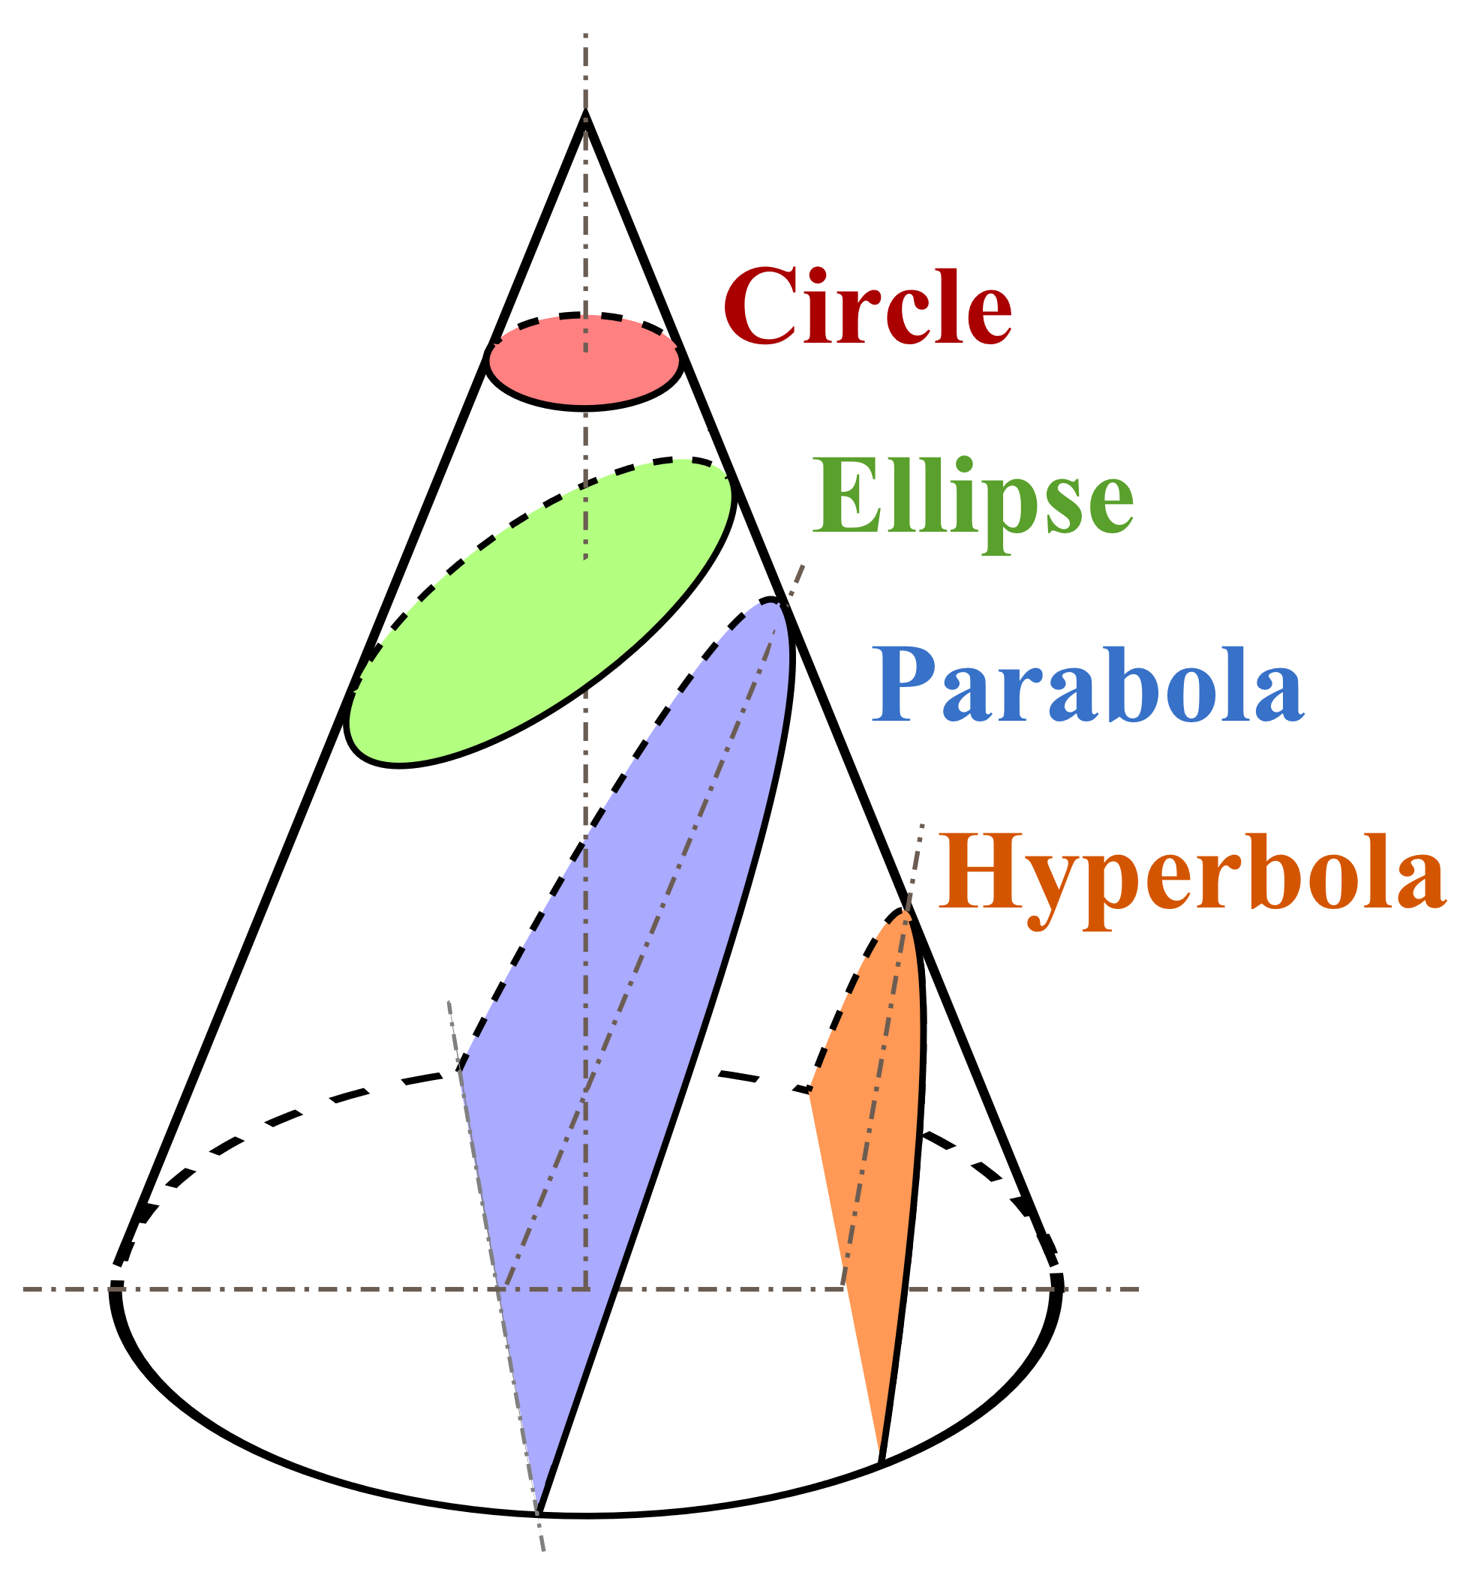

“Conic Sections” by Magister Mathematicae is licensed under CC BY-SA 3.0

<http://creativecommons.org/licenses/by-sa/3.0/deed.en>

In the previous lesson, we saw how the ellipse, parabola, and hyperbola can come together in the context of a satellite orbiting a body such as a planet; we learned that the velocity of the satellite determines the shape of its orbit. Another context in which these curves and a circle arise is in slicing a cone. The intersection of a plane with a solid is called a *cross section* of the solid.

* Imagine a cone. How many different cross sections could you make by slicing the cone from any angle? Make a sketch of each one.
  + *Answers will vary, but students should have parabolas, circles, ellipses, and hyperbolas.*
* Share your results with a neighbor. Do you have the same cross sections?
  + *Answers will vary.*

The figure above shows that these four curves are cross sections of the cone, which explains why they are often referred to as the *conic sections.*

In this lesson, we’ll use cross sections to discover a relationship between cones, cylinders, and spheres. In particular, we will derive the formula for the volume of a sphere. This formula was used to solve problems in Geometry, so today we will focus on the derivation of that formula.

Discussion (4 minutes): A Sphere Enclosed by a Cylinder

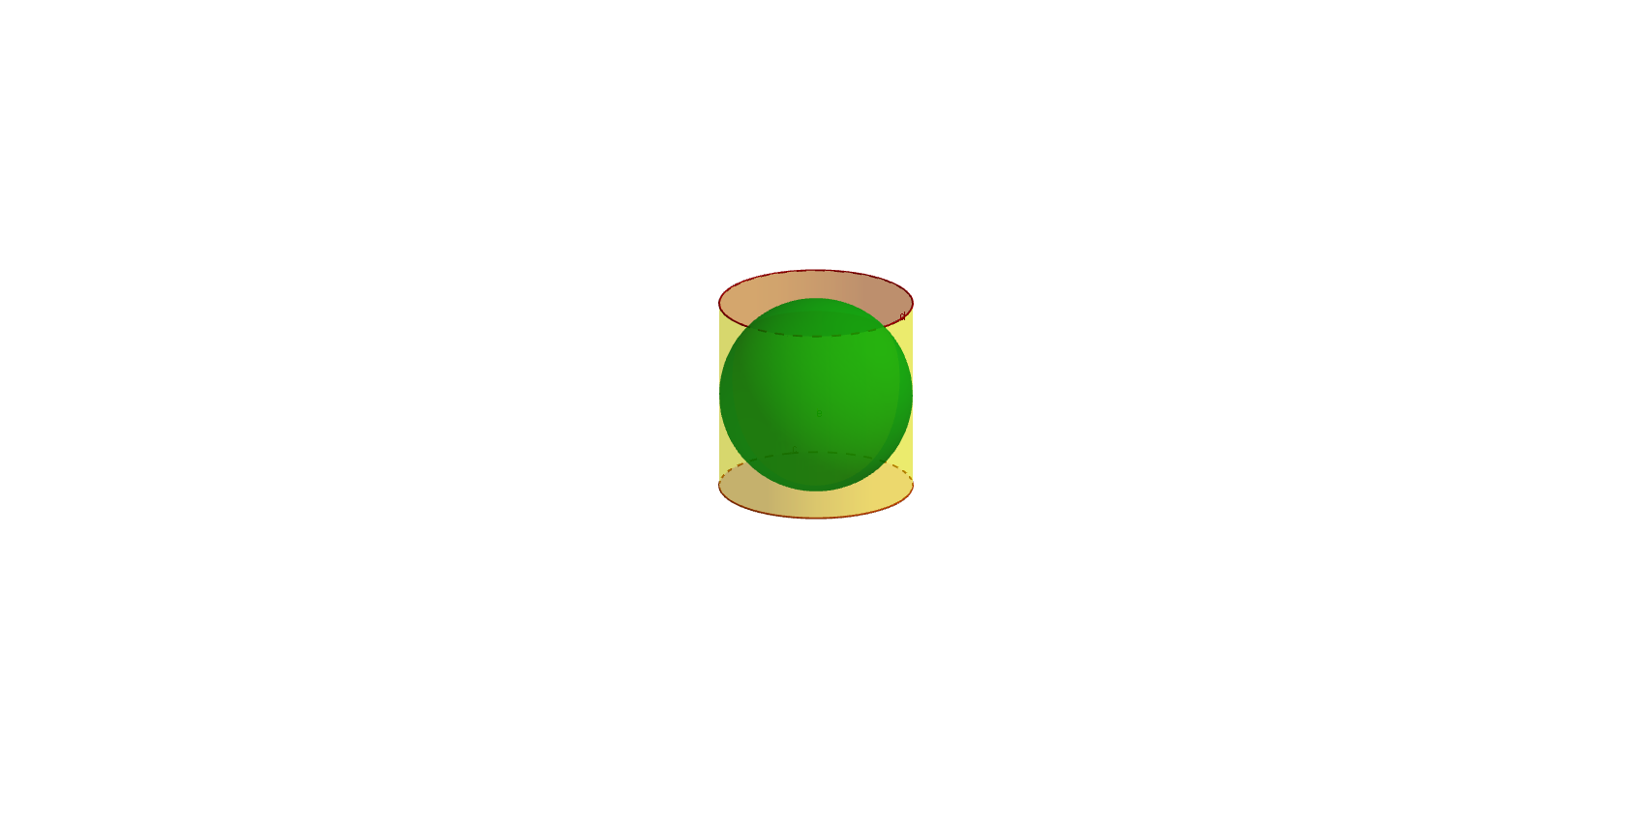

* Imagine that a spherical balloon filled with water is placed into a cylindrical container as shown above. If you took a pin and pricked the balloon, allowing the water to leak out into the cylinder, how high would the water go? Would the water fill more or less than of the cylinder? More or less than ? Write down your best guess, and then share your conjecture with a partner.
* Here’s an exercise for you: If the diameter of the sphere above is , what is the volume of the cylinder that encloses the sphere?
  + *Since the diameter of the sphere is , the height of the cylinder is , and the radius of the cylinder is .*
  + *The base of the cylinder is a circle, so its area is .*
  + *Thus, the volume of the cylinder is .*
* Finding the volume of the cylinder was straightforward. But finding the volume of the sphere is going to require some work!
* The ancient Greek mathematician Archimedes discovered the relationship between the volume of a sphere and the volume of a cylinder and was so proud of this achievement that he had the above figure etched into his tombstone. The key to his approach is to think of a sphere as a solid formed by many disks, as shown in the figure below. If we can somehow relate the size of each disk to the corresponding disks in the cylinder, we will know how the volumes of the two solids are related.

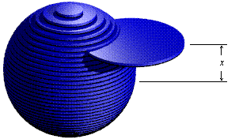

© Joe Mercer

[http://www.ceemrr.com](http://www.ceemrr.com/" \t "_blank)

**Discussion (4 minutes): Cavalieri’s Principle**

* There is a general principle that can help us with this task. See if you can gain an understanding of this principle by studying the figure below. What do you notice? Take a moment to reflect on this image.

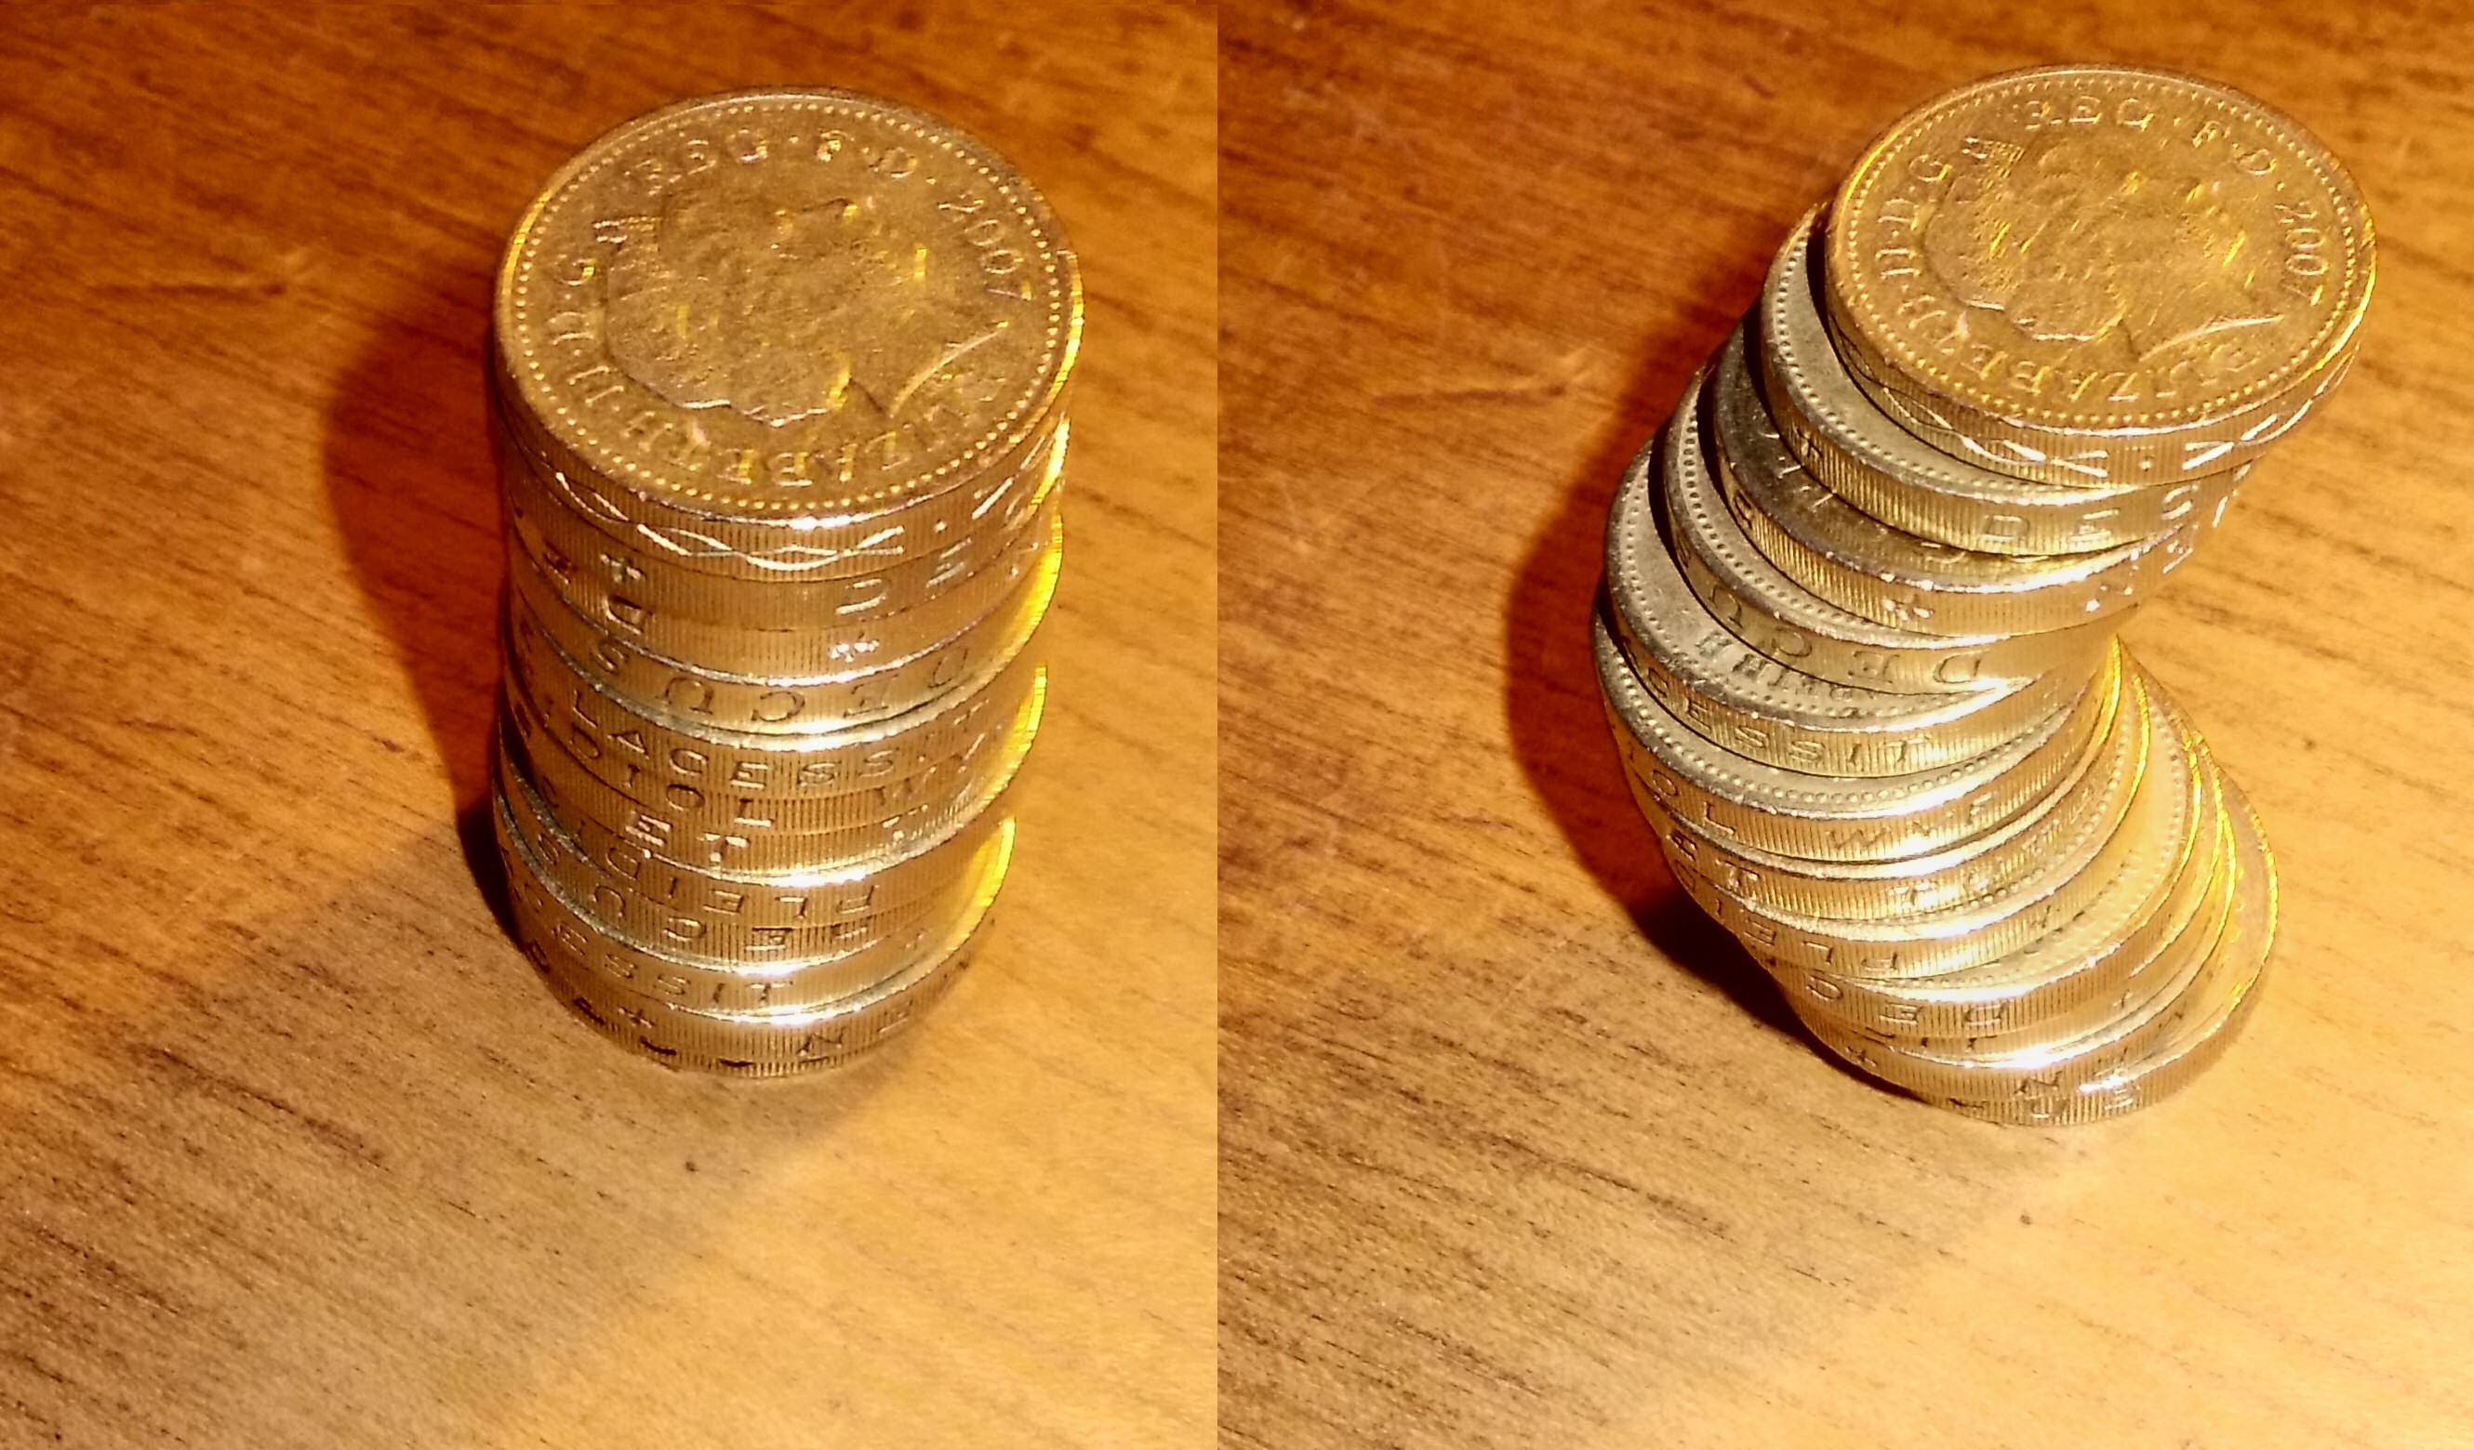

“Cavalieri's Principle in Coins” by Chiswick Chap is licensed under CC BY-SA 3.0

<http://creativecommons.org/licenses/by-sa/3.0/deed.en>

* Do the two stacks of coins have the same volume? How do you know?

**MP.3**

* + *It appears that the two stacks contain exactly the same objects, so it makes sense to say that the two stacks have the same volume. It does not matter whether the coins are arranged in a regular fashion, as in the first image, or an irregular fashion, as in the second image.*
* What about the stacks shown below? Can you tell whether these have the same volume? Why or why not?



"Stacks of Coins" by Austin Kirk is licensed under CC BY 2.0

<http://creativecommons.org/licenses/by/2.0>

* + *Some of the coins are larger than the others. There is no easy way to tell whether the stacks have the same volume.*
* If you knew that two stacks both contained quarters, nickels, 8 pennies, and dimes, do you feel confident that the stacks would have the same volume? Knowing the coins are the same size would be helpful. In a more general setting, we would like to know that the *cross sections* of two solids have the same area.
* Now, let’s state the principle suggested by this discussion: Suppose two solids are included between two parallel planes. If every plane parallel to these two planes intersects both regions in cross sections of equal area, then the two regions have equal volumes.
* Can you understand the role that *parallel planes* play in this principle? For example, in the image below, where are the parallel planes that bound the two solids?



“Cavalieri's Principle in Coins” by Chiswick Chap is licensed under CC BY-SA 3.0

<http://creativecommons.org/licenses/by-sa/3.0/deed.en>

* + *The lower plane is the plane of the table on which the coins are resting. The upper plane is parallel to the plane of the tabletop and rests on the topmost coin in each stack.*
* Notice that when two solids are bounded by the same parallel planes, they are guaranteed to have the same height. Now, imagine the plane that lies halfway between these two boundary planes. Describe the intersection of this plane with the two stacks.
  + *Each plane that is parallel to the tabletop will produce a cross section that is exactly equal in shape and size to the face of a coin. In particular, the area of a cross section is equal to the area of the face of a coin.*
* The idea we have been discussing is called Cavalieri’s volume principle, which is named after an Italian mathematician who lived in the 17th century. But Archimedes was aware of this principle even in much more ancient times! We will soon see how he used this volume principle to derive the relationship between the volume of a sphere and the volume of a cylinder.

**Discussion (4 minutes): The Volume of a Pyramid**

* Here we can see how Cavalieri’s principle applies to some pyramids. (This can be viewed as an animation at <http://nrich.maths.org/7086&part=>.) It can be shown that if two pyramids have the same base area and the same height, then they must have the same volume.

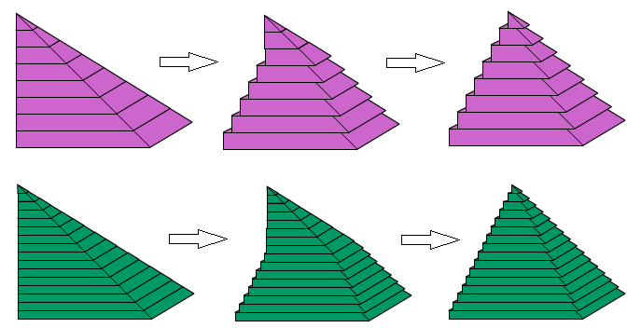

The NRICH website [http://nrich.maths.org](http://nrich.maths.org/) publishes free mathematics resources designed to challenge, engage and develop the mathematical thinking of students aged 5 to 19.

* Note that the pyramids on the left can be arranged to form a cube:

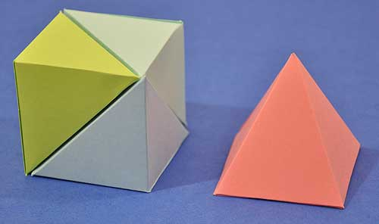

C2

C1

C3

PC1

© Laszlo Bardos

* Here is a challenge for you: If the edges of the cube on the left are long, try to determine the volume of the pyramid on the right. Here is a decomposed picture of the cube to help you visualize what you are looking at:

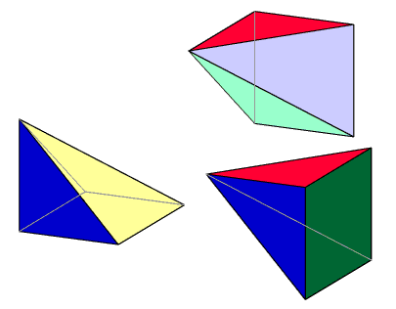

C1

C2

C3

The NRICH website <http://nrich.maths.org> publishes free mathematics resources designed to challenge, engage and develop the mathematical thinking of students aged 5 to 19.

* + *If the edges of the cube are long, then the volume of the cube is .*
  + *The heights of each of the three pyramids must be equal since each of these is equal to the height of the cube. The base areas of each of the four pyramids must be equal since each of these is equal to the area of a face of the cube. Thus, each of the four pyramids have the same volume.*
  + *It follows that each of the three pyramids on the left is one-third of the volume of the cube, which is . Thus, the volume of the pyramid above on the right of the cube is also .*
* The same reasoning can be used to show that any pyramid has one-third as much volume as a prism with the same base and the same height and that any cone has one-third as much volume as a cylinder with the same base and the same height.
* At this point, all of the groundwork has been laid. Let’s see how Archimedes derived the formula for the volume of a sphere!

**Discussion (6 minutes): Slicing a Hemisphere**

*Scaffolding:*

* If students are having trouble visualizing three-dimensional shapes, use cutouts from Geometry Module 3, or use common items such as balls, funnels, and disks that students can use to represent these shapes. You can help by cutting some of these shapes apart so students can see the cross sections.
* The key to this task is to apply the Pythagorean theorem to a right triangle like the one shown in the drawing on the left. If students are struggling, provide them with a copy of this diagram, and ask, “What is the relationship between the lengths of the sides in a right triangle?”
* In the figure below, we see a hemisphere on the left and a cone on the right that is sitting inside a cylinder. The cylinder is just large enough to enclose the hemisphere. Our goal is to determine the relationship between the volumes of these three solids.

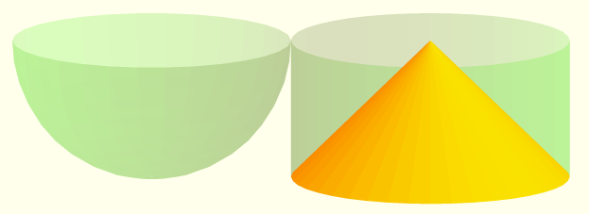

© Roberto Cardil, Matematicas Visuales

[http://www.matematicasvisuales.com](http://www.matematicasvisuales.com/)

* We will suppose that the radius of the sphere is . Next, we will imagine that a plane is cutting through these solids, where the plane is parallel to the bases of the cylinder. Try to imagine what the cross sections look like. What will the cross sections of the sphere look like? What about the cylinder and the cone?
  + *All of the cross sections are circles.*

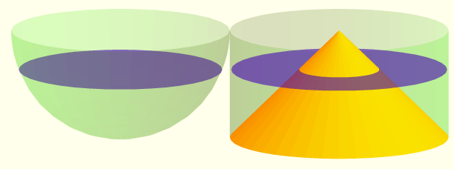

© Roberto Cardil, Matematicas Visuales

[http://www.matematicasvisuales.com](http://www.matematicasvisuales.com/)

* Let’s see if we can compute the area of a few cross sections of these solids. Let represent the distance between the slicing plane and the center of the sphere. If , what is the area of the blue disk on the left?

Give students several minutes to work on this task. Ask students to get into groups of three or four. Select a student or a group of students to present their work to the class at an appropriate time.

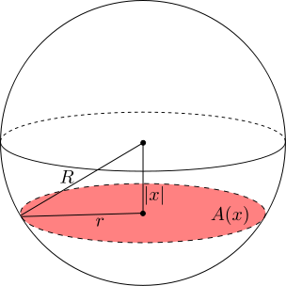

“Sphere with Cross Section” by Theneb 314 is licensed under CC BY-SA 3.0

<http://creativecommons.org/licenses/by-sa/3.0/deed.en>

* + *The area of the circle is . To determine the area, we need to find the value of .*
  + *The plane cuts the sphere at , and since the radius of the sphere is , we have . This means that , and so the area of the cross section is .*
* Let’s get some additional practice finding the areas of the cross sections of a sphere.

Exercise 1 (3 minutes)

Ask students to solve the following problems and to compare their results with a partner. Ask one or more students to present their solutions on the board.

Exercises 1–3

1. Let , and let represent the area of a cross section for a circle at a distance from the center of the sphere.



“Sphere with Cross Section” by Theneb 314 is licensed under CC BY-SA 3.0

<http://creativecommons.org/licenses/by-sa/3.0/deed.en>

* 1. Find . What is special about this particular cross section?

. This is the largest cross section in the sphere; it’s the area of a “great circle.”

* 1. Find .

When , we have . Thus, .

* 1. Find .

When , we have . Thus, .

* 1. Find .

When , we have . Thus, .

* 1. Find . What is special about this particular cross section?

. When the plane reaches the point where , the cross section is a single point, so the area vanishes.

**Discussion (6 minutes): Slicing the Cylinder and the Cone**

* As we perform these calculations, a structure is beginning to emerge. Let’s now turn our attention to the general case: Can you describe the area of a cross section formed by a plane cutting the sphere at a distance from its center?



“Sphere with Cross Section” by Theneb 314 is licensed under CC BY-SA 3.0

<http://creativecommons.org/licenses/by-sa/3.0/deed.en>

* Notice that we could use the distributive property to get . This looks like it could be the difference of two circles, and indeed it is! Momentarily, we will show that the area of each disk in the sphere is equal to the difference in the areas of two other disks, as this diagram shows:

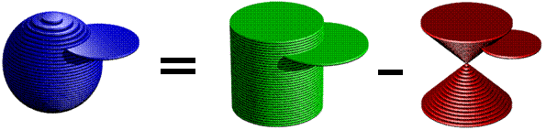

© Joe Mercer

http://[www.ceemrr.com](http://www.ceemrr.com/)

* Let’s return now to the diagram that will lead us to Archimedes’ result:



© Roberto Cardil, Matematicas Visuales

<http://www.matematicasvisuales.com>

* We have analyzed the cross sections of the sphere; now, let’s analyze the cross sections of the cone. In fact, let’s focus on the blue ring surrounding the cone. If the slicing plane is units below the top of the cylinder, what is the area of the blue ring in the figure on the right?

*Scaffolding:*

* The key to this task is to recognize that the right triangle shown in the diagram to the left is similar to the triangle formed by the largest cone. Ask students, “How do we know when triangles are similar? What evidence do we have that the right triangles shown here are similar?”
* If students are struggling, provide them with a copy of this diagram.

Give students several minutes to work on this task in groups. Select a student or a group of students to present their work to the class at an appropriate time.

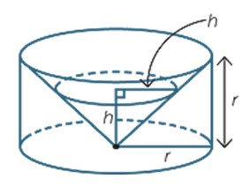

* + *As the height of the slicing plane varies, the angles in the right triangle shown stay the same. Thus, a family of similar triangles is produced. Since the largest such triangle is an isosceles triangle with legs of length 5, it follows that all of the triangles are isosceles. So, at a distance from the base of the cylinder, the radius of the cross section is as well. Thus, the area of the cross section of the cone is .*
  + *The cross sections of the cylinder are uniform. Thus, for any height , the area of a cross section of the cylinder is .*
* Our next task is to describe the space *around* the cone:

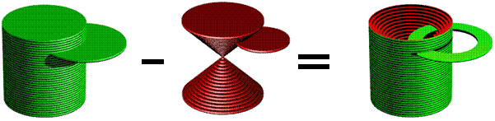

© Joe Mercer

[http://www.ceemrr.com](http://www.ceemrr.com/)

* If we take a section of this solid that is units below the vertex of the double cone, then what is its area?
  + *The area of such a cross section is .*
* Does this look familiar? It’s the same formula that describes the cross section of the sphere! Let’s take a few minutes to confirm this result in specific cases.

Exercise 2 (2 minutes)

Ask students to solve the following problems and to compare their results with a partner. Ask one or more students to present their solutions on the board.

1. Let the radius of the cylinder be , and let represent the area of the blue ring when the slicing plane is at a distance from the top of the cylinder.



© Roberto Cardil, Matematicas Visuales

[http://www.matematicasvisuales.com](http://www.matematicasvisuales.com/)

* 1. Find . Compare this area with , the area of the corresponding slice of the sphere.

This is equivalent to .

* 1. Find . Compare this area with , the area of the corresponding slice of the sphere.

This is equivalent to .

* 1. Find . Compare this area with , the area of the corresponding slice of the sphere.

This is equivalent to .

**Discussion (4 minutes): The Volume of a Sphere**

* Now we have shown that the cross sections of the sphere are equal in area to the sections of the cylinder that lie outside the cone. What exactly does this prove about the solids themselves?
  + *Using Cavalieri’s volume principle, we can conclude that the solids have equal volumes. That is, since their cross sections have equal areas and since the two solids are bounded between the same pair of parallel planes, they must have equal volumes.*
* How can we use the previous observation to compute the volume of the sphere with radius ? Take a minute to think about this.



* + *We already found that the volume of the cylinder is .*
  + *We know that a cone contains one-third as much volume as an enclosing cylinder, so the volume of the double cone inside the cylinder is .*
  + *It follows that the space around the cone occupies the remaining two-thirds of the volume of the cylinder, which is .*
  + *We proved that the volume of the hemisphere is equal to the volume of the space around the lower cone. It follows that the volume of the whole sphere is equal to the volume of the space around the double cone, which we just showed is . This is the volume of the sphere with radius .*
* Now would be a good time to revisit the balloon problem from the opening of the lesson. If a spherical balloon were pricked with a pin, allowing the water to leak out, how much of the cylinder would it fill? That’s right. !
* The only thing left to do is to write a general formula for a sphere with radius .

Exercise 3 (4 minutes)

Ask students to solve the following problem in their groups. Select a group to present their solution to the class.

**MP.3**

1. Explain how to derive the formula for the volume of a sphere with radius .

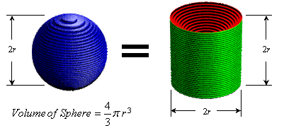

© Joe Mercer

[http://www.ceemrr.com](http://www.ceemrr.com/)

If we pass a plane through the sphere that is parallel to the bases of the cylinder at a distance from the center of the sphere, we get a circle with area .

When the same plane intersects the cylinder, a ring is formed around the double cone. The area of this ring is .

It’s easy to see that , and since both solids have height , it follows from Cavalieri’s principle that the volume of the sphere is equal to the volume of the space outside the double cone.

The volume of the cylinder is .

Thus, the volume of the double cone is .

The volume of the space outside the double cone is therefore . Since the sphere also has this volume, this is the formula for the volume of the sphere!

* What do you make of this? James says that he prefers to think about the volume of a sphere using the formula . What do you suppose the variables and represent relative to the sphere? What do you suppose his rationale is for this preference?
  + *The cylinder that encloses the sphere has base area and height , and the gist of this lesson is that the sphere has two-thirds as much volume as the cylinder. The formula makes all of these things visible.*

Closing (1 minutes)

* How are pyramids and prisms related with respect to their volumes? How are cones and cylinders related? How are spheres and cylinders related?
  + *A pyramid is one-third of a prism.*
  + *A cone is one-third of a cylinder.*
  + *A sphere is two-thirds of a cylinder.*

Exit Ticket (5 minutes)

Name Date

Lesson 9: Volume and Cavalieri’s Principle

Exit Ticket

Explain how Cavalieri’s principle can be used to find the volume of any solid.

Exit Ticket Sample Solutions

Explain how Cavalieri’s principle can be used to find the volume of any solid.

Cavalieri’s principle tells us that to find the volume of a solid, we can examine cross sections of the solid. If another shape exists with the same height and the equal areas of cross sections, then the two shapes will have equal volume.

Problem Set Sample Solutions

1. Consider the sphere with radius . Suppose that a plane passes through the sphere at a height above the center of the sphere, as shown in the figure below.

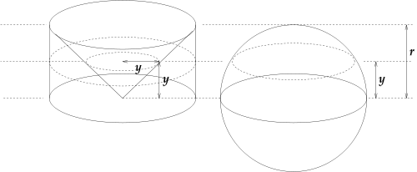

* 1. Find the area of the cross section of the sphere.

The sphere has radius , and the cross section passes through at , which tells us that the radius at the cross section is . Thus, the area of the cross section is .

* 1. Find the area of the cross section of the cylinder that lies outside of the cone.

The cone will have radius equal to its height at the cross section, and the circle passing through it will have radius equal to (since the radius of the cylinder is constant).

* 1. Find the volume of the cylinder, the cone, and the hemisphere shown in the figure.

*The volume of the cylinder is . The volume of the cone is   
. The volume of the hemisphere is twice the volume of the cone, so .*

* 1. Find the volume of the sphere shown in the figure.

*The sphere is twice the volume of the hemisphere, so .*

* 1. Explain using Cavalieri’s principle the formula for the volume of any single solid.

Cavalieri’s principle tells us that to find the volume of a solid, we can examine cross sections of the solid. If another shape exists with the same height and the equal areas of cross sections, then the two shapes will have equal volume.

1. Give an argument for why the volume of a right prism is the same as an oblique prism with the same height.

Since the cross sections of both a right prism and an oblique prism would be the same shape (same area), it does not matter if the object is on a slant or straight up and down; they will have the same volume.

1. A paraboloid of revolution is a three-dimensional shape obtained by rotating a parabola around its axis. Consider the solid between a paraboloid described by the equation and the line .

|  |  |
| --- | --- |
|  |  |

* 1. Cross sections perpendicular to the -axis of this paraboloid are what shape?

Circles

* 1. Find the area of the largest cross section of this solid, when .

When , so .

* 1. Find the area of the smallest cross section of this solid, when .

When , , so .

* 1. Consider a right triangle prism with legs of length , hypotenuse of length , and depth as pictured below. What shape are the cross sections of the prism perpendicular to the -axis?

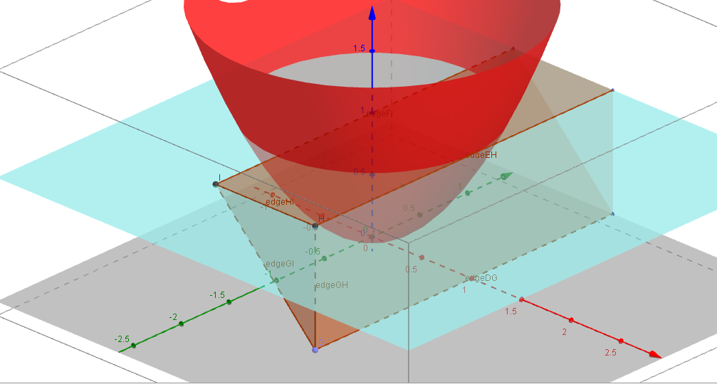

Cross sections will be rectangles.

* 1. Find the areas of the cross sections of the prism at and .

At , the width is , and the depth is , so .

At , the width is , and the depth is , so .

* 1. Verify that at , the areas of the cross sections of the paraboloid and the prism are equal.

At , the cross sections of the paraboloid have radius , so the area is .

Similarly, the width of the rectangle is equal to the height of the prism, so at , the width will be , and the depth is a constant , so the area is .

* 1. Find the volume of the paraboloid between and .

The volume of the paraboloid is equal to the volume of the right triangular prism, which has volume   
.

* 1. Compare the volume of the paraboloid to the volume of the smallest cylinder containing it. What do you notice?

The volume of the paraboloid is half the volume of the cylinder.

* 1. Let be the volume of a cylinder, be the volume of the inscribed paraboloid, and be the volume of the inscribed cone. Arrange the three volumes in order from smallest to largest.

since and .

1. Consider the graph of described by the equation for .
   1. Find the area of the 10 rectangles with height and width , for .

In each case, the width is one, so the area is equal to the height of the function at that point; we get .

* 1. What is the total area for ? That is, evaluate: for .
  2. Draw a picture of the function and rectangles for .

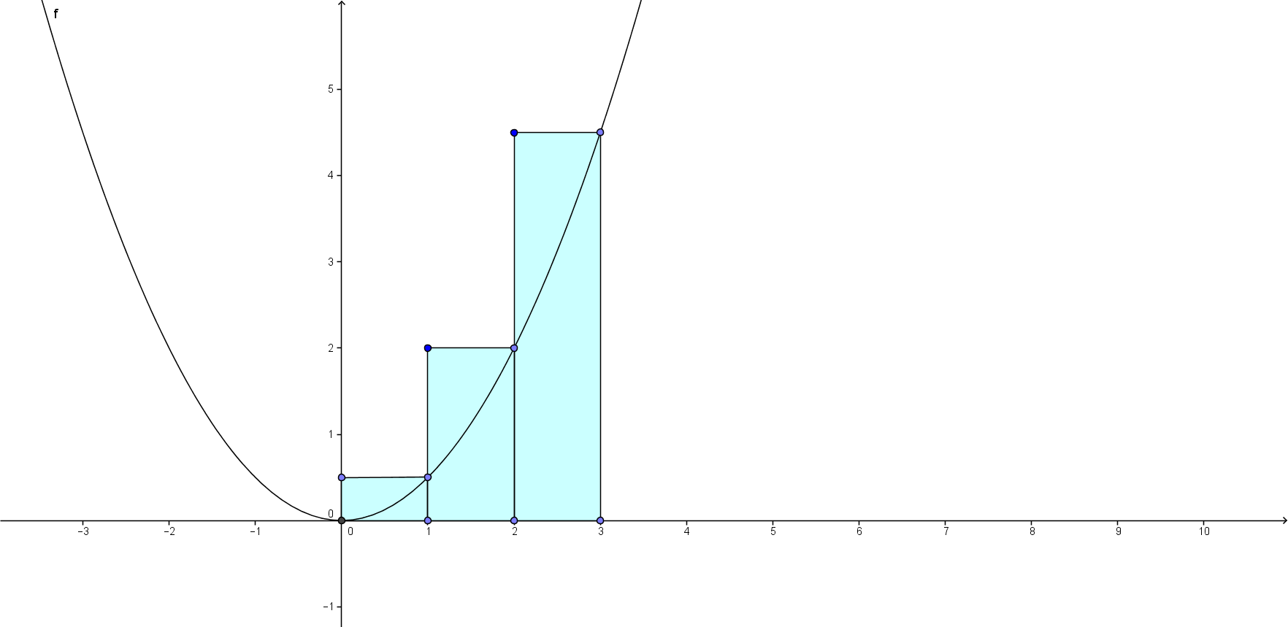

* 1. Is your approximation an overestimate or an underestimate?

Since each rectangle contains more area than is under the parabola, the estimate is an overestimate.

* 1. How could you get a better approximation of the area under the curve?

Answers may vary and may include that you could find smaller rectangles, you could find the underestimate by using the left endpoints, and you could cut off the triangles above the function to get a trapezoid.

1. Consider the three-dimensional solid that has square cross sections and whose height at position is given by the equation for .
   1. Approximate the shape with four rectangular prisms of equal width. What is the height and volume of each rectangular prism? What is the total volume?

The heights are , and the volumes are . The total volume is .

* 1. Approximate the shape with eight rectangular prisms of equal width. What is the height and volume of each rectangular prism? What is the total volume?

The heights are , and the volumes are . The total volume is .

* 1. How much did your approximation improve? The volume of the shape is . How close is your approximation from part (b)?

*The approximation improved by . The approximation is off by .*

* 1. How many rectangular prisms would you need to be able to approximate the volume accurately?

It is hard to say, but many would be needed to get significant accuracy, although this could be reduced by taking both an upper and a lower bound.