Lesson 9: Volume and Cavalieri’s Principle

Classwork
Exercises 1–3
- Let $R=5$, and let $A(x)$ represent the area of a cross section for a circle at a distance $x$ from the center of the sphere.
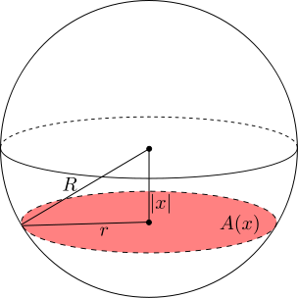
“Sphere with Cross Section” by Theneb 314 is licensed under CC BY-SA 3.0
http://creativecommons.org/licenses/by-sa/3.0/deed.en
  - Find $A(0)$. What is special about this particular cross section?

  - Find $A(1)$.

  - Find $A(3)$.

  - Find $A(4)$.

  - Find $A(5)$. What is special about this particular cross section?

- Let the radius of the cylinder be $R=5$, and let $B(x)$ represent the area of the blue ring when the slicing plane is at a distance $x$ from the top of the cylinder.
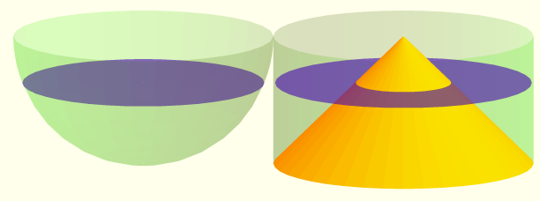
© Roberto Cardil, Matematicas Visuales
http://www.matematicasvisuales.com
  - Find $B(1)$. Compare this area with $A(1)$, the area of the corresponding slice of the sphere.

  - Find $B(2)$. Compare this area with $A(2)$, the area of the corresponding slice of the sphere.

  - Find $B(3)$. Compare this area with $A(3)$, the area of the corresponding slice of the sphere.

- Explain how to derive the formula for the volume of a sphere with radius $r$.
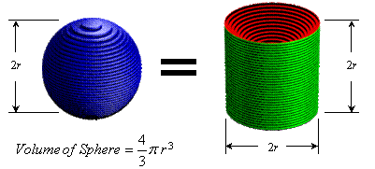
© Joe Mercer
http://www.ceemrr.com

Problem Set

- Consider the sphere with radius $r=4$. Suppose that a plane passes through the sphere at a height $y=2 units$ above the center of the sphere, as shown in the figure below.
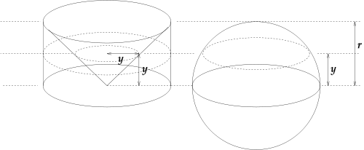
  - Find the area of the cross section of the sphere.
  - Find the area of the cross section of the cylinder that lies outside of the cone.
  - Find the volume of the cylinder, the cone, and the hemisphere shown in the figure.
  - Find the volume of the sphere shown in the figure.
  - Explain using Cavalieri’s principle the formula for the volume of any single solid.

- Give an argument for why the volume of a right prism is the same as an oblique prism with the same height.

- A paraboloid of revolution is a three-dimensional shape obtained by rotating a parabola around its axis. Consider the solid between a paraboloid described by the equation $y=x^{2}$ and the line $y=1$.
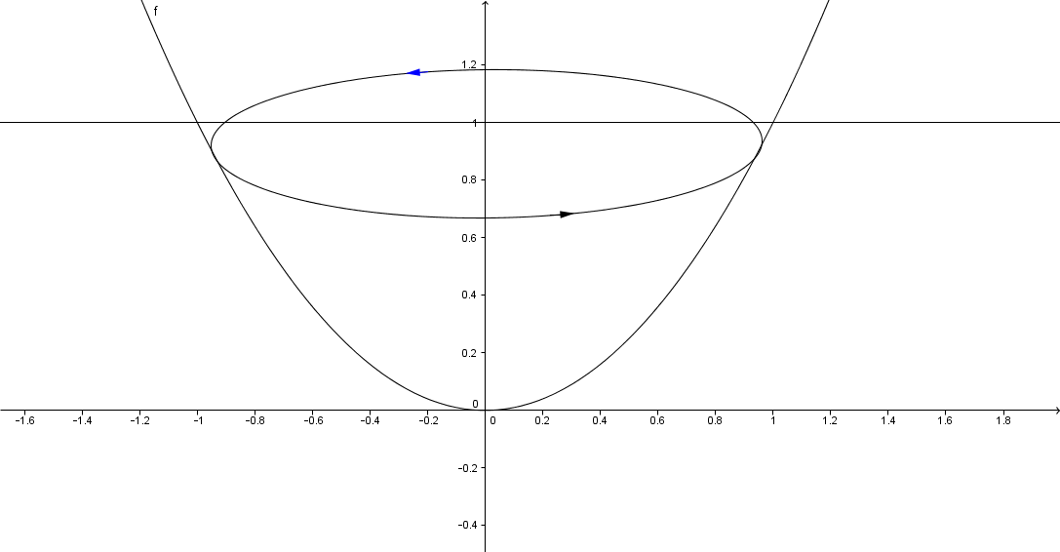 | 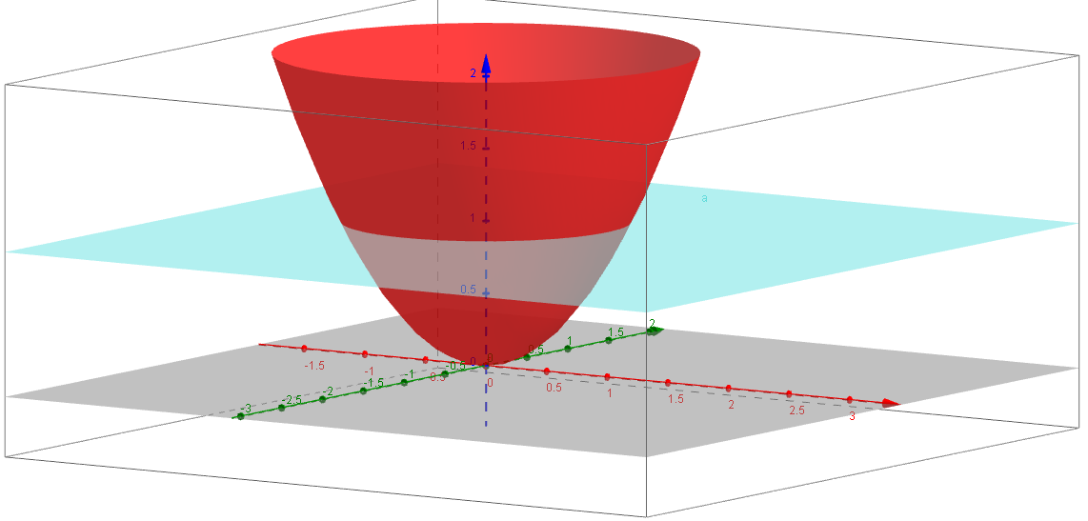
  - Cross sections perpendicular to the $y$-axis of this paraboloid are what shape?
  - Find the area of the largest cross section of this solid, when $y=1$.
  - Find the area of the smallest cross section of this solid, when $y=0$.

  - Consider a right triangle prism with legs of length $1$, hypotenuse of length $\sqrt{2}$, and depth $π$ as pictured below. What shape are the cross sections of the prism perpendicular to the $y$-axis?
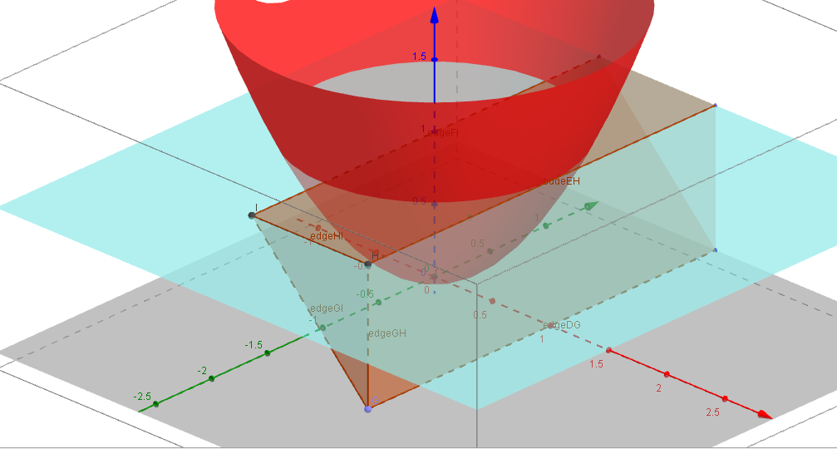
  - Find the areas of the cross sections of the prism at $y=1$ and $y=0$.
  - Verify that at $y=y_{0}$, the areas of the cross sections of the paraboloid and the prism are equal.
  - Find the volume of the paraboloid between $y=0$ and $y=1$.
  - Compare the volume of the paraboloid to the volume of the smallest cylinder containing it. What do you notice?
  - Let $V_{cyl}$ be the volume of a cylinder, $V_{par}$ be the volume of the inscribed paraboloid, and $V_{cone}$ be the volume of the inscribed cone. Arrange the three volumes in order from smallest to largest.

- Consider the graph of $f$ described by the equation $f\left(x\right)=\frac{1}{2}x^{2}$ for $0≤x≤10$.
  - Find the area of the 10 rectangles with height $f(i)$ and width $1$, for $i=1,2,3,…,10$.
  - What is the total area for $0≤x≤10$? That is, evaluate: $\sum_{i=1}^{10}{f\left(i\right)⋅Δx}$ for $Δx=1$.
  - Draw a picture of the function and rectangles for $i=1,2,3$.
  - Is your approximation an overestimate or an underestimate?
  - How could you get a better approximation of the area under the curve?

- Consider the three-dimensional solid that has square cross sections and whose height $y$ at position $x$ is given by the equation $y=2\sqrt{x}$ for $0≤x≤4$.
  - Approximate the shape with four rectangular prisms of equal width. What is the height and volume of each rectangular prism? What is the total volume?
  - Approximate the shape with eight rectangular prisms of equal width. What is the height and volume of each rectangular prism? What is the total volume?
  - How much did your approximation improve? The volume of the shape is $32 cubic units$. How close is your approximation from part (b)?
  - How many rectangular prisms would you need to be able to approximate the volume accurately?

