Lesson 8: Curves from Geometry

Student Outcomes
- Students learn to graph equations of the form $\frac{x^{2}}{a^{2}}-\frac{y^{2}}{b^{2}}=1$.
- Students derive the equations of hyperbolas given the foci, using the fact that the difference of distances from the foci is constant (G-GPE.A.3).

Lesson Notes
In the previous lessons, students learned how to describe an ellipse, how to graph an ellipse, and how to derive the standard equation of an ellipse knowing its foci. In this lesson, students learn to perform these tasks for a hyperbola. The opening of the lesson establishes a connection between ellipses, parabolas, and hyperbolas in the context of the orbital path of a satellite.

Classwork
Opening (2 minutes)
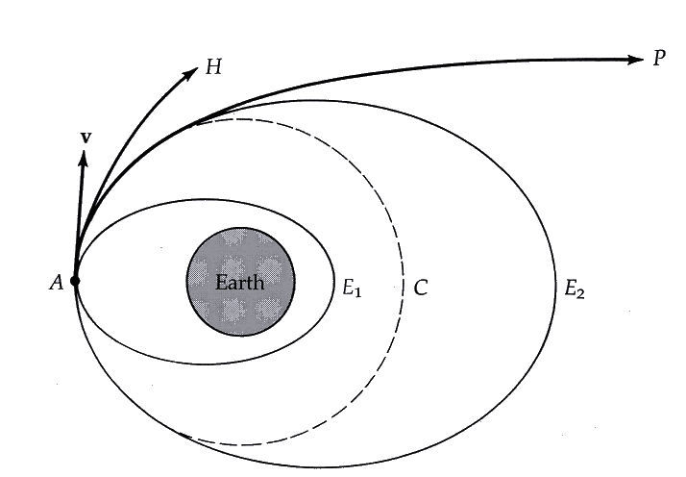
Display this picture and the paragraph below for the class.
When a satellite moves in a closed orbit around a planet, it follows an elliptical path. However, if the satellite is moving fast enough, it will overcome the gravitational attraction of the planet and break out of its closed orbit. The minimum velocity required for a satellite to escape the closed orbit is called the escape velocity. The velocity of the satellite determines the shape of its orbit.
In pairs, have students answer the following questions. Call the class back together to debrief.
- If the velocity of the satellite is less than the escape velocity, it follows a path that looks like $E_{2}$ in the diagram. Describe the path, and give the mathematical term for this curve.
  - Elliptical Path, Ellipse.

- If the velocity of the satellite is exactly equal to the escape velocity, it follows a path that looks like $P$ in the diagram. Describe the path, and give the mathematical term for this curve.
  - Parabolic Path, Parabola.
- If the velocity of the satellite exceeds the escape velocity, it follows a path that looks like $H$ in the diagram. Describe the path, and give the mathematical term for this curve.
  - Students may describe the path in general terms but won’t know the name. You can tell them the name for this curve is a hyperbola.
All three trajectories are shown in the diagram. The ellipse and the parabola were studied in previous lessons; the focus of this lesson is the hyperbola.

Discussion (12 minutes): Analysis of $x^{2}-y^{2}=1$
- Consider the equation $x^{2}+y^{2}=1$. When we graph the set of points $(x,y)$ that satisfy this equation, what sort of curve do we get?
MP.2
&
MP.3
  - The graph of this equation produces a circle. The center of the circle is $(0,0)$, and the radius of the circle is $1$.
- Let’s make one small change to this equation: Consider $x^{2}-y^{2}=1$.
- What sort of curve will this produce? Develop an argument, and share it with a neighbor. (Debrief as a class.)
- Let’s explore this question together. We will focus on three features that are of general interest when studying curves: intercepts, symmetries, and end behavior.
- Does this curve intersect the $x$-axis? Does it intersect the $y$-axis? If so, where?
  - When $x=0$, we have $-y^{2}=1$, which is equivalent to $y^{2}=-1$. Since there are no real numbers that satisfy this equation, the graph of $x^{2}-y^{2}=1$ does not intersect the $y$-axis.
  - When $y=0$, we have $x^{2}=1$, which is true when $x=1$ or $x=-1$. So the graph of $x^{2}-y^{2}=1$ intersects the $x$-axis at $(1,0)$ and again at $(-1,0)$.
Scaffolding:
- Some students may need guidance on how to determine the symmetries of the graph. Offer the following cues as needed: “If $(a,b)$ satisfies the equation, does $(-a,b)$ also satisfy the equation? How can you tell? If both $(a,b)$ and $(-a,b)$ satisfy the equation, what does this mean for the graph?”
- Ask advanced students to determine the key features of the curve produced by
$x^{2}-y^{2}=1$ independently, without scaffolded questions.

- What sort of symmetries do you expect this graph to have?
  - If $(a,b)$ satisfies $x^{2}-y^{2}=1$, then we have $a^{2}-b^{2}=1$. We can see that $(-a,b)$ also satisfies the equation since ${(-a)}^{2}-b^{2}=a^{2}-b^{2}=1$. Thus, the graph is symmetrical about the $y$-axis.
  - Similarly, the point $(a,-b)$ is on the graph whenever $(a,b)$ is, showing us that the graph is symmetrical about the $x$-axis.
- So if we can sketch a portion of the graph in the first quadrant, we can immediately infer what the rest of the graph looks like. That should come in handy!
- Now, let’s try to get a feel for what this curve looks like. It never hurts to plot a few points, so let’s start with that approach. Solving for $y$ makes this process a bit easier, so go ahead and isolate the $y$-variable.
  - We can write $y^{2}=x^{2}-1$, which means $y=±\sqrt{x^{2}-1}$.

- Since we are only going to deal with points in the first quadrant, we can simply consider $y=\sqrt{x^{2}-1}$. Use this relation to find the $y$-values that correspond to $x=1, 2, 3, 4,$ and $5$.
$$x$$ | $$1$$ | $$2$$ | $$3$$ | $$4$$ | $$5$$
$$y$$ | $$0$$ | $$\sqrt{3}$$ | $$\sqrt{8}$$ | $$\sqrt{15}$$ | $$\sqrt{24}$$
- To get a feel for these numbers, use your calculator to obtain a decimal approximation for each square root.
$$x$$ | $$1$$ | $$2$$ | $$3$$ | $$4$$ | $$5$$
$$y$$ | $$0$$ | $$1.73$$ | $$2.83$$ | $$3.87$$ | $$4.90$$
- Now, let’s use a software tool to plot these points for us:
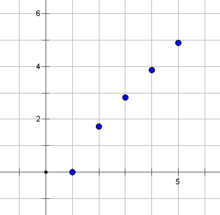
- Perhaps you’re beginning to get a sense of what the graph will look like, but more data will surely be useful. Let’s use a spreadsheet or a graphing calculator to generate some more data. In particular, what happens to the $y$-values when the $x$-values get larger and larger? Let’s have a look:
$$x$$ | $1$0 | $$20$$ | $$50$$ | $$100$$ | $$500$$
$$y$$ | $$9.949$$ | $$19.974$$ | $$49.989$$ | $$99.994$$ | $$499.999$$
- Here the data are shown to three decimal places without rounding. Now this is interesting! Make some observations about the data in front of you, and then share those observations with a partner. In a minute, I’ll ask some of you to share your thinking with the class.
  - The $y$-value is always smaller than the $x$-value.
  - As the value of $x$ increases, the $y$-value seems to get closer and closer to the $x$-value.
- So the data are telling us a particular story, but the power of mathematics lies in its ability to explain that story. Let’s do some further analysis to see if we can confirm our conjectures, and possibly along the way we will discover why they are true.
- If $(x,y)$ satisfies $x^{2}-y^{2}=1$, is it true that $y<x$? How can we be sure?
  - We have $y^{2}=x^{2}-1$; that is, $y^{2}$ is $1$ less than $x^{2}$. This means that $y^{2}<x^{2}$, and since we’re only considering points in the first quadrant, we must have $y<x$.

- What does this tell us about the curve we’re studying? In particular, where is the graph in relation to the line $y=x$?
  - The relation $y<x$ tells us that the graph lies below the line $y=x$.
- So apparently, the line $y=x$ acts as an upper boundary for the curve. Let’s draw this boundary line for visual reference. We’ll also use software to draw a portion of the curve for us:
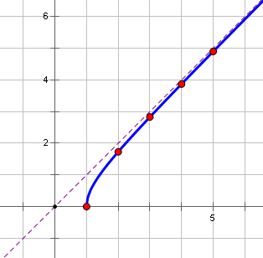
- Since the points on the curve are getting closer and closer to the line $y=x$, this graph provides visual confirmation of our observation that the $y$-value gets closer and closer to the $x$-value as $x$ gets larger and larger. So now let’s turn our attention to that conjecture: Why exactly must this be true? We’ll approach this question a bit informally in this lesson.
- We have $y^{2}=x^{2}-1$. If the value of $x^{2}$ is $100$, then the value of $y^{2}$ must be $99$. So when $x=\sqrt{100}$, $y=\sqrt{99}$.
- Let’s get some practice with this kind of thinking. Do the following exercises with a partner. Partner A, complete the sentence, “If the value of $x^{2}$ is $1,000$, then…” Partner B, complete the sentence, “If the value of $x^{2}$ is $1,000,000$, then…”
  - We have $y^{2}=x^{2}-1$. If the value of $x^{2}$ is $1,000$, then the value of $y^{2}$ must be $999$. So when
$x=\sqrt{1000}$, $y=\sqrt{999}$.
  - We have $y^{2}=x^{2}-1$. If the value of $x^{2}$ is $1,000,000$, then the value of $y^{2}$ must be $999,999$. So when $x=\sqrt{1,000,000}$, $y=\sqrt{999,999}$.
- Even without picking up a calculator, does it make sense to you intuitively that the value of$\sqrt{999,999}$ is extremely close to $\sqrt{1,000,000}$? When we check this on a calculator, we see that the values are $999.9995$ and $1,000.0000$, respectively. Those values are indeed close!
- To sum up, we have four important facts about the graph of $x^{2}-y^{2}=1$: First, the graph contains the point $(1,0)$. Second, the graph lies below the line $y=x$. Third, as we move along to the right, the points on the curve get extremely close to the line $y=x$. And fourth, the graph is symmetric with respect to both the $x$-axis and the $y$-axis.

- Let’s bring symmetry to bear on this discussion. Since the graph is symmetric with respect to the $x$-axis, we can infer the location of points in the fourth quadrant:
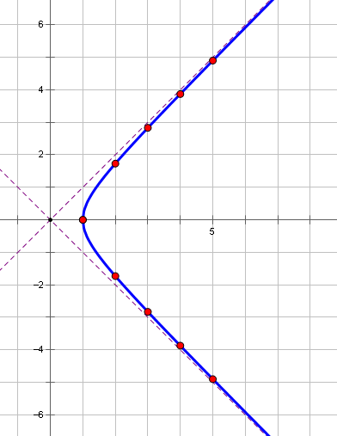
- Does this remind you of anything from the start of today’s lesson? That’s right! It’s the trajectory followed by a satellite that has exceeded its escape velocity. This curve is called a hyperbola, and thus we say that the satellite is following a hyperbolic path.
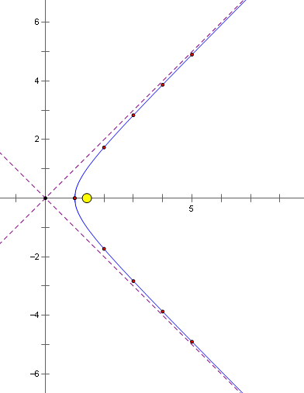
- In the diagram above, the yellow dot could represent a large body, such as a planet or the sun, and the blue curve could represent the trajectory of a hyperbolic comet, which is a comet moving at such great speed that it follows a hyperbolic path. The boundary lines, which for this hyperbola have equations $y=x$ and $y=-x$, are known as oblique or slant asymptotes. The location of the yellow dot is called a focus of the hyperbola. In fact, since the curve is also symmetrical with respect to the $y$-axis, a hyperbola actually has two foci:
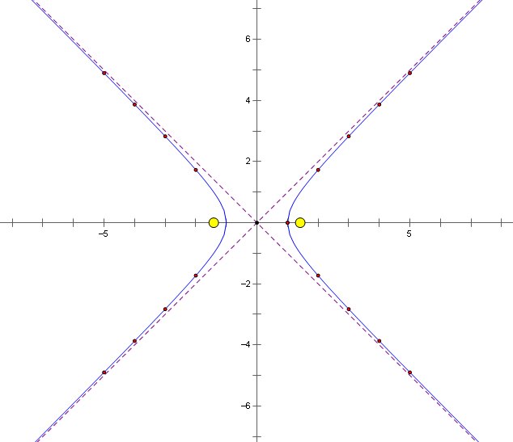
- So that you can be perfectly clear on what a hyperbola really looks like, here is an image that contains just the curve and the two foci:
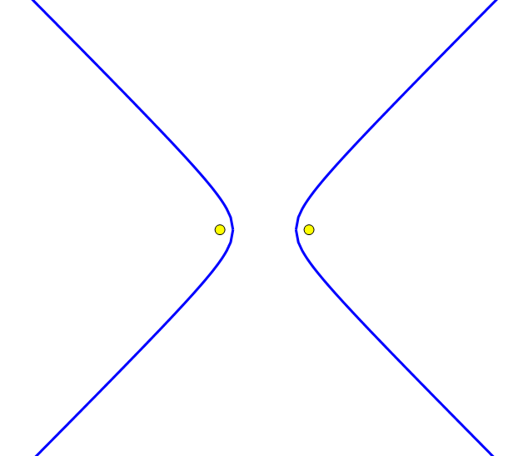
- Turn to your neighbor, and answer the original question: What sort of curve results when we graph the set of points that satisfy $x^{2}-y^{2}=1$? Describe this curve in as much detail as you can.
  - The graph of $x^{2}-y^{2}=1$ is a hyperbola that has intercepts on the $x$-axis and gets very close to the asymptotes $y=x$ and $y=-x$.

Discussion (6 minutes): Analysis of $\frac{x^{2}}{3^{2}}-\frac{y^{2}}{2^{2}}=1$
- Okay. Now that we have a sense for what a hyperbola looks like, let’s analyze the basic equation. We began with $x^{2}-y^{2}=1$.
- What do you suppose would happen if we took the curve $x^{2}-y^{2}=1$ and replaced $x$ and $y$ with $\frac{x}{3}$ and $\frac{y}{2}$?
Allow the students to have a few minutes to think about the answer to this question and discuss quietly with a partner before continuing.
MP.2 & MP 3
- Rewrite the equation ${\left(\frac{x}{3}\right)}^{2}-{\left(\frac{y}{2}\right)}^{2}=1$ without parentheses.
  - $\frac{x^{2}}{3^{2}}-\frac{y^{2}}{2^{2}}=1$
- Find the $x$-intercepts.
  - $\frac{x^{2}}{3^{2}}-\frac{0^{2}}{2^{2}}=1$
  - $\frac{x^{2}}{3^{2}}=1$
  - $x^{2}=9$
  - $x=±3$
  - The $x$-intercepts are $(3, 0)$ and $(-3, 0)$.
- How do the $x$-intercepts compare to those of the graph of $x^{2}-y^{2}=1$?
  - The $x$-intercepts are now $(3,0)$ and $(-3,0)$ instead of $(1, 0)$ and $(-1, 0)$.
MP.2 & MP 3
- Do you think the graph would still be symmetrical?
  - Yes, the graph should still be symmetrical for exactly the same reasons as before.
- If graphing software is available, show the graph of both equations on the same axis. If software is not available, plot points to construct each graph.
- What can we say about the end behavior of this curve? Let’s think about this together. In the equation
$\frac{x^{2}}{3^{2}}-\frac{y^{2}}{2^{2}}=1$, suppose that the value of the first term was $100,000$. What value would be needed for the second term?
  - To satisfy the equation, the value of the second term would have to be $99,999$.
- So we need to have $\frac{x}{3}=\sqrt{100 000}≈316.227$ and $\frac{y}{2}=\sqrt{99 999}≈316.226$. Whereas before we had $y≈x$ for large values of $x$, notice that in this case $\frac{y}{2}≈\frac{x}{3}$. Thus, if $x$ is a large number, then $\frac{y}{2}≈\frac{x}{3}$ , and so $y≈\frac{2}{3}x$. The larger $x$ becomes, the better this approximation becomes.
- Let’s summarize this part of the discussion. What was the boundary line for points on the curve generated by the original equation $x^{2}-y^{2}=1$? What is the boundary line for points on the new curve $\frac{x^{2}}{3^{2}}-\frac{y^{2}}{2^{2}}=1$?
  - For $x^{2}-y^{2}=1$, the line $y=x$ was an asymptote for the curve.
  - For $\frac{x^{2}}{3^{2}}-\frac{y^{2}}{2^{2}}=1$, the line $y=\frac{2}{3}x$ is an asymptote for the curve.
- With these things in mind, can you sketch the graph of the equation $\frac{x^{2}}{3^{2}}-\frac{y^{2}}{2^{2}}=1$?
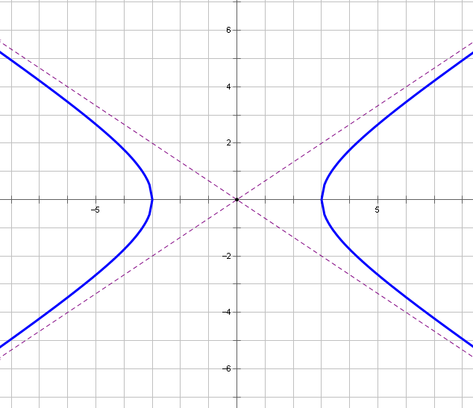
- Notice that this is really the same shape as before; it is just that the plane has been stretched horizontally by a factor of $3$ and vertically by a factor of $2$.
- Where do you suppose the foci of this curve are located? This is not an easy question! Recall that in the last lesson, we used the foci of an ellipse to generate an equation for the ellipse. We can use an analogous procedure to find the relationship between the foci of a hyperbola and the equation that generates the hyperbola.

Discussion (2 minutes): Formal Properties of Hyperbolas
- Like the ellipse, the formal definition of the hyperbola involves distances. In the figure below, the red segments shown differ in length by a certain amount; the green segments differ in length by exactly the same amount.
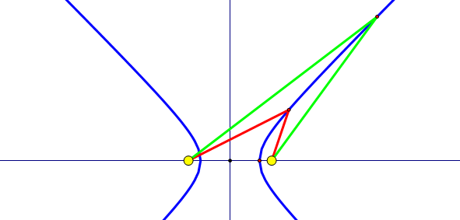
- This suggests the following formal definition: Given two points $F$ and $G$, a hyperbola is a set of points $P$ such that the difference $PF-PG$ is constant; that is, there is some number $k$ such that $PF-PG=k$. The points $F$ and $G$ are called the foci of the hyperbola.
- As we’ll show in the upcoming example, a hyperbola can be described by an equation of the form $\frac{x^{2}}{a^{2}}-\frac{y^{2}}{b^{2}}=1$.
This is called the standard equation of the hyperbola. Note that some hyperbolas are described by an equation with this form: $\frac{y^{2}}{a^{2}}-\frac{x^{2}}{b^{2}}=1$. (Which kinds of curves go with which equation? We will explore this in a moment.)

Example (7 minutes)
In this example, students use the foci of a hyperbola to derive an equation for the hyperbola.
- Let’s take $F=(-1,0)$ and $G=(1,0)$ to be the foci of a hyperbola, with each point $P$ on the hyperbola satisfying either $PF-PG=1$ or $PG-PF=1$. What is the equation of such a hyperbola? In particular, can we express the equation in the standard form $\frac{x^{2}}{a^{2}}-\frac{y^{2}}{b^{2}}=1$? The diagram below may help you to get started.
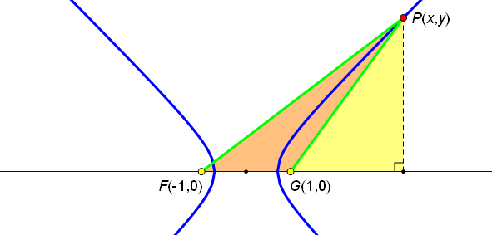
  - We can use the distance formula to see that $PF=\sqrt{{\left(x+1\right)}^{2}+y^{2}}$ and $PG=\sqrt{{\left(x-1\right)}^{2}+y^{2}}$. Thus, we need to have $PF-PG=\sqrt{{\left(x+1\right)}^{2}+y^{2}}-\sqrt{{\left(x-1\right)}^{2}+y^{2}}=1$.
- In the last lesson, we learned a technique that can be used to deal with equations that contain two radical expressions. Apply that technique to this equation, and see where you end up!

$$\sqrt{{\left(x+1\right)}^{2}+y^{2}}-\sqrt{{\left(x-1\right)}^{2}+y^{2}}=1 \\ \sqrt{{\left(x+1\right)}^{2}+y^{2}}=1+\sqrt{{\left(x-1\right)}^{2}+y^{2}} \\ {\left(x+1\right)}^{2}+y^{2}=1+2\sqrt{{\left(x-1\right)}^{2}+y^{2}}+{\left(x-1\right)}^{2}+y^{2} \\ x^{2}+2x+1=1+2\sqrt{{\left(x-1\right)}^{2}+y^{2}}+x^{2}-2x+1 \\ 4x-1=2\sqrt{{\left(x-1\right)}^{2}+y^{2}} \\ 16x^{2}-8x+1=4\left[{\left(x-1\right)}^{2}+y^{2}\right] \\ 16x^{2}-8x+1=4\left[x^{2}-2x+1+y^{2}\right] \\ 16x^{2}-8x+1=4x^{2}-8x+4+4y^{2} \\ 12x^{2}-4y^{2}=3 \\ 4x^{2}-\frac{4}{3}y^{2}=1$$
- This equation looks much friendlier than the one we started with. Rewrite the equation in the standard form $\frac{x^{2}}{a^{2}}-\frac{y^{2}}{b^{2}}=1$.
  - $\frac{x^{2}}{\frac{1}{4}}-\frac{y^{2}}{\frac{3}{4}}=1$
- Thus, we have $a^{2}=\frac{1}{4}$ and $b^{2}=\frac{3}{4}$ so that $a=\sqrt{\frac{1}{4}}$ and $b=\sqrt{\frac{3}{4}}$.

Exercises (8 minutes)
Give students time to work on the following exercises. Monitor their work, and give assistance to individual students as needed. Encourage students to work in pairs.
Exercises
- Let $F(0,5)$ and $G(0,-5)$ be the foci of a hyperbola. Let the points $P(x,y)$ on the hyperbola satisfy either $PF-PG=6$ or $PG-PF=6$. Use the distance formula to derive an equation for this hyperbola, writing your answer in the form $\frac{x^{2}}{a^{2}}–\frac{y^{2}}{b^{2}}=1$.
$$PG-PF=6 \\ \sqrt{x^{2}+{\left(y+5\right)}^{2}}-\sqrt{x^{2}+{\left(y-5\right)}^{2}}=6 \\ \sqrt{x^{2}+{\left(y+5\right)}^{2}}=6+\sqrt{x^{2}+{\left(y-5\right)}^{2}} \\ x^{2}+\left(y^{2}+10y+25\right)=36+12\sqrt{x^{2}+{\left(y-5\right)}^{2}}+\left(x^{2}+y^{2}-10y+25\right) \\ 20y-36=12\sqrt{x^{2}+{\left(y-5\right)}^{2}} \\ 5y-9=3\sqrt{x^{2}+{\left(y-5\right)}^{2}} \\ 25y^{2}-90y+81=9\left(x^{2}+y^{2}-10y+25\right) \\ 25y^{2}-90y+81=9x^{2}+{9y}^{2}-90y+225 \\ 16y^{2}-9x^{2}=144 \\ \frac{y^{2}}{9}-\frac{x^{2}}{16}=1$$
- Where does the hyperbola described above intersect the $y$-axis?
The curve intersects the $y$-axis at $(0,3)$ and $(0,-3)$.

- Find an equation for the line that acts as a boundary for the portion of the curve that lies in the first quadrant.
For large values of $x$, $\frac{y}{3}≈\frac{x}{4}$, so the line $y=\frac{3}{4}x$ is the boundary for the curve in the first quadrant.

- Sketch the graph of the hyperbola described above.
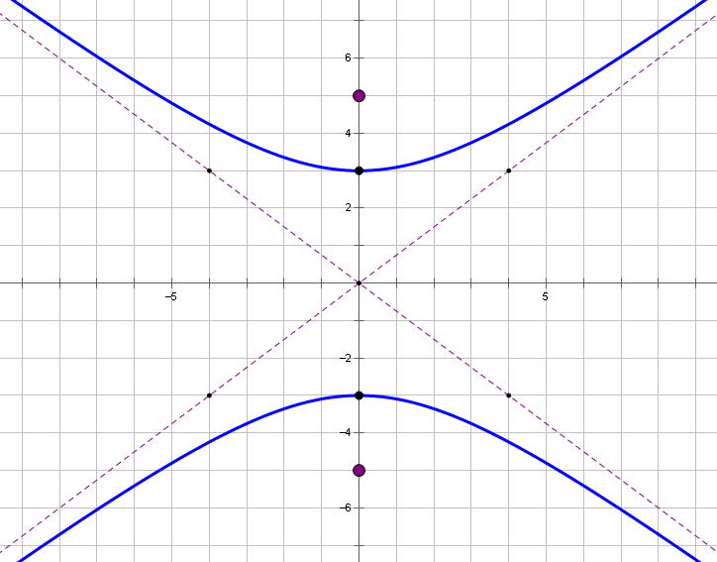

(Complete the graphic organizer comparing ellipses and hyperbolas. A blank copy is attached at the end of the lesson.)

Curve | Equation | Center | Asymptotes | Symmetry | Graph
Ellipse | $$\frac{x^{2}}{a^{2}}+\frac{y^{2}}{b^{2}}=1$$ | $$(0, 0)$$ | None | About center | 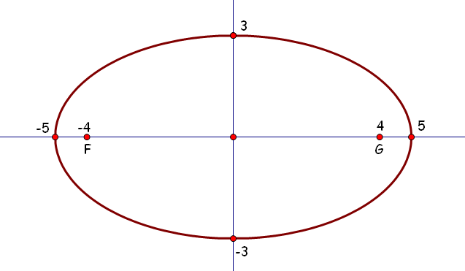
Hyperbola opening up/down | $$\frac{x^{2}}{a^{2}}-\frac{y^{2}}{b^{2}}=1$$ | $$(0, 0)$$ | $$y=\frac{a}{b}x$$  $$y=-\frac{a}{b}x$$ | About $y-$axis
Hyperbola opening left/right | $$\frac{y^{2}}{a^{2}}-\frac{x^{2}}{b^{2}}=1$$ | $$(0, 0)$$ | $$y=\frac{a}{b}x$$  $$y=-\frac{a}{b}x$$ | About $x-$axis
Closing (3 minutes)
Instruct students to write responses to the questions below in their notebooks. Call on students to share their responses with the class.
- What is the definition of a hyperbola? How is this definition different from that of the ellipse?
  - Given two points $F$ and $G$, a hyperbola is a set of points $P$ such that the difference $PF-PG$ is constant.
  - For the ellipse, the sum $PF+PG$ is constant (rather than the difference).
- What is the standard equation of a hyperbola? How is this equation different from that of the ellipse?
  - The standard equation is either $\frac{x^{2}}{a^{2}}–\frac{y^{2}}{b^{2}}=1$ or $\frac{y^{2}}{a^{2}}–\frac{x^{2}}{b^{2}}=1$.
  - For the ellipse, the standard equation is $\frac{x^{2}}{a^{2}}+\frac{y^{2}}{b^{2}}=1$.
- What are the equations of the asymptotes for the graph of the equation $\frac{y^{2}}{a^{2}}-\frac{x^{2}}{b^{2}}=1$?
  - The equations for the asymptotes are $y=\frac{a}{b}x$ and $y=-\frac{a}{b}x$.

Exit Ticket (5 minutes)

Name Date
Lesson 8: Curves from Geometry

Exit Ticket

Let $F(-4,0)$ and $B(4,0)$ be the foci of a hyperbola. Let the points $P\left(x,y\right)$ on the hyperbola satisfy either $PF-PG=4$ or $PG-PF=4$. Derive an equation for this hyperbola, writing your answer in the form $\frac{x^{2}}{a^{2}}–\frac{y^{2}}{b^{2}}=1$.
Exit Ticket Sample Solutions

Let $F(-4,0)$ and $B(4,0)$ be the foci of a hyperbola. Let the points $P\left(x,y\right)$ on the hyperbola satisfy either $PF-PG=4$ or $PG-PF=4$. Derive an equation for this hyperbola, writing your answer in the form $\frac{x^{2}}{a^{2}}–\frac{y^{2}}{b^{2}}=1$.
$$PA=\sqrt{{\left(x+4\right)}^{2}+y^{2}} \\ PB=\sqrt{{\left(x-4\right)}^{2}+y^{2}} \\ \sqrt{{\left(x+4\right)}^{2}+y^{2}}=4+\sqrt{{\left(x-4\right)}^{2}+y^{2}} \\ {\left(x+4\right)}^{2}+y^{2}=16+8\sqrt{{\left(x-4\right)}^{2}+y^{2}}+{\left(x-4\right)}^{2}+y^{2} \\ x^{2}+8x+16+y^{2}=16+8\sqrt{{\left(x-4\right)}^{2}+y^{2}}+x^{2}-8x+16+y^{2} \\ 16x-16=8\sqrt{{\left(x-4\right)}^{2}+y^{2}} \\ 2x-2=\sqrt{{\left(x-4\right)}^{2}+y^{2}} \\ 4x^{2}-8x+4={\left(x-4\right)}^{2}+y^{2} \\ 4x^{2}-8x+4=x^{2}-8x+16+y^{2} \\ 3x^{2}-y^{2}=12 \\ \frac{x^{2}}{4}-\frac{y^{2}}{12}=1$$

Problem Set Sample Solutions

- For each hyperbola described below: (1) Derive an equation of the form $\frac{x^{2}}{a^{2}}–\frac{y^{2}}{b^{2}}=1$ or $\frac{y^{2}}{b^{2}}–\frac{x^{2}}{a^{2}}=1$.
(2) State any $x$- or $y$-intercepts. (3) Find the equations for the asymptotes of the hyperbola.
  - Let the foci be $A(-2,0)$ and $B(2,0)$, and let $P$ be a point for which either $PA-PB=2$ or $PB-PA=2$.
    - $x^{2}-\frac{y^{2}}{3}=1$
    - $\left(-1,0\right), \left(1,0\right)$; no $y$-intercepts
    - $y≈\sqrt{3}x$, so $y=±\sqrt{3}x$

  - Let the foci be $A(-5,0)$ and $B\left(5,0\right)$, and let $P$ be a point for which either $PA-PB=5$ or $PB-PA=5$.
    - $\frac{x^{2}}{\frac{25}{4}}-\frac{y^{2}}{\frac{75}{4}}=1$
    - $\left(-2.5,0\right),\left(2.5,0\right)$; no $y$-intercepts
    - $y≈\frac{\sqrt{75}}{2}⋅\frac{2}{5}x=\sqrt{3}x$, so $y=±\sqrt{3}x$

  - Consider $A(0,-3)$ and $B(0,3)$, and let $P$ be a point for which either $PA-PB=2.5$ or $PB-PA=2.5$.
    - $\frac{y^{2}}{\frac{9}{4}}-\frac{x^{2}}{\frac{27}{4}}=1$
    - $\left(0,1.5\right),\left(0,-1.5\right)$; no $x$-intercepts
    - $y≈\frac{3}{2}⋅\frac{2}{\sqrt{27}}x=\frac{1}{\sqrt{3}}x$, so $y=±\frac{\sqrt{3}}{3}x$
  - Consider $A\left(0,-\sqrt{2}\right)$ and $B\left(0,\sqrt{2}\right)$, and let $P$ be a point for which either $PA-PB=4$ or
$PB-PA=2$.
    - $y^{2}-x^{2}=1$
    - $\left(0,1\right),\left(0,-1\right)$; no $x$-intercepts.
    - $y=±x$

- Graph the hyperbolas in parts (a)–(d) in Problem 1.

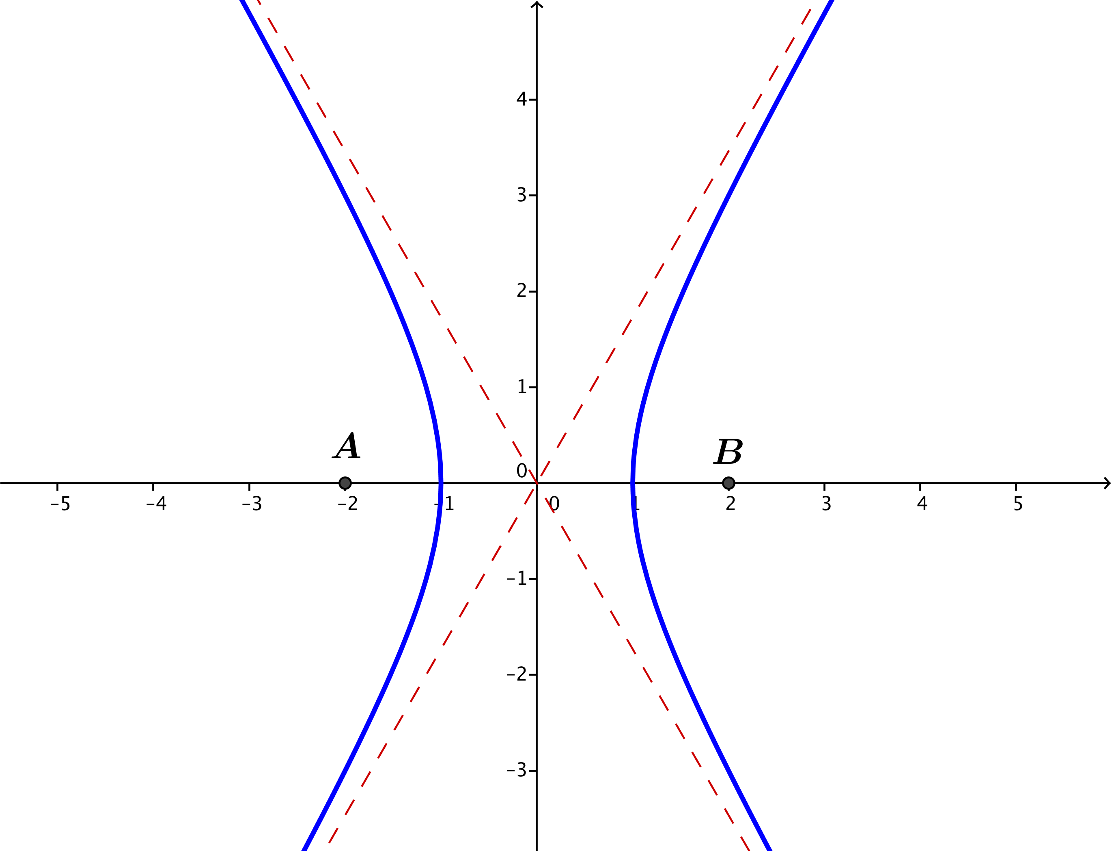

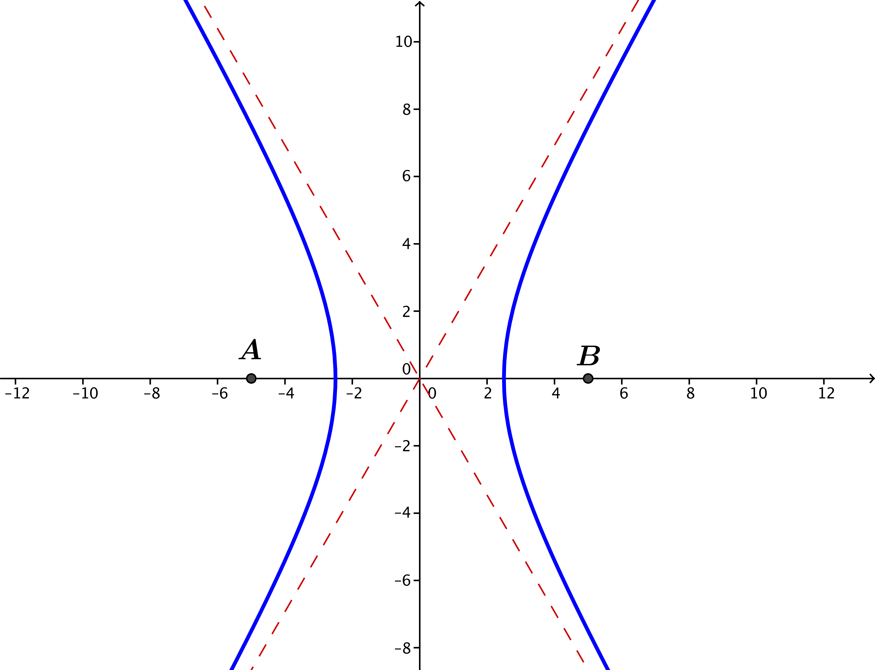

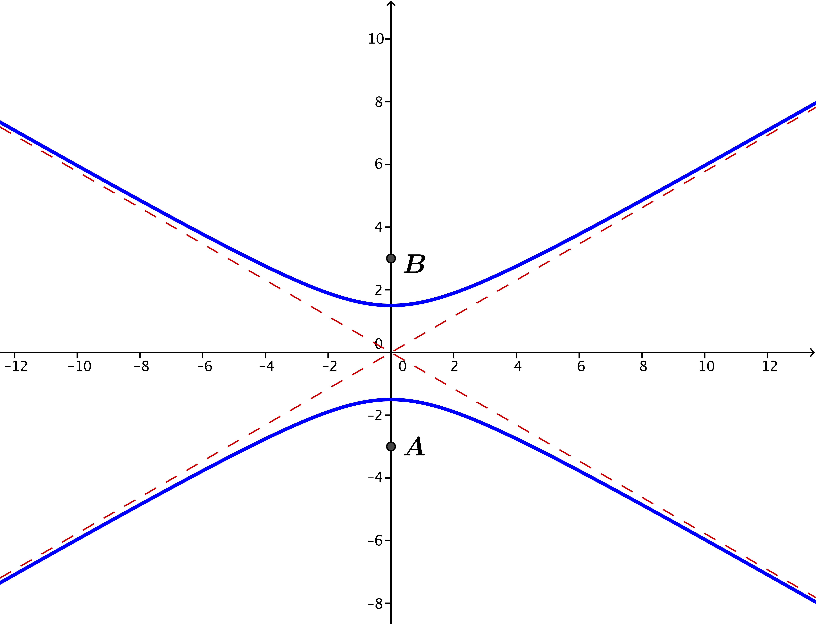

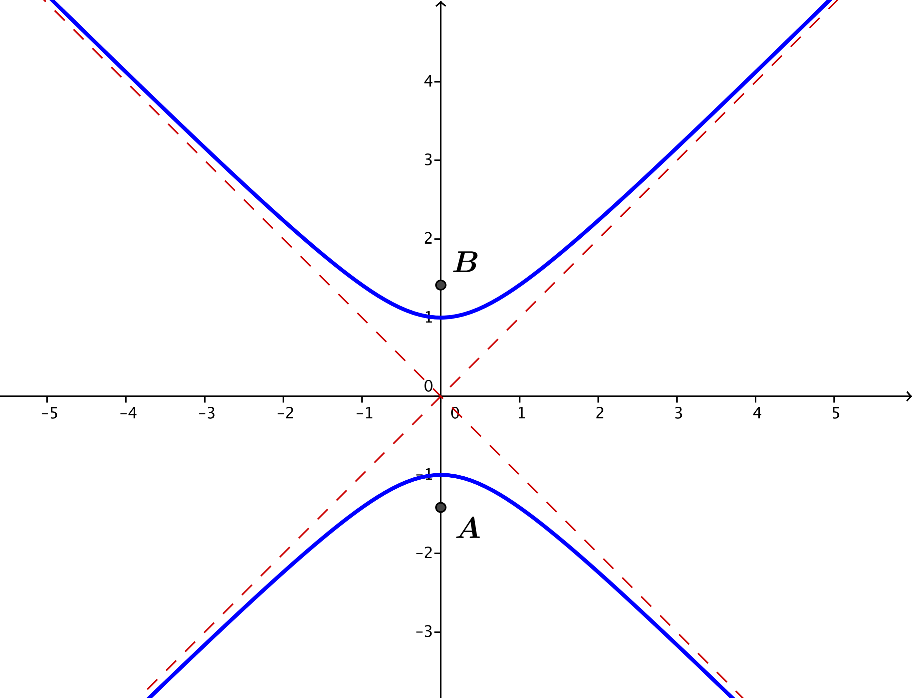

- For each value of $k$ specified in parts (a)–(e), plot the set of points in the plane that satisfy the equation
$x^{2}-y^{2}=k$.
  - $k=4$
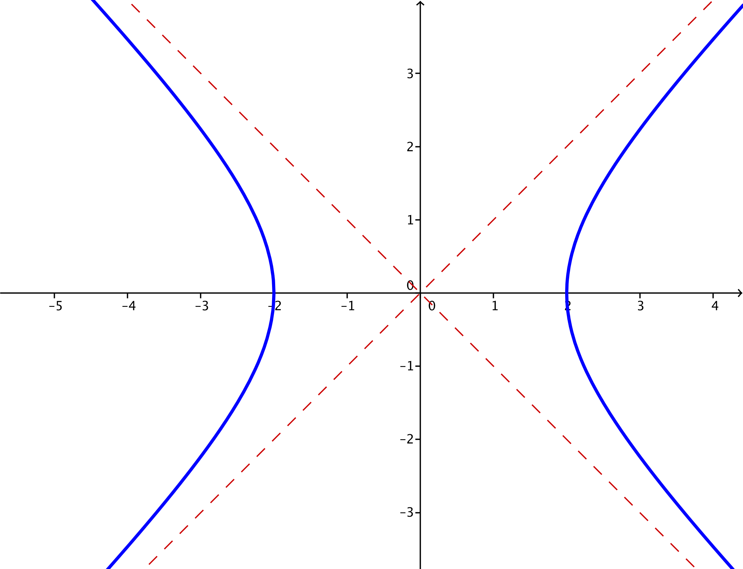

  - $k=1$
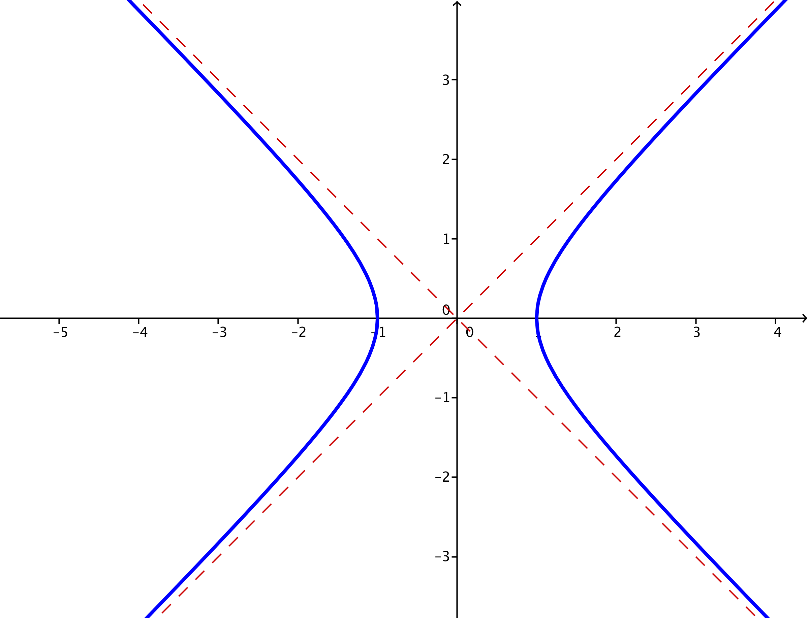

  - $k=\frac{1}{4}$
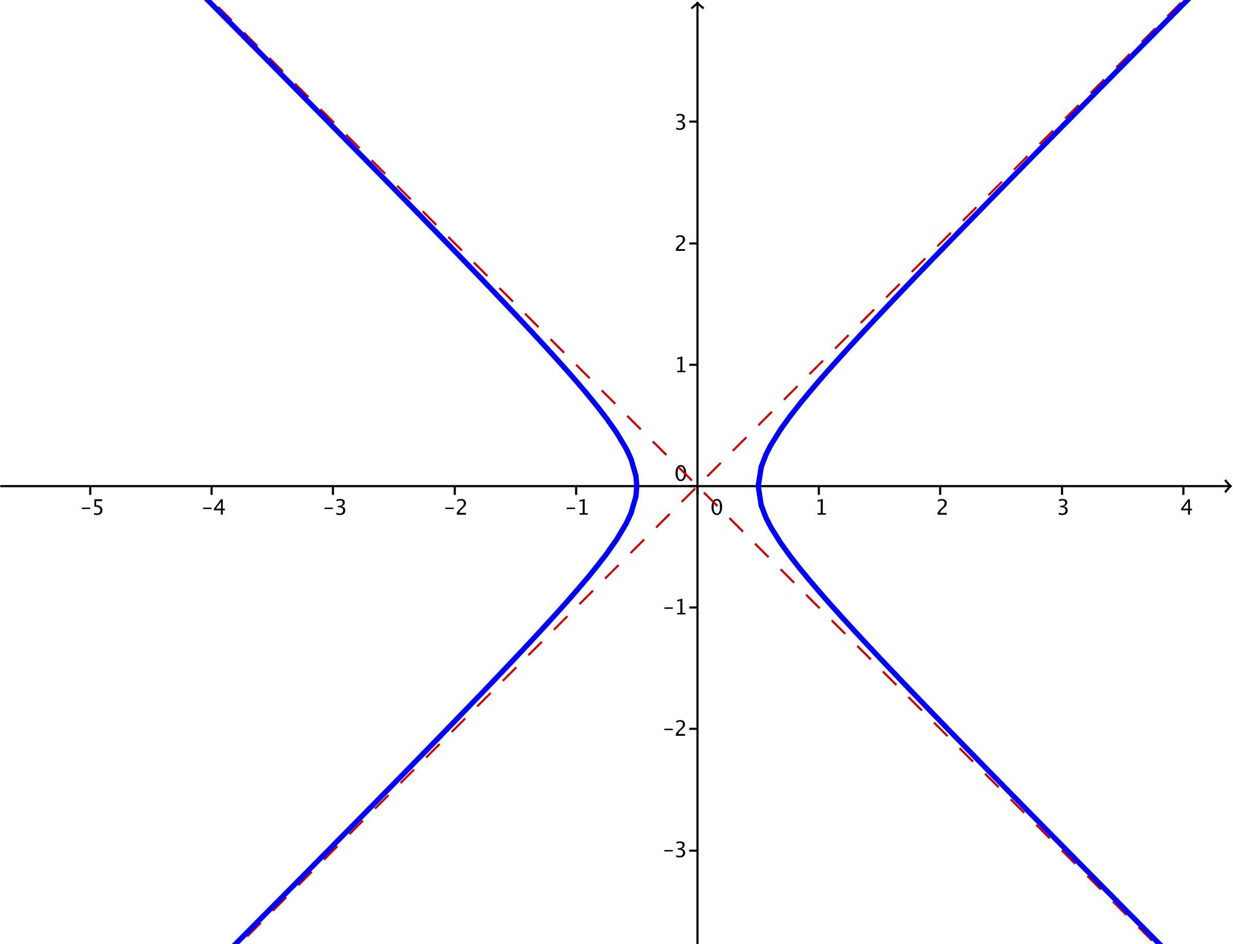

  - $k=0$
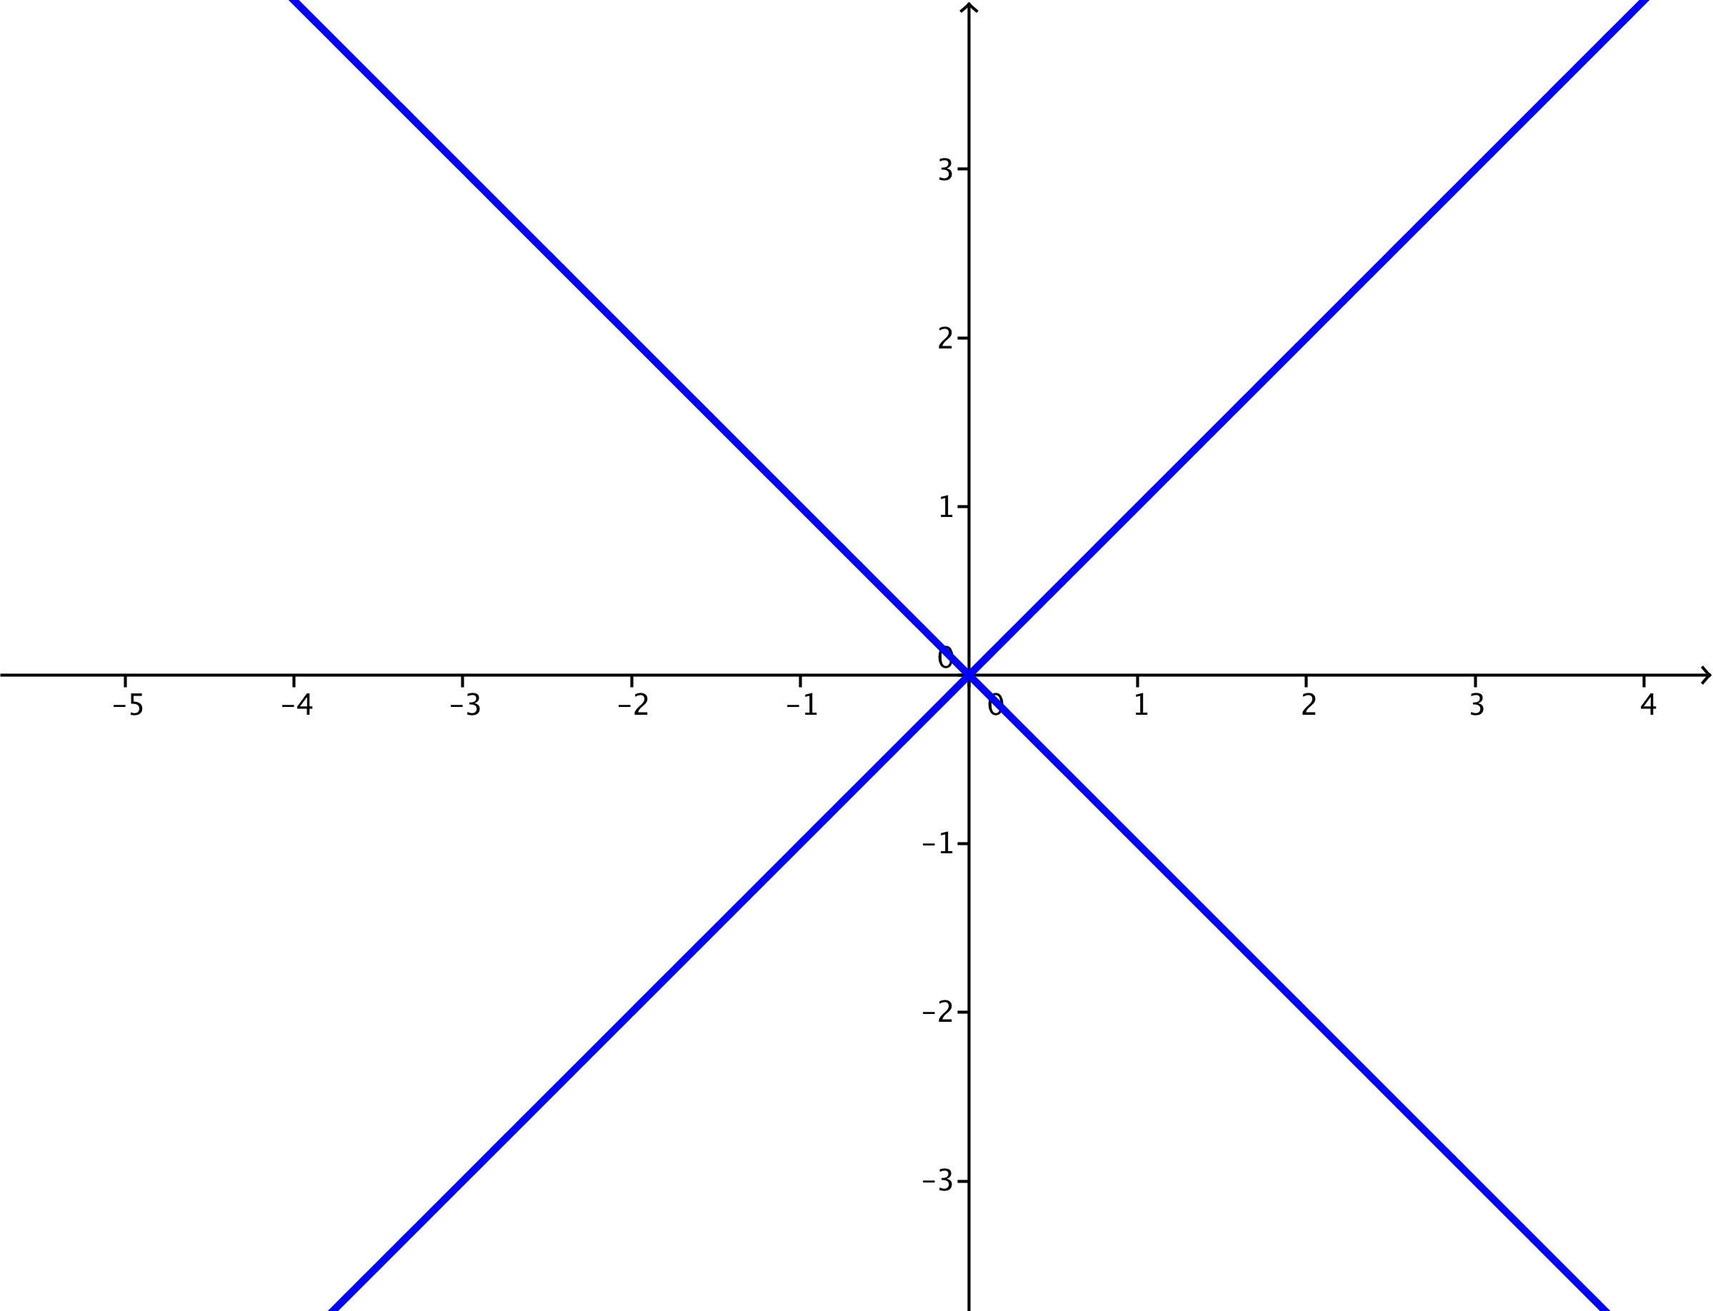

  - $k=-\frac{1}{4}$
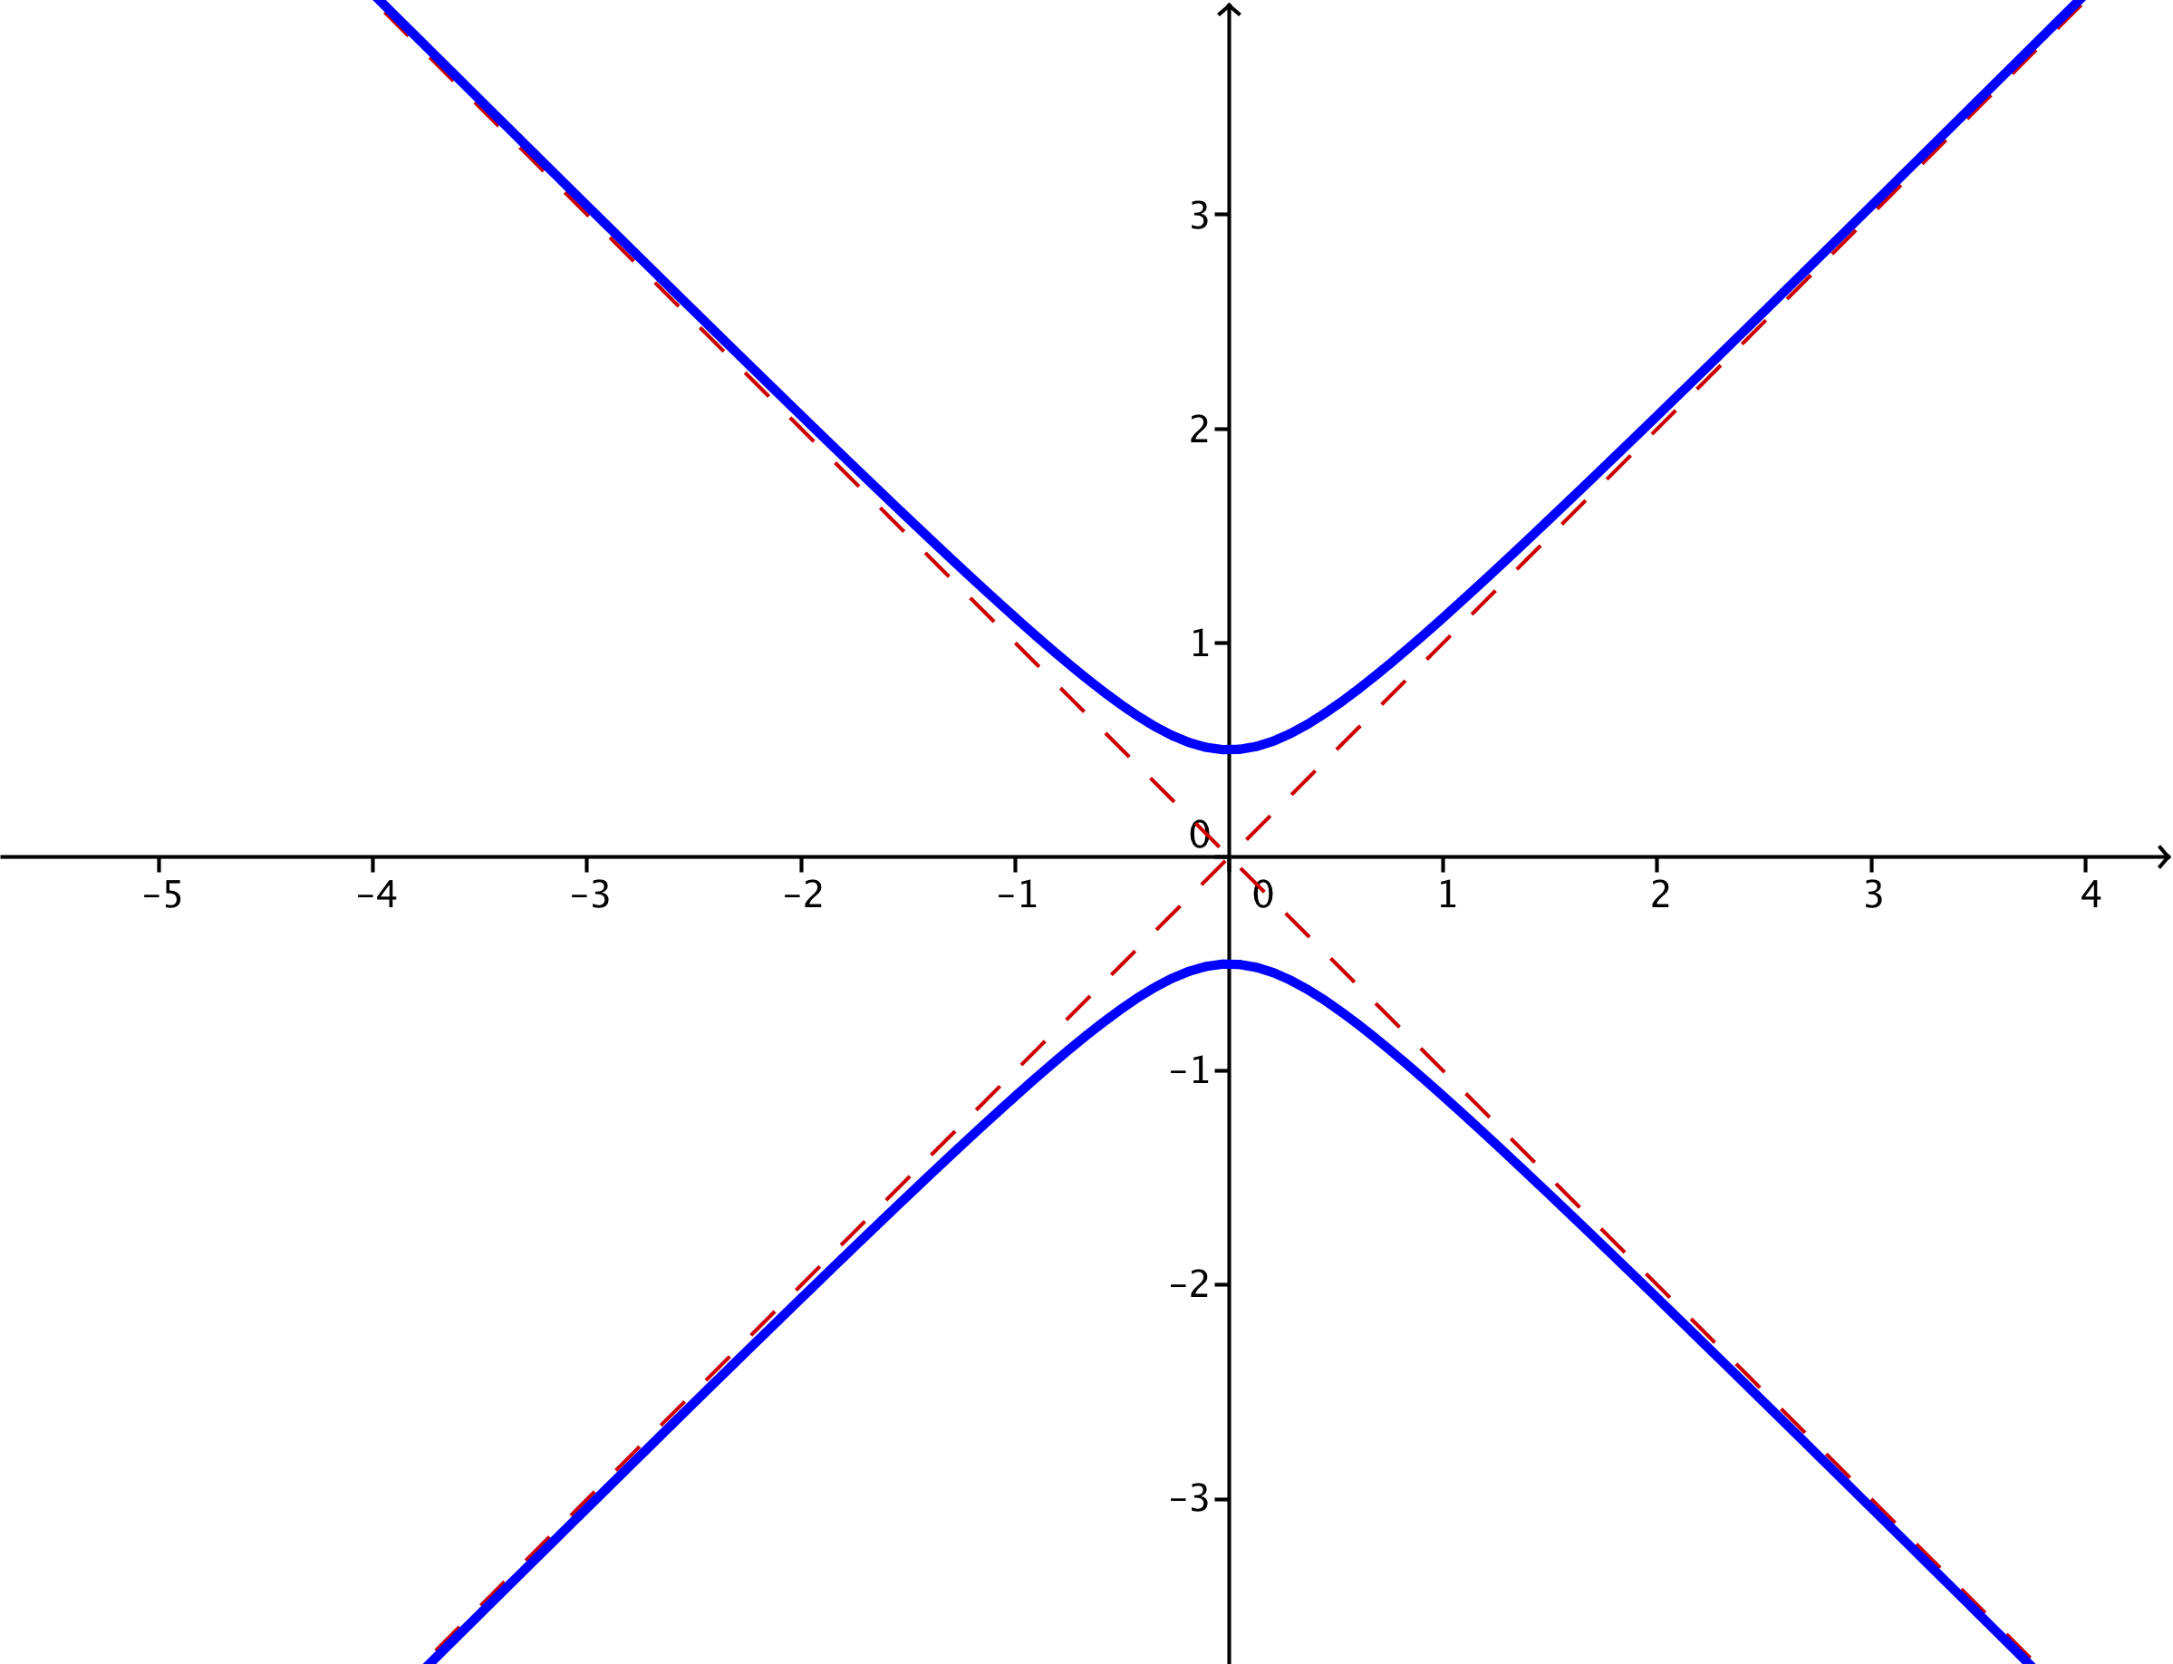

  - $k=-1$
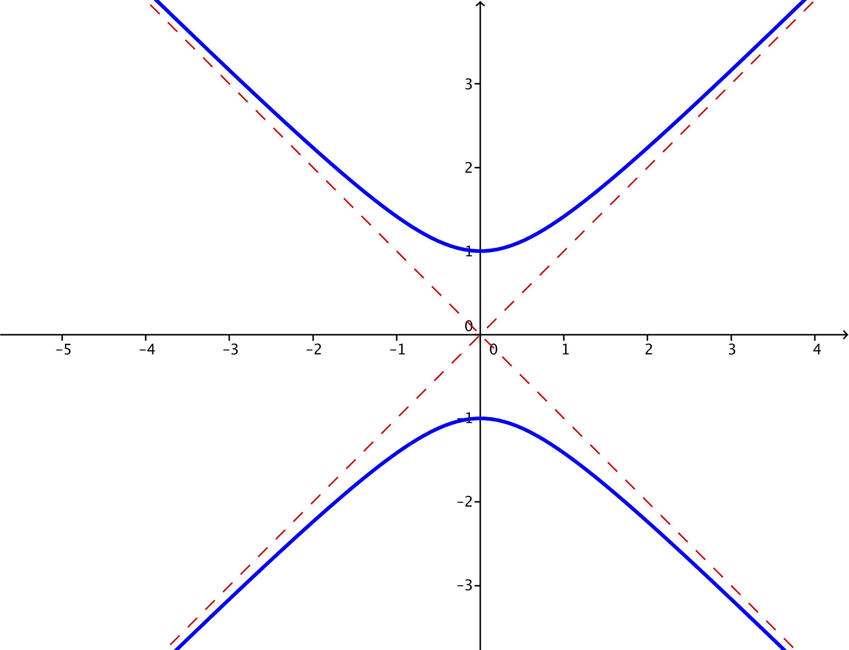

  - $k=-4$
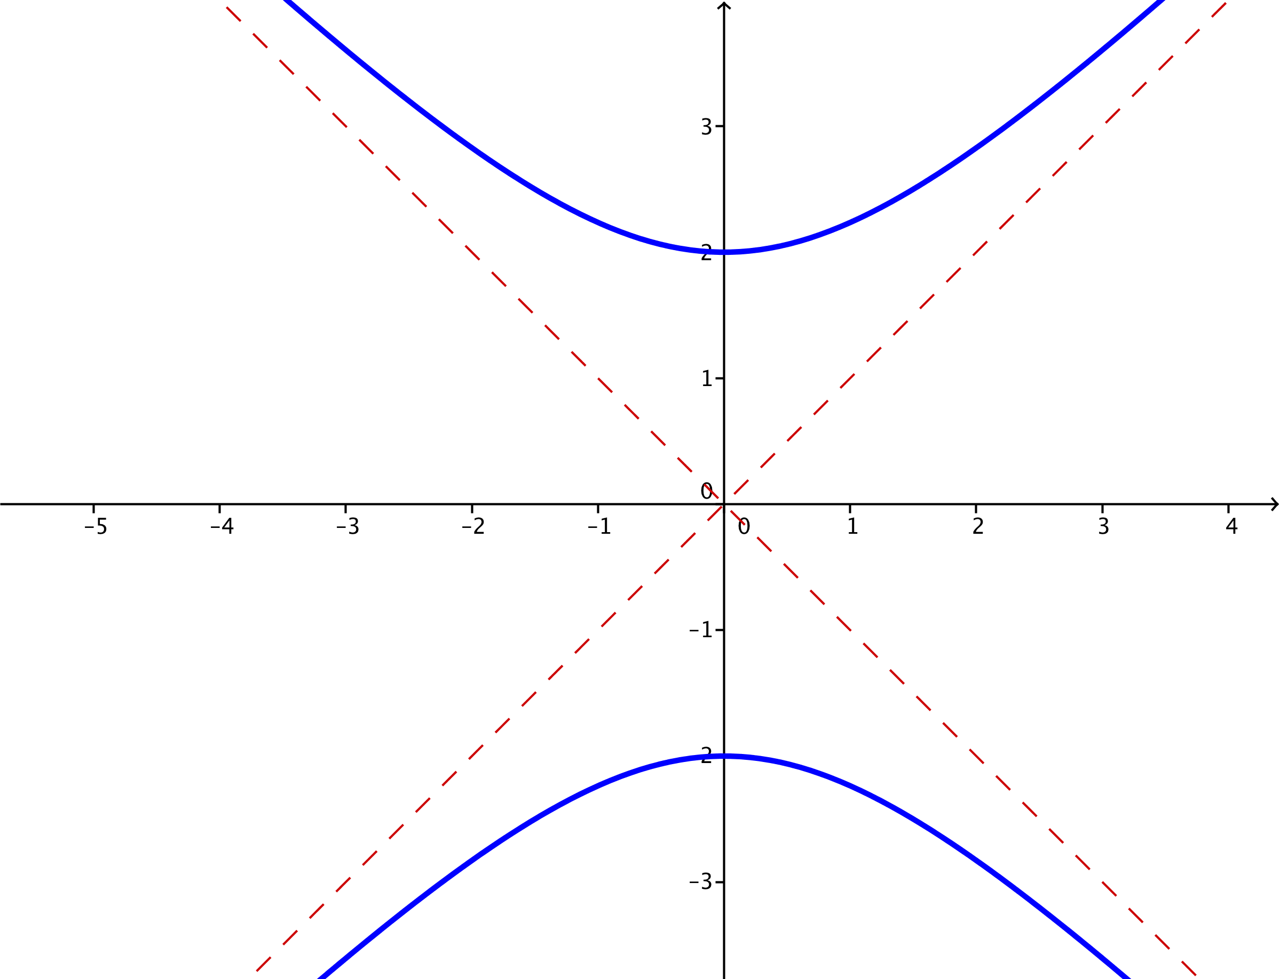

  - Describe the hyperbolas $x^{2}-y^{2}=k$ for different values of $k$. Consider both positive and negative values of $k$, and consider values of $k$ close to zero and far from zero.
If $k$ is close to zero, then the hyperbola is very close to the asymptotes $y=x$ and $y=-x$, appearing almost to have corners as the graph crosses the $x$-axis. If $k$ is far from zero, the hyperbola gets farther from the asymptotes near the center. If $k>0$, then the hyperbola crosses the $x$-axis, opening to the right and left, and if $k<0$, then the hyperbola crosses the $y$-axis, opening up and down.
MP.7

  - Are there any values of $k$ so that the equation $x^{2}-y^{2}=k$ has no solution?
No. The equation $x^{2}-y^{2}=k$ always has solutions. The solution points lie on either two intersecting lines or on a hyperbola.

- For each value of $k$ specified in parts (a)–(e), plot the set of points in the plane that satisfy the equation
$\frac{x^{2}}{k}-y^{2}=1$.
  - $k=-1$
There is no solution to the equation $\frac{x^{2}}{-1}-y^{2}=1$, because there are no real numbers $x$ and $y$ so that $x^{2}+y^{2}=-1$.

  - $k=1$
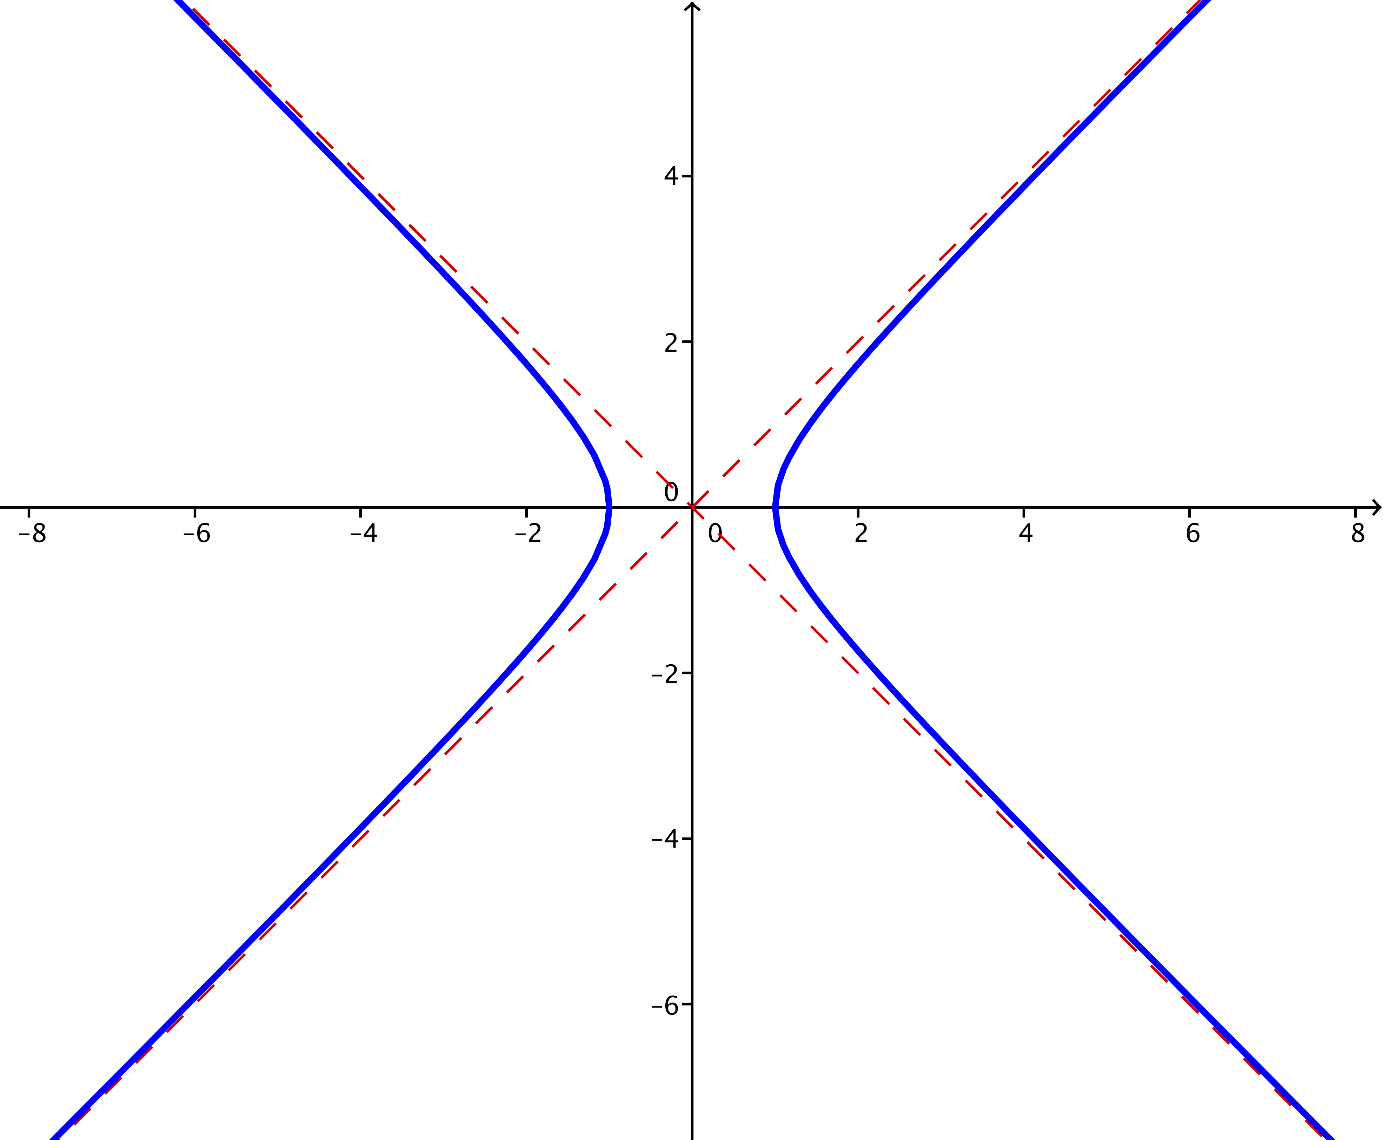

  - $k=2$
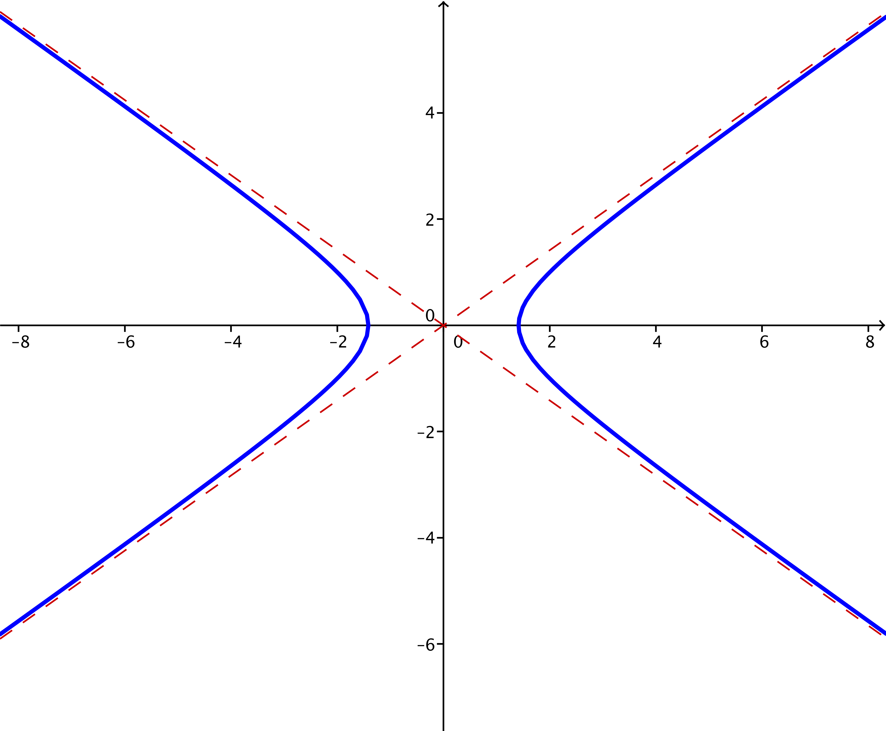

  - $k=4$
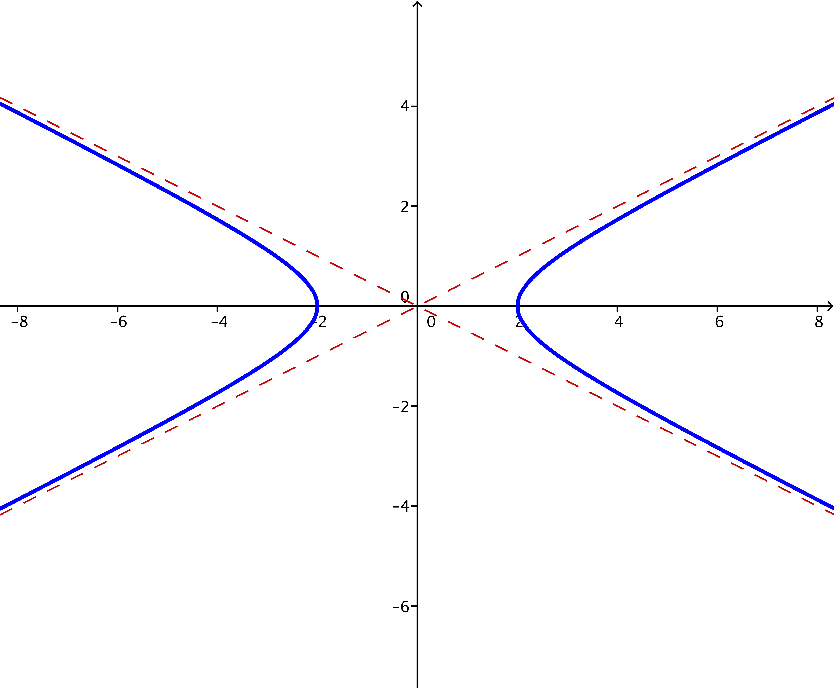

  - $k=10$
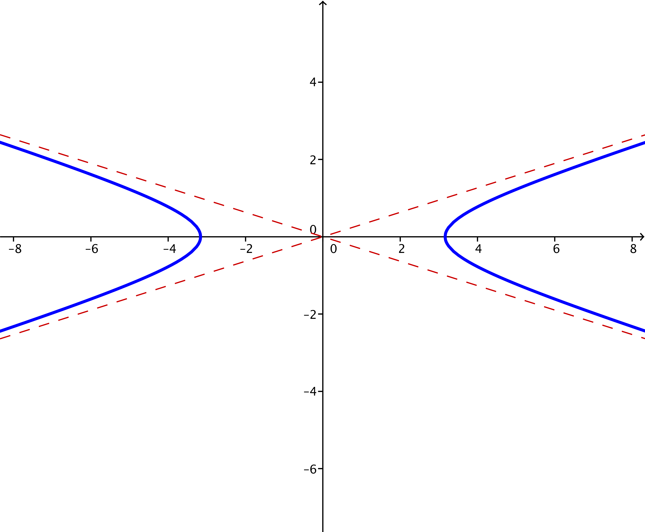

  - $k=25$
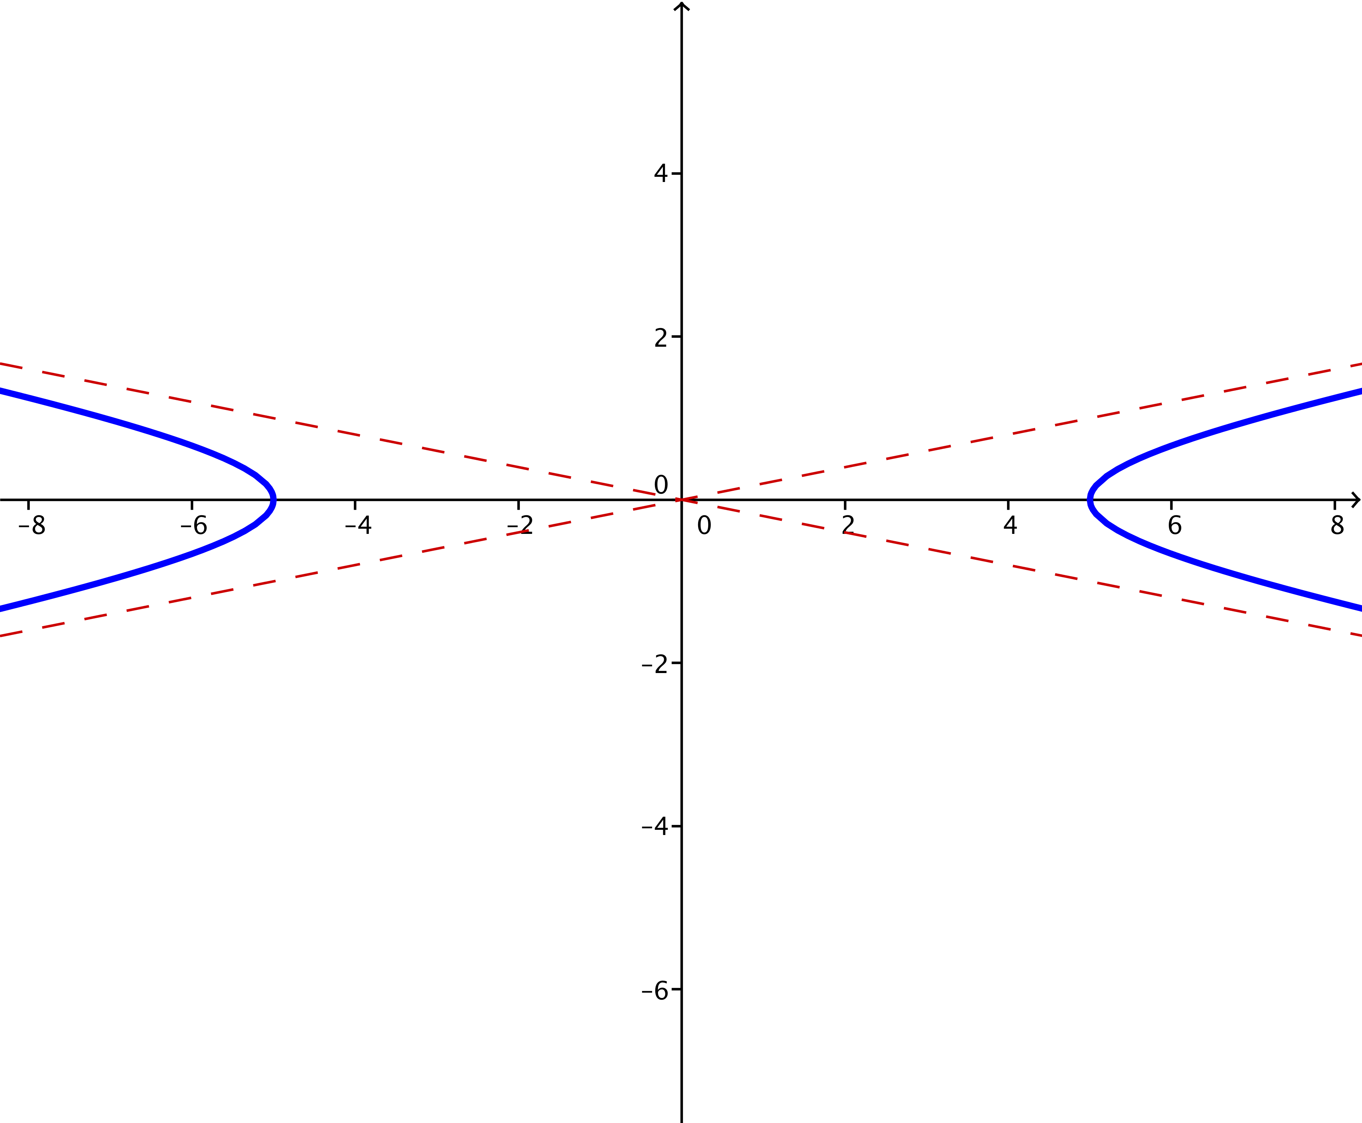

  - Describe what happens to the graph of $\frac{x^{2}}{k}-y^{2}=1$ as $k→∞$.
MP.7
As $k→∞$, it appears that the hyperbolas with equation $\frac{x^{2}}{k}-y^{2}=1$ get flatter; the $x$-intercepts get farther from the center at the origin, and the asymptotes get less steep.
- For each value of $k$ specified in parts (a)–(e), plot the set of points in the plane that satisfy the equation
$x^{2}-\frac{y^{2}}{k}=1$.
  - $k=-1$
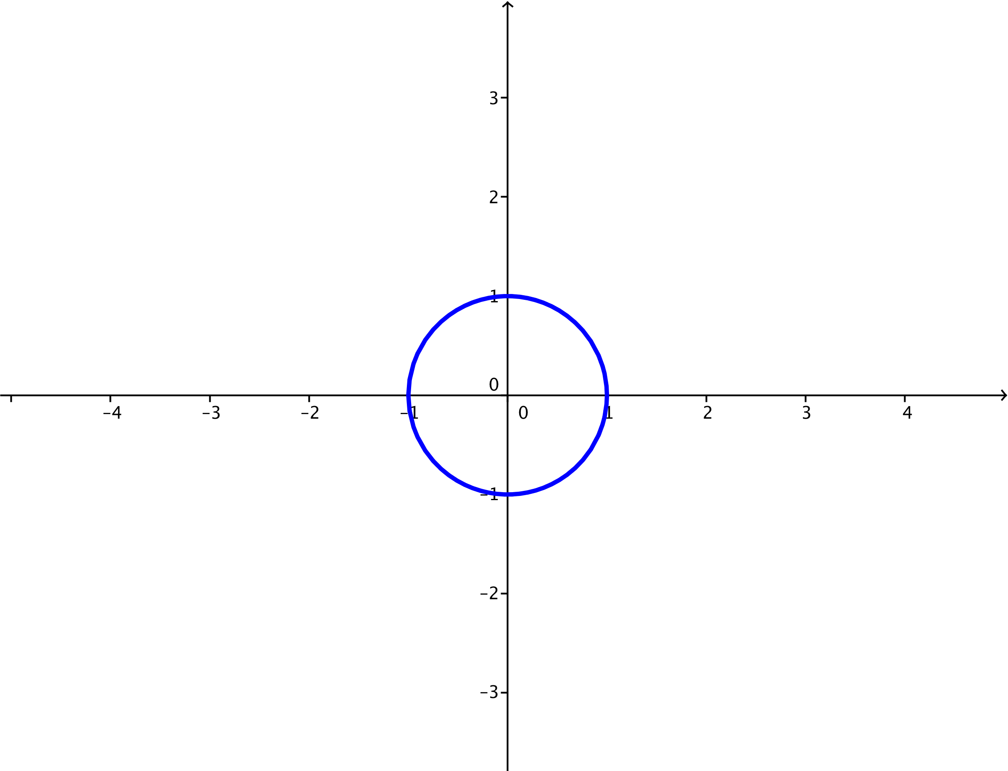

  - $k=1$
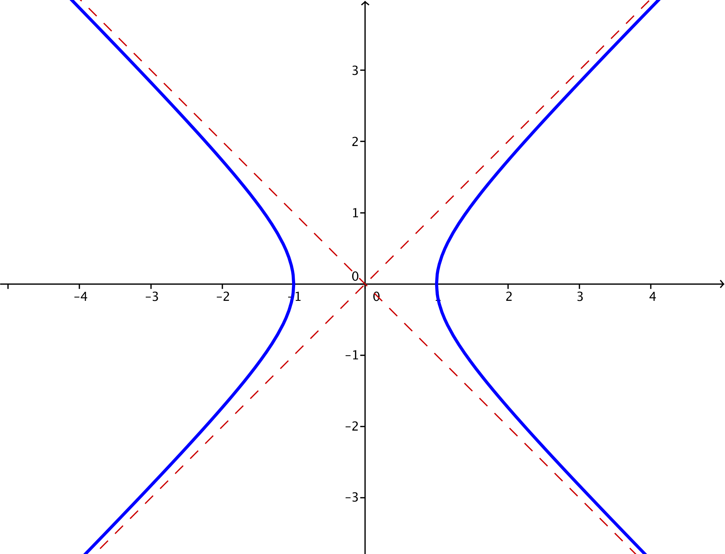

  - $k=2$
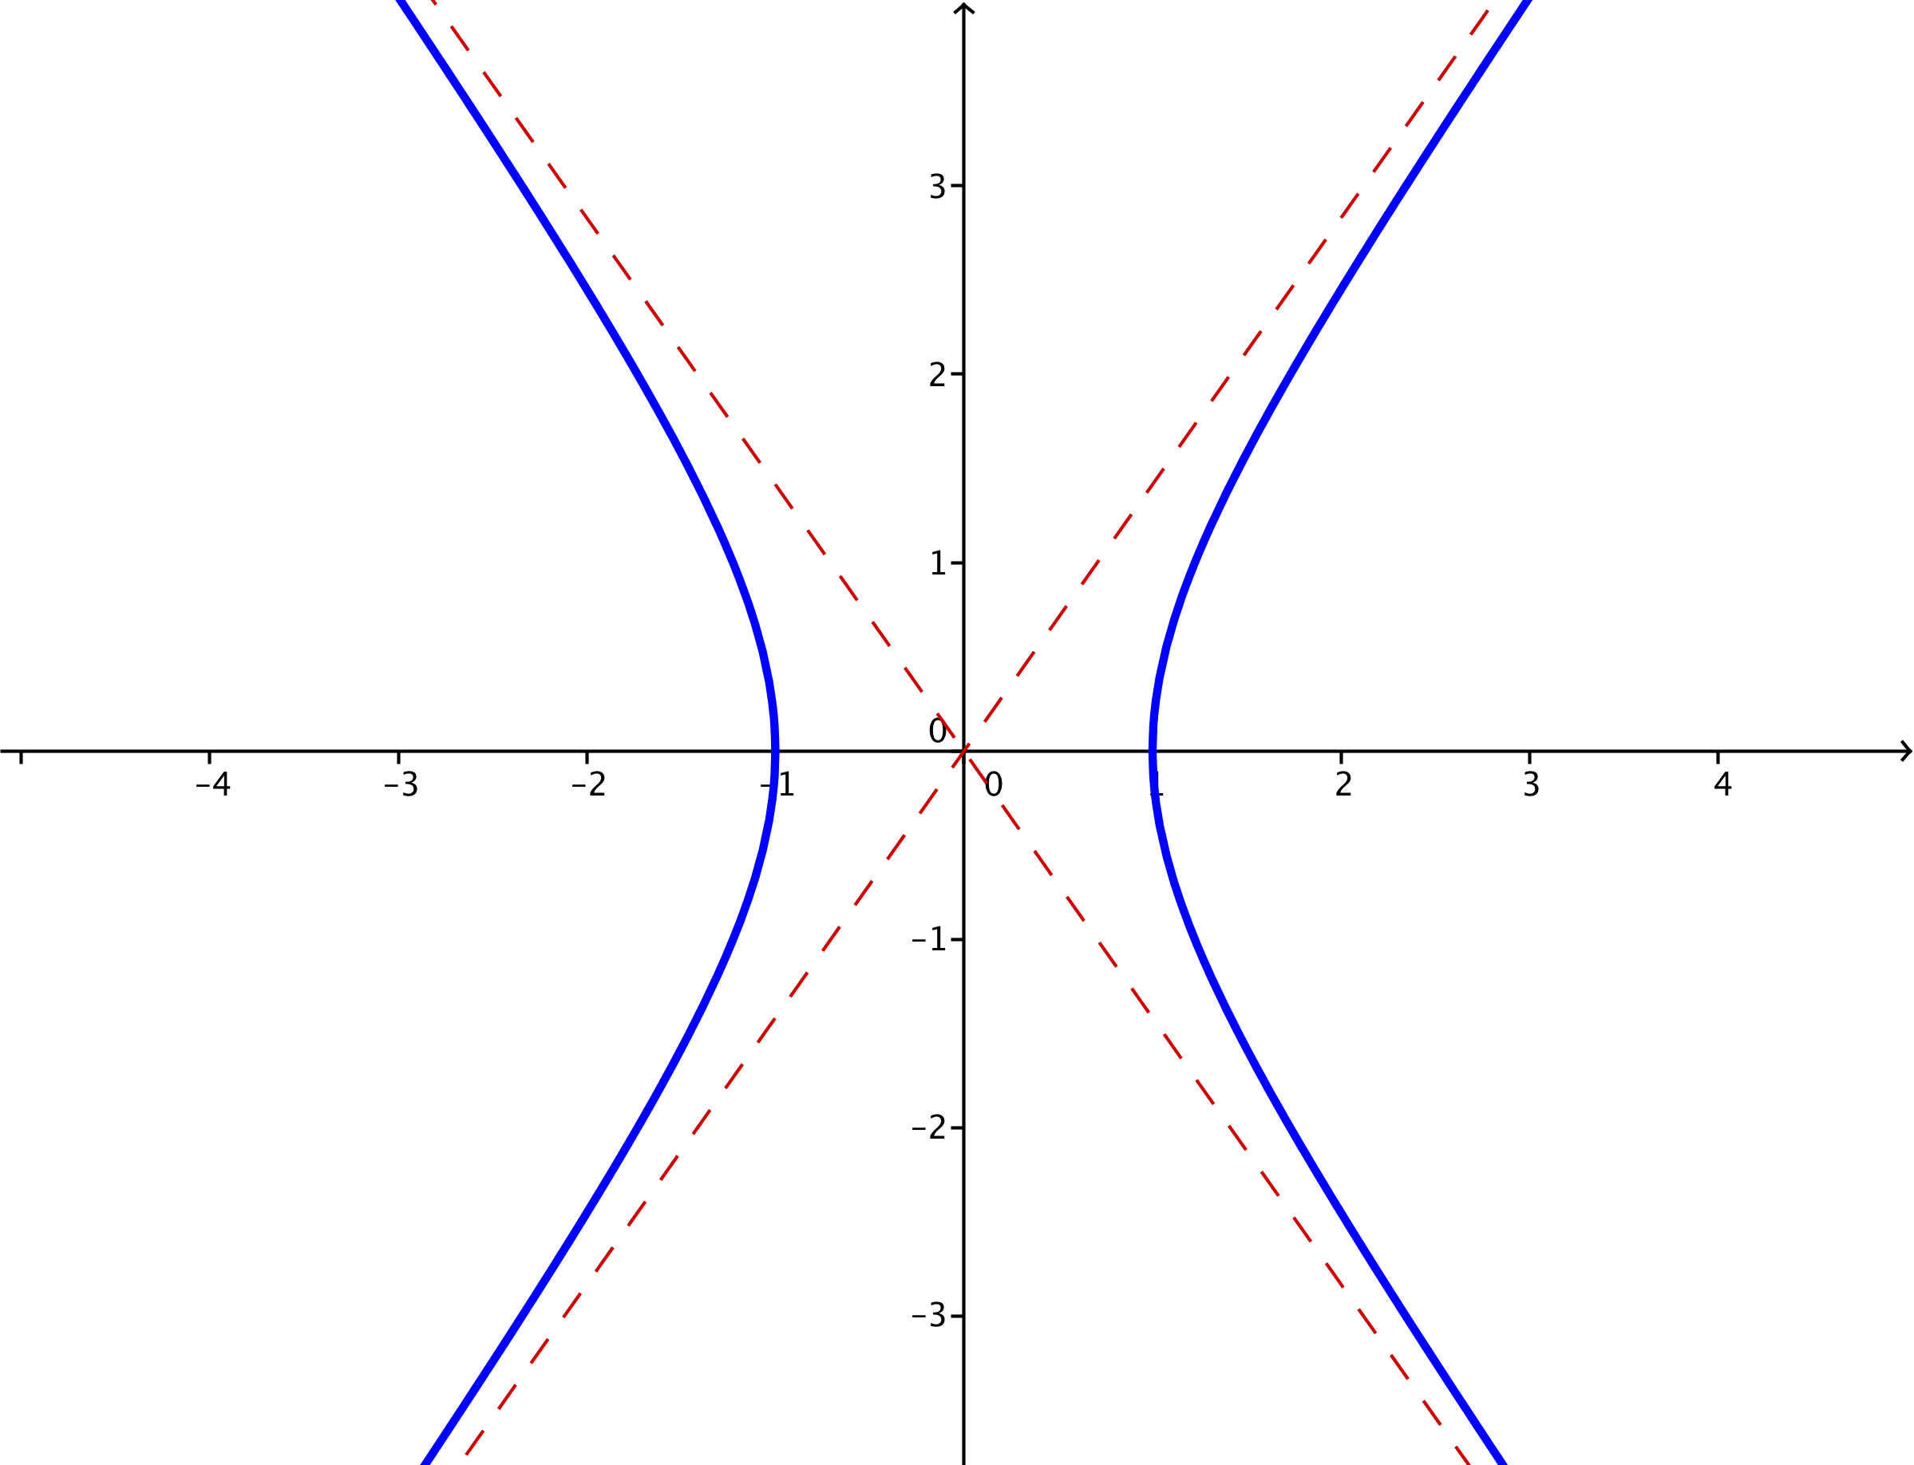

  - $k=4$
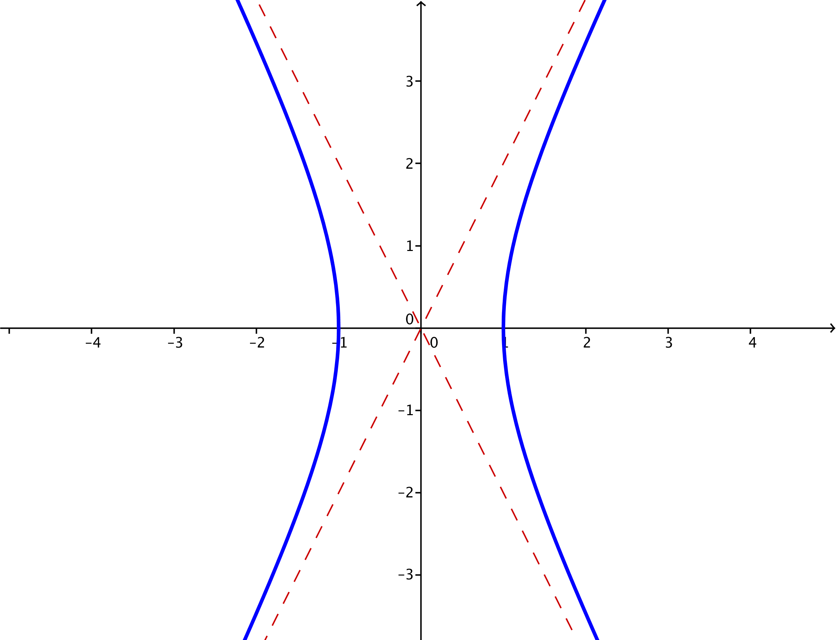

  - $k=10$
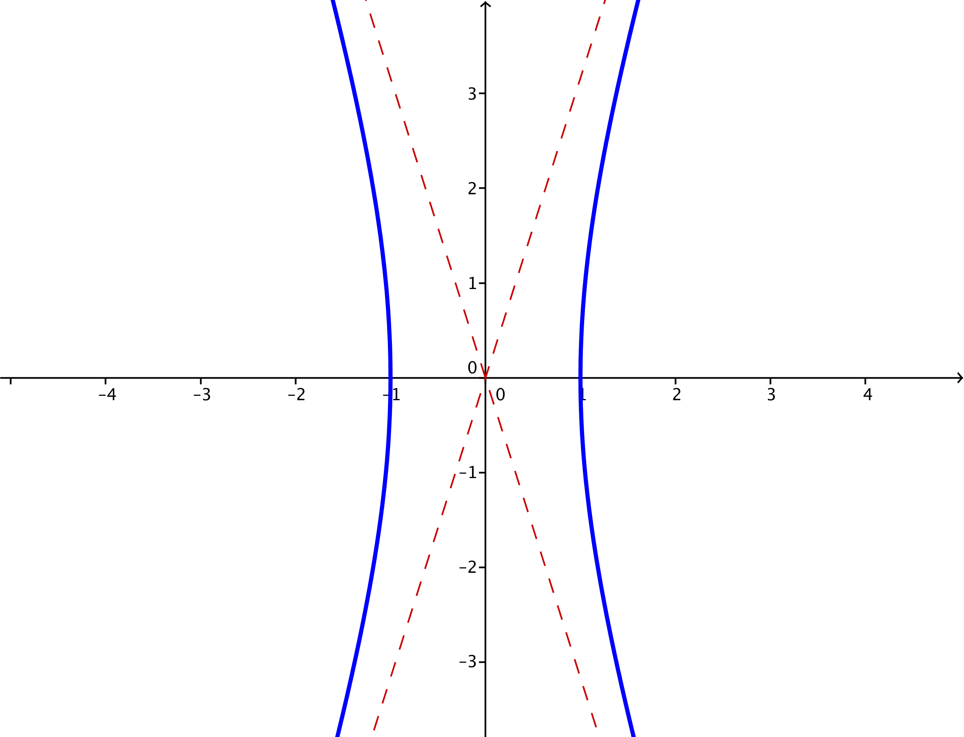

  - Describe what happens to the graph $x^{2}-\frac{y^{2}}{k}=1$ as $k→∞$.
MP.7
As $k→∞$, the hyperbola with equation $x^{2}-\frac{y^{2}}{k}=1$ is increasingly stretched vertically. The center and intercepts do not change, but the steepness of the asymptotes increases.

- An equation of the form $ax^{2}+bx+cy^{2}+dy+e=0$ where $a$ and $c$ have opposite signs might represent a hyperbola.
  - Apply the process of completing the square in both $x$ and $y$ to convert the equation $9x^{2}-36x-4y^{2}-8y-4=0$ to one of the standard forms for a hyperbola: $\frac{{\left(x-h\right)}^{2}}{a^{2}}–\frac{{\left(y-k\right)}^{2}}{b^{2}}$=$1$ or $\frac{{\left(y-k\right)}^{2}}{b^{2}}–\frac{{\left(x-h\right)}^{2}}{a^{2}}=1$.
$$9x^{2}-36x-4y^{2}-8y=4 \\ 9\left(x^{2}-4x\right)-4\left(y^{2}+2y\right)=4 \\ 9\left(x^{2}-4x+4\right)-4\left(y^{2}+2y+1\right)=4+36-4 \\ 9{\left(x-2\right)}^{2}-4{\left(y+1\right)}^{2}=36 \\ \frac{{\left(x-2\right)}^{2}}{4}-\frac{{\left(y+1\right)}^{2}}{9}=1$$

  - Find the center of this hyperbola.
The center is $(2,-1)$.

  - Find the asymptotes of this hyperbola.
$\frac{x-2}{2}=±\frac{y+1}{3}$
$y=\frac{3}{2}x-4$ or $y=-\frac{3}{2}x+2$

  - Graph the hyperbola.
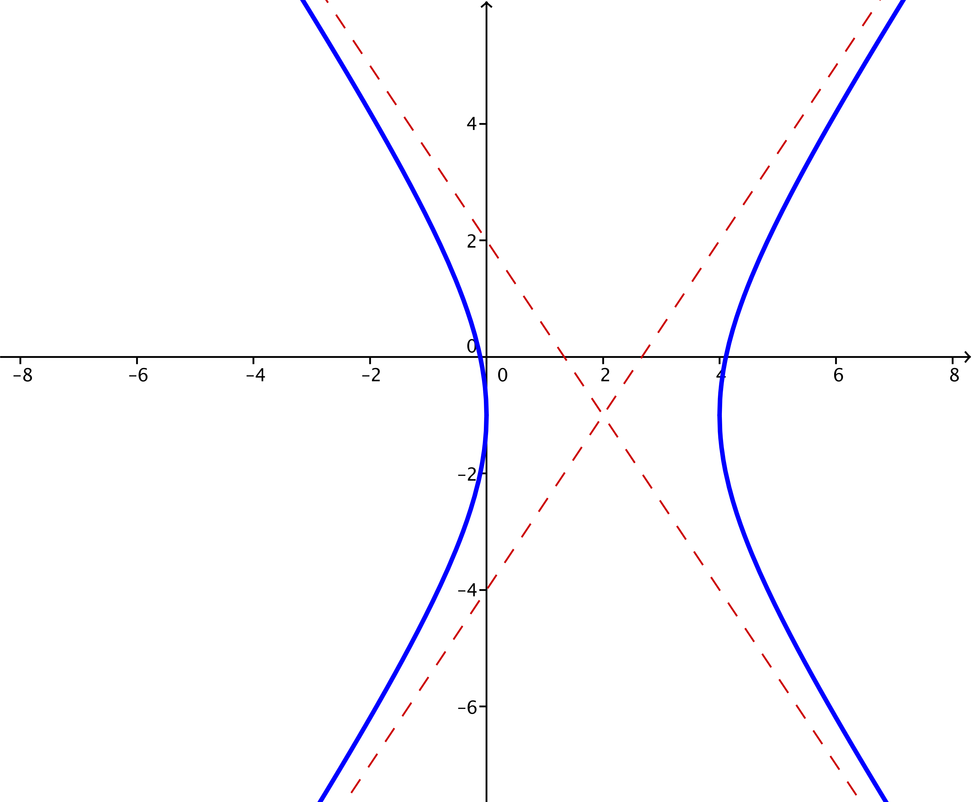

- For each equation below, identify the graph as either an ellipse, a hyperbola, two lines, or a single point. If possible, write the equation in the standard form for either an ellipse or a hyperbola.
  - $4x^{2}-8x+25y^{2}-100y+4=0$
In standard form, this is the equation of an ellipse: $\frac{{\left(x-1\right)}^{2}}{25}+\frac{{\left(y-2\right)}^{2}}{4}=1$.

  - $4x^{2}-16x-9y^{2}-54y-65=0$
When we try to put this equation in standard form, we find $\frac{{\left(x-2\right)}^{2}}{9}-\frac{{\left(y+3\right)}^{2}}{4}=0$, which gives $\frac{x-2}{3}=±\frac{y+3}{2}$. These are the lines with equation $y=\frac{1}{3}\left(2x-13\right)$ and $y=\frac{1}{3}\left(-2x-5\right)$.

  - $4x^{2}+8x+y^{2}+2y+5=0$
When we try to put this equation in standard form, we find ${\left(x+1\right)}^{2}+\frac{{\left(y+1\right)}^{2}}{4}=0$. The graph of this equation is the single point $\left(-1,-1\right)$.

  - $-49x^{2}+98x+4y^{2}-245=0$
In standard form, this is the equation of a hyperbola: $\frac{y^{2}}{49}-\frac{{\left(x-1\right)}^{2}}{4}=1$.

  - What can you tell about a graph of an equation of the form $ax^{2}+bx+cy^{2}+dy+e=0$ by looking at the coefficients?
MP.7
There are two categories; if the coefficients $a$ and $c$ have the same sign, then the graph will be either an ellipse, a point, or an empty set. If the coefficients $a$ and $c$ have opposite signs, then the graph will be a hyperbola or two intersecting lines. We cannot tell just by looking at the coefficients which of these sub-cases will hold.

Graph
Symmetry
Asymptotes
Center
Equation
Curve | Ellipse | Hyperbola opening up/down | Hyperbola opening left/right

