|  |
| --- |
|  |

Lesson 7: Curves from Geometry

Student Outcomes

* Students derive the equations of ellipses given the foci, using the fact that the sum of distances from the foci is constant (**G-GPE.A.3**).

Lesson Notes

In the previous lesson, students encountered sets of points that satisfy an equation of the form . In this lesson, students are introduced to ellipses as sets of points such that each point satisfies the condition , where points and are the foci of the ellipse and is a constant. The goal of this lesson is to connect these two representations. That is, if a point satisfies the condition , then it also satisfies an equation of the form for suitable values of and .

Classwork

Opening (8 minutes)

* In the previous lesson, we learned that an ellipse is an oval-shaped curve that can arise in the complex plane. In this lesson, we will continue our analysis of elliptical curves. But first, let’s establish a connection to another curve that was studied in Algebra II.
* In Algebra II, we learned that parabolic mirrors are used in the construction of telescopes. Do you recall the key property of parabolic mirrors? Every light ray that is parallel to the axis of the parabola reflects off the mirror and is sent to the same point, the focus of the parabola.

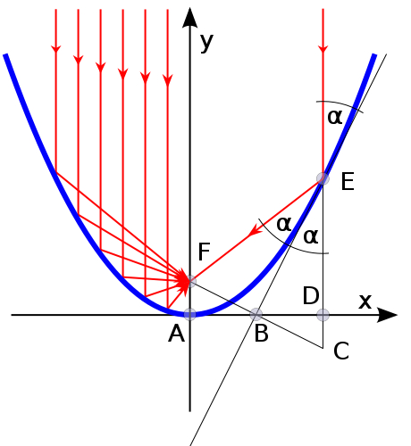

* Like the parabola, the ellipse has some interesting reflective properties as well. Imagine that you and a friend are standing at the focal points of an elliptical room, as shown in the diagram below. Though your friend may be 100 feet away, you would be able to hear what she is saying, even if she were facing away from you and speaking at the level of a whisper! How can this be? This phenomenon is based on the reflective property of ellipses: Every ray emanating from one focus of the ellipse is reflected off the curve in such a way that it travels to the other focal point of the ellipse.

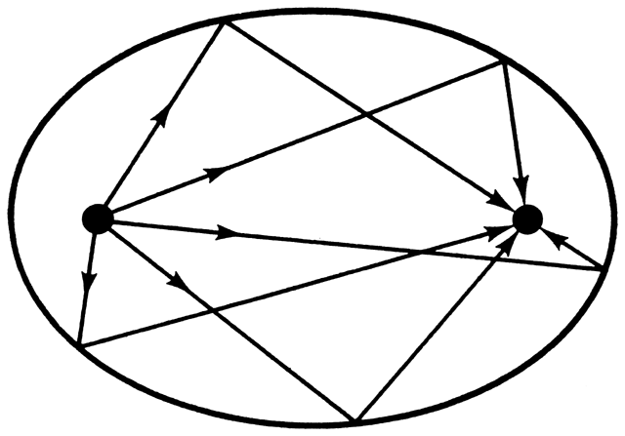

* A famous example of a room with this curious property is the National Statuary Hall in the United States Capitol. Can you see why people call this chamber “the Whispering Gallery?” The brief video clip below serves to illustrate this phenomenon.

<https://www.youtube.com/watch?v=FX6rUU_74kk>

* Now, let’s turn our attention to the mathematical properties of elliptical rooms. If every sound wave emanating from one focus bounces off the walls of the room and reaches the other focus at exactly the same instant, what can we say about the lengths of the segments shown in the following two diagrams?

 

* In the second figure, the sound is directed toward a point that is closer to the focus on the left but farther from the focus on the right. So, it appears that is less than and is more than . Can we say anything more specific than this? Think about this for a moment, and then share your thoughts with a neighbor.
* Draw as many segments as you can from one focus, to the ellipse, and back to the other focus. Share what you notice with a neighbor. (Debrief as a class.)

**MP.7**

* + *As one segment gets longer, the other* *gets shorter.*
  + *The total length of the two segments seems to be roughly the same.*
* If the sound waves travel from one focus of the ellipse to the other in the same period of time, it follows that they must be traveling equal distances! So, while we can’t say for sure what the individual distances and are, we do know that . This leads us to the distance property of ellipses: For any point on an ellipse, the sum of the distances to the foci is constant.
* Here is a concrete demonstration of the distance property for an ellipse. Take a length of string, and attach the two ends to the board. Then, place a piece of chalk on the string, and pull it taut. Move the chalk around the board, keeping the string taut. Because the string has a fixed length, the sum of the distances to the foci remains the same. Thus, this drawing technique generates an ellipse.

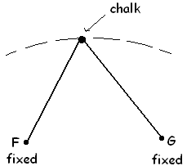

* In the previous lesson, we viewed an ellipse centered at the origin as a set of points that satisfy an equation of the form . Do you think that a room with the reflection property discussed above can be described by this kind of equation? Let’s find out together!

**Discussion (16 minutes)**

* Since we are going to describe an ellipse using an equation, let’s bring coordinate axes into the picture.
* Let’s place one axis along the line that contains the two focal points, and let’s place the other axis at the midpoint of the two foci.

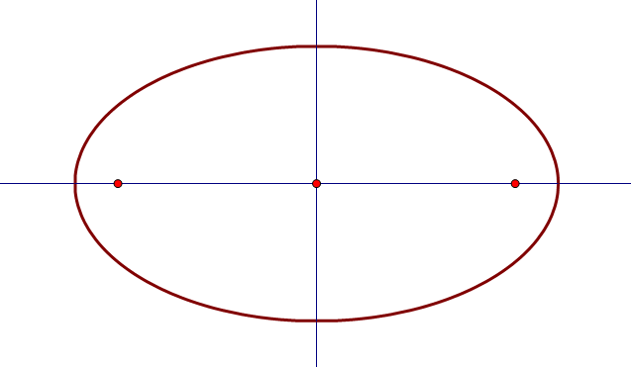

* Suppose that the focal points are located feet apart, and a sound wave traveling from one focus to the other moves a total distance of feet. Exactly which points in the plane are on this elliptical curve? Perhaps it will help at this stage to add in a few labels.

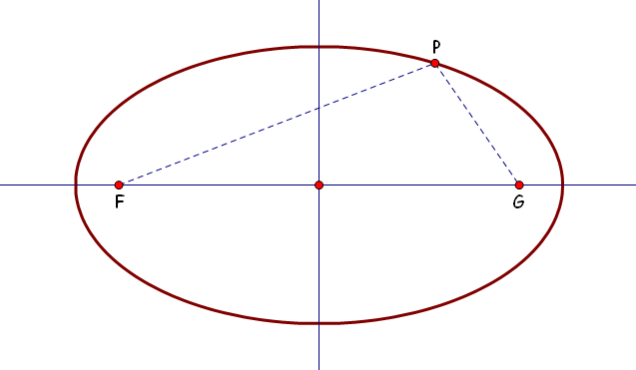

* Can you represent the distance condition that defines this ellipse into an equation involving these symbols?

**MP.2**

* + *Since we were told that sound waves travel feet from one focal point to the other, we need to have .*
* What can we say about the coordinates of ? In other words, what does it take for a point to be on this ellipse? First of all, we were told that the foci were feet apart, so the coordinates of the foci are and . Can you represent the condition as an equation about and ? The picture below may help you to do this.

*Scaffolding:*

* In order to help students construct radical expressions such as and , prompt them to recall the Pythagorean theorem and its meaning.
* In the context of the Pythagorean theorem, what do , , and represent in ?
* How could this equation be transformed so that we have an equation for in terms of and ?
* What expressions could be substituted for , , and in this example?

**MP.2**

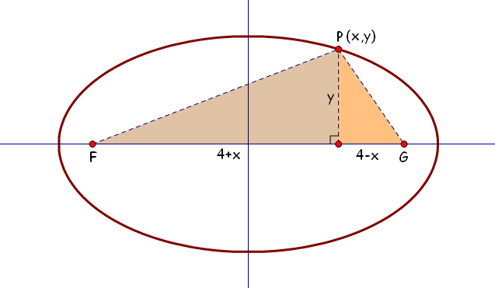

* + *The distance from points and to the -axis is . If point is a distance of from the -axis, that means the horizontal distance from to is and from to is .*
  + *The distance is given by , and the distance is given by . Since the sum of these two distances must be , the coordinates of must satisfy the equation   
    .*
* Now that it’s done, we can set about verifying that a curve with this special distance property can be written in the very simple form . It looks like the first order of business is to get rid of the square roots in the equation. How should we go about that?
  + *We can eliminate the square roots by squaring both sides.*
* Experience shows that we will have a much easier time of it if we put one of the radical expressions on the other side of the equation first. (Try squaring both sides without doing this, and you will quickly see the wisdom of this approach!) Let’s subtract the second radical expression from both sides:
* Now, we are all set to square both sides:
* As usual, we have a variety of choices about how to proceed. What ideas do you have?
  + *We can subtract from both sides, giving:*

.

* + *We can expand the binomials, giving:*

.

* Now what?
  + *We can subtract and from both sides of this equation, giving:*

.

* We started out with two radical expressions, and we have managed to get down to one. That’s progress! But we will want to square both sides again to eliminate all radicals from the equation. With that goal in mind, it will be helpful to put the radical expression on one side of the equation and everything else on the other side, like this:
* Now, we will square both sides:
* Expanding the binomial gives:
* We began with an equation that contained two radical expressions and generally looked messy. After many algebraic manipulations, things are looking a whole lot simpler! There is just one further step to whip this equation into proper shape, that is, to check that this curve indeed has the form of an ellipse, namely, . Can you see what to do?
  + *We just divide both sides of the equation by :*
* Here’s a recap of our work up to this point: An ellipse is a set of points where the sum of the distances to two fixed points (called *foci*) is constant. We studied a particular example of such a curve, showing that it can be written in the form .
* Let’s see what else we can learn about the graph of this ellipse by looking at this equation. Where does the curve intersect the axes?
  + *You can tell by inspection that the curve contains the points and , as well as the points and .*

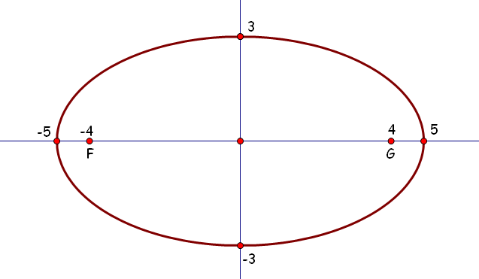

* Now, let’s verify that these features are consistent with the facts we started with: that the foci were feet apart and that the distance each sound wave travels between the foci is feet. Do the -intercepts make sense in light of these facts? Think about this, and then share your response with a neighbor.
  + *Yes; the intercepts are and . If a person is standing at and another person is standing at , and the person at point speaks while facing left, the sound will travel 1 foot to the wall, then bounce 9 feet back to . The sound travels a total of feet.*
* Next, let’s check to see if the -intercepts are consistent with the initial conditions of this problem.

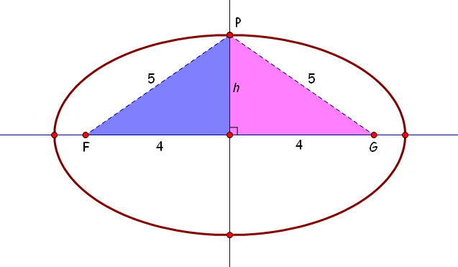

* + *It looks as though the -axis is a line of symmetry for this ellipse, so we should expect that the -intercept is a point on the elliptical wall where the distance from to is the same as the distance from to . Since the total distance is feet, we must have . In that case, the height of the triangles in the picture must satisfy the Pythagorean theorem so that . It’s clear that the equation is true when , so one of the -intercepts is indeed !*

Example (5 minutes)

In this example, students derive the equation of an ellipse whose foci lie on the -axis.

* Tammy takes an -inch length of string and tapes the ends to a chalkboard in such a way that the ends of the string are inches apart. Then, she pulls the string taut and traces the curve below using a piece of chalk.



* Where does this curve intersect the -axis? Take a minute to think about this.
  + *When the chalk is at point , the string goes from to , then back down to . We know that* , *and the string is inches long, so we have , which means , which means must be .*
  + *Thus, point is* , *and point is . Similarly, point is* , *and point is at .*
* So, where does the curve intersect the -axis? Use the diagram to help you.
  + *When the chalk is at point , the string is divided into two equal parts. Thus, . The length must satisfy , so .*

Exercise (6 minutes)

In this exercise, students practice rewriting an equation involving two radical expressions. This is the core algebraic work involved in meeting standard **G-GPE.A.3** as it relates to ellipses.

Exercise

Points and are located at and . Let be a point such that . Use this information to show that the equation of the ellipse is .

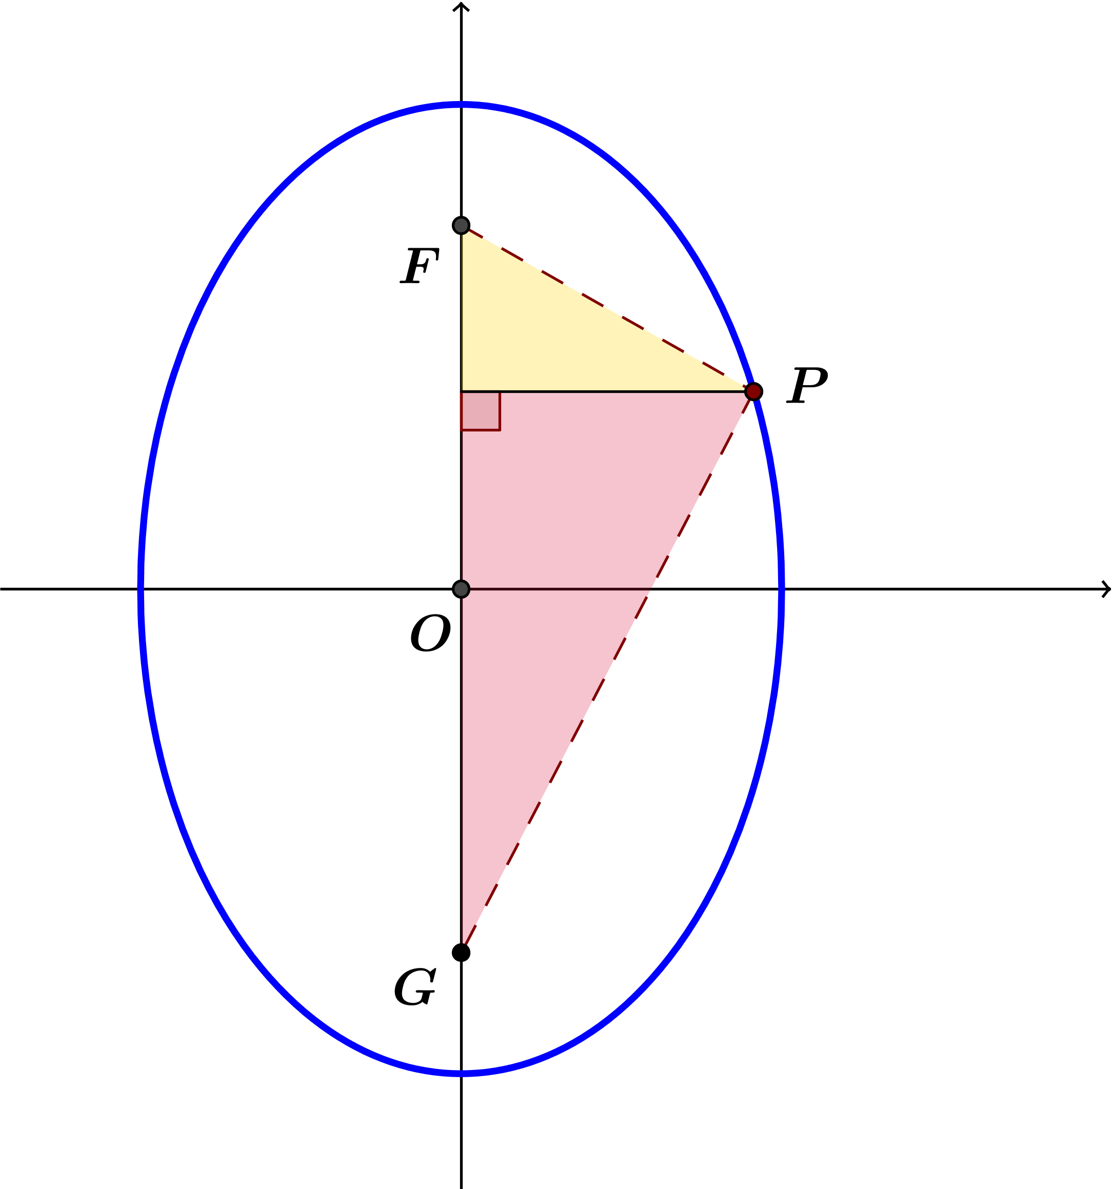

The distance from the -axis to point and to point is . The distance from the -axis to point is ; that means the vertical distance from to is , and the vertical distance from to is .

Closing (2 minutes)

Give students a moment to respond to the questions below, and then call on students to share their responses with the whole class.

* Let and be the foci of an ellipse. If and are points on the ellipse, what conclusion can you draw about distances from and to and ?
* What information do students need in order to derive the equation of an ellipse?
  + *The foci and the sum of the distances from the foci to a point on the ellipse*.
* What is fundamentally true about every ellipse?
  + *From every point on the ellipse, the sum of the distance to each focus is constant*.
* What is the standard form of an ellipse centered at the origin?

Exit Ticket (8 minutes)

Name Date

Lesson 7: Curves from Geometry

Exit Ticket

Suppose that the foci of an ellipse are and and that the point satisfies the condition   
.

* 1. Derive an equation of an ellipse with foci and that passes through . Write your answer in standard form: .
  2. Sketch the graph of the ellipse defined above.
  3. Verify that the -intercepts of the graph satisfy the condition .
  4. Verify that the -intercepts of the graph satisfy the condition .

Exit Ticket Sample Solutions

Suppose that the foci of an ellipse are and and that the point satisfies the condition  
.

* 1. Derive an equation of an ellipse with foci and that passes through . Write your answer in standard form: .
  2. Sketch the graph of the ellipse defined above.

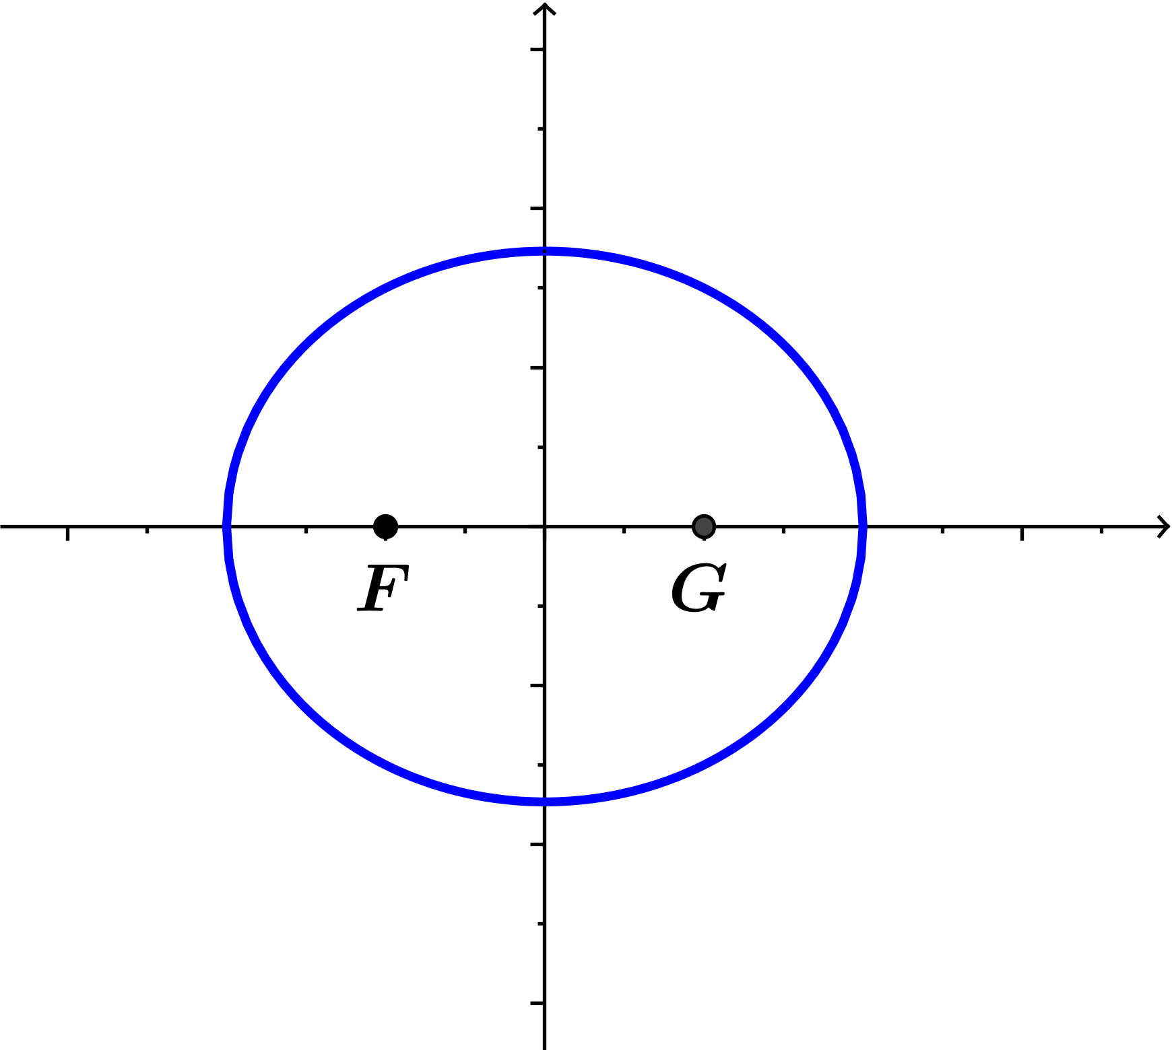

* 1. Verify that the -intercepts of the graph satisfy the condition .

For the -intercepts and , we have and .

* 1. Verify that the -intercepts of the graph satisfy the condition .

For the -intercepts and , we have and .

Problem Set Sample Solutions

1. Derive the equation of the ellipse with the given foci and that passes through point . Write your answer in standard form: .
   1. The foci are and , and point satisfies the condition .
   2. The foci are and , and point satisfies the condition .
   3. The foci are and , and point satisfies the condition .
   4. The foci are and , and point satisfies the condition .
   5. The foci are and , and point satisfies the condition .
   6. The foci are and , and point satisfies the condition .
2. Recall from Lesson 6 that the semi-major axes of an ellipse are the segments from the center to the farthest vertices, and the semi-minor axes are the segments from the center to the closest vertices. For each of the ellipses in Problem 1, find the lengths and of the semi-major axes.
3. Summarize what you know about equations of ellipses centered at the origin with vertices , , , and .

**MP.8**

For ellipses centered at the origin, the equation is always , where is the positive -value of the -intercepts and is the positive -value of the -intercepts. If we know the - and -intercepts, then we know the equation of the ellipse.

1. Use your answer to Problem to find the equation of the ellipse for each of the situations below.
   1. An ellipse centered at the origin with -intercepts , and -intercepts , .
   2. An ellipse centered at the origin with -intercepts , and -intercepts , .
2. Examine the ellipses and the equations of the ellipses you have worked with, and describe the ellipses with equation in the three cases , , and .

If , then the foci are on the -axis and the ellipse is oriented horizontally, and if , the foci are on the -axis and the ellipse is oriented vertically. If , then the ellipse is a circle with radius .

1. Is it possible for to have foci at and for some real number ?

No. Since , the foci must be along the -axis.

1. For each value of specified in parts (a)–(e), plot the set of points in the plane that satisfy the equation  
    .

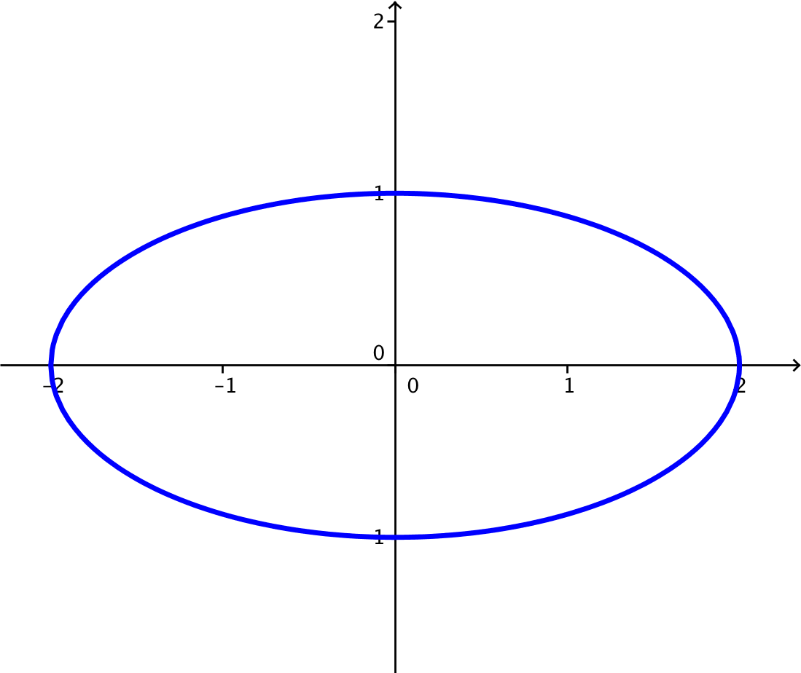

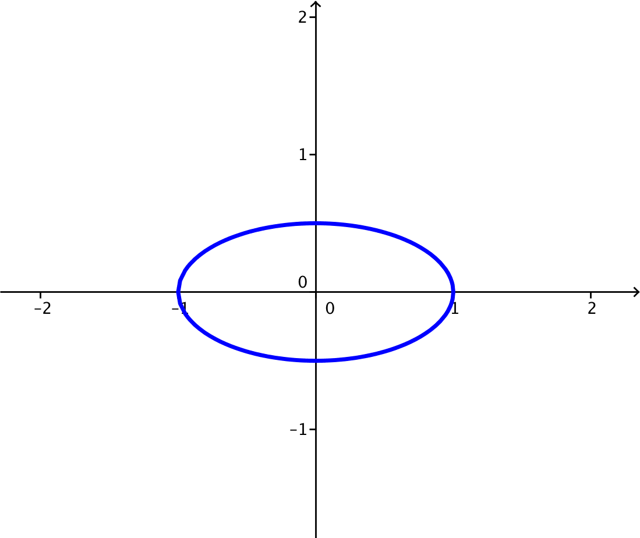

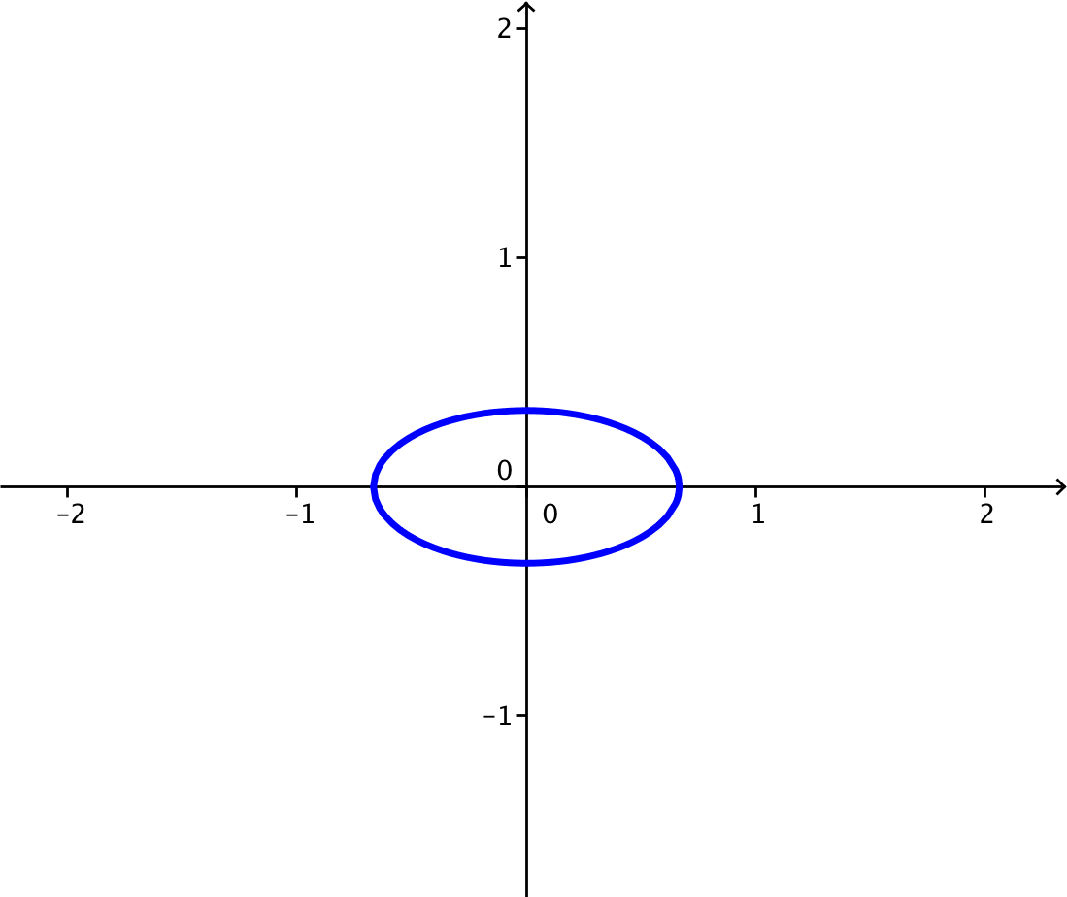

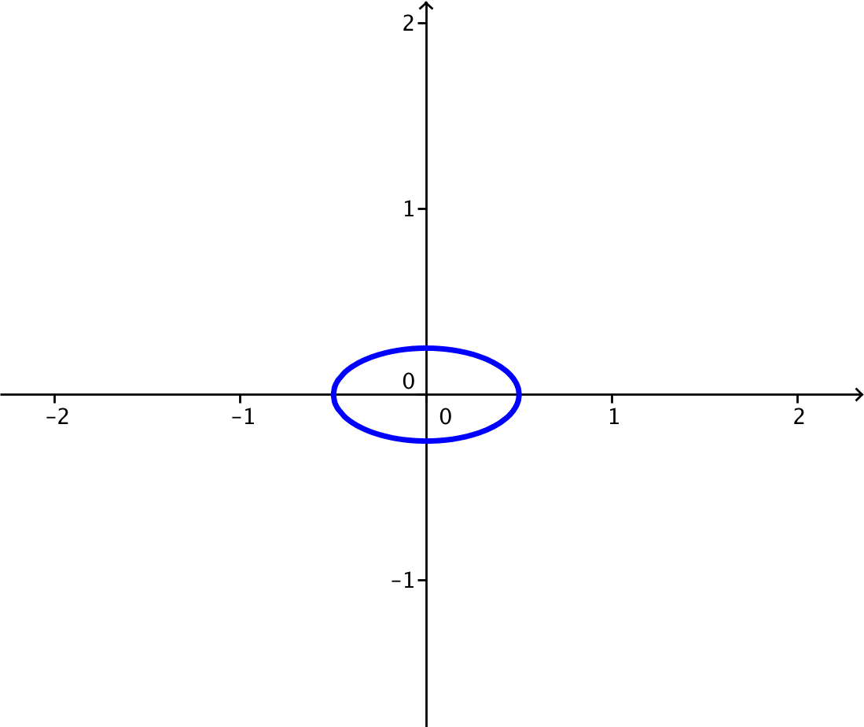

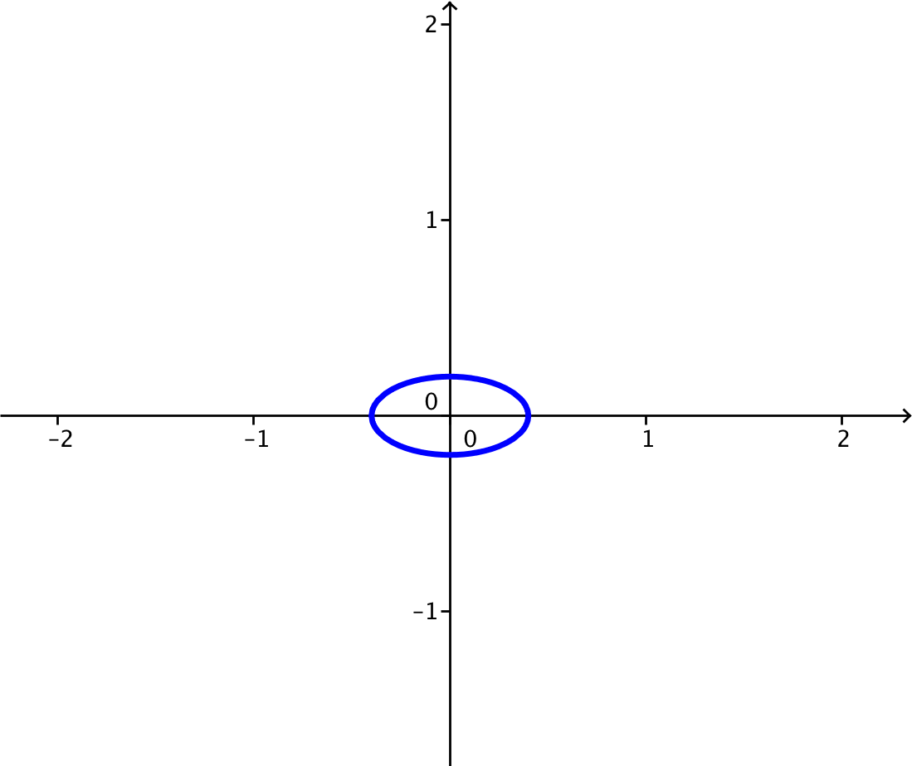

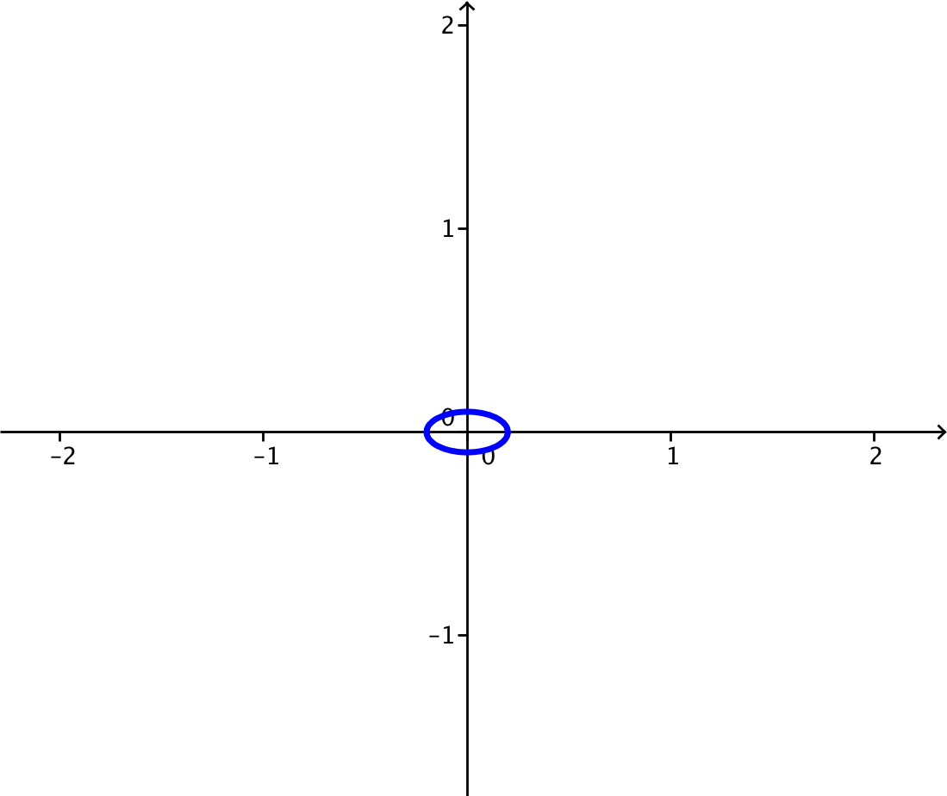

* 1. Make a conjecture: Which points in the plane will satisfy the equation ?

**MP.3**

**&**

**MP.7**

**As is getting smaller, the ellipse is shrinking. It seems that the only point that lies on the curve given by would be the single point .**

* 1. Explain why your conjecture in part (g) makes sense algebraically.

Both and are nonnegative numbers, and the only way to sum two nonnegative numbers and get zero would be if they were both zero. Thus, and , which means that .

* 1. Which points in the plane will satisfy the equation ?

**There are no points in the plane that will satisfy the equation , because for all real numbers and** .

1. For each value of specified in parts (a)–(e), plot the set of points in the plane that satisfy the equation   
   .

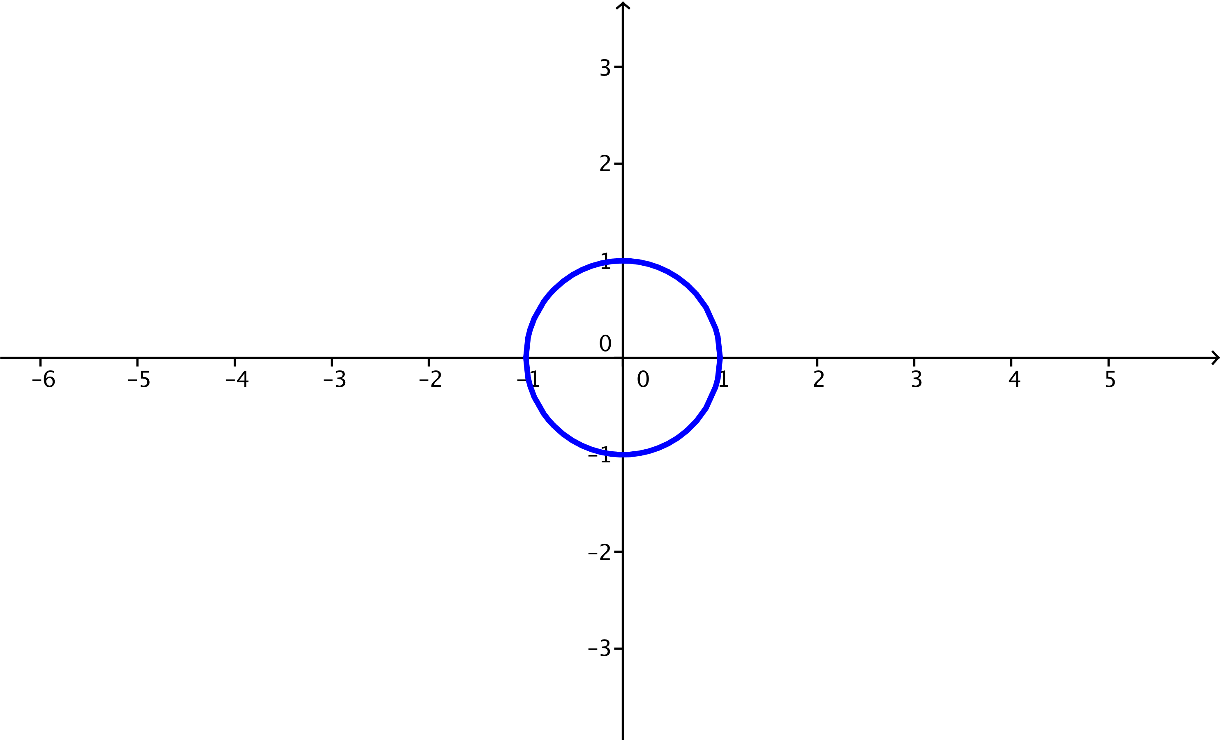

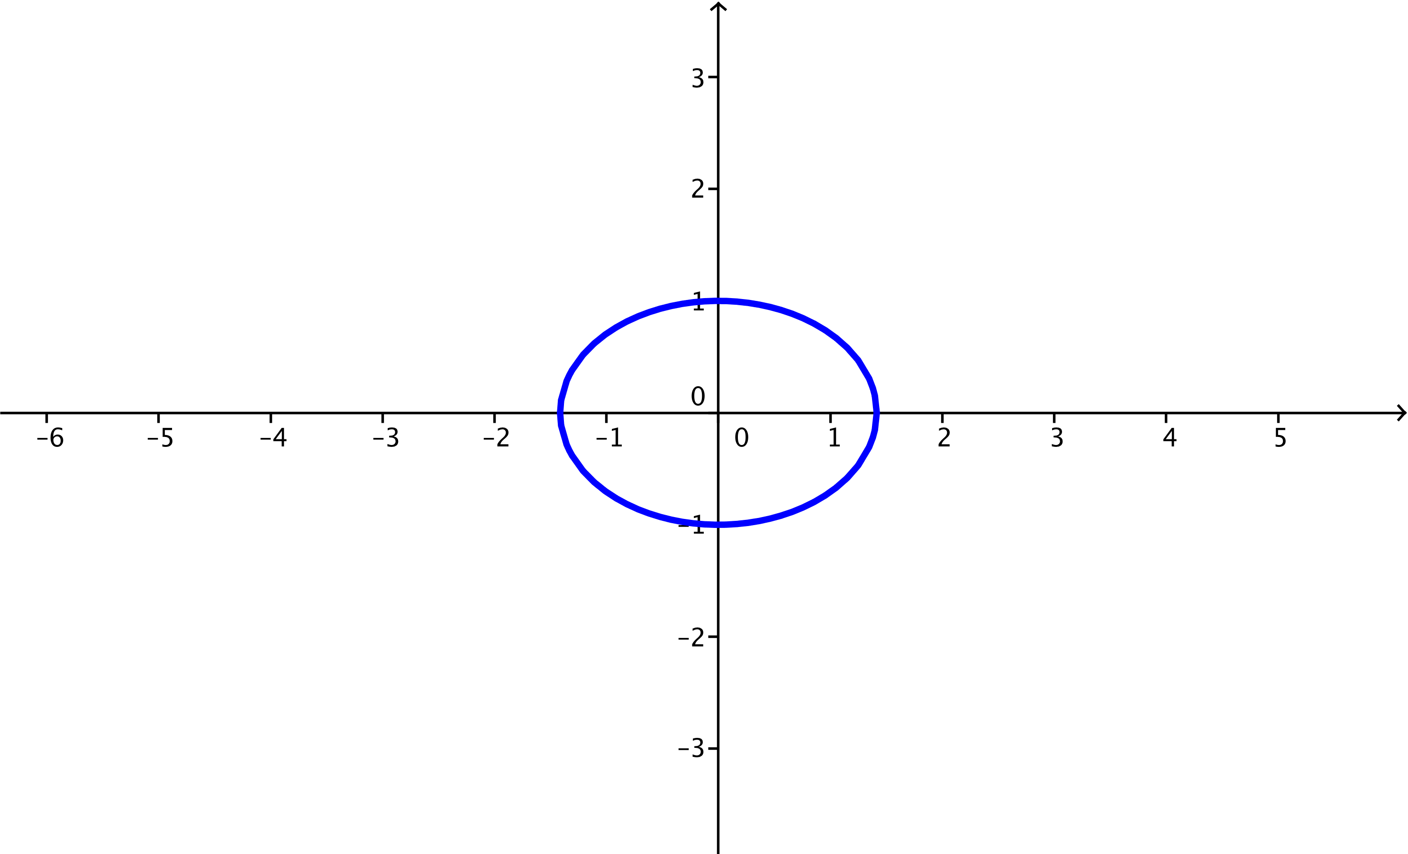

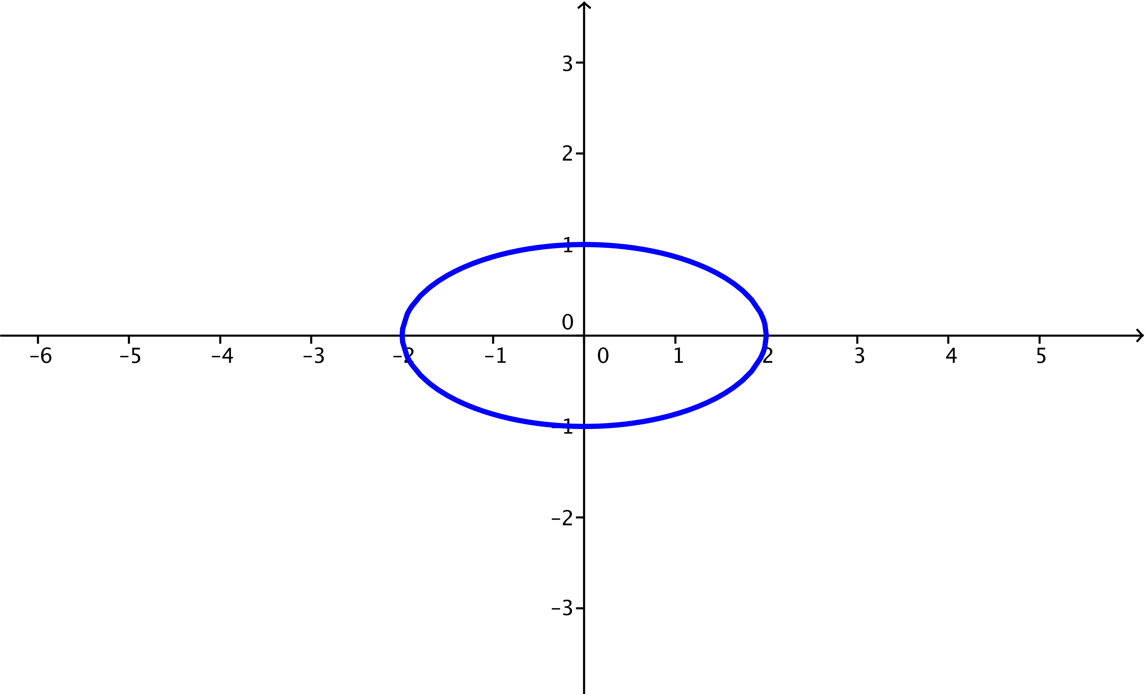

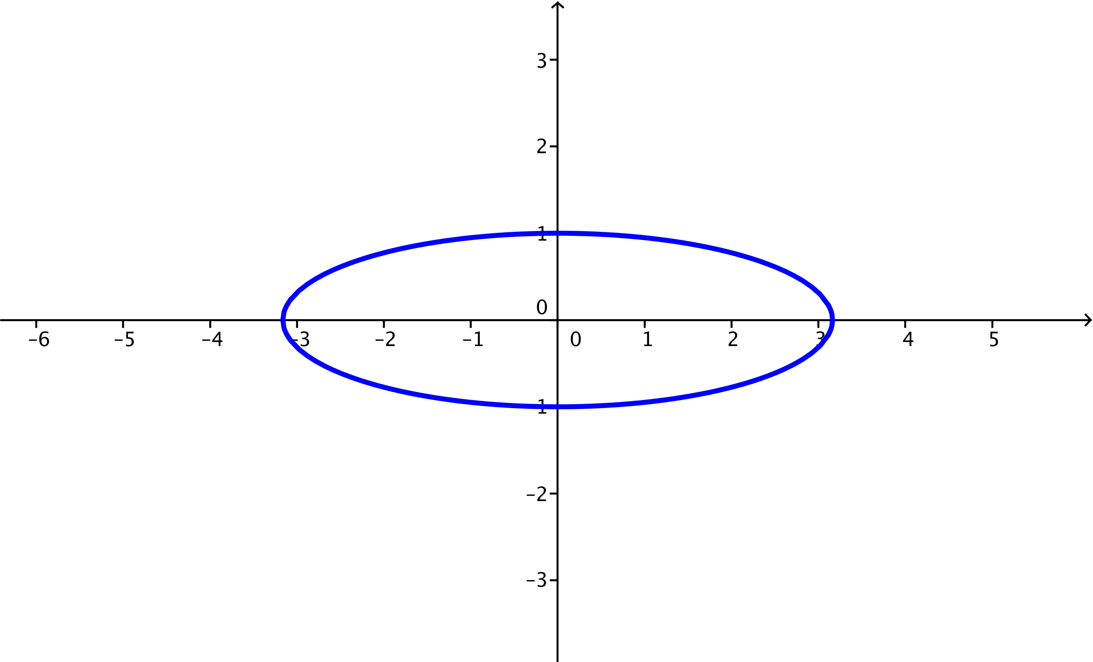

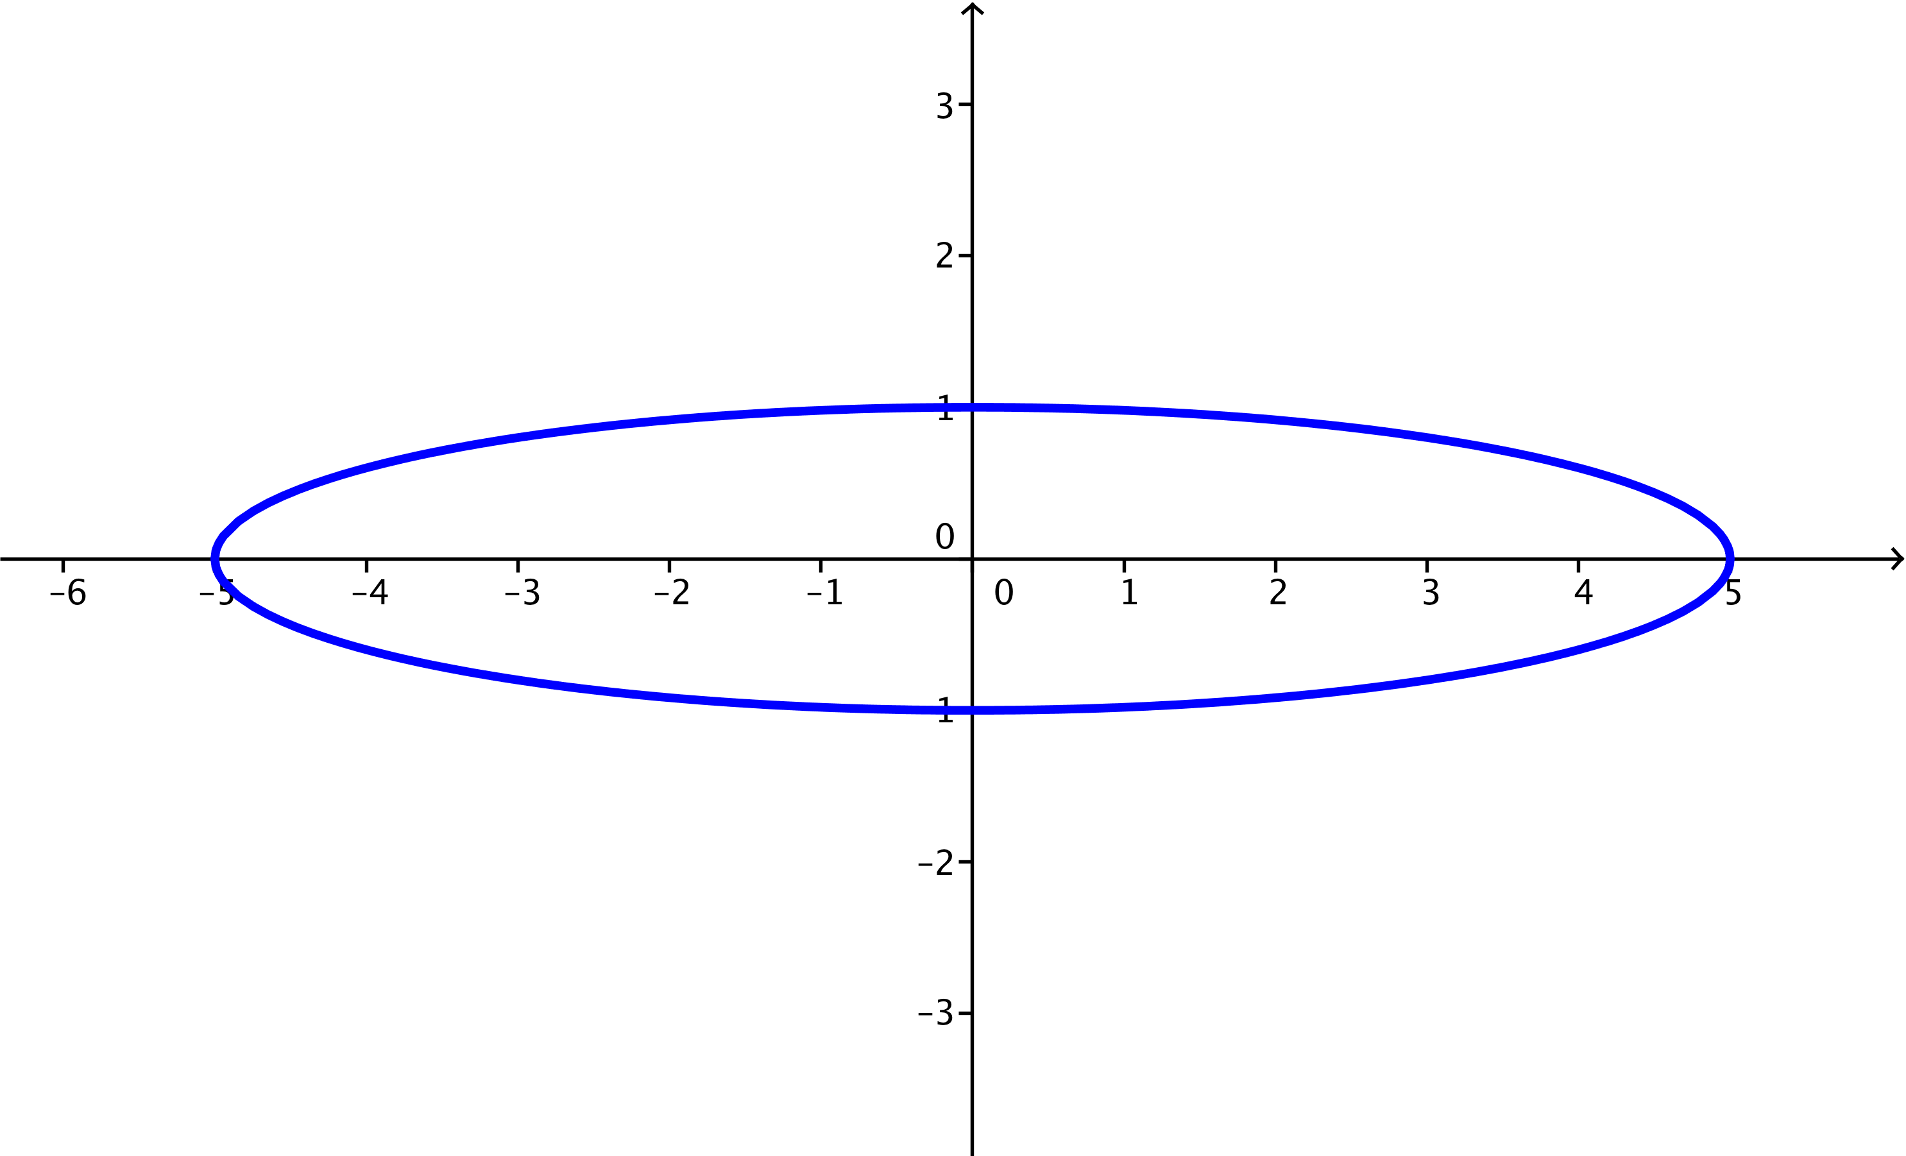

* 1. Describe what happens to the graph of as .

**MP.7**

As gets larger and larger, the ellipse stretches more and more horizontally, while not changing vertically. The vertices are , , and .

1. For each value of specified in parts (a)–(e), plot the set of points in the plane that satisfy the equation   
   .

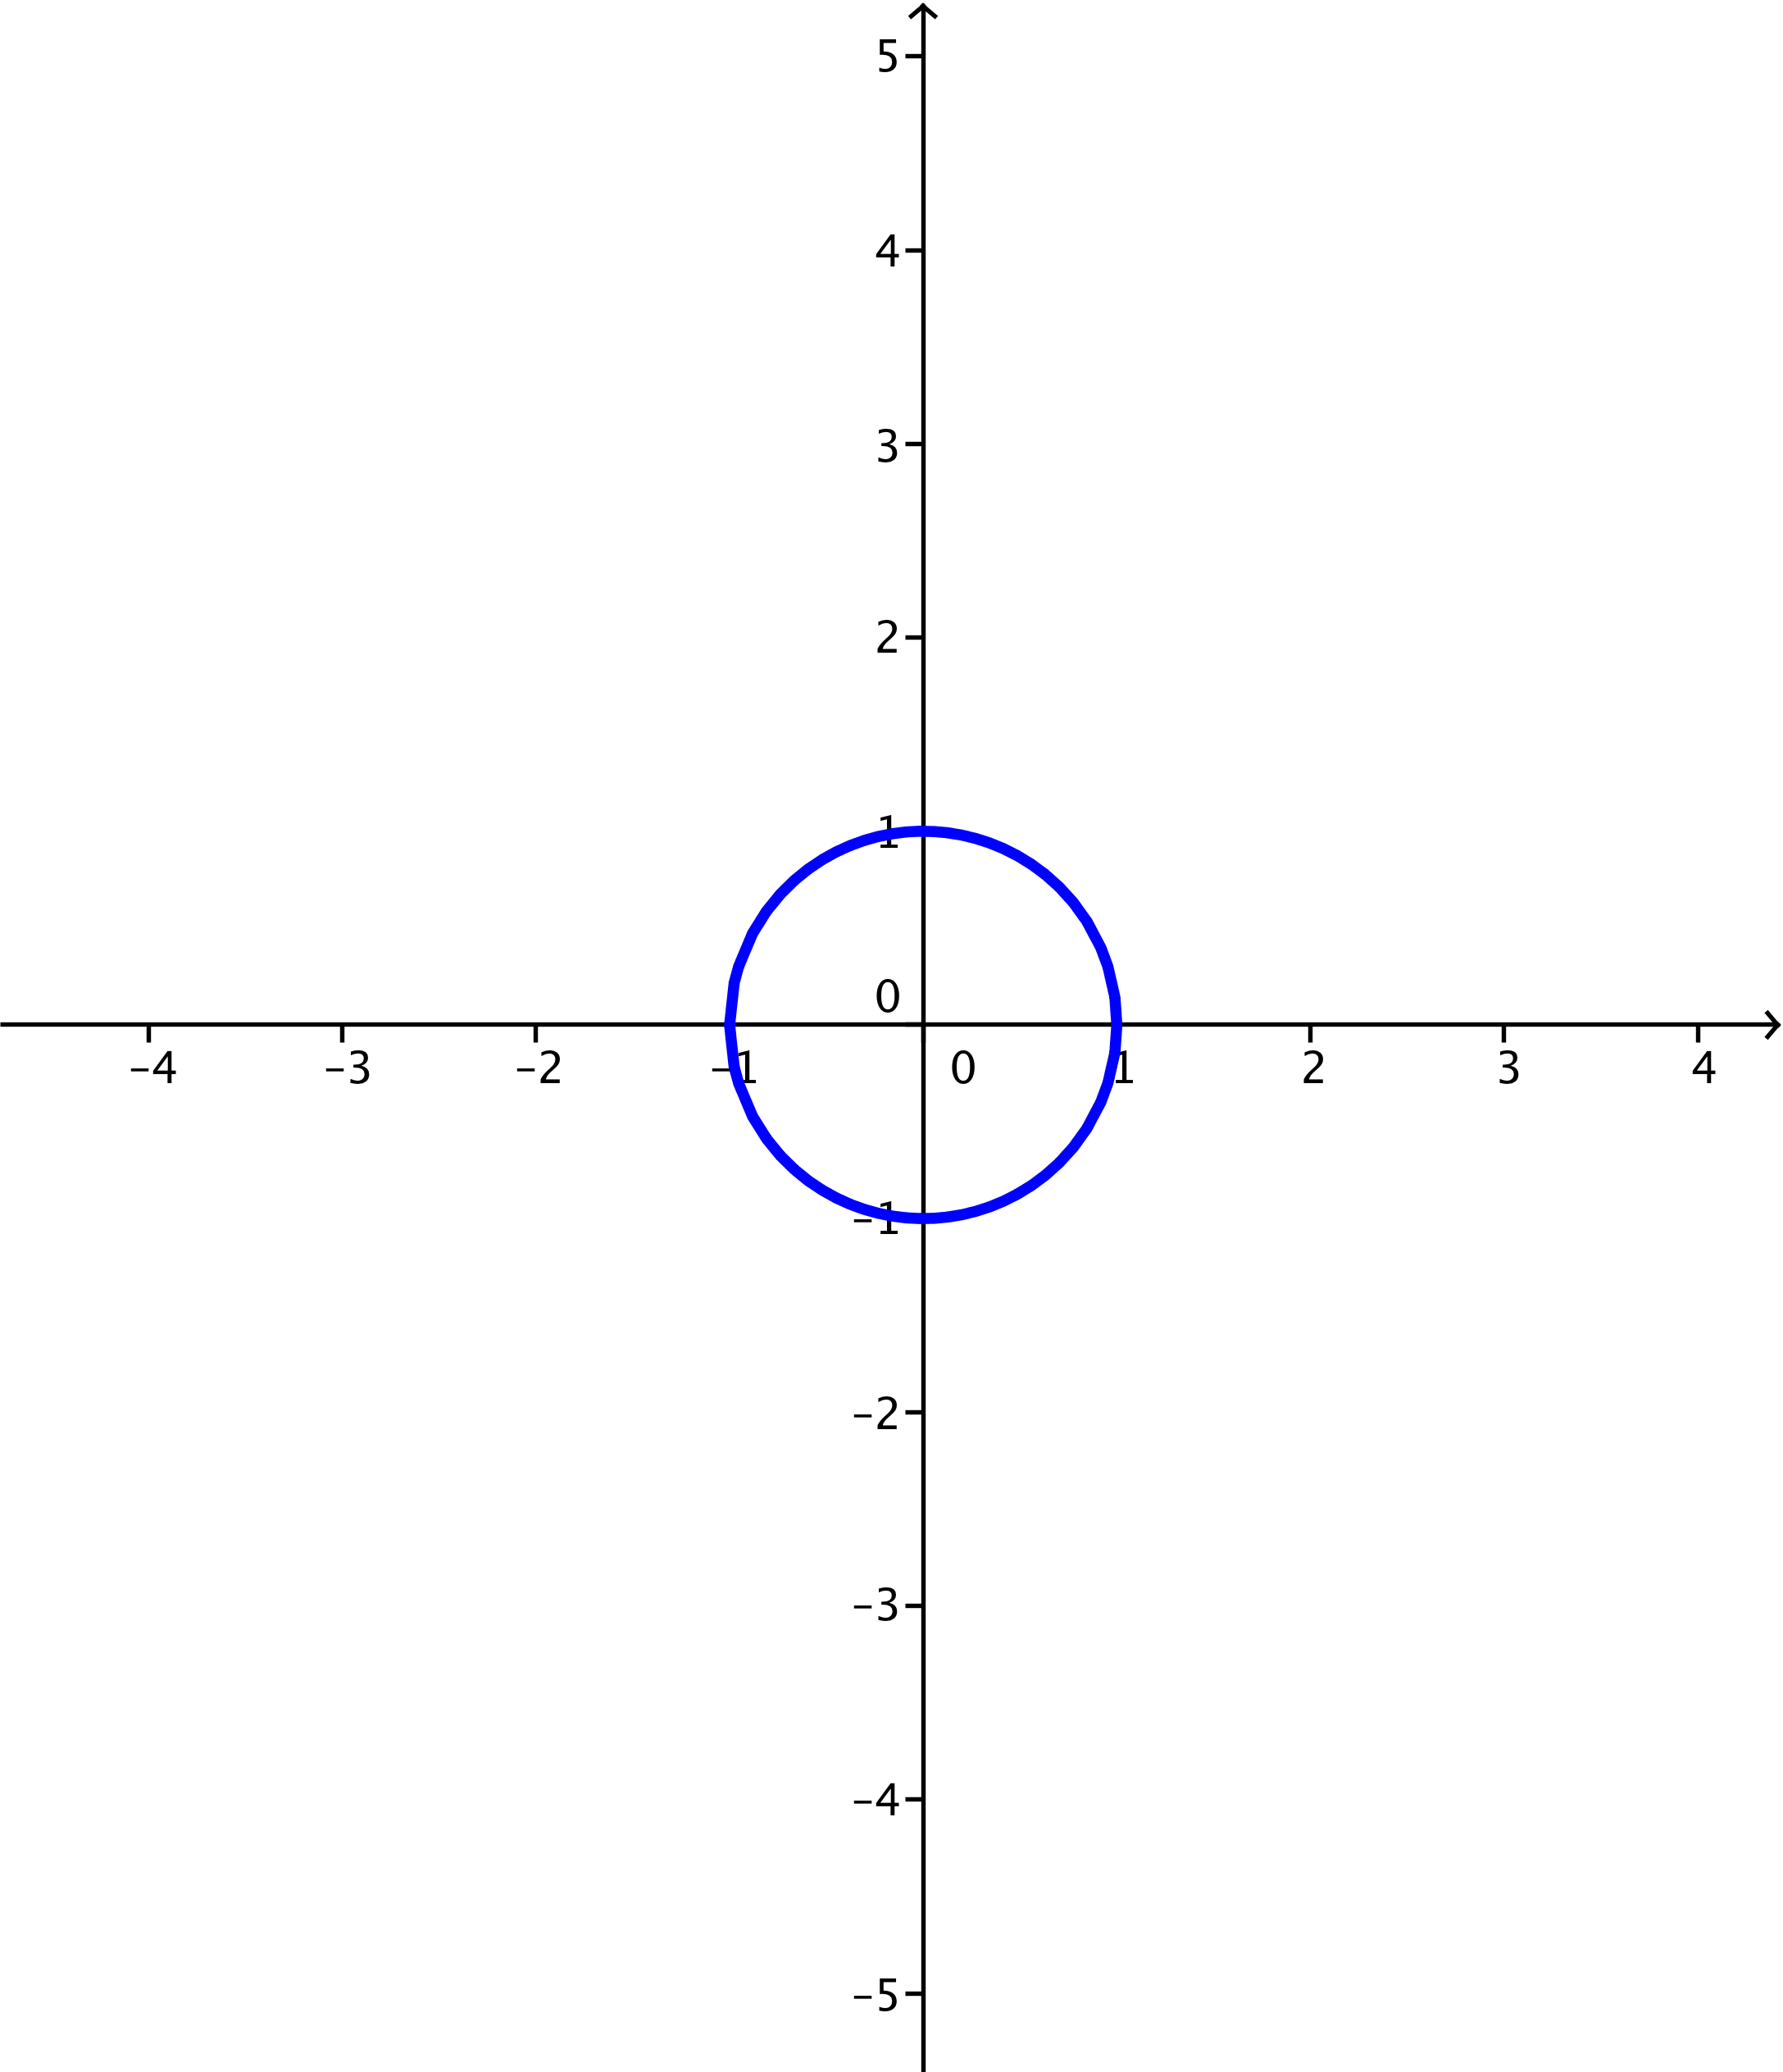

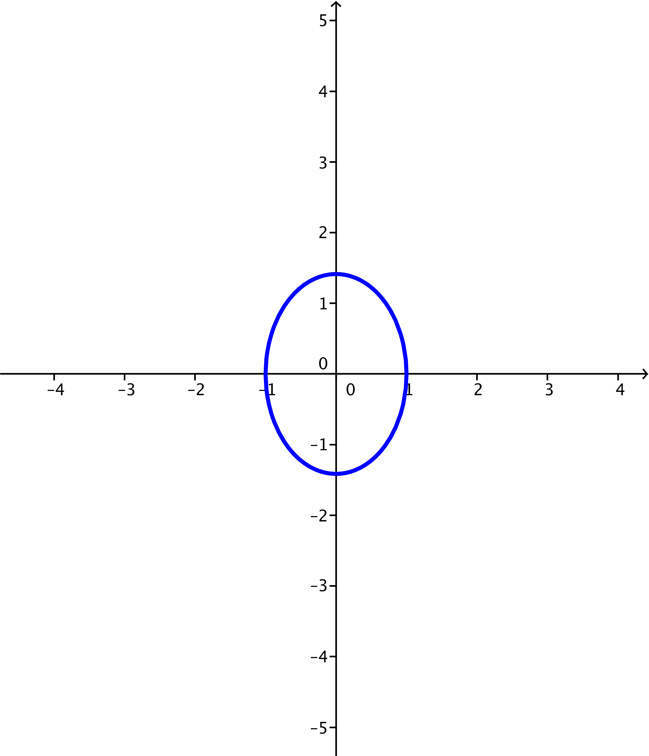

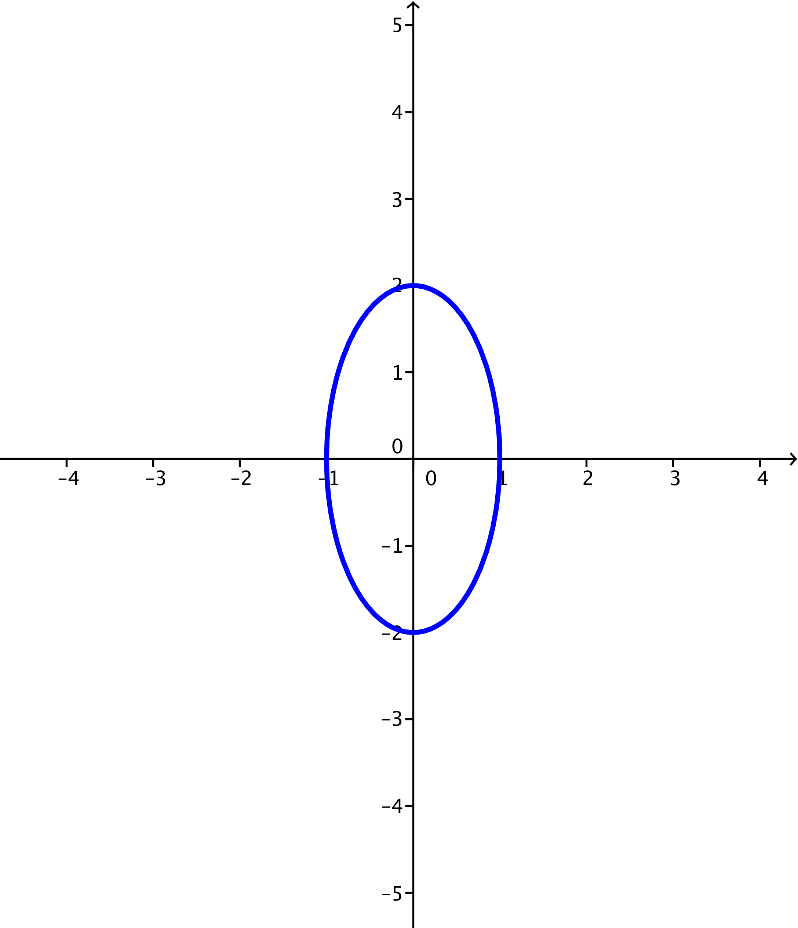

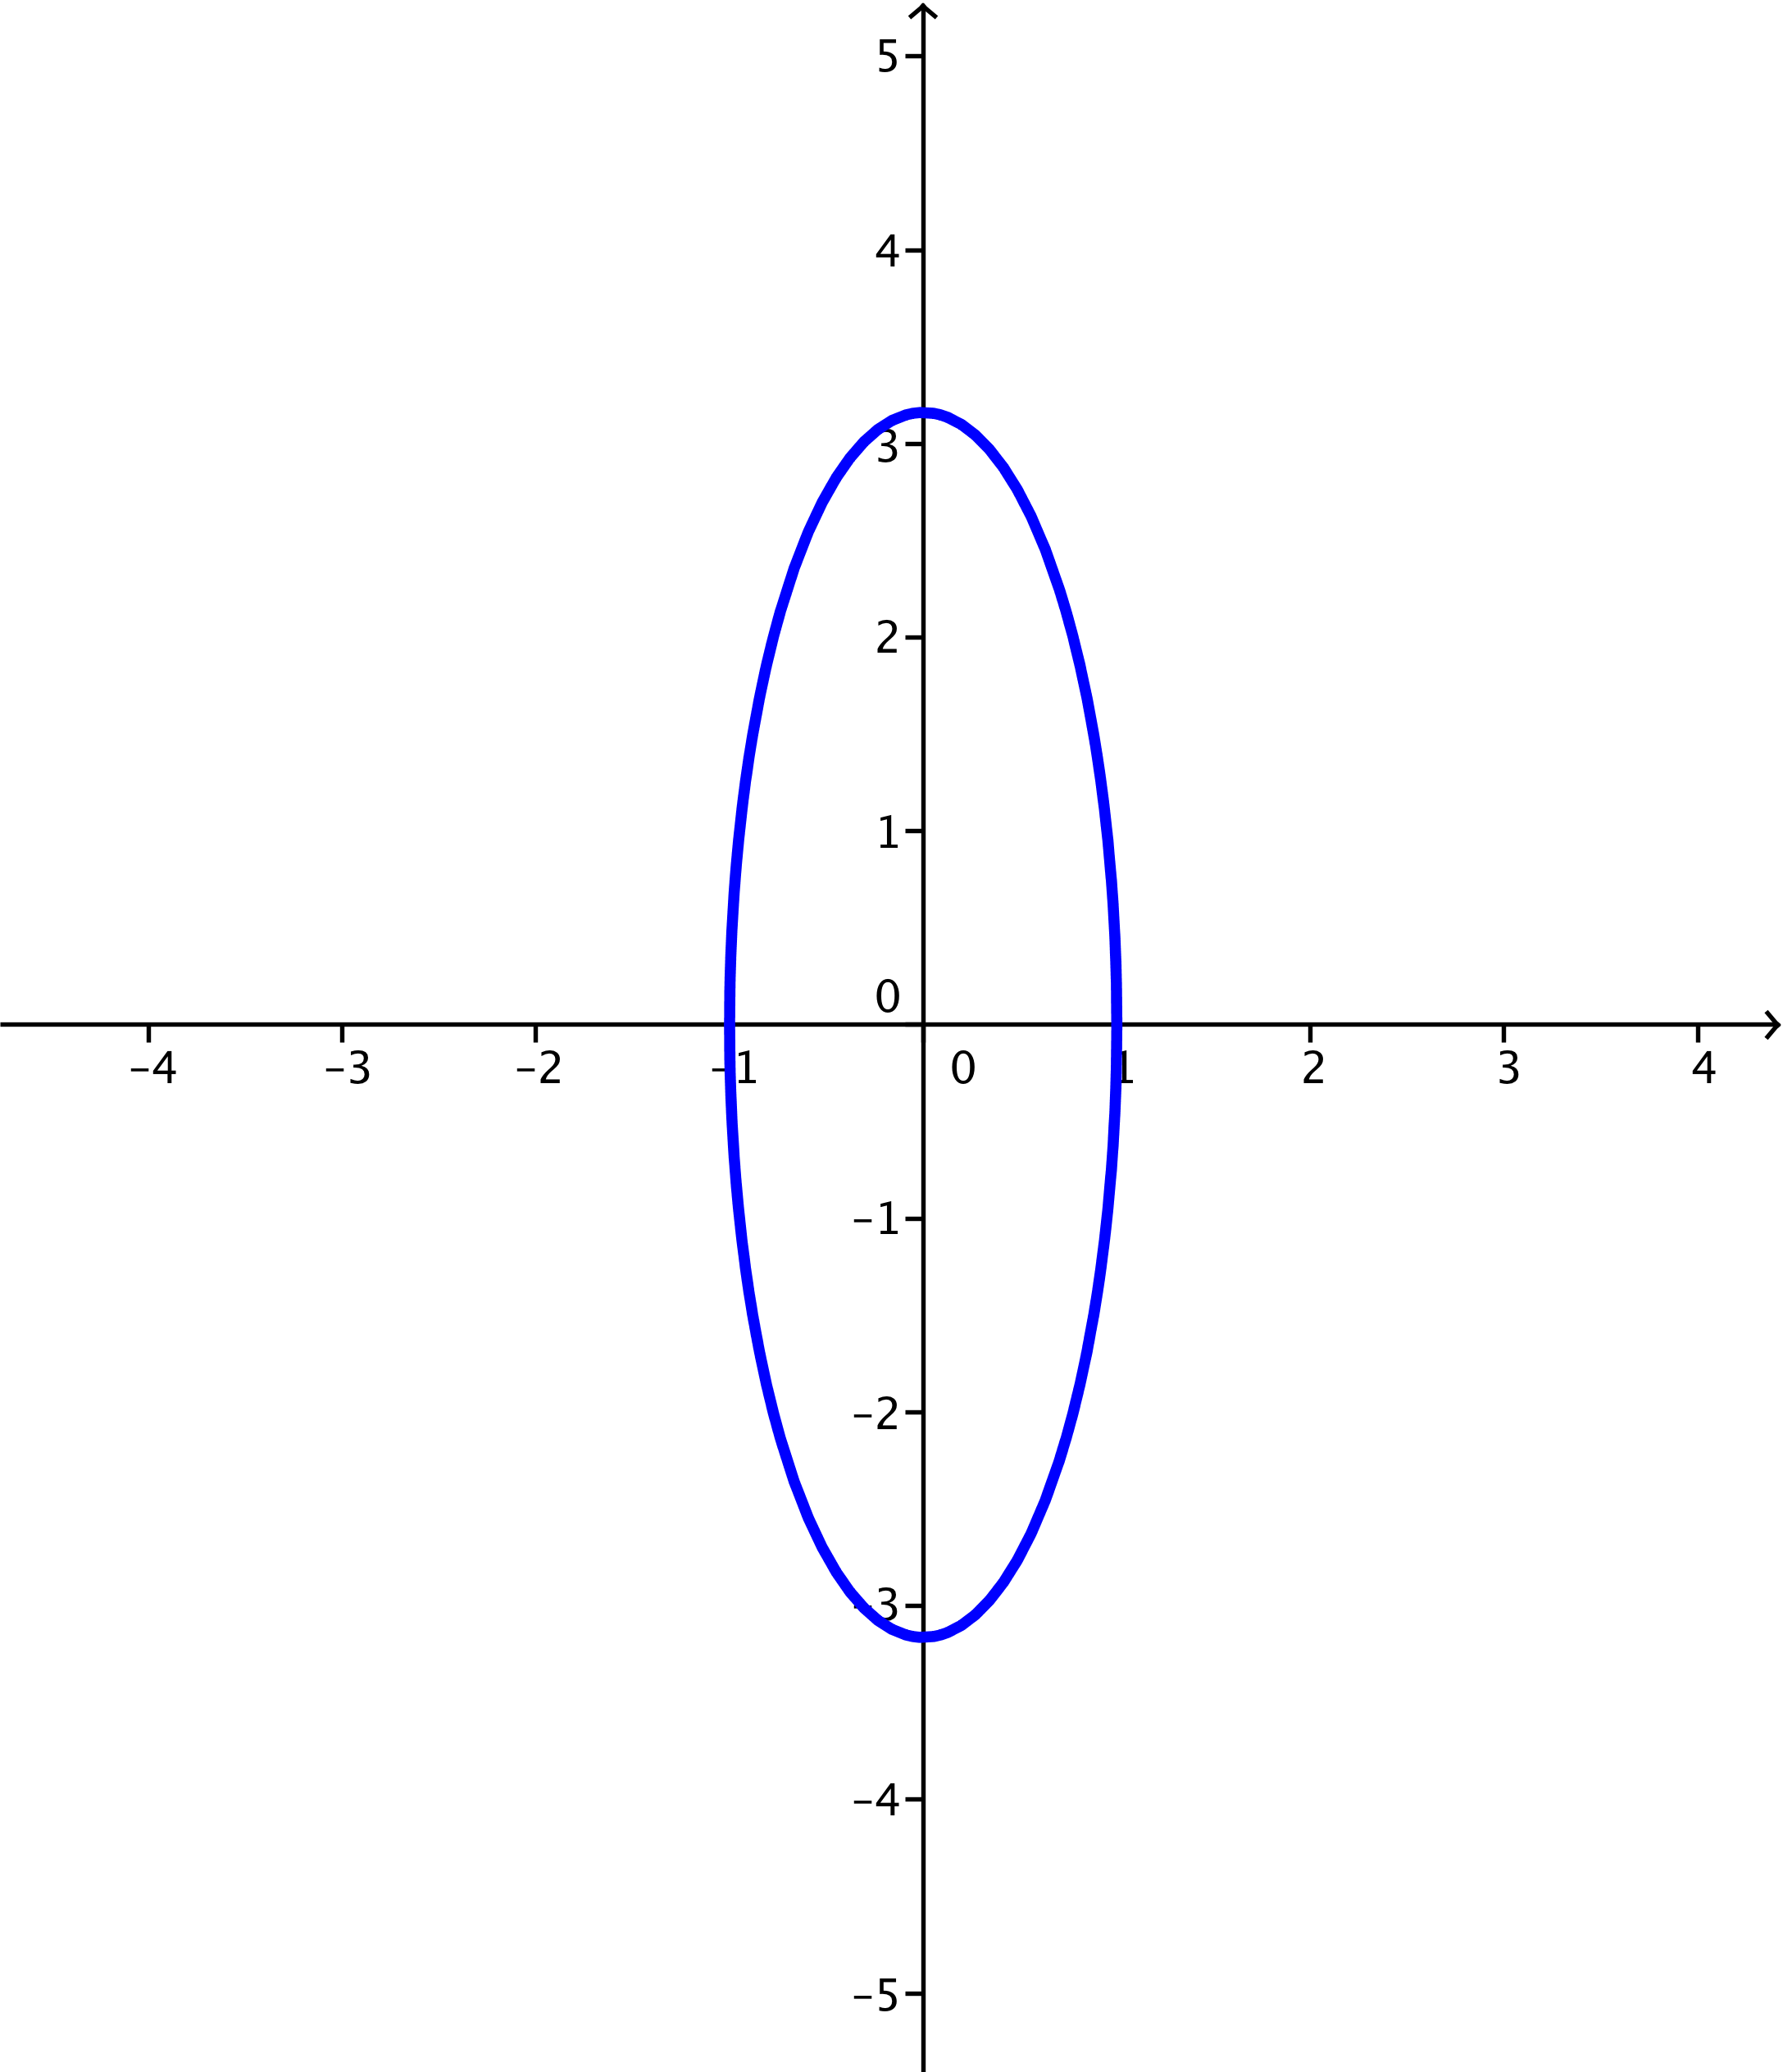

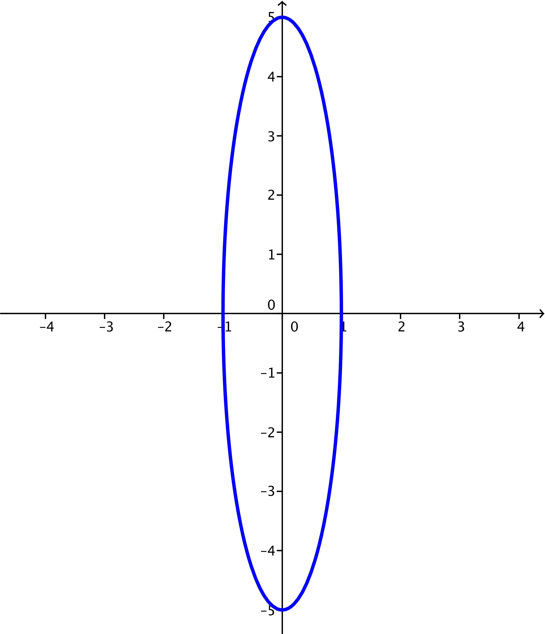

* 1. Describe what happens to the graph of as .

**MP.7**

As gets larger and larger, the ellipse stretches more and more vertically, while not changing horizontally. The vertices are , , , and .