Lesson 7: Curves from Geometry

Classwork
Exercise
Points $F$ and $G$ are located at $(0,3)$ and $(0,-3)$. Let $P(x,y)$ be a point such that $PF+PG=8$. Use this information to show that the equation of the ellipse is $\frac{x^{2}}{7}+\frac{y^{2}}{16}=1$.
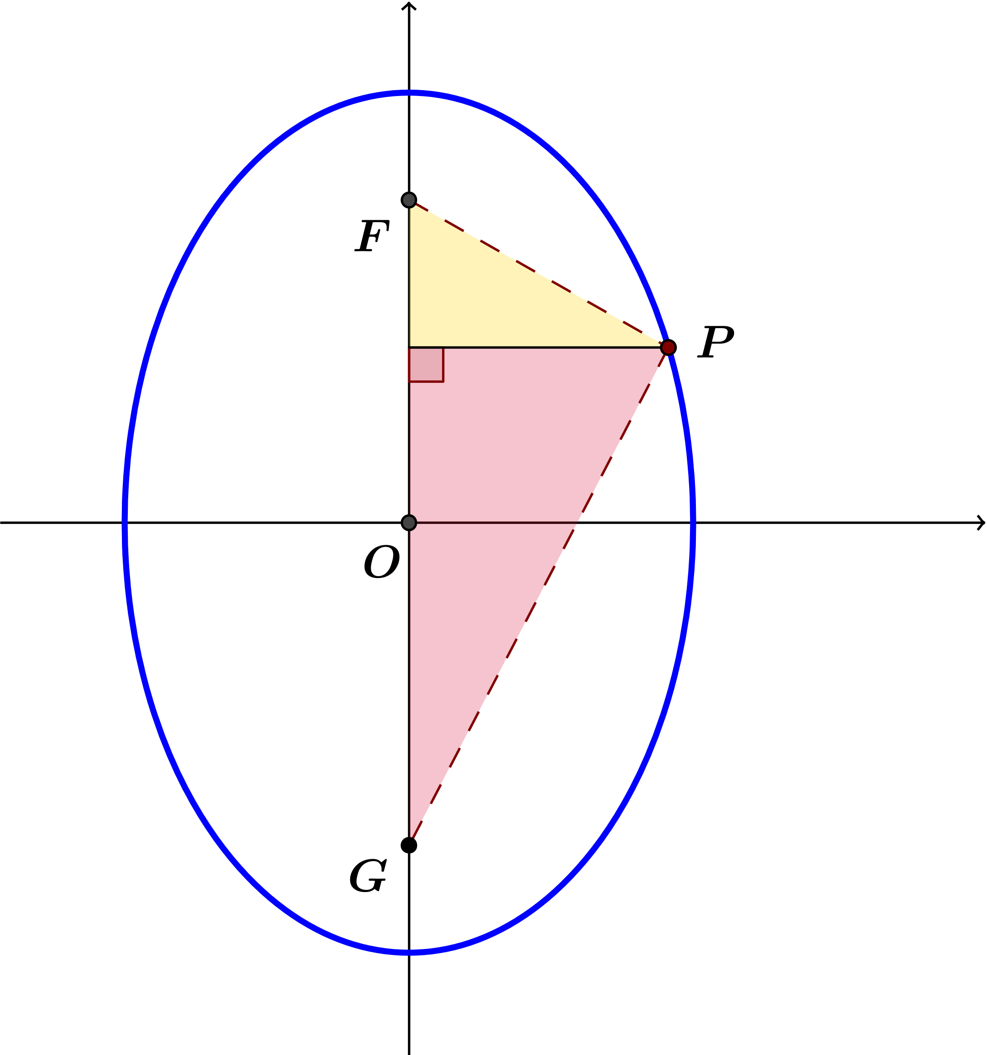

Problem Set

- Derive the equation of the ellipse with the given foci $F$ and $G$ that passes through point $P$. Write your answer in standard form: $\frac{x^{2}}{a^{2}}+\frac{y^{2}}{b^{2}}=1$.
  - The foci are $F(-2,0)$ and $G(2,0)$, and point $P\left(x,y\right)$ satisfies the condition $PF+PG=5$.
  - The foci are $F(-1,0)$ and $G(1,0)$, and point $P(x,y)$ satisfies the condition $PF+PG=5$.
  - The foci are $F(0,-1)$ and $G(0,1)$, and point $P(x,y)$ satisfies the condition $PF+PG=4$.
  - The foci are $F\left(-\frac{2}{3},0\right)$ and $G\left(\frac{2}{3},0\right)$, and point $P(x,y)$ satisfies the condition $PF+PG=3$.
  - The foci are $F(0,-5)$ and $G\left(0,5\right)$, and point $P(x,y)$ satisfies the condition $PF+PG=12$.
  - The foci are $F(-6,0)$ and $G(6,0)$, and point $P(x,y)$ satisfies the condition $PF+PG=20$.

- Recall from Lesson 6 that the semi-major axes of an ellipse are the segments from the center to the farthest vertices, and the semi-minor axes are the segments from the center to the closest vertices. For each of the ellipses in Problem 1, find the lengths $a$ and $b$ of the semi-major axes.

- Summarize what you know about equations of ellipses centered at the origin with vertices $\left(a,0\right)$, $\left(-a,0\right)$, $\left(0,b\right)$, and $(0,-b)$.

- Use your answer to Problem $3$ to find the equation of the ellipse for each of the situations below.
  - An ellipse centered at the origin with $x$-intercepts $(-2,0)$, $(2,0)$ and $y$-intercepts $\left(8,0\right)$, $(-8,0)$.
  - An ellipse centered at the origin with $x$-intercepts $(-\sqrt{5},0)$, $(\sqrt{5},0)$ and $y$-intercepts $\left(3,0\right)$, $(-3,0)$.

- Examine the ellipses and the equations of the ellipses you have worked with, and describe the ellipses with equation
$\frac{x^{2}}{a^{2}}+\frac{y^{2}}{b^{2}}=1$ in the three cases $a>b$, $a=b$, and $b>a$.

- Is it possible for $\frac{x^{2}}{4}+\frac{y^{2}}{9}=1$ to have foci at $\left(-c,0\right)$ and $\left(c,0\right)$ for some real number $c$?

- For each value of $k$ specified in parts (a)–(e), plot the set of points in the plane that satisfy the equation
$\frac{x^{2}}{4}+y^{2}=k$.
  - $k=1$
  - $k=\frac{1}{4}$
  - $k=\frac{1}{9}$
  - $k=\frac{1}{16}$
  - $k=\frac{1}{25}$
  - $k=\frac{1}{100}$
  - Make a conjecture: Which points in the plane will satisfy the equation $\frac{x^{2}}{4}+y^{2}=0?$
  - Explain why your conjecture in part (g) makes sense algebraically.
  - Which points in the plane will satisfy the equation $\frac{x^{2}}{4}+y^{2}=-1?$

- For each value of $k$ specified in parts (a)–(e), plot the set of points in the plane that satisfy the equation $\frac{x^{2}}{k}+y^{2}=1$.
  - $k=1$
  - $k=2$
  - $k=4$
  - $k=10$
  - $k=25$
  - Describe what happens to the graph of $\frac{x^{2}}{k}+y^{2}=1$ as $k→∞$.

- For each value of $k$ specified in parts (a)–(e), plot the set of points in the plane that satisfy the equation $x^{2}+\frac{y^{2}}{k}=1$.
  - $k=1$
  - $k=2$
  - $k=4$
  - $k=10$
  - $k=25$
  - Describe what happens to the graph of $x^{2}+\frac{y^{2}}{k}=1$ as $k→∞$.

