Lesson 6: Curves in the Complex Plane

Student Outcomes
- Students convert between the real and complex forms of equations for ellipses.
- Students write equations of ellipses and represent them graphically.

Lesson Notes
Initially, the students will review how to represent numbers in the complex plane using the modulus and argument. They will review the characteristics of the graphs of the numbers $=r(cos(θ)+i sin(θ))$, recognizing that they represent circles centered at the origin with the radius equal to the modulus $r$. They will then explore sets of complex numbers written in the form $z=a cos\left(θ\right)+bi sin(θ)$, identifying the graphs as ellipses. Students will convert between the complex and real forms of equations for ellipses, including those whose center is not the origin. They will also be introduced to some of the components of ellipses, such as the vertices, foci, and axes. This will prepare them to explore ellipses more formally in Lesson 7, where they will derive the equation of an ellipse using its foci.

Classwork
Opening Exercise (5 minutes)
This exercise should be completed in pairs or small groups. After a few minutes, students should discuss their responses to Exercises 1–2 with another pair or group before completing Exercise 5. If the students are struggling with how to convert between the rectangular and polar form, the exercises could be completed as part of a teacher-led discussion. Early finishers could display their conjectures and plots for Problem 3, which could be used in a teacher-led discussion of the characteristics of the graph.
Scaffolding:
- For students below grade level, consider a concrete approach using $z=3+2i$, or provide a graphical representation of $z=a+bi$.
- Advanced students could explore the properties of the graph of $z=3\cos\left(θ\right)+5i sin(θ)$ and compare it to the graph of
$z=5\cos\left(θ\right)+3i sin(θ)$ to form conjectures about the properties of graphs represented by
$z=a\cos\left(θ\right)+bi sin(θ)$.
Opening Exercise
  - Consider the complex number $z=a+bi$.
    - Write $z$ in polar form. What do the variables represent?
$z=r(\cos\left(θ\right)+i sin(θ))$, where $r$ is the modulus of the complex number and $θ$ is the argument.

    - If $r=3$ and $θ=90°$, where would $z$ be plotted in the complex plane?
The point $z$ is located $3 units$ above the origin on the imaginary axis.

    - Use the conditions in part (ii) to write $z$ in rectangular form. Explain how this representation corresponds to the location of $z$ that you found in part (ii).
$z=a+bi$, where $a=r \text{cos}(θ)$ and $b=r \text{sin}(θ)$
$a=3\cos\left(90°\right)=0$; $b=3\sin\left(90°\right)=3$
Then $z=3i$, which is located three units above the origin on the imaginary axis.

  - Recall the set of points defined by $z=3\left(\cos\left(θ\right)+i sin(θ)\right)$ for $0≤θ<360°$, where $θ$ is measured in degrees.
    - What does $z$ represent graphically? Why?
It is the set of points that are $3 units$ from the origin in the complex plane. This is because the modulus is $3$, which indicates that for any given value of $θ$, $z$ will be located a distance of $3 units$ from the origin.

    - What does $z$ represent geometrically?
A circle with radius $3 units$ centered at the origin.

  - Consider the set of points defined by $z=5\cos{θ+3i sin }θ$.
    - Plot $z$ for $θ=0°$, $90°$, $180°$, $270°$, $360°$. Based on your plot, form a conjecture about the graph of the set of complex numbers.
0
0
2
-2
2
-2
For $θ=0$, $z=5\cos\left(0°\right)+3i sin\left(0°\right)=5+0i↔\left(5,0\right)$.
For $θ=90$, $z=5\cos\left(90°\right)+3i sin(90°)=3i↔\left(0,3i\right)$.
For $θ=180$, $z=5\cos\left(180°\right)+3i sin\left(180°\right)=-5+0i↔\left(-5,0\right)$.
For $θ=270$, $z=5\cos\left(270°\right)+3i sin\left(270°\right)=-3i↔\left(0,-3i\right)$.
This set of points seems to form an oval shape centered at the origin.

    - Compare this graph to the graph of $z=3\left(\cos\left(θ\right)+i sin(θ)\right)$. Form a conjecture about what accounts for the differences between the graphs.
The coefficients of $cos(θ)$ and $i sin(θ)$ are equal for
$z=3\left(\cos\left(θ\right)+i sin(θ)\right)$, which results in a circle, which has a constant radius, while the coefficients are different for $z=5\cos\left(θ\right)+3i sin\left(θ\right)$, which seems to stretch the circle.

Example 1 (5 minutes)
The students will be led through an example to demonstrate how to convert the equation of a circle from its complex form to real form, i.e., an equation in $x$ and $y$. This will prepare them to convert the equations of ellipses from complex form to real form.
- We have seen that in the complex plane, the graph of the set of complex numbers defined by
$z=3\left(\cos\left(θ\right)+i sin\left(θ\right)\right)$ for $0°≤θ<360°$ is a circle centered at the origin with radius $3 units$. How could we represent each point on the circle using an ordered pair?
  - $\left(3cos{(θ), 3i sin}\left(θ\right)\right)$
- Let’s say we wanted to represent $z$ in the real coordinate plane. We’d need to represent the points on the circle using an ordered pair $(x, y)$. How can we write any complex number $z$ in terms of $x$ and $y$?
- $z=x+iy$
- So for $z=3\left(\cos\left(θ\right)+i sin\left(θ\right)\right)$, which expressions represent $x$ and $y$?
  - $z=3\cos\left(θ\right)+3i sin(θ)$, so $x=3\cos{(θ)}$ and $y=3\sin{(θ)}$
- What is the resulting ordered pair?
  - $\left(3cos\left(θ\right), 3sin\left(θ\right)\right)$
- Let’s graph some points and verify that this will give us a circle. Complete the table for the given values of $θ$.
Example 1
Consider again the set of complex numbers represented by $z=3\left(\cos\left(θ\right)+i sin(θ)\right)$ for $0≤θ<360°$.
$$θ$$ | $$3cos(θ)$$ | $$3sin(θ)$$ | $$\left(3cos\left(θ\right), 3i\sin\left(θ\right)\right)$$
$$0$$ | $$3$$ | $$0$$ | $$(3,0)$$
$$\frac{π}{4}$$ | $$\frac{3\sqrt{2}}{2}$$ | $$\frac{3\sqrt{2}}{2}$$ | $$\left(\frac{3\sqrt{2}}{2},\frac{3\sqrt{2}}{2}\right)$$
$$\frac{π}{2}$$ | $$0$$ | $$3$$ | $$(0,3)$$
$$\frac{3π}{4}$$ | $$-\frac{3\sqrt{2}}{2}$$ | $$\frac{3\sqrt{2}}{2}$$ | $$\left(-\frac{3\sqrt{2}}{2},\frac{3\sqrt{2}}{2}\right)$$
$$π$$ | $$-3$$ | $$0$$ | $$(-3,0)$$
$$\frac{5π}{4}$$ | $$-\frac{3\sqrt{2}}{2}$$ | $$-\frac{3\sqrt{2}}{2}$$ | $$\left(-\frac{3\sqrt{2}}{2},-\frac{3\sqrt{2}}{2}\right)$$
$$\frac{3π}{2}$$ | $$0$$ | $$-3$$ | $$(0,-3)$$
$$\frac{7π}{4}$$ | $$\frac{3\sqrt{2}}{2}$$ | $$-\frac{3\sqrt{2}}{2}$$ | $$\left(\frac{3\sqrt{2}}{2},-\frac{3\sqrt{2}}{2}\right)$$
$$2π$$ | $$3$$ | $$0$$ | $$(3,0)$$

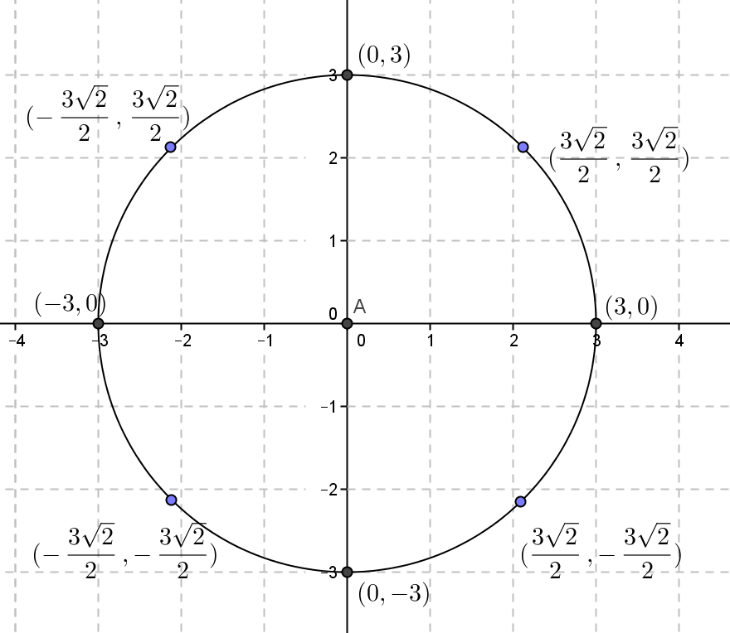
- Plot the points in the table, and determine the type of curve created.
  - The curve is a circle with center $(0, 0)$ and radius $3$.
- If $x=3cos⁡(θ)$ and $y=3sin⁡(θ)$, write an equation that relates $x^{2}$ and $y^{2}$.
  - $x^{2}+y^{2}={\left(3\cos\left(θ\right)\right)}^{2}+{\left(3\sin\left(θ\right)\right)}^{2}$
- Now, simplify the right side of that equation.
  - $x^{2}+y^{2}=9\cos^{2}\left(θ\right)+9\sin^{2}\left(θ\right)$
  - $x^{2}+y^{2}=9(\cos^{2}\left(θ\right)+\sin^{2}\left(θ\right))$
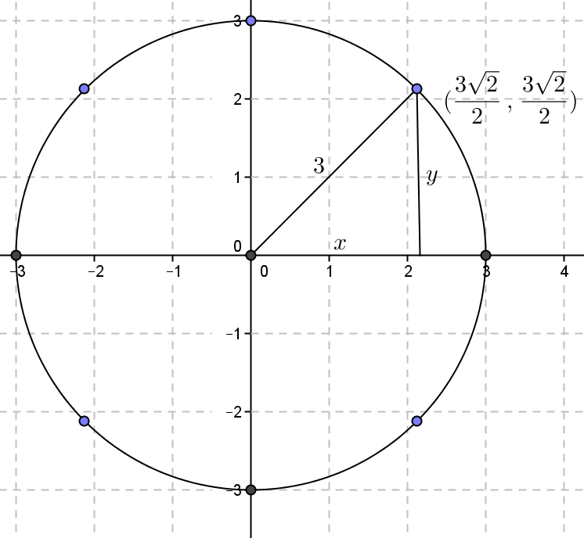
- Do you know a trigonometric identity that relates $sin^{2}(θ)$ and $cos^{2}(θ)$?
  - $\cos^{2}(θ)+\sin^{2}(θ)=1$
- Substitute into the previous equation.
  - $x^{2}+y^{2}=9$
- How does the graph of this equation compare with the graph of our equation in complex form?
  - Both graphs are circles centered at the origin with radius $3 units$.

  - Use an ordered pair to write a representation for the points defined by $z$ as they would be represented in the coordinate plane.
$$(3cos(θ), 3sin(θ))$$

  - Write an equation that is true for all the points represented by the ordered pair you wrote in part (a).
Since $x=3cos(θ)$ and $y=3sin(θ)$:
$$x^{2}+y^{2}={(3cos\left(θ\right))}^{2}+{(3sin\left(θ\right))}^{2}$$
$$x^{2}+y^{2}={9(cos\left(θ\right))}^{2}+{9(sin\left(θ\right))}^{2}$$
$$x^{2}+y^{2}={9((cos\left(θ\right))}^{2}+{(sin\left(θ\right))}^{2})$$
We know that ${(sin\left(θ\right))}^{2}+{(cos\left(θ\right))}^{2}=1$, so $x^{2}+y^{2}=9$.
  - What does the graph of this equation look like in the coordinate plane?
The graph is a circle centered at the origin with radius $3 units$.
Scaffolding:
If students are struggling with converting the equations into real form, suggest that they square $x$ and $y$ and then isolate $\cos^{2}(θ)$ or $\sin^{2}(θ)$ in the equations. Alternatively, Exercise 1 could be completed as guided practice, and the students could then complete Exercise 2 independently.

Exercises 1–2 (6 minutes)
The students should complete the exercises independently. After a few minutes, they could verify their responses with a partner. The solutions should be reviewed in a whole-class setting after students have had a sufficient amount of time to complete the exercises.
Exercises 1–2
- Recall the set of points defined by $z=5\cos\left(θ\right)+3i sin(θ)$.
  - Use an ordered pair to write a representation for the points defined by $z$ as they would be represented in the coordinate plane.
$$(5cos(θ), 3sin(θ))$$

  - Write an equation in the coordinate plane that is true for all the points represented by the ordered pair you wrote in part (a).
We have $x=5cos(θ)$ and $y=3sin(θ)$, so $x^{2}=25(\cos^{2}(θ))$ and $y^{2}=9\left(\sin^{2}\left(θ\right)\right)$. We know $\left(\cos^{2}(θ)+\sin^{2}(θ)\right)=1$.
Since $x^{2}=25(\cos^{2}(θ))$, then $\cos^{2}\left(θ\right)=\frac{x^{2}}{25}$. Since $y^{2}=9(\sin^{2}(θ))$, then $\sin^{2}\left(θ\right)=\frac{y^{2}}{9}$. By substitution, $\frac{x^{2}}{25}+\frac{y^{2}}{9}=1$.

- Find an algebraic equation for all the points in the coordinate plane traced by the complex numbers
$z=\sqrt{2}\cos\left(θ\right)+i sin(θ)$.
All the complex numbers represented by $z$ can be written using the ordered pair $(\sqrt{2}cos(θ), sin(θ))$ in the coordinate plane.
We have $x=\sqrt{2}cos(θ)$ and $y=sin(θ)$, so $x^{2}=2\cos^{2}(θ)$ and $y^{2}=\sin^{2}(θ)$. We know $\cos^{2}(θ)+\sin^{2}(θ)=1$.
Since $x^{2}=2\cos^{2}(θ)$, then $\cos^{2}\left(θ\right)=\frac{x^{2}}{2}$. Then by substitution, $\frac{x^{2}}{2}+y^{2}=1$.

Discussion (5 minutes): Describing an Ellipse
- At the outset of the lesson, we determined that the graph of the complex numbers defined by
$z=5\cos{θ+3i sin}θ$ was an oval shape that was centered about the origin and intersected the axes at the points $\left(5, 0\right)$, $\left(-5, 0\right)$, $\left(0, 3i\right)$ and $(0, -3i)$.
- Make a conjecture about the graph of the complex numbers defined by $z=\sqrt{2}\cos\left(θ\right)+i sin(θ)$. Sketch a rough graph of the points to test your conjecture. Share and discuss your conjecture with a neighbor. (Pull the class back together to debrief.)
MP.3
  - Answers will vary, but students should recognize that the graph would be a closed curve centered at the origin that intersects the axes at the points $\left(\sqrt{2}, 0\right)$, $\left(-\sqrt{2}, 0\right)$, $\left(0, 1\right)$ and $(0,-1)$.
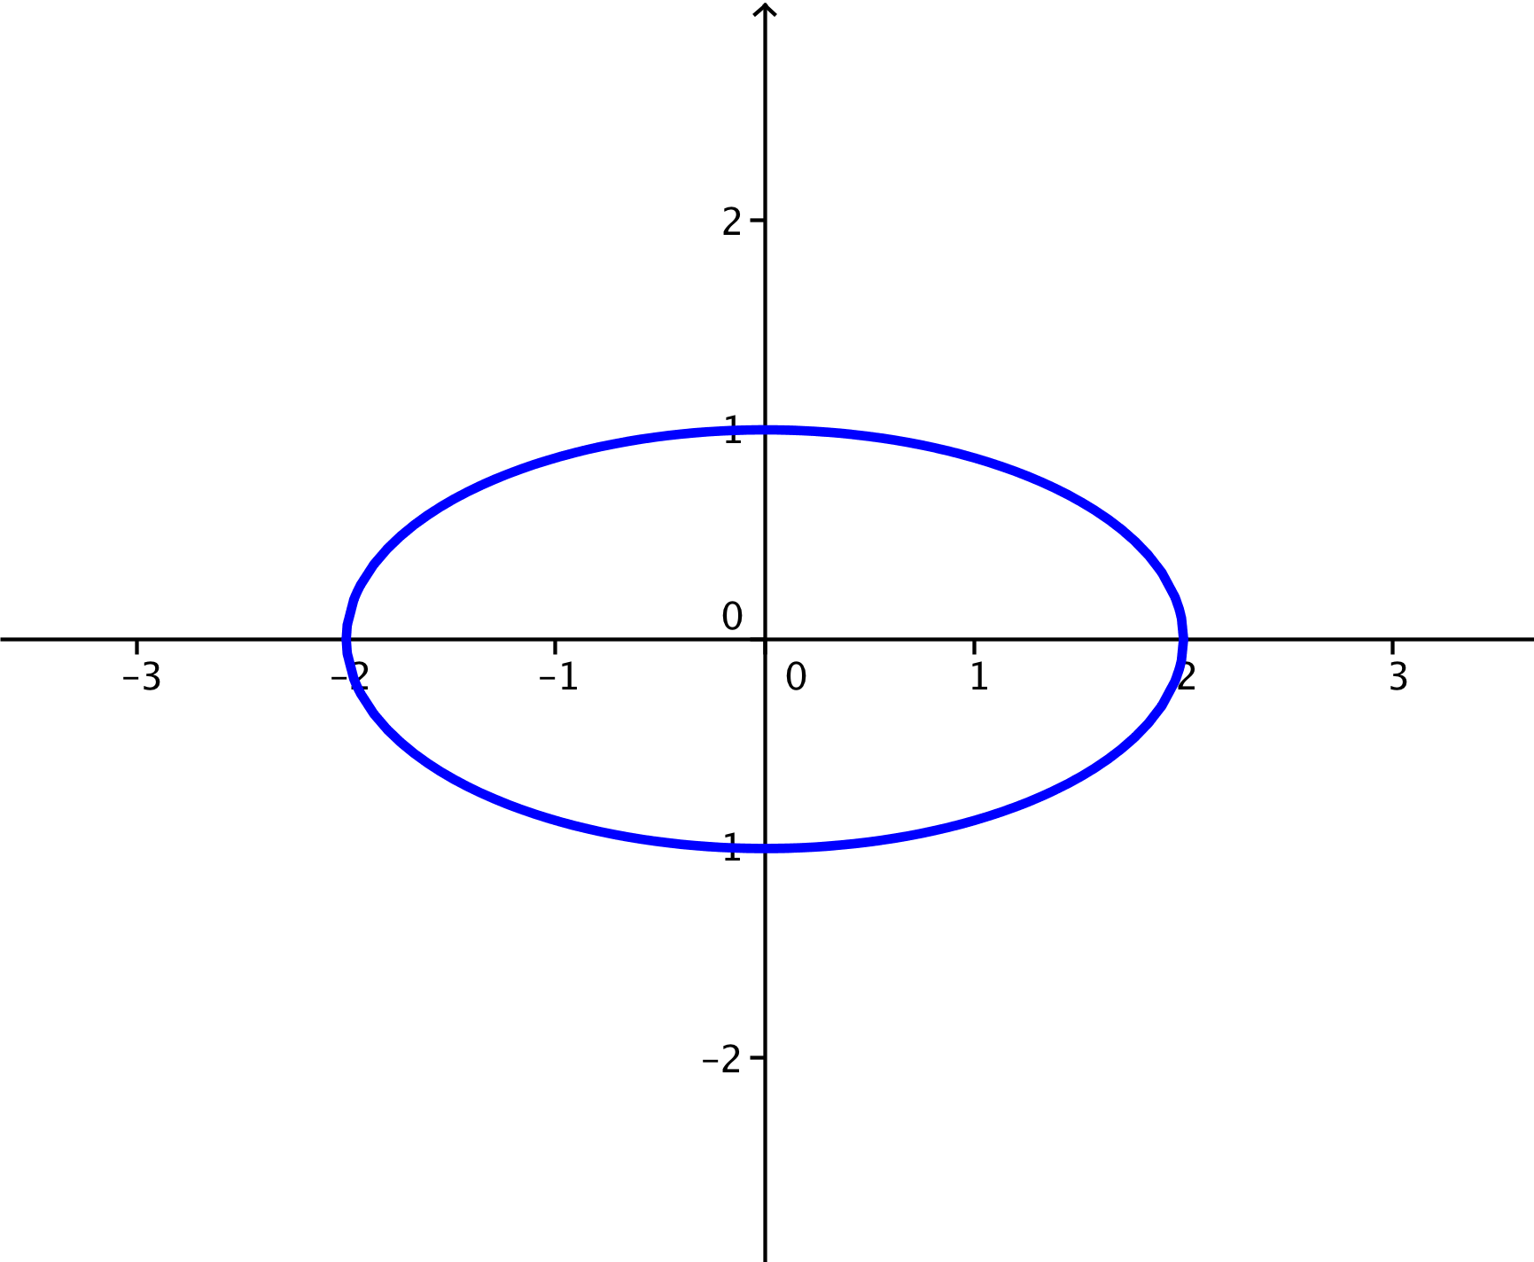
- What patterns do you notice between the graphs we have sketched and the structure of their equations in real form?
  - Answers will vary but might include that the equations are written in the form of $\frac{x^{2}}{a^{2}}+\frac{y^{2}}{b^{2}}=1$, where $|a|$ is the distance from the origin to the $x$-intercepts and $|b|$ is the distance from the $y$-intercepts.
- And what patterns do you notice between the graphs we have sketched and the structure of their equations in complex form?
MP.7
  - Answers will vary but might include that $a$ is the coefficient of $\cos{(θ)}$ and $b$ is the coefficient of $i\sin{(θ)}$.
- Let’s formalize these observations. The shape that arises from the curve given by an equation in the form $\frac{x^{2}}{a^{2}}+\frac{y^{2}}{b^{2}}=1$ is called an ellipse centered at the origin. An ellipse can be stretched horizontally or vertically, as shown in the figure below.
Scaffolding:
Have students complete a Frayer diagram for an ellipse. An example can be found in Module 1 Lesson 5.

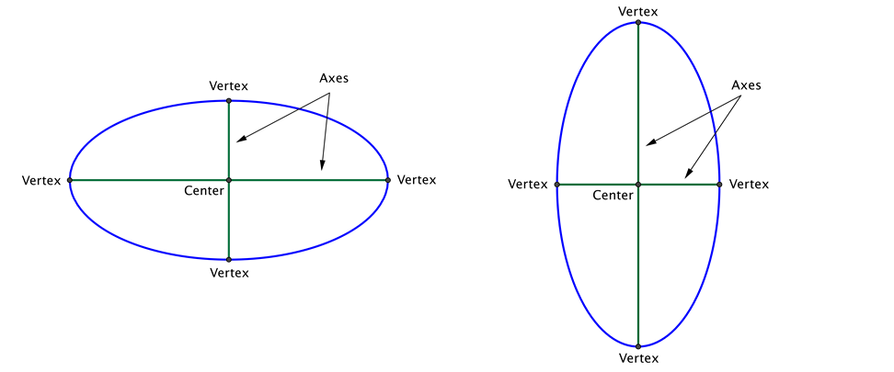
The vertices of the ellipse are the four points on the ellipse that are the closest to and farthest from the center. The axes of the ellipse are the segments connecting opposite vertices. The major axis is the longer of the two axes, and the minor axis is the shorter of the two axes. In the ellipse shown to the left above, the major axis is horizontal; in the ellipse shown to the right, the major axis is vertical.
The semi-major axis is defined as a segment between the center of the ellipse and a vertex along the major axis, and the semi-minor axis is a segment between the center of the ellipse and a vertex along the minor axis.
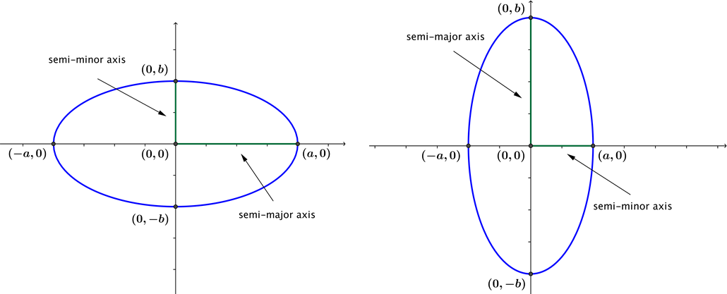
- If the ellipse is centered at the origin, then the vertices of the ellipse are the intercepts $(-a,0)$, $(a,0)$, $(0,-b)$ and $(0,b)$. In this case, what is the length of the semi-major axis?
  - Either $|a|$ or $|b|$, whichever is larger.
- Good. For an ellipse centered at the origin, what is the length of the semi-minor axis?
- Either $|a|$ or $|b|$, whichever is smaller.
- And what happens when $a=b$? Explain how you know.
- We get a circle because the distances from the center to $a$ and $b$ are the same.

Example 2 (5 minutes)
This example will prepare students to sketch the graphs of ellipses from their equations written in real form. It will also demonstrate how to convert equations of ellipses from real to complex form.
- How can we tell that an algebraic equation represents an ellipse without being told?
  - It can be written in the form $\frac{x^{2}}{a^{2}}+\frac{y^{2}}{b^{2}}=1$.
- And how can we use what we know about $a$ and $b$ to plot the ellipse?
  - Answers may vary but should address that $|a|$ represents the distance from the center of the ellipse to the points to the right and left of its center, so the graph of our equation will intersect the $x$-axis at $\left(4, 0\right)$ and $\left(-4, 0\right)$. The number $|b|$ represents the distance from the center of the ellipse to the points above and below its center, so the graph will intersect the $y$-axis at $\left(0, 2\right)$ and $\left(0, -2\right)$.
- Now, let’s write the equation $\frac{x^{2}}{16}+\frac{y^{2}}{4}=1$ in complex form. What is the structure of a general equation for an ellipse in complex form?
  - $z=a\cos\left(θ\right)+bi sin(θ)$
- What do we need to find, then, to write the equation in complex form?
  - Values of $a$ and $b$.
- How could we find values of $a$ and $b$?
  - Since $\frac{x^{2}}{a^{2}}+\frac{y^{2}}{b^{2}}=1$, we have $16=a^{2}$ and $4=b^{2}$, which means $a=4$ and $b=2$.
- What is the complex form of the equation of the ellipse given by $\frac{x^{2}}{16}+\frac{y^{2}}{4}=1$?
  - $z=4cos\left(θ\right)+2i sin(θ)$
Example 2
The equation of an ellipse is given by $\frac{x^{2}}{16}+\frac{y^{2}}{4}=1$.
  - Sketch the graph of the ellipse.
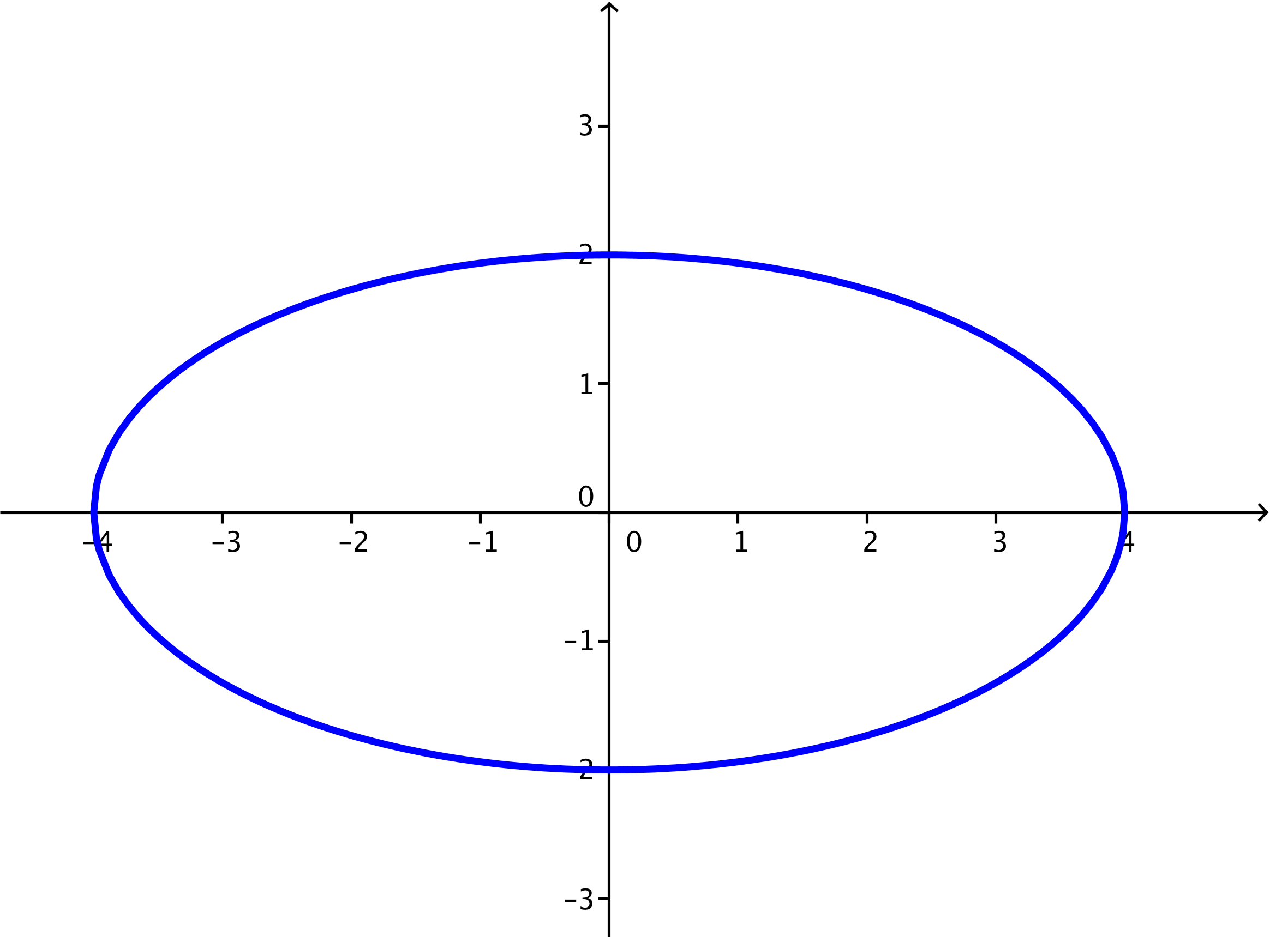

  - Rewrite the equation in complex form.
$\frac{x^{2}}{16}+\frac{y^{2}}{4}=1$
Since $\frac{x^{2}}{a^{2}}+\frac{y^{2}}{b^{2}}=1$, we have $a=4$ and $b=2$.
The complex form of the ellipse is $z=a cos\left(θ\right)+bi sin\left(θ\right)=4cos\left(θ\right)+2i sin\left(θ\right)$.
Exercise 3 (4 minutes)
Students should complete the exercise in pairs. They should solve the problem independently and, after a few minutes, verify their solutions with a partner. At an appropriate time, pairs of selected students should share their sketches or the complex form for the equation. Make sure the students recognize the change in the orientation of the ellipse, i.e., that it is elongated vertically because $b>a$.
Exercise 3
- The equation of an ellipse is given by $\frac{x^{2}}{9}+\frac{y^{2}}{26}=1$.
  - Sketch the graph of the ellipse.
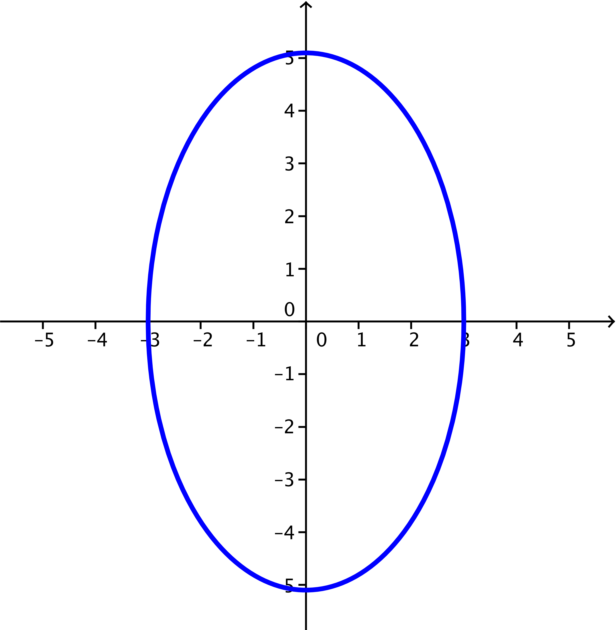

  - Rewrite the equation of the ellipse in complex form.
$$\frac{x^{2}}{9}+\frac{y^{2}}{26}=1 \\ \left|a\right|=3 \\ \left|b\right|=\sqrt{26}$$
The complex form of the ellipse is $z=a cos\left(θ\right)+bi sin\left(θ\right)=3cos\left(θ\right)+\sqrt{26}i sin\left(θ\right)$.

Example 3 (5 minutes)
This example will introduce students to ellipses that are not centered at the origin and will prepare them to convert translated ellipses from complex to real form and to sketch their graphs.
- How does this equation look different from others we have seen in this lesson?
  - There are constants included that were not in the other equations.
- How can we represent the complex numbers $z$ in rectangular form?
  - $z=x+iy$
- And what are the values of $x$ and $y$ for this equation?
  - $x=2+7cos(θ)$ and $y=$ $1+sin(θ)$
- What has been our procedure for converting equations of ellipses from complex to real form?
  - Isolate $cos(θ)$ and $sin(θ)$, and then substitute the equivalent expressions into the equation $\cos^{2}(θ)+\sin^{2}(θ)=1$.
- What is the resulting equation?
  - ${\frac{(x-2}{49}}^{)2}+{(y-1)}^{2}=1$
- How do we know this equation represents an ellipse?
  - It is written in the form $\frac{x^{2}}{a^{2}}+\frac{y^{2}}{b^{2}}=1$.
- What are the values of $a$ and $b$?
  - $a=7$ and $b=1$
- How do the constants subtracted from $x$ and $y$ affect the graph of the ellipse?
  - They represent a translation of the center from the origin $2 units$ to the right and $1 unit$ up.
- Describe the graph of the ellipse.
  - Answers will vary but should address that the ellipse is centered at $(2, 1)$ and is elongated horizontally, so the semi-major axis has length $7 units$, and the semi-minor axis has length $1 unit$.
Example 3
A set of points in the complex plane can be represented in the complex plane as $z=2+i+7cos(θ)+i sin(θ)$ as $θ$ varies.
  - Find an algebraic equation for the points described.
$$z=2+i+7cos\left(θ\right)+i sin(θ)=\left(2+7cos\left(θ\right)\right)+i(1+sin(θ))$$
Since $z=x+iy$, then $x=2+7cos(θ)$ and $y=1+sin(θ)$.
So $cos\left(θ\right)=\frac{x-2}{7}$ and $sin(θ)=\left(y-1\right)$
Since $\cos^{2}(θ)+\sin^{2}(θ)=1$, we have ${\left(\frac{x-2}{7}\right)}^{2}+{\left(y-1\right)}^{2}=1$, which is equivalent to
$\frac{{\left(x-2\right)}^{2}}{49}+{\left(y-1\right)}^{2}=1$.

  - Sketch the graph of the ellipse.
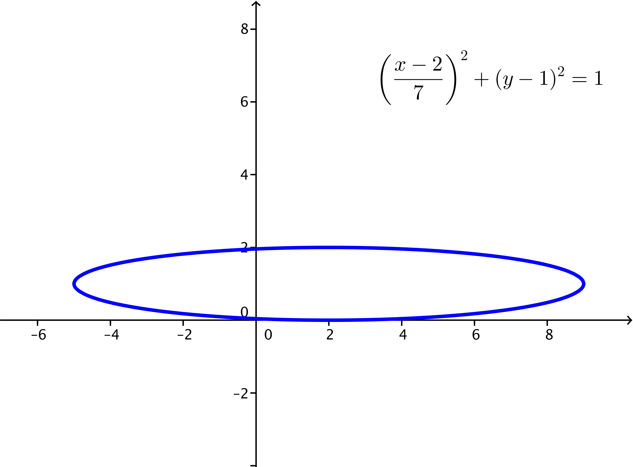
Closing (5 minutes)
Have the students summarize the information on ellipses. As a class, a list of the key features of an ellipse can be compiled and displayed. A list of key features should address:
- An ellipse is a curve that represents the set of complex numbers that satisfy the equation
$z=a\cos\left(θ\right)+bi sin(θ)$ for $0≤θ<360$.
- If $a=b$, the curve is a circle with radius $r$, and the equation can be simplified to $z=r(\cos\left(θ\right)+i\sin\left(θ\right))$.
- In the coordinate plane, ellipses centered at the origin can be represented by the equation $\frac{x^{2}}{a^{2}}+\frac{y^{2}}{b^{2}}=1$, where $|a|$ is the half of the length of the horizontal axis and $|b|$ is the half of the length of the vertical axis.
- The sketch of a general ellipse is:
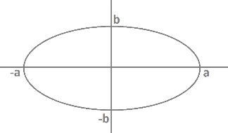
- An ellipse is elongated horizontally if $a>b$ and elongated vertically when $b>a$.
- The points on an ellipse can be written in polar form as $\left(a\cos\left(θ\right),b\sin\left(θ\right)\right)$.
- An ellipse with center $(h, k)$ can be represented by the equation $\frac{{\left(x-h\right)}^{2}}{a^{2}}+\frac{{\left(y-k\right)}^{2}}{b^{2}}=1$.

Exit Ticket (5 minutes)

Name Date
Lesson 6: Curves in the Complex Plane

Exit Ticket

- Write the real form of the complex equation $z=\cos\left(θ\right)+3i sin\left(θ\right)$. Sketch the graph of the equation.

- Write the complex form of the equation $\frac{x^{2}}{25}+\frac{y^{2}}{4}=1$. Sketch the graph of the equation.

Exit Ticket Sample Solutions

- Write the real form of the complex equation $z=\cos\left(θ\right)+3i sin(θ)$. Sketch the graph of the equation.
$$x^{2}+\frac{y^{2}}{9}=1$$
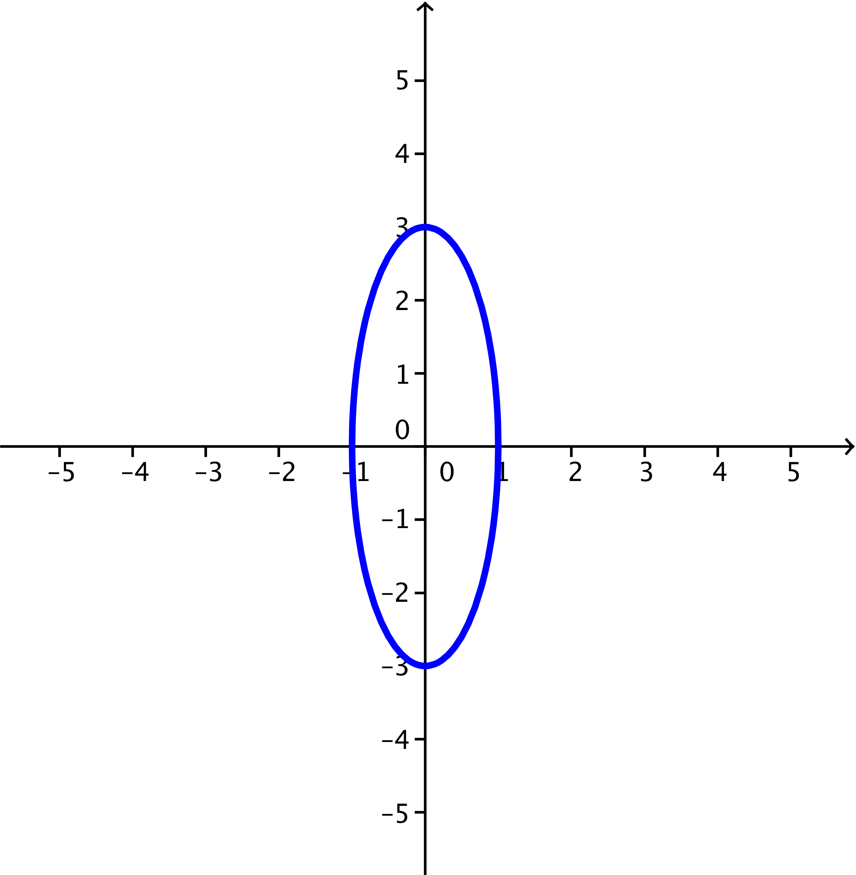

- Write the complex form of the equation $\frac{x^{2}}{25}+\frac{y^{2}}{4}=1$. Sketch the graph of the equation.
$$z=5cos\left(θ\right)+2i sin(θ)$$
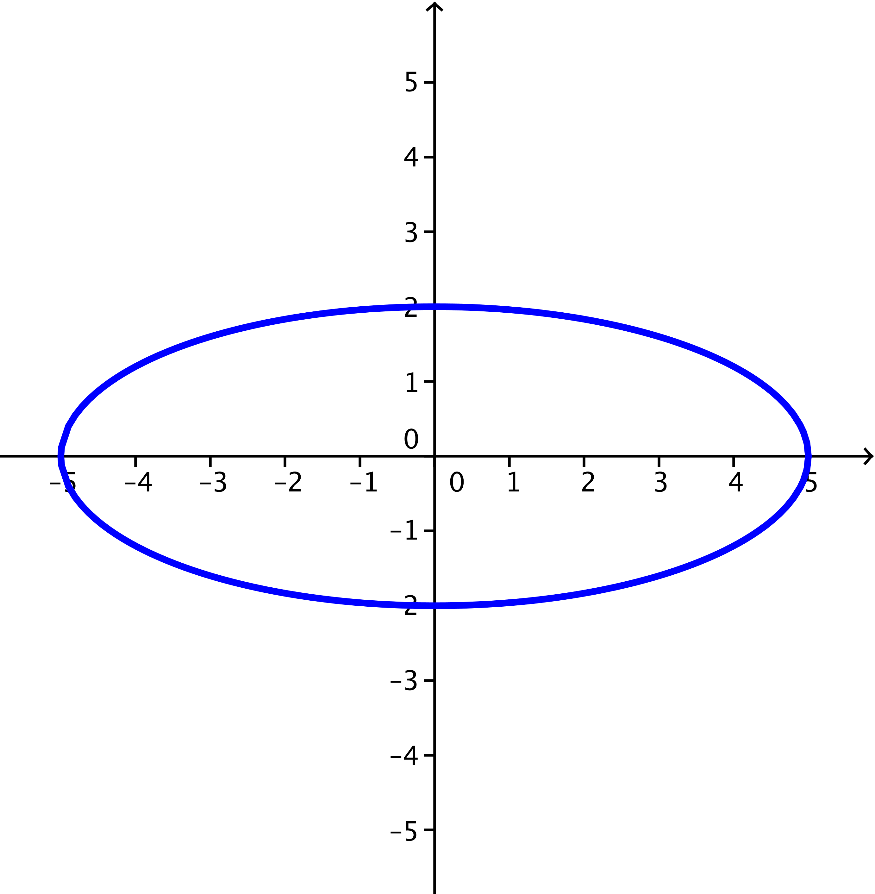

Problem Set Sample Solutions
Problem 6 is an extension that requires students to convert an algebraic equation for an ellipse to standard form. The problem could be presented using the standard form of the equation (the answer for part (a)) to provide students with additional practice converting the equations of ellipses between complex and real forms.

- Write the real form of each complex equation.
  - $z=4\cos\left(θ\right)+9i sin(θ)$
$$\frac{x^{2}}{16}+\frac{y^{2}}{81}=1$$
  - $z=6\cos\left(θ\right)+i sin\left(θ\right)$
$$\frac{x^{2}}{36}+y^{2}=1$$

  - $z=\sqrt{5}\cos{(θ)+\sqrt{10}i sin}(θ)$
$$\frac{x^{2}}{5}+\frac{y^{2}}{10}=1$$

  - $z=5-2i+4\cos\left(θ\right)+7i sin(θ)$
$$\frac{{(x-5)}^{2}}{16}+\frac{({y+2)}^{2}}{49}=1$$

- Sketch the graphs of each equation.
  - $z=3\cos\left(θ\right)+i sin(θ)$
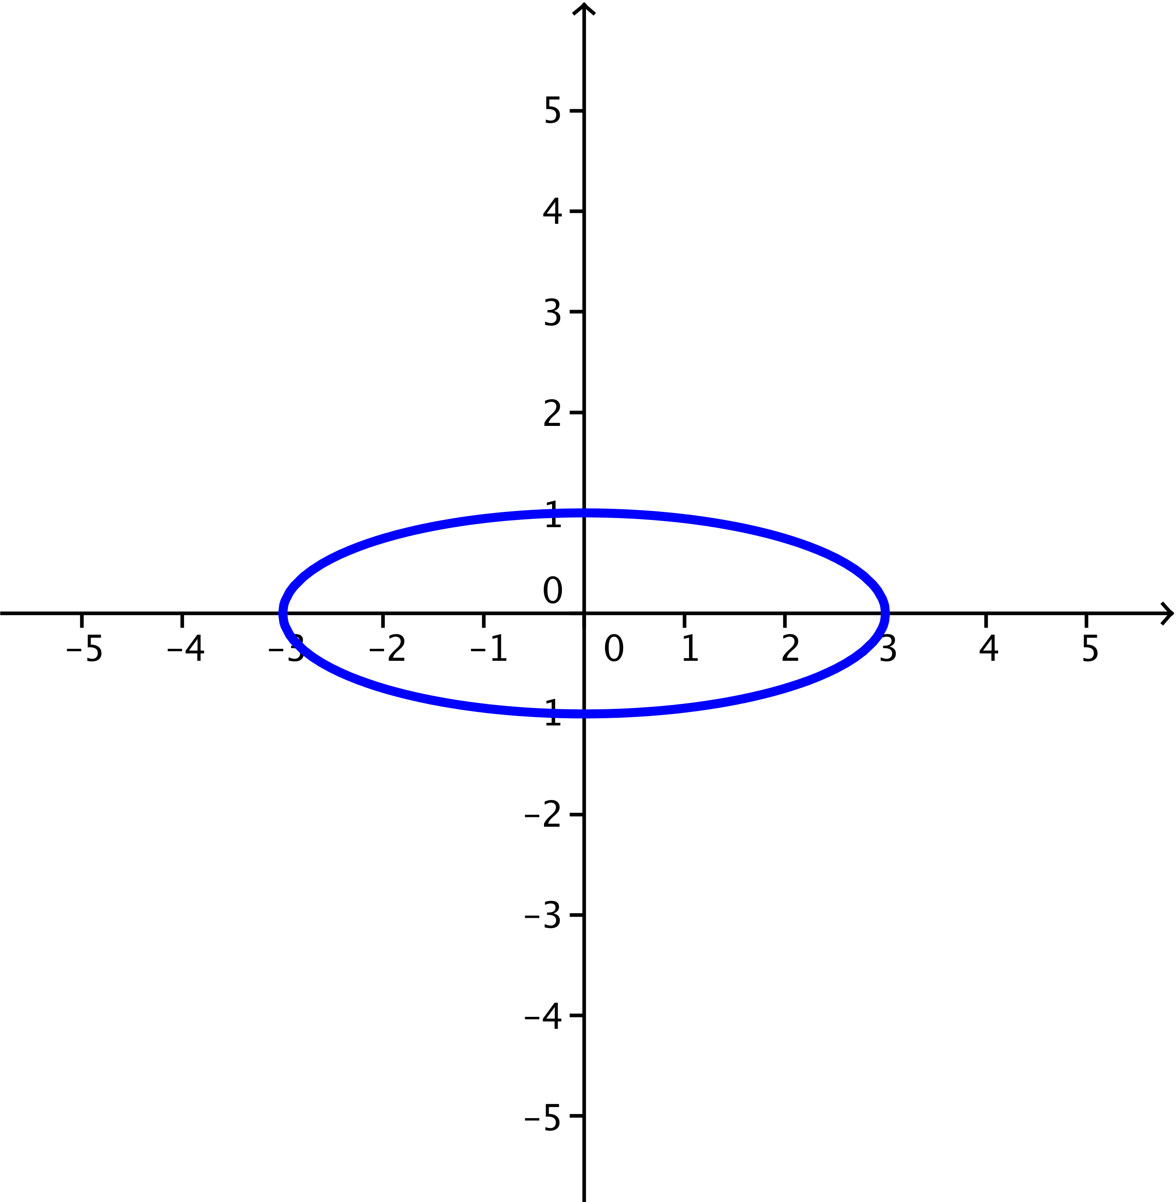

  - $z=-2+3i+4\cos\left(θ\right)+i sin(θ)$
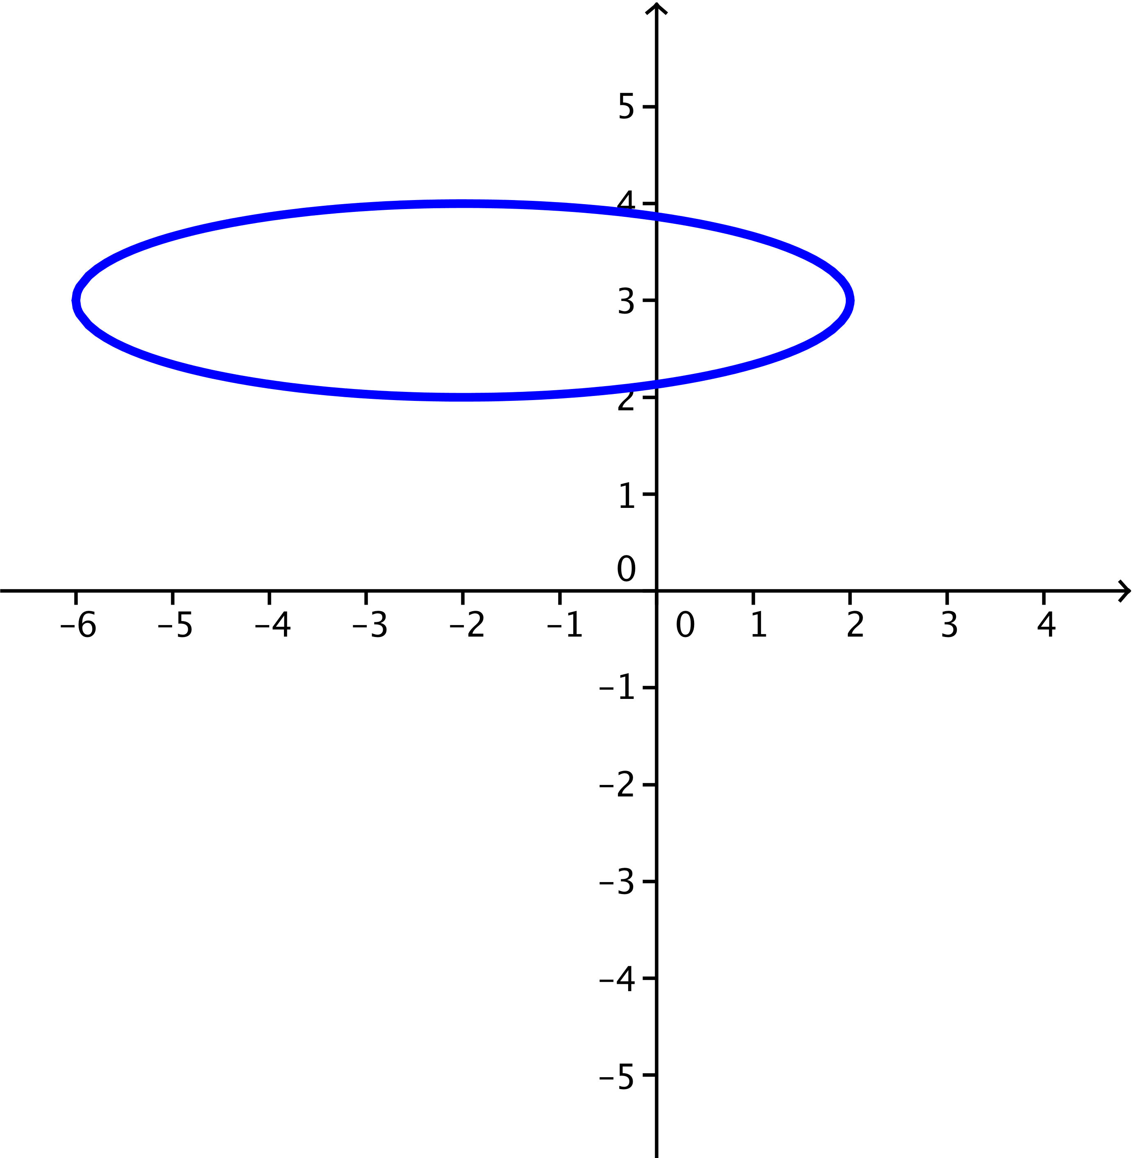

  - $\frac{{\left(x-1\right)}^{2}}{9}+\frac{y^{2}}{25}=1$
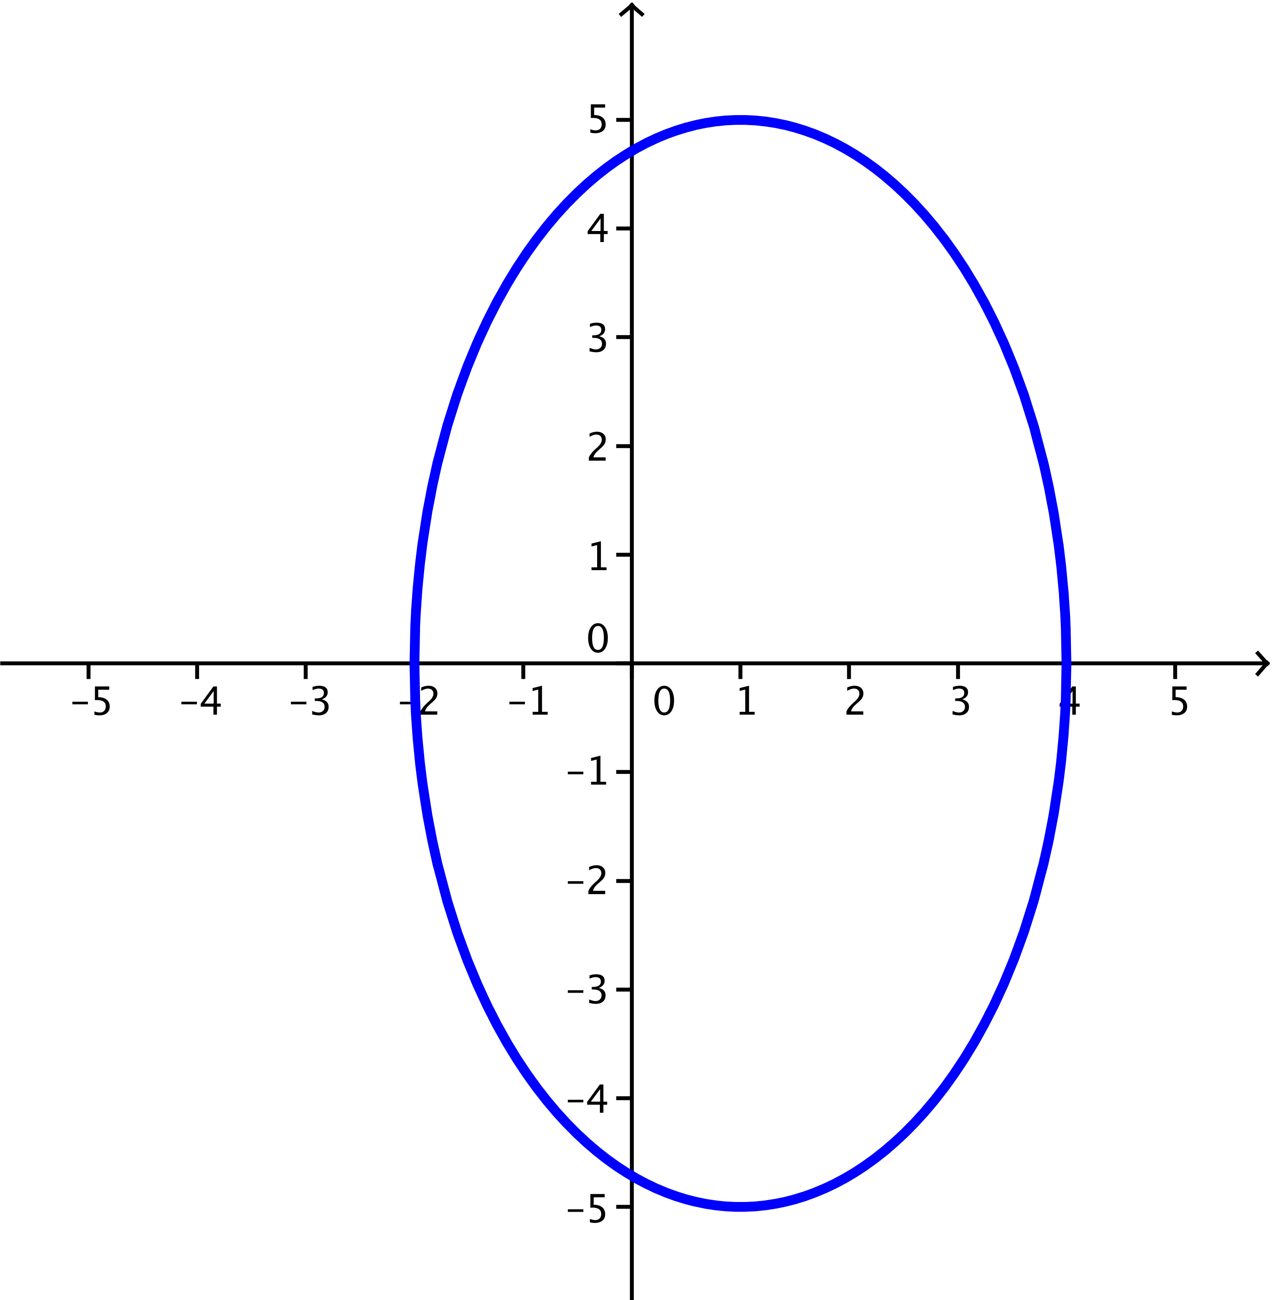

  - $\frac{{\left(x-2\right)}^{2}}{3}+\frac{y^{2}}{15}=1$
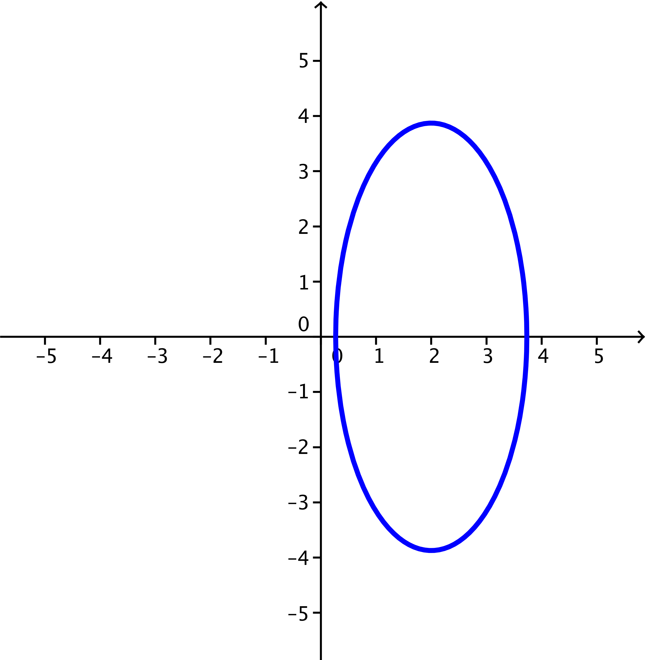

- Write the complex form of each equation.
  - $\frac{x^{2}}{16}+\frac{y^{2}}{36}=1$
$$z=4\cos\left(θ\right)+6i sin(θ)$$

  - $\frac{x^{2}}{400}+\frac{y^{2}}{169}=1$
$$z=20\cos\left(θ\right)+13i sin(θ)$$

  - $\frac{x^{2}}{19}+\frac{y^{2}}{2}=1$
$$z=\sqrt{19}\cos\left(θ\right)+\sqrt{2}i sin(θ)$$

  - $\frac{{\left(x-3\right)}^{2}}{100}+\frac{{\left(y+5\right)}^{2}}{16}=1$
$$z=3-5i+10\cos\left(θ\right)+4i sin(θ)$$
- Carrie converted the equation $z=7cos\left(θ\right)+4i sin(θ)$ to the real form $\frac{x^{2}}{7}+\frac{y^{2}}{4}=1$. Her partner Ginger said that the ellipse must pass through the point $\left(7cos\left(0\right), 4sin\left(0\right)\right)=\left(7,0\right)$ and this point does not satisfy Carrie’s equation, so the equation must be wrong. Who made the mistake, and what was the error? Explain how you know.
Ginger is correct. Carrie set $a=7$ and $b=4$ which is correct but then made an error in converting to the real form of the equation by dividing by $a$ and $b$ instead of $a^{2}$ and $b^{2}$.

- Cody says that the center of the ellipse with complex equation $z=4-5i+2cos\left(θ\right)+3i sin\left(θ\right)$ is $(4,-5)$, while his partner Jarrett says that the center of this ellipse is $\left(-4,5\right)$. Which student is correct? Explain how you know.
Cody is correct. This ellipse is the translation of the ellipse with equation $z=2cos\left(θ\right)+3i sin\left(θ\right)$ by the vector
$〈4,-5〉$, which moves the center of the ellipse from the origin to the point $\left(4,-5\right)$.

Extension:
- Any equation of the form $ax^{2}+bx+cy^{2}+dy+e=0$ with $a>0$ and $c>0$ might represent an ellipse. The equation $4x^{2}+8x+3y^{2}+12y+4=0$ is such an equation of an ellipse.
  - Rewrite the equation $\frac{{\left(x-h\right)}^{2}}{a^{2}}+\frac{{\left(y-k\right)}^{2}}{b^{2}}=1$ in standard form to locate the center of the ellipse $(h, k)$.
$$4{(x}^{2}+2x)+3(y^{2}+4y)+4=0 \\ 4{(x}^{2}+2x+1)+3\left(y^{2}+4y+4\right)=-4+4\left(1\right)+3(4) \\ 4({x+1)}^{2}+3{(y+2)}^{2}=12 \\ \frac{4({x+1)}^{2}}{12}+\frac{3{\left(y+2\right)}^{2}}{12}=1 \\ \frac{({x+1)}^{2}}{3}+\frac{{\left(y+2\right)}^{2}}{4}=1$$
The center of the ellipse is the point $\left(-1,-2\right)$.

  - Describe the graph of the ellipse, and then sketch the graph.
The graph of the ellipse is centered at $(-1, -2)$. It is elongated vertically
with a semi-major axis of length $2 units$ and a semi-minor axis of length $\sqrt{3} units$.
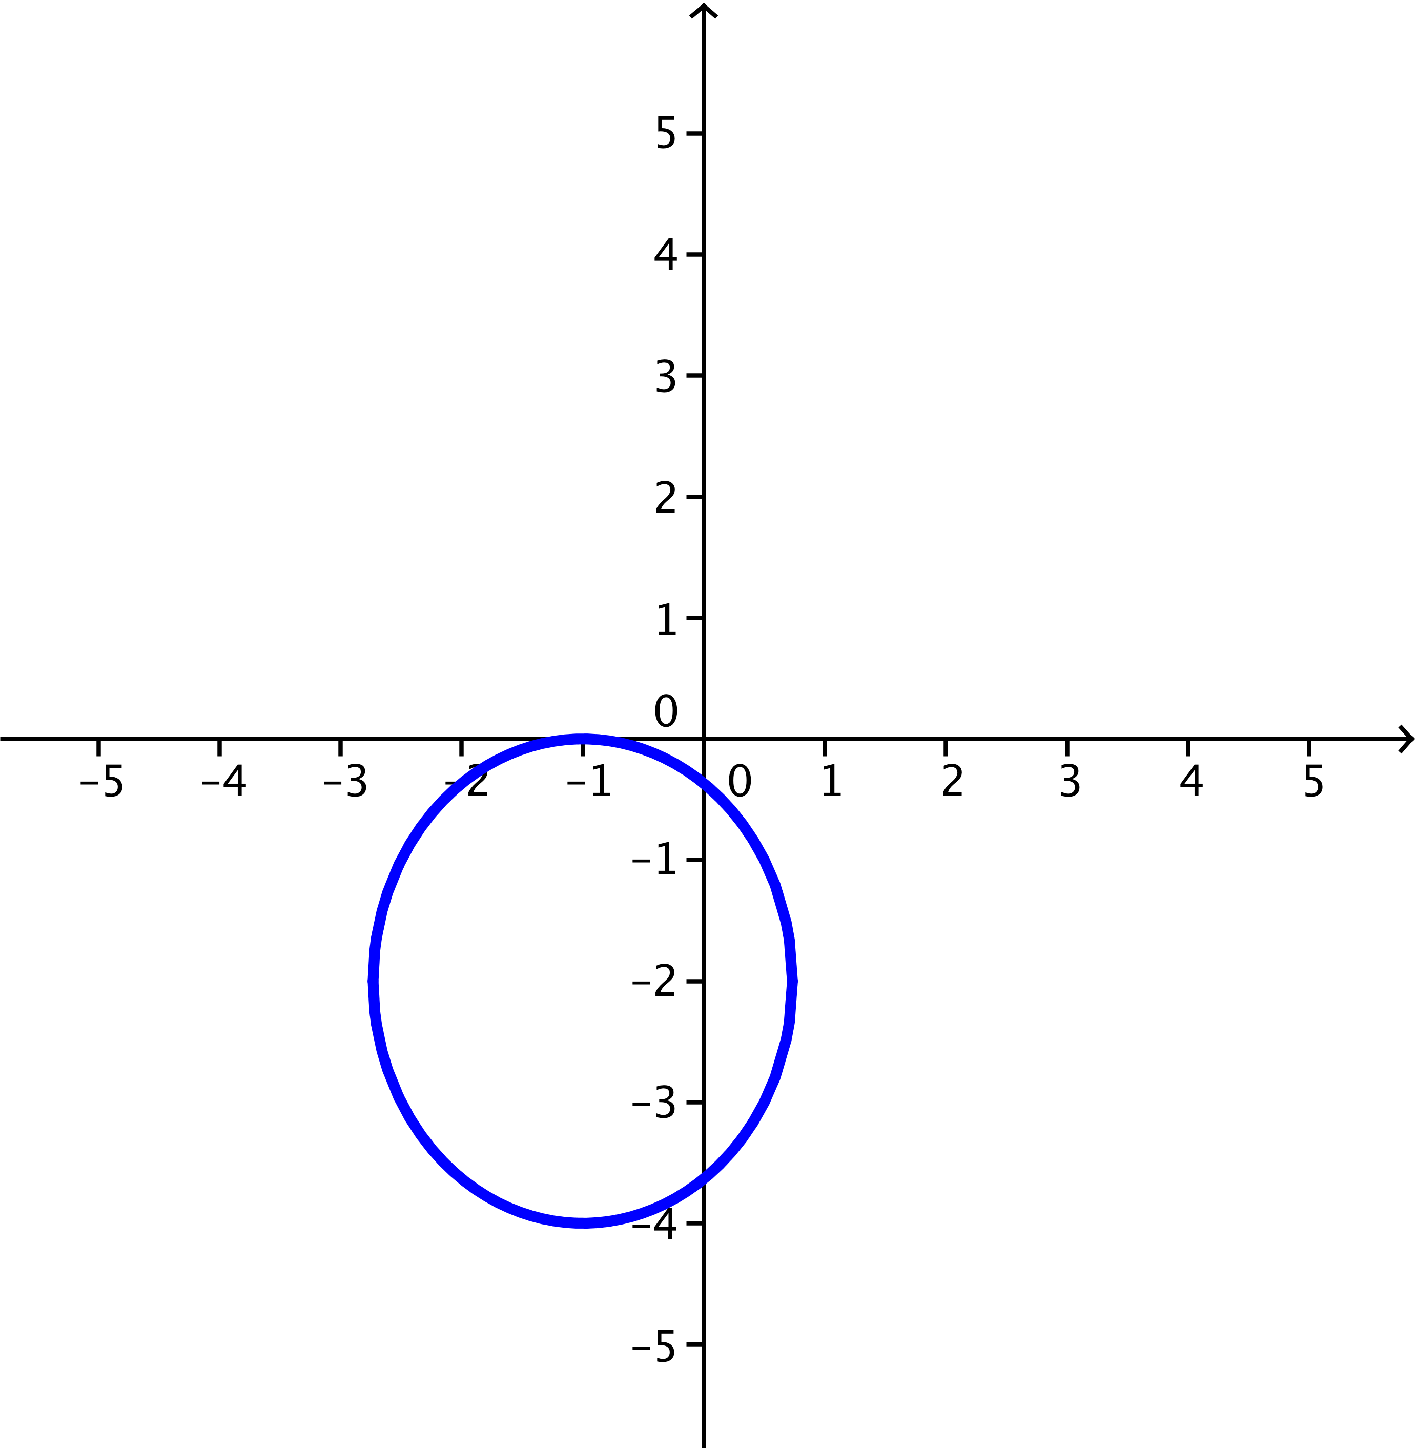

  - Write the complex form of the equation for this ellipse.
$$\frac{({x+1)}^{2}}{3}+\frac{{\left(y+2\right)}^{2}}{4}=1$$
$\cos^{2}(θ)+\sin^{2}(θ)=1$, so $\cos^{2}(θ)=\frac{({x+1)}^{2}}{3}$ and $\sin^{2}(θ)=\frac{{\left(y+2\right)}^{2}}{4}$
$3\cos^{2}(θ)=({x+1)}^{2}$, so $x=\sqrt{3}cos(θ)-1$
$4\sin^{2}(θ)=({y+2)}^{2}$, so $y=2sin(θ)-2$
$$z=x+iy \\ =\sqrt{3}cos\left(θ\right)-1+i\left(2sin\left(θ\right)-2\right) \\ =-1-2i+\sqrt{3}cos\left(θ\right)+2i sin(θ)$$

